Amended PROJECT Area BUDGET

Olympus Hills
Community Reinvestment Area (CRA)

Millcreek Community Reinvestment Agency, UTah


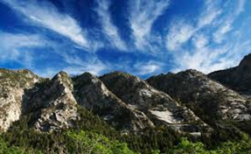

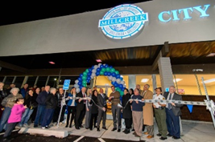

December 11, 2023
[Draft Version Amending November 26, 2018 Adopted Version]

Table of Contents

Table of Contents 2
Section 1: Introduction 3
Section 2: Description of Community Development Project Area 3
Section 3: General Overview of Amended Project Area Budget 4
Section 4: Property Tax Increment 5
Section 5: Cost/Benefit Analysis 7
Exhibit A: Project Area Map 8
Exhibit B: Multi-Year Budget 9

Section 1: Introduction

The Millcreek Community Reinvestment Agency (the “Agency”), following thorough consideration of the needs and desires of the City of Millcreek (the “City”) and its residents, as well as understanding the City’s capacity for new development, has carefully crafted the Amended Project Area Plan (the “Amended Plan” or “Amended Project Area Plan”) for the Olympus Hills Community Reinvestment Project Area (the “Project Area”). The Amended Plan is the result of a comprehensive evaluation of the types of appropriate land-uses and economic development opportunities for the land encompassed by the Project Area which includes land east of Interstate 215 East along Wasatch Blvd near the freeway interchange.

The Amended Plan is envisioned to define the method and means of development for the Project Area from its current state to a higher and better use. The City has determined it is in the best interest of its citizens to assist in the development of the Project Area. This Amended Project Area Budget document (the “Amended Budget”) is predicated upon certain elements, objectives and conditions outlined in the Amended Plan and intended to be used as a financing tool to assist the Agency in meeting Amended Plan objectives discussed herein and more specifically referenced and identified in the Amended Plan.

The creation of the Project Area is being undertaken as a community reinvestment project pursuant to certain provisions of Chapters 1 and 5 of the Utah Community Reinvestment Agency Act (the “Act”, Utah Code Annotated (“UCA”) Title 17C). The requirements of the Act, including notice and hearing obligations, have always been observed throughout the establishment of the Project Area.

Section 2: Description of Community Development Project Area

The Project Area includes land east of Interstate 215 East along Wasatch Blvd near the freeway interchange. The Project Area is comprised of approximately 42 acres of property.

A map of the Project Area is attached hereto in Exhibit A.

Section 3: General Overview of Amended Project Area Budget

The purpose of the Amended Project Area Budget is to provide the financial framework necessary to implement the Project Area Amended Plan vision and objectives. The Amended Project Area Plan has identified that tax increment financing is essential to meet the objectives of the CRA Project Area. The following information will detail the sources and uses of tax increment and other necessary details needed for public officials, interested parties, and the public in general to understand the mechanics of the Amended Project Area Budget.

Base Year Value
The Agency has determined that the base year property tax value for the Project Area will be the total taxable value for the 2017 tax year which is estimated to be $3,768,320. Using the tax rates established within the Project Area the property taxes levied equate to $56,412 annually. Accordingly, this amount will continue to flow through to each taxing entity proportional to the amount of their respective tax rates being levied.

Payment Trigger
The Project Area will have a twenty-year (20) duration from the date of the first tax increment received by the Agency. The collection of tax increment will be triggered at the discretion of the Agency prior to March 1 of the tax year in which they intend to begin the collection of increment. The following year in which this increment will be remitted to the Agency will be Year 1, e.g., if requested prior to March 1, 2023, Year 1 of increment will be 2024. The Agency anticipates it will trigger tax increment by March 1, 2026, but in no case will the Agency trigger the first year of tax increment collection after March 1, 2027.

Projected Tax Increment Revenue – Total Generation
Development within the Project Area will commence upon favorable market conditions which will include both horizontal and vertical infrastructure and development. The Agency anticipates that new development will begin in the Project Area in 2020. The contemplated development will generate significant additional property tax revenue as well as incremental sales and use tax above what is currently generated within the Project Area.

Property Tax Increment will begin to be generated in the tax year (ending Dec 1st) following construction completion and Tax Increment will be paid to the Agency in March or April after collection. It is projected that property Tax Increment generation within the Project Area could begin as early as 2025 or as late as 2027. It is currently estimated that during the 20-year life of the Amended Project Area Budget, property Tax Increment could be generated within the Project Area in the approximate amount of $4.56 million or at a net present value (NPV) of $3.21 million. This amount is over and above the $1.13 million of base taxes that the property would generate over 20 years at the $56,412 annual amount it currently generates as shown in Table 4.1 below.

Section 4: Property Tax Increment

Base Year Property Tax Revenue
The taxing entities are currently receiving - and will continue to receive - property tax revenue from the current assessed value of the property within the Project Area (“Base Taxes”). The current assessed value is estimated to be $3,768,320. Based upon the tax rates in the area, the collective taxing entities are receiving $56,412 in property tax annually from this Project Area. This equates to approximately $1,128,235 over the 20-year life of the Project Area.

Table 4.1: Total Base Year to Taxing Entities (Over 20 Years)
Entity | Total | NPV at 4%
Salt Lake County | $152,617 | 103,706
Salt Lake County Library | 42,130 | 28,628
Granite School District | 589,516 | 400,586
Millcreek City | 151,637 | 103,040
South Salt Lake Valley Mosquito Abatement District | 1,130 | 768
Mt. Olympus Improvement District | 21,027 | 14,288
Central Utah Water Conservancy District | 30,147 | 20,485
Unified Fire Service Area | 140,031 | 95,153
Total Revenue | $1,128,235 | $766,654

Property Tax Increment Shared with RDA
It is anticipated that Salt Lake County will not participate in the Amended Project Area Budget, but all other taxing entities will participate. Specifically, Granite School District will participate at 75% for a 15-year period, Millcreek City for 90% for a 20-year period, and other taxing entities at a 65% for a 20-year period, as depicted below in Table 4.2. The City, County and the State will not contribute any portion of their incremental sales tax to implement the Amended Project Area Plan. Table 4.2 shows the amount of Tax Increment shared with the Agency assuming the participation levels discussed above.

Table 4.2: Sources of Tax Increment Funds
Entity | Percentage | Length | Total | NPV at 6.5%
Salt Lake County | 0% | - | $ - | $ -
Salt Lake County Library | 0% | - | - | -
Granite School District | 75% | 15 Years | 2,634,976 | 1,592,975
Millcreek City | 90% | 20 Years | 987,986 | 524,129
South Salt Lake Valley Mosquito Abatement District | 65% | 20 Years | 4,420 | 2,345
Mt. Olympus Improvement District | 65% | 20 Years | 92,324 | 48,978
Central Utah Water Conservancy District | 0% | - | - | -
Unified Fire Service Area | 65% | 20 Years | 649,214 | 344,409
Total Sources of Tax Increment Funds |  |  | $4,368,919 | $2,512,836

Uses of Tax Increment
The Agency will use 5% of the tax increment to administer the CRA. Most of the remaining tax increment collected by the Agency will be used for redevelopment activities in the Project Area (85%). Including: offsetting certain on-site public infrastructure costs, land assemblage, development incentives, Agency requested improvements and upgrades, desirable Project Area improvements, and other redevelopment activities as approved by the Agency. The remaining 10% will go towards affordable housing, as required by the Act.

Table 4.3: Uses of Tax Increment
Uses | Total | NPV at 6.5%
Redevelopment Activities | $3,713,581 | $2,135,910
CRA Housing Requirement | 436,892 | 251,284
Project Area Administration | 218,446 | 125,642
Total Uses of Tax Increment Funds | $4,368,919 | $2,512,836

A multi-year projection of tax increment is including in Exhibit B.

Total Annual Property Tax Revenue for Taxing Entities at Conclusion of Project
As described above, the collective taxing entities are currently receiving approximately $56,412 in property taxes annually from this Project Area. At the end of 20 years an additional $458,398 in property taxes annually is anticipated, totaling approximately $514,812 in property taxes annually for the area. “But for” the assistance provided by the Agency through tax increment revenues, this greater than 700 percent increase in property taxes generated for the taxing entities would not be possible.

Table 4.4: Total Base Year and End of Project Life Annual Property Taxes
Entity | Annual Base Year Property Taxes | Annual Property Tax Increment at Conclusion of Project | Total Annual Property Taxes
Salt Lake County | $7,631 | $58,016 | $65,647
Salt Lake County Library | 2,106 | 15,349 | 17,455
Granite School District | 29,476 | 250,950 | 280,426
Millcreek City | 7,582 | 57,777 | 65,359
South Salt Lake Valley Mosquito Abatement District | 57 | 358 | 415
Mt. Olympus Improvement District | 1,051 | 7,476 | 8,527
Central Utah Water Conservancy District | 1,507 | 15,906 | 17,413
Unified Fire Service Area | 7,002 | 52,568 | 59,570
Total Revenue | $56,412 | $458,398 | $514,812

Section 5: Cost/Benefit Analysis

Additional Revenues

Other Tax Revenues
The development within the Project Area will also generate sales taxes for the City and County.

Table 5.1 shows the total revenues generated by the Project Area. This total includes the anticipated property tax increment and sales and use tax.

Table 5.1 Total Revenues
Entity | Property Tax | Sales Tax | Total Revenues
Salt Lake County (Including Library) | $1,393,924 | $4,700,520 | $6,094,444
Granite School District | 4,768,052 | - | 4,768,052
Millcreek City | 1,097,762 | 9,401,039 | 10,498,801
South Salt Lake Valley Mosquito Abatement District | 6,800 | - | 6,800
Mt. Olympus Improvement District | 302,206 | - | 302,206
Central Utah Water Conservancy District | 142,037 | - | 142,037
Unified Fire Service Area | 998,790 | - | 998,790
Total Revenues | $8,709,571 | $14,101,559 | $22,811,130

Additional Costs
The development anticipated within the Project Area will also likely result in additional general government, public works, and public safety costs. These costs, along with the estimated budget to implement the Amended Project Area Plan, are identified below.

Table 5.2 Total Expenditures
Entity | CRA Budget | General Government | Public Works | Public Safety | Total Expenditures
Salt Lake County (Including Library) | $ - | $39,158 | $ - | $ - | $39,158
Granite School District | 2,634,976 | 384,500 | - | - | 3,019,476
Millcreek City | 987,986 | 190,836 | 224,965 | 405,414 | 1,809,201
South Salt Lake Valley Mosquito Abatement District | 4,420 | 542 | - | - | 4,962
Mt. Olympus Improvement District | 92,324 | 25,715 | - | - | 118,039
Central Utah Water Conservancy District | - | 15,966 | - | - | 15,966
Unified Fire Service Area | 649,214 | 64,275 | - | - | 713,489
Total Expenditures | $4,386,919 | $720,992 | $224,965 | $405,414 | $5,720,291

The total net benefit to the taxing entities of participating in the Project Area is $17,090,839, with the City’s net benefit being $8,689,600.

Exhibit A: Project Area Map

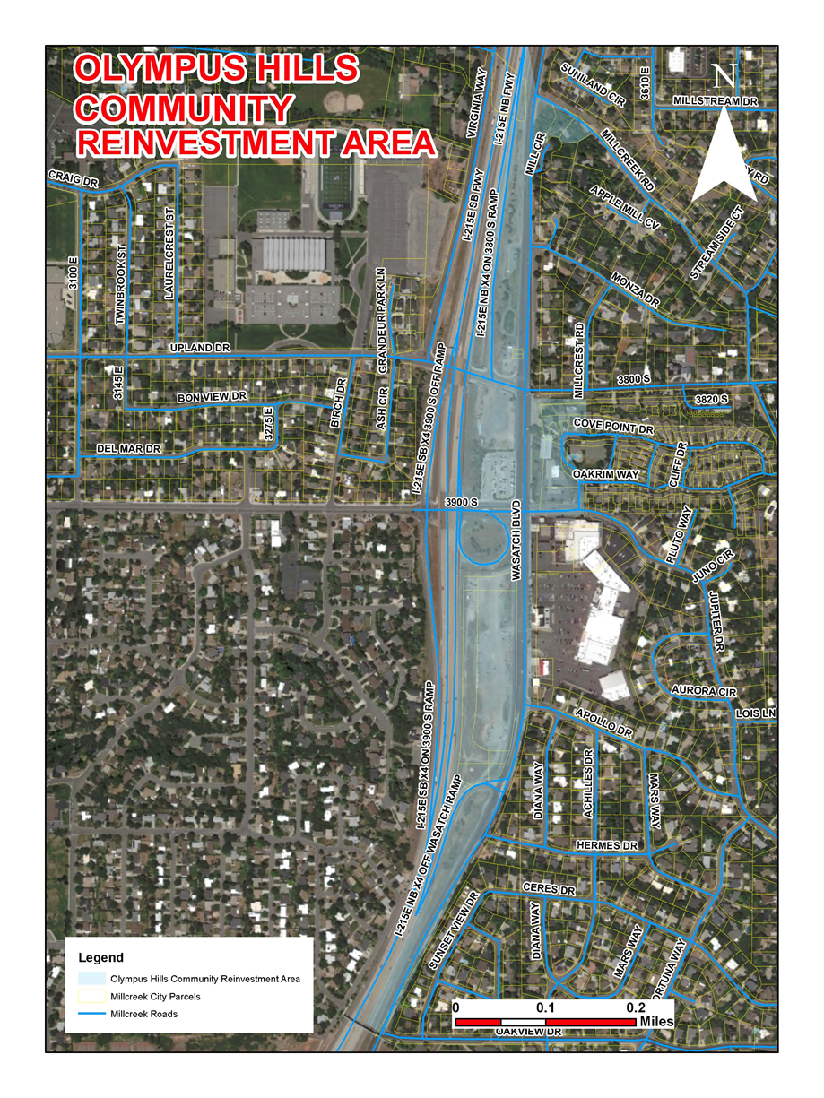

Exhibit B: Multi-Year Budget

Net Present Value of future cash flows assumes a 4% discount rate. The same 4% discount rate is used in all remaining NPV calculations. This total is prior to accounting for the flow-through of tax increment to the respective taxing entities.

