Amended Project Area Plan

olympus hills
Community Reinvestment Area (CRA)

Millcreek community reinvestment agency, UTah

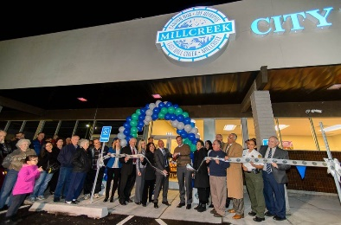




December 11, 2023
[Draft Version Amending November 26, 2018 Adopted Version]

Table of Contents
Table of Contents 2
Definitions 3
Introduction 5
Description of the Boundaries of the Proposed Project Area 6
General Statement of Land Uses, Layout of Principal Streets, Population Densities, Building Densities and How They Will be Affected by the Project Area 6
Standards Guiding the Community Reinvestment 7
How the Purposes of this Title Will Be Attained By Project Area Development 7
Conformance of the Proposed Development to the Community's General Plan 7
Describe any Specific Project or Projects that are the object of the Proposed Community Reinvestment 7
How the Agency Plans to Select a Participant 8
Reason for Selection of the Project Area 8
Description of Physical, Social and Economic Conditions Existing in the Project Area 8
Description of any Financial Assistance that the Agency Anticipates Offering a Participant 9
Anticipated Public Benefit to be Derived from the Community Development 9
EXHIBIT A: Legal Description of Farm Meadows CRA 11
EXHIBIT B: Project Area Map 11
EXHIBIT B: Parcel List 13

Definitions

As used in this Community Reinvestment Amended Project Area Plan, the term:

"Act" shall mean and include the Limited Purpose Local Government Entities – Community Reinvestment Agency Act in Title 17C, Chapters 1 through 5, Utah Code Annotated 1953, as amended, or such other amendments as shall from time to time be enacted or any successor or replacement law or act.

“Agency” shall mean the Millcreek Community Reinvestment Agency, which is a separate body corporate and politic created by the City pursuant to the Act.

“Amended Project Area Plan” or “Amended Plan” shall mean the written plan (outlined by 17C-5-105 of the Act) that, after its effective date, guides and controls the community reinvestment activities within the Project Area. Amended Project Area Plan refers to this document and all the attachments to this document, which attachments are incorporated by this reference. It is anticipated that the collection of tax increment to fund the Amended Project Area Plan will be subject to an interlocal agreement process with the taxing entities within the Project Area.

"Base taxable value" shall mean the agreed value specified in a resolution or interlocal agreement under Subsection 17C-1-102(8) from which tax increment will be collected.

“Base year” shall mean the agreed upon year for which the base taxable value is established and shall be incorporated into the interlocal agreements with participating taxing entities.

“City” or “Community” shall mean Millcreek City.

“Legislative body” shall mean the City Council of Millcreek City, which is the legislative body of the City.

“Plan Hearing” shall mean the public hearing on the draft Amended Project Area Plan required under Subsection 17C-1-102 (41) and 17C-5-104(3)(e).

“Project Area” shall mean the geographic area described in the Amended Project Area Plan or draft Amended Project Area Plan where the community reinvestment set forth in this Amended Project Area Plan or draft Amended Project Area Plan takes place or is proposed to take place (Exhibit A & Exhibit B).

“Net Present Value (NPV)” shall mean the discounted value of a cash flow. The NPV illustrates the total value of a stream of revenue over several years in today’s dollars.

“Project Area Budget” shall mean (as further described under 17-C-5-303 of the Act) the multi-year projection of annual or cumulative revenues, other expenses and other fiscal matters pertaining to the Project Area that includes:

- the base taxable value of property in the Project Area;

- the projected tax increment expected to be generated within the Project Area;

- the amount of tax increment expected to be shared with other taxing entities;

- the amount of tax increment expected to be used to implement the Amended Project Area Plan;

- if the area from which tax increment is to be collected is less than the entire Project Area:

      - the tax identification number of the parcels from which tax increment will be collected; or

      - a legal description of the portion of the Project Area from which tax increment will be collected; and

- for property that the Agency owns and expects to sell, the expected total cost of the property to the Agency and the expected selling price.

“Taxes” includes all levies on an ad valorem basis upon land, local and centrally assessed real property, personal property, or any other property, tangible or intangible.

“Taxing Entity” shall mean any public entity that levies a tax on any property within the Project Area.

“Tax Increment” is as defined by the Act, but in general shall mean the difference between the amount of property tax revenues generated each tax year by all taxing entities from the Project Area using the current assessed value of the property and the amount of property tax revenues that would be generated from the same area using the base taxable value of the property.

“Tax Increment Period” shall mean the period in which the taxing entities from the Project Area consent that a portion of their tax increment from the Project Area be used to fund the objectives outlined in the Amended Project Area Plan.

“Tax Year” shall mean the 12-month period between sequential tax roll equalizations (November 1st - October 31st) of the following year, e.g., the November 1, 2023 - October 31, 2024 tax year.

To the extent of the foregoing terms are defined by the Act or other applicable statutory law, the definitions set forth in this document are supplemental to those statutory definitions and are intended as clarifications only.

Introduction

The Millcreek Community Reinvestment Agency (the “Agency”), following thorough consideration of the needs and desires of Millcreek City (the “City”) and its residents, as well as the City’s capacity for new development, has carefully crafted this Amended Project Area Plan (the “Amended Project Area Plan” or “Amended Plan”) for the Olympus Hills Community Reinvestment Project Area (the “Project Area”). This Amended Plan is the result of a comprehensive evaluation of the types of appropriate land-uses and economic development for the land encompassed by the Project Area which includes land east of Interstate 215 East along Wasatch Blvd near the freeway interchange. The Amended Plan is intended to define the method and means of the Project Area from its current state to a higher and better use.

The City has determined it is in the best interest of its citizens to assist in the redevelopment of the Project Area. It is the purpose of this Amended Plan to clearly set forth the aims and objectives of development, scope, financing mechanism, and value to the residents of the City and other taxing entities within the Project Area.

The Project Area is being undertaken as a community reinvestment project area pursuant to certain provisions of Chapters 1 and 5 of the Utah Limited Purpose Local Governmental Entities -- Community Reinvestment Agency Act (the “Act”, Utah Code Annotated (“UCA”) Title 17C). The requirements of the Act, including notice and hearing obligations, have always been observed throughout the establishment of the Project Area. The realization of the Amended Plan is subject to interlocal agreements between the taxing entities individually and the Agency.

Resolution Authorizing the Preparation of a Draft Community Reinvestment Project Area Plan
Pursuant to the provisions of §17C-5-103 of the Act, the governing body of the Agency adopted a survey resolution authorizing the preparation of a draft Community Reinvestment Amended Project Area Plan on May 14, 2018.

Recitals of Prerequisites for Adopting a Community Reinvestment Amended Project Area Plan
Utah Code
§17C-5-104
To adopt this Olympus Hills Community Reinvestment Amended Project Area Plan, the Agency confirms each of the requirements enumerated below have either been completed or will be completed prior to or at the time the Amended Plan is considered and adopted.

- Pursuant to the provisions of §17C-5-104(1)(a) and (b) of the Act, the City has a planning commission and general plan as required by law;

- Pursuant to the provisions of §17C-5-104 of the Act, the Agency has conducted or will conduct one or more public hearings for informing the public about the Project Area, and allowing public input into the Agency’s deliberations and considerations regarding the Project Area; and

- Pursuant to the provisions of §17C-5-104 of the Act, the Agency has allowed opportunity for input on the Amended Project Area Plan and has made a Amended Project Area Plan available to the public at the Agency’s offices during normal business hours, provided notice of the plan hearing, sent copies of the Amended Project Area Plan to all required entities prior to the hearing, and provided opportunities for affected entities to provide feedback.

Description of the Boundaries of the Project Area
Utah Code
§17C-5-105(1)

A legal description of the Project Area along with a detailed map of the Project Area is attached respectively as Exhibit A and Exhibit B and incorporated herein. The Project Area includes parcels east of Interstate 215 East along Wasatch Blvd near the freeway interchange.

As delineated in the office of the Salt Lake County Recorder, the Project Area encompasses all the parcels detailed in Exhibit C.

General Statement of Land Uses, Layout of Principal Streets, Population Densities, Building Densities and How They Will be Affected by the Project Area
Utah Code
§17C-5-105(2)

General Land Uses
The property within the Project Area is currently zoned for commercial and residential uses. This Amended Project Area Plan is consistent with the General Plan of the City. Any zoning change, amendment or conditional use permit necessary to the successful development contemplated by this Amended Project Area Plan shall be undertaken in accordance with the requirements of the City’s Code and all other applicable laws including all goals and objectives in the City’s General Plan.

Layout of Principal Streets
There principal streets of the Project Area are Wasatch Blvd and 3900 South. All the streets within the Project Area are outlined in the attached map in Exhibit A.

Population Densities
There are 4 residences within the Project Area. The average household size within Salt Lake County is 2.97. Therefore, it is estimated that there is a population of approximately 12 within the Project Area, or 0.28 persons per acre. It is anticipated that the Project Area development may increase the population size within the Project Area.

Building Densities
There are currently 6 buildings within the Project Area. It is anticipated that the redevelopment of the Project Area will result in additional buildings and increased density within the Project Area.

Impact of Community Reinvestment on Land Use, Layout of Principal Streets, and Population Densities
Community reinvestment activities within the Project Area will mostly consist of redevelopment of underutilized areas.

Land Use – It is anticipated that future development within the Project Area will include: residential, commercial, office and public gathering space

Layout of Principal Streets – It is anticipated that the community reinvestment of the Project Area will not alter the layout of the principal streets in the area. UDOT is currently studying freeway interchanges and has contemplated realigning the on and off ramps within the Project Area.

Population Densities –The Project Area will include residential development; therefore, the population density will increase within the Project Area.

Standards Guiding the Community Reinvestment
Utah Code
§17C-5-105(3)

To provide maximum flexibility in the development and economic promotion of the Project Area, and to encourage and obtain the highest quality in development and design, specific development controls for the uses identified above are not set forth herein. Each development proposal in the Project Area will be subject to appropriate elements of the City’s proposed General Plan; the Zoning Ordinance of the City, including adopted Design Guidelines pertaining to the area; institutional controls, deed restrictions if the property is acquired and resold by the Agency, other applicable building codes and ordinances of the City; and, as required by ordinance and agreement, review and recommendations of the Planning Commission and approval by the Agency.

Each development proposal by an owner, tenant, participant or a developer shall be accompanied by site plans, development data and other appropriate material that clearly describes the extent of proposed development, including land coverage, setbacks, height and massing of buildings, off-street parking and loading, use of public transportation, and any other data determined to be necessary or requested by the Agency or the City.

How the Purposes of this Title Will Be Attained By Project Area Development
Utah Code
§17C-5-105(4)

It is the intent of the Agency, with the assistance and participation of private developers and property owners, to facilitate the development within the Project Area

Conformance of the Proposed Development to the Community's General Plan
Utah Code
§17C-5-105(5)

The proposed Community Reinvestment Amended Project Area Plan and the development contemplated are consistent with the City’s proposed General Plan and land use regulations.

Describe any Specific Project or Projects that are the object of the Community Reinvestment
Utah Code
§17C-5-105(7)

With commanding views of both the mountains and the Salt Lake Valley, as well as visibility from an interstate highway, the CRA could someday include attractive mixed-use developments, including restaurants, public spaces such as plazas and parks, and high-end multi-family housing. Additionally, the Agency anticipates auto dealerships and the possibility of a corporate headquarters and a hotel.

How the Agency Plans to Select a Participant
Utah Code
§17C-5-105(8)

The City and Agency will select or approve such development as solicited or presented to the Agency and City that meets the development objectives set forth in this Amended Plan, consistent with the City’s General Plan and specific zoning characteristics assigned to this Project Area. The City and Agency retain the right to approve or reject any such development plan(s) that in their judgment do not meet the development intent for the Project Area. The City and Agency may choose to solicit development through an RFP or RFQ process, through targeted solicitation to specific industries, from inquiries to the City, EDC Utah, and/or from other such references.

The City and Agency will ensure that all development conforms to this Amended Plan and is approved by the City. All potential developers may need to provide a detailed development plan including enough financial information to provide the City and Agency with confidence in the sustainability of the development and the developer. Such a review may include a series of studies and reviews including reviews of the Developers financial statements, third-party verification of benefit of the development to the City, appraisal reports, etc.

Any participation between the Agency and developers and property owners shall be by an approved agreement.

Reason for Selection of the Project Area
Utah Code
§17C-5-105(9)

The Olympus Hills Shopping Center was built in 1963 along Wasatch Boulevard, and when the eastern portion of the Belt Route (I-215) was completed in 1969 it created an undeveloped “no man’s land” in between. The difficult properties have remained undeveloped ever since. With the potential realignment of the on and off ramps, the parcels within the Project Area can become prime locations for high-end office tenants, multi-family residential units, and other commercial retail and business uses, including auto dealerships.

Description of Physical, Social and Economic Conditions Existing in the Project Area
Utah Code
§17C-5-105(10)

Physical Conditions
The Project Area consists of approximately 42 acres of relatively flat, privately and publicly owned land as shown on the Project Area map.

Social Conditions
There are currently 4 residential units within the Project Area. There are currently no social gathering spaces within the Project Area.

Economic Conditions
The Agency wants to encourage upgrades and improvements within the Project Area that will directly benefit the existing economic base of the City.

Description of any Financial Assistance that the Agency Anticipates Offering a Participant
Utah Code
§17C-5-105(11)

Tax increment arising from the development within the Project Area shall be used for public infrastructure improvements, Agency requested improvements and upgrades, on-site improvements, desirable Project Area improvements, land assemblage, and other items as approved by the Agency. Subject to provisions of the Act, the Agency may agree to pay for eligible costs and other items from taxes during the tax increment period which the Agency deems to be appropriate under the circumstances.

In general, tax incentives may be offered to achieve the community development goals and objectives of this Amended Plan, specifically to:

- Foster and accelerate economic development;
- Stimulate job development;
- Promote the use of transit and the walkability of the area;
- Make needed infrastructure improvements to roads, street lighting, water, storm water, sewer, and parks and open space;
- Assist with property acquisition and/or land assembly; and
- Provide attractive development for high-quality tenants.

The Project Area Budget, which is a companion document to this Amended Project Area Plan, will include specific participation percentages and timeframes for participation of Tax Increment by each participating taxing entity.

Anticipated Public Benefit to be Derived from the Community Development
Utah Code
§17C-5-105(12)

The Beneficial Influences upon the Tax Base of the Community
The beneficial influences upon the tax base of the City and the other taxing entities will include increased property tax revenues, job growth, and affordable housing opportunities in the community. The increased revenues will come from the property values associated with new construction in the area.

Job growth in the Project Area will result in increased wages, increasing local purchases and benefiting existing businesses in the area. Job growth will also result in increased income taxes paid. Additionally, business growth will generate corporate income taxes.

There will also be a beneficial impact on the community through increased construction activity within the Project Area. Positive impacts will be felt through construction wages paid, as well as construction supplies purchased locally.

“But For” Analysis
The Olympus Hills Shopping Center was built in 1963 along Wasatch Boulevard, and when the eastern portion of the Belt Route (I-215) was completed in 1969 it created an undeveloped “no man’s land” in between. The difficult properties have remained undeveloped ever since, and are likely to continue underutilized and undeveloped “but for” the assistance of tax increment financing.

Cost/Benefit Analysis
Based on the land use assumptions and tax increment participation levels, the following tables outline the benefits anticipated in the Project Area. As shown below, the proposed community reinvestment will create a net benefit to the City and the other taxing entities that participate in the Project Area.

Table 1: Project Area Revenues
Entity | Property Tax | Sales Tax | Total Revenues
Salt Lake County (Including Library) | $1,393,924 | $4,700,520 | $6,094,444
Granite School District | 4,768,052 | - | 4,768,052
Millcreek City | 1,097,762 | 9,401,039 | 10,498,801
South Salt Lake Valley Mosquito Abatement District | 6,800 | - | 6,800
Mt. Olympus Improvement District | 302,206 | - | 302,206
Central Utah Water Conservancy District | 142,037 | - | 142,037
Unified Fire Service Area | 998,790 | - | 998,790
Total Revenues | $8,709,571 | $14,101,559 | $22,811,130

Table 2: Project Area Expenditures
Entity | CRA Budget | General Government | Public Works | Public Safety | Total Expenditures
Granite School District | $ 2,634,976 | $384,500 | - | - | $3,019,476
Salt Lake County (Including Library) | - | 39,158 | - | - | 39,158
Millcreek City | 987,986 | 190,836 | 224,965 | 405,414 | 1,809,201
South Salt Lake Valley Mosquito Abatement District | 4,420 | 542 | - | - | 4,962
Mt. Olympus Improvement District | 92,324 | 25,715 | - | - | 118,039
Central Utah Water Conservancy District |  | 15,966 | - | - | 15,966
Unified Fire Service Area | 649,214 | 64,275 | - | - | 713,489
Total Expenditures | $4,368,919 | $720,992 | $224,965 | $405,414 | $5,720,291

The total net benefit to the taxing entities related to the creation and proposed development within the Project Area is $17,090,839, with the City’s net benefit being $8,689,600.

EXHIBIT A: Legal Description of Olympus Hills CRA

That area of incorporated Millcreek, a Municipal Corporation to be known as Olympus Hills Community Reinvestment Agency located in the Northeast Quarter of Section 02, Township 2 South, Range 1 East, the East Half of Section 35, and the West Half of Section 36, of the Salt Lake Base and Meridian. Said area is further described as follows:

Beginning at the Northeast corner of Lot 2 in the Mill Hollow Subdivision as depicted on that Plat recorded in Book NN, at Page 99 in the Office of the Salt Lake County Recorder, said point is located South 1318.75 feet and East 344.65 feet from the Northwest Corner of said 36; thence Westerly along the Southeasterly and Southerly boundary of said lot 251.05 feet, more, or less, and continuing Westerly along the South boundary of lot 1 in said Subdivision 95.13 feet, more, or less, to the West boundary of said Subdivision and East right of way of Wasatch Boulevard; thence Southerly along said East right of way and the West boundaries of said Subdivision, the property described in that Warranty Deed recorded in Book 10418, at Page 984, Wasatch Grove Subdivision as depicted on that Plat recorded in Book 88, at Page 53, Millcrest Subdivision as depicted on that Plat recorded in Book N, at Page 73, Canyon Flats Subdivision as depicted on that Plat recorded in Book 2013, at Page 35, Cove Point Phase 3 Planned Unit Development as depicted on that Plat recorded in Book 77, at Page 172, 1744 feet, more, or less, to a Southwest Corner in said Planned Unit Development; thence Easterly along a Southerly boundary of said Planned Unit Development 114.14 feet, more, or less, to the West right of way of Cove Point Drive and the West boundary of the Cove Point Phase 1 Planned Unit Development as depicted on that Plat recorded in Book 1976, at Page 118; thence Southerly along said Planned Unit Development, right of way, and the Southerly extension thereof 522.94 feet, more, or less, to the South right of way of Jupiter Drive; thence West along said right of way 273.36 feet, more, or less, to the East right of way of Wasatch Boulevard; thence Southerly along said right of way 3180 feet, more, or less, to the centerline of Oakview Drive; thence West along the Westerly extension of said centerline 100 feet, more, or less, to the East side of the existing northbound emergency and travel lanes of Interstate 215; thence Northerly along said East side 5730 feet, more, or less, to a point where it intersects the Westerly extension of the centerline of Millcreek Road; thence Easterly along said extension and centerline 511 feet, more, or less, to a point that is approximately N. 59°24’ E. 30.00 feet from the Northeast corner of said lot 2 of the Mill Hollow Subdivision; thence S. 59°24’ W. 30.00 feet, more, or less, to the point of beginning.

The above described Community Reinvestment agency contains 41.627 acres, more, or less.

EXHIBIT B: Project Area Map
MAP OF PROPOSED PROJECT AREA BOUNDARIES
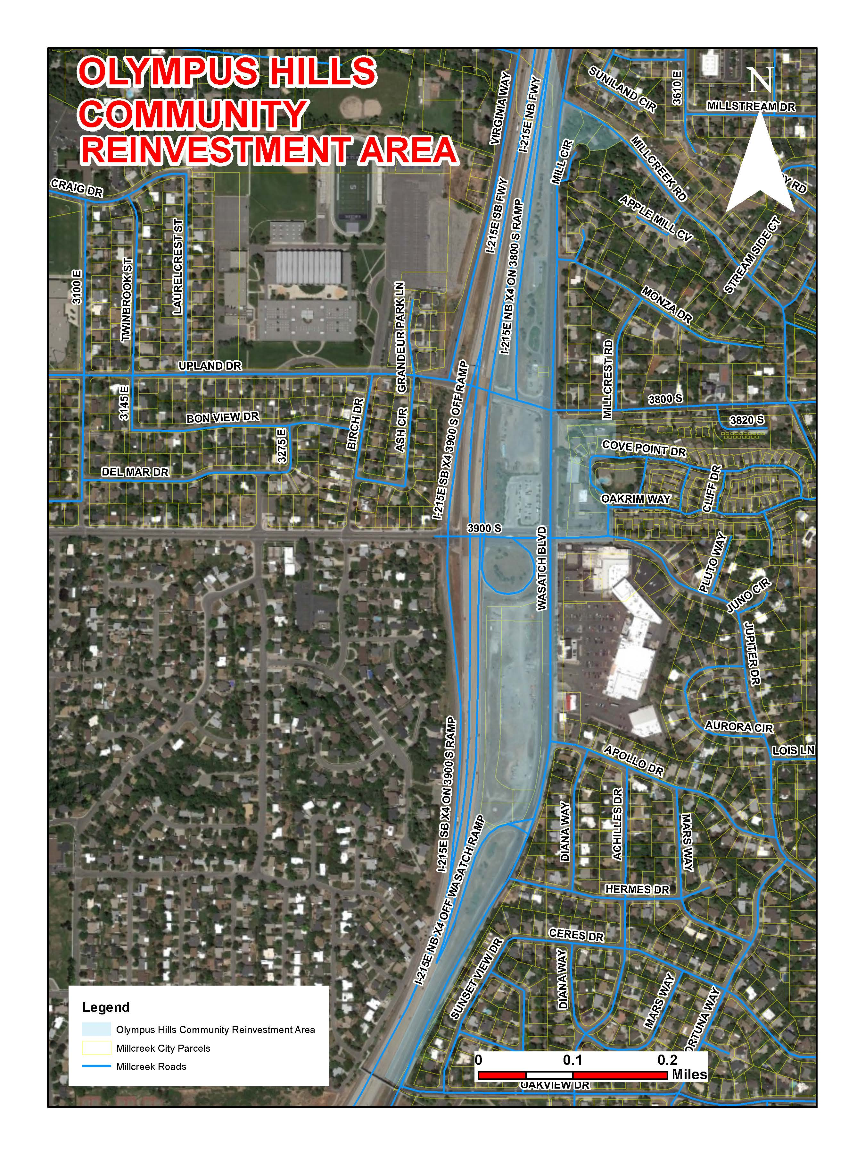

EXHIBIT C: Parcel List
Taxable Property Schedule (2018)
Parcel_ID | Owner | Acres
16361510010000 | MILL CIRCLE LLC | 0.43
16354810060000 | Metropolitan Water District of Salt Lake & Sandy
16354810140000 | UTAH DEPARTMENT OF TRANSPORTATION
163548101200000 | UTAH DEPARTMENT OF TRANSPORTATION
16354810090000 | UTAH DEPARTMENT OF TRANSPORTATION
16354810110000 | EP GT3 LLC
16354810080000 | EP GT3 LLC
16354810150000 | EP GT3 LLC
16354810130000 | EP GT3 LLC
16354810110000 | 1010 STIRLING LLC | 0.48
16354810070000 | UTAH DEPARTMENT OF TRANSPORTATION | 2.20
16363050030000 | MILLSTREEM PROPERTIES LLC | 0.94
16363040380000 | KEITZ, KEVIN J | 0.11
16363040020000 | KELLY, PATTI R | 0.09
16363050040000 | FIRST SECURITY BANK OF UTAH | 0.72
16354810060000 | METROPOLITAN WATER DISTRICT OF SALT LAKE | 0.63
16363040370000 | ANDERSON, DARLENE R; TR | 0.11
16354810090000 | UTAH DEPARTMENT OF TRANSPORTATION | 0.18
16354280010000 | QUESTAR GAS COMPANY | 0.03
16354810100000 | UTAH DEPARTMENT OF TRANSPORTATION | 0.15
16354810080000 | 1010 STIRLING LLC | 4.93
16361510020000 | MILL CIRCLE LLC | 0.43
16363030260000 | CORNERLOT 2016 LLC | 0.15
Roads, Easements, Right-of-Ways, etc. |  | 30.05
Total |  | 41.63

