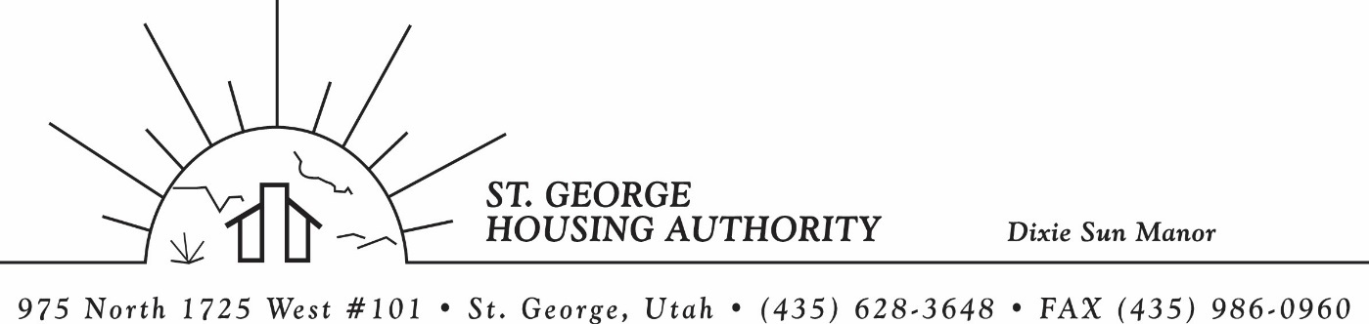
BOARD MEETING
DIXIE SUN MANOR 975 N. 1725 W. # 101
Tuesday November 14, 2023

PRESENT: Mike Barben, Greg Whitehead, Jimmie Hughes, Gloria Shakespeare, Tom Cover, Jane Fehrenbacher.

EXCUSED: Kenny Miller

MINUTES: Minutes of Board Meeting held October 10, 2023 were reviewed. Motion made by Tom Cover to approve minutes as reviewed, motion seconded by Jimmie Hughes. Motion carried.

Review Housing Assistance Report for November 2023: Mike Barben handed out the HAP reports for November 2023. Board members were able to see the money spent for the months on rental assistance, see the average unit cost, and verify the units leased for the month. The board was also able to ask questions and have a discussion about portability, C of C, VASH, EHV, & Mainstream Vouchers. Each board member present signed off on the HAP payments and month end totals.

Review current 2023-2024 budget: Mike Barben handed the board a copy of the fiscal year 2023-2024 SGHA budget. The board was able to see how the SGHA is doing in the current fiscal year budget. Mike reported that for the most part, SGHA was right on budget, and let the board ask questions on any of the items on the report. The board has asked Mike to provide and present the most recent budget accounts at each board meeting. By providing the current budget monthly, the board can see how the SGHA is keeping up with the current budget throughout the whole year. The board thought it would be great to ask questions and be on top of what the SGHA is doing financially. Greg Whitehead asked Mike if he could break the budget down into separate programs to verify which programs are doing well and which ones are needing help.

Utah NAHRO Conference 2024: Mike Barben reported that he is no longer the President of Utah NAHRO after his 2 years of service. Mike reported that Kim Wolford is the President for the next 2 years. Mike reported that the 2024 Conference will be in St. George April 25-26. Mike asked any board members who would want to come. About half of the board members were interested and want to come.

CAP Funds for new piping at DSM: Mike Barben reported that Dixie Sun Manor has had quit a few leaks in the DSM units. Mike reported that the flex piping is becoming brittle and causing many water leaks. Mike reported that he is doing preventative maintenance and re-pipping all the DSM units with new piping. Mike reported that he would be using CAP monies to pay for the maintenance. So far 4 units have been re-pipped.

Jane Fehrenbacker report on DSM: Jane reported that DSM had one vacancy. She said DSM has had more change this past year than any other year that she has lived here. A lot of turn-over. Jane also reported a big leak in unit’s 105 & 106. It has all been cleaned up and taken care of. She said most residents are very happy to have a garden. Jane said DSM is a great place to live and call home.

Report from Jimmie Hughes on City of St. George: Jimmie Hughes reported on the election taking place this next week. He also reported on some of things Washington County residents would be voting on. Specifically, taxes to help pay for parks, trails, and community upkeep. Jimmie is up for re-election and the board wished him luck.

Christmas Bonus Approval for SGHA employees: Mike Barben reported that Christmas was right around the corner and reported that the HA had funds for Christmas Bonus’s. The board asked Mike for his opinion on the amount for the Bonuses. Mike suggested $400 for DSM Manager, $500 for Section 8 Manager, $500 for Maintenance/Inspector and $600 for Executive Director. Tom Cover made a motion to approve the bonus amounts. Gloria Shakespeare seconded the motion. Motion carried.

Motion made by Gloria Shakespeare to close the meeting. Greg Whitehead seconded the motion. Motion carried. Meeting adjourned at 9:15 a.m. Next board meeting will be December 12, 2023 at 8:30 am.

