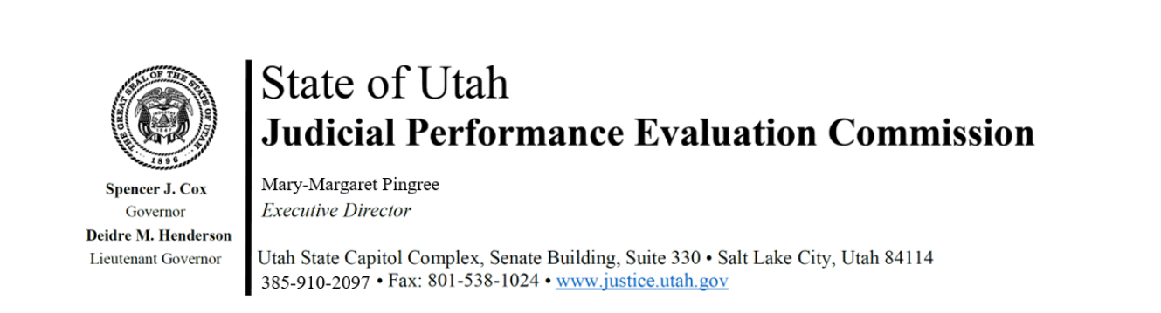

Judicial Performance Evaluation Commission
AGENDA
Tuesday, December 12, 2023
8:30-12:00 p.m.
CCJJ Conference Room, Suite 330

Members: Gil A. Miller, Mallory Bateman, Jim Jenkins, Christine Durham, David Jordan, Shannon P. Sebahar, Blair Hodson, Sherrie Hayashi, Curtis Jensen, Rick Hoffman, Tom Ross, Sonya Martinez-Ortiz, Bridget Romano

Staff: Mary-Margaret Pingree, Madison Klein, Chris Russell, and Chris Pieper (AAG)

Guests: Ron Gordon, Chief Justice Durrant

8:30 a.m. Welcome Gil Miller
Approval of Minutes – November 14, 2023

8:35 a.m. Announcements Mary-Margaret Pingree

8:40 a.m. Review of Deliberation Policies and Procedures cont. Commissioners

9:00 a.m. Community Report Review Mary-Margaret Pingree

9:10 a.m. Survey Analysis Jamie Nelson
Mary-Margaret Pingree

9:20 a.m. Board of District Court Judges response Gil Miller
Mary-Margaret Pingree

9:30 a.m. Commissioner Community Access Madison Klein
Questions

9:40 a.m. Disclosures, Recusals, Disqualifications Gil Miller Closed Session

9:55 a.m. Break

10:00 a.m. Utah State Courts Message Chief Justice Matthew Durrant Ron Gordon, SCA

10:20 am Midlevel Justice Court Evaluations Chris Russell
Closed Session

10:40 am Basic Justice Court Evaluations Chris Russell
Closed Session

11:00 am 2026 Midterm Evaluations Mary-Margaret Pingree
Closed Session Chris Russell

Next Meeting: Tuesday, January 9. 2024
8:30 am – noon
CCJJ Conference Room, Suite 330

