Davis-Salt Lake Aerial Spray Authority
Quarterly Board Meeting
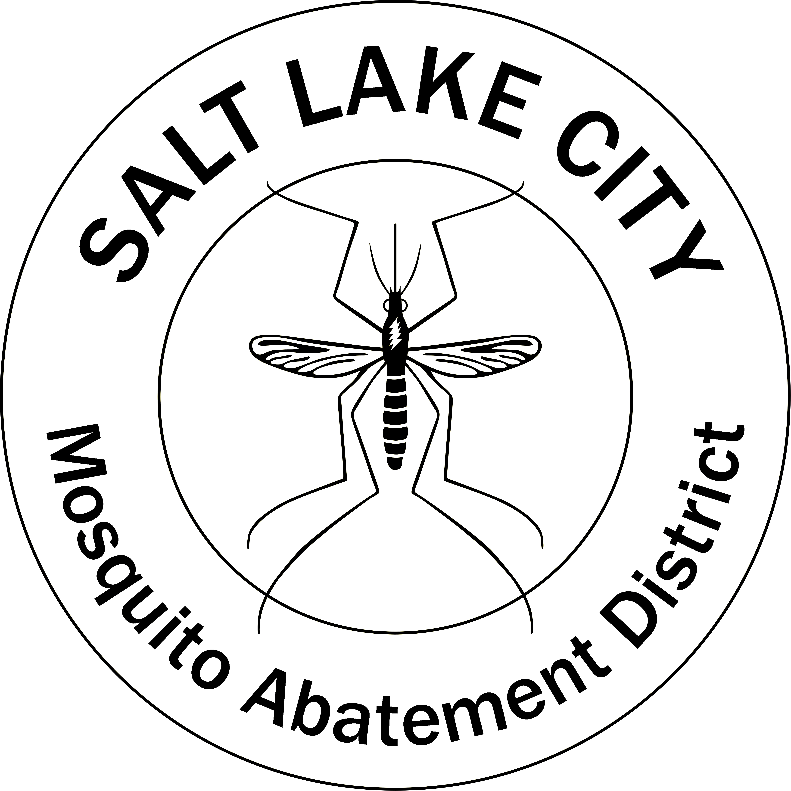
6 December 2023
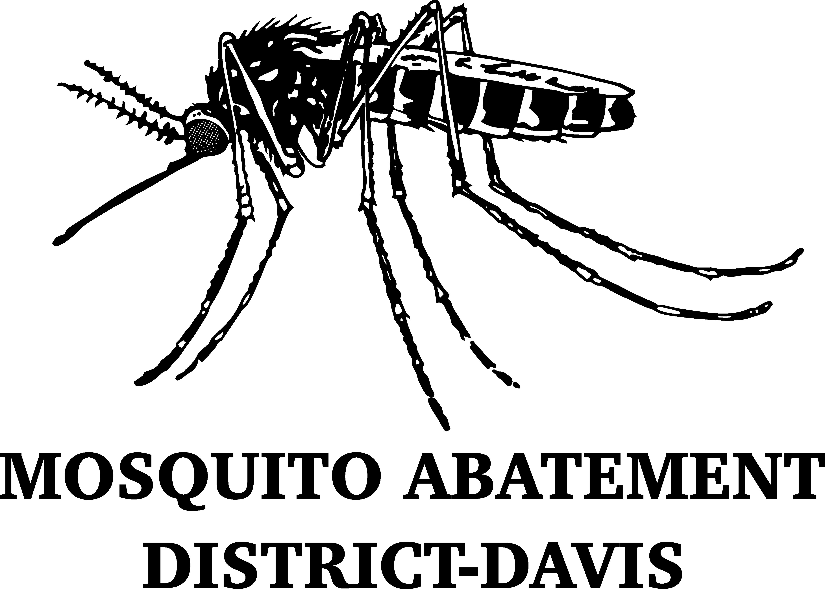
5:30 PM

MEETING TO BE HELD AT:

Salt Lake City Mosquito Abatement District
2215 N 2200 W
Salt Lake City, Utah 84116

https://us02web.zoom.us/j/88390782202?pwd=K0IzeHp2M0xkTjB4R0NWR1BhV0dLQT09

Presiding: Ary Faraji, Executive Director 2022-2023

Agenda:

- Confirm Recorder is On, Roll Call, Conflicts of Interest Declarations

- Approval of the 8 September 2023 Minutes of the DSLASA Quarterly Board Meeting

- Presentation of the 2023 Fourth Quarter Financial Statements and Approval of Bills for Payment

- 2023 Amended Budget Discussion and Approval

- 2024 Proposed Budget Discussion and Approval

- Update on DSLASA Credit Cards

- Hangar Maintenance, Pesticide Inventory, and Ogden Airport Updates

- Discussion and Approval of the 2024 DSLASA Board Calendar

- Probable Agenda Items for 28 March 2024 DSLASA Quarterly Board Meeting at SLCMAD (5:00 pm)
- Pesticide Orders
- Maintenance Updates

- Public Comment
- Limited to 3 Minutes per Individual for General Comments
- Limited Comments will also be Entertained from the Public During Individual Agenda Items

- Adjournment

