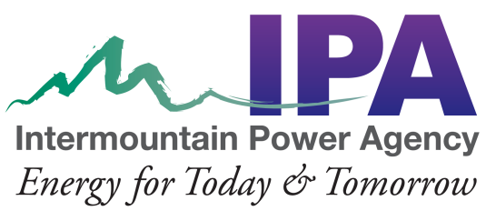

NOTICE OF INTERMOUNTAIN POWER AGENCY
2023 ANNUAL MEETING

Intermountain Power Agency will hold its 2023 Annual Meeting on Tuesday, December 5, 2023, from 9:30 a.m. (MST) to 12:00 noon (MST) (times are approximate), at the Little America Hotel
500 S Main Street, Salt Lake City, Utah 84101.

https://youtube.com/live/CcpDsDLax8s?feature=share

AGENDA

Business Meeting
- Welcome – Eric Larsen, Board Secretary
- Introduction of IPA Member Representatives
- Approval of the 2022 IPA Annual Meeting Minutes
- IPA Board Election – Eric Bawden, General Counsel
- Committee Reports
- IPA Audit Committee – Allen Johnson, Board Treasurer
- IPA Governance Committee – Joel Eves, IPA Board Member and Chair of the IPA Governance Committee
- Report from the Generation & Transmission Subcommittee of the Intermountain Power Project Coordinating Committee - Lori Morrish, Project Manager, Los Angeles Department of Water and Power
- Other Business

General Meeting
- Welcome – Nick Tatton, Board Vice Chair
- Reports
- 2023 Financial and Operating Report
- IPP Renewed
- Remarks – Nick Tatton, Board Vice Chair
- Adjourn

