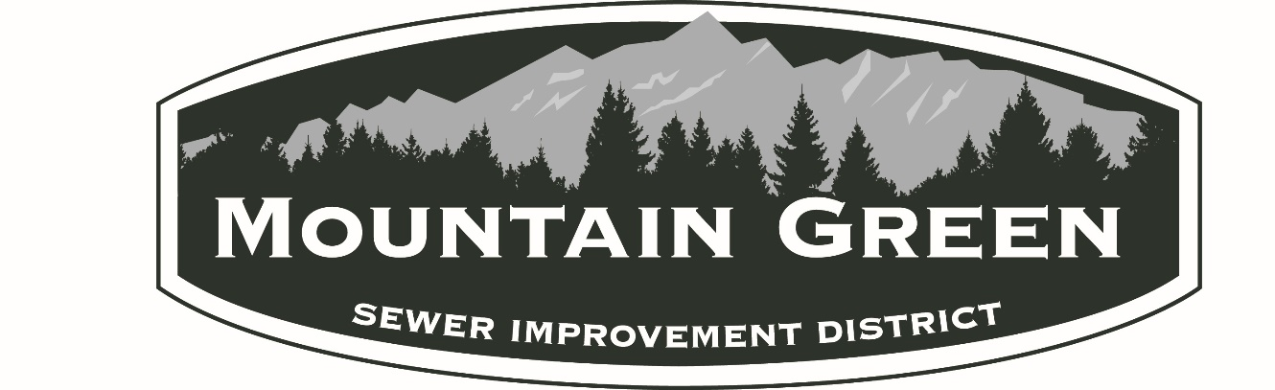
MOUNTAIN GREEN SEWER IMPROVEMENT DISTRICT
5455 West Old Highway Road, Mountain Green, Utah
Wednesday, December 6, 2023

2024 BUGET HEARING – 7:30 PM

NOTICE OF PUBLIC HEARING
FOR THE
MOUNTAIN GREEN SEWER IMPROVEMENT DISTRICT
2024 BUDGET

The Mountain Green Sewer Improvement District
will hold its 2023 Budget Hearing on Wednesday,
December 7, 2022 at 7:30 P.M. This Public Hearing
will be held at the District Offices located at:
5455 West Old Highway Road
Mountain Green, UT 84050.
The purpose of this Hearing will be to discuss and
approve the proposed 2023 Budget.
All interested residents of the District are invited
to attend. Please call 801-876-3416 for
additional information.

