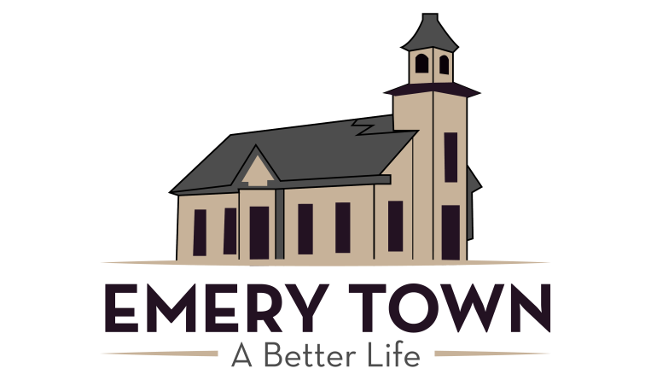
Emery Town Board of Canvassers Wednesday, November 29, 2023 7:30 p.m.

Notice is hereby given that Emery Town shall canvass the November 21 Municipal General Election final returns during a public meeting, to be held on Wednesday, November 29, 2023 at 7:30 p.m. in the town council room at Emery town hall 65 North Center, Emery Utah.

