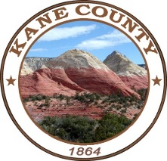
RESOURCE DEVELOPMENT COMMITTEE

76 North Main Street Kanab, UT 84741

KANE COUNTY

NOTICE OF PUBLIC MEETING

Notice is hereby given that the Kane County Resource Development Committee meeting will be held on Tuesday, November 21, 2023 at 9:00 a.m. Located in the Pinion Room at the Kanab Center - 20 North 100 East, Kanab, UT.

This meeting is available via telephone.
Dial: 435-676-9000
Participant code: 168030

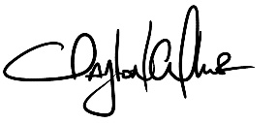

Clayton Cutler - District Clerk

Dated November 13, 2023

