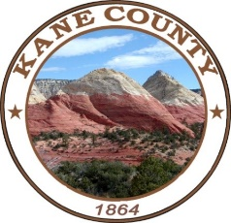
RECREATION &
TRANSPORTION
SPECIAL SERVICE DISTRICT

KANE COUNTY

76 North Main Street Kanab, UT 84741

November 21, 2023 Board Meeting.
10:00 AM, Kanab Center, Pinion Room
20 N. 100 E. Kanab, UT

- Call to Order

- Business:

- Approval of 09-19-2023 RTSSD meeting minutes
- Letters of Intent

- Financial:
- Budget overview and Discussion
- Review of the 2024 Tentative Budget
- Approval of the 2024 Tentative Budget (December- 7 day Notice)
- Set Public Hearing Date for Adoption of the 2024 Budget

- Discussion/Possible action on funding for pickle ball court- KCPBA

- Other Items

This meeting is available for call in option – # 435-676-9000 –Enter participant code- 168030

