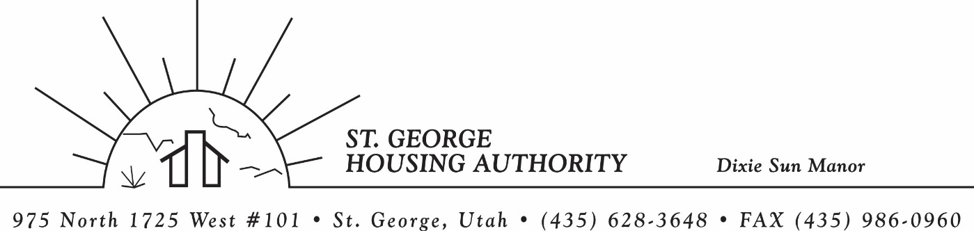
BOARD MEETING
DIXIE SUN MANOR 975 N. 1725 W. # 101
Tuesday October 10, 2023

PRESENT: Mike Barben, Greg Whitehead, Kenny Miller, Gloria Shakespeare, Tom Cover, Jane Fehrenbacher.

EXCUSED: Jimmie Hughes

MINUTES: Minutes of Board Meeting held October 10, 2023 were reviewed. Motion made by Kenny Miller to approve minutes as reviewed, motion seconded by Jane Fahrenbacher. Motion carried.

Review Housing Assistance Report for October 2023: Mike Barben handed out the HAP reports for October 2023. Board members were able to see the money spent for the months on rental assistance, see the average unit cost, and verify the units leased for the month. The board was also able to ask questions and have a discussion about portability, C of C, VASH, EHV, & Mainstream Vouchers. Each board member present signed off on the HAP payments and month end totals.

Review current 2023-2024 budget: Mike Barben handed the board a copy of the fiscal year 2023-2024 SGHA budget. The board was able to see how the SGHA is doing in the current fiscal year budget. Mike reported that for the most part, SGHA was right on budget, and let the board ask questions on any of the items on the report. The board has asked Mike to provide and present the most recent budget accounts at each board meeting. By providing the current budget monthly, the board can see how the SGHA is keeping up with the current budget throughout the whole year. The board thought it would be great to ask questions and be on top of what the SGHA is doing financially. Greg Whitehead asked Mike if he could break the budget down into separate programs to verify which programs are doing well and which ones are needing help.

Homeless Summitt Conference Training: Mike Barben asked the board for approval to take Becky Workman and himself to the Homeless Summitt Conference. Mike said this conference is a great conference with good training. Greg Whitehead made a motion to approve the training. Gloria Shakespeare seconded the motion. The board approved Mike and Becky to attend the conference on October 16th. Mike thanked the board for the approval.

Jane Fehrenbacker report on DSM: Jane reported that DSM had no vacancies. She said DSM has had more change this past year than any other year that she has lived here. A lot of turn-over. Jane also reported a big leak in unit’s 105 & 106. It has all been cleaned up and taken care of. She said most residents are very happy to have a garden. Jane said DSM is a great place to live and call home.

Report from Jimmie Hughes on City of St. George: Jimmie Hughes was excused from the meeting.

Financial Certification Signatures for 2023 CAP Fund: Mike reported that signatures were needed from Greg Whitehead the board Chief officer. The signatures are for Capital Funding 2023. The board approved Greg to sign the documents. Greg signed the documents and Mike will send the documents to HUD for approval of funding. Mike reported that the amount of funds awarded to SGHA was $94,729. Capital funds are for specifically for the DSM complex.

SGHA Audit: Mike reported that the SGHA was scheduled for the rest of the week for the annual audit from FJ & Associates. Mike reported to the board that he was confident that the audit would go well and that the SGHA would remain a high performing agency. Mike said he would report how the audit went at the next board meeting.

Motion made by Tom Cover to close the meeting. Gloria Shakespeare seconded the motion. Motion carried. Meeting adjourned at 9:30 a.m.

