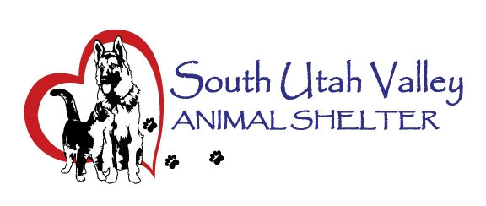

South Utah Valley Animal Special Service District
Board Meeting Minutes Tuesday September 13, 2022
South Utah Valley Animal Shelter Conference Room
582 W 3000 N Spanish Fork UT 84660
Board Member Attendance
Lt. Joseph Otte Chief Rod Hurst* @RandiLynWarner
Chief Lance Haight Chief John Jackson @Dr Bott
Chief Brad James Chief Brad Bishop @Marcus Draper
Dep. Kyler Gilstrap Kevin Oyler Janet Lunt
(*Absent / @ At large)
The meeting was called to order at 10:40 AM by Chairman Chief Bishop.
- Approval of minutes from Board meeting held on July 12, 2022. Motion to approve the minutes. 1st Chief Jackson, 2nd Chief James. Motion passed.
- Open meeting ACT Training by Attorney Marcus Draper. He presented the video and talked about a few things that need to be addressed. SUVAS needs to have a policy in place before Zoom meetings for the public to participate and for what counts as being present for Board Members. Board members were cautioned to not address Board business with each other in a social setting as that isn’t an open meeting available to the public. Closed meetings need to have 2/3 of the Quorum and can’t do public business in these sessions. No final action can be done in the closed portion of a meeting. Only emergency meetings don’t need 24 hour notice. Written minutes and recordings for each meeting. Minutes must be done within 30 days of meeting and after approval be available within 3 days.
- Shelter report by Executive Director Kierstan Munford. The Shelter is really full with over 200 cats and over 100 dogs in the Shelter right now. With no low cost spay/neuter options for the public, lack of owners claiming pets and low adoption numbers the Shelter may soon have to euthanize for space which no one wants. Board members asked about adoption events, social media posts and attending city events to raise awareness in the District. There was a lot of brainstorming and getting video (Channel 17) to share online would be a good way to raise public awareness. Kevin Oyler will approach them to make a video here. A shelter adoption and donation event will be planned soon. Kierstan and Janet Lunt will be planning together for this event. It was discussed to do a dog walk or obstacle course at Spanish Fork Canyonview Park in the Spring. Kierstan gave totals for the last couple of Clinics. We also still need a new license system that is secure and can be tiered to user access. Chief Bishop suggested budgeting to have a website brought up to date with emailing, newsletter, licensing ability and sending out reminder options. Kevin Oyler suggested putting something out for recommendations for anyone that could do a site or system for this. Marcus Draper brought up an issue that will need to be put on a future agenda. The need for a written interlocal agreement between NUVAS and SUVAS if there is a high volume of animals that need to be housed and how that will be paid. Lt. Otte asked at what point we need to look at adding staff for volunteer coordinator, foster and social media. Interns from the college may be able to kick start this.
- To set a date, time and location for a closed meeting to discuss the character, professional competence or physical or mental health of an individual. No business.
There was no public present for the public forum.
The next meeting will be on November 8, 2022 at 10:30 AM at SUVAS.
Motion to adjourn. 1st Kevin Oyler, 2nd Chief Jackson. Motion passed.

