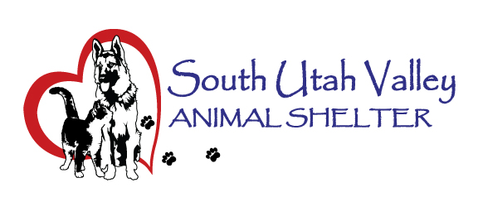
South Utah Valley Animal Special Service District
Board Meeting Minutes Tuesday January 10, 2023
South Utah Valley Animal Shelter Conference Room
582 W 3000 N Spanish Fork UT 84660
Board Member Attendance
Lt. Joseph Otte* Chief Rod Hurst* @RandiLyn Warner
Chief Lance Haight Chief John Jackson @Dr Bott*
Chief Brad James Chief Brad Bishop @Legal-Vacant
Dep. Kyler Gilstrap Kevin Oyler Janet Lunt
(*Absent / @ At large)
The meeting was called to order by Chief Jackson at 10:46 AM. Chairman Bishop arrived.
- Approval of minutes of Board Meeting held on 11/8/2022. Motion to approve the minutes of the Board Meeting held on 11/8/2022. 1st Councilman Kevin Oyler, 2nd Chief James. Passed unanimously.
- Audit Report by HBME. Warren Anderson of HBME reported (via speaker phone) the audit report: Pages 1-3 of the audit had a clean opinion for the attached financials. Pages 6-8 were comparative tables for the past three years and assets are up due to net patient assets. Liabilities are slightly up due to lease which is up in 2026. On page 7 there has been an increase in net position over the last three years from $276,000 in 2020 to $547,000 in 2022. Revenue has been up and expenses down. Pension liability has flipped to a net pension asset. This last year revenue was up about $80,000 and expenses were only up by about $35,000. The District is in fairly good financial shape. Internal control on pages 35-36 show no deficiencies. Pages 37-39 on state compliance. Opinion is that the District is in compliance.
- Fee schedule amendments. Director Kierstan Munford is proposing a fee increase for owner release fees. In District will go from $75 to $150 and out of District will go from $200 to $400. There will be a new fee added for animals that SUVAS has had altered before adoption. This fee may go higher due to market price. Motion to approve the new fee schedule. 1st Janet Lunt, 2nd Deputy Gilstrap. Passed unanimously.
- Budget presented by Director Kierstan Munford. She went over some line items. The PTIF can’t have more than 25% of the budget, so a new licensing program may be paid through this or funds may have to be moved. There were some questions from Board members about some of the line items. Credit card fees, vehicle leases, etc. Wages were discussed with a 4% COLA and up to 4% Merit. It was also proposed that the starting wage should go up to retain and get employees. The Board is giving Kierstan leeway to adjust pay $15-$17 for part time. Kierstan proposed another possible full time employee from one part time position. Board would like to see proposed increase for wages and benefits in Budget for this. Kevin Oyler suggested that part time employees should be an hourly number and that full time should be position based range. He also suggested having the salary range comparison done annually.
- Shelter Report by Director Kierstan Munford. There is a young veterinarian that would like to come into the shelter to do some spay/neuter free for shelter animals. She is checking with the corporate company she works for to see if they are ok with her doing this. The Parvo we had came in on November 9th and the last positive case was on December 7th. There were 13 dogs affected. Four of them died, six were euthanized and three survived with treatment here at the shelter. The animal count this morning was 115 dogs and 162 cats. Chief Jackson asked if anyone has given their city councils a heads up that another shelter or adoption center will need to built in coming years due to the large numbers of animals coming in. Councilman Kevin Oyler has already brought this up with his city. (There will have to be some forethought and planning for how big and how much and how to fund it.) Kierstan will continue to work up the preliminary Budget and get it sent out by February. Then at the March meeting it will be ready for input and tweaks for a May vote.
- To set a date, time and location for a closed meeting to discuss the character, professional competence or physical or mental health of an individual. No business.
There was no public present for the public forum.
The next Board meeting is scheduled for March 7 at 10:30 AM.
Motion to adjourn. 1st Chief Jackson, 2nd RandiLyn Warner. Unanimously approved.

