Mayor
Colten Johnson City Council Arlon Chamberlain Scott Colson
Chris Heaton Kerry Glover
J.D. Wright
City Manager Kyler Ludwig City Attorney Kent Burggraaf City Recorder Celeste Cram City Treasurer Danielle Ramsay



KANAB CITY COUNCIL
November 14, 2023
Council Chambers, 26 NORTH 100 EAST, KANAB, UTAH

NOTICE is hereby given that the Kanab City Council will hold a regular council meeting on the 14th day of November 2023, in the City Council chambers at the Kanab City Office, 26 N 100 E, Kanab, Utah. The Council Meeting will convene at 6:30 p.m. and the agenda will be as follows:

Work Meeting

- Liaison Report
- City Staff Report
- Other Business Meeting
- Call to Order and Roll Call

- Approval of Minutes of Previous Meeting

- Approval of Accounts Payable Vouchers.

- Public Comment Period: Members of the public are invited to address the Council. Participants are asked to keep their comments to 3 minutes and follow the rules of civility outlined in Kanab Ordinance 3-601.

- Public Hearing, Discussion, and Consideration of a plat amendment to adjust lot lines on parcel K -358-52 and K-358-53 approximately at Kanati Circle [applicant: Iron Rock/Kenny Seng]

- Public Hearing, Discussion, and Consideration of a plat amendment of the Johnson Hills Subdivision (Parcel K-310-3) splitting Lot 3 into 6 separate lots approximately located at 900 East HWY 89. [applicant: Iron Rock/Sam Noel]

- Public Hearing, Discussion, and Consideration of an Ordinance changing the zone on Parcel K-310-3 from RA to C-3 approximately located at 900 East HWY 89 [applicant: Iron Rock/Sam Noel

– A Western Classic –
26 North 100 East • Kanab, Utah 84741 • Phone 435-644-2534 • Fax 435-644-2536 • www.kanab.utah.gov


- Public Hearing, Discussion, and Consideration of a Conditional Use Permit for a private lane on parcel 34-30 approximately located at 504 West Hamblin Dr. [applicant: Iron Rock/RAHMO]

- Public Hearing, Discussion, and Consideration of a plat amendment to adjust lot lines and subdivide into two lots on parcel 34-40 approximately located at 504 West Hamblin Dr. [applicant: Iron Rock/RAHMO]

- Discussion and Consideration of an Ordinance amending the Kanab City Land Use Ordinance, Chapter 20 Commercial Zones (adding uses Spas, Carwash, Car Restoration, & Body Art)

- Discussion and Consideration of an Ordinance amending a Development Agreement with Catori Canyon Subdivision. [applicant: Iron Rock/ Kenny Seng]

- Discussion and Consideration of Work Task Order 2023-1 with Civil Science for the Cave Lakes Spring Redevelopment Project.

- Discussion and Consideration of Work Task Order 2023-2 with Civil Science for the Ranchos Park Irrigation Plan & Cemetery Expansion.

- Discussion and Consideration of 40 Year Water Usage Report

- Discussion and Consideration of a repair to the City Public Works Department D5N Engine

- Discussion and Consideration of an ordinance amending the Kanab City Land Use Ordinance, Chapter 22 Outdoor Lighting.

- Presentation of First Quarter Report FY23

- Closed Session to discuss the character, professional competence, or physical or mental health of an individual.

ADDITIONAL NOTICES:
Times listed for each item on the agenda may be accelerated, as time permits, or taken out of order.
The public comment period and public hearings are intended for the public to provide input to the Council or to pose questions individuals believe the Council and City staff should consider. Public hearings are not intended for individual members of the public to engage in conversation. While questions may be posed by a member of the public, the Council and City staff will attempt to refrain from answering or engaging in conversation during the public hearing.
An item listed on the agenda may be discussed in a closed portion of the public meeting, in which the public may be excused, if it meets the criteria outlined in the Open and Public Meetings Act (see Utah Code 52- 4-204 and -205).
If you are planning to attend this public meeting and due to a disability need assistance in understanding or participating in the meeting, please notify the City eight (8) or more hours in advance of the meeting, and we will try to provide whatever assistance may be required. Please contact Celeste Cram at the Kanab City offices.

– A Western Classic –
26 North 100 East • Kanab, Utah 84741 • Phone 435-644-2534 • Fax 435-644-2536 • www.kanab.utah.gov

1 Kanab City Council Meeting

2 October 10th, 2023

3 Kanab City Council Chambers

4 26 North 100 East

5 6:30 PM

6

- Work Meeting

- 1. Liaison Report

9

- Councilmember Chamberlain – None.

- Councilmember Wright – Raising Kane is Friday January 12th, save the date.

- Councilmember Glover – There was an Arts board meeting last week. RedRocktoberfest is
- this weekend. Chalk art starts tomorrow 10/11/23.

- Mayor Johnson – None.

- Councilmember Heaton – EMS, Police and Fire have been very busy, thank you to our first
- responders. Special thank you to Darrin Coleman.

- Councilmember Colson – None.

18

- 2. City Staff Report –

- Mr. Ludwig stated that Mr. Loveless values our relationship with Kane County Hospital. Many
- lives were saved due to our capacity to respond to the recent accidents. A big thank you to the
- council for their support.

- 3. Other – None.

24

25

- Business Meeting

- 1. Call to Order and Roll Call – Mayor Pro-Tem Chamberlain called the meeting to order. Josh Beazer
- offered the invocation. Brett Pierson led the pledge of allegiance.

- In attendance: Mayor Johnson (7:23); Councilmember Chamberlain, Councilmember Wright,
- Councilmember Glover, Councilmember Colson, Councilmember Glover, Councilmember Heaton;
- City Manager Kyler Ludwig; Recorder Celeste Cram; Building Inspector & Land Use Coordinator
- Janae Chatterley; and City Attorney Kent Burggraaf.

- Not in attendance – None.

- 2. Approval of Minutes of Previous Meeting – Councilmember Colson made a motion to approve the
- minutes from September 26th, 2023 meeting. Councilmember Heaton seconded, unanimous vote.
- Motion passed.

37

- 3. Approval of Accounts Payable Vouchers - A motion was made by Councilmember Heaton and
- seconded by Councilmember Glover to approve the check registers for September 28th, 2023 in the
- amount of $163,222.16, and October 10th, 2023 in the amount of $115,782.66. Unanimous vote, motion
- carried.

42

- Public Comment Period: Members of the public are invited to address the Council.

- 4. Participants are asked to keep their comments to 3 minutes and follow the rules of civility.

- outlined in Kanab Ordinance 3-601.

46

- Mark Potter:

- Mr. Potter stated that he is gone more than he is in town, so he turns his water on and off frequently.
- The city now requires a 24-hour notice to turn water on or turn it off, and nobody he talked to was
- aware of it. He continued that the form to turn water on is intrusive and invasive, it asks for birthdays,
- social security numbers, etc. The Pentagon was hacked, and anyone can get hacked, and he thinks
- people will lose their money and identity filling out the paper forms.

- Linda Marpole:
- Mrs. Marpole stated that she is against any building on the Hillside drive hill. She stated that Michael
- Stewart, Iron Rock Group employee, stated that his clients are aware of the blue clay issues, but that she
- has also seen several other groups that have been aware of clay issues, and have still ended up either

- not completing the work, or disaster has occurred. She believes that disturbing the hill in any way,
- especially for building construction, will bring damaging consequences for the existing residents and
- new unsuspecting homebuyers.
60

- Robert Woods:

- Mr. Woods stated that he is a former landscaper/developer, and that he previously worked for someone
- doing a project in blue clay. They used every method at their disposal, and 175 of 200 homes were
- inhabitable a couple years later, and the homeowners sued the City for over $200 million dollars. He
- hopes the City votes against the zone change.

66

67 Councilmember Heaton recused himself for items 6-8

68

- 5. Discussion and Consideration of an Ordinance to Change the Zoning of Parcel K-7-2-Annex
- Located in the Area of Chinle Dr. and Hillside Dr. from Rural Residential (RR-1) to Single Family Zone
- (R-1-8). (Applicant Michael Stewart / Mike and Jamie Little).

- Mrs. Chatterley stated that property owners Mike & Jamie Little, represented by Michael Stewart, are
- requesting a zone change to rezone parcel K-7-2-Annex from Rural Residential (RR-1) to Single Family
- Residential (R-1-8). The parcel is 7.05 acres and currently vacant land. She also went over the
- surrounding properties and their zones. Mr. Ludwig stated that in the last meeting, they asked the
- developer to go back to their client and see if they would be willing to change it to a different zone.

- Michael Stewart (Iron Rock Group Representative), spoke briefly on the soil, and that they are trying to
- sell some of the smaller lots at a more affordable rate. He also spoke on storm water and that reducing
- the blue clay will help with that.

- Councilmember Colson asked if they could put a minor subdivision through at the same time as a zone
- change, so they could zone specific ones the zones they see fit. Mr. Burggraaf responded that they
- could do that, but it would cause the developer to jump through hoops without knowing if it would get
- approved.

- Councilmember Wright doesn’t feel comfortable giving them the R-1-8 zone, he would prefer to see a
- zone with a less dense population.

- The council continued to discuss and ask Mr. Stewart questions.

- Councilmember Heaton made a motion to approve to assign zone R-1-8 to Parcel K-7-2-Annex and adopt
- ordinance 10-1-23 O based on the findings and conditions outlined in Staff Report #2023038.
- Councilmember Chamberlain seconded the motion.

90

- Councilmember Colson – Yes

- Councilmember Heaton – Yes

- Councilmember Wright – Nay

- Councilmember Glover - Nay

- Councilmember Chamberlain – Yes

- Motion passed.

97

- 6. Discussion and Consideration of a Conditional Use Permit for a private lane on parcel K-17-36-
- ANNEX approximately located at 1100 South and 600 East [applicant; Iron Rock Engineering/C&A
- Ranches LLC]

- Councilmember Heaton recused.

- Mrs. Chatterley stated that an application for a Conditional Use Permit was received by Iron Rock Group
- requesting a Private Lane for parcel K-17-36-ANNEX. Iron Rock Group has also applied for a minor
- subdivision. In approving or recommending approval of a conditional use permit, the Kanab City
- Planning Commission finds: 1. That the proposed use is necessary or desirable and will contribute to the
- general well-being of the community. 2. That the use will not be detrimental to the health, safety, or
- welfare of persons residing, or working in the vicinity, or injurious to property or improvements in the
- vicinity. 3. That the proposed use will comply with the regulations of this Ordinance. 4. That the
- proposed use is in harmony with the intent and purpose of the Kanab City Master Plan or that the plan
- shall have first been amended through public hearing. Finally, she stated that the planning commission
- voted unanimously for a positive recommendation to the City Council.

- Councilmember Chamberlain made a motion to approve the conditional use permit for a private lane
- based on Staff’s findings and conditions listed in the staff report, File # 2023046 and the findings in
- Chapter 8, Section 8-6 (B). Councilmember Glover seconded.

115

- Councilmember Colson – Yes

- Councilmember Heaton – Recused

- Councilmember Wright – Yes

- Councilmember Glover - Yes

- Councilmember Chamberlain – Yes

- Motion passed.

122

- 7. Discussion and Consideration of a Minor Subdivision on parcel K-17-36-ANNEX approximately
- located at 1100 South and 600 East [applicant; Iron Rock Engineering/C&A Ranches LLC]

- Councilmember Heaton recused.

- Councilmember Glover made a motion to approve the minor subdivision of parcel K-17-36-ANNEX
- located approximately at 1100 S 600 E based on the findings and conditions of approval as outlined in
- the staff report for file #2023040. Councilmember Colson seconded the motion.

129

- Councilmember Colson – Yes

- Councilmember Heaton – Recused

- Councilmember Wright – Yes

- Councilmember Glover - Yes

- Councilmember Chamberlain – Yes

- Motion passed.

136

- 8. Discuss and Consideration of a Conditional Use Permit for a private lane on parcel K-19-16-ANNEX
- approximately located at 910 S HWY 89A [applicant; Iron Rock Engineering/Kirk Heaton]

- Mrs. Chatterley stated that an application for a Conditional Use Permit was received from Iron Rock
- Group requesting a Private Lane for parcel K-19-16-ANNEX. Iron Rock Engineer has also applied for a
- minor subdivision. The private lane is being requested to access some of the proposed lots in the minor
- subdivision.

- Councilmember Heaton went down to the podium to answer questions for the council.

144

- Councilmember Chamberlain made a motion to approve the conditional use permit for a private lane
- based on Staff’s findings and conditions listed in the staff report, File # 2023044 and the findings in
- Chapter 8, Section 8-6 (B). Councilmember Glover seconded the motion.

148

- Councilmember Colson – Yes

- Councilmember Heaton – Recused

- Councilmember Wright – Yes

- Councilmember Glover - Yes

- Councilmember Chamberlain – Yes

- Motion passed.

155

- 9. Discuss and Consideration of a Minor Subdivision on parcel K-19-16-ANNEX approximately located
- at 910 S HWY 89A [applicant; Iron Rock Engineering/Kirk Heaton]

158

- Councilmember Colson made a motion to approve the minor subdivision of parcel K-19-14-ANNEX
- located approximately at 910 S HWY 89A based on the findings and conditions of approval as outlined in
- the staff report for file #2023043. Councilmember Glover seconded the motion.

162

- Councilmember Colson – Yes

- Councilmember Heaton – Recused

- Councilmember Wright – Yes

- Councilmember Glover - Yes

- Councilmember Chamberlain – Yes

- Motion passed.

169

- 10. Discussion and Consideration of a Resolution Opposing the Proposed Resource Management Plan
- for the Grand Staircase-Escalante National Monument.

- Councilmember Heaton stated that the Grand Staircase-Escalante National Monument management are
- revising their management plan. They are proposing four options. Option A is to keep the plan as it
- currently exists today, option B is a little more restrictive, and option C is more restrictive than B, and
- option D is very restrictive and quite detrimental to our local communities. The county passed a similar
- resolution to stay with option A, and keep it as close to the same as it currently is. The council and
- Mayor Johnson expressed their views and opinions on the matter.

- Councilmember Heaton made a motion to approve Resolution No. 10-1-23 R, A Resolution For Kanab
- City Opposition to the Proposed Resource Management Plan for the Grand Staircase-Escalante National
- Monument. Councilmember Wright seconded the motion.

- Councilmember Colson – Yes

- Councilmember Heaton – Yes

- Councilmember Wright – Yes

- Councilmember Glover - Yes

- Councilmember Chamberlain – Yes

- Motion passed.

187

- 11. Discussion and Consideration of a Resolution Approving a Cooperation Agreement Between Kane
- County and Kanab City to Assist the County in Providing Structure Fire Protection.

- Mr. Ludwig stated that Under state code governing bodies of Cities and Counties are required to “shall:
- provide adequate fire protection within their own territorial limits” (11-7-1a). Kanab City provides the
- required protection from fire through a full-time Fire/EMS Department.

- Kane County does not currently provide protection against structure fires, and the Kanab Fire
- Department has historically responded to fires in the surrounding unincorporated county. In October of
- 2022 the City and County entered into a one-year agreement, which gave Kanab City the ability to
- respond to fires in Kane County; the agreement was passed to provide Kanab City and Fire/EMS
- employees legal protection if they are able to respond. The one-year agreement was designed to give
- Kane County time to determine the best options for structure fire protection in unincorporated areas.

- Kane county approved a year agreement agreeing to pay for structure fire and responses and will pay a
- fee structure to allow us to be reasonably compensated. Fee per use model is not an adequate
- reimbursement policy but it will work while they figure out what will work.

- The County asked that a minimum fee be removed and that we only bill for individual occurrences.

- Councilmember Wright stated his concern that the County will never get fire services of their own.
- Mr. Burggraaf stated that after the commissioners approved the agreement, they got into a discussion
- about getting their own special service district and fire department. The council discussed at length the
- agreement, and that they will not be doing this for another year after this year. If they feel like the
- county isn't moving towards finding a solution, they will give notice to terminate the contract.

- Councilmember Heaton made a motion to approve Resolution 10-2-23 R A Resolution Approving A
- Cooperation Agreement between Kane County and Kanab City to Assist the County in Providing
- Structure Fire Protection. Councilmember Glover seconded the motion.

- Councilmember Colson – Yes

- Councilmember Heaton – Yes

- Councilmember Wright – Yes

- Councilmember Glover - Yes

- Councilmember Chamberlain – Yes

- Motion passed.

217

- 12. Strategy Session for Pending or Reasonably Imminent Litigation

- Councilmember Colson made a motion to go into executive session to discuss imminent litigation.
- Councilmember Wright seconded. Unanimous vote.

221

- Councilmember Wright made a motion to adjourn, Councilmember Glover seconds. Unanimous vote,
- meeting adjourned.

224

Kanab City Council Staff Report File #2023042

Date: | November 8, 2023
Meeting Date: | November 14, 2023
Agenda Item: | Discuss and recommend to City Council a plat amendment to the Catori Canyon Subdivision,  parcels K-358-52 & K-358-53
Subject Property Address: | Kanati Circle
Applicant: | Kenny Seng
Applicant Agent: | Iron Rock Engineer
Zoning Designation: | R-1-20 PD
General Plan Designation: | MDR
Parcel #: | K-358-52 & K-358-53
Applicable Ordinances: | Subdivision Ordinance, Chapter 2-4

Attachments:
Exhibit A: Subject Property Exhibit B: Amended Plat

Summary:
Iron Rock Engineer, representative of Kenny Seng applied to amend the plat for Catori Canyon Subdivision parcels K-358-52 & K-358-53 located approximately at Kanati Circle. The plat amendment consists of adjusting the lot line for both lots.

Applicable Regulation(s):
Plat Amendments are addressed in Utah Code, Title 10, Chapter 9a, Part 6, and the Kanab City Subdivision Ordinance, Chapter 2, upon application that includes a Sketch Plan and Narrative. Chapter 2-4 specifically address the plat amendment process and requirements.

Analysis
Development Committee has reviewed the application, sketch plan and narrative provided by the applicant. Staff has determined:

- The application meets the requirements of the subdivision ordinance.
- No sensitive lands have been identified necessitating abatement of conditions.
- The subdivision is consistent with the General Plan, in that the amendment complies with the aspiration outlined in the current Future Land Use Map of rural residential district;
- Parcel is zoned R-1-20 PD.

- The streets have not been changed and conform to the guidelines found in the Transportation Master Plan.
The owner of record contained within the plat is Kenny Seng. Subdivision construction improvement plans for grading, drainage, streets and utility infrastructure, as modified by the proposed amendment are not needed; the change of the lots does not affect the plan previously provided. A title report has been submitted to Kanab City. The applicant has paid the amended plat fee required. Impact fees will be collected through the building permitting process.

Public Hearing will be held with City Council on October 24, 2023.

Proposed Findings:

  - This application was initiated by the owners.
  - The property included within the amended plat boundaries are zoned R-1-20 PD.
  - The Future Land Use Map designation for these properties on the City’s General Plan is Medium Density Residential.
  - The applicant is requesting to adjust the lot line.
  - The proposed plat amendment meets the subdivision and zoning standards in the City’s Ordinance with the contingency listed above.
  - The owner is responsible for securing the appropriate development permits prior to any construction activity.
  - The Kanab City Planning Commission is the body responsible for making subdivision plat amendment recommendations to the City Council, upon application.
  - Neither the public nor any person will be materially injured by the proposed amendment.
  - There is good cause for the amendment.

Planning Commission Recommendation:
The planning commission voted unanimously for a positive recommendation to City Council.

Conditions of Approval:
Staff does not have any conditions currently.

Recommended Motion:
I move to approve the plat amendment to the Catori Canyon Subdivision, affecting parcel K-358- 52 and K-358-53 based on the findings and conditions of approval as outlined in the staff report #2023042.

Alternate motion:
I move to approve the plat amendment to the Catori Canyon Subdivision, affecting parcel K-358- 52 and K-358-53 based on the findings and conditions of approval as outlined in the staff report #2023042, with the additional findings and conditions: .

I move to deny the plat amendment to the Catori Canyon Subdivision, affecting parcel K-358-52 and K-358-53 demonstrating the applicant has not met the standards outlined in the Kanab City ordinances: .

Exhibit A: Subject Property

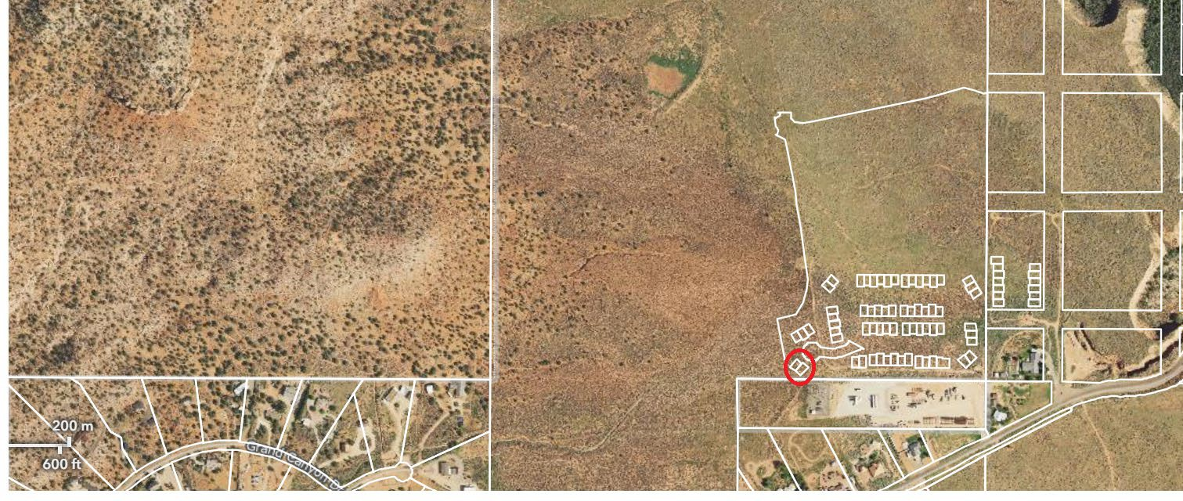


Mayor City Council
T. Colten Johnson Arlon Chamberlain
City Manager Chris Heaton
Kyler Ludwig Scott Colson
Treasurer Kerry Glover
Danielle Ramsay JD Wright

Exhibit B: Amended Plat

AMENDED LOT 52 & 53 CATORI CANYON PHASE 1 SUBDIVISION
CITY OF KANAB, UTAH
LOCATED IN E1 2 OF SECTION 29 & THE W1 2 OF SECTION 28,
TOWNSHIP 43 SOUTH, RANGE 6 WEST, SALT LAKE BASE AND MERIDIAN
SURVEYOR'S CERTIFICATE

I, Thomas W. Avant, a Professional Land Surveyor, License No. 5561917, hold this license in
accordance with Title 58, Chapter 22, Professional Engineers and Professional Land Surveyors Licensing Act and have completed this survey of the Property described hereon in accordance with Section 17-23-17 and have verified all measurements and have placed monuments as
AMENDED LOT 52 & 53
CATORI CANYON PHASE 1 SUBDIVISION
KANATI CIR KANAB, UTAH
represented on this plat. I certify that by authority of the hereon owners, I have made a survey of the tract of land as shown on this Plat as well as Public Utility and Ingress & Egress Easements, as shown, which are herein after known as

"AMENDED LOT 52 & 53 CATORI CANYON PHASE 1 SUBDIVISION"

and that the same has been correctly surveyed and staked on the ground as shown on this plat.

SURVEYED AT THE REQUEST OF : KENNETH L SENG REVOCABLE TRUST 8692 S 1150 E
SPANISH FORK, UT 84660

Thomas W. Avant, PLS # 5561917 Date:

NARRATIVE
The purpose of this survey was to retrace and mark on the ground the lines as shown on this Amended Plat at the request of the client. The purpose of this survey is to move lots 52 and 63 to the Northwest. The basis of bearing for this survey is the Utah State Plane coordinate system South Zone, as measured between the North-East ¹₁₆ corner of Section 29 and the North ¹₁₆
corner of Section 28 with a basis of S89°31'30"E and a distance of 1316.40 feet, as shown on this
Plat.

REFERENCED DOCUMENTS

- AMENDED PLAT OF KANAB CREEK RANCHOS UNIT No.1
- BLM SURVEY, 43S, 6W, SLB&M, 1877
- BLM SURVEY, 43S, 6W, SLB&M, 1986
- FINAL PLAT OF CEDAR HEIGHTS INC. SUBDIVISION, BOOK 5, PAGE 1691
- FINAL PLAT OF CATORI CANYON PHASE 1 SUBDIVISION K-358

LEGEND

SET 5/8" x 36" REBAR WITH PLASTIC CAP MARKED IR ENG. PLS 5561917
FOUND MONUMENT AS NOTED

Phase 1 Amended Lots 52 and 53:
A portion Catori Canyon Phase 1 Subdivision as recorded as Plat K-358 in the Office of the Kane County Recorder, Utah, more particularly described as-follows:
Commencing at the South 1/16 Corner of Sections 29 and 28 on said plat; thence, along the South 1/16 Line of said Section 29, North 89° 17' 16" West 910.83 feet, to the Southeast Corner of Open Space; thence, along the east line of said open space, North 00° 00' 00" West 20.00 feet, to the corner common to said open space and Common Area and the POINT OF BEGINNING, an
running; thence, along said common area, North 00° 00' 00" East 40.05 feet; thence South 89° 17' 16" East 39.28 feet; thence North 09° 18' 13" West 62.56 feet, to the southernly right-of-way of Kanati Circle and the beginning of a non-tangential curve;
thence, along said right-of-way and the curve to the left, 9.63 feet, having a radius 15.00 feet, a central angle of 36° 47' 05" and whose long chord bears South 60° 44' 07" West 9.47 feet, to a reverse curve; thence, along the curve to the right, 236.79 feet,
having a radius of 50.00 feet, a central angle of 271° 20' 09" and whose long chord bears North 01° 59' 20" West 69.88 feet, to the easterly line of said common area; thence, departing said right-of-way and along said line, North 09° 18' 13" West 238.54 feet, to the beginning of a non-tangential curve; thence, along the curve to the right, 185.22 feet, having a radius of 225.00 feet, a central angle of 47° 10' 00" and whose long chord bears South 57° 06' 48" West 180.04 feet; thence South 80° 41' 47" West 24.76 feet;
thence South 09° 18' 13" East 302.35 feet; thence South 89° 18' 17" East 146.83 feet, to the POINT OF BEGINNING; containing 1.26 acres (more or less).
08/29/2023

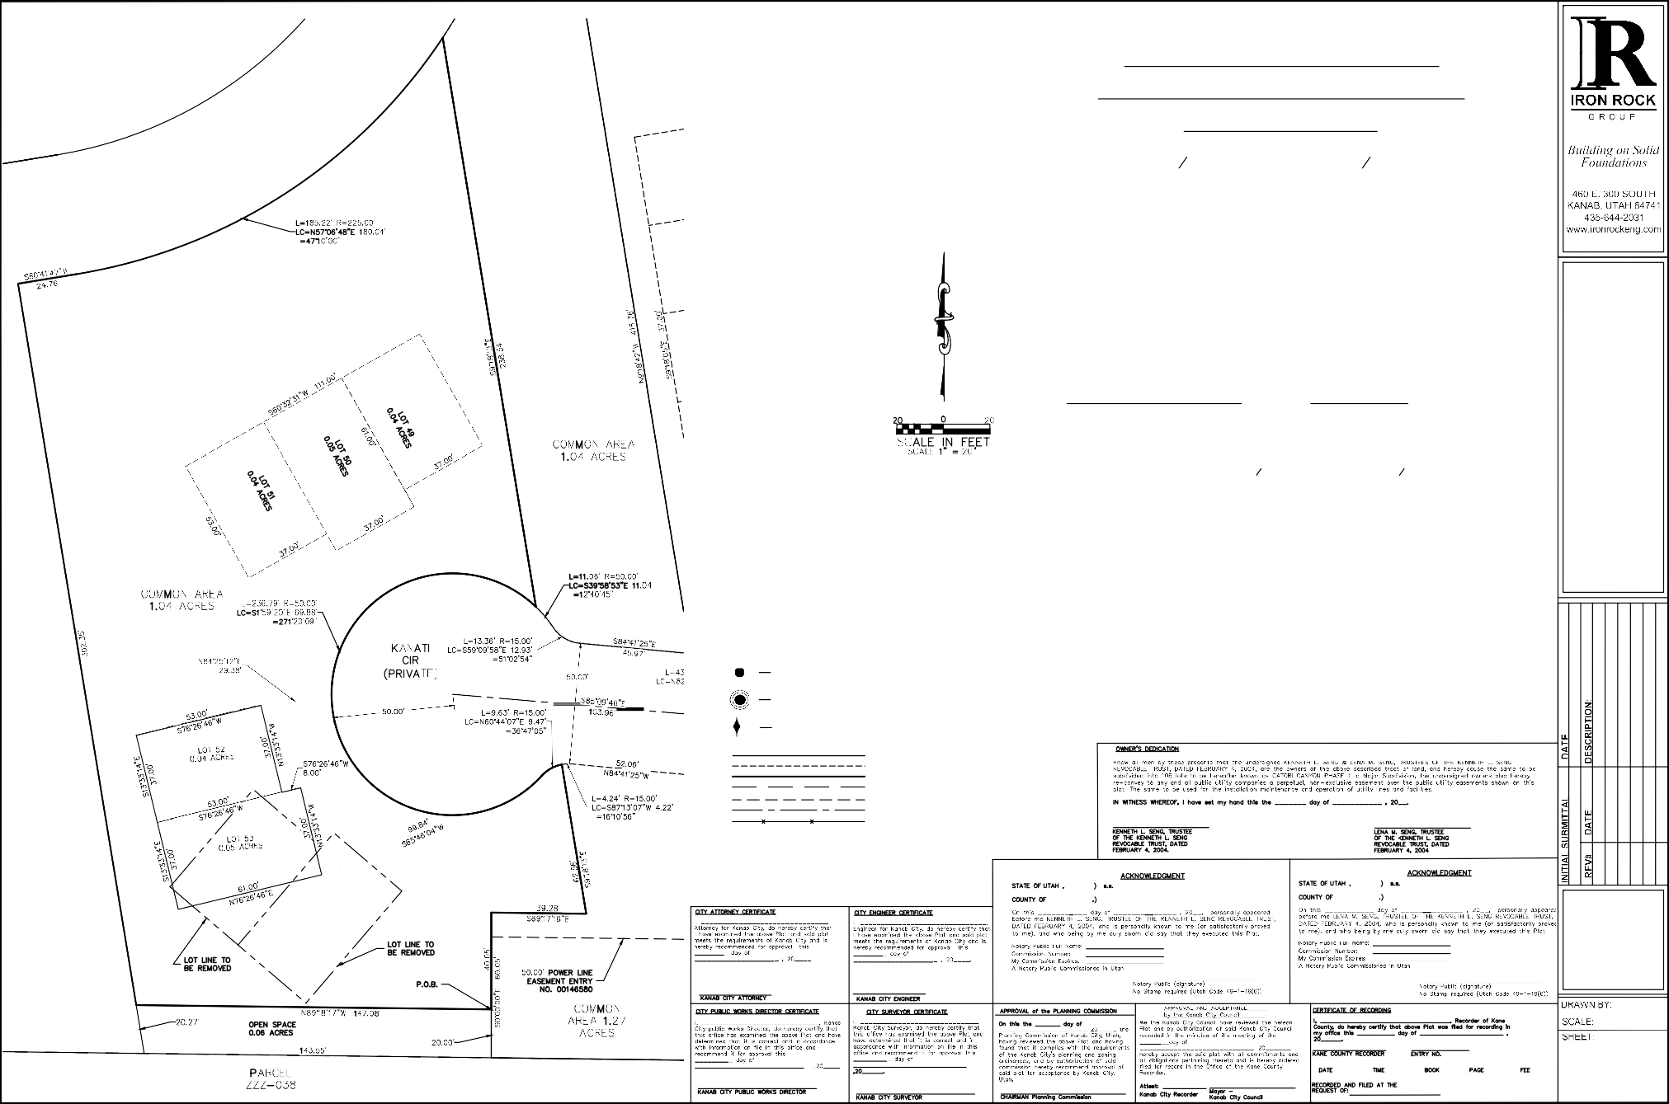
FOUND SECTION MONUMENT AS NOTED

PROPERTY LINE
ADJACENT PROPERTY LINE SURVEY BOUNDARY BUILDING
EASEMENT STREET CL
FENCE
[ ] RECORD BEARING AND DISTANCE

CM
1" = 20'

1 OF 1

Y:\Catori Canyon\Drawings\Amended Lot 52 & 53 Final Plat Phase 1.dwg, 8/29/2023 12:53:07 PM, AutoCAD PDF (General Documentation).pc3

Kanab City Council Staff Report File #2023047

Date: | November 8, 2023
Meeting Date: | November 14, 2023
Agenda Item: | Discuss and recommend to City Council a plat amendment to the Johnson Hills Subdivision
Subject Property Address: | 900 E HWY 89
Applicant: | Iron Rock Engineer
Applicant Agent:
Zoning Designation: | RA
General Plan Designation: | Medium Density Residential (MDR)/High Density Residential (HDR)
Parcel #: | K-310-3
Applicable Ordinances: | Subdivision Ordinance, Chapter 2-4

Attachments:
Exhibit A: Subject Property Exhibit B: Amended Plat

Summary:
Iron Rock Engineer, representative of Seventy-Seven, LLC applied to amend the plat for Johnson Hills Subdivision parcels K-310-3 located approximately at 900 E HWY 89. The plat amendment consists of a minor subdivision splitting the lot into 6 lots. The current zone of lot 3 is RA. The proposed lots will be split as follows: Lot 3 - 65.37 acres, Lot 4 - 4.39 acres, Lot 5 - 3.00 acres, Lot 6 - 1.00 acres, Lot 7 - 1.50 acres and Lot 8 - 0.75 acres.

Applicable Regulation(s):
Plat Amendments are addressed in Utah Code, Title 10, Chapter 9a, Part 6, and the Kanab City Subdivision Ordinance, Chapter 2, upon application that includes a Sketch Plan and Narrative. Chapter 2-4 specifically address the plat amendment process and requirements.

Analysis
Development Committee is reviewing the application, sketch plan and narrative provided by the applicant. Staff has determined:

- The application does meet the requirements of the subdivision ordinance.
- The application does not meet the zoning ordinance, lot 3 is currently zoned RA which requires a minimum of 2-acres per lot. The owner and their representative have submitted a zone change for proposed lots 4, 5, 6, 7, & 8. The proposed zone change is requesting

these lots be a C-3 zone. If zone change is approved the proposed lots will meet the zoning requirements for the minor subdivision.
- Sensitive lands have been identified necessitating abatement of conditions; staff recommends a Geotech study prior to any issuance of building permits due to the high clay content known in this area. Geotech studies will also be needed prior to any approval of improvements required (streets, stormwater, curb, gutter, sidewalk, etc.) with the development of the property.
- The subdivision is consistent and not consistent with the General Plan, the amendment doesn’t comply with the aspiration outlined in the current Future Land Use Map (designation is MDR/HDR) but does meet the general plan and land use ordinances in regard to commercial property development along highways.
- Parcel is zoned RA.
- The proposed streets conform to the guidelines found in the Transportation Master Plan.
The owner of record contained within the plat is Seventy-Seven, LLC. Subdivision construction improvement plans for grading, drainage, streets and utility infrastructure, as modified by the proposed amendment will be addressed with a site plan and building permit. A title report has been submitted to Kanab City. The applicant has paid the amended plat fee required. Impact fees will be collected through the building permitting process.

Public Hearing will be held with City Council on November 14, 2023.

Proposed Findings:

- This application was initiated by Iron Rock Engineer.
- The property included within the amended plat boundaries is zoned RA.
- The Future Land Use Map designation for these properties on the City’s General Plan is Medium Density Residential/High Density Residential.
- The applicant is requesting a minor subdivision.
- The proposed plat amendment meets the subdivision and zoning standards in the City’s Ordinance with the contingency listed above.
- The owner is responsible for securing the appropriate development permits prior to any construction activity.
- The Kanab City Planning Commission is the body responsible for making subdivision plat amendment recommendations to the City Council, upon application.
- Neither the public nor any person will be materially injured by the proposed amendment.
- There is good cause for the amendment.

Planning Commission Recommendation:
The planning commission voted unanimously for a positive recommendation to City Council.

Conditions of Approval:

  - Will serve letters for utilities have been signed and copies given to the city
  - Building permits may not be issued until utilities are available for connection and adequate fire protection is in place to the lot or parcel.
  - Lot Addressing has been completed, reviewed, and approved by city staff.
  - City engineers have reviewed and provided sign-off on mylar.
  - Minor subdivisions are contingent upon zone change from RA to C-3 for lots 4, 5, 6, 7, & 8.

Recommended Motion:
I move to approve the plat amendment to the Johnson Hills Subdivision, affecting parcel K-310-3 based on the findings and conditions of approval as outlined in the staff report #2023047.

Alternate motion:
I move to approve the plat amendment to the Johnson Hills Subdivision, affecting parcel K-310-3 based on the findings and conditions of approval as outlined in the staff report #2023047, with the additional findings and conditions: .

I move to deny the plat amendment to the Johnson Hills Subdivision, affecting parcel K-310-3 demonstrating the applicant has not met the standards outlined in the Kanab City ordinances:
.

Exhibit A: Subject Property

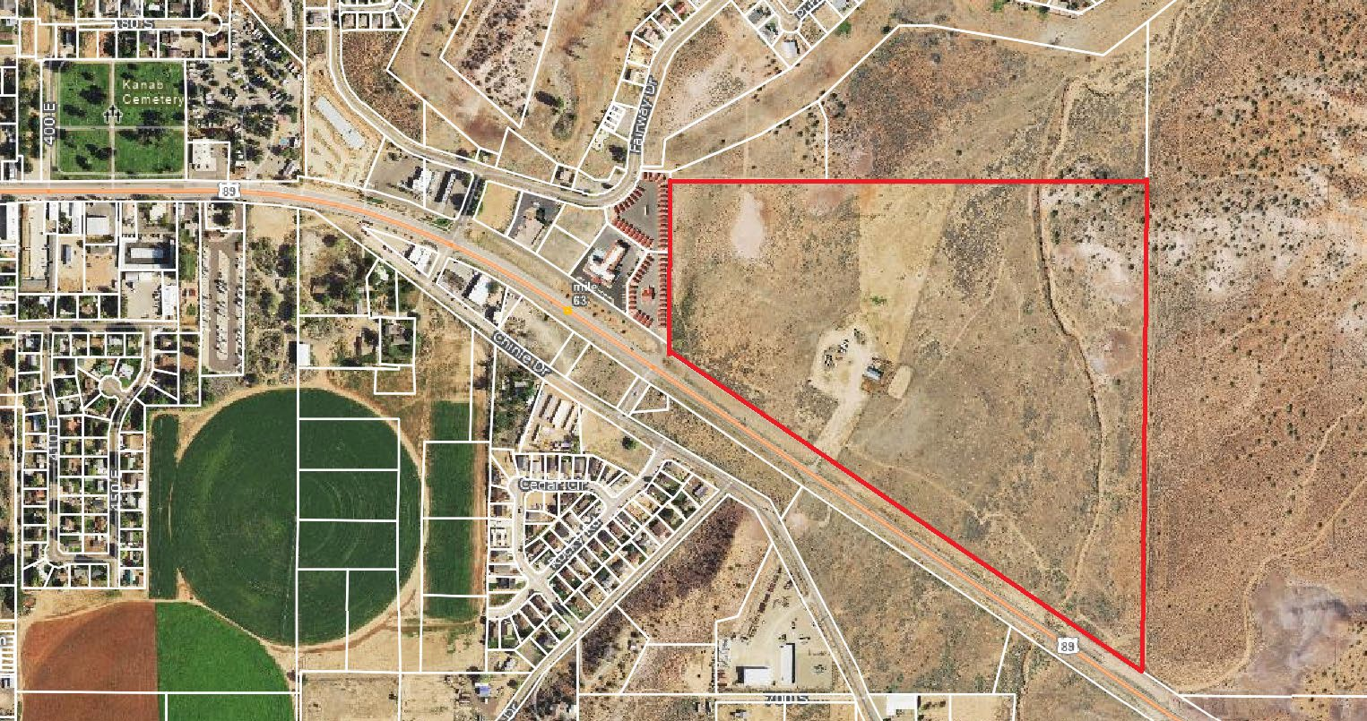

Mayor City Council
T. Colten Johnson Arlon Chamberlain
City Manager Chris Heaton
Kyler Ludwig Scott Colson
Treasurer Kerry Glover
Danielle Ramsay JD Wright

Exhibit B: Amended Plat

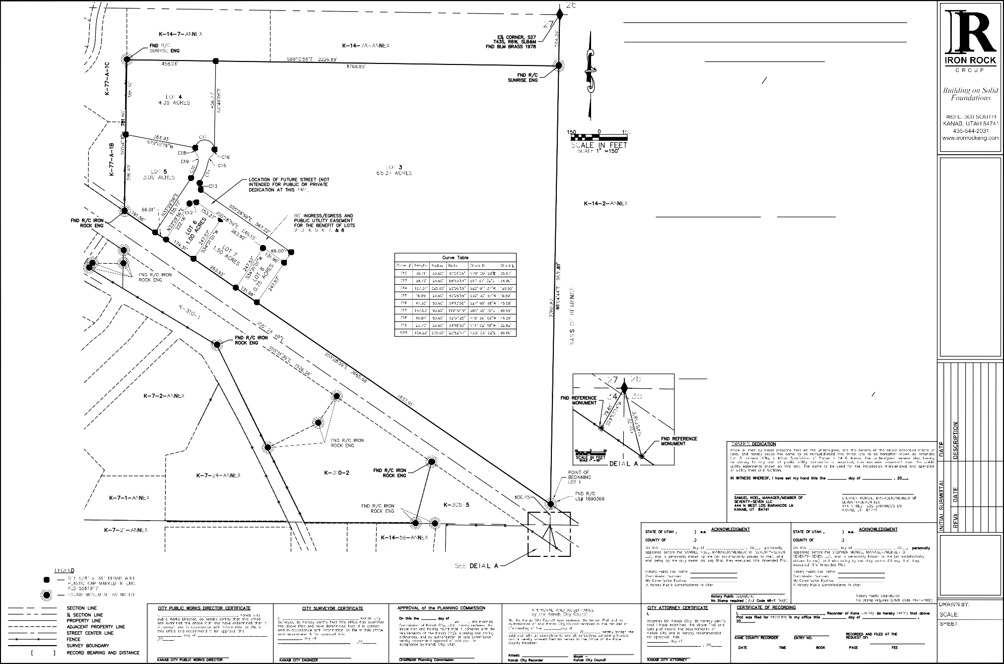
AMENDED LOT 3 JOHNSON HILLS MINOR SUBDIVISION OF PARCEL K-14-6-ANNEX
CITY OF KANAB, UTAH
LOCATED IN SE14 OF SECTION 27,
TOWNSHIP 43 SOUTH, RANGE 6 WEST, SALT LAKE BASE AND MERIDIAN
SURVEYOR'S CERTIFICATE

I, Thomas W. Avant, a Professional Land Surveyor, License No. 5561917, hold this license in accordance with Title 58,
Chapter 22, Professional Engineers and Professional Land Surveyors Licensing Act and have completed this survey of the Property described hereon in accordance with Section 17-23-17 and have verified all measurements and have placed monuments as represented on this plat. I certify that by authority of the hereon owners, I have made a survey of the
tract of land as shown on this Plat and have subdivided the same tract into 5 lots as well as Public Utility and Ingress & Egress Easements, as shown, which are herein after known as
AMENDED LOT 3 JOHNSON HILLS
A MINOR SUBDIVISION
OF PARCEL K-14-6-ANNEX KANAB, UTAH

"AMENDED LOT 3 JOHNSON HILLS, A MINOR SUBDIVISION OF K-14-6-ANNEX"

and that the same has been correctly surveyed and staked on the ground as shown on this plat.

Thomas W. Avant, PLS # 5561917 Date:

LEGAL DESCRIPTION:
ALL OF LOT 3 OF THE JOHNSON HILLS MINOR SUBDIVISION OF PARCEL K-14-6-ANNEX AS RECORDED IN THE OFFICE OF
THE KANE COUNTY RECORDER, UTAH; more particularly described as follows:

COMMENCING at the Southeast corner of Section 27; thence, along the east section line of said section, North 01°04'44" East 106.35 feet, to the POINT OF BEGINNING of Parcel 1 coincident with the Northeasterly right-of-way of US Highway
89; thence, along said right-of-way, North 55°28'59" West 2665.68 feet; thence, leaving said right-of-way, North 00°54'11" East 781.86 feet; thence, South 89°10'55" East 2226.89 feet; thence, South 01°04'44" West 2260.87 feet, to the POINT OF BEGINNING; containing 77.71 acres (more or less).

REFERENCED DOCUMENTS

- AMENDED LOT 2 JOHNSON HILLS MINOR SUBDIVISION OF PARCEL K-14-6 ANNEX (K-310)
- JOHNSON HILLS MINOR SUBDIVISION OF PARCEL K-14-6 ANNEX (K-310)
- UDOT Map F-035-1(4) 1962
- UDOT Map S-280(1), Old Highway 89
- Record of Survey CS-547 So Central Tele Assoc.
- BLM Dependent Resurvey Township 43 South, Range 6 West, SLB&M, 1986
- BLM Subdivision of Sections 22 & 27, Township 43 South, Range 6 West, SLB&M, 1980

NARRATIVE
The purpose of this survey was to retrace and mark on the ground the lines as shown on this Record of Survey at the request of the owner, in order to divide into 5 Lots. All corners are set and found as shown.The basis of bearing
for this survey is measured from the Southeast corner of Section 27 to the East ¹₄ corner of Section 27, N01°04'44"E 2631.61 feet, of the Utah State Plane coordinate system South Zone.

SURVEYED AT THE REQUEST OF : SEVENTY-SEVEN LLC
5/19/2023
444 N WEST LOS BARANCOS LN KANAB, UT 84741

CH
1" - 150'

1 OF 1

Y:\Surveys\Kanab City\Drawings\Kanab_7_23-16 AMENDED LOT 3 JOHNSON HILLS.dwg, 5/19/2023 1:47:03 PM, AutoCAD PDF (General Documentation).pc3

Kanab City Council Staff Report File # 2023048

Date: | November 8, 2023
Meeting Date: | November 14, 2023
Agenda Item: | Discuss and recommend a zone change to City Council from RA [Residential Agriculture] to C-3 [Commercial] for parcel K-310-3 located in the  approximate area of 900 East HWY89.
Subject Property Address: | N/A
Property Owner: | Seventy-Seven, LLC
Applicant Agent: | Iron Rock Engineer
General Plan Designation: | Medium Density Residential/High Density Residential
Parcel #: | K-7-9-2A-Annex

Attachments:
Exhibit A: Subject/Vicinity Property

Summary:
Property Owner Seventy-Seven, LLC represented by Iron Rock Engineer, is requesting a zone change to rezone parcel K310-3 proposed lots 4, 5, 6, 7, & 8 from Rural Agriculture (RA) to Commercial (C-3).

Site Description:
The subject property is approximately 76 acres. The parcel is vacant and fronts Highway 89. It is lot 3 of the Johnson Hills Subdivision. Surrounding zoning designations and the density designations are as follows:

North | South | East | West
Golden Circle Estates Planned Development / Medium Density Residential (MDR) | Commercial (C-3) / General Commercial (GC) & Manufacturing District (MD) | Golden Circle Estates Planned Development / Medum Density Residential (MDR) &  High Density Residential (HDR) | Commercial (C-3) / General Commercial (GC)

Kanab City Land Use Ordinance, General Plan and Zoning Map Analysis:
Zoning designations and zone changes are regulated by the Kanab City Land Use Ordinance, Chapter 15 – Establishment of Zoning Districts regulates zoning designations within Kanab City. Section 15-7 Transitioning and Maintaining Balance, states:
It is the objective of the City to encourage and provide for proper transition and compatibility between zones and intensity of uses, which should be regulated by the City Land Use Code, the General Plan, Future Land Use Map and the Kanab City Annexation Policy Plan. The City also seeks to maintain a healthy balance and mix of land uses within the community, representing the atmosphere of existing development. Areas for growth have been planned with a balance for all uses, including agriculture, residential, commercial and industrial uses, as demonstrated in the Kanab City General Plan and Future Land Use Map. Future decisions regarding land use and zoning in Kanab should be guided by this map.
The City promotes orderly growth, with an emphasis for new developments to occur in the core community areas first. Rezoning of adjacent undeveloped property should be compatible with developed property.

Findings:

- The application was initiated by the owners representative Iron Rock Engineer.
- The property is zoned as RA and approximately 76-acres.
- The City Council is the decision-making authority for a zoning application. The Council may adopt or reject the request as it deems appropriate or may assign a different zoning designation.
- Assigning a C-3 zone is not consistent with the Kanab City Future Land Use Map designation of MDR/HDR. The General Plan and Land Use Ordinances designating commercial property development along the highway corridors.
- The requested zone of C-3 is consistent with the adjacent properties to the West and South of the property.
Suggested Motion(s):

I move to approve zone C-3 to Parcel K-310-3 based on the findings and conditions outlined in Staff Report #2023048 and adopt Ordinance 11-x-23 O.

I move to deny the requested zone change of C-3 to Parcel K-310-3 based on the findings and conditions outlined in Staff Report #2023048.

Exhibit A: Subject Property

ORDINANCE NO. 11-X-23 O

AN ORDINANCE APPROVING A ZONE CHANGE FOR PARCEL K-7-9-2A-Annex

WHEREAS, pursuant to Utah Code § 10-9a-501, and Kanab City Land Use Ordinance, Chapter 1, Section 17, the City Council is authorized on its own motion or pursuant to an application, to amend and assign zoning district boundaries, after receiving a recommendation from the Kanab City Planning Commission;

WHEREAS, applicant Iron Rock Engineering submitted an application for a zone change on behalf of Seventy-Seven, LLC for the parcel identified as K-7-9-2A-Annex, requesting they be changed from Rural Agriculture (RA-2) to Commercial 3 (C-3);

WHEREAS, the Kanab City Planning Commission meet in regular session on November 7, 2023, and gave a unanimous recommendation to the City Council in favor of a zone change from RA-2 to C-3;

WHEREAS, after proper notice was provided, the Kanab City Council held a public hearing on November 14, 2023, in which public comments were received, and then reviewed; and

WHEREAS, the City Council met during its regularly scheduled and properly noticed meeting on November 14, 2023, received input from the applicant/applicant’s representative and staff, and reviewed and discussed the Kanab City Planning Commission’s recommendation and the zoning options for the parcels.

NOW, THEREFORE, BE IT ORDAINED by the Kanab City Council that the parcel identified on the Kane County records as K-7-9-2A-Annex is hereby assigned the zone of C-3, a Commercial zone under the Kanab City Land Use Ordinance;

All former zoning designations for the subject parcel conflicting or inconsistent with the provisions of this Ordinance hereby adopted are hereby repealed.

The provisions of this Ordinance shall be severable, and, if any provision thereof or any application of such provision is held invalid, it shall not affect any other provisions of this code or the application in a different circumstance.

This ordinance shall be effective upon the required posting. [Signatures on the next page.]

PASSED AND ORDERED POSTED this 14th day of November, 2023.

KANAB CITY ATTEST:

MAYOR
RECORDER

VOTING:

Kerry Glover Yea Nay
J.D. Wright Yea Nay Arlon Chamberlain Yea Nay Scott Colson Yea Nay
Chris Heaton Yea Nay

POSTED the day of , 2023, as certified by the Recorder: .
RECORDER

Kanab City Council Staff Report Reference File #2023045

Date: | November 8, 2023
Meeting Date: | November 14, 2023
Agenda Item: | Conditional Use Permit_Private Lane
Subject Property Address: | Approximately 504 Hamblin Dr
Applicant: | Nick & Carol Ramsay
Applicant Agent: | Iron Rock Engineer

Attachment:
Exhibit A: Private Lane Specification

Summary:
An application for a Conditional Use Permit was received, Iron Rock Engineer is requesting a Private Lane for parcel 34-40. Iron Rock Engineer has also applied for a plat amendment to create a minor subdivision. The private lane is being requested to access one of the proposed lots in the minor subdivision.

Applicable Regulation(s):
Kanab City Land Use Ordinance, Chapter 4, Section 4-21 regulates private lanes allowing residential development without frontage upon dedicated public streets access through a private lane provided recommendation by the Planning Commission and approval by City Council. Land Use Ordinances, Chapter 8 regulates the approval of Conditional Uses. Chapter 4-21 requires the following:

- A scale drawing of the proposed private lane and lot, the lot shall meet all size and setback requirements of the zone in which the lot is located.
- A determination shall be made as to the future width of dedicated street that may be needed to serve the lot, based upon the City Master Plan of streets. The private lane must meet all requirements of such a class of street, including width.
- The applicant for the Conditional Use Permit shall record a written agreement to dedicate the private lane at such time as the City shall require dedication.
- An easement shall be recorded across the private lane between the subject property and the public-street or right-of-way providing for installation and maintenance of utility lines and services, emergency vehicle access and access of City or public personnel or vehicles as

may be required in order to carry out the responsibilities of the City and other governmental entities,
- The private lane shall be improved with a road base or better surface across such width as the City may, from time to time, determine. The driving surface shall be well maintained, and it shall be readily passable by a standard passenger car and emergency vehicles,
- Utility lines shall be extended at the cost of the applicant from the public street to the subject dwelling at such size as may be required by the City to serve the applicant or future development in the area. Upon installation and acceptance, the lines on the City side of the meter shall become the property of the City. The city will then assume responsibility for the upkeep and maintenance of the line. No reimbursement contracts will be issued by the City to the property owner for any future connections to any required utility line that may be installed as a part of a conditional use permit approval,
- Water meters shall be located at the future property line in front of the dwelling. Other meters, such as electricity, shall be located as required by the City,
- All dwellings shall be no further than two hundred and fifty (250) feet from an approved fire hydrant. If installation of a hydrant is necessary, it shall be done at the expense of the applicant,
- A letter of consent and non-opposition to any future improvement district initiated by the City shall be recorded against the land and shall run with the land. The City, at its option, may initiate a special improvement district for the improvement of any private lane approved for use under these conditions.

Proposed Findings:

- This application was initiated by Iron Rock Engineer.
- The private lane meets the Land Use Ordinances of Chapter 4, section 4-21; a fire hydrant must be within 250 feet of proposed dwelling, or a fire hydrant will be installed within 250 feet from any dwelling at the expense of the applicant/owner.
- Letter of Agreement and Non-Opposition shall be recorded.
- Findings for approval as outlined in Chapter 8, Section 8-6 (B) and as listed below in the Findings of Approval in the staff report.
- An emergency apparatus turn around as outlined in the International Fire Code will be provided as the private lane is a dead-end road greater than 150 feet.

Finding for Approval:

In approving or recommending approval of a conditional use permit, the Kanab City Planning Commission finds:

- That the proposed use is necessary or desirable and will contribute to the general well- being of the community.
- That the use will not be detrimental to the health, safety, or welfare of persons residing, or working in the vicinity, or injurious to property or improvements in the vicinity.
- That the proposed use will comply with the regulations of this Ordinance.
- That the proposed use is in harmony with the intent and purpose of the Kanab City Master Plan or that the plan shall have first been amended through public hearing.
Planning Commission Recommendation:

The planning commission voted unanimously for a positive recommendation to City Council.

Conditions of Approval:

- The owner is responsible for securing the appropriate development permits prior to any construction activity.
- A fire hydrant must be within 250 feet of proposed dwelling or a fire hydrant will be installed within 250 feet from any dwelling at the expense of the applicant/owner.
- Letter of Agreement and Non-Opposition shall be recorded.
- An emergency apparatus turn around as outlined in the International Fire Code will be provided as the private lane is a dead-end road greater than 150 feet.

Recommended Motion:
I move to approve the conditional use permit for a private lane based on Staff’s findings and conditions listed in the staff report, File # 2023045 and the findings in Chapter 8, Section 8-6 (B).

Alternate motion:
I move to approve the conditional use permit for a private lane based on Staff’s findings and conditions listed in the staff report, File # 2023045 and the findings in Chapter 8, Section 8-6 (B), and the following additional finding(s): .

I move to deny the conditional use permit for a private lane, the applicant has not met the standards outlined in the Kanab City ordinances): .

Exhibit A:
Private Lane Specification

EXHIBIT A
AMENDED & EXTENDED LOT LOT 40 KANAB CREEK RANCHOS UNIT NO. 1 CITY OF KANAB, UTAH
LOCATED IN E½ NW1/4 OF SECTION 27,
JIRONRROCK
GROUP

LEGAL DESCRIPTION:

PRIVATE LANE:
EAST 34.00' OF AMENDED & EXTENDED LOT 40
TOWNSHIP 43 SOUTH, RANGE 6 WEST, SALT LAKE BASE AND MERIDIAN
ROAD 26' WIDE


\......l_?,;:-"CL\......l_?,;:-"CL\......l_?,;:-"CL\...j ROAD BASE/GRAVEL 8"

Building on Solid Foundations

460 E. 300 SOUTH
KANAB, UTAH 84741
435-644-2031
www.ironrockeng.com


BEGINNING, at the Northwest Corner of Lot 40 of Kanab Creek Ranchos, as recorded on Plat 34 in the Office of the Kane County Recorder, Utah, and running; thence, along the westerly line of said lot, South 08° 25' 20" West 239.88 feet, to the southeast lot corner and the beginning of a non-tangential curve; thence, along the south line and the curve to the right, 241.59 feet, having a radius of
460.00 feet, a central angle of 30° 05' 28" and whose long chord bears South 66° 28' 37" East 238.82 feet, to the southeast lot corner; thence, along the easterly lot line, North 38° 26' 17" East 417.11 feet, to the northeasterly lot corner; thence, along the north lot line, North 89° 14' 16" West 37.90 feet; thence, departing said line, North 00° 00' 00" East 2.90 feet; thence North 89° 14' 16" West 405.26

feet, to the East-East 1/64 Line of Section 32, Township 43 South, Range 6 West, Salt Lake Base and Meridian; thence, along said line, South 00° 15' 56" West 2.90 feet, to the POINT OF BEGINNING; containing 2.28 acres (more or less).
BASE DIRT

z<( 0 ::J.
w
w co "'Z
I-
r

N89°14'16"W
• _· -=-405.26'_:_ s0·15'55"w No·oo·oo"
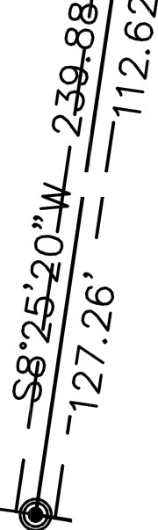
_,,.:. 2.90' 2.9
ADDRESS
I I
490 WEST HAMBLIN LOT 40B
_ 65.98' N87°59'56"W

EAST 34.00' OF
,3/ I
si;r o so
-•••- I
SCALE IN FEET
SCALE 1" =100'
'.:i--J
...J::J
I- -WO
:'.';Iii0
x
ci:: <(w
o..wo..

---------
LOT 40A
ADDRESS
504 WEST HAMBLIN
L=36.48' R=25.00' LC=S80°14' 41"W 33.33'
' // ,,<v
()O; (o::-
<:o<:o· ci>"v/
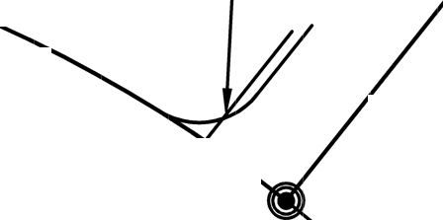
I// "v I
AMENDED AND EXTENDED LOT 40

------ - ----,---
Ll=83°36' 48" I
I /
llliWJ
ro:,mml


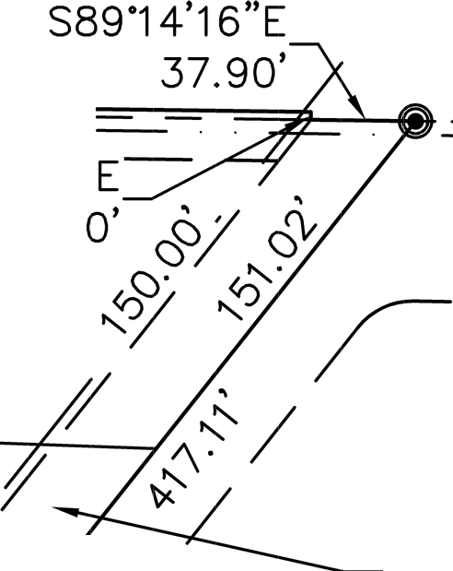
L=241.59' R=460.00'· '- /
,(
LC=S66°28'37"E 238.82' ', "- /
/
Ll=30°05'28" "- "-.. /
/
I "

DRAWNBY: CH SCALE, 1"' = 100"" SHEET:

1 OF 1

Kanab City Council Staff Report File #2023041

Date: | November 8, 2023
Meeting Date: | November 14, 2023
Agenda Item: | Discuss and recommend to City Council a plat amendment to the Kanab Creek Subdivision, Unit 1,  parcels 34-40
Subject Property Address: | 504 Hamblin Dr
Applicant: | Nick & Carol Ramsay
Applicant Agent: | Iron Rock Engineer
Zoning Designation: | RR-1
General Plan Designation: | VLDR
Parcel #: | 34-40
Applicable Ordinances: | Subdivision Ordinance, Chapter 2-4

Attachments:
Exhibit A: Subject Property Exhibit B: Amended Plat

Summary:
Iron rock Engineer representative for Nick & Carol Ramsay, have applied to amend the plat for Kanab Creek Ranchos, Unit #1 parcels 34-40 located approximately at 504 Hamblin Drive. The plat amendment consists of adjusting the lot line and subdividing the lot into two lots.
The lot line adjustment will affect parcel K-19-4-Annex and is needed to ensure the lots are at least 1 acre to accommodate the 60-foot public utility easement that may become a dedicated city street at a future date.

Applicable Regulation(s):
Plat Amendments are addressed in Utah Code, Title 10, Chapter 9a, Part 6, and the Kanab City Subdivision Ordinance, Chapter 2, upon application that includes a Sketch Plan and Narrative. Chapter 2-4 specifically address the plat amendment process and requirements.

Analysis
Development Committee has reviewed the application, sketch plan and narrative provided by the applicant. Staff has determined:

- The application meets the requirements of the subdivision ordinance; with the condition that a Conditional Use Permit for a private land is approved by City Council.
- No sensitive lands have been identified necessitating abatement of conditions;

- The subdivision is consistent with the General Plan, in that the amendment complies with the aspiration outlined in the current Future Land Use Map of rural residential district.
- Parcel is zoned RR-1.
- The streets have not been changed and conform to the guidelines found in the Transportation Master Plan.
- If approved by City Council, the back lot will front a private lane.
The owners of record contained within the plat is Nick & Carol Ramsay. Subdivision construction improvement plans for grading, drainage, streets and utility infrastructure, as modified by the proposed amendment will be required when the vacant lot(s) are developed, prior to a building permit being issued; the change of the lot does not affect the plan previously provided. A title report has been submitted to Kanab City. The applicant has paid the amended plat fee required. Impact fees will be collected through the building permitting process.

Public Hearing will be held with City Council on October 24, 2023.

Proposed Findings:

- This application was initiated by the owners.
- The property included within the amended plat boundaries are zoned RR-1
- The Future Land Use Map designation for these properties on the City’s General Plan is Very Low Density Residential.
- The applicant is requesting a lot line adjustment and minor subdivision.
- The proposed plat amendment meets the subdivision and zoning standards in the City’s Ordinance with the contingency listed above.
- The owner is responsible for securing the appropriate development permits prior to any construction activity.
- The Kanab City Planning Commission is the body responsible for making subdivision plat amendment recommendations to the City Council, upon application.
- There is not a petition to vacate easement in the proposed amendment.
- Neither the public nor any person will be materially injured by the proposed amendment.
- There is good cause for the amendment.

Planning Commission Recommendation:
The planning commission voted unanimously for a positive recommendation to City Council.

Conditions of Approval:
Approval is contingent with an approval of a Conditional Use Permit for a private lane.

Recommended Motion:
I move to approve the plat amendment to the Kanab Creek Ranchos Subdivision, affecting parcel 34-40 based on the findings and conditions of approval as outlined in the staff report #2023041.

Alternate motion:
I move to approve the plat amendment to the Kanab Creek Ranchos Subdivision, affecting parcel 34-40 based on the findings and conditions of approval as outlined in the staff report #2023041, with the additional findings and conditions: .

I move to deny the plat amendment to the Kanab Creek Ranchos Subdivision, affecting parcel 34- 40 demonstrating the applicant has not met the standards outlined in the Kanab City ordinances:
.

Exhibit A: Subject Property

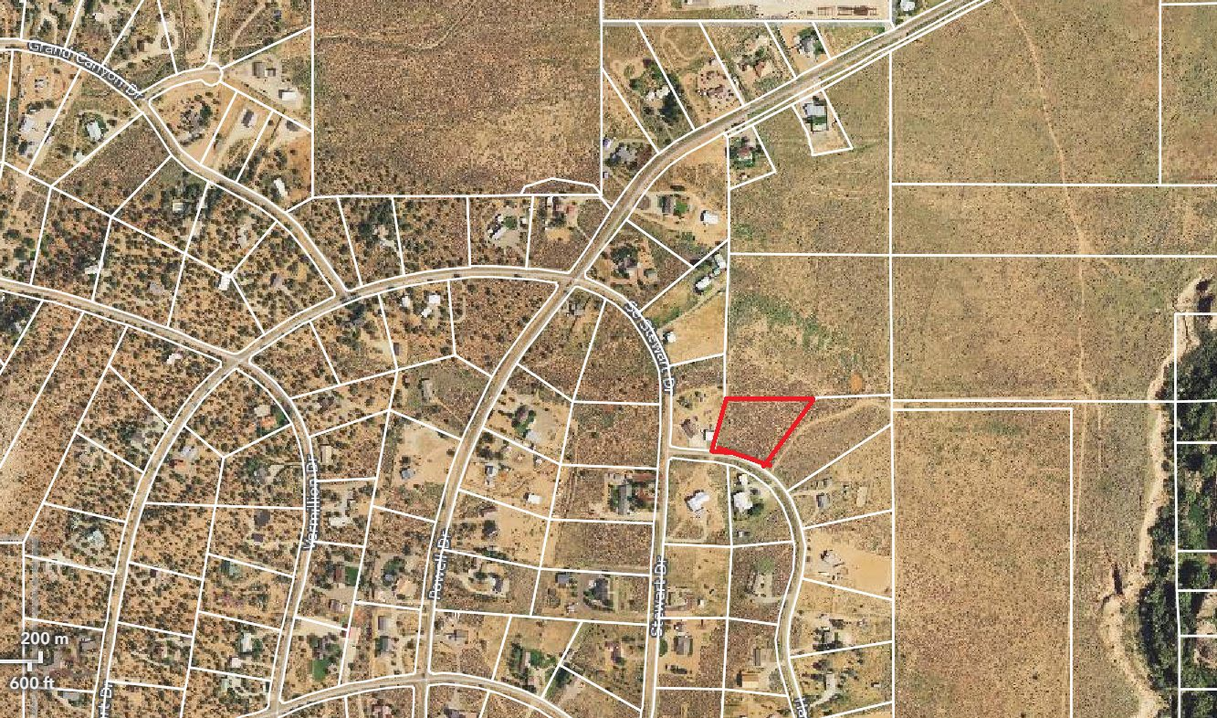

Mayor City Council
T. Colten Johnson Arlon Chamberlain
City Manager Chris Heaton
Kyler Ludwig Scott Colson
Treasurer Kerry Glover
Danielle Ramsay JD Wright

Exhibit B: Amended Plat

– A Western Classic –
26 North 100 East • Kanab, Utah 84741 • Phone 435-644-2534 • Fax 435-644-2536 • www.kanab.utah.gov

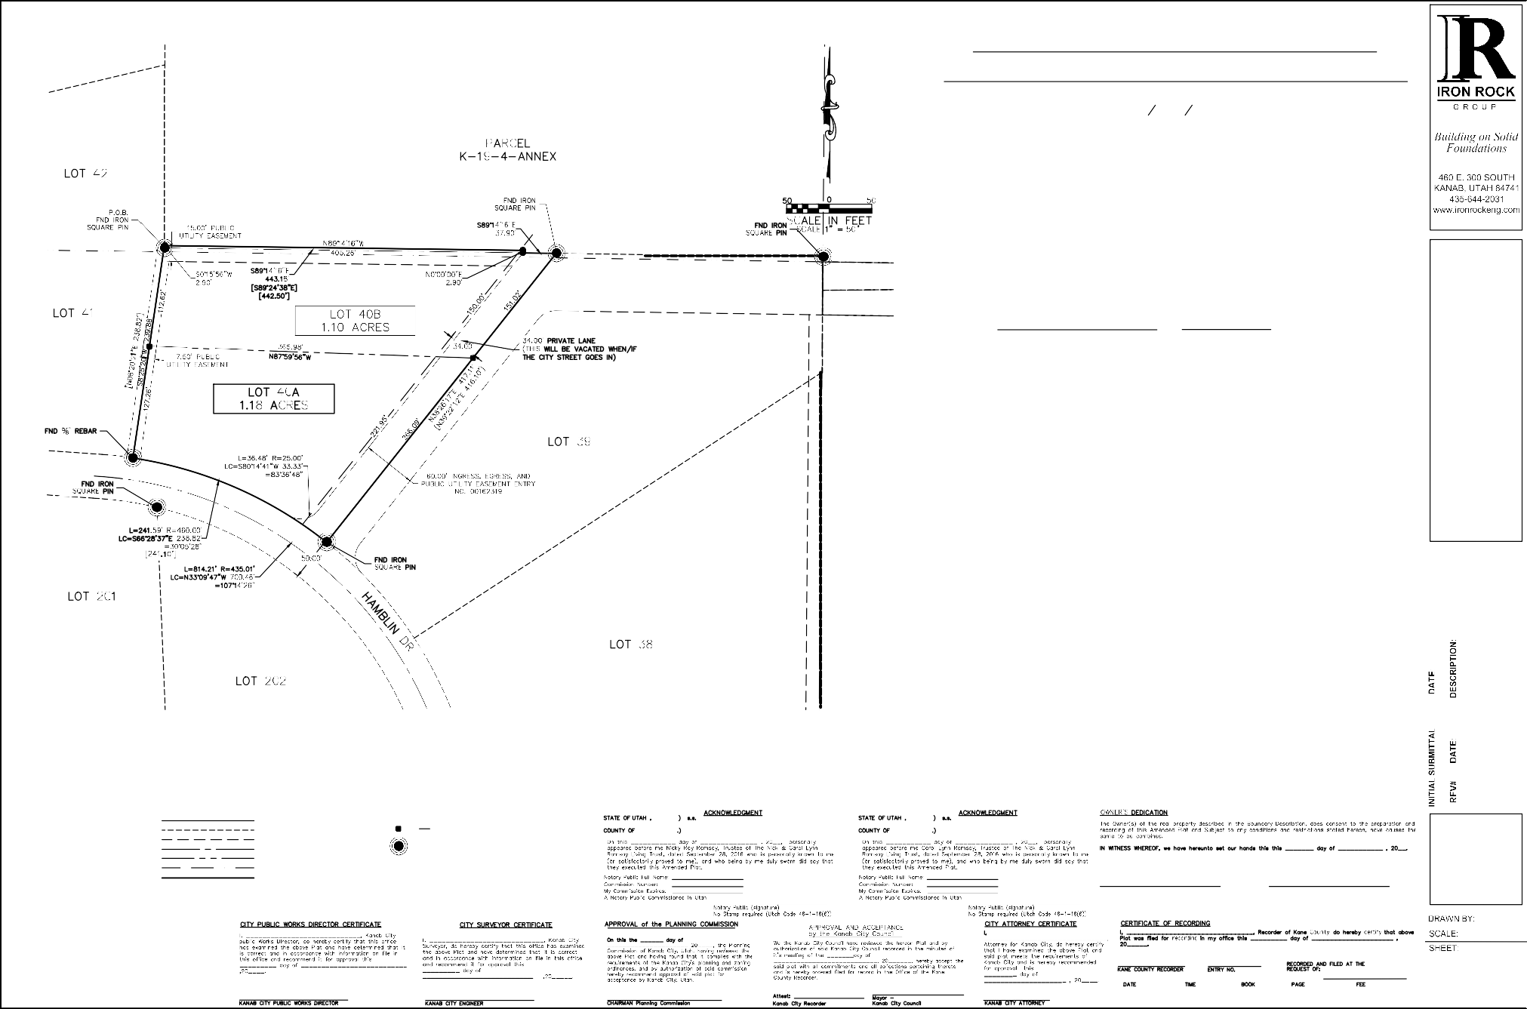
Δ | LEGEND |  |  |  |  | AMENDED & EXTENDED LOT 40  KANAB CREEK RANCHOS UNIT No. 1  CITY OF KANAB, UTAH  LOCATED IN E1 2 NW14 OF SECTION 27,  TOWNSHIP 43 SOUTH, RANGE 6 WEST, SALT LAKE BASE AND MERIDIAN  SURVEYOR'S CERTIFICATE  I, Thomas W. Avant, a Professional Land Surveyor, License No. 5561917, hold this license in  accordance with Title 58, Chapter 22, Professional Engineers and Professional Land Surveyors Licensing Act and have completed this survey of the Property described hereon in accordance with Section 17-23-17 and have verified all measurements and have placed monuments as  represented on this plat. I certify that by authority of the hereon owners, I have made a survey of the tract of land as shown on this Plat and have amended the lot, as shown, which are herein after known as  "AMENDED & EXTENDED LOT 40 KANAB CREEK RANCHOS UNIT No. 1"  and that the same has been correctly surveyed and staked on the ground as shown on this plat.  Thomas W. Avant, PLS # 5561917 Date:  NARRATIVE  The purpose of this survey was to retrace and mark on the ground the lines as shown on this Amended & Extended Plat at the request of the client. The purpose of the survey is to delineate the boundaries and add a portion of Parcel  K-19-4-Annex to Lot 40 of the Kanab Creek Ranchos Unit 1. All corners are set and found as shown.The basis of bearing for this survey is from the South West Corner of old Lot 107 to the North West Corner of old Lot 107 with a Bearing of N9°23'55"W and a Distance of 110.17' in the Utah State Plane coordinate system South Zone.  LEGAL DESCRIPTION:  Lot 40 Amended and Extended - Legal Description:  BEGINNING, at the Northwest Corner of Lot 40 of Kanab Creek Ranchos, as recorded on Plat 34 in the Office of the Kane County Recorder, Utah, and running; thence, along the westerly line of said lot, South 08° 25' 20"  West 239.88 feet, to the southeast lot corner and the beginning of a non-tangential curve; thence, along the south line and the curve to the right, 241.59 feet, having a radius of 460.00 feet, a central angle of 30° 05' 28" and whose long chord bears South 66° 28' 37" East 238.82 feet, to the southeast lot corner; thence, along the easterly lot line, North 38° 26' 17" East 417.11 feet, to the northeasterly lot corner; thence, along the north lot line, North 89° 14' 16" West 37.90 feet; thence, departing said line, North 00° 00' 00" East 2.90 feet; thence  North 89° 14' 16" West 405.26 feet, to the East-East 1/64 Line of Section 32, Township 43 South, Range 6 West, Salt Lake Base and Meridian; thence, along said line, South 00° 15' 56" West 2.90 feet, to the POINT OF  BEGINNING; containing 2.28 acres (more or less).  SURVEYED AT THE REQUEST OF :  THE NICK & CAROL LYNN RAMSAY LIVING TRUST 9-26-2016 111 E 575 N  KANAB, UT 84741  REFERENCED DOCUMENTS  - KANAB CREEK RANCHOS UNIT NO.1. CS-34  - EASEMENTS AND RIGHT OF WAYS, ENTRY NO. 00162319
RAMSAY
AMENDED & EXTENDED LOT 40
KANAB CREEK RANCHOS UNIT No. 1 KANAB, UTAH
 |  |  |  |  |  |  |  |  |  | 8/23/2023
 | PROPERTY LINE  ADJACENT PROPERTY LINE  EASEMENT |  | SET 5/8" x 36" REBAR WITH PLASTIC CAP MARKED IR ENG. PLS 5561917
 | STREET CENTER LINE |  | FOUND MONUMENT AS NOTED
 | LOT LINE TO BE REMOVED
 | SECTION LINE
 | SURVEY BOUNDARY
 | RECORD BEARING AND DISTANCE |  |  |  |  |  |  | Nicky Ray Ramsay, Trustee of The Carol Lynn Ramsay, Trustee of The  Nick & Carol Lynn Ramsay Living Trust, dated September 28, 2016 Nick & Carol Lynn Ramsay Living Trust, dated September 28, 2016 111 E 575 N 111 E 575 N  Kanab, UT 84741 Kanab, UT 84741
 |  |  |  |  |  |  |  |  |  | CM
 |  |  |  |  |  |  |  |  |  | 1" - 50'
 |  |  |  |  |  |  |  |  |  | 1 OF 1

Δ

Δ

[ ]

Y:\Surveys\Kanab City\Drawings\Kanab_7_23-25 Nick Ramsey - Lot Line Adjust.dwg, 8/29/2023 11:59:55 AM, AutoCAD PDF (General Documentation).pc3

Kanab City Council Staff Report October 31, 2023 File Number 20231031
Date: | November 9, 2023
Meeting Date: | November 14, 2023
Agenda Item: | Public Hearing discuss and recommend to City Council a  text amendment on Chapter 20 Commercial Zone

Attachments:
- Exhibit A: Proposed Amendment Summary:
Staff have received business license application(s) and inquiries for types of businesses
that are not included in the Land Use Chart. The proposed text amendments are to review the types of business uses and make a recommendation to permit, not permit or conditionally permit the uses in the commercial zones.

Planning Commission:
Made a positive recommendation to City Council to adopt Exhibit A with the following amendments: Body Art and Car Wash be permitted in all commercial zones.

Recommended Motion:
I move to approve the amendments to City Code identified in exhibit A of the staff report for 20231031 and adopt Ordinance 11-x-23 O.

I move to approve the adopt changes to City Code identified in exhibit A of the staff report for 20231031 and adopt Ordinance 11-x-23 O, with the following amendments:
.

– A Western Classic –
26 North 100 East • Kanab, Utah 84741 • Phone 435-644-2534 • Fax 435-644-2536 • www.kanab.utah.gov

Exhibit A: Proposed Amendment

Kanab
Land Use Ordinance
Chapter 20 – Commercial Zones

Section 20-1 Purpose
Section 20-2 Commercial Zones
Section 20-3 Commercial Temporary Structures Section 20-4 Height Regulations
Section 20-5 Temporary Events on Public Right-of-Way Section 20-6 Minimum Area, Width, and Yard Regulations Section 20-7 Special Regulations
Section 20-8 Design Standards for the Commercial Zones (C-1, C-2, C-3) Section 20-9 Other Regulations
Section 20-10 Land Use Chart and Exhibits A & B

Section 20-1 Purpose
The purpose is to provide various zones within the City of Kanab where a wide variety of goods and services can be provided.

Section 20-2 Commercial Zones
- C-1 Commercial Zone (Downtown Core)
  - The C-1 zone has been established to distinguish the historic downtown commercial area of Kanab. This zone is characterized by a variety of types of goods and services that complement one another and is intended to facilitate a high density of economic activity in a walkable atmosphere. The C-1 Zone encourages a mix of store front commercial retail, restaurants, hotels, mixed residential/commercial, and office space.
- C-2 Commercial Zone (Transition)
  - The objective of the commercial zone is to provide space within the city where nearly all types of commercial goods and services may be provided, such as retail, office and mixed use (work/live). Since the zone permits such a wide variety of uses, the protective features which zoning normally affords to adjacent properties are mostly nonexistent. Therefore, owners should develop and maintain their property in recognition thereof.
  - The C-2 commercial zone is located principally along major roadways for maximum visibility to the public. To maximize traffic safety, property owners should work together to provide access, parking, etc., to adjacent parcels and access should be provided in a manner that will minimize the hazard of traffic leaving and entering major roadways.
- C-3 Commercial Zone

Kanab
Land Use Ordinance
Chapter 20 – Commercial Zones

  - The principal objective in establishing the C-3 commercial zone is to provide space within the city where facilities that serve the local and traveling public can be most appropriately located for ease of ingress and egress. Other purposes for establishing the C-3 commercial zone is to promote safety on the highways and convenience of the traveling local and public, to promote beauty in the appearance of roadsides and interchanges leading into and out of the city.

Section 20-3 Commercial Temporary Structures
A “Commercial Temporary Structure” is defined as a temporary structure intended for outdoor use for a limited time, not to exceed one hundred seventy-nine (179) days in any rolling twelve (12) month period, in a commercial zone. All commercial temporary structures shall be approved by the Planning Commission and shall meet the following requirements:
- Shall not include illumination on the exterior, except for pedestrian safety;
- Shall be removed upon expiration of the permit period;
- May be used for temporary sales, grand openings, holiday promotions, temporary seating;
- Shall be installed on private property, unless otherwise approved and permit granted under Kanab General Ordinance, Section 9-05, Special Sales Events and Promotions;
- Shall require a permit from the City Building Department and pay required fee(s);
- Shall not block the visibility or normal movement of vehicles and pedestrians;
- Shall not eliminate required parking;
- Shall be maintained in good repair at all times;
- Shall be installed on a hard surface with proper tie-downs;
- Shall meet all adopted fire and building codes for a temporary structure; and
- Shall meet all design standards for the underlying zone, except building material requirements (unless specified in the building or fire codes).
The applicant shall specify the period of time for which the approval is sought. Section 20-4 Height Regulations
No building shall be erected to a height greater than forty-five (45) feet, nor lower than twelve (12) feet, except that a building may be erected to a height of forty-eight (48) feet if the additional top three (3) feet is a parapet wall. Must also follow guidelines in Section 20-9.

Kanab
Land Use Ordinance
Chapter 20 – Commercial Zones

Section 20-5 Temporary Events on Public Right-of-Way
In no case shall business be conducted on public right-of-ways except as allowed by a special events permit.

Section 20-6 Minimum Area, Width, and Yard Regulations

 |  |  | Yard Setbacks in Feet
Zone | Area | Width | Front | Side | Rear
C-1 | 5,000 sq ft | 0 | 0 | 0 | 2
C-2 | 5,000 sq ft | 0 | 0 | 0 | 2
C-3 | 12,0000 sq ft | 0 | 20 | 20 | 2

Where a commercial zone abuts a residential district, building setbacks will be as follows:

Building Height | Yard Setbacks in Feet
Building Height | Front | Side | Rear
Greater than 16 feet | 0 | 20 | 20
Less than 16 feet | 0 | 10 | 10

Section 20-7 Special Regulations

- All used materials and used merchandise that are not for decorative purpose, except vehicles in running order, shall be stored in an enclosed building or within an enclosure surrounded by a sight-obscuring fence or wall of not less than six (6) feet in height and no material or merchandise shall be stored to a height of more than the height of the enclosing fence or wall.

- No trash, rubbish, weeds, nor other combustible material shall be allowed to remain on any lot outside of approved containers in any Commercial District. No junk, debris, abandoned or dismantled automobile or automobile parts or similar material shall be stored or allowed to remain on any lot in any Commercial District.

- All solid waste storage facilities shall be located at the rear of the main building or else behind a sight-obscuring fence or wall which will prevent the facility from being seen from a public street.

Section 20-8 Design Standards for the Commercial Zones (C-1, C-2, C-3)

- The purpose of the Design Standards is to maintain the character of Kanab City as a destination community with breathtaking scenery, to preserve the city’s corridors, preserve and enhance the rural western character of the downtown area, provide a

Kanab
Land Use Ordinance
Chapter 20 – Commercial Zones

significant landscaped buffer between development and highway uses, minimize curb cuts and access points to highways, and enhance Kanab’s walkable downtown atmosphere.

- In this section, “building surface” refers to any outside portion of the building that is viewable from an adjacent street or walkway, not including the roof.

- Any design or landscape requirements that apply to C-1 in this chapter, or in any other Land Use Ordinance, shall also apply to any lots that:

  - Have any frontage to the continuous section of street that starts as 300 W, then Center Street, and continuing into 100 E; and

  - Are between the northern city entrance (approximately one block north of 300 N) and approximately one block south of 400 South (the furthest southern point of the La Quinta property).

- Lot and Site Requirements are subject to the following:
  - A façade improvement that requires a building permit within the commercial zones needs approval from the Planning Commission. A façade improvement that does not require a building permit needs approval from the Land Use Coordinator.
  - When possible, driveways shall be shared between adjoining properties. Driveways must be placed where they create the least interference with traffic on highways. Driveways and drive-thrus shall be located away from adjoining residentially zoned areas, when feasible, and provide privacy walls and landscape buffers along common boundaries with residences in residential zones.
  - The Planning Commission shall review all proposals for pedestrian, bicycle paths and trails through the commercial zones.
  - Street trees shall be planted in the right-of-way as part of the site landscaping requirements and shall be maintained according to City landscape requirements.
  - Businesses proposing outdoor street front seating/dining should consider an adequate front setback in their site plan to accommodate such front area use.
  - Parking Lots: Some established and new businesses in the downtown area do not have adequate parking. With new construction and/or when a change of use occurs, parking standards for these businesses shall be considered by the Planning Commission, as specified in Chapter 6, (6-4.3 Commercial properties fronting on Highways 89/89A). Parking for new buildings in the C-1 zone shall be located in the rear, unless access to the rear is not feasible.
  - Buildings in the C-1 zone shall be located near the sidewalk with setbacks used for pedestrians, plazas, benches, landscaping and outdoor eating areas, but not for parking (unless requiring parking to the side or back is unfeasible). Diagonal

Kanab
Land Use Ordinance
Chapter 20 – Commercial Zones

parking on side streets is permitted within the Downtown Parking District in order to create additional downtown parking.
  - Trails and sidewalks shall be provided in all new development within the C-1 zone in accordance with the Kanab City Trails Master Plan. Trails and sidewalks may be located within the setback areas.
  - Outdoor Display of Art, or Public Park Facilities: The permanent installation of an outdoor art display, or outdoor recreational equipment, such as bike racks that require a fixed location on or above the ground and is within 30’ of a UDOT right- of-way, may be allowed as a Conditional Use.
  - Building Front Design: In conjunction with a required site plan, architectural designs for new construction and refurbishing the exterior of an existing commercial building are required, addressing the design standards in this section. Site plans or façade improvements in the commercial zones, that require a building permit, need approval from the Planning Commission. All other construction or refurbishments that do not require a building permit need approval from the Land Use Coordinator.
  - The following guidelines apply to new construction or changes to the exterior of an existing commercial building in the commercial zones.
    - No high gloss or mirrored metal products shall be permitted on the building surface, unless for trim or decorative purpose that consists of less than 10 percent of the building surface. The building surface shall consist of at least two City approved materials, the predominant material not surpassing 85% of the building surface. The ground floor front façade area shall consist of a minimum of 25% window area. City approved materials must be high quality and durable, and include window glass, stucco, rock, stone, metal, brick, and any other material that is substantially similar to these. The following shall not make up more than 50% of the building surface: concrete block, un- textured tilt-up concrete panels, or pre-fabricated steel panels.
    - Awnings: Awnings shall not be vinyl, aluminum, nor have a shiny or glossy appearance. Corrugated metal awnings are allowed.
    - Colors: No fluorescent colors are allowed on building surface or roof. Black cannot be the predominant color of any building surface. Earth tone colors in accordance with Section 20-10 Exhibits A & B are encouraged.
    - The primary pedestrian entry of the building shall face the street and be identified, defined, and reinforced by significant architectural elements of mass. The appearance of the building front shall present a three dimensional effect through the utilization of such architectural features as pop outs, vertical relief overbuilds, recesses, canopies or porticos supported by columns or protrusions, significant variations in the roof or parapet, etc.
    - The design standards for building fronts described above shall wrap around

Kanab
Land Use Ordinance
Chapter 20 – Commercial Zones

the building sides adjacent to the primary front, for at least ten feet, unless the Planning Commission finds that it would be impractical.
    - Building surface shall be broken into smaller elements. Building surface shall be reduced by using a combination of the following techniques: variation in roof lines; variations in wall plane with projections and recessed areas; use of windows on elevations facing a street; and use of vertical accents.
    - Kanab City’s goal is to maintain a “western theme” in the commercial areas, particularly the C-1 zone. While not required, applicants are encouraged to incorporate western features into the design scheme. These western features may include hitching posts, sculptures, public art, covered canopies, benches, and similar features that promote a western feel.
- Design Standards unique to the C-3 Zone:
  - Minimum setback on the east side of SR-89A shall be forty-five feet (45’) per UDOT.
  - Berms and Earthwork Screening must be graded and planted in such a manner so as to permit views of primary uses on the site from adjacent entry corridor roadway. Additionally, berm crests shall be contoured and varied in height to avoid a straight-line barrier effect.
  - All fences in the C-3 zone must be one of the following styles: wooden rail; vinyl fencing; architecturally compatible solid wood or natural stone; stock fences that do not front on State Highway; and various forms of steel fencing as determined by the Planning Commission. Chain link fencing is not allowed except behind front of structure.

Section 20-9 Other Regulations
- Other relevant standards and requirements are found in other sections of this code, including Landscape Requirements in Section 9-8, Parking Requirements in Chapter 6, Signs in Chapter 7, and Site Plan Review in chapter 9.
- Except those lots or areas in commercial zones that have been designated or adopted to meet the design standards of the C-1 zone, all new residential buildings and developments on C-2 and C-3 commercial lots shall comply with Chapter 18 (Multi- Family Residential Zone) or Chapter 17 (Single Family) in the event of a residential structure.

Kanab
Land Use Ordinance
Chapter 20 – Commercial Zones

Section 20-10 Land Use Chart and Exhibits A & B

LAND USE CHART COMMERCIAL | ZONES
LAND USE CHART COMMERCIAL | C1 | C2 | C3 | CPD
Agricultural Crop Sales (Farm Only) | - | - | P | -
Airport Support Facility | - | - | P | P
Amphitheater | C | C | C | C
Antique / Secondhand Store | P | P | P | P
Apartment(s)* | - | P | P | C
Arcade (Games/Food) | P | P | P | P
Archery Range / Course Outdoor | - | C | C | C
Art Gallery | P | P | P | P
Auto / Boat Dealer | - | - | P | C
Auto Rental / Sales | - | C | P | C
Auto Service Station | - | P | P | C
Auto Supply Store | P | P | P | P
Bar Establishment | - | - | - | -
Beauty/Spa Salon | P | P | P | P
Bed and Breakfast / Short-term Vacation Rental | P | P | P | -
Body Art | P | P | P | P
Bowling Alley | P | P | P | P
Brewery (Large) | - | - | - | -
Brewery (Small) Restaurant | P | P | P | P
Car Wash | P | P | P | P
Cemetery | - | - | C | -
Church | P | P | P | P
College / University | P | P | P | P
Commercial Marine Supply | - | P | P | C
Commercial / Residential Mix* | P | P | P | P
Communications Facility | - | - | P | C
Conference / Convention Center | P | P | P | P
Construction Trade and Storage | - | - | C | -
- Land Use Chart – Permitted (P) and Conditional (C) Uses

Kanab
Land Use Ordinance
Chapter 20 – Commercial Zones
LAND USE CHART COMMERCIAL | ZONES
LAND USE CHART COMMERCIAL | C1 | C2 | C3 | CPD
Convalescent Center / Nursing Home | C | P | P | P
Convenience Store | P | P | P | P
Day Care I (under 6 children) | - | P | P | C
Day Care II (over 6 children) | - | P | P | C
Distillery | - | - | - | -
Dry Cleaner | P | P | P | P
Drug Store | P | P | P | P
Elementary – Jr. High | - | P | P | P
Espresso Stand | P | P | P | P
Event Center | P | P | P | P
Farmer’s Market | P | P | P | P
Farm Equipment Sales | - | P | P | P
Financial Institution | P | P | P | P
Florist Shop | P | P | P | P
Food Truck Parks | - | - | - | -
Food Truck Vendors | P | P | P | P
Funeral Home/Crematory | - | P | P | -
Garage/Vehicle Repair & Restoration | - | P | P | C
Gas Station | - | P | P | C
General Retail and Services | P | P | P | P
Grocery Store | P | P | P | C
Group Home | - | - | P | C
Halfway House | - | - | P | C
Hardware / Garden Material | - | P | P | C
Health Club | P | P | P | P
High School | - | P | P | -
Hospital | - | - | P | -
Hotel / Motel / Extended-Stay | P | P | P | C
Kennel / Public | - | - | P | -
Landscaping Business | - | - | P | -
Laundromat | P | P | P | P
Library | P | P | P | P

Kanab
Land Use Ordinance
Chapter 20 – Commercial Zones

LAND USE CHART COMMERCIAL | ZONES
LAND USE CHART COMMERCIAL | C1 | C2 | C3 | CPD
Liquor Store / Packaging Agency | P | P | P | C
Live or amplified music | P | P | P | P
Media Material | P | P | P | P
Medical / Dental Lab | - | P | P | P
Misc. Equipment Rental Facility | - | P | P | -
Miscellaneous Health | P | P | P | P
Mobile / Park Model Home Park | - | - | P | -
Mobile Vendor | P | P | P | P
Multi-family Dwelling Units* | - | P | P | P
Museum | P | P | P | P
Park | P | P | P | P
Photographic and Electronic Store | P | P | P | P
Police / Fire Facility | P | P | P | P
Preschool | - | P | P | P
Printing / Publishing | P | P | P | P
Professional Office | P | P | P | P
Public / Private Parking | P | P | P | P
Recreational Center | P | P | P | P
Restaurant | P | P | P | P
RV / Camp Park | - | P | P | -
Self-Service Storage | - | - | P | -
Sexually Oriented Business | - | - | - | -
Shooting / Archery Range Indoor | C | P | P | P
Single Detached Dwelling Unit* | - | P | P | -
Single Attached Dwelling Unit* | - | P | P | -
Social / Public Agency offices | P | P | P | P
Tavern | - | - | - | -
Theater | P | P | P | P
Towing Operation | - | P | P | -
Truck Stop | - | - | P | -
Two-family Dwelling Units* | - | P | P | -

Kanab
Land Use Ordinance
Chapter 20 – Commercial Zones

LAND USE CHART COMMERCIAL | ZONES
LAND USE CHART COMMERCIAL | C1 | C2 | C3 | CPD
Veterinary Clinic large animal | - | - | P | -
Veterinary Clinic small animal | - | P | P | C
Vocational School | - | P | P | C
Youth Home | - | P | P | -
Wholesale / Bulk Store | - | P | P | -
Wireless Telecommunications retail | P | P | P | P
Wood Products Sales | - | C | P | -
Zip Lines | - | - | C | -

* Commercial / Residential Mix:

In a Commercial/Residential mix, a commercial use is required on the main (ground) floor for all properties that have frontage along Highway 89 and Highway 89A, in the area of 400 North through Center Street, continuing on 100 East to 700 South and headed East on Highway 89A to 650 East. Residential use is permitted to be on any level above the main (ground) floor. Residential uses for “Commercial / Residential Mix” may include one or more units.

Kanab
Land Use Ordinance
Chapter 20 – Commercial Zones

See also Chapter 4 Supplementary Regulations

- Exhibit A
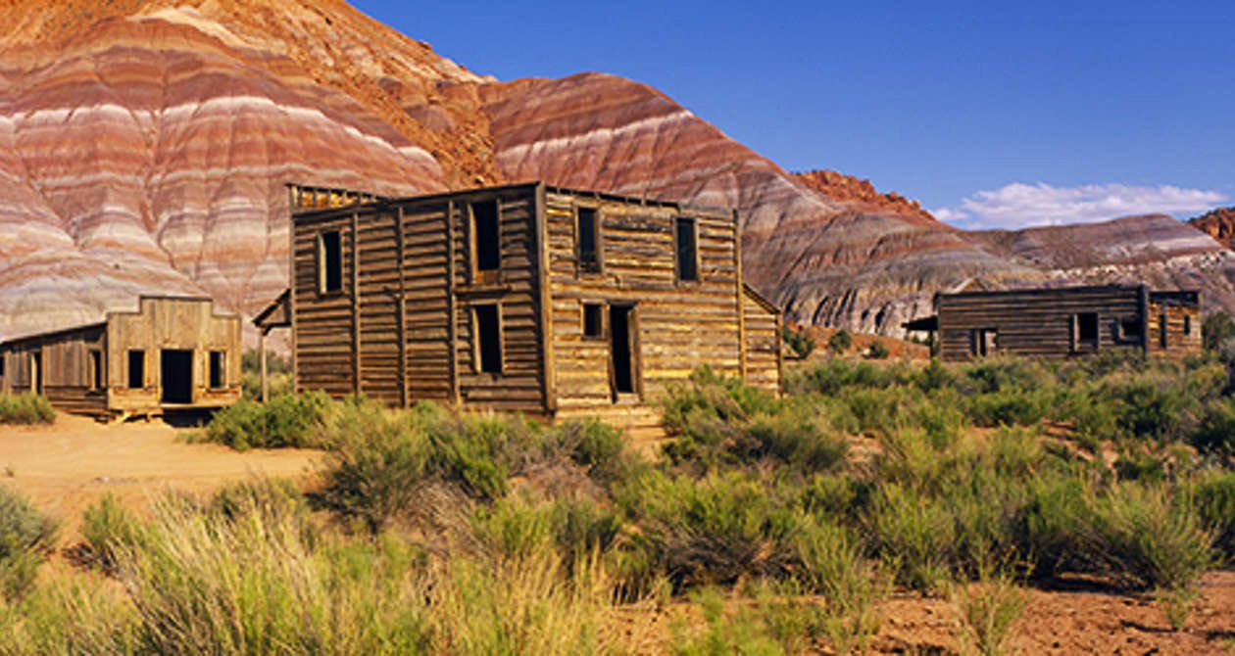
(color purposes only)

Kanab
Land Use Ordinance
Chapter 20 – Commercial Zones

- Exhibit B
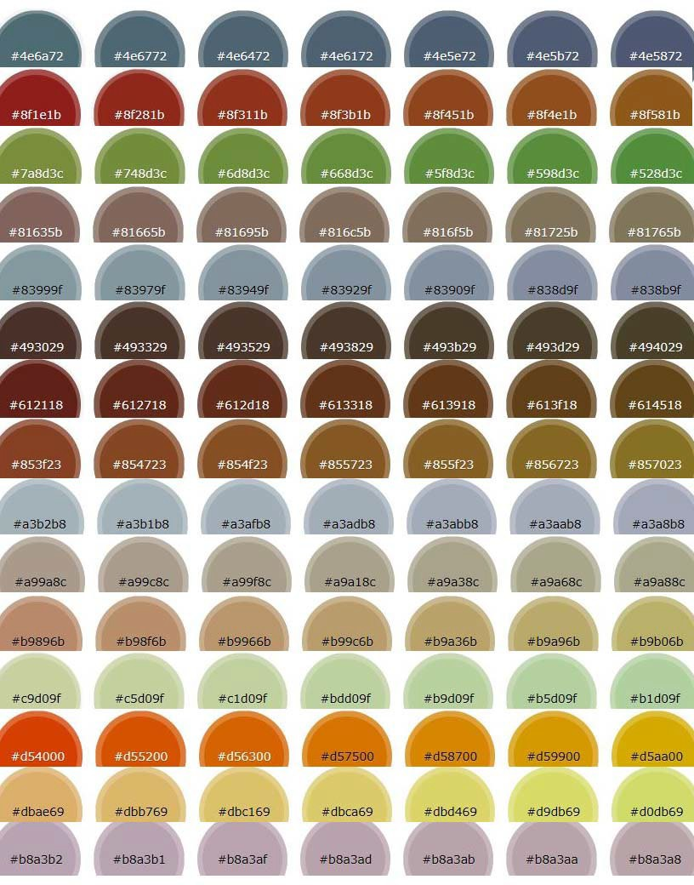

ORDINANCE NO. 11-X-23 O
AN ORDINANCE AMENDING KANAB CITY LAND USE ORDINANCE
Chapter 20, Commercial Zones

WHEREAS, the Kanab City Planning Commission and City staff have evaluated the current land use ordinance related to commercial zones, including the description of each zone and the permitted and conditional uses in each zone;

WHEREAS, the Planning Commission has found a need for clarification, modification, and certain additions to Chapter 20, Commercial Zones;

WHEREAS, the Kanab City Planning Commission held a public hearing on November 7, 2023, reviewed, discussed, and then recommended to the Kanab City Council changes to the Land Use Ordinance, Chapter 20; and

WHEREAS, the Kanab City Council met during its regularly scheduled meeting on November 14, 2023, to consider, among other things, amending the Kanab City Land Use Ordinance, Chapter 20, Commercial Zones.

NOW, THEREFORE, BE IT ORDAINED by the Kanab City Council that the Kanab City Land Use Ordinance is hereby amended as reflected in the page(s) attached hereto.

All former ordinances or parts thereof conflicting or inconsistent with the provisions of this Ordinance or of the Code hereby adopted are hereby repealed. The provisions of this Ordinance shall be severable, and, if any provision thereof or any application of such provision is held invalid, it shall not affect any other provisions of this code or the application in a different circumstance.

This ordinance shall be effective upon the required posting.

PASSED AND ORDERED POSTED this 14th day of November, 2023.

KANAB CITY ATTEST:

MAYOR RECORDER

VOTING:

Kerry Glover Yea Nay
JD Wright Yea Nay Arlon Chamberlain Yea Nay Scott Colson Yea Nay
Chris Heaton Yea Nay

POSTED the day of , 2023, as certified by the Recorder: .
RECORDER

Kanab City Council Staff Report File # 20231102

Date: | November 9, 2023
Meeting Date: | November 14, 2023
Agenda Item: | Discuss and recommend to City Council an amendment to the Development Agreement for  Catori Canyon Subdivision
Subject Property Address: | N/A
Property Owner: | Kenny & Lena Seng
Applicant Agent: | Iron Rock Engineer
General Plan Designation: | Medium Density Residential
Parcel #: | K-47-1

Attachments:
Exhibit A: Development Agreement

Summary:
Property Owner Kenny & Lena Seng represented by Iron Rock Engineering, is requesting an amendment to the development agreement for Catori Canyon Subdivision. The amendments include a request for variation on the height of fences around the Garkane property to the height of 10-feet; that open space such as trails, parking areas, roads and other areas identified in the exhibits of the development agreement be maintain by the city.

Planning Commission
The planning commission discussed the request for fence request of 10 feet and the open spaces being maintained by the city. There was some concern regarding the streets with the cul-de-sacs being maintained by the city since they are not through roads and generally not accessed by the public. A positive recommendation was made with an amendment that the through roads be accepted by the city and analyze the cost impact of the non-through streets to the tax base of Kanab City.

Suggested Motion(s):

I move that we make a positive recommendation of the first amended Development Agreement for Catori Canyon Subdivision as shown in exhibit A of the staff report.

I move that we make a positive recommendation of the first amended Development Agreement for Catori Canyon Subdivision as shown in exhibit A of the staff report with the following amendments .

I move that we make a negative recommendation of the first amended Development Agreement for Catori Canyon Subdivision..

Exhibit A: Development Agreement

When Recorded Return to:
Kanab City
26 North 100 East
Kanab, UT 84741

Tax ID Numbers: K-B-17-1, K-B-7-1; K-47-1; K-6-1; K-38-1-Annex

FIRST AMENDMENT TO DEVELOPMENT AGREEMENT FOR
CATORI CANYON

This First Amendment to the Development Agreement for Catori Canyon (herein "First Amendment”) is entered into this 14th day of November, 2023 (“Effective Date”), by and between Kenneth
L. Seng and Lena M. Seng, Trustees of the Kenneth L. Seng Revocable Trust dated February 4, 2004 (hereafter referred to as “Seng”), and Maylee Land and Livestock, LLC, a Utah limited liability company (hereafter referred to as “Maylee”) (Seng and Maylee may collectively be referred to as the “Owners”) and Catori Canyon Development, Inc., a Utah corporation, ("Developer") and the City of Kanab, a municipal corporation and political subdivision of the State of Utah (herein "City") for the Development Property included in or affected by the project known as "Catori Canyon” (herein the "Planned Community"). The City, Owners, and Developer may be referred to collectively as “Parties,” or individually as a “Party.”

RECITALS

WHEREAS, Rocky Canyon Properties, LLC., a Utah limited liability company, Plumb Investment, LC, a Utah limited liability company and Plumb Land Investments, LLC, a Utah limited liability company (the “Original Developer”), and the City of Kanab, a municipal corporation and political subdivision of the State of Utah (the “City”), entered into a Development Agreement for the Planned Community, approved and dated August 17, 2022, and recorded August 24, 2022, as Entry No. 00200958 of the official records of the Kane County Recorder (hereafter referred to as the “Development Agreement”) which described on Exhibit “A” thereto certain real property located in Kane County, Utah and referred therein as the “Development Property” (such Exhibit “A” is attached hereto as well); and

WHEREAS, Seng, by execution of an Owners Consent dated November 7, 2022 and recorded on November 21, 2022 as Entry No. 00201939 in the official records of the Kane County Recorder, consented to the preparation and recording of the above described Development Agreement and to its attachment to and binding effect on the real property owned by Seng referred to as Parcel K-B-17-1 which was included in the Exhibit “A” to the original Development Agreement (hereafter the original Development Agreement shall be deemed to include the real property described in such recorded Owners Consent); and

WHEREAS, the Original Developer sold the Development Property to Owners and assigned the Development Rights to Owners; and

WHEREAS, Owners have or will enter into one or more agreements with Developer to acquire portions of the Development Property in order for Developer to develop the same; and

WHEREAS, Developer is contemplating acquiring portions of the Development Property in order to develop the Planned Community; and

WHEREAS, it is contemplated as provided in the Development Agreement that the Planned Community will include a number of open space areas some of which it is intended that the City will own and maintain and others which the Owner will retain and maintain; and

WHEREAS, Owners, Developer and City desire to confirm the respective obligations regarding the open space areas; and

WHEREAS, Seng was the purchaser and is the owner of certain of the Development Property which is referred to as the Catori Canyon Subdivision Phase 1 (hereafter “Phase 1”) which is intended to be developed by Developer; and

WHEREAS, Developer has determined that it would be in the best interest of the development of Phase 1 and of the future owners thereof that fences or walls be constructed along the Phase 1 Property and any other parts of the Development Property which are adjacent to the substation property of Garkane Power, identified as parcel ZZZ-038 (hereafter the “Garkane Substation Property”), which height exceeds the permitted height of such fences under the City’s ordinances; and

WHEREAS, City believes it would be in the best interest of the Planned Community and the future lot owners thereof that the Developer construct fences on the Development Property adjacent to the Garkane Substation Property which exceed the permitted height of fences under the City’s ordinances; and

WHEREAS, on November 7, 2023, the Kanab City Planning Commission held a duly noticed public hearing to consider this First Amendment, and thereafter made a recommendation to the Kanab City Council pertaining thereto; and

WHEREAS, on November 14, 2023, having received the Planning Commission’s recommendation, the Kanab City Council met during its duly noticed regular meeting, considered this First Amendment with any modifications, and considered the input of City staff, the public (if any), and the Planning Commission, and discussed the First Amendment; and

WHEREAS, City, acting pursuant to its authority under UTAH CODE ANNOTATED 10-9a-101, et seq. and its ordinances, resolutions, and regulations and in furtherance of its land use policies, has made certain determinations with respect to the proposed Planned Community, and, in the exercise of its legislative discretion, has elected to approve this First Amendment to the Development Agreement, the City finding that it will promote the health, safety, prosperity, security, and general welfare of the inhabitants and taxpayers of the City.

NOW, THEREFORE, in consideration of the mutual covenants and conditions contained herein, the parties agree as follows:

AGREEMENT

  - Recitals. The Recitals above are hereby incorporated into this Agreement.

  - Section 4.5 of the General Obligations is amended to read as follows:

  - Exceptions to City Ordinance. In accordance with Section 23-7 of the Kanab City Land Use Ordinance, City agrees to allow the Development Property to deviate from the City Standards and Ordinances in the following ways:
    - Allow flexibility with regards to the cul-de-sac lengths, as long as hydrant flow is met, and the fire chief approves of the layout, as shown on the preliminary plat.
    - Allow flexibility with the 25% requirement for multi-family landscaping, by shifting the landscaping to the perimeter of the multi-family area.
    - Developer or Owners, as applicable, shall be entitled to construct fences or walls on the Development Property adjacent to the Garkane Substation Property (the Garkane substation being located on parcel # ZZZ-038) up to a height of ten (10) feet and adjacent to other easements of Garkane Power up to a height of eight (8) feet as determined by Owners or Developer, as applicable. Developer or Owner shall comply with all other fencing regulations and be required to apply for the required building permit for all fences and walls over seven (7) feet in height.
    - The fences or walls to be constructed by Developer or Owners shall be as described on Exhibit B-2 through B-6 attached hereto and by reference incorporated herein.

  - Section 4.10 of the General Obligations is amended to read as follows:

4.10 The approved Open Spaces will remain open space indefinitely. Such Open Spaces are divided into the following categories.
- Dedicated Open Spaces shall mean those areas identified on the Amended Exhibit B-1 attached hereto and by reference incorporated herein that are intended to be dedicated and used for trails, drainage channels, and detention areas. The description and location of the trails to be constructed and improved are as shown Exhibit B-2 and B-3. Upon completion of the improvements to the Dedicated Open Spaces by Developer in accordance with and as required by City standards, Owners or Developer shall convey or dedicate the Dedicated Open Spaces to City. Upon written acceptance of the Dedicated Open Spaces, City shall maintain the Dedicated Open Spaces in accordance with normal and usual City standards and practices.
- Undisturbed Open Spaces shall be those areas identified on the Amended Exhibit B-1 that are intended to be retained by Owners or Developer and include the areas located in the Kanab Creek bottom area. It is acknowledged that it is not intended that Owners or Developer will do any improvements to the Undisturbed Open Spaces but that the same shall remain generally in their natural condition.
- Dedicated Roads and Parking Lots shall mean those public roads and parking lots identified on the Amended Exhibit B-1 that are intended to be dedicated to the City. Upon completion of the improvements to the Dedicated Roads and Parking Lots by Developer in accordance with and as required by City

standards, Owners or Developer shall convey or dedicate the Dedicated Roads and Parking Lots to City. Upon written acceptance of the Dedicated Roads and Parking Lots, City shall maintain the Dedicated Roads and Parking Lots in accordance with normal and usual City standards and practices.
- Private Roads shall mean those private roads identified on the Amended Exhibit B-1 that are intended to be retained by Developer and to be treated as common areas for the Kivas at Catori Canyon portion of the Development Property. City shall have no obligation to improve or maintain the Private Roads, but they shall be improved by Developer in accordance with City standards for private roads, if any, and maintained by Developer or the HOA for the Kivas at Catori Canyon.

  - Section 4.12 of the General Obligations is deleted and replaced by the provisions of Section 4.10(c) above.

  - The following terms and provisions are added to and amend the Development Agreement. Where any of the following terms contained herein are inconsistent with the original terms of the Development Agreement, the terms herein shall be controlling and amend and replace the corresponding term within the Development Agreement.

  - Owners and Developer Acknowledgment.

    - Developer and Owners acknowledge that they have been sufficiently advised orally and in writing by the City and Owner and Developer’s own legal counsel (including by way of this written First Amendment and the previously executed Development Agreement) of any and all rights “under clearly established state law” to which Owner and Developer are entitled but conceding and giving up by way of entering into the Development Agreement and this First Amendment, and will therefore be estopped from a future related claim, including claims brought under Utah Code § 10-9a-532(2)(c) (i.e., claim of undisclosed or unknown right forfeited through this First Amendment or the previously executed Development Agreement). [If a term of this written First Amendment or previously executed Development Agreement could be interpreted or constructed to abridge the rights of the Owner or Developer, or seen in a light less favorable to the Owner or Developer, it should be considered as notice of a possible if not an outright concession or abridgement of the Owner’s or Developer’s “clearly established” statutory right(s).]

    - Owners and Developer further acknowledge that this First Amendment, and the previously executed Development Agreement are not a condition for development of the Development Property; however, a development agreement is a requirement for planned developments under Kanab City’s ordinances, which zoning designation the Original Developer requested and was granted. Developer acknowledges there are other avenues for developing the Property without entering into this Agreement.

    - Notwithstanding the foregoing, the Owners, Developer, and City jointly acknowledge that, except as specifically provided herein, nothing herein will bind the City to any future legislative action, decision, or appropriation, and that any future administrative decision (i.e., approval or denial) shall be made in accordance with the terms of the Development Agreement, this First Amendment, local ordinance, and state law.

  - Applicability of State Law and Kanab City Ordinances.

    - The Development Agreement and any amendment thereto shall be governed by the laws in the State of Utah.

    - All provisions of State Law and the City ordinances shall be applicable to the development of the Development Property, except to the extent the Development Agreement or any amendment thereto is more restrictive than State Law or modifies provisions of City ordinances.

    - The Development Agreement and any amendment thereto does not exempt nor override any procedure, process, necessary approvals, design standards, provision of applicable State law, building code, fire code, or Kanab City ordinance (e.g., General, Land Use, and Subdivision) except where specifically outlined, and as permitted by law.

    - Owners and Developer shall be entitled to application of the relevant local ordinances, laws, and fees in effect at the time a complete application is submitted, except as outlined or restricted herein.

    - Owners and Developer shall submit the necessary application(s) with requisite supporting documentation and plans, preliminary and final if required, for administrative consideration and approval. For administrative applications, the City shall approve such application(s), site plan(s), plat(s), etc., if such items meet the standards and requirements outlined in applicable State Law and local ordinances, or as provided in this Development Agreement.

    - The Parties agree, intend, and understand that the obligations imposed by the Development Agreement and any amendments thereto are only such as are consistent with state and federal law. The Parties further agree that if any provision of the Development Agreement, or any amendments thereto, becomes, in its performance, inconsistent with state or federal law or is declared invalid, the Development Agreement and any amendment thereto shall be deemed amended to the extent necessary to make it consistent with state or federal law, as the case may be, and the balance of the Development Agreement shall remain in full force and effect. If City’s approval of the development of the Development Property is held entirely invalid by a court of competent jurisdiction, the Development Agreement shall be null and void.

  - Reserved Legislative Powers.

    - Nothing in the Development Agreement or any amendment thereto shall limit the future exercise of the police powers of City in enacting zoning, subdivision, development, growth management, platting, environmental, open space, transportation and other land use plans, policies, ordinances, and regulations after the date of the Development Agreement. The Development Agreement and any amendment thereto are not intended to bind a future governing body of the City to a specific legislative decision.

    - Notwithstanding the retained power of City to enact such legislation under its police power, such legislation shall not modify Owners’ or Developer’s rights as set forth within

the Development Agreement or any amendment thereto, unless facts and circumstances are present which meet the compelling, countervailing public interest exception to the vested rights doctrine as set forth in Western Land Equities, Inc., v. City of Logan, 617 P.2d 388 (Utah, 1988), or successor case law or statute. Any such proposed change affecting Owners’ or Developer’s rights shall be of general application to all development activity in City. Unless City declares an emergency, Owners and Developer shall be entitled to prior written notice and an opportunity to be heard with respect to the proposed change and its applicability to development of the Development Property.

    - Temporary Land Use Regulation/Moratorium. The Development Property and the rights and obligations of Owners and Developer under the Development Agreement, and any amendment thereto, shall not be subject to any temporary land use regulation or moratorium enacted by the City, except upon a finding by the legislative body of a compelling, countervailing public interest, or if the area is unregulated, pursuant to Utah Code Ann. § 10-9a-504 (2022).

  - Default or Breach.

    - Upon the happening of one (1) or more of the following events or conditions Owners, Developer, or City, as applicable, shall be in default or breach (“Default”) under the Development Agreement or amendment thereto:

      - A warranty, representation or statement made or furnished by Owner or Developer under the Development Agreement or any amendment thereto is intentionally false or misleading in any material respect when it was made; or

      - A determination by City made upon the basis of substantial evidence that Owners or Developer has not complied in good faith with one (1) or more of the material terms or conditions of the Development Agreement or any amendment thereto; or

      - Any other event, condition, act or omission, either by City, Owners, or Developer that (i) breaches or violates the terms of, or (ii) materially interferes with the intent and objectives of the Development Agreement or any amendment thereto.

    - Upon the occurrence of Default, the non-defaulting party shall give the other party thirty (30) days written notice specifying the nature of the alleged Default and, when appropriate, the manner in which said Default must be satisfactorily cured. In the event the Default cannot reasonably be cured within thirty (30) days, the defaulting party shall have such additional time as may be necessary to cure such Default so long as the defaulting party takes action to begin curing such Default within such thirty (30) day period and thereafter proceeds diligently to cure the Default. After proper notice and expiration of said thirty (30) day or other appropriate cure period without cure, the non-defaulting party may declare the other party to be in breach of the Development Agreement and may take the actions outlined in the Remedies provision included herein. Failure or delay in giving notice of Default shall not constitute a waiver of any Default.

    - Any Default or inability to cure a Default caused by strikes, lockouts, labor disputes, acts of God, inability to obtain labor or materials or reasonable substitutes therefor, governmental restrictions, governmental regulations, governmental controls, enemy or hostile governmental action, civil commotion, fire or other casualty, and other similar causes beyond the

reasonable control of the party obligated to perform, shall excuse the performance by such party for a period equal to the period during which any such event prevented, delayed or stopped any required performance or effort to cure a Default.

  - Remedies.

    - Defaults or Breach. Upon Default as set forth in the preceding section above, City may declare Owners or Developer to be in breach of the Development Agreement, and any amendment thereto, and City: (i) may withhold approval of any or all building permits or certificates of occupancy applied for by Owners or Developer in development of the Development Property, but not yet issued; and (ii) shall be under no obligation to approve or to issue any additional building permits or certificates of occupancy for any building of Developer within the development until the breach has been corrected by Owners or Developer.

    - The Parties to this First Amendment to the Development Agreement recognize that City has the right to enforce its ordinances, and the terms of the Development Agreement, and any amendment thereto, by seeking an injunction to compel compliance. In the event Owners or Developer violate the ordinances of City or violates the terms of the Development Agreement, or any amendment thereto, City may, without declaring a Default hereunder or electing to seek an injunction, and after thirty (30) days written notice to correct the violation (or such longer period as may be established in the discretion of City or a court of competent jurisdiction if Owners or Developer has used its reasonable best efforts to cure such violation within such thirty (30) days and is continuing to use its reasonable best efforts to cure such violation), take such actions as shall be deemed appropriate under law until such conditions have been rectified by Owners or Developer.

    - Any assertions of breach or default asserted by either the Owners or Developer against City shall first be handled as a Land Use Appeal and addressed in accordance with the administrative appeal process outlined in Utah Code, Title 10, Part 7, and the Kanab City Land Use Ordinance, Chapter 3, and other applicable provisions of the Kanab City ordinances. All administrative process and remedies must be exhausted, prior to seeking judicial review of an appeal authority’s final decision, but which final decision is thereafter subject to review by a court of competent jurisdiction.

6.5. No Monetary Damages. The parties acknowledge that City would not have entered into the Development Agreement, nor any amendment thereto, had it been exposed to monetary damage claims from Owners or Developer for any breach thereof except as set forth herein. As such, the Parties agree that specific performance, as may be determined through the Kanab City administrative appeals process (the final decision of which is subject to review by a court of competent jurisdiction) is the only intended remedy for any breach of the Development Agreement. Accordingly, the Parties waive all other remedies in law or equity, including monetary damages (e.g., actual, future, and speculative damages, including economic, special, punitive, or other monetary damages).

    - In the event of a dispute over or relating to the terms of the Development Agreement, or any amendment thereto, or any Party’s performance under the same, the Parties in any action or proceeding brought in connection with such dispute or the enforcement of the

Development Agreement and any amendment thereto shall cover their or its own costs, including reasonable attorney fees, whether incurred in litigation or otherwise.

    - The City is a governmental entity under the Governmental Immunity Act of Utah, Utah Code §§ 63G-7-101 et seq. (the "Immunity Act"). The City does not waive any defenses or limits of liability available under the Immunity Act and other applicable law. The City maintains all privileges, immunities, and other rights granted by the Immunity Act and all other applicable law. Nothing in the Development Agreement or any amendment thereto should be interpreted as a waiver of the City’s privileges, immunities, and other rights granted by the Immunity Act and all other applicable law.

    - Owners and Developer shall provide improvement completion assurances and improvement warranties for public landscaping improvements and public infrastructure improvements included in the approval of any subdivision plats as authorized under Utah Code, Title 10, Chapter 9a, and as outlined and required in Kanab City ordinances.

    - In the event of a dispute over or relating to the terms of the Development Agreement or any amendment thereto are resolved short of a final contested decision by a court of competent jurisdiction, the Parties shall cover their or its own costs, including reasonable attorney fees, whether incurred in litigation or otherwise. The Parties agree that an advisory opinion rendered by a representative of the Utah Property Rights Ombudsman, while potentially helpful in reaching a resolution to a dispute between the Parties, shall not be considered grounds for awarding attorney fees.

    - Reserved.

    - The City shall have the additional following remedies in the case of default by the Developer:
      - Enforcement of Security. The right to draw on any security posted or provided in connection with the improvements to the Planned Community, relating to remedying the particular default, consistent with the Developer’s warranty under Kanab City ordinances or any public improvement agreement regarding such improvements..

      - Claim Reimbursement – Public Infrastructure. Consistent with and in accordance with Developer’s warranty under Kanab City ordinances or any public improvement agreement, the right to demand repair or replacement of failed Public Infrastructure/System Improvements or for reimbursement from the Developer for costs of remedying a particular failure or default relating to the Public Infrastructure/System Improvements, in excess of any security posted or provided.

6.5.10.2 Withholding Further Development Approvals. The right to withhold all further reviews, approvals, licenses, building permits, certificates of occupancy, and/or other permits for development of the Development Property owned by the defaulting party.

  - Binding Effect.

    - This First Amendment shall be recorded, putting future prospective purchasers on notice as to the terms and provisions contained herein, as well as those of the Development Agreement, and shall bind and inure to the benefit of each party hereto and their successors and assigns in interest. As with the Development Agreement, this First Amendment thereto shall run with the Development Property, binding all successors, heirs, and assigns to the Development Property.

    - If the Development Property is transferred (“Transfer”) to a third party (“Transferee”"), Owners and Developer hereunder and the Transferee shall be jointly and severally liable for the performance of each of the obligations contained in the Development Agreement and any amendment thereto, unless prior to such Transfer (i) Owners and Developer hereunder provide to City a letter from Transferee acknowledging the existence of the Development Agreement, and any amendments thereto, and agreeing to be bound thereby. Said letter shall be signed by the Transferee, notarized, and delivered to City prior to the Transfer. Upon execution of the letter described above, the Transferee shall be substituted as Owners/Developer under the Development Agreement, and any amendment thereto, and the persons and/or entities executing this First Amendment and the Development Agreement shall be released from any further obligations as to the transferred property.

    - Notwithstanding the provisions of the preceding paragraph, a transfer by Owners or Developer of a lot or dwelling unit located on the Development Property within a City approved and recorded plat shall not be deemed a Transfer as set forth above so long as Owners’ and Developer’s obligations with respect to such lot or dwelling unit have been completed. In such event, Owners and Developer shall be released from any further obligations under the Development Agreement and any amendment thereto pertaining to such lot or dwelling unit.

  - Hold Harmless.

    - Owners and Developer agree to and shall hold City, its officers, agents, employees, consultants, special counsel, and representatives harmless from liability for damages, just compensation, restitution, or judicial or equitable relief which may arise from or are related to any activity connected with the development of the Development Property, including approval of the development, the Development Agreement, and any amendment thereto; the direct or indirect operations of Owners, Developer, or their contractors, subcontractors, agents, employees or other persons acting on its behalf which relates to the development of the Development Property; or which arises out of claims for personal injury, including health, and claims for property damage.

      - The hold harmless agreement of Owners and Developer shall not be applicable to any claim arising by reason of the negligence, willful acts or intentional tort actions of City or relative to any directly related breach by the City of its obligations under the Development Agreement..

      - City shall give written notice of any claim, demand, action or proceeding which is the subject of Owners’ and Developer’s hold harmless agreement as soon as practicable but not later than thirty (30) days after the assertion or commencement of the

claim, demand, action or proceeding. If any such notice is given, Owners and Developer shall be entitled to participate in the defense of such claim. Each party agrees to cooperate with the other in the defense of any claim and to minimize duplicative costs and expenses.

  - Headings and Interpretation. The Parties acknowledge that the paragraph headings contained herein are only for the convenience of the Parties. The substance and provisions hereof control without regard to the headings. This First Amendment shall be construed so as to effectuate its public purpose of ensuring the Development Property is developed as set forth in the Development Agreement, as modified herein, to protect health, safety, and welfare of the citizens of City.

  - Third-Party Beneficiaries. The Development Agreement and this First Amendment do not create any third-party beneficiary rights. It is specifically understood by the Parties that: (i) all rights of action and enforcement of the terms and conditions of the Development Agreement and this First Amendment shall be reserved to City, Owners, and Developer; (ii) the development of the Development Property is a private development; (iii) City has no interest in or responsibilities for or duty to third parties concerning any improvements to the Development Property; and (iv) Owners and Developer shall have the full power and exclusive control of the Development Property, subject to the obligations of Owner and Developer as set forth in the Development Agreement and this First Amendment.

  - Term. The Development Agreement and this First Amendment shall terminate when certificates of occupancy have been issued for all buildings and/or dwelling units in development of the Development Property; provided, however, that any covenant included in the Development Agreement or this First Amendment which is intended to run with the land, as set forth in any term or condition, shall survive the term of the Development Agreement and accompanying amendments thereto.

  - Time of the Essence. Time shall be of the essence with respect to the duties imposed on the parties under the Development Agreement, and any amendment thereto. Unless a time limit is specified for the performance of such duties each party shall commence and perform its duties in a diligent manner in order to complete the same as soon as reasonably practicable.

  - No Waiver. Failure of a party hereto to exercise any right hereunder shall not be deemed a waiver of any such right and shall not affect the right of such party to exercise at some future time said right or any other right it may have hereunder. Unless the Development Agreement is amended by vote of the Kanab City Council, taken with the same formality as the vote approving this First Amendment, no officer, official or agent of City has the power to amend, modify or alter the terms of the Development Agreement or waive any of its conditions as to bind City by making any promise or representation not contained herein.

//

//

  - Notices. All notices and communications required by or pertaining to the Development Agreement and this First Amendment shall be sent to the Parties at the following addresses:

Kanab City
Attn: City Manager 26 North 100 East
Kanab, Utah 84741 Developer:
Catori Canyon Development, Inc. Attn: Kenneth L. Seng
8629 South 1150 East Spanish Fork, Utah 84660

OWNERS:

Kenneth L. Seng and Lena M. Seng, Trustees 8629 South 1150 East
Spanish Fork, Utah 84660

Maylee Land and Livestock, LLC Attn: Kenneth L. Seng
8629 South 1150 East Spanish Fork, Utah 84660

  - The Parties each warrant and acknowledge that (i) they have read and understood the terms of this Agreement; (ii) they have had the opportunity to retain legal counsel of their choice throughout the negotiations which preceded the signing of this First Amendment; and (iii) they have entered into this First Amendment for reasons of their own and not based upon representations of any other party hereto.

  - Entire Agreement. This First Amendment, in conjunction with the original Development Agreement, incorporated by reference and reaffirmed, except as modified herein, represent the entire agreement between the Parties related to the subject matter herein. All other agreements regarding the subject matter hereof, with exception of the Subdivision Improvements Agreement (entered into between City and Developer, dated August 8, 2023), are merged into the Development Agreement and this First Amendment, which cannot be modified except by the written consent of all Parties. Any modification to the Development Agreement and this First Amendment thereto shall require the same notice(s) and public hearing required for the modification of a land use regulation.

  - Authority to Execute Agreement. Each party hereto expressly warrants that it has the necessary authority to execute this First Amendment on behalf of its governing board or board of directors that each signatory hereto has authority to execute this First Amendment on behalf of the respective named party.

  - Counterparts. This First Amendment may be executed in one or more counterparts, each of which shall be deemed an original, but all of which together shall constitute but one and the same instrument. Owners and Developer shall provide City with an original signed copy of the First Amendment for recording purposes.

  - Severability. The provisions of this First Amendment and the Development Agreement are severable and the invalidity or unenforceability of any provision of this First Amendment or the Development Agreement shall not affect the validity or enforceability of the remaining provisions.

Except as herein provided, the Development Agreement is affirmed and shall remain in full force and effect.

[Signatures on the following page(s).]

IN WITNESS WHEREOF, the parties hereunder have executed this First Amendment to the Development Agreement on the date first written above.

KANAB CITY: Attest:

Troy Colten Johnson, Mayor City Recorder

Approved as to form:

City Attorney

STATE OF UTAH )
ss:
COUNTY OF KANE )

On the day of , 20 personally appeared before me Troy Colten Johnson, who being duly sworn did say that he is the Mayor of Kanab City and Troy Colten Johnson indicated to me that said company executed the same.

Notary Public

OWNERS:

Maylee Land and Livestock, L.L.C., a Utah limited liability company

By: Kenneth L. Seng, manager
By: Lena M. Seng, manager

STATE OF UTAH )
ss: COUNTY OF )

On the day of , 2023 personally appeared before me Kenneth L. Seng and Lena M. Seng, the managers of Maylee Land and Livestock, L.L.C., a Utah limited liability company who duly acknowledged that they executed the same on behalf of Maylee Land and Livestock, LLC.

Notary Public

Kenneth L. Seng Revocable Trust, dated February 4, 2004

Kenneth L. Seng, Trustee Lena M. Seng, Trustee

STATE OF UTAH )
ss: COUNTY OF )

On the day of , 2023 personally appeared before me Kenneth L. Seng and Lena M. Seng, Trustees of the Kenneth L. Seng Revocable Trust, dated February 4, 2004, who duly acknowledged that they executed the same on behalf of the said Trust.

Notary Public

DEVELOPER:

Catori Canyon Development, Inc., a Utah corporation

By: Kenneth L. Seng, President

STATE OF UTAH )
ss: COUNTY OF )

On the day of , 2023 personally appeared before me Kenneth L. Seng, the President of Catori Canyon Development, Inc., a Utah corporation who duly acknowledged that he executed the same on behalf of Catori Canyon Development, Inc.

Notary Public

EXHIBIT A

LEGAL DESCRIPTION FOR CATORI CANYON SUBDIVISION
The S½ NE¼ and the N½ SE¼; and a portion of the SW¼ E½ and the SE¼ SW¼ of Section 29, Township 43 South, Range 6 West, Salt Lake Base and Meridian, more particularly described as follows:
BEGINNING at the Center-North 1/16 corner of said Section 29; thence, along the north 1/16 line, South 89° 30' 58" East 1316.80 feet, to the Northeast 1/16 corner; thence, continuing along said line, South 89° 31' 30" East 1316.46 feet, to the North 1/16 corner of Sections 29 and 28; thence, along the east line of said Section 29, South 00° 32' 10" West 1316.38 feet, to the East ¼ corner of said section; thence, continuing along said section line, South 00° 32' 31" West 1319.34 feet, to the South 1/16 corner of Sections 29 and 28; thence, along the south 1/16 line of said Section 29, North 89° 17' 16" West 1310.42 feet, to the Southeast 1/16 corner; thence, continuing along said 1/16 line, North 89° 17' 16" West 13.95 feet; thence South 00° 24' 13" West 256.05 feet, to the most north and west corner of Lot 49 of the Kanab Creek Ranchos Unit 1; thence, along the subdivision boundary, South 00° 24' 13" West 791.80 feet, to the corner of Lots 51 and 50; thence, continuing along said boundary, North 89° 15' 21" West 1319.95 feet, to the corner of
Lots 55 and 56; thence, continuing along said boundary, North 00° 23' 10" East 1049.29 feet, to the most north and east corner of Lot 60; thence South 89° 19' 13" East 23.65 feet, to the ¼ section line of said section; thence, along the ¼ section line, North 00° 16' 01" East 1312.53 feet, to the Center ¼ corner; thence, continuing along said ¼ section line, North 00° 16' 28" East 1310.37 feet, to the POINT OF BEGINNING, containing 190.39 acres (more or less).

A portion of the Official Survey of Kanab Townsite Plat “A” and Plat “B”, lying within the following described boundary:
BEGINNING at the Northwest corner of Block 16 of said Plat “B”; thence, along the west boundary of said townsite plats, North 00° 32' 31" East 1040.16 feet, to the West ¼ corner of Section 28, Township 43 South, Range 6 West, Salt Lake Base and Meridian; thence, continuing along said townsite boundary, North 00° 32' 10" East 1316.38 feet, to the North 1/16 corner between Sections 28 and 29 of said township and range; thence, continuing along said townsite boundary, North 00° 38’ 17” East 794.20 feet, to the Northwest corner of Block 53 of said Plat “A”; thence, along the south right-of-way of 1st North Street of said Plat “A”, South 89° 07' 53" East 397.00 feet, to the Northwest corner of Block 52 of said Plat “A”; thence, along the west line of said block, South 00° 25' 55" West 265.92 feet, to the Northwest corner of Lot 2 of said Block 52; thence, along the north line of said lot, South 89° 00' 48" East 264.38 feet, to the Northeast corner of said Lot 2; thence, along the east line of said lot, South 00° 26' 05" West 269.63 feet, to the Southeast corner of said lot; thence, along the south line of said Block 52, South 89° 34' 52" East 264.49 feet, to the southeast corner of said Block 52; thence, along the west right-of-way of 3rd West Street, South 00° 25' 26" West 99.00 feet, to the northeast corner of Block 51 of said Plat “A”; thence, along the south right-of-way of 1st South Street, South 89° 34' 52" East 99.00 feet, to the northwest corner of Block 18 of said Plat “A”; thence, along the west line of said Block 18, South 00° 25' 27" West 527.47 feet, to the southwest corner of said Block 18; thence, along the east right-of-way line of 3rd West Street, South 00° 25' 17" West 99.00 feet, to the northwest corner of Block 7 of said Plat “A”; thence, along the west line of said Block 7, South 00° 25' 07" West 530.54 feet, to the southwest corner of said Block 7; thence, along the east right-of-way of 3rd South Street, South 00° 25' 07" West 99.00 feet, to the northwest corner of Block 6 of said Plat “A”; thence, along the north line of said Block 6, South 89° 35' 28" East 403.89 feet; thence South 00° 25' 03"

West 165.00 feet; thence South 89° 34' 57" East 125.00 feet, to the East line of said Block 6; thence, along said block line, South 00° 25' 15" West 99.20 feet, to the southeast corner of Lot 4 of said Block 6; thence South 89° 34' 45" East 99.00 feet, to the northwest corner of Lot 2 of Block 5 of said Plat “A”; thence, along the west line of said Block 5, South 00° 25' 07" West 264.21 feet, to the southwest corner of said Block 5; thence, along the east right-of-way of 2nd West Street, South 00° 25' 07" West 84.01 feet, to the northwesterly right-of-way of Powell Drive; thence, along Powell Drive as-follows, South 41° 07' 42" West
556.68 feet, to the beginning of a curve; thence, along the curve to the left, 103.64 feet, having a radius of 1390.70 feet, a central angle of 04° 16' 12" and whose long chord bears South 38° 59' 35" West 103.62 feet; thence South 36° 51' 30" West 320.86 feet, to the beginning of a curve; thence, along the curve to the right,
304.87 feet, having a radius 318.36 feet, a central angle of 54° 52' 05" and whose long chord bears South 64° 17' 32" West 293.35 feet, to a non-tangent curve; thence, along the curve to the left, 262.11 feet, having a radius of 821.59 feet, a central angle of 18° 16' 44" and whose long chord bears South 82° 35' 12" West
261.00 feet, to the south boundary of said Townsite Plat “B”; thence, along said boundary, North 89° 04' 34" West 214.59 feet, to the southeast corner of said Block 16; thence, along the east line of said Block 16, North 00° 25' 07" East 281.79 feet, to the northeast corner of said Block 16; thence, along the north line of said Block 16, North 89° 33' 56" West 305.71 feet, to the POINT OF BEGINNING, containing 85.35 acres (more or less).

AMENDED EXHIBIT B-1

Open Space Diagram and Plat

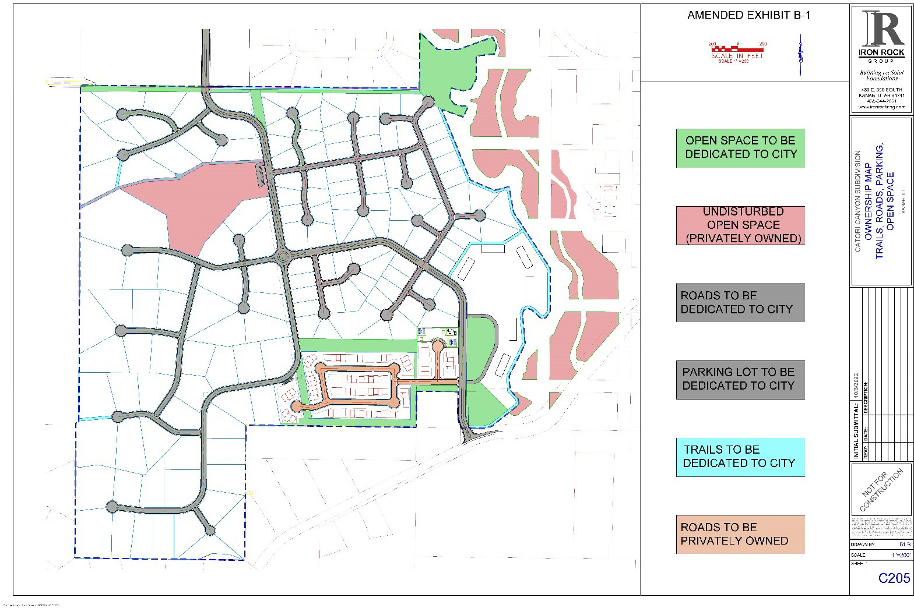

EXHIBIT B-2
Fence, Wall and Trail Improvements
Catori Canyon is a Planned Unit Development intending to enhance the beauty and nature of Southern Utah’s high desert environment on the west side of Kanab, Utah. Anytime you plan to intrude on what is natural and yet provide a safe and comfortable environment for the owners of the development takes much effort to blend nature together with safety and comfort for all owners. To this end, we will detail our desired actions to ensure the safety and comfort of those living at Catori Canyon as well as the public who will use the asphalt trails and parking.
The three areas of concern are:
- The proposed screen wall on the property boundary between Garkane Energy’s distribution yard/electrical substation and the Catori Canyon Kivas.
- Asphalt trails and parking.
- Vinyl-coated steel chain link fence restricting access to potentially unsafe or sensitive areas.
Below as Exhibit B-3 is a diagram showing the location of the screen walls mentioned above as well as the asphalt trails and chain link fencing.
Area 1) Garkane Energy has an existing industrial property for the distribution of propane, storage, and handling of power through an electrical substation. In the fall season, Garkane Energy is quite busy filling propane tanks and handling the power needs of Kanab and surrounding areas. With their needs comes an increase in noise. We want the Kivas to be minimally impacted by this activity. To this end, we propose an 8 ft. high and 10 ft. high wall on the boundary between the Kivas and the Garkane Energy yard. This two- height wall in the locations shown in Exhibit B-3 below is a combined total of 1622 linear ft. long. In the center of the combined 1622 linear ft. wall is the specific 10 ft. high section that is 301 linear ft. long - situated directly in front of Garkane Energy’s electrical substation. Due to sound noise in the 301 linear ft. reaching a higher level, we are proposing this 10 ft. wall here to reduce sound noise reaching the Kivas and the 8 ft. wall on along the rest of Garkane Energy’s property as shown. Exhibit B-3 also shows the location of the 6 ft. high privacy fences for the Kivas. All these walls are of the type shown in Exhibit B-4 marketed as Verti-Crete by Olympus Precast. The 10 ft. walls will have a structural design as shown in Exhibit B-4. The 8 ft. and 6 ft. walls will be a similar structure but with engineering consistent with their lower heights. The reinforced concrete 10 ft. and 8 ft. walls require a building permit. We will submit plans stamped by a third-party structural engineer, as needed. Exhibit B-5 displays an example of a precast reinforced concrete wall type.
Area 2) The asphalt trails will serve many purposes, but generally, they will provide a path for safe exercise and access to the BLM property west of the development. The trails will be ten feet wide and constructed with 3 inches of asphalt, over 6 inches of road base, and over 18 inches of properly prepared subgrade. They will be properly graded to keep water off their surface. These trails will require minimum maintenance for many years. As we expect these trails to be widely used by the public, we have provided three public parking areas. One is located just west of the Kivas, another just east of the privately owned open space near the middle of the project, and the last is at the end of a cul-de-sac at the northeast corner of the project. There is a public open space in the northeast corner. The north drainage channel crosses this asphalt path, and a box culvert is provided to serve as the bridge over the channel for access into the public open space. Shown in Exhibit B-3 are the locations of the two asphalt trails that continue westward and terminate at the BLM boundary where all people may enjoy Bunting Mountain and BLM’s trails.

Area 3) Vinyl-coated steel chain link fencing seen in Exhibit B-6 will be provided in areas where we want to control both public and development property owner's access to sensitive areas. We intend to construct this fence in a manner to minimize its impact on the natural setting of Catori Canyon. We want to control access for animals and persons into Kanab Creek, the north drainage channel, and the privately owned open space in the middle of the development. The black vinyl-coated 4 ft. chain link fence with top rail should be adequate to limit both pets and young children. As shown on Exhibit B-3 in gold color, we will install this fence on the east side of the asphalt trail overlooking Kanab Creek from its south beginning at the sewer lift station until the drainage channel on the north end at the north open space. The fence will continue along both sides of the drainage channel going west until it reaches the BLM property. The asphalt trail on the north will continue until the road exiting Catori Canyon enters the Cedar Heights subdivision. The fence on the very north side of the development will be the existing fence of our neighbors north of Catori Canyon. At the middle parking lot where the privately owned open space is, this same fence will surround the parking area and continue between the open space and the asphalt trail until it reaches the cul-de-sac where the asphalt goes directly to the BLM boundary.

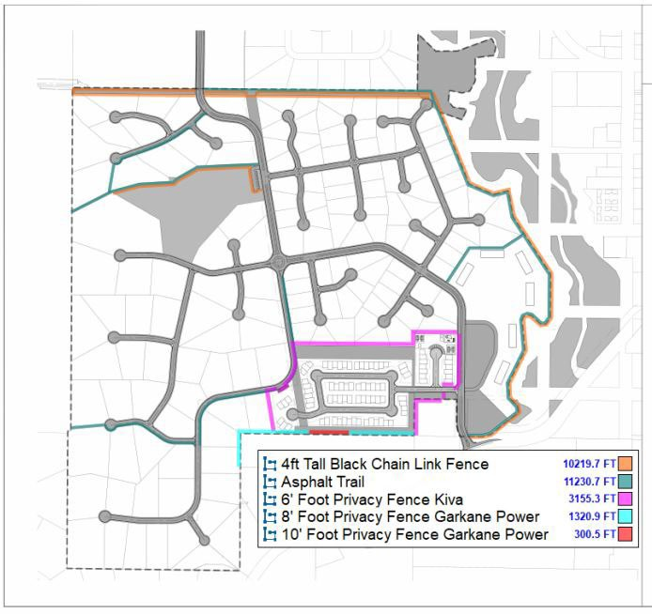

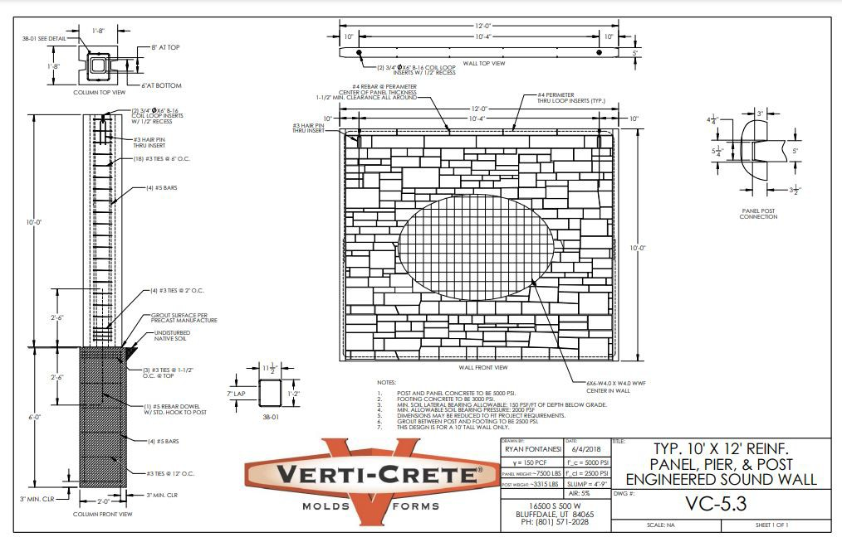

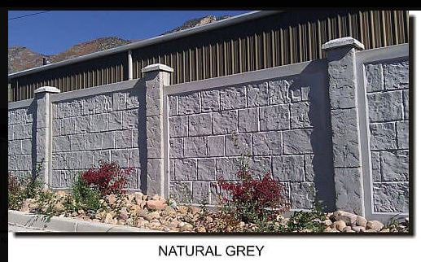

BLACK VINYL-COATED STEEL CHAIN LINK FENCING

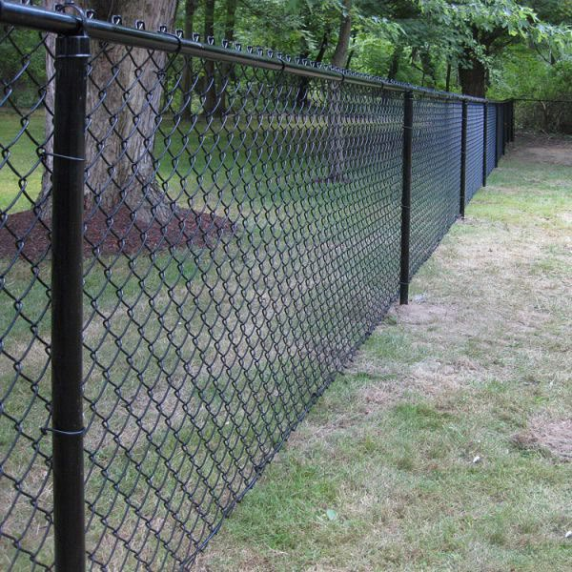

Mayor
Colten Johnson City Council Arlon Chamberlain Scott Colson
Chris Heaton Kerry Glover
J.D. Wright
City Manager Kyler Ludwig City Attorney Kent Burggraaf City Recorder Celeste Cram City Treasurer Danielle Ramsay

DATE: November 14, 2023
TO: Mayor and City Council
SUBJECT: Kanab Spring Project
PREPARED BY: Kyler Ludwig, City Manager

Background:
On March 14, 2023 the City Council passed a resolution supporting the Spring Rehabilitation at Cave Lakes Project for the Community Project Funding.
Congressman Chris Stewart recommended the Kanab spring rehabilitation project for funding within the annual federal appropriation bill.

In anticipation of receiving the funding, the City approved part of a task order with Civil Science to complete the preliminary design of this project in May of 2023.

The City grant is currently awaiting final approval through the Interior and Environmental Budgets. The most recent bill project $1,123,704 in federal funding for this project. The funding if approved will come through the State Drinking Water Revolving Fund. This proposed grant is down from the $1,627,840 that was originally proposed to come from federal funding.

Analysis:
Civil Science has worked with the State of Utah and with our Public Works Department on this project since the springs were taken off the system. They have put together a work task order for the City to approve which would allow for some of the work to begin.

Staff is comfortable moving forward with a final design, which can be acted upon once the funds are approved. In the event funds are not approved it will give the City the ability to work on the project in smaller pieces.

Legal:

Financial:
Funding was budgeted for this projected during the FY2024 Budget Process.

– A Western Classic –
26 North 100 East • Kanab, Utah 84741 • Phone 435-644-2534 • Fax 435-644-2536 • www.kanab.utah.gov

Mayor
Colten Johnson City Council Arlon Chamberlain Scott Colson
Chris Heaton Kerry Glover
J.D. Wright

Recommendations/Actions: It is recommended the City Council approve staff to sign the Springs Project Task Order with Civil Science.

Attachments:
City Manager Kyler Ludwig City Attorney Kent Burggraaf City Recorder Celeste Cram City Treasurer Danielle Ramsay



– A Western Classic –
26 North 100 East • Kanab, Utah 84741 • Phone 435-644-2534 • Fax 435-644-2536 • www.kanab.utah.gov

May 8, 2023

Kanab City
Attn: Kyler Ludwig 26 North 100 East
Kanab, UT 84741

RE: Work Task Order 2023-1
Cave Lakes Spring Redevelopment Dear Mr. Ludwig,
Civil Science (CS) is pleased to submit this Work Task Order No. 2023-1 for professional services for the Cave Lakes Spring Redevelopment (Project). As always, we appreciate the opportunity to work with City of Kanab (City) on this and other projects and we value our affiliation as the City’s Engineer.

PROJECT UNDERSTANDING
The City is looking to diversify its water source by redeveloping springs located in Cave Lakes Canyon north of Kanab – see figure below. These springs were part of the City’s water source until they were taken offline in 2016 due to noncompliance with Department of Drinking Water (DDW) requirements. Kanab was recently awarded a grant which will cover a portion of the project costs associated with redeveloping these springs to conform with State standards. The funds associated with this grant will be available in October of this year. Based on a preliminary engineer’s opinion of cost the total project cost is approximately $2.2M. It is the intent of the City to assemble construction drawings and contract documents in sufficient detail for issuance of a bid package for construction of the Project.
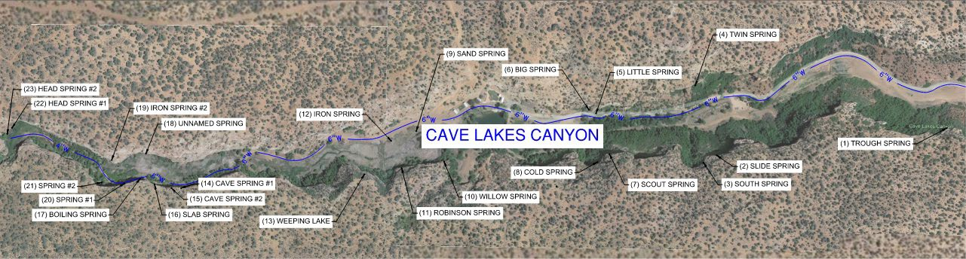
Project Limits Map

SCOPE OF WORK
Based on the Project Understanding outlined above, CS will provide the Basic and Additional Services where tasks will include:

BASIC SERVICES

Topographical Survey and Base Mapping
- Set survey control and establish control points for future use during the construction phase of the project.
- Provide design survey for the Project, perform topographical GPS survey, and provide updated aerials via UAV.

- Review and collect data pertinent to the design, obtain information from utility owners and incorporate it into the base map.
- Locate other utilities by GIS mapping, blue stakes, or as evident in the field.
- Map existing utilities based upon as-builts and apparent points collected in the field with invert elevations with GPS equipment.
- Research property deeds and prepare mapping of property boundaries.
- Provide a legal description or other easement documentation for springs and proposed waterlines within the project.
- Prepare an existing base map to include existing aerials, property, existing utilities and known depths, and existing topography and surface.

Deliverables:
  - Project Base Map, Existing Conditions
  - Easement Legal Description & Sketch

Assumptions
- The City will coordinate the easement acquisition, negotiations and agreements with the property owner.
- Project limits are located within one (1) property owner.

Preliminary Engineering Design (30%)
- Meet with the City as required to review goals, objectives, scope and schedule for the Project.
- Visit the site, or potential Project sites, to review the existing conditions and facilities. The purpose of these visits are to identify locations and flows of the existing spring sites.
- Meet with the existing property owner up to two (2) times to review objectives, construction timelines, and aesthetic considerations.
- Perform 30% preliminary engineering design; evaluate existing spring conditions, preliminary calculations, alignments, profiles, and sizing for the Project based upon the Project Understanding.
- Prepare preliminary evaluations of the project including schedule, construction budget and requirements.
- Prepare a preliminary design criteria document that includes all assumptions, preliminary drawings, design concepts, preliminary calculations, sizing, materials, outline specifications, written descriptions and analyses of the Project.
- Prepare and provide an updated Engineer’s Opinion of Cost.
- Furnish preliminary design documents to the City and DDW for review and concurrence.

Deliverables:
  - Project Design Criteria Document
  - Preliminary Drawings
  - Engineer’s Opinion of Cost

Assumptions
- All as-builts, spring inspection reports, water right information and other documentation concerning the existing springs will be provided to CS.
- The City will meet CS on site during the field investigation phase and provide means to measure existing spring flows. There may be need for pumping and other equipment as necessary.
- One (1) submission to the DDW is assumed during this phase of the project.

Final Engineering Design
- Incorporate comments from preliminary engineering design review, up to one (1) comment response from the City and DDW.
- Perform final engineering design; accomplish detail design; prepare for incorporation into the contract documents, construction drawings, and specifications to show the character and scope of work to be performed by contractors on the Project.
  - Final construction drawings are anticipated to include: cover sheet, general sheets, survey control sheets, demolition plan, site plan of spring locations, spring rehabilitation details, spring box details, waterline plan and profile, and other detail sheets as required.
  - Special provision specifications are anticipated to supplement the APWA standard specifications.
- Prepare and provide a project manual that will include bidding documents, agreement document, bid schedule, quantity takeoffs, etc.
- Prepare and provide an updated Engineer’s Opinion of Cost.
- Prepare and submit final construction documents to the City and DDW for review and approval.
- Assist the City in consultations with DDW, revise final construction documents as necessary to obtain final approval for construction.
- Obtain a Plan Approval certification letter from DDW in behalf of the City.

Deliverables:
  - Construction Drawings
  - Project Manual
    - Bid Documents
    - Agreement Documents
    - Special Provisions Specifications
  - Engineer’s Opinion of Cost
  - DDW Plan Approval

Assumptions
- The project funding is to be dispersed from the State and therefore no federal funding requirements are anticipated for the Project. This excludes environmental review, environmental assessment, AIS requirements, contract document requirements, and other federal funding requirements.

Bid Phase Services
- Assist the City in advertisement for public bid.
- Conduct a pre-bid meeting, answer questions, clarify expectations of the contractor, explain design rationale.
- Answer bid phase questions related to the construction documents.
- Issue addenda to clarify requirements, scope, quality and quantity of the improvements to be completed.
- Conduct bid opening in accordance with the City’s procurement policies.
- Review bids with project requirements, issue bid tabulation and issue Notice of Intent to Award.
- Assist the City in securing agreement, bonds, and insurance from the contractor.

Deliverables:
  - Conduct Pre-Bid Meeting
  - Conduct Bid Opening

  - Addenda (if required)
  - Bid Tabulation
  - Bidder Document Review
  - Engineers Recommendation for Award

Assumptions
- Anticipated effort of 40 man-hours for a single bid period of 30 days.

Construction Phase Services
- Provide general administration of the construction contract which tasks may include:
  - Consult with the City and act as the City’s representative. All of the City’s instructions to Contractor will be issued through CS, which shall have authority to act on behalf of City in dealing with the Contractor.
  - Conduct a pre-construction conference prior to commencement of work at the site. Answer questions relative to expectations of the Contractor, clarify drawings and specifications, etc.
  - Conduct weekly progress meetings with the City and Contractor. Provide meeting minutes documenting discussion items from these meetings.
  - Maintain and safeguard during the Construction Phase at least one original printed record version of the Construction Contract Documents signed and sealed by CS.
  - Receive, review and determine the acceptability of any and all schedules that the Contractor is required to submit to CS, including the progress schedule, schedule of submittals, etc.
  - Ensure the work completed is compatible with the design concept. If CS believes any part of the completed Project is incompatible with the design, then inform the City and provide recommendations for addressing such work.
  - Accept from the Contractor and City a submittal of all matters in question concerning the requirement of the Construction Contract Documents (sometimes referred to as requests for information – RFIs). Render a written clarification, interpretation, or decision of the issue submitted, or initiate an amendment or supplement to the Construction Contract Documents
  - Prepare and issue Field Orders requiring minor changes in the work.
  - Prepare and issue Change Orders and Work Change Directives as required.
  - Respond to any notice from the Contractor of differing site conditions including: conditions relating to utilities, hazardous environmental conditions, etc. Promptly conduct reviews and prepare findings, conclusions, and recommendations for City’s use.
  - Review and take appropriate action with respect to shop drawings, samples, and other required contractor submittals to ensure compliance with Construction Contract Documents and design concept.
  - Evaluate and determine the acceptability of substitute or “or-equal” materials and equipment proposed by the Contractor.
  - Receive from the Contractor, review and transmit to the City maintenance and operating instructions, schedules, guarantees, bonds, certificates or other evidence of insurance required by the Construction Contract Documents.
  - Receive notice from the Contractor that the entire work is ready for use and provide a site visit to review the work and determine the status of completion. Provide a punch list of items to be completed and issue a final certificate of substantial completion.
  - Conduct a final visit to the Project to determine if the work is complete and acceptable so that CS may issue a recommendation for final payment.

  - At the completion of the Project, prepare record drawings (or as-builts) and furnish to the City.
- Provide periodic construction observation at the site during the construction of the Project. Specific tasks may include:
  - Provide the services of a field engineer and to provide more extensive observation of the Contractor’s work.
  - Provide observation during the spring exploration phase of the work. The Contractor shall inform CS of all spring exploration efforts and shall coordinate to have either the field engineer or other CS representative at the site.
  - Receive and review all certificates of inspections, tests and approvals required by the Construction Contract Documents. CS shall review certificates for compliance with the Construction Contract Documents.
  - Provide a daily field observation report each day the field engineer is on site.

Deliverables:
- Conduct Pre-Construction Meeting
- Conduct Weekly Progress Meetings
- Response to RFIs
- Submittal Reviews
- Field Orders
- Issue Substantial Completion
- Conduct Weekly Progress Meetings
- Record Drawings/As-Builts
- Periodic Construction Observation

Assumptions
- The majority of CS’s time for construction observation will be during the spring exploration phase of construction.
- Anticipated effort of 680 man-hours for a construction timeline of eight (8) months.

ADDITIONAL SERVICES

Geotechnical Investigation
- Perform field logging services for several test pits (waterline alignment).
- Transport collected soil and rock samples for further testing and characterization.
- Prepare a Geotechnical Technical Memorandum stamped by a State of Utah Professional Engineer that will provide the following:
  - Site Data
    - Site description and history
    - Site and regional geology
    - Summary of test pit operations and findings
    - Summary of laboratory testing
  - Backfill recommendations
  - Subgrade recommendations
  - Pavement recommendations
- Comments from the review will be addressed, if necessary, and a final stamped copy will be provided.

Deliverables:
  - Soil Sampling, Lab Testing
  - Geotechnical Technical Memorandum

Assumptions
- Operator and machinery for the test pitting will be provided by the City.
- Test pits can be performed in a single day.
- CS will utilize a subconsultant to complete this Scope of Work.

Source Protection Plan
- Provide a Drinking Water Source Protection Plan in accordance with DDW requirements and standards which may include:
  - Delineation report
  - Inventory of potential contamination sources
  - Identification and assessment of current controls
  - Management program for existing and future potential contamination sources
  - Implementation schedule
  - Resource evaluation and recordkeeping
  - Contingency plan and public notifications

Construction Staking
- Verify survey control, reset control/benchmarks for the Contractor
- Provide utility stakes for waterline alignment as necessary.
- Provide easement and/or property boundary stakes as necessary.
- Provide rough grade stakes for spring site collection boxes and other improvements.
- Provide final grade and finish surface stakes for spring site collection boxes, limits, fencing and other improvements as necessary.
- Provide other construction surveying services including survey verification as needed.

Assumptions
  - CS has assumed four (4) trips to the site to stake the improvements.

Miscellaneous Services
The City may authorize CS to furnish or obtain from others miscellaneous services of the types listed below. We will not know the extent of these services until further design has been completed and funding requirements are known.
- Provide funding administration for the project. Specific tasks may include:
  - Meet with the applicable funding agency as required to review goals, objectives, scope and schedule for the Project.
  - Follow project reporting and documentation requirements as required by the funding agency.
  - Prepare monthly pay requests during the design and construction phases of the project.
  - Manage funding sources and all contracts throughout the duration of the project.
  - Attend funding meetings, conferences, etc. as required.
- Provide the services of an independent testing agency for material sampling and testing. Specific tasks may include:
  - Providing materials sampling and testing in accordance with the Project specifications, City standards, and State requirements for a public drinking water system.

  - Provide and complete any special inspections as part of the Project.
  - Provide testing results and reports to verify compliance with the Project requirements.
- Design of Supervisory Control and Data Acquisition (SCADA) and integration into the spring collection system.
- Preparation or review of environmental assessments and impact statements; review and evaluation of the effects on the design requirements for the project of any such statements and documents prepared by others; and assistance in obtaining approvals of authorities having jurisdiction over the anticipated environmental impact of the project (which are not part of Scope of Work).
- Services attributable to more than one prime construction contract unless provided for otherwise in the Scope of Work.
- Preparing for, coordinating with, participating in and responding to structured independent review processes, including, but not limited to, construction management, cost estimating, project peer review, value engineering, and constructability review requested by Owner; and performing or furnishing services required to revise studies, reports, drawings, specifications, or other bidding documents as a result of such review processes.
- Preparing additional bidding documents or contract documents for alternate bids or prices requested by Owner for the work or a portion thereof.
- Assistance in connection with bid protests, rebidding, or renegotiating contracts for construction, materials, equipment, or services, except when such assistance is required by the Scope of Work.
- Providing construction phase services beyond the contract times established in the Scope of Work.
- Providing assistance in responding to the presence of any constituent of concern at the site, in compliance with current laws and regulations.
- Preparation of operation and maintenance manuals.
- Preparing to serve or serving as a consultant or witness for Owner in any litigation, arbitration, or other dispute resolution process related to the project.
- Additional or extended services during construction made necessary by (1) emergencies or acts of God endangering the work, (2) the presence at the site of any constituent of concern, (3) work damaged by fire or other cause during construction, (4) a significant amount of defective, neglected, or delayed work by the contractor, (5) acceleration of the progress schedule involving services beyond normal working hours, or (6) default by the contractor.
- Evaluating an unreasonable claim or an excessive number of claims submitted by the contractor or others in connection with the work.
- Laboratory tests, well tests, borings, hydraulic investigations, soils investigations, water quality studies, or other studies or tests recommended by CS and completed by CS, CS’s consultants, or specialists in the discipline, subject to the provisions outlined in this agreement, regardless of which phase of the project the studies or tests are requested or occur in.
- Searching out property owners and negotiating for easements, land, or rights-of-way, etc. (which are not part of the Scope of Work).
- Completing property surveys, property plats, property descriptions, and abstracting (which are not part of the Scope of Work).
- Researching water rights, preparing change applications, involvement with water rights adjudications or litigation, and other miscellaneous tasks associated with water rights and not otherwise provided for in this agreement.

FEE PROPOSAL
CS proposes to complete the Scope of Work outlined above as follows:

Additional Services Basic Services | Task Description | Total Fee | Fee Type | Comments
Additional Services Basic Services | Topographical Survey and Base Mapping | $20,500 | Lump Sum | Includes One (1) Easement Legal Description Preparation
Additional Services Basic Services | Preliminary Engineering Design | $57,900 | Lump Sum
Additional Services Basic Services | Final Engineering Design | $51,100 | Lump Sum
Additional Services Basic Services | Bid Phase Services | $6,300* | Hourly | Fee given as budgetary amount based on anticipated level of effort
Additional Services Basic Services | Construction Phase Services | $96,700* | Hourly | Fee given as budgetary amount based on anticipated level of effort
Additional Services Basic Services | Basic Services Subtotal | $232,500*
Additional Services Basic Services | Geotechnical Investigation | $5,000 | Lump Sum | CS will use a subconsultant for this Scope of Work
Additional Services Basic Services | Source Protection Plan | $11,500 | Lump Sum
Additional Services Basic Services | Construction Staking | $6,200* | Hourly | Fee given as budgetary amount based on anticipated level of effort
Additional Services Basic Services | Miscellaneous Services | - | Hourly | Project may require these services once funding source is established
Additional Services Basic Services | Additional Services Subtotal | $22,700*
Additional Services Basic Services | Task Order Total | $255,200* | *CS may alter the distribution of the compensation between individual tasks of the Scope of Work to be consistent with services rendered but shall not exceed the total hourly compensation amount.

Professional fees shown are not to exceed unless upon written authorization from the Client. Professional services rendered for the Hourly Fee Type will be completed by CS at the rates and fees given in the attached Exhibit A.

We appreciate the opportunity to work with the City on this and other projects. If the City wishes to move forward with this project, we recommend execution of this Task Order in accordance with the Agreement between the two parties. Please contact me at (435) 231-9599 (tgardner@civilscience.com) or (435) 773- 3120 (chowick@civilscience.com) with any questions or concerns.

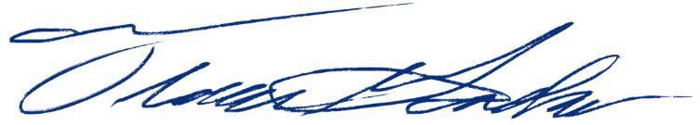
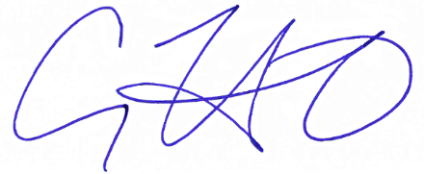
Respectfully,
Trevor G. Gardner, P.E. Cody C. Howick, P.E.
Project Manager St. George Office Manager

Acknowledgement of Task Order by

City: Date:


CIVIL SCIENCE INFRASTRUCTURE, INC.
Short Form Consulting Services Contract
Client/Engineer Form
Exhibit A – CS Standard Hourly Rates and Fee Schedule (UT01/2023)

LABOR RATES – Services provided by CS personnel will be invoiced at the hourly rates identified below:

Labor Category | Hourly Labor Rate1 |  | Labor Category | Hourly Labor Rate1
Technician I | $85.00 |  | Survey I | $84.00
Technician II | $95.00 |  | Survey II | $99.00
Technician III | $109.00 |  | Survey III | $115.00
Technician IV | $123.00 |  | Survey IV | $137.00
Technician V | $136.00 |  | Survey V | $159.00
Technician VI | $171.00 |  | Survey VI | $169.00
Engineer I | $109.00 |  | Sr. Survey | $215.00
Engineer II | $129.00 |  | Survey Crew – 1-Man | $134.00
Engineer III | $146.00 |  | Survey Crew – 2-Man | $204.00
Engineer IV | $160.00 |  | Landscape Architect I | $89.00
Engineer V | $171.00 |  | Landscape Architect II | $107.00
Engineer VI | $192.00 |  | Landscape Architect III | $124.00
Sr. Engineer | $229.00 |  | Landscape Architect IV | $141.00
Admin I | $70.00 |  | Sr. Landscape Architect | $159.00
Admin II | $87.00 |  | Visual Designer | $136.00
Admin III | $106.00 |  | Project Manager I | $141.00
Admin IV | $134.00 |  | Project Manager II | $159.00
Admin V | $156.00 |  | Project Manager III | $178.00
Admin VI | $219.00

DIRECT REIMBURSABLE RATES:

Mileage | $ 0.655 /mile (IRS std.)
Full Day Per-Diem (as necessary and agreed upon) | $ 59 /person/day (IRS std.)
Partial Day Per-Diem (as necessary and agreed upon) | $ 44.25 /person/day (IRS std.)
Lodging (as necessary and agreed upon) | $ Cost/Night + 15% Mark Up
Outside Consultants / Subconsultants | $ Cost + 15% Mark Up
Other Expenses or Direct Costs Occurred | $ Cost + 15% Mark Up

TIME CHARGES: Time reporting for all office personnel is based upon actual time in office. Time reporting for all field work is based upon actual field work plus travel time to and from assigned office location. Time billed in 15 minutes increments.
AUDIT PRIVILEGES: All job audit privileges of CLIENT will extend only to review, and approval of monthly invoices submitted by CS to CLIENT. Invoices prepared and submitted by CS will include copies of source documents of all expenditures including: time, travel, subcontracts, supplies, equipment, materials, or premiums. The CLIENT may review, debate, or qualify items for payment at the time of invoice review and approval and payment of invoice. CLIENT waves post job audit privileges beyond invoice approval. CS will not retain job related support documents or any other billing documents beyond the periodic period, review period, and collection by CS of invoices submitted.
ESTIMATES: Estimates are provided to the CLIENT for budgeting purposes only and are not an agreement by CS to perform the services for a lump- sum, fixed fee, or not to exceed price unless otherwise provided for in the contract. CS reserves the right to change rates used on rate-based reimbursable contracts.
¹ Rates change annually at beginning of year and may change on other occasions

Mayor
Colten Johnson City Council Arlon Chamberlain Scott Colson
Chris Heaton Kerry Glover
J.D. Wright
City Manager Kyler Ludwig City Attorney Kent Burggraaf City Recorder Celeste Cram City Treasurer Danielle Ramsay

DATE: November 14, 2023
TO: Mayor and City Council
SUBJECT: Irrigation Plan
PREPARED BY: Kyler Ludwig, City Manager

Background:
The City has worked with Civil Science on a preliminary design of both the Ranchos Park, and the Kanab Cemetery. City Council has discussed and determined both of these projects to be high priority.

Analysis:
The landscape and irrigation plans are estimated to cost $8,800 with the bid and construction management costing $10,000.

The City anticipates working to complete these projects at the same time in an effort to attract more bids and reduce costs.

Legal:

Financial:
Funding for the cemetery irrigation was budgeted for during the FY2024 Budget Process. The Ranchos Park project will be paid for through impact fees.

Recommendations/Actions: It is recommended the City Council authorize staff to sign the Ranchos Park Irrigation Plan and Cemetery Expansion Task Order with Civil Science.

Attachments:

– A Western Classic –
26 North 100 East • Kanab, Utah 84741 • Phone 435-644-2534 • Fax 435-644-2536 • www.kanab.utah.gov

October 25, 2023

Kanab City
Attn: Kyler Ludwig 26 North 100 East
Kanab, UT 84741

RE: Work Task Order 2023-3
Ranchos Park Irrigation Plan & Cemetery Expansion Dear Mr. Ludwig,
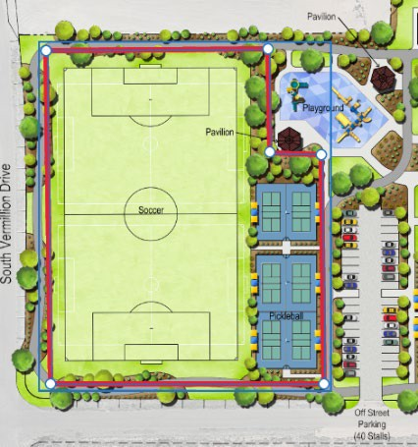
Civil Science (CS) is pleased to submit this Work Task Order No. 2023-3 for professional services for the Kanab Impact Fee Facilities Plans & Analyses (Project). As always, we
appreciate the opportunity to work with City of Kanab (City) on this and other projects and we value our affiliation as the City’s Engineer.

PROJECT UNDERSTANDING
The City is looking to increase the use of the Ranchos Park by adding another multi-use field. The City has requested CS to provide basic landscape and irrigation plans for the area outlined in red. Once the design is complete the City intends to publicly bid the irrigation system for the park as well as the irrigation system for the cemetery expansion as one project.

SCOPE OF WORK
Based on the Project Understanding outlined above, CS will provide the following services where tasks will include:

Landscape & Irrigation Plans – Ranchos Park West Field
- Meet with the City as required to review goals, objectives, scope, and schedule for the Project.
- Collect and review data pertinent to the design and coordinate for irrigation connection.
- Provide Landscape Drawings to show areas and quantities to be grassed, landscape curb, tree plantings mulch and associated detail and schedules.
- Provide Irrigation Drawings to show system connection points, valves, sprinklers, spacing, line sizes, zones, flow charts, and associated details and schedules.
- Prepare any technical specifications as required to supplement APWA standards.
- Prepare schedules including item descriptions and quantities and other information to inform Bidders.

Deliverables:
  - Landscape & Irrigation Plans

Bid & Construction Phase Services – Ranchos Park West Field & Cemetery Expansion
- Prepare a bid package including landscape and irrigation plans from the Ranchos Park and Cemetery Expansion as well as contract documents, specifications, agreement documents, etc. for public bidding.

- Provide bid and construction phase services requested by the City and as allowed by available budget (approx. 30 man-hours). Services may include:
  - Advertise the Project for public bid, and general administration of the contract.
  - Conduct a pre-bid meeting, answer questions, clarify expectations of the contractor, explain design rationale, etc.
  - Answer bid phase questions related to the construction documents.
  - Issue addenda to clarify requirements, scope, quality and quantity of the improvements to be completed.
  - Review bids with project requirements, issue bid tabulation and issue Notice of Intent to Award.
  - Assist the City in securing agreement, bonds, and insurance from the contractor.
  - Conduct a pre-construction meeting, answer questions relative to expectations of the contractor, clarify drawings and specifications, etc.
  - Issue Notice to Proceed to the contractor.
  - Provide general administration of construction contract: Consult with the City and act as City’s representative as provided in the Construction Contract.
  - Receive, review and determine acceptability of any and all schedules that the Contractor is required to submit.
  - Provide observation as an experienced and qualified design professional the progress of Contractor’s executed work and determine in general if the Work is proceeding in accordance with the Construction Contract Documents.
  - Provide clarifications and/or interpretations to the Contract Documents, Drawings, and Specifications and answer questions related to the work.
  - Issue and prepare Field Orders requiring minor changes in the work.
  - Recommend and prepare Change Orders, as appropriate.
  - Review and approve or take other appropriate action with respect to shop drawings, samples, submittals and other required shop drawings, samples, and other required Contractor submittals.
  - Review Contractor’s application for payments and accompanying supporting documentation.
  - Prepare and issue Notice of Substantial Completion.
  - Issue punch lists and notices of defective work as required.
  - Prepare and issue Notice of Final Acceptance and recommend final payment to the Contractor.
  - Provide electronic copies of construction phase documents to the City at the conclusion of the Project in electronic format.

Deliverables:
- Public Bid Package

Assumptions
  - It is assumed the City will take a lead role during the bid and construction phase services and CS will assist in an as-needed role within the allowed budget.
  - All meetings will be held via zoom during the design phase.
  - Three meetings are planned during the bid & construction phase services which include the pre-bid, pre-construction and substantial completion meetings.
  - Layout of irrigation will be based on latest concept plan for Ranchos Park.

Exclusions
  - Site plan, design survey, property and/or boundary survey.
  - Utility plans including but not limited to water, sewer, storm drain, power, etc.

  - Grading and drainage plans (improvements will be built based upon grading done by the City)
  - Geotechnical report or evaluation
  - Hardscape plans for curbs, gutter, pavement, etc.

FEE PROPOSAL
CS proposes to complete the Scope of Work outlined above as follows:

Task Description | Total Fee | Fee Type | Comment
Landscape & Irrigation Plans | $8,800 | Lump Sum
Bid & Construction Phase Services | $10,000 | Hourly | Includes preparation of bid package for both projects
Task Order Total | $18,800

Professional fees shown are not to exceed unless upon written authorization from the Client. Professional services rendered for the Hourly Fee Type will be completed by CS at the rates and fees given in the attached Exhibit A.

We appreciate the opportunity to work with the City on this and other projects. If the City wishes to move forward with this project, we recommend execution of this Task Order in accordance with the Agreement between the two parties. Please contact either of us with any questions or concerns.

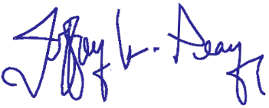
Respectfully,
Jeff Peay, PLA. Cody C. Howick, P.E.
Landscape Architect St. George Office Manager

Acknowledgement of Task Order by

City: Date:

CIVIL SCIENCE INFRASTRUCTURE, INC.
Short Form Consulting Services Contract
Client/Engineer Form
Exhibit A – CS Standard Hourly Rates and Fee Schedule (UT01/2023)

LABOR RATES – Services provided by CS personnel will be invoiced at the hourly rates identified below:

Labor Category | Hourly Labor Rate1 |  | Labor Category | Hourly Labor Rate1
Technician I | $85.00 |  | Survey I | $84.00
Technician II | $95.00 |  | Survey II | $99.00
Technician III | $109.00 |  | Survey III | $115.00
Technician IV | $123.00 |  | Survey IV | $137.00
Technician V | $136.00 |  | Survey V | $159.00
Technician VI | $171.00 |  | Survey VI | $169.00
Engineer I | $109.00 |  | Sr. Survey | $215.00
Engineer II | $129.00 |  | Survey Crew – 1-Man | $134.00
Engineer III | $146.00 |  | Survey Crew – 2-Man | $204.00
Engineer IV | $160.00 |  | Landscape Architect I | $89.00
Engineer V | $171.00 |  | Landscape Architect II | $107.00
Engineer VI | $192.00 |  | Landscape Architect III | $124.00
Sr. Engineer | $229.00 |  | Landscape Architect IV | $141.00
Admin I | $70.00 |  | Sr. Landscape Architect | $159.00
Admin II | $87.00 |  | Visual Designer | $136.00
Admin III | $106.00 |  | Project Manager I | $141.00
Admin IV | $134.00 |  | Project Manager II | $159.00
Admin V | $156.00 |  | Project Manager III | $178.00
Admin VI | $219.00

DIRECT REIMBURSABLE RATES:

Mileage | $ 0.655 /mile (IRS std.)
Full Day Per-Diem (as necessary and agreed upon) | $ 59 /person/day (IRS std.)
Partial Day Per-Diem (as necessary and agreed upon) | $ 44.25 /person/day (IRS std.)
Lodging (as necessary and agreed upon) | $ Cost/Night + 15% Mark Up
Outside Consultants / Subconsultants | $ Cost + 15% Mark Up
Other Expenses or Direct Costs Occurred | $ Cost + 15% Mark Up

TIME CHARGES: Time reporting for all office personnel is based upon actual time in office. Time reporting for all field work is based upon actual field work plus travel time to and from assigned office location. Time billed in 15 minutes increments.
AUDIT PRIVILEGES: All job audit privileges of CLIENT will extend only to review, and approval of monthly invoices submitted by CS to CLIENT. Invoices prepared and submitted by CS will include copies of source documents of all expenditures including: time, travel, subcontracts, supplies, equipment, materials, or premiums. The CLIENT may review, debate, or qualify items for payment at the time of invoice review and approval and payment of invoice. CLIENT waves post job audit privileges beyond invoice approval. CS will not retain job related support documents or any other billing documents beyond the periodic period, review period, and collection by CS of invoices submitted.
ESTIMATES: Estimates are provided to the CLIENT for budgeting purposes only and are not an agreement by CS to perform the services for a lump- sum, fixed fee, or not to exceed price unless otherwise provided for in the contract. CS reserves the right to change rates used on rate-based reimbursable contracts.
¹ Rates change annually at beginning of year and may change on other occasions

Mayor
Colten Johnson City Council Arlon Chamberlain Scott Colson
Chris Heaton Kerry Glover
J.D. Wright
City Manager Kyler Ludwig City Attorney Kent Burggraaf City Recorder Celeste Cram City Treasurer Danielle Ramsay

DATE: November 14, 2023
TO: Mayor and City Council
SUBJECT: 40 Year Water Usage Plan
PREPARED BY: Kyler Ludwig, City Manager

Background:
The City of Kanab currently services approximately 2,600 culinary water connections. Population Projections estimate that to be 6,300 by the year 2062. Utah State Law requires a 40 year plan to show if existing water rights meet the future system needs.

Analysis:
Kanab City can deliver a peak day demand of 6,107 gpm with all water rights being used. If the City meets their goals, they would only be using 63.2% of the city’s existing water rights. Even if the goals are not met only 75.4% of peak day demand will be used.

At the build-out population of 49,538 Kanab City will no longer meet the required peak day demand for the population, falling short by 697 gpm and 1,125 ac-ft. Kanab City will need to continue to actively acquire water rights to serve the future needs of its citizens. This includes both surface and subsurface rights.

Legal:

Financial:

Recommendations/Actions: It is recommended the City Council approve the 40 Year Water Use Report.

Attachments:

– A Western Classic –
26 North 100 East • Kanab, Utah 84741 • Phone 435-644-2534 • Fax 435-644-2536 • www.kanab.utah.gov


KANAB 40 YEAR
WATER USE

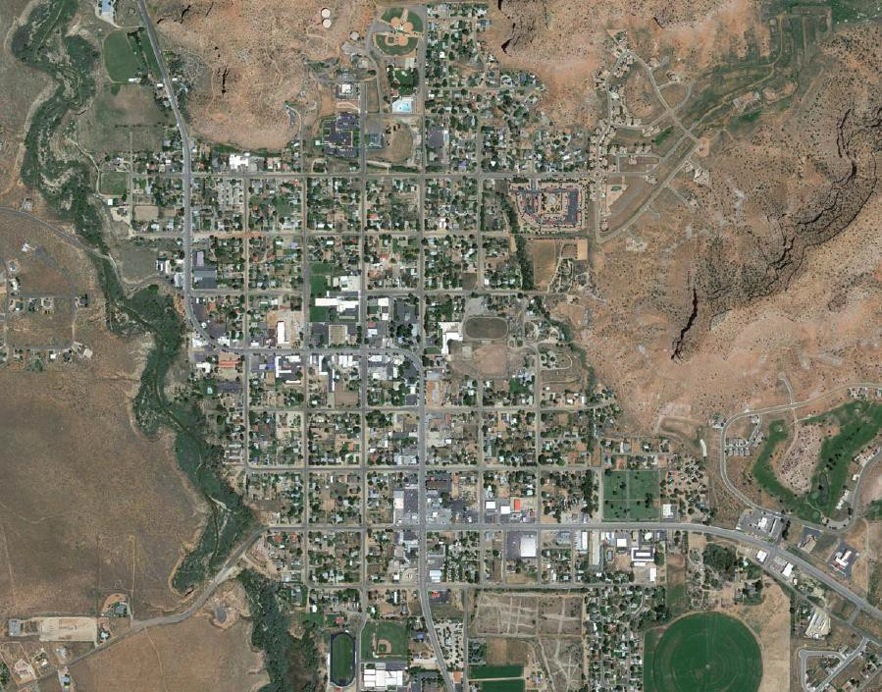

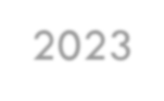

2023
40 Year Water Projected Usage Report



40 Year Water Projected Usage Report
September 21, 2023

MAYOR
Colten Johnson

CITY COUNCIL
JD Wright Scott Colson
Arlon Chamberlain Kerry Glover
Chris Heaton

CITY MANAGER
Kyler Ludwig

PUBLIC WORKS DIRECTOR
Jake Dutton

TREASURER
Danielle Ramsay

Prepared by:





1453 S. Dixie Drive, Suite 150 St. George, UT 84770

9/21/2023
Office: (435) 986-0100
Fax: (435) 986-4046

TABLE OF CONTENTS
- INTRODUCTION 1
- EXISTING WATER USAGE 1
- PROJECTED POPULATION 1
- EXISTING WATER RIGHTS 3
- CONCLUSION 3
Table 1: Kanab City ERC's 1
Table 2: Population and Water Use Projections 2
Table 3: Build-out Projections 2
Table 4: Kanab City Water Rights 3

INTRODUCTION
The City of Kanab currently services approximately 2,600 culinary water connections in 2022. By population projections that number is expected to grow to approximately 6,300 in the year 2062. Utah state law requires that a 40 year plan must be prepared to show that the existing water rights currently held by the City will meet the requirements for future water use based on the growth. The existing culinary water system is being fed by 14 wells, with a spring system currently the design phases of development.

EXISTING WATER USAGE
Culinary water connections are broken down into two main categories, residential and non-residential. Non- residential connections consist of commercial, industrial, and institutional. These use far more water on an average day than a residential connection. For that reason, Equivalent Residential Units (ERU’s) are used to factor in this difference. While Kanab only services 2,575 total connections, when factored these are equal to 3,599 ERU’s.
TABLE 1: KANAB CITY ERC'S

Connection Type Usage (1000 Gal) Connections Daily Use/connection Factor ERC's
Residential | 267,051.00 | 2,304 | 317.55 | 1 | 2304
Non-Residential | 150,115.00 | 271 | 1,517.62 | 4.78 | 1295
 |  |  |  | Total | 3599

Based on the total flow for the year 2022, the average daily demand per ERU was 317.55 gallons. The peak day demand for that same year was 556.69 gallons. This was found using monthly flow rates. July had the highest flow rate of any month for Kanab City at 175% of the average. By multiplying the average flow rate of 317.55 gallons by July’s 175% of the average, we arrive at our 556.69 gallons per peak day.
The daily demands for Kanab City are summarized below:
  - Average Day Demand: 317.55 gal/ERU
  - Peak Day Demand: 556.69 gal/ERU
  - Total Day Demand: 1,142,920 gal
  - Total Annual Demand: 417,166,000 Gal (1,280 acft)

PROJECTED POPULATION
The growth rate for the population of Kanab City has varied greatly over the last 40 years, but the average growth rate over this time period has been 3%. It was lower than this in the 2010’s but has been picking up significantly since then. For this reason, the projected growth rate used for this report is 3% for the next 40 years. This projection rate results in the projected populations given in Table 2.

TABLE 2: POPULATION AND WATER USE PROJECTIONS

Year | Population | ERU's | Annual (Acft) |  | Peak Day (gpm)
Year | Population | ERU's | Current | Goal | Current | Goal
2022 | 5131 | 3,599.00 | 1,280.19 | 1,280.19 | 1,391.34 | 1,391.34
2032 | 6896 | 4,907.78 | 1,745.73 | 1,573.29 | 1,897.30 | 1,709.88
2042 | 9267 | 6,595.65 | 2,346.12 | 2,046.15 | 2,549.81 | 2,223.80
2052 | 12454 | 8,864.00 | 3,152.99 | 2,658.19 | 3,426.73 | 2,888.97
2062 | 17240 | 11,912.47 | 4,237.35 | 3,449.17 | 4,605.24 | 3,861.09

Based on these numbers, the ERU’s for the City are expected to grow to approximately 11,900. The yearly usage based on that goal can be seen in the Table. These numbers can be contrasted with the City’s water rights to project future needs.
An estimate of the Kanab City population at build-out (when all vacant land within the city limits has been developed) has also been prepared. The calculations along with the estimated build-out population for Kanab City are summarized in Table 3 taken from the Capital Facilities Plan. This would result in a 4.36% growth rate over the next 40 years.
TABLE 3: BUILD-OUT PROJECTIONS

Type of Use¹ Acres Units/Acre Units at Build-out
Build-out Population³
West of Kanab Creek
Very Low Density² | 535 | 0.4 | 214 | 505
Very Low Density | 1209 | 1 | 1209 | 2853
Low Density² | 124 | 2 | 248 | 585
Low Density | 384 | 3.5 | 1344 | 3172
Medium Density² | 557 | 1.5 | 836 | 1972
Total | 2809 |  | 3851 | 9087
East of Kanab Creek
Very Low Density | 2242 | 1 | 2242 | 5291
Low Density² | 514 | 2 | 1028 | 2426
Low Density² | 130 | 2.64 | 343.2 | 810
Low Density | 1771 | 3.5 | 6198.5 | 14628
Medium Density | 45 | 1.5 | 67.5 | 159
Medium Density | 133 | 7 | 931 | 2197
Planned Unit  Development | 422 | 15 | 6330 | 14939
Total | 5257 |  | 17140 | 40451
Combined Total | 8066 |  | 20991 | 49538

- Table includes only zones where dwellings are allowed.
- Modified to show actual densities where development has occurred.
- Persons per household assumed to be 2.36 based on culinary water account data supplied by the city of Kanab.

Based on 2.36 persons per household the buildout ERU’s would be approximately 20,990. The water rights required to provide for this population would be a peak flow of 6,804 gpm and a total diversion of 10,975 ac-ft, based on the assumption that Kanab City meets their goals for water conservation. If they were to continue at today’s usage rates, Peak usage would be 8,114 gpm with a total diversion of 13,088 ac-ft.

EXISTING WATER RIGHTS
The following table is a summary of existing water rights owned by Kanab City with their status.
TABLE 4: KANAB CITY WATER RIGHTS

CONCLUSION
With their current water rights, Kanab City can deliver a peak day demand of 6,107 gpm with all of their rights being used. If the City meets their goals, they would only be using 63.2% of the city’s existing water rights. Even if the goals are not met only 75.4% of peak day demand will be used. However, if we assume the build-out population of 49,538 within 40 years, Kanab City will no longer meet the required peak day demand for the population, falling short by 697 gpm and 1,125 ac-ft. For this reason, Kanab City will need to continue to actively acquire water rights to serve the future needs of its citizens. This includes both surface and subsurface rights.


Wheeler Machinery Co.,
348 S 5300 WHEELER WAY
HURRICANE, UT 84737
Tel: 435-634-9904

KANAB CITY CORP
Estimate No: 84215 - 1

CUSTOMER NO. | CONTACT PHONE NO. |  | Email/Fax
049155
ESTIMATE NO. | P.O.NO. | DATE | WORK ORDER NO.
84215 |  | 11/8/2023 12:00:00 AM
MAKE | MODEL | SERIAL NO. | UNIT NO. | hours
AA | D5N LGP | 0AKD02135 |  | 2446
NOTES

SEGMENT: 01
REMOVE& INSTALL ENGINE (010 1000) NOTES:
CLEANING ALL EXPOSED PARTS AND THE INSTALLING THE NEW ENGINE. PLUMBING THE ENGINE AND STARTING THE ENGINE IN THE MACHINE. REPLACING ALL PANELS AND COVERS

Parts
Part Number

Description

Qty Unit Price

Discount%

Ext Price

Total Parts: 8,546.00

Labor
Item Number
FSL-1*-**-FS

Description
FIELD LABOR

Qty
55

Unit Price
203.25

Discount%
0
Total Labor:

Ext Price
11,178.75
11,178.75

SEGMENT: 98

TRAVEL TO/FROM MACHINE (056 7000) NOTES:
Segment 01 Total:
19,724.75

Labor
Item Number
FSL-1*-**-FS

Description
FIELD LABOR

Qty
12

Unit Price
203.25

Discount%
0
Total Labor:

Ext Price
2,439.00
2,439.00

 | Segment 98 Total: | 2,439.00
 | Total Segments Parts: | 8,546.00
 | Total Segments: | 22,163.75
SUB TOTAL (BEFORE TAXES) |  | 22,163.75

This estimate will expire 30 days from the estimate date.
Price excludes Freight Charges, Operating Supplies/EPA Fees and Overtime. Terms: Net 30.
Sales Taxes where applicable are not included with the above prices.

This is an estimate of work to be performed and it should be noted that upon disassembly and inspection the customer will be advised of any additional repairs or cost.

Issued PO# , Date
_:/
_:/ _

Authorized Name (Print)

Authorized Signature
"The Signature is an authorization to proceed with the required repair work as described within the estimate".

Any Question? Please Call Kirby Sorensen at 1-435-201-7798.

Kanab City Council Staff Report File Number 20231101

Date: | November 9, 2023
Meeting Date: | November 14, 2023
Agenda Item: | Public Hearing discuss and recommend to City Council a  text amendment on Chapter 22 Outdoor Lighting

Attachments:

- Exhibit A: Proposed Amendment
- Exhibit B: Alternative Amendment

Summary:
Mayor Johnson and City Council requested that Planning Commission review Chapter 22 Outdoor Lighting. The reason for the review is to amend the ordinance to make it clearer and more understood by the public.

Public Comment:
Deborah Unck spoke in favor of keeping the outdoor lighting ordinance and discussed a duplex and another home near her home that had bright lights that she didn’t like. She mentioned the duplex did have down lit lights but when the light was on it still “trespassed” on her property.

Planning Commission
The planning commission discussed this in length, the consensus was to move forward with the alternate draft (exhibit b). During the public hearing period and the speakers comments there was suggestions from one of the planning commission members that he would like to see a limit on the kelvins to help with the glare that neighbors if they must install a lower kelvin light bulb. Motion was made for a positive recommendation for exhibit B, without any amendments.

Recommended Motion:
I move to approve the amendments to City Code identified in exhibit B of the staff report for 20231101 and adopt Ordinance 11-x-23 O.

I move to approve the amendments to City Code identified in exhibit B of the staff report for 20231101 and adopt Ordinance 11-x-23 O, with the following amendments:

.

– A Western Classic –
26 North 100 East • Kanab, Utah 84741 • Phone 435-644-2534 • Fax 435-644-2536 • www.kanab.utah.gov

Exhibit A: Proposed Amendment

Section 22-1 Purpose and Intent
Style Definition: TOC 1: Tab stops: 7.49", Right,Leader: …
Section 22-2 Definition Section 22-3. Lighting Zones
Section 22-4. General Requirements
Section 22-5 Commercial and Multi-Residential Lighting Section 22-6 Residential Lighting (new construction) Section 22-7 Existing Lighting (Commercial and Residential) Section 22-8 Special Standards (Commercial property only) Section 22-9 Lighting by Special Permit Only
Section 22-10. Enforcement and Penalties Section 22-11. Tables & Illustrations
Table B. Allowed lumens per square foot for specified commercial applications. Table C. Residential lighting limits

Section 22-1 Purpose and Intent
To limit glare, light trespass and conserve energy while enhancing night sky visibility, and ensuring a starry night sky.

Section 22-2 Definition
Authority: The adopting municipality, agency or other governing body. Commercial: Any property zoned commercial or manufacture.
Emergency conditions: Generally, lighting that is only energized during an emergency; lighting fed from a backup power source; or lighting for illuminating the path of egress solely during a fire or other emergency situation; or, lighting for security purposes used solely during an alarm.
Fully Shielded Luminaire: A luminaire constructed and installed in such a manner that all light emitted by the luminaire, either directly from the lamp or a diffusing element, or indirectly by reflection or refraction from any part of the luminaire, is projected below the horizontal plane through the luminaire's lowest light-emitting part.
Glare: Lighting entering the eye directly from luminaires or indirectly from reflective surfaces that causes visual discomfort or reduced visibility.
Hardscape: Permanent hardscape improvements to the site including parking lots, drives,

entrances, curbs, ramps, stairs, steps, medians, walkways and non-vegetated landscaping that is 10 feet or less in width. Materials may include concrete, asphalt, stone, gravel, etc.
Hardscape Area: The area measured in square feet of all hardscape. It is used to calculate the Total Site Lumen Limit. Refer to Hardscape definition.
Hardscape Perimeter: The perimeter measured in linear feet is used to calculate the Total Site Lumen Limit. Refer to Hardscape definition.
Initial Lumens: The initial intensity/output of a brand-new bulb. Over time bulbs will lose their intensity.
Lamp: A generic term for a source of optical radiation (i.e. “light”), often called a “bulb” or “tube.” Examples include incandescent, fluorescent, high- intensity discharge (HID) lamps, and low-pressure sodium (LPS) lamps, as well as light-emitting diode (LED) modules and arrays.
Landscape Lighting: Lighting of trees, shrubs, or other plant material as well as ponds and other landscape features.
LED: Light-Emitting Diode.
Light Pollution: Any adverse effect of artificial light including, but not limited to, glare, light trespass, sky glow, energy waste, compromised safety and security, and impacts on the nocturnal environment.
Light Trespass: Light that falls beyond the property it is intended to illuminate Lighting: “Electric” or “man-made” or “artificial” lighting. See “lighting equipment.”
Lighting Zone: An overlay zoning system establishing legal limits for lighting for particular parcels, areas, or districts in a community.
Lumen: The unit of measure used to quantify the amount of light produced by a lamp (bulb) or emitted from a luminaire (as distinct from “watt,” a measure of power consumption).
Mounting Height: The height of the photometric center of a luminaire above grade level.
Net Acre: A net acre is defined as the portion of a lot that is developed, not just the buildings/footprint but includes all improved areas. See definition for Hardscape perimeter.
Non-Conforming Lighting: Lighting legally installed before the date of enactment of this ordinance but not conforming to the provisions of this ordinance.
Outdoor Lighting: Lighting equipment installed within the property line and outside the building envelopes, whether attached to poles, building structures, the earth, or any other location; and any associated lighting control equipment.
Partly Shielded Luminaire: A luminaire with opaque top and translucent or perforated sides, designed to emit most light downward.
Sales area: Uncovered area used for sales of retail goods and materials, including but not limited to automobiles, boats, tractors and other farm equipment, building supplies, and

Commented [KC1]: These are not established zones on the Kanab Zoning Map or in chapter 15 of the Kanab Land Use ordinances. These reference "designations" outlined in the General Plan and the Future Land Use Map.
Commented [KC2]: Kanab City does not have a "Distribution" zone
Commented [KC3]: This was added through legal review. I think if PC and CC want sports and recreation venues to be included as a "commercial" zone then we add that as a note under LZ2.

gardening and nursery products.
Seasonal Lighting: Temporary lighting installed and operated in connection with holidays or traditions.
Shielded Directional Luminaire: A luminaire that includes an adjustable mounting device allowing aiming in any direction and contains a shield, louver, or baffle to reduce direct view of the lamp.
Sign: Advertising, directional or other outdoor promotional display of art, words and/or pictures.
Sky Glow: The brightening of the nighttime sky that results from scattering and reflection of artificial light by moisture and dust particles in the atmosphere. Sky glow is caused by light directed or reflected upwards or sideways and reduces one's ability to view the night sky.
Temporary Lighting: Lighting installed and operated for periods not to exceed 60 days, completely removed and not operated again for at least 30 days.
Third Party: A party contracted to provide lighting, such as a utility company.
Time Switch: An automatic lighting control device that switches lights according to time of day.
Translucent: Allowing light to pass through, diffusing it so that objects beyond cannot be seen clearly (not transparent or clear).
Unshielded Luminaire: A luminaire capable of emitting light in any direction including downwards.
Uplight: For an exterior luminaire, flux radiated in the hemisphere at or above the horizontal plane.
Vertical Illuminance: Illuminance measured or calculated in a plane perpendicular to the site boundary or property line.

Section 22-3. Lighting Zones
Lighting Zones in this ordinance conform to the Kanab Zoning Map and are utilized here to recognize differing lighting needs around the city. Lighting levels are specified as LZ1 and LZ2 in the Tables of this ordinance.
LZ1 (Residential where low to medium levels of lighting are appropriate):
Residential Agricultural, Rural, Low, Medium and High Density Residential Zones LZ2 (Commercial and Manufacturing where moderate to high levels of lighting are appropriate):
Commercial, Manufacturing, & Distribution | Zones, | sports and recreation venues (regardless of
zoning designation), unless otherwise exempted elsewhere herein.

Commented [KC4]: Building Codes (including electrical and energy) does not have standards regarding lighting in relation to light pollution, light trespass unshielded, fully shielded, refractive, glare, etc. These codes govern the installation of lights in regards to how it is installed such as type of wire, size of wire, grounding, bonding, disconnects, etc.
Commented [KB5]: I recommend the deletion of the reference(s) to this standard (Illuminating Engineering Society), because it appears that it would require the purchase of the organizations manual/standards in order to know what is allowed. For example, if a homeowner wanted to provide lighting for a path through their property, or walkway around a building, they would have to purchase the required standards in order to know what type of lighting they could install. On the Illuminating Engineering Society, it appears the applicable standard for this would cost $120, I believe (the different section of their standards are purchased individually, and vary in price). We should not have an ordinance that requires payment in order to know what the law is.
If reference to this standard is still desired, then the City should pay for the manual from Illuminating Engineering Society, and include the details of the referenced standard in this ordinance, or in our design standards.
Commented [KB6]: Commentary: This standard eliminates the usage of several types of lighting, including some forms of LED lighting and some fluorescent bulbs (e.g., warm or cool white tubes, clear flash bulbs).

Section 22-4. General Requirements
- Conformance with All Applicable Codes:
All commercial and residential outdoor lighting shall be installed in conformance with the provisions of this Ordinance, applicable Electrical and Energy Codes, and the Building Code. By Resolution, it is the intent of the City of Kanab to comply with this ordinance. In regards to lumens, a property may exceed the allotted limit for safety purposes so long as the property does not exceed the average maintained foot-candles recommended by the
Illuminating Engineering Society.
- Applicability:
All outdoor lighting shall comply with the requirements of this ordinance, EXCEPT
  - Lighting within the public right-of-way or easement for the principal purpose of illuminating state or federally controlled highways.
  - Lighting for public monuments, statuary, and flagpoles.
  - Lighting solely for signs.
  - Temporary lighting for theatrical, television, performance areas and construction sites.
  - Underwater lighting in swimming pools and other water features.
  - Lighting that is only used under emergency conditions.
  - Lighting specified or identified in a specific use permit.
  - Lighting required by federal, state, county or city ordinances and regulations.
  - Temporary lighting for civic events at any time and holiday decorations.
  - Lighting required for the safe takeoff and landing of aircraft.

- Lighting Controls: (Commercial)
  - Time of outdoor lighting reduction shall be 11:00 pm or one hour after the close of business, whichever is later. After such time, total outdoor brightness (lumens) shall be reduced by at least 50% or turned off.
  - Lighting reductions are NOT required for any of the following:
    - Residential properties.
    - Outdoor lighting where only one single fixture exists on the entire property.
    - Lighting required by Code for steps, stairs, walkways and building entrances.
    - Lighting for outdoor recreational facilities is allowed one hour prior to sunset and until 11 PM, unless needed to complete a specific organized activity authorized by the City, or an event already in progress.
    - Lighting governed by special use permit in which times of operation are specifically identified.
    - Where lighting levels must be maintained for safety reasons or special events. (See Section 22-9)
- Color Temperature of Lamps:
To minimize the amount of harmful blue light in the nighttime environment, lamps (bulbs) shall not exceed a maximum Correlated Color Temperature (CCT) of 3,000 degrees
Kelvin. (as listed on the packaging)

Section 22-5 Commercial and Multi-Residential Lighting
Outdoor lighting for all new construction of non-residential properties, and multiple residential properties of 7 dwellings or more with common outdoor areas, including RV/Mobile Home Parks, Cabin Parks and Tiny House Parks shall comply with this section.
Commented [KB7]: Are either of these actually referencing anything in the Land Use Ordinance? If not, then it should be
removed, to avoid confusion about their allowance.
Commented [KC8R7]: Land Use Review agrees with this comment.
Commented [KB9]: I could not locate a figure H. Modify this reference to the correct figure, or include the appropriate figure H.
Commented [KC10]: Figure I & J may have been intended. They both illustrate canopy lighting and calculations.

- Site Lumen Limits
The total Site Lumen Limit is determined by using the Hardscape Area Method (Table B). All existing lighting shall be included in the calculation of total installed lumens. See

illustration figures H
and I
- Fixture Shielding:
for canopy applications.

All fixtures shall be fully shielded and installed such that no light is emitted above a horizontal plane passing through the lowest portion of the lamp.
- Off-Site Impacts:
Light emitted by any lamp, or directed by reflecting or refracting optics in the fixture, shall not be directly visible from equal grade on any other property when measured on a horizontal line passing through the lowest point of the fixture.
- Mounting Height Limit:
The height of pole-mounted fixtures shall be held to a minimum practical height not exceeding twenty (20) feet above grade.
- Light Trespass Standard:
All light fixtures, including motion sensing fixtures and security lighting, shall be aimed and shielded so that the direct illumination shall be confined to the property boundaries of the source, including any public or private street or road. Motion sensing light fixtures shall be adjusted according to the manufacturer’s instructions to turn off no more than 10 minutes after detected motion ceases.

Section 22-6 Residential Lighting (new construction)
- General Requirements:
For single family and multi-family residential properties, including multiple residential properties not having common areas, light emitted by any outdoor lamp, or directed by reflecting or refracting optics in the fixture, shall not be directly visible from equal grade on any other property when measured on a horizontal line passing through the lowest point in the fixture. Lamps shall not exceed the allowed lumen output shown in Table C. Lighting controlled by a motion sensor shall be extinguished within 10 minutes of being activated.
- Landscape Lighting shall not shine onto adjacent properties, and be shielded as shown by Figure B.
- Total outdoor light output of any residential property shall not exceed a total of 25,000 lumens per net acre. A net acre equals all improved areas and shall include buildings,

Commented [KC11]: We currently do not require a lighting plan or photometric plan to be submitted with a residential building permit.
Kanab City does not require residential properties (except two- family in a R-1-8 or MH-KCR zone) to be landscaped or "developed" as the definition for net-acre, hardscape, hardscape area and hardscape perimeter outlined in the ordinance. This is a disadvantage for lots/properties who like the natural vegetation, non-hardscaped driveways (dirt driveway) in regards to the amount of outdoor lighting that can be installed.
Commented [KB12]: This effectively would require commercial property owners to pay for new lighting (i.e., part with some of their property, specifically money) in order to be compliant with the City's regulation. Arguably, the property owners could request that the City fund the replacement of their lights--thereby requiring the City to set aside a funding mechanism for these commercial property owners.
It is customary to grandfather in/permit non-conforming structures/fixtures, as opposed to requiring they change their structure or fixture to become compliant.
My legal recommendation is to delete this paragraph, or provide a funding mechanism for the commercial property owners to change out their lighting.
Commented [KB13]: This is essentially a policy statement, not a regulation; perhaps more appropriately placed in the recitals of the adopting ordinance, or included in the Purpose section of this ordinance.
Commented [KB14]: See prior comment about this standard. Comment: Where there are multiple lights of the same type, the aesthetics of updating just one bulb may be undesirable, thereby requiring the property owner to replace all similar lamps (bulbs) when an individual one fails, in order to keep a consistent lighting appearance. [Not suggesting a specific change, but noting the potential impact of this provision.]
Commented [KB15]: Consider whether the IRC would impose an undesirable requirement on the Jacob Hamblin Park, ball fields, tennis courts, skatepark, Ranchos Park, etc., since those areas are zoned residential.
Commented [KC16]: As mentioned above, the IRC does not have standards regarding lighting in relation to light pollution, light trespass, unshielded, fully shielded, refractive, glare, etc. The IRC does not govern "recreational play" in residential zones. The IRC and NEC governs the installation of lights in regards to how it is ...
Commented [KB17]: As with the prior reference to this organization's standards: I recommend the deletion of the reference to this standard (Illuminating Engineering Society), because it appears that it would require the purchase of the
organization's manual/standards in order to know what is
Commented [KB18]: I believe IES is referencing the Illuminating Engineering Society standards. See my prior comments.
Commented [KB19]: Figure L may have been intended, as opposed to Figure K.
Commented [KB20]: Figure M may have been intended, as opposed to Figure L.
...

driveways and other areas where outdoor lighting is installed. See full explanation of Net Acre in Definitions.
- Output of unshielded fixtures shall not exceed 10% of total site lumens.

Section 22-7 Existing Lighting (Commercial and Residential)
Lighting installed prior to the effective date of this ordinance shall comply with the following:
- Ten Year Waiver of Compliance:
Ten years from the enactment date of this ordinance, all commercial lighting shall comply with this ordinance.
- A. Non-Conforming Commercial and Residential Outdoor Lighting.
  - Kanab City suggests and encourages all non-conforming outside lighting be brought in conformity as soon as possible.
2.1. When a lighting installation is expanded or replaced it shall be brought into conformance with this ordinance.
3.2. Upon replacing a failed lamp, the rated correlated color temperature (CCT) of the replacement lamp (bulb) shall not exceed 3000 degrees Kelvin.
- B. New Uses or Structures:
Whenever there is a new use or structure or remodel on a property that requires all non- conforming aspects to be updated per the International Building Code, all outdoor lighting on the property shall likewise be brought into compliance with this ordinance. Lighting for recreational play in residential zones shall conform to those standards referred to in the International Residential Code and/or the Illuminating Engineering Society.

Section 22-8 Special Standards (Commercial property only)
- Recreational Lighting:
  - The Planning Commission shall approve new recreational lighting fixtures for fields, courts, pools, tracks or ranges in accordance with this ordinance IES recommended standards.
- Installations prohibited:
  - Lighting contrary to this ordinance.
  - New outdoor neon lighting.
  - Searchlights and Aerial Lasers
  - Mercury vapor fixtures or lamps.
  - Outdoor wall pack style fixtures, unless fully shielded, as shown by illustration Figure KL.
  - Installation of any outdoor barn-light style fixture, unless it includes a full opaque reflector instead of the standard translucent lens, as shown by illustration Figure LM.
  - Other than signs, new flashing, blinking, intermittent or other lights that move or give the impression of movement, not including holiday lighting.

  - Failure toLighting that does not comply with any terms or conditions set forth in a permit issued under this ordinance.

Section 22-9 Lighting by Special Permit Only
- High Intensity and Special Purpose Lighting:
The following lighting systems shall be prohibited from being installed or used except by a temporary special use permit:
  - Temporary lighting in which any single light fixture exceeds 20,000 initial lumens or the total lighting load exceeds 160,000 lumens.
  - Other very intense lighting defined as having a light source exceeding 200,000 initial lumens or an intensity in any direction of more than 2,000,000 candelas.
Commented [KB21]: Commentary: When an application is considered, the Planning Commission will have to approve the non- conforming lighting proposed, if the applicant satisfies (B)(1) and (2) below. These are very non-specific requirements, so (B) should more or less be considered as permitting deviation from the ordinance when an effort to meet (1) and (2) is made, unless the non-compliance with this provision is blatant/obvious.
- Non-Conforming or Complex Uses shall require a conditional use permit. Upon a conditional use permit issued by the City, lighting not complying with the technical requirements of this ordinance but consistent with its intent may be installed for complex sites or special uses. To obtain such a permit, applicants shall demonstrate that the proposed lighting installation:
  - Mitigates the effects of light on the environment and surrounding properties so as to comply with the purpose of this ordinance, and supported by a signed statement describing the mitigation measures.
  - Uses controls to reduce lighting at a project specific time as defined in the Permit.

Section 22-10. Enforcement and Penalties
A. Public Nuisance:
Any violation of this ordinance that results in light trespass or an unreasonable interference with the common and usual use of neighboring property is hereby declared to be a public nuisance, which is prohibited by this ordinance. The provisions of this lighting ordinance shall be regulated and enforced in accordance with Section 10 of the Kanab City Nuisance General Ordinance.
Commented [KC22]: Enforcement overall for the lighting ordinance is difficult for the Land Use Department. It requires special equipment that we do not have. The equipment would need to be used after dark which would require city staff to work after hours to investigate or research any complaints about outdoor lighting.
Some of the equipment requires you to be close to the lighting to get accurate measurements of the lumens, kelvins or foot candles. If property owner refuses to let staff on the property we would be required to get a court order allowing us on the property.

Section 22-11. Tables & Illustrations
Table A. Allowed total initial lumens per site for commercial outdoor lighting, hardscape area method.
May be used for any project. When lighting intersections of site drives and public streets or road, a total of 600 square feet for each intersection may be added to the actual site hardscape area to provide for intersection lighting.
Commented [KC23]: This is confusing, LZ1 per the ordinances under section 22-3 calls out zones and references the Kanab Zoning Map. This table is for commercial outdoor lighting. I am not sure why LZ1 is listed on this table if it indicates a residential zone.
LZ1
LZ2

1.0 lumens per SF of hardscape | 2.0 lumens per SF of hardscape
Maximum 50,000 lumens per net acre | Maximum 100,000 lumens per net acre

Table B.
Allowed lumens per square foot for specified commercial applications.
Commented [KC24]: This is confusing, LZ1 per the ordinances under section 22-3 calls out zones and references the Kanab Zoning Map. This table is for commercial applications. I am not sure why LZ1 is listed on this table if it indicates a residential zone. The uses in this table would never be allowed in a residential zone.

 | LZ1 | LZ2
Base allowance of lumens per SF of hardscape | 1.0 | 2.0
Maximum lumens per net acre including additional allowances | 75,000 | 150,000
Outdoor Sales Lots. This allowance is lumens per square foot of uncovered sales lots used exclusively for the display of vehicles or other merchandise for sale, and may not include driveways, parking or other non-sales areas. To use this allowance, luminaires must be within 2 mounting heights of  sales lot area. | 4  lumens per square foot | 8  lumens per square foot
Outdoor Sales Frontage. This allowance is for lineal feet of sales frontage immediately adjacent to the principal viewing location(s) and unobstructed for its viewing length. A corner sales lot may include two adjacent sides provided that a different principal viewing location exists for each side. In order to use this allowance, luminaires must be located between the principal viewing location and the frontage  outdoor sales area. | 0 | 800  per linear foot
Drive-Up Windows. In order to use this allowance, luminaires must be within 20 feet horizontal distance of the center of the window. | 2,000  lumens per drive-up window | 4,000  lumens per drive-up window
Vehicle Service Station. This allowance is lumens per installed fuel pump. | 4,000  lumens per pump | 8,000  lumens per pump
*Hardscape is defined in this ordinance. See Definition for Hardscape.

Table C. Residential lighting limits
Commented [KC25]: This is also confusing, I am not sure why LZ2 is listed on this table if it indicates a commercial zone.
Is this to capture the residential uses allowed in a commercial zone. This may need to be more specific our ordinances allow single family, two-family, townhomes and apartments in commercial zones and I would think the lumens would be different for all of these uses.

 | LZ1 | LZ2
Row 1: Maximum allowed lumens for each fully shielded fixture | 1,260 | 1,260
Row 2: Maximum allowed lumens for each landscape lighting fixture | 600 | 900
Row 3: Maximum allowed lumens for each shielded directional flood lighting fixture | 1125 | 1,500

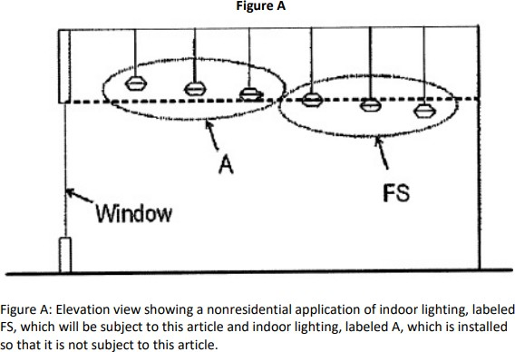
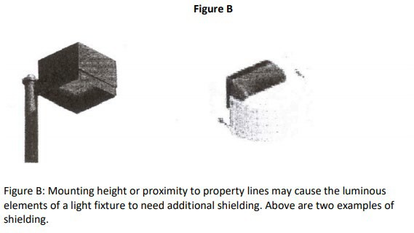

Commented [KC26]: Figure A is not referenced in any section of the ordinance and it is related to indoor lights reflecting through a window, which is not regulated/referenced in this ordinance. It should not be listed as a figure since it is not referenced in the body of the ordinance

Commented [KC27]: Figure B is referenced in Section 22-6. May need to be updated if changed.

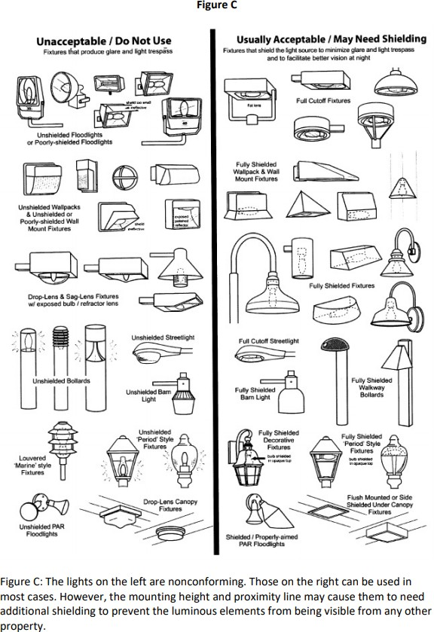
Commented [KC28]: Figure C is not referenced in the body of the ordinance. This may have been indicated as an example of what lighting is appropriate but it should not be listed as a figure since it is not referenced in the body of the ordinance.

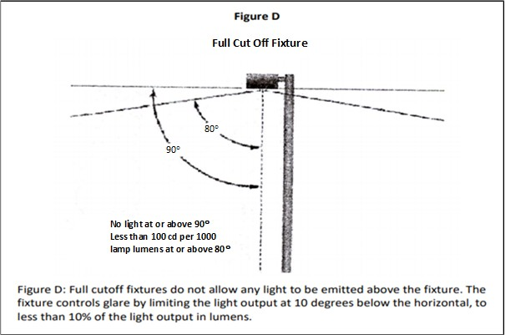
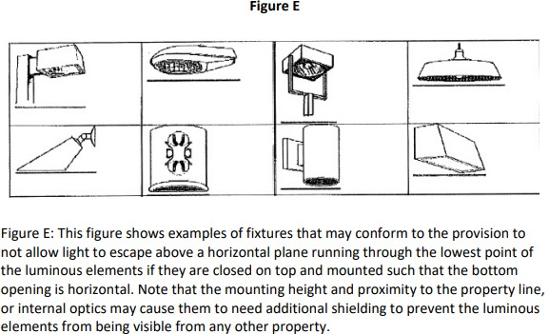

Commented [KC29]: Figure D is not referenced in the body of the ordinance. It should not be listed as a figure since it is not referenced in the body of the ordinance

Commented [KC30]: Figure E is not referenced in the body of the ordinance. It should not be listed as a figure since it is not referenced in the body of the ordinance

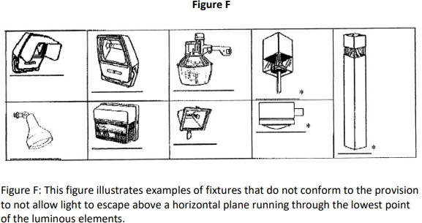

Commented [KC31]: Figure F is not referenced in the body of the ordinance. It should not be listed as a figure since it is not referenced in the body of the ordinance

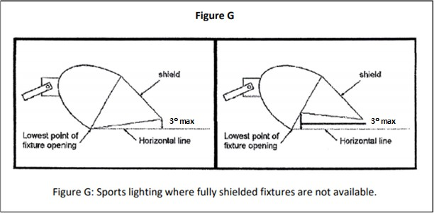
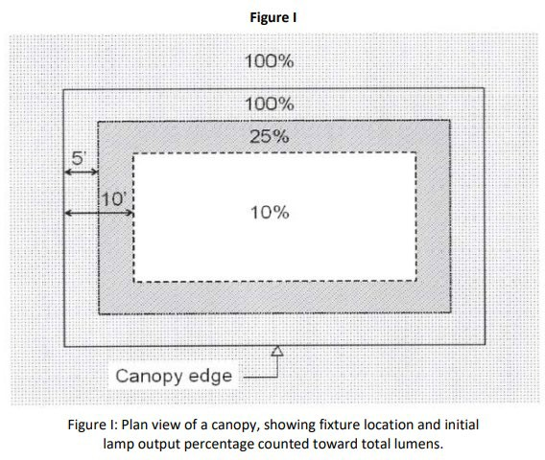

Commented [KC32]: Figure G is not referenced in the body of the ordinance. It should not be listed as a figure since it is not referenced in the body of the ordinance

Commented [KC33]: Labeled incorrectly, these should be H & I, that are referenced in Section 22-5 regarding canopies.

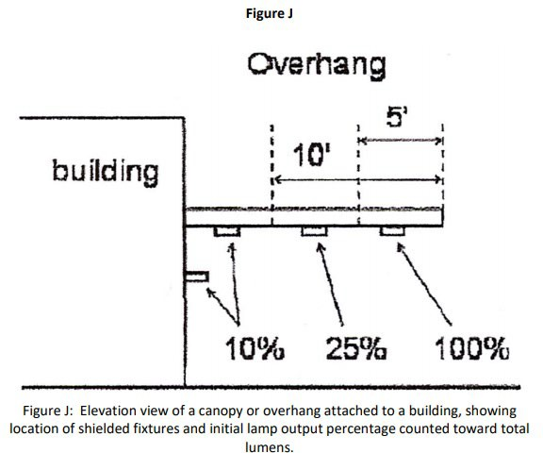

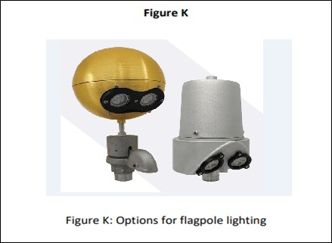
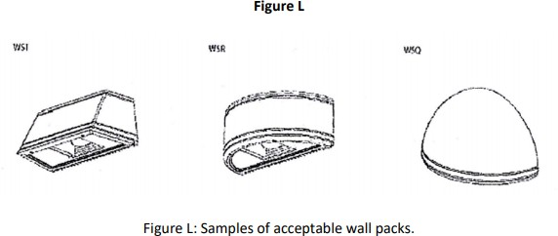

Commented [KC34]: Figure K indicating lights for flag poles. Flag Poles are exempt from the outdoor lighting requirements per section 22-4 (B). Should be removed.

Commented [KC35]: Figure L is referenced in Section 22-8 for outdoor barn lights. The description of figure L is referencing wall packs not outdoor barn lighting. Figure M is a description and image of an outdoor barn light.

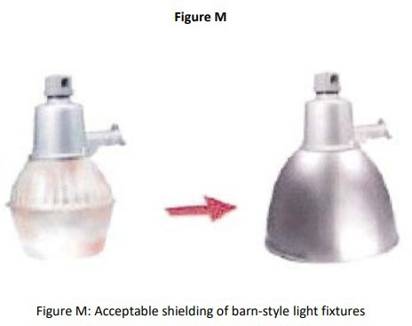

Mayor
T. Colten Johnson City Manager Kyler Ludwig Treasurer Danielle Ramsay


Exhibit B: Alternative Amendment
City Council
Arlon Chamberlain
Chris Heaton Scott Colson Kerry Glover JD Wright

GENERAL PROVISIONS:

- Intent Statement: The Purpose of the Kanab Outdoor Lighting Ordinance is to establish regulations and guidelines for outdoor lighting that enhance public safety and security while preserving the night sky.
- General Standards:

  - Light Shielding and Direction: Unless specifically exempted below, all outdoor lighting shall be fully shielded and downward directed in compliance with the following:
    - No artificial light source shall project direct artificial light into the nighttime sky;

    - No artificial light source shall be placed at a location, angle, or height that creates a light trespass;
    - The shielding shall be made of completely opaque§ material such that light escapes only through the bottom. Shielding that is translucent, transparent, has perforations or slits of any kind, or allows light to escape through it in any other manner is not permitted; and
    - Shielding may be attained by light fixture design, building design, or other site design features such as fencing, walls, or other screening; provided, it is in strict compliance with subsections B1a through B1c of this section.
- Property Lighting:

  - Spot or flood lighting from a building or other structure is prohibited;

  - The overall height of any light, on a pole or building, used to illuminate the property shall not exceed twenty feet (20');
  - All parking lot lighting shall use full cutoff fixtures along property lines.

- Specific Standards: In addition to the general standards of subsection B of this section, the following are specific standards that apply to certain lighting types and circumstances:
  - Canopy Lighting: All direct artificial light sources shall be shielded or recessed and shall not produce more than an average of twenty-five (25) foot-candles under the canopy;
  - Property Lighting: All artificial outdoor light sources shall not exceed one (1) foot-candle at property line;
  - Flickering or flashing lights shall not be permitted;

  - Property and Canopy Lighting: Dimming controls shall be installed, which allow the lighting to dim below the required average foot-candles.
- Exemptions: The following light sources are exempt from the requirements of this chapter:

  - Federal and state flag lighting;

  - Seasonal Lighting: Outdoor lighting; provided, it is in compliance with the following:

    - Lighting shall not create a hazard or glare nuisance; and

    - The lighting shall be temporary (less than ninety (90) days in a calendar year);

  - Low-Output Light Source: An artificial light source having an output equal to or less than one hundred five (105) lumens; provided, that the cumulative lumen output of all low- output light sources shall not exceed a ratio of one and one-half (1½) lumens per square foot of cumulative illuminated area. This ratio shall be calculated by combining the total lumen output of each low-output light source divided by the square footage of the area intended to be illuminated;
  - Motion Sensor Controlled Light Source: An artificial light source that has a light output equal to or less than nine hundred (900) lumens and is controlled by a motion sensor; provided, it is in compliance with the following:

    - The motion sensor is set to turn the artificial light source off no more than ten (10) minutes after the last detection of motion; and
    - The artificial light source is sufficiently shielded in a manner that prevents light trespass;
  - Tower Lighting: Tower lighting required by the FAA or the FCC; provided, that it shall not exceed the minimum requirements of those agencies. Collision markers shall have a dual mode for day and night to minimize impact to the night sky and migrating birds;
  - Traffic control devices and city facilities.

  - Lighting for Athletic fields, courts, and recreational play areas provided the lighting is shielded and directed in a manner that prevents light trespass.
  - Temporary lighting for approved special events including outdoor concerts, theatrical performances, community events, or film production.
  - Single Family Residential: Single Family Residences in compliance with the following:

    - Exterior lights are down lighting so that lighting does not trespass to adjoining properties.
    - All exterior lighting shall be shielded, hooded, or directed so that no direct light is allowed to directly trespass onto adjacent properties.
- Procedures for Compliance:

Prior to occupancy a commercial development shall be required to provide plans indicating the location of all artificial light sources on the premises. The required plans shall be presented in a manner that clearly demonstrates the development’s compliance to the Kanab City Outdoor Lighting Ordinance
- Legal Nonconforming Lighting

  - Upon the adoption of this ordinance, all outdoor lighting fixtures not in conformity herewith shall be considered legal nonconforming outdoor lighting (i.e., grandfathered use), provided they were in compliance with the lighting regulations in effect at the time of their installation, modification, expansion, or relocation.
  - Any modification, expansion, or relocation of existing lighting fixtures shall require compliance with this ordinance.

ORDINANCE NO. 11-X-23 O
AN ORDINANCE AMENDING KANAB CITY LAND USE ORDINANCE
Chapter 22, Outdoor Lighting

WHEREAS, the Kanab City Planning Commission and City staff have evaluated the current land use ordinance related to outdoor lighting;

WHEREAS, the Planning Commission has found a need for clarification, modification, and certain additions to Chapter 22, Outdoor Lighting;

WHEREAS, the Kanab City Planning Commission held a public hearing on November 7, 2023, reviewed, discussed, and then recommended to the Kanab City Council changes to the Land Use Ordinance, Chapter 22, Outdoor Lighting; and

WHEREAS, the Kanab City Council met during its regularly scheduled meeting on November 14, 2023, to consider, among other things, amending the Kanab City Land Use Ordinance, Chapter 22, Outdoor Lighting.

NOW, THEREFORE, BE IT ORDAINED by the Kanab City Council that the Kanab City Land Use Ordinance is hereby amended as reflected in the page(s) attached hereto.

All former ordinances or parts thereof conflicting or inconsistent with the provisions of this Ordinance or of the Code hereby adopted are hereby repealed. The provisions of this Ordinance shall be severable, and, if any provision thereof or any application of such provision is held invalid, it shall not affect any other provisions of this code or the application in a different circumstance.

This ordinance shall be effective upon the required posting.

PASSED AND ORDERED POSTED this 14th day of November, 2023.

KANAB CITY ATTEST:

MAYOR RECORDER

VOTING:

Kerry Glover Yea Nay
JD Wright Yea Nay Arlon Chamberlain Yea Nay Scott Colson Yea Nay
Chris Heaton Yea Nay

POSTED the day of , 2023, as certified by the Recorder: .
RECORDER

Mayor
Colten Johnson City Council Arlon Chamberlain Scott Colson
Chris Heaton Kerry Glover
J.D. Wright
City Manager Kyler Ludwig City Attorney Kent Burggraaf City Recorder Celeste Cram City Treasurer Danielle Ramsay

DATE: November 14, 2023
TO: Mayor and City Council
SUBJECT: Q1 FY24
PREPARED BY: Kyler Ludwig, City Manager

The financial report for the first quarter of the fiscal year indicates several trends and changes in various revenue and expenditure categories. Here's a breakdown of the key points:

Licenses and Permits: The significant decline in licenses and permits revenue is primarily attributed to the sharp decrease in building permits from $217,620 to $10,295. This could potentially indicate a slowdown or shift in construction activities within the city during this quarter.

Sales and Use Taxes: A positive trend is observed in the sales and use taxes, which have shown an approximate 8% increase. This growth reflects a stronger economic activity and consumer spending within Kanab City during this period.

Charges for Services: The rise in Charges for Services is linked to the increased revenue resulting from the expanded EMS Contract with the hospital. This contract expansion has evidently boosted the income from service charges.

Interest Income: Interest income has experienced a substantial increase, rising from $24,009 to
$93,519. This surge is due to the favorable interest rates within the PTIF account, which is currently over 5%. The interest accrued in this account has significantly contributed to the higher income in this category.

Federal Funds: Although ARPA funds were recorded as received in Q1 of FY 22, these funds were moved to an unearned revenue prior to the end of the year. The City anticipates including State and Local Fiscal Recovery Funds as received funds later in the current fiscal year once future capital needs are discussed

Increased Expenditures: Most funds have seen a 10% increase, primarily influenced by rising employee costs. Other notable increases in costs include:

– A Western Classic –
26 North 100 East • Kanab, Utah 84741 • Phone 435-644-2534 • Fax 435-644-2536 • www.kanab.utah.gov

Mayor
Colten Johnson City Council Arlon Chamberlain Scott Colson
Chris Heaton Kerry Glover
J.D. Wright

- Capital outlay costs of $94,411 from the Police Department due to the remodel and transition into the new facility.
City Manager Kyler Ludwig City Attorney Kent Burggraaf City Recorder Celeste Cram City Treasurer Danielle Ramsay

- Increased employee costs in the Fire Department due to the addition of two new positions funded through the Hospital EMS Agreement.

- Increment in wages and equipment expenses at the Heritage House, attributed to new staffing for the museum and the acquisition of new display cases through a grant, respectively.

The General Fund is tracking lower on revenues and higher on expenditures compared to where the City was last year. The revenues over expenses are approximately $150,000 lower this year as opposed to the prior year.

Beyond the General Fund overview, the specific analysis of non-general funds presents key insights into various specialized revenue streams and expenditures. Here's a detailed breakdown:

Wildland Revenues: Wildland Revenues have surged by $70,000, reflecting an increase in income. Additionally, the city foresees another payment for work completed in Colorado, the increase in revenue will help offset losses from last year.

Recreation and Pool Revenues: While Recreation revenues have seen a slight decline from
$44,759 to $37,354, a compensating factor is observed in the Pool revenues, which have risen from $33,803 to $42,821. A considerable increase in Pool Chemicals costs will require some change in a future budget amendment.

Impact Fee Plans: Total impact fees collected is approximately $60,000 during the first quarter of FY24. However, the revenues from impact fees are closely linked to building permit numbers, and have dramatically decreased from $391,751 in the previous year's Q1.

Utility Revenues - Water and Sewer: The Utility Revenues from Water and Sewer have demonstrated consistency. However, there's an increase in expenses attributed to higher employee costs and inflated expenses for parts, equipment, and contracted labor.

– A Western Classic –
26 North 100 East • Kanab, Utah 84741 • Phone 435-644-2534 • Fax 435-644-2536 • www.kanab.utah.gov

Report Criteria:
Print Fund Titles
Page and Total by Fund Print Source Titles
Total by Source
Print Department Titles Total by Department
All Segments Tested for Total Breaks
Account Number Account Title |  | 2022-22  Prior year Actual |  | 2022-23  Prior year Budget |  | 2023-23  Current year Actual |  | 2023-24  Current year Budget
GENERAL FUND
10-2311 UNEARNED REVENUE-ASSESSED  TAXES  10-31-10 PROPERTY TAXES |  | 610,840.00-  3,886.59 |  | .00  388,000.00 |  | 902,633.50-  5,260.13 |  | .00  885,876.00
10-31-11 PRIOR YEARS PROPERTY TAXES |  | 1,475.11 |  | 26,000.00 |  | 2,231.35 |  | 20,000.00
10-31-15 PROPERTY TAX - FEES IN LIEU |  | 9,527.45 |  | 40,000.00 |  | 12,795.02 |  | 35,000.00
10-31-30 SALES TAXES |  | 389,281.97 |  | 1,475,000.00 |  | 421,255.77 |  | 1,425,000.00
10-31-31 SALES TAXES (RESORT) |  | 337,826.24 |  | 1,150,000.00 |  | 385,865.56 |  | 1,250,000.00
10-31-32 Municipal Transient Room Tax |  | 76,090.51 |  | 270,000.00 |  | 93,049.10 |  | 270,000.00
10-31-33 Municipal Energy Tax |  | 71,012.15 |  | 330,000.00 |  | 70,935.74 |  | 300,000.00
10-31-70 MOBILE PHONE SVC. REVENUE TAX |  | 10,974.93 |  | 40,000.00 |  | 10,052.41 |  | 40,000.00
10-31-80 FRANCHISE TAXES |  | 349.56 |  | 20,000.00 |  | 272.30 |  | 1,500.00
Total TAXES: |  | 900,424.51 |  | 3,739,000.00 |  | 1,001,717.38 |  | 4,227,376.00
LICENSES AND PERMITS  10-32-10 BUSINESS LICENSES |  | 1,829.70 |  | 43,000.00 |  | 1,879.47 |  | 45,000.00
10-32-21 BUILDING PERMITS |  | 217,620.59 |  | 300,000.00 |  | 10,295.09 |  | 200,000.00
10-32-22 ENGINEERING REVIEW FEE |  | .00 |  | 2,500.00 |  | .00 |  | .00
10-32-25 DOG LICENSES & POUND FEES |  | 365.00 |  | 3,300.00 |  | 225.00 |  | 3,300.00
Total LICENSES AND PERMITS: |  | 219,815.29 |  | 348,800.00 |  | 12,399.56 |  | 248,300.00
INTERGOVERNMENTAL REVENUES  10-33-31 STATE - AIRPORT |  | .00 |  | .00 |  | .00 |  | .00
10-33-33 COUNTY GRANT - POLICE OVERTIME |  | .00 |  | .00 |  | .00 |  | .00
10-33-38 COLOR COUNTRY GRANT - TRAILS |  | .00 |  | .00 |  | .00 |  | .00
10-33-39 STATE GRANT - TRAILS CONST. |  | .00 |  | .00 |  | .00 |  | .00
10-33-40 STATE GRANT - UDOT SIDEWALK |  | 82,487.07 |  | 82,487.07 |  | .00 |  | .00
10-33-41 STATE GRANT-FIRESTATION SDWALK |  | .00 |  | .00 |  | .00 |  | .00
10-33-42 ST GRANT (HERIT COMM & OMS) |  | .00 |  | 1,000.00 |  | 20,000.00 |  | .00
10-33-43 STATE GRANT - C.E.R.T. |  | .00 |  | .00 |  | .00 |  | .00
10-33-44 STATE GRANT - FIRE DEPT. |  | .00 |  | .00 |  | .00 |  | .00
10-33-45 STATE GRANT - UT ARTS COUNCIL |  | .00 |  | 22,000.00 |  | .00 |  | .00
10-33-46 STATE GRANT - CDBG MESA HILLS |  | .00 |  | .00 |  | .00 |  | .00
10-33-47 ST GRANT - UT STATE LIBRARY |  | .00 |  | 14,725.44 |  | 1,073.33 |  | .00
10-33-48 STATE GRANT - COMM. FORESTRY |  | .00 |  | .00 |  | .00 |  | .00
10-33-49 STATE GRANT - POLICE DEPT |  | .00 |  | .00 |  | .00 |  | .00
10-33-53 FEDERAL GRANT - BLM TRAILS |  | .00 |  | .00 |  | .00 |  | .00
10-33-54 FEDERAL GRANT |  | .00 |  | .00 |  | .00 |  | .00
10-33-55 FEDERAL GRANT - FAA AIRPORT |  | .00 |  | .00 |  | .00 |  | .00
10-33-56 CLASS "C" ROAD FUND ALLOTMENT |  | 114,917.75 |  | 300,000.00 |  | 133,402.46 |  | 325,000.00
10-33-58 STATE LIQUOR FUND |  | .00 |  | 13,000.00 |  | .00 |  | 12,000.00
10-33-59 STATE AVIATION FUEL TAX |  | 242.49 |  | 350.00 |  | .00 |  | 500.00
10-33-67 STATE LOAN - CIB (TEA 21 PJCT) |  | .00 |  | .00 |  | .00 |  | .00

 |  | 2022-22 | 2022-23 | 2023-23 | 2023-24
 |  | Prior year | Prior year | Current year | Current year
Account Number | Account Title | Actual | Budget | Actual | Budget

Total INTERGOVERNMENTAL REVENUES: 197,647.31 433,562.51 154,475.79 337,500.00

CHARGES FOR SERVICES
10-34-09 | LIBRARY DONATIONS | .00 | 1,200.00 |  | 400.00 |  | .00
10-34-11 | FIRE DEPARTMENT FEES RECEIVED | 56,250.00 | 337,500.00 |  | 115,280.00 |  | 450,000.00
10-34-13 | ZONING & SUBDIVISION FEES | 1,735.00 | 40,000.00 |  | 11,335.00 |  | 40,000.00
10-34-14 | CEMETERY LOT SALES | 2,600.00 | 8,000.00 |  | 4,900.00 |  | 8,000.00
10-34-15 | CEMETERY OPEN & CLOSE | 2,850.00 | 8,000.00 |  | 5,900.00 |  | 8,000.00
10-34-16 | CEMETERY UPKEEP FEES | .00 | .00 |  | .00 |  | .00
10-34-17 | PAPER SERVICE | .00 | .00 |  | .00 |  | .00
10-34-30 | SPEC. SVC. DIST. BILLING FEES | 4,775.60 | 17,300.00 |  | 5,273.60 |  | 18,000.00
10-34-41 | FIRE INSPECTIONS | 500.00 | 7,000.00 |  | 425.00 |  | 5,700.00
10-34-80 | PARK FUND | 11,877.50 | 13,500.00 |  | 2,170.00 |  | 1,000.00
Total CHARGES FOR SERVICES: |  | 80,588.10 |  | 432,500.00 |  | 145,683.60 |  | 530,700.00
FINES & FORFEITURES
10-35-10 | DISTRICT COUR FINES | .00 | .00 |  | .00 |  | .00
10-35-11 | J.P. COURT FINES | 10,175.94 | 28,000.00 |  | 10,171.05 |  | 20,000.00
10-35-15 | LIBRARY FINES & FEES | 1,705.16 | 4,000.00 |  | 1,151.85 |  | 1,000.00
Total FINES & FORFEITURES: |  | 11,881.10 |  | 32,000.00 |  | 11,322.90 |  | 21,000.00
MISCELLANEOUS
10-36-10 | INTEREST INCOME | 24,009.13 | 95,000.00 |  | 93,519.16 |  | 15,000.00
10-36-11 | INT. EARNED- CLASS C ROAD FUND | .00 | .00 |  | .00 |  | .00
10-36-20 | RENTS & LEASES - BLDGS & GRNDS | 6,407.48 | 17,000.00 |  | 23,598.00 |  | 20,000.00
10-36-50 | AIRPORT FUEL SALES | 56,873.30 | 125,000.00 |  | 22,949.18 |  | 250,000.00
10-36-52 | AIRPORT FEES | .00 | .00 |  | .00 |  | .00
10-36-53 | HERITAGE MUSEUM DONATIONS | .00 | 500.00 |  | 64.00 |  | .00
10-36-54 | CREDIT CARD CASH BACK | 4.18 | 2,000.00 |  | 21.86 |  | .00
10-36-55 | HERITAGE BATHROOM DONATIONS | .00 | .00 |  | .00 |  | .00
10-36-70 | BANK ACCOUNT TRANSFER ACCT. | 500.00- | .00 |  | 1,750.00 |  | .00
10-36-80 | DONATIONS | .00 | .00 |  | .00 |  | .00
10-36-89 | Glazier home Rental | .00 | .00 |  | .00 |  | .00
10-36-90 | SUNDRY REVENUE | 9,836.79 | 40,000.00 |  | 464.40 |  | 15,000.00
10-36-91 | ARPA | 291,793.50 | .00 |  | .00 |  | .00
10-36-95 | ON-LINE CONVENIENCE FEES | 1,209.00 | 4,200.00 |  | 1,359.00 |  | 4,500.00
Total MISCELLANEOUS: |  | 389,633.38 |  | 283,700.00 |  | 143,725.60 |  | 304,500.00
CONTRIBUTIONS & TRANSFERS
10-38-06 | WATER & SEWER FUND LOAN | .00 | .00 |  | .00 |  | .00
10-38-10 | TRANSFERS FROM OTHER FUNDS | .00 | .00 |  | .00 |  | .00
10-38-11 | TRANFSERS FROM EQUIP. REPLACE | .00 | .00 |  | .00 |  | .00
10-38-12 | TRANSFERS FROM PERPETUAL CAR | .00 | .00 |  | .00 |  | .00
10-38-70 | CONTRIBUTIONS - SWIMMING POOL | .00 | .00 |  | .00 |  | .00
10-38-72 | CONTRIBUTIONS - VARIETY ARTS | .00 | 3,325.00 |  | 1,650.00 |  | .00
10-38-73 | CONTIRBUTIONS - JUNIPER ROOM | .00 | .00 |  | .00 |  | .00
10-38-74 | CONTRIBUTIONS - HERITAGE HOUSE | 2,043.00 | 4,500.00 |  | 1,664.00 |  | .00
10-38-76 | CONTRIBUTIONS - LIBRARY FRIEND | .00 | .00 |  | .00 |  | .00
10-38-78 | CONTRIBUTIONS - ANIMAL POUND | .00 | .00 |  | .00 |  | .00
10-38-79 | CONTRIBUTIONS - PARK | .00 | .00 |  | .00 |  | .00
10-38-80 | FIRE DEPT CONTRIBUTIONS | .00 | .00 |  | .00 |  | .00
10-38-84 | TRANSFER FROM RECREATION FUN | .00 | .00 |  | .00 |  | .00

Account Number | Account Title |  | 2022-22  Prior year Actual |  | 2022-23  Prior year Budget |  | 2023-23  Current year Actual |  | 2023-24  Current year Budget
10-38-86 |  | TRANSFERS FROM IMPACT FEE FD |  | .00 |  | .00 |  | .00 |  | .00
10-38-90 |  | BEG FD BAL TO APPROP - GEN FD |  | .00 |  | .00 |  | .00 |  | .00
10-38-92 |  | BEG FD BAL TO APPROP - CLASS C |  | .00 |  | .00 |  | .00 |  | .00
10-38-93 |  | BEG FD BAL TO APPROP - EQUIP R |  | .00 |  | .00 |  | .00 |  | .00
Total CONTRIBUTIONS & TRANSFERS: |  |  | 2,043.00 |  | 7,825.00 |  | 3,314.00 |  | .00
ADMINISTRATIVE
10-41-11 |  | SALARIES |  | 36,086.30 |  | 130,000.00 |  | 39,700.10 |  | 145,000.00
10-41-13 |  | EMPLOYEE BENEFITS |  | 21,147.80 |  | 80,000.00 |  | 24,384.45 |  | 90,000.00
10-41-15 |  | SALARY (COUNCILMEMBERS) |  | 9,054.00 |  | 36,500.00 |  | 9,054.00 |  | 36,500.00
10-41-21 |  | SUBSCRIPTION & MEMBERSHIPS |  | 625.00 |  | 1,000.00 |  | 500.00 |  | 2,500.00
10-41-23 |  | TRAVEL & TRAINING |  | 672.41 |  | 6,000.00 |  | 1,391.27 |  | 6,000.00
10-41-24 |  | OFFICE EXPENSE & SUPPLIES |  | 12,030.48 |  | 60,000.00 |  | 11,758.49 |  | 60,000.00
10-41-25 |  | AUTO EXPENSE |  | 120.13 |  | 2,500.00 |  | 298.93 |  | 2,500.00
10-41-27 |  | Utilities |  | 782.11 |  | 7,000.00 |  | 1,069.78 |  | 7,000.00
10-41-31 |  | ATTORNEY SERVICES - URMMA |  | .00 |  | 15,000.00 |  | .00 |  | 15,000.00
10-41-32 |  | AUDIT FEES |  | .00 |  | 32,000.00 |  | .00 |  | 35,000.00
10-41-33 |  | ENGINEERING FEES |  | .00 |  | 10,000.00 |  | .00 |  | 10,000.00
10-41-35 |  | COMPUTER MAINTENANCE CONTRA |  | 4,436.10 |  | 14,000.00 |  | 3,635.34 |  | 14,000.00
10-41-50 |  | INSURANCE & SURETY BONDS |  | 5,070.64 |  | 19,000.00 |  | 2,584.47 |  | 15,000.00
10-41-54 |  | DONATIONS |  | .00 |  | .00 |  | .00 |  | .00
10-41-55 |  | SPECIAL EVENTS - DONATIONS |  | .00 |  | .00 |  | .00 |  | .00
10-41-59 |  | MANPOWER STUDY |  | .00 |  | .00 |  | .00 |  | .00
10-41-60 |  | ELECTION EXPENSE |  | .00 |  | .00 |  | .00 |  | 15,000.00
10-41-61 |  | COUNCIL EXPENSES |  | .00 |  | 4,500.00 |  | 42.20 |  | 3,500.00
10-41-64 |  | SUNDRY (CAFETERIA PLAN) |  | .00 |  | .00 |  | .00 |  | .00
10-41-65 |  | SICK LEAVE REIMBURSEMENT FUND |  | .00 |  | .00 |  | .00 |  | .00
10-41-69 |  | EQUIP. REPLACEMNT FUND DEPOSIT |  | .00 |  | .00 |  | .00 |  | .00
10-41-70 |  | CAPITAL OUTLAY |  | .00 |  | .00 |  | 6,669.26 |  | .00
10-41-99 |  | Cares Act |  | .00 |  | .00 |  | .00 |  | .00
Total ADMINISTRATIVE: |  |  | 90,024.97 |  | 417,500.00 |  | 101,088.29 |  | 457,000.00
JUDICIAL
10-42-11 | SALARIES |  |  | .00 |  | .00 |  | .00 |  | .00
10-42-13 | EMPLOYEE BENEFITS |  |  | .00 |  | .00 |  | .00 |  | .00
10-42-23 | TRAVEL & TRAINING |  |  | .00 |  | .00 |  | .00 |  | .00
10-42-24 | OFFICE EXPENSE & SUPPLIES |  |  | .00 |  | .00 |  | .00 |  | .00
10-42-27 | UTILITIES |  |  | .00 |  | .00 |  | .00 |  | .00
10-42-29 | RENT EXPENSE |  |  | .00 |  | .00 |  | .00 |  | .00
10-42-35 | COMPUTER MAINTENANCE CONTRA |  |  | .00 |  | .00 |  | .00 |  | .00
10-42-62 | WITNESS & JURY FEES |  |  | .00 |  | .00 |  | .00 |  | .00
10-42-63 | PUBLIC DEFENDER FEES |  |  | 3,500.00 |  | 12,000.00 |  | 4,000.00 |  | 20,000.00
10-42-70 | CAPITAL OUTLAY |  |  | .00 |  | .00 |  | .00 |  | .00
10-42-80 | Prisoner Transport |  |  | .00 |  | .00 |  | .00 |  | .00
10-42-99 | JUDICIAL DEPARTMENT |  |  | .00 |  | .00 |  | .00 |  | .00
Total JUDICIAL: |  |  | 3,500.00 |  | 12,000.00 |  | 4,000.00 |  | 20,000.00
CITY ATTORNEY
10-43-11 | SALARIES |  |  | 19,438.28 |  | 60,000.00 |  | 17,586.72 |  | 66,000.00
10-43-13 | EMPLOYEE BENEFITS |  |  | 8,779.36 |  | 29,000.00 |  | 8,067.77 |  | 31,000.00
10-43-23 | TRAVEL & TRAINING |  |  | 608.79 |  | 3,500.00 |  | 375.00 |  | 3,500.00
10-43-24 | OFFICE EXPENSE & SUPPLIES |  |  | 243.00 |  | 10,000.00 |  | 1,415.36 |  | 10,000.00
10-43-27 | UTILITIES |  |  | 141.73 |  | .00 |  | .00 |  | .00

Account Number | Account Title |  | 2022-22  Prior year Actual |  | 2022-23  Prior year Budget |  | 2023-23  Current year Actual |  | 2023-24  Current year Budget
10-43-29 |  | RENT EXPENSE |  | .00 |  | .00 |  | .00 |  | .00
10-43-31 |  | ATTORNEY SERVICES |  | .00 |  | .00 |  | .00 |  | .00
10-43-70 |  | PLANNING EXP. - LAND USE ORD. |  | .00 |  | .00 |  | .00 |  | .00
10-43-99 |  | CITY ATTORNEY DEPARTMENT |  | .00 |  | .00 |  | .00 |  | .00
Total CITY ATTORNEY: |  |  | 29,211.16 |  | 102,500.00 |  | 27,444.85 |  | 110,500.00
GENERAL GOVERNMENT BUILDINGS
10-44-99 | GOVERNMENT BUILDINGS DEPART. |  | .00 |  | .00 |  | .00 |  | .00
Total GENERAL GOVERNMENT BUILDINGS: |  |  |  | .00 |  | .00 |  | .00 |  | .00
PLANNING COMM & BOARD OF ADJ.
10-45-12 | SALARIES (ZONING ADMIN.) PART |  | 34,380.01 |  | 90,000.00 |  | 18,631.60 |  | 70,000.00
10-45-13 | EMPLOYEE BENEFITS |  | 17,537.81 |  | 50,000.00 |  | 10,841.51 |  | 44,000.00
10-45-14 | CONTRACT SERVICES - PLANNER |  | 1,800.00 |  | 12,000.00 |  | 1,800.00 |  | 12,000.00
10-45-23 | TRAVEL & TRAINING |  | 330.00 |  | 5,500.00 |  | .00 |  | 5,500.00
10-45-24 | OFFICE EXPENSE & SUPPLIES |  | 416.74 |  | 13,000.00 |  | .00 |  | 6,500.00
10-45-33 | ENGINEERING FEES |  | 89.50 |  | 30,000.00 |  | 802.54 |  | 13,500.00
10-45-34 | ENGR. FEES - CAP. FACILITIES |  | .00 |  | .00 |  | .00 |  | .00
10-45-63 | PLANNING EXP. - BLM BUILDING |  | .00 |  | .00 |  | .00 |  | .00
10-45-64 | PLANNING EXP. - GIS PARCELING |  | .00 |  | .00 |  | .00 |  | .00
10-45-65 | PLANNING EXP- GIS MAPPING |  | .00 |  | .00 |  | .00 |  | .00
10-45-66 | PLANNING EXP. - DANNY MASON |  | .00 |  | .00 |  | .00 |  | .00
10-45-67 | PLANNING EXP. - SENSITIVE LAND |  | .00 |  | .00 |  | .00 |  | .00
10-45-68 | PLANNING EXP. -SUBDIVISION ORD |  | .00 |  | .00 |  | .00 |  | .00
10-45-69 | PLANNING EXP- UPGRADE GEN PLAN |  | .00 |  | .00 |  | .00 |  | .00
10-45-99 | PLANNING COMMISSION DEPARTME |  | .00 |  | .00 |  | .00 |  | .00
Total PLANNING COMM & BOARD OF ADJ.: |  |  |  | 54,554.06 |  | 200,500.00 |  | 32,075.65 |  | 151,500.00
GENERAL GOVERNMENT BUILDINGS
10-46-20 | MAINTENANCE (BUILDINGS) |  | 800.78 |  | 10,000.00 |  | .00 |  | 10,000.00
10-46-22 | KANAB CITY BUILDING AUTHORITY |  | 2,040.53 |  | 2,850.00 |  | .00 |  | 3,000.00
10-46-25 | MULTI-PURPOSE ROOM MAINT |  | .00 |  | .00 |  | .00 |  | .00
10-46-29 | RENTS & LEASES (BUILDINGS) |  | .00 |  | .00 |  | .00 |  | .00
Total GENERAL GOVERNMENT BUILDINGS: |  |  |  | 2,841.31 |  | 12,850.00 |  | .00 |  | 13,000.00
Grant Expenditures
10-47-10 | Library Grant Expenditure |  | .00 |  | .00 |  | .00 |  | .00
Total Grant Expenditures: |  |  |  | .00 |  | .00 |  | .00 |  | .00
POLICE DEPARTMENT  10-54-11 SALARIES |  |  | 160,556.34 |  | 564,000.00 |  | 173,378.01 |  | 665,000.00
10-54-13 EMPLOYEE BENEFITS |  |  | 105,023.28 |  | 405,000.00 |  | 115,001.07 |  | 445,000.00
10-54-14 LIQUOR LAW |  |  | .00 |  | .00 |  | .00 |  | .00
10-54-15 WAGES - DRUG TASK FORCE OFFICE |  |  | .00 |  | .00 |  | .00 |  | .00
10-54-16 WAGES (RESERVE OFFICERS) |  |  | 542.93 |  | 5,000.00 |  | 977.16 |  | 3,500.00
10-54-17 WAGES (Overtime) |  |  | .00 |  | .00 |  | .00 |  | 15,000.00
10-54-19 WAGES (CROSSING GUARD) |  |  | 536.23 |  | 4,000.00 |  | 600.57 |  | 4,000.00
10-54-21 SUBSCRIPTION & MEMBERSHIPS |  |  | 250.00 |  | 2,000.00 |  | 2,049.00 |  | 2,000.00
10-54-23 TRAVEL & TRAINING |  |  | 578.76 |  | 10,000.00 |  | 111.41 |  | 10,000.00
10-54-24 OFFICE EXPENSE & SUPPLIES |  |  | 3,231.58 |  | 20,000.00 |  | 10,544.83 |  | 20,000.00
10-54-25 AUTO EXPENSE |  |  | 4,614.21 |  | 30,000.00 |  | 5,554.62 |  | 30,000.00

Account Number | Account Title |  | 2022-22  Prior year Actual |  | 2022-23  Prior year Budget |  | 2023-23  Current year Actual |  | 2023-24  Current year Budget
10-54-27 |  | UTILITIES |  | 835.61 |  | 6,000.00 |  | 1,641.80 |  | 10,000.00
10-54-29 |  | RENT EXPENSE (OFFICE) |  | 2,250.00 |  | 9,000.00 |  | 2,250.00 |  | 91,000.00
10-54-35 |  | COMPUTER MAINTENANCE CONTRA |  | 186.24 |  | 6,000.00 |  | 229.08 |  | 6,000.00
10-54-37 |  | JAIL DAYS |  | .00 |  | .00 |  | .00 |  | .00
10-54-45 |  | DEPARTMENT SUPPLIES |  | 3,073.00 |  | 22,000.00 |  | 13,090.61 |  | 32,000.00
10-54-51 |  | INSURANCE (LINE OF DUTY) |  | .00 |  | .00 |  | .00 |  | .00
10-54-52 |  | INSURANCE (OFF DUTY AUTO) |  | 3,498.68 |  | 12,000.00 |  | 7,752.73 |  | 12,000.00
10-54-55 |  | TASK FORCE OFFICE EXPENSES |  | .00 |  | 58,000.00 |  | 14,499.99 |  | 58,000.00
10-54-65 |  | SUNDRY (JAIL EXPENSES) |  | .00 |  | .00 |  | .00 |  | .00
10-54-66 |  | Animal Control Salary |  | .00 |  | .00 |  | .00 |  | .00
10-54-67 |  | ANIMAL CONTROL |  | 310.69 |  | 8,000.00 |  | 1,821.37 |  | 8,000.00
10-54-68 |  | ANIMAL CONTROL - MADDIE FUND |  | .00 |  | .00 |  | .00 |  | .00
10-54-69 |  | Animal Control Employee Benfit |  | .00 |  | .00 |  | .00 |  | .00
10-54-70 |  | OPERATING LEASE PAYMENT |  | .00 |  | .00 |  | .00 |  | .00
10-54-74 |  | CAPITAL OUTLAY |  | .00 |  | 150,000.00 |  | 94,411.67 |  | .00
10-54-75 |  | CAPITAL OUTLAY (ANIMAL POUND) |  | .00 |  | .00 |  | .00 |  | .00
10-54-76 |  | CAPITAL OUTLAY - COMP. UPDATE |  | .00 |  | .00 |  | .00 |  | .00
10-54-99 |  | Police Department Vehicles |  | .00 |  | .00 |  | .00 |  | 60,000.00
Total POLICE DEPARTMENT: |  |  | 285,487.55 |  | 1,311,000.00 |  | 443,913.92 |  | 1,471,500.00
FIRE DEPARTMENT
10-58-11 | SALARIES |  | 135,319.50 |  | 550,000.00 |  | 212,470.88 |  | 675,000.00
10-58-13 | EMPLOYEE BENEFITS |  | 77,378.97 |  | 320,000.00 |  | 106,437.69 |  | 390,000.00
10-58-20 | MAINTENANCE (RESCUE TRUCK) |  | .00 |  | .00 |  | .00 |  | .00
10-58-23 | TRAVEL & TRAINING |  | 955.87 |  | 7,000.00 |  | 1,823.43 |  | 10,000.00
10-58-24 | OFFICE EXPENSE & SUPPLIES |  | 588.43 |  | 11,000.00 |  | 5,150.30 |  | 7,000.00
10-58-25 | AUTO EXPENSE |  | 1,816.00 |  | 22,000.00 |  | 11,143.40 |  | 21,000.00
10-58-26 | EQUIP. SUPPLIES & MAINTENANCE |  | 11,088.60 |  | 67,000.00 |  | 28,345.95 |  | 53,200.00
10-58-27 | UTILITIES |  | 1,583.87 |  | 13,500.00 |  | 1,962.06 |  | 13,500.00
10-58-38 | VOLUNTEER SERVICES |  | 286.51 |  | 10,500.00 |  | .00 |  | 25,000.00
10-58-50 | INSURANCE & SURITY BONDS |  | 2,894.18 |  | 5,000.00 |  | 15,948.15 |  | 15,500.00
10-58-64 | SUNDRY (FIRE STATION REPAIR) |  | .00 |  | .00 |  | .00 |  | .00
10-58-70 | CAPITAL OUTLAY |  | .00 |  | .00 |  | .00 |  | .00
10-58-99 | FIRE DEPARTMENT Vehicles |  | .00 |  | .00 |  | .00 |  | 10,000.00
Total FIRE DEPARTMENT: |  |  |  | 231,911.93 |  | 1,006,000.00 |  | 383,281.86 |  | 1,220,200.00
BUILDING INSPECTION
10-59-11 | SALARIES |  | .00 |  | 25,000.00 |  | 13,131.46 |  | 50,000.00
10-59-13 | EMPLOYEE BENEFITS |  | .00 |  | 16,000.00 |  | 8,969.08 |  | 39,000.00
10-59-23 | TRAVEL & TRAINING |  | 2,204.22 |  | 10,000.00 |  | 815.86 |  | 10,000.00
10-59-24 | OFFICE EXPENSE & SUPPLIES |  | 139.40 |  | 10,000.00 |  | 1,132.90 |  | 5,000.00
10-59-25 | AUTO EXPENSE |  | 260.65 |  | 5,000.00 |  | 1,344.35 |  | 5,000.00
10-59-26 | EQUIP. SUPPLIES & MAINTENANCE |  | 775.00 |  | 3,000.00 |  | .00 |  | 3,000.00
10-59-27 | UTILITIES |  | .00 |  | .00 |  | .00 |  | .00
10-59-29 | RENT EXPENSE |  | .00 |  | .00 |  | .00 |  | .00
10-59-33 | PROFESSIONAL FEES - PLAN CHECK |  | .00 |  | 8,000.00 |  | .00 |  | 12,000.00
10-59-64 | SUNDRY (PAYMENTS TO STATE) |  | .00 |  | 5,000.00 |  | .00 |  | 5,000.00
10-59-70 | CAPITAL OUTLAY |  | .00 |  | .00 |  | .00 |  | .00
10-59-99 | BUILDING INSPECTION DEPT. |  | .00 |  | .00 |  | .00 |  | .00
Total BUILDING INSPECTION: |  |  |  | 3,379.27 |  | 82,000.00 |  | 25,393.65 |  | 129,000.00
STREETS  10-60-11 | SALARIES |  | .00 |  | .00 |  | .00 |  | .00

Account Number | Account Title |  | 2022-22  Prior year Actual |  | 2022-23  Prior year Budget |  | 2023-23  Current year Actual |  | 2023-24  Current year Budget
10-60-12 |  | SALARIES (PART TIME) |  | .00 |  | .00 |  | .00 |  | .00
10-60-13 |  | EMPLOYEE BENEFITS |  | .00 |  | .00 |  | .00 |  | .00
10-60-23 |  | TRAVEL & TRAINING |  | .00 |  | 2,000.00 |  | .00 |  | 5,000.00
10-60-24 |  | OFFICE EXPENCE & SUPPLIES |  | 5,694.03 |  | 6,000.00 |  | .00 |  | 6,000.00
10-60-25 |  | AUTO EXPENSE |  | 389.97 |  | 5,000.00 |  | 230.13 |  | 6,000.00
10-60-26 |  | EQUIP. SUPPLIES & MAINTENANCE |  | 8,768.90 |  | 25,000.00 |  | 13,591.08 |  | 25,000.00
10-60-33 |  | ENGINEERING FEES |  | .00 |  | 8,000.00 |  | .00 |  | 8,000.00
10-60-41 |  | SAFE SIDEWALK GRANT EXP. |  | .00 |  | .00 |  | .00 |  | .00
10-60-42 |  | CLASS "C" ROADS (SIDEWALK REP) |  | .00 |  | 1,000.00 |  | .00 |  | 10,000.00
10-60-44 |  | CLASS "C" ROADS (PROJECTS) |  | 6,027.50 |  | 320,000.00 |  | 4,952.50 |  | 320,000.00
10-60-46 |  | TRANS TO DEBT SVC. - YARD |  | .00 |  | .00 |  | .00 |  | .00
10-60-65 |  | SUNDRY (STREET LIGHT UTILITY) |  | 4,090.80 |  | 22,000.00 |  | 4,062.80 |  | 25,000.00
10-60-70 |  | CAPITAL OUTLAY (EQUIPMENT) |  | .00 |  | .00 |  | .00 |  | .00
10-60-71 |  | CAPITAL OUTLAY (SIDEWALK PJCT) |  | .00 |  | .00 |  | .00 |  | 5,000.00
10-60-72 |  | CAPITAL OUTLAY (TRAFFIC LIGHT) |  | .00 |  | .00 |  | .00 |  | .00
10-60-73 |  | CAPITAL OUTLAY (FLOOD CONT) |  | .00 |  | .00 |  | .00 |  | .00
10-60-74 |  | CAPITAL OUTLAY (CHIP SEAL) |  | .00 |  | .00 |  | .00 |  | 50,000.00
10-60-75 |  | CAPITAL OUTLAY (TEA 21 PROJECT |  | .00 |  | .00 |  | .00 |  | .00
10-60-76 |  | CAPITAL OUTLAY |  | 56,003.74 |  | 185,000.00 |  | .00 |  | 100,000.00
10-60-77 |  | CAPITAL OUTLAY - KANAB CREEK B |  | .00 |  | .00 |  | .00 |  | .00
10-60-95 |  | TRANSFERS TO KCR BRIDGE REPLA |  | .00 |  | .00 |  | .00 |  | .00
10-60-96 |  | TRANSFER CLASS C TO DEBT SVC |  | .00 |  | .00 |  | .00 |  | .00
10-60-99 |  | HIGHWAYS & STREETS DEPT. |  | 189,915.05 |  | 310,000.00 |  | .00 |  | .00
Total STREETS: |  |  | 270,889.99 |  | 884,000.00 |  | 22,836.51 |  | 560,000.00
GOLF COURSE
10-61-27 | UTILITIES |  |  | .00 |  | .00 |  | .00 |  | .00
Total GOLF COURSE: |  |  | .00 |  | .00 |  | .00 |  | .00
AIRPORT
10-62-11 | SALARIES |  |  | 17,202.01 |  | 64,000.00 |  | 18,687.10 |  | 70,000.00
10-62-12 | SALARIES (PART TIME) |  |  | .00 |  | .00 |  | .00 |  | .00
10-62-13 | EMPLOYEE BENEFITS |  |  | 9,651.23 |  | 35,000.00 |  | 9,878.72 |  | 40,000.00
10-62-14 | FUEL SALES COMMISSIONS PAID |  |  | .00 |  | .00 |  | .00 |  | 5,000.00
10-62-24 | OFFICE EXPENCE & SUPPLIES |  |  | 557.31 |  | 5,500.00 |  | 219.24 |  | 5,500.00
10-62-26 | EQUIP. SUPPLIES & MAINTENANCE |  |  | 4,195.88 |  | 21,000.00 |  | 6,029.71 |  | 25,000.00
10-62-27 | UTILITIES |  |  | 1,995.02 |  | 13,000.00 |  | 2,241.08 |  | 13,000.00
10-62-50 | INSURANCE & SURITY BOND |  |  | 23.55 |  | 10,000.00 |  | 2,215.26 |  | 10,000.00
10-62-65 | SUNDRY (FUEL PURCHASES) |  |  | 33,157.41 |  | 125,000.00 |  | 47,144.80 |  | 215,000.00
10-62-68 | MAINTENANCE (AWOS) |  |  | .00 |  | 7,500.00 |  | .00 |  | 7,500.00
10-62-69 | CAPITAL OUTLAY (SEAL COAT PJCT |  |  | .00 |  | .00 |  | .00 |  | .00
10-62-70 | CAPITAL OUTLAY |  |  | .00 |  | .00 |  | .00 |  | .00
10-62-71 | CAPITAL OUTLAY-(AIRPORT LIGHT |  |  | .00 |  | .00 |  | .00 |  | .00
10-62-99 | AIRPORT DEPARTMENT |  |  | .00 |  | .00 |  | .00 |  | .00
Total AIRPORT: |  |  | 66,782.41 |  | 281,000.00 |  | 86,415.91 |  | 391,000.00
PARKS
10-64-11 | SALARIES |  |  | 34,922.34 |  | 140,000.00 |  | 41,014.89 |  | 153,000.00
10-64-12 | SALARIES (PART TIME) |  |  | 9,698.56 |  | 30,000.00 |  | 8,778.40 |  | 30,000.00
10-64-13 | EMPLOYEE BENEFITS |  |  | 29,038.99 |  | 111,000.00 |  | 32,011.30 |  | 115,000.00
10-64-14 | RECREATION DIRECTOR |  |  | .00 |  | .00 |  | .00 |  | .00
10-64-23 | TRAVEL & TRAINING |  |  | .00 |  | .00 |  | .00 |  | 5,000.00
10-64-25 | AUTO EXPENSE |  |  | 1,946.57 |  | 12,500.00 |  | 2,945.96 |  | 12,500.00

Account Number | Account Title |  | 2022-22  Prior year Actual |  | 2022-23  Prior year Budget |  | 2023-23  Current year Actual |  | 2023-24  Current year Budget
10-64-26 |  | EQUIP. SUPPLIES & MAINTENANCE |  | 14,443.10 |  | 60,000.00 |  | 15,857.04 |  | 75,000.00
10-64-27 |  | UTILITIES |  | 1,846.04 |  | 16,000.00 |  | 2,752.84 |  | 16,000.00
10-64-30 |  | TRASH REMOVAL |  | 860.00 |  | 6,000.00 |  | 970.00 |  | 6,000.00
10-64-60 |  | (SUNDRY - (REC. MASTER PLAN) |  | .00 |  | .00 |  | .00 |  | .00
10-64-63 |  | SUNDRY (TRAILS) |  | .00 |  | .00 |  | .00 |  | .00
10-64-64 |  | SUNDRY (SUMMER RECREATION) |  | .00 |  | .00 |  | .00 |  | .00
10-64-65 |  | SUNDRY - MAINT. CONT. |  | .00 |  | .00 |  | .00 |  | .00
10-64-66 |  | SUNDRY (4TH JULY EXPENSES) |  | 3,053.88 |  | 15,000.00 |  | 821.33 |  | 15,000.00
10-64-67 |  | SUNDRY (FIREWORKS) |  | .00 |  | .00 |  | .00 |  | .00
10-64-70 |  | CAPITAL OUTLAY |  | .00 |  | 10,000.00 |  | .00 |  | 25,000.00
10-64-73 |  | CAPITAL OUTLAY -J HAMBLIN PARK |  | .00 |  | .00 |  | .00 |  | .00
10-64-74 |  | CAPITAL OUTLAY-HAMBLIN (CITY) |  | .00 |  | .00 |  | .00 |  | .00
10-64-81 |  | YOUTH RECREATION |  | .00 |  | .00 |  | .00 |  | .00
10-64-99 |  | PARKS GENERAL |  | 3,047.63 |  | 4,000.00 |  | .00 |  | .00
Total PARKS: |  | 98,857.11 |  |  | 404,500.00 |  | 105,151.76 |  | 452,500.00
CEMETERY  10-65-11 | SALARIES |  |  | .00 |  | .00 |  | .00 |  | .00
10-65-12 | SALARIES (PART TIME) |  |  | .00 |  | .00 |  | .00 |  | .00
10-65-13 | EMPLOYEE BENEFITS |  |  | .00 |  | .00 |  | .00 |  | .00
10-65-23 | TRAVEL & TRAINING |  |  | .00 |  | .00 |  | .00 |  | 3,000.00
10-65-25 | AUTO EXPENSE |  |  | .00 |  | .00 |  | .00 |  | .00
10-65-26 | EQUIP. SUPPLIES & MAINTENANCE |  |  | .00 |  | .00 |  | .00 |  | .00
10-65-40 | CHEMICALS (CEMETERY) |  |  | .00 |  | .00 |  | .00 |  | .00
10-65-65 | Maint Contract |  |  | .00 |  | .00 |  | .00 |  | .00
10-65-70 | CAPITAL OUTLAY |  |  | .00 |  | 1,000.00 |  | .00 |  | .00
10-65-80 | LOT BUY BACKS |  |  | .00 |  | .00 |  | 330.00 |  | 5,000.00
10-65-99 | CEMETERY GENERAL |  |  | .00 |  | .00 |  | .00 |  | .00
Total CEMETERY: |  |  | .00 |  | 1,000.00 |  | 330.00 |  | 8,000.00
LIBRARY  10-66-11 | SALARIES |  |  | 13,983.62 |  | 75,000.00 |  | 12,664.21 |  | 55,000.00
10-66-12 | SALARIES (PART TIME) |  |  | 5,353.78 |  | 30,000.00 |  | 13,257.54 |  | 50,000.00
10-66-13 | EMPLOYEE BENEFITS |  |  | 6,263.71 |  | 30,000.00 |  | 8,250.53 |  | 35,000.00
10-66-23 | TRAVEL & TRAINING |  |  | .00 |  | 1,000.00 |  | 531.44 |  | 1,000.00
10-66-24 | OFFICE EXPENSE & SUPPLIES |  |  | 2,638.15 |  | 6,000.00 |  | 1,414.26 |  | 6,000.00
10-66-26 | EQUIP. SUPPLIES & MAINTENANCE |  |  | 646.51 |  | 13,000.00 |  | 2,656.51 |  | 13,000.00
10-66-27 | UTILITIES |  |  | 1,836.24 |  | 11,000.00 |  | 1,901.19 |  | 12,000.00
10-66-34 | CONTRACT SERVICES |  |  | .00 |  | .00 |  | .00 |  | .00
10-66-35 | COMPUTER MAINTENANCE CONTRA |  |  | 348.00 |  | 3,000.00 |  | .00 |  | 4,000.00
10-66-41 | MAGAZINES & NEWSPAPERS |  |  | 354.56 |  | 1,500.00 |  | 328.57 |  | 1,500.00
10-66-42 | BOOKS |  |  | 2,404.64- |  | 10,000.00 |  | 2,449.11 |  | 20,000.00
10-66-69 | STATE LIBRARY GRANT EXPENDITUR |  |  | 2,311.96 |  | 11,000.00 |  | .00 |  | 10,000.00
10-66-70 | Program Development |  |  | .00 |  | 3,000.00 |  | 325.31 |  | 7,500.00
10-66-99 | LIBRARY DEPARTMENT |  |  | .00 |  | .00 |  | .00 |  | .00
Total LIBRARY: |  |  | 31,331.89 |  | 194,500.00 |  | 43,778.67 |  | 215,000.00
HERITAGE HOUSE
10-67-12 | SALARIES (PART TIME) |  | 15,299.50 |  | 55,000.00 |  | 19,299.05 |  | 80,000.00
10-67-13 | EMPLOYEE BENEFITS |  | 1,422.56 |  | 4,800.00 |  | 1,855.65 |  | 6,000.00
10-67-14 | LABOR |  | .00 |  | .00 |  | .00 |  | .00
10-67-23 | TRAVEL & TRAINING |  | .00 |  | 1,400.00 |  | 284.33 |  | 1,800.00
10-67-26 | EQUIP. SUPPLIES & MAINTENANCE |  | 3,220.89 |  | 20,000.00 |  | 11,265.15 |  | 15,000.00

Account Number | Account Title |  | 2022-22  Prior year Actual |  | 2022-23  Prior year Budget |  | 2023-23  Current year Actual |  | 2023-24  Current year Budget
10-67-27 |  | UTILITIES |  | 984.56 |  | 9,000.00 |  | 874.88 |  | 11,000.00
10-67-34 |  | CONTRACT SERVICES |  | .00 |  | .00 |  | .00 |  | .00
10-67-58 |  | HERITAGE MUSEUM EXPENSES |  | 12,584.04- |  | 1,500.00 |  | 1,902.01 |  | .00
10-67-60 |  | HERITAGE HOUSE EXPENSES |  | .00 |  | 50.00 |  | .00 |  | .00
10-67-63 |  | HERITAGE DEVELOPMENT GRANT EX |  | .00 |  | .00 |  | .00 |  | .00
10-67-70 |  | CAPITAL OUTLAY MUSEUM |  | 2,860.00 |  | 30,000.00 |  | 256.08 |  | 3,000.00
10-67-99 |  | CAPITAL OUTLAY HOUSE |  | 41.95 |  | 2,000.00 |  | .00 |  | 3,000.00
Total HERITAGE HOUSE: |  |  | 11,245.42 |  | 123,750.00 |  | 35,737.15 |  | 119,800.00
COMMUNITY DEVELOPMENT
10-68-60 | MISC-WELCOM SIGN & POWER LINE |  | .00 |  | .00 |  | .00 |  | .00
10-68-61 | ARTS BOARD EXPENSES |  | .00 |  | 8,000.00 |  | 1,400.00 |  | 8,000.00
10-68-65 | SUNDRY (TREE COMMITTEE) |  | .00 |  | .00 |  | .00 |  | .00
10-68-66 | SUNDRY (BEAUTIFICATION COMM) |  | .00 |  | 11,000.00 |  | .00 |  | 5,000.00
10-68-67 | MESA HILLS CDBG EXPENDITURES |  | .00 |  | .00 |  | .00 |  | .00
10-68-68 | SUNDRY (VOLUNTEER CENTER) |  | .00 |  | .00 |  | .00 |  | 15,000.00
10-68-69 | HOMLAND SECURITY |  | .00 |  | .00 |  | .00 |  | .00
10-68-70 | STORY TELLING GUILD |  | .00 |  | .00 |  | .00 |  | .00
10-68-71 | STORY TELLERS GUILD GRANTS |  | .00 |  | .00 |  | .00 |  | .00
Total COMMUNITY DEVELOPMENT: |  |  |  | .00 |  | 19,000.00 |  | 1,400.00 |  | 28,000.00
ECONOMIC DEVELOPMENT
10-69-23 | TRAVEL |  | .00 |  | .00 |  | .00 |  | .00
10-69-24 | OFFICE EXPENSE & SUPPLIES |  | .00 |  | .00 |  | .00 |  | .00
10-69-51 | Special Events |  | .00 |  | 5,000.00 |  | 845.90 |  | 20,000.00
10-69-52 | DocUtah |  | .00 |  | .00 |  | .00 |  | .00
10-69-53 | Business of Art |  | .00 |  | .00 |  | .00 |  | .00
10-69-54 | C.E.B.A. |  | .00 |  | 10,000.00 |  | .00 |  | 10,000.00
10-69-60 | AMAZING EARTH FEST |  | .00 |  | .00 |  | .00 |  | .00
10-69-64 | SUNDRY (WEB PAGE DEVELOPMENT) |  | .00 |  | .00 |  | .00 |  | .00
10-69-65 | SPECIAL EVENTS |  | .00 |  | .00 |  | .00 |  | .00
10-69-66 | ECONOMIC DEV. - DIRECTOR |  | .00 |  | .00 |  | .00 |  | .00
10-69-67 | ECONOMIC DEV. - Council |  | .00 |  | .00 |  | .00 |  | 25,000.00
10-69-68 | ECONOMIC DEV. - Mayor |  | 100.00 |  | 10,000.00 |  | .00 |  | 10,000.00
10-69-99 | ECON DEVLOP GENERAL |  | .00 |  | .00 |  | .00 |  | .00
Total ECONOMIC DEVELOPMENT: |  |  |  | 100.00 |  | 25,000.00 |  | 845.90 |  | 65,000.00
TRANSFERS  10-70-11 | TRANSFER TO CAPITAL PJCTS FUND |  | .00 |  | 250,000.00 |  | .00 |  | 200,000.00
10-70-12 | TRANSFER TO CAPITAL PJCTS FUND |  | .00 |  | .00 |  | .00 |  | .00
10-70-21 | TRANSFER TO DEBT SVC-FIRE TRK |  | .00 |  | .00 |  | .00 |  | .00
10-70-23 | TRANSFER TO DEBT SVC-P.W. BLDG |  | .00 |  | .00 |  | .00 |  | .00
10-70-24 | TRANSFER TO IMPACT FEE - PAYBK |  | .00 |  | .00 |  | .00 |  | .00
10-70-25 | TRANSFER TO CP KCR BRIDGE REP |  | .00 |  | .00 |  | .00 |  | .00
10-70-31 | Trans to W/S Fund - Payback |  | .00 |  | .00 |  | .00 |  | .00
10-70-45 | TRANS TO DEBT SV-CLASS C TEA21 |  | .00 |  | .00 |  | .00 |  | .00
10-70-50 | Transfer to Recreation Fund |  | .00 |  | .00 |  | .00 |  | .00
10-70-51 | TRANS TO FUND 42 |  | .00 |  | 20,000.00 |  | .00 |  | 20,000.00
10-70-92 | TRANSFER TO DEBT SVC |  | .00 |  | 75,500.00 |  | .00 |  | 75,500.00
Total TRANSFERS: |  |  |  | .00 |  | 345,500.00 |  | .00 |  | 295,500.00

2022-22 2022-23 2023-23 2023-24
Prior year Prior year Current year Current year Account Number Account Title Actual Budget Actual Budget
Department: 71
10-71-12 |  | TRANSFER TO RECREATION FUND |  | .00 |  | .00 |  | .00 |  | .00
Total Department: 71: |  |  |  | .00 |  | .00 |  | .00 |  | .00
GENERAL FUND Revenue Total: |  |  |  | 1,802,032.69 |  | 5,277,387.51 |  | 1,472,638.83 |  | 5,669,376.00
GENERAL FUND Expenditure Total: |  |  |  | 1,180,117.07 |  | 5,422,600.00 |  | 1,313,694.12 |  | 5,707,500.00
Net Total GENERAL FUND: |  |  |  | 621,915.62 |  | 145,212.49- |  | 158,944.71 |  | 38,124.00-

Account Number  DEBT SERVICE FUND |  | Account Title |  | 2022-22  Prior year Actual |  | 2022-23  Prior year Budget |  | 2023-23  Current year Actual |  | 2023-24  Current year Budget
TAXES
15-31-13 PROP TAX - G.O. BOND RETIREMNT .00 |  |  |  |  |  | .00 |  | .00 |  | .00
Total TAXES: .00 |  |  |  |  |  | .00 |  | .00 |  | .00
CHARGES FOR SERVICES
15-34-50 RENT & LEASE-AIRPORT T HANGERS |  |  |  | .00 |  | .00 |  | .00 |  | .00
15-34-51 RENT & LEASE-AIRPORT HANGER |  |  |  | .00 |  | .00 |  | .00 |  | .00
Total CHARGES FOR SERVICES: |  |  |  | .00 |  | .00 |  | .00 |  | .00
MISCELLANEOUS
15-36-15 | INTEREST EARNED - KCR GUARANTY |  | .00 |  | .00 |  | .00 |  | .00
15-36-21 | TRAN FROM GF-TEA21 LOAN PMT |  | .00 |  | .00 |  | .00 |  | .00
15-36-30 | TRANSFER FROM G.F - FIRE TRUCK |  | .00 |  | .00 |  | .00 |  | .00
15-36-33 | TRANSFER FROM REC - SWIM POOL |  | .00 |  | 93,000.00 |  | .00 |  | 93,000.00
15-36-34 | TRANSFER FROM IMP. FEES - REC |  | .00 |  | .00 |  | .00 |  | .00
15-36-35 | TRANS FROM G.F. - P.U. BLDG. |  | .00 |  | 75,500.00 |  | .00 |  | 175,500.00
15-36-36 | TRANS. FROM W&S - P.U. BLDG. |  | .00 |  | .00 |  | .00 |  | .00
15-36-71 | Trans. CP - Kanab Creek Bridge |  | .00 |  | .00 |  | .00 |  | .00
15-36-90 | DEBT PROCEEDS |  | .00 |  | .00 |  | .00 |  | .00
Total MISCELLANEOUS: |  |  |  | .00 |  | 168,500.00 |  | .00 |  | 268,500.00
LEASE PURCHASE EXPENSE  15-71-82 LEASE PURCHASE - POLICE CARS |  |  |  | .00 |  | .00 |  | .00 |  | 100,000.00
Total LEASE PURCHASE EXPENSE: |  |  |  | .00 |  | .00 |  | .00 |  | 100,000.00
BOND INTERST EXPENSE
15-73-79 | PAYING AGENT FEES |  | .00 |  | .00 |  | .00 |  | .00
15-73-80 | CIB LOAN - DWNTOWN PJCT |  | 8,505.00 |  | 10,000.00 |  | 8,505.01 |  | 10,000.00
15-73-81 | SWIMMING POOL BOND - INT. |  | 12,422.55 |  | 27,000.00 |  | .00 |  | 27,000.00
15-73-87 | FIRE TRUCK LEASE PURCHASE-INT. |  | .00 |  | .00 |  | .00 |  | .00
15-73-88 | FIRE STATION BOND PMT. - INT. |  | .00 |  | .00 |  | 11,581.00 |  | .00
15-73-89 | PUBLIC WORKS BLDG. LOAN |  | .00 |  | .00 |  | .00 |  | .00
15-73-91 | STORM WATER/CIB 2013 - INT |  | .00 |  | 450.00 |  | .00 |  | 500.00
15-73-92 | 2020 SALES TAX REF BONDS INT |  | .00 |  | .00 |  | .00 |  | .00
Total BOND INTERST EXPENSE: |  |  |  | 20,927.55 |  | 37,450.00 |  | 20,086.01 |  | 37,500.00
BOND PRINCIPAL EXPENSE
15-74-70 | CIB - Kanab Creek Bridge |  | .00 |  | .00 |  | .00 |  | .00
15-74-80 | CIB LOAN - DWNTOWN PJCT |  | 20,000.00 |  | 20,000.00 |  | 20,000.00 |  | 20,000.00
15-74-81 | SWIMMING POOL BOND - PRIN |  | .00 |  | 93,000.00 |  | .00 |  | 93,000.00
15-74-87 | FIRE TRUCK LEASE PURCHASE-PRIN |  | .00 |  | .00 |  | .00 |  | .00
15-74-88 | FIRE STATION BOND PMT. - PRIN. |  | .00 |  | .00 |  | .00 |  | .00
15-74-89 | PUBLIC WORKS BLDG. LOAN |  | .00 |  | .00 |  | .00 |  | .00
15-74-91 | STORM WATER/CIB 2013 - PRIN |  | .00 |  | 18,000.00 |  | .00 |  | 18,000.00
15-74-92 | 2020 SALES TAX REF BONDS PRINC |  | .00 |  | .00 |  | .00 |  | .00
15-74-99 | BOND ISSUANCE COSTS |  | .00 |  | .00 |  | .00 |  | .00
Total BOND PRINCIPAL EXPENSE: |  |  |  | 20,000.00 |  | 131,000.00 |  | 20,000.00 |  | 131,000.00

Account Number | Account Title | 2022-22  Prior year Actual | 2022-23  Prior year Budget |  |  | 2023-23  Current year Actual |  |  | 2023-24  Current year Budget
CAPITAL PROJECT EXPENDITURES
15-75-90 | TRANSFER TO YEAR END FUND BAL. | .00 |  | .00 |  |  | .00 |  | .00
Total CAPITAL PROJECT EXPENDITURES: |  | .00 |  |  | .00 |  |  | .00 |  | .00
DEBT SERVICE FUND Revenue Total: |  | .00 |  |  | 168,500.00 |  |  | .00 |  | 268,500.00
DEBT SERVICE FUND Expenditure Total: |  | 40,927.55 |  |  | 168,450.00 |  |  | 40,086.01 |  | 268,500.00
Net Total DEBT SERVICE FUND: |  | 40,927.55- |  |  | 50.00 |  |  | 40,086.01- |  | .00

Account Number |  | Account Title |  | 2022-22  Prior year Actual |  | 2022-23  Prior year Budget |  | 2023-23  Current year Actual |  | 2023-24  Current year Budget
Wildland Fire
Source: 30
37-30-10 Wildland Revenue 1,044.00 |  |  |  |  |  | 120,000.00 |  | 72,041.39 |  | 150,000.00
Total Source: 30: 1,044.00 |  |  |  |  |  | 120,000.00 |  | 72,041.39 |  | 150,000.00
Revenue  37-36-10 | Intrest Earned |  | 708.58 |  | 3,500.00 |  | 1,855.85 |  | .00
37-36-90 | Debt Proceeds |  | .00 |  | .00 |  | .00 |  | .00
Total Revenue: |  |  |  | 708.58 |  | 3,500.00 |  | 1,855.85 |  | .00
Expense  37-60-10 | Equipment, Supplies & Maint |  | 2,923.18 |  | 5,000.00 |  | .00 |  | 10,000.00
37-60-11 | Salaries |  | 45,850.05 |  | 65,000.00 |  | 41,054.13 |  | 45,000.00
37-60-13 | Employee Benefits |  | 8,764.26 |  | 10,000.00 |  | 4,581.00 |  | 4,000.00
37-60-20 | Wildland Fire Expense |  | 6,994.80 |  | 15,000.00 |  | 26,876.78 |  | 25,000.00
37-60-90 | Capital Outlay |  | .00 |  | .00 |  | .00 |  | .00
37-60-95 | Capital Outlay |  | .00 |  | 45,196.45 |  | .00 |  | 46,000.00
Total Expense: |  |  |  | 64,532.29 |  | 140,196.45 |  | 72,511.91 |  | 130,000.00
Department: 73  37-73-80 | PRICIPAL PAYMENTS - FIRE TRUCK |  | .00 |  | .00 |  | .00 |  | .00
37-73-81 | INTEREST PAYMENTS - FIRE TRUCK |  | .00 |  | .00 |  | .00 |  | .00
Total Department: 73: |  |  |  | .00 |  | .00 |  | .00 |  | .00
Wildland Fire Revenue Total: |  |  |  | 1,752.58 |  | 123,500.00 |  | 73,897.24 |  | 150,000.00
Wildland Fire Expenditure Total: |  |  |  | 64,532.29 |  | 140,196.45 |  | 72,511.91 |  | 130,000.00
Net Total Wildland Fire: |  |  |  | 62,779.71- |  | 16,696.45- |  | 1,385.33 |  | 20,000.00

Account Number Account Title |  | 2022-22  Prior year Actual |  | 2022-23  Prior year Budget |  |  | 2023-23  Current year Actual |  | 2023-24  Current year Budget
Public Safety Fitness CIP
38-1100 CASH ALLOCATION  Revenue  38-30-10 Other Fund Transfers |  | 11,607.15  .00 |  |  | .00  .00 |  | 11,607.15  .00 |  | .00  .00
Total Revenue: |  | .00 |  |  | .00 |  | .00 |  | .00
Public Safety Fitness CIP Revenue Total: |  | .00 |  |  | .00 |  | .00 |  | .00
Public Safety Fitness CIP Expenditure Total: |  | .00 |  |  | .00 |  | .00 |  | .00
Net Total Public Safety Fitness CIP: |  | .00 |  |  | .00 |  | .00 |  | .00

Account Number | Account Title |  | 2022-22  Prior year Actual |  | 2022-23  Prior year Budget |  | 2023-23  Current year Actual |  | 2023-24  Current year Budget
STORM WATER | CIP
39-1100 | CASH ALLOCATION |  | .00 |  | .00 |  | .00 |  | .00
39-1120  Revenue  39-30-10 | PTIF-STORM WA  General Fund Transfer |  | .00  .00 |  | .00  .00 |  | .00  .00 |  | .00  .00
39-30-15 | CIB Loan & Grant |  | .00 |  | .00 |  | .00 |  | .00
Total Revenue: |  | .00 |  | .00 |  | .00 |  | .00
Revenue Misc  39-36-01 | GRANT REVENUE |  | .00 |  | .00 |  | .00 |  | .00
39-36-10 | INTEREST EARNED |  | .00 |  | .00 |  | .00 |  | .00
39-36-50 | DEBT PROCEEDS |  | .00 |  | .00 |  | .00 |  | .00
Total Revenue Misc: |  | .00 |  | .00 |  | .00 |  | .00
Expenditures  39-60-10 | 200 N Storm Cap. Improv. |  | .00 |  | .00 |  | .00 |  | .00
39-60-20 | Tom’s Canyon Detention exp |  | .00 |  | .00 |  | .00 |  | .00
39-60-30 | Engineering fees |  | .00 |  | .00 |  | .00 |  | .00
39-60-90 | TRANSFERS OUT |  | .00 |  | .00 |  | .00 |  | .00
Total Expenditures: |  |  | .00 |  | .00 |  | .00 |  | .00
Street/Storm Water Capital Imp Revenue Total: |  |  | .00 |  | .00 |  | .00 |  | .00
Street/Storm Water Capital Imp Expenditure Total: |  |  | .00 |  | .00 |  | .00 |  | .00
Net Total STORM WATER CIP: |  |  | .00 |  | .00 |  | .00 |  | .00

 |  | 2022-22 | 2022-23 | 2023-23 | 2023-24
 |  | Prior year | Prior year | Current year | Current year
Account Number | Account Title | Actual | Budget | Actual | Budget

AIRPORT IMPROVEMENT CAP. PJCTS

Source: 30  40-30-10 | FIRE STATION REMODEL | .00 |  | .00 |  | .00 |  | .00
Total Source: 30: |  | .00 |  |  | .00 |  | .00 |  | .00
TRANSFERS  40-70-25 | TRANSFERS TO OTHER FUNDS | .00 |  | .00 |  | .00 |  | .00
Total TRANSFERS: |  | .00 |  |  | .00 |  | .00 |  | .00
CAPITAL PROJECT EXPENDITURES
40-75-30 | Airport Terminal Construction | .00 |  | .00 |  | .00 |  | .00
40-75-50 | Project Management Expense | .00 |  | .00 |  | .00 |  | .00
40-75-70 | MISC. EXPENSES | .00 |  | .00 |  | .00 |  | .00
Total CAPITAL PROJECT EXPENDITURES: |  |  | .00 |  | .00 |  | .00 |  | .00
AIRPORT IMPROVEMENT CAP. PJCTS Revenue Total: |  |  | .00 |  | .00 |  | .00 |  | .00
AIRPORT IMPROVEMENT CAP. PJCTS Expenditure Total: |  |  | .00 |  | .00 |  | .00 |  | .00
Net Total AIRPORT IMPROVEMENT CAP. PJCTS: |  | .00 |  | .00 |  | .00 |  | .00

 |  | 2022-22 | 2022-23 | 2023-23 | 2023-24
 |  | Prior year | Prior year | Current year | Current year
Account Number | Account Title | Actual | Budget | Actual | Budget

RECREATION - CAPITAL PROJECTS

REVENUE  41-30-11 | TRANSFERS FROM GENERAL FUND | 5,624.25- | 4,500.00 |  | 14,940.71- |  | .00
41-30-20 | KANE COUNTY GRANT - TRAV CNL | .00 | .00 |  | .00 |  | .00
41-30-30 | RAP Tax | 35,475.21 | 110,000.00 |  | 40,707.34 |  | 125,000.00
41-30-36 | BASKEBALL | 2,542.00 | 11,500.00 |  | 810.00 |  | 10,000.00
41-30-37 | CANYONEERING | .00 | .00 |  | .00 |  | .00
41-30-41 | Baseball Fees | .00 | 17,500.00 |  | .00 |  | 15,000.00
41-30-42 | Softball Fees | 15.00 | 13,500.00 |  | .00 |  | 15,000.00
41-30-43 | CHEER | .00 | .00 |  | .00 |  | .00
41-30-44 | CO-ED ADULT SOFTBALL | .00 | .00 |  | .00 |  | .00
41-30-45 | 10-K REG FEES/DONATIONS | .00 | 3,500.00 |  | .00 |  | 3,000.00
41-30-46 | CROSS COUNTRY | .00 | 500.00 |  | 735.00 |  | 500.00
41-30-50 | Soccer | 4,487.00 | 4,500.00 |  | 4,668.00 |  | 4,000.00
41-30-55 | Volleyball | 3,160.00 | 3,100.00 |  | 3,440.00 |  | 2,000.00
41-30-56 | YOGA | 2,035.00 | 5,000.00 |  | 1,045.00 |  | 5,000.00
41-30-57 | MISC EQUIPMENT REVENUE | .00 | .00 |  | .00 |  | .00
41-30-60 | Tennis Fees | 30.00 | 5,000.00 |  | 740.00 |  | 5,000.00
41-30-62 | YOUTH WRESTLING | .00 | .00 |  | .00 |  | .00
41-30-63 | CONCESSIONS - HOT FOOD | .00 | 500.00 |  | .00 |  | .00
41-30-64 | Outdoor Rec | .00 | .00 |  | .00 |  | 150,000.00
41-30-65 | CONCESSIONS | .00 | 3,000.00 |  | .00 |  | .00
41-30-66 | DONATIONS/EVENTS | .00 | .00 |  | 150.00 |  | .00
41-30-70 | PROPERTY TAX - RECREATION | .00 | 230,000.00 |  | .00 |  | 360,000.00
41-30-71 | MISC RECREATION REV | 2,640.00 | 2,500.00 |  | .00 |  | .00
Total REVENUE: |  | 44,759.96 |  | 414,600.00 |  | 37,354.63 |  | 694,500.00
Fees  41-34-01 | Pool Lessons | 905.00 |  | 2,500.00 |  | 449.50 |  | 2,500.00
41-34-02 | Pool Concessions | 7,152.85 |  | 9,000.00 |  | 15,426.13 |  | 8,000.00
41-34-05 | Pool Admissions | 23,876.03 |  | 50,000.00 |  | 25,553.00 |  | 50,000.00
41-34-06 | Pool Rentals | 1,870.00 |  | 4,000.00 |  | 1,328.00 |  | 5,000.00
41-34-07 | SWIM TEAM FEES | .00 |  | 8,500.00 |  | 65.00 |  | 8,500.00
Total Fees: |  | 33,803.88 |  | 74,000.00 |  | 42,821.63 |  | 74,000.00
MISCELLANEOUS
41-36-05 | INTEREST EARNED | .00 | .00 |  | .00 |  | .00
41-36-10 | INTEREST EARNED - REC. TAX | 96.97 | 500.00 |  | 253.99 |  | .00
41-36-11 | INTEREST EARNED - SKATE PARK | .00 | .00 |  | .00 |  | .00
41-36-13 | INTEREST EARNED-SWIM POOL LOA | .00 | .00 |  | .00 |  | .00
41-36-15 | INTEREST EARNED -CIB POOL LOAN | .00 | .00 |  | .00 |  | .00
41-36-16 | INT EARNED (10-K) | .00 | .00 |  | .00 |  | .00
41-36-17 | INT EARNED JHM | .00 | .00 |  | .00 |  | .00
41-36-20 | DONATIONS | .00 | .00 |  | .00 |  | .00
41-36-21 | DONATIONS - STONE BENCHES | .00 | .00 |  | .00 |  | .00
41-36-30 | Skate Park Donations | .00 | .00 |  | .00 |  | .00
Total MISCELLANEOUS: |  | 96.97 |  | 500.00 |  | 253.99 |  | .00
Source: 37  41-37-70 | PROP TAX | .00 | .00 |  | .00 |  | .00

 |  | 2022-22 | 2022-23 | 2023-23 | 2023-24
 |  | Prior year | Prior year | Current year | Current year
Account Number | Account Title | Actual | Budget | Actual | Budget

Total Source: 37: .00 .00 .00 .00

CONTRIBUTIONA & TRANSFERS
41-38-90 | TRANSFERS FROM GENERAL FUND | .00 | .00 |  | .00 |  | .00
41-38-91 | TRANSFER FROM CLASS C ROADS | .00 | .00 |  | .00 |  | .00
41-38-95 | TRANSFERS FROM YEAR END BALAN | .00 | .00 |  | .00 |  | .00
41-38-97 | FUND BALANCE TO APPROPRIATE | .00 | .00 |  | .00 |  | .00
Total CONTRIBUTIONA & TRANSFERS: |  | .00 |  | .00 |  | .00 |  | .00
RECREATION EXPENDITURES
41-41-11 | SALARIES | 25,611.74 | 95,000.00 |  | 17,562.09 |  | 115,000.00
41-41-12 | SALARIES (PART TIME) | .00 | .00 |  | 14,881.04 |  | .00
41-41-13 | EMPLOYEE BENEFITS | 19,861.52 | 66,000.00 |  | 7,872.36 |  | 50,000.00
41-41-23 | TRAVEL & TRAINING | .00 | .00 |  | .00 |  | .00
41-41-24 | OFFICE EXPENSE & SUPPLIES | 880.21 | 5,000.00 |  | 524.31 |  | 5,000.00
41-41-25 | AUTO EXPENSE | .00 | .00 |  | .00 |  | .00
41-41-26 | EQUIP. SUPPLIES & MAINTENANCE | .00 | 3,000.00 |  | 14.99 |  | 3,000.00
41-41-27 | UTILITIES | .00 | .00 |  | .00 |  | .00
41-41-46 | CROSS COUNTRY EXPENSE | 192.55 | .00 |  | 399.75 |  | .00
41-41-50 | INSURENACE & BONDS | .00 | .00 |  | .00 |  | .00
41-41-51 | VOLLEYBALL EXPENSE | 1,151.02 | .00 |  | 2,090.04 |  | 1,500.00
41-41-52 | YOGA EXPENSE | 917.15 | 5,500.00 |  | 1,792.16 |  | 5,500.00
41-41-53 | Cheerleading | .00 | .00 |  | .00 |  | 200.00
41-41-54 | RECREATION CENTER EXPENSES | .00 | .00 |  | .00 |  | .00
41-41-55 | Basketball Expense | .00 | 6,400.00 |  | .00 |  | 6,000.00
41-41-56 | Baseball Expense | .00 | 13,000.00 |  | .00 |  | 18,000.00
41-41-57 | Soccer Expense | 1,023.61 | 2,500.00 |  | .00 |  | 3,000.00
41-41-58 | Tennis Expense | 1,825.00 | 4,500.00 |  | 1,250.00 |  | 4,500.00
41-41-59 | Football Expense | 5,834.10 | 13,500.00 |  | 7,644.05 |  | 13,500.00
41-41-60 | Heatstriker Baseball | .00 | 2,000.00 |  | .00 |  | .00
41-41-61 | Heatstroker Softball | .00 | 10,500.00 |  | .00 |  | 10,000.00
41-41-62 | YOUTH WRESTLING | .00 | 2,500.00 |  | .00 |  | 2,500.00
41-41-63 | POOL OPERATIONS | .00 | .00 |  | .00 |  | .00
41-41-64 | Outdoor Rec | .00 | .00 |  | .00 |  | 150,000.00
41-41-65 | MISC EQUIPMENT EXPENSE | .00 | .00 |  | .00 |  | .00
41-41-66 | SPECIAL EVENTS | .00 | .00 |  | .00 |  | .00
41-41-70 | CAPITAL OUTLAY | 2,685.00 | .00 |  | .00 |  | 100,000.00
Total RECREATION EXPENDITURES: |  | 59,981.90 |  | 229,400.00 |  | 54,030.79 |  | 487,700.00
Department: 47
41-47-30 | 10-K EXPENSES | .00 | 4,000.00 |  | .00 |  | 3,500.00
Total Department: 47: |  | .00 |  | 4,000.00 |  | .00 |  | 3,500.00
Swimming Pool
41-50-11 | Salaries | .00 | .00 |  | 3,840.39 |  | .00
41-50-12 | Lifeguards | 40,681.32 | 55,000.00 |  | 40,788.88 |  | 60,000.00
41-50-13 | Employee Costs | 4,099.99 | 7,000.00 |  | 4,524.73 |  | 6,000.00
41-50-23 | Travel/Training | .00 | 3,000.00 |  | .00 |  | 3,000.00
41-50-26 | Equipment/Supplies/Maint | 1,758.85 | 25,000.00 |  | 1,321.47 |  | 30,000.00
41-50-27 | Utilities | 21,872.76 | 50,000.00 |  | 19,521.48 |  | 40,000.00
41-50-28 | SWIM TEAM EXPENSES | 1,177.08- | 6,500.00 |  | .00 |  | 6,500.00
41-50-30 | Chemicals | 10,912.19 | 30,000.00 |  | 27,485.56 |  | 25,000.00

Account Number | Account Title |  | 2022-22  Prior year Actual |  | 2022-23  Prior year Budget |  | 2023-23  Current year Actual |  | 2023-24  Current year Budget
41-50-40 |  | Concessions |  | 3,265.50 |  | 8,000.00 |  | 5,193.66 |  | 8,000.00
41-50-50 |  | Insurance |  | 1,523.54 |  | 3,500.00 |  | 1,476.83 |  | 3,500.00
Total Swimming Pool: |  |  | 82,937.07 |  | 188,000.00 |  | 104,153.00 |  | 182,000.00
Parks Maintenance
41-60-11 | Salaries |  | .00 |  | .00 |  | .00 |  | .00
41-60-12 | Part-time Salaries |  | .00 |  | .00 |  | .00 |  | .00
41-60-13 | Employee Benefits |  | .00 |  | .00 |  | .00 |  | .00
41-60-23 | Travel/Training |  | .00 |  | .00 |  | .00 |  | .00
41-60-25 | Auto |  | .00 |  | .00 |  | .00 |  | .00
41-60-26 | Equip/Supplies/Maint |  | .00 |  | .00 |  | .00 |  | .00
41-60-27 | Utilities |  | .00 |  | .00 |  | .00 |  | .00
41-60-30 | Trash Pick Up |  | .00 |  | .00 |  | .00 |  | .00
41-60-65 | Maint Contract |  | .00 |  | .00 |  | .00 |  | .00
41-60-66 | Landscape Maint. Cont. |  | .00 |  | .00 |  | .00 |  | .00
41-60-67 | Fireworks |  | .00 |  | .00 |  | .00 |  | .00
Total Parks Maintenance: |  |  |  | .00 |  | .00 |  | .00 |  | .00
CAPITAL PROJECT EXPENDITURES
41-75-07 | LEGAL SERVICES |  | .00 |  | .00 |  | .00 |  | .00
41-75-08 | ARCHITECTURAL SERVICES |  | .00 |  | .00 |  | .00 |  | .00
41-75-09 | ENGINEERING SERVICES |  | 13,940.50 |  | 20,000.00 |  | .00 |  | .00
41-75-10 | CONTINGENCIES |  | .00 |  | .00 |  | .00 |  | .00
41-75-11 | MISC. SERVICES |  | .00 |  | .00 |  | .00 |  | .00
41-75-20 | CONSTRUCTION - SWIMMING POOL |  | .00 |  | .00 |  | .00 |  | .00
41-75-21 | CONSTRUCTION - LITTLE LEAGUE |  | .00 |  | .00 |  | .00 |  | .00
41-75-22 | CONSTRUCTION - PLAYGROUNDS |  | .00 |  | .00 |  | .00 |  | .00
41-75-23 | CONSTRUCTION - OLD MID SCHOOL |  | .00 |  | .00 |  | .00 |  | .00
41-75-24 | CONSTRUCTION - GOLF COURSE |  | .00 |  | .00 |  | .00 |  | .00
41-75-25 | CONSTRUCTION - SOFTBALL FIELDS |  | .00 |  | .00 |  | .00 |  | .00
41-75-26 | CONSTRUCTION - SKATE PARK |  | .00 |  | .00 |  | .00 |  | .00
41-75-27 | CONSTRUCTION - PARKS |  | .00 |  | .00 |  | .00 |  | .00
41-75-28 | CONSTRUCTIION - REC CENTER |  | .00 |  | .00 |  | .00 |  | .00
41-75-29 | CONSTRUCTION - EAGLE PJCTS. |  | .00 |  | .00 |  | .00 |  | .00
41-75-50 | TRANSFER TO YR. END FUND BAL. |  | .00 |  | .00 |  | .00 |  | .00
41-75-51 | TRANSFER TO GENERAL FUND |  | .00 |  | .00 |  | .00 |  | .00
41-75-90 | TRANS TO SKATE PARK |  | .00 |  | .00 |  | .00 |  | .00
41-75-95 | TRANSFERS TO DEBT SERVICE FUND |  | .00 |  | 93,000.00 |  | .00 |  | 93,000.00
41-75-99 | TOTAL EXPENSES |  | .00 |  | .00 |  | .00 |  | .00
Total CAPITAL PROJECT EXPENDITURES: |  |  |  | 13,940.50 |  | 113,000.00 |  | .00 |  | 93,000.00
Department: 80  41-80-35 | Professional Fees |  | .00 |  | .00 |  | .00 |  | .00
Total Department: 80: |  |  |  | .00 |  | .00 |  | .00 |  | .00
RECREATION - CAPITAL PROJECTS Revenue Total: |  |  |  | 78,660.81 |  | 489,100.00 |  | 80,430.25 |  | 768,500.00
RECREATION - CAPITAL PROJECTS Expenditure Total: |  |  |  | 156,859.47 |  | 534,400.00 |  | 158,183.79 |  | 766,200.00

 |  | 2022-22 | 2022-23 | 2023-23 | 2023-24
 |  | Prior year | Prior year | Current year | Current year
Account Number | Account Title | Actual | Budget | Actual | Budget

Net Total RECREATION - CAPITAL PROJECTS: 78,198.66- 45,300.00- 77,753.54- 2,300.00

 |  | 2022-22 | 2022-23 | 2023-23 | 2023-24
 |  | Prior year | Prior year | Current year | Current year
Account Number | Account Title | Actual | Budget | Actual | Budget

AIRPORT CAPITAL IMPROVMENT

REVENUE  42-30-10 | TRANSFERS FROM GENERAL FUND | .00 | 20,000.00 |  | .00 |  | 20,000.00
42-30-35 | MISCELLANEOUS | .00 | .00 |  | 397.00 |  | .00
42-30-40 | DONATIONS | .00 | .00 |  | .00 |  | .00
Total REVENUE: |  | .00 |  | 20,000.00 |  | 397.00 |  | 20,000.00
INTERGOVERNMENTAL REVENUES
42-33-11 | STATE GRANT - AIRPORT FENCING | 74,410.02 | 82,300.00 |  | .00 |  | 7,500.00
42-33-30 | FEDERAL GRANT - AIRPORT FENCE | .00 | 45,000.00 |  | .00 |  | 150,000.00
42-33-40 | MISCELLANEOUS GRANTS | .00 | .00 |  | .00 |  | .00
Total INTERGOVERNMENTAL REVENUES: |  | 74,410.02 |  | 127,300.00 |  | .00 |  | 157,500.00
MISCELLANEOUS
42-36-10 | INTEREST EARNED | .00 | .00 |  | .00 |  | .00
Total MISCELLANEOUS: |  | .00 |  | .00 |  | .00 |  | .00
CONTRIBUTIONS & TRANSFERS  42-38-65 TRANSFERS FROM GENERAL FUND |  | .00 |  | .00 |  | .00 |  | .00
Total CONTRIBUTIONS & TRANSFERS: |  | .00 |  | .00 |  | .00 |  | .00
CAPITAL PROJECT EXPENDITURES
42-75-30 | ENGINEERING FEES Master Plan | .00 | 200,000.00 |  | .00 |  | 166,000.00
42-75-70 | ADMINISTRATION | .00 | .00 |  | .00 |  | .00
42-75-71 | ARCHITECTURAL FEES | .00 | .00 |  | .00 |  | .00
42-75-72 | AIRPORT CONSTRUCTION EXP. | .00 | .00 |  | .00 |  | .00
42-75-73 | LEGAL FEES | .00 | .00 |  | .00 |  | .00
42-75-79 | CONSTRUCTIION - A.W.O.S. | .00 | .00 |  | .00 |  | .00
42-75-80 | CONSTRUCTION - RUNWAY REHAB | .00 | .00 |  | .00 |  | .00
42-75-90 | LAND PURCHASES | .00 | .00 |  | .00 |  | .00
42-75-99 | TOTAL TRANSFERS AND EXPENSES | .00 | .00 |  | .00 |  | .00
Total CAPITAL PROJECT EXPENDITURES: |  | .00 |  | 200,000.00 |  | .00 |  | 166,000.00
AIRPORT CAPITAL IMPROVMENT Revenue Total: |  | 74,410.02 |  | 147,300.00 |  | 397.00 |  | 177,500.00
AIRPORT CAPITAL IMPROVMENT Expenditure Total: |  | .00 |  | 200,000.00 |  | .00 |  | 166,000.00
Net Total AIRPORT CAPITAL IMPROVMENT: |  | 74,410.02 |  | 52,700.00- |  | 397.00 |  | 11,500.00

 |  | 2022-22 | 2022-23 | 2023-23 | 2023-24
 |  | Prior year | Prior year | Current year | Current year
Account Number | Account Title | Actual | Budget | Actual | Budget

RECREATION - CAPITAL PROJECTS

CONTRIBUTIONS & TRANSFERS
43-38-90 | FUND BALANCE TO APPROPRIATE | .00 | .00 |  | .00 |  | .00
Total CONTRIBUTIONS & TRANSFERS: |  | .00 |  | .00 |  | .00 |  | .00
CAPITAL PROJECT EXPENDITURES
43-75-10 | Recreation Capital Expense | .00 | .00 |  | .00 |  | .00
Total CAPITAL PROJECT EXPENDITURES: |  | .00 |  | .00 |  | .00 |  | .00
RECREATION - CAPITAL PROJECTS Revenue Total: |  | .00 |  | .00 |  | .00 |  | .00
RECREATION - CAPITAL PROJECTS Expenditure Total: |  | .00 |  | .00 |  | .00 |  | .00
Net Total RECREATION - CAPITAL PROJECTS: |  | .00 | .00 |  | .00 |  | .00

 |  | 2022-22 | 2022-23 | 2023-23 | 2023-24
 |  | Prior year | Prior year | Current year | Current year
Account Number | Account Title | Actual | Budget | Actual | Budget

Heritage House Bathrooms – Cap

REVENUE  44-30-71 | Transfer from General Fund | .00 | .00 |  | .00 |  | .00
44-30-72 | Kane County Contribution | .00 | .00 |  | .00 |  | .00
44-30-73 | INTEREST INCOME | .00 | .00 |  | .00 |  | .00
44-30-77 | Heritage Council | .00 | .00 |  | .00 |  | .00
44-30-78 | Grants | .00 | .00 |  | .00 |  | .00
44-30-79 | Donations | .00 | .00 |  | .00 |  | .00
Total REVENUE: |  | .00 |  | .00 |  | .00 |  | .00
Source: 38  44-38-80 | TRANSFER FROM GENERAL FUND | .00 | .00 |  | .00 |  | .00
Total Source: 38: |  | .00 |  | .00 |  | .00 |  | .00
CAPITAL PROJECT EXPENDITURES
44-75-71 | ARCHITECTS FEES | .00 | .00 |  | .00 |  | .00
44-75-72 | LEGEL FEES | .00 | .00 |  | .00 |  | .00
44-75-73 | CONSTRUCTION EXPENSES - BLDG. | .00 | .00 |  | .00 |  | .00
44-75-74 | CONSTRUCTION EXPENSES - ROADS | .00 | .00 |  | .00 |  | .00
44-75-75 | PROFESSIONAL FEES | .00 | .00 |  | .00 |  | .00
44-75-77 | EQUIPMENT | .00 | .00 |  | .00 |  | .00
44-75-79 | MISC. EXPENSES | .00 | .00 |  | .00 |  | .00
44-75-90 | TRANSFER TO YEAR END FUND BAL. | .00 | .00 |  | .00 |  | .00
Total CAPITAL PROJECT EXPENDITURES: |  | .00 |  | .00 |  | .00 |  | .00
Heritage House Bathrooms – Cap Revenue Total: |  | .00 |  | .00 |  | .00 |  | .00
Heritage House Bathrooms – Cap Expenditure Total: |  | .00 |  | .00 |  | .00 |  | .00
Net Total Heritage House Bathrooms – Cap: |  | .00 |  | .00 |  | .00 |  | .00

Account Number |  | Account Title |  | 2022-22  Prior year Actual |  |  | 2022-23  Prior year Budget |  | 2023-23  Current year Actual |  | 2023-24  Current year Budget
Capital Projects
REVENUE  45-30-10 |  | Property Tax |  |  | .00 |  | 11,500.00 |  | .00 |  | 11,500.00
45-30-72 |  | TRANS FROM GEN FUND |  |  | .00 |  | 250,000.00 |  | .00 |  | 200,000.00
45-30-74 |  | DONATIONS - MISCELLANEOUS |  |  | .00 |  | .00 |  | .00 |  | .00
45-30-75 |  | LIB-NEW BLDG. FURNISHINGS |  |  | .00 |  | .00 |  | .00 |  | .00
45-30-76 |  | LIB-NEW BLDG. FURNISHINGS |  |  | .00 |  | .00 |  | .00 |  | .00
45-30-79 |  | RECIPTS - SALE OF OLD FIRE ST. |  |  | .00 |  | .00 |  | .00 |  | .00
Total REVENUE: |  |  | .00 |  |  | 261,500.00 |  | .00 |  | 211,500.00
INTERGOVERNMENTAL REVENUES
45-33-10 | GRANT - C.D.B.G. |  | .00 |  |  | .00 |  | .00 |  | .00
45-33-40 | GRANTS - STATE LIBRARY |  | .00 |  |  | .00 |  | .00 |  | .00
45-33-41 | GRANTS - STATE OF UTAH |  | .00 |  |  | .00 |  | .00 |  | .00
45-33-42 | GRANT - R.C.&D. |  | .00 |  |  | .00 |  | .00 |  | .00
Total INTERGOVERNMENTAL REVENUES: |  |  |  | .00 |  |  | .00 |  | .00 |  | .00

FINES & FORFEITURES
45-35-80 MISC. REVENUE .00 .00 .00 .00

Total FINES & FORFEITURES: .00 .00 .00 .00

MISCELLANEOUS
45-36-10 | INTEREST EARNED | 3,870.33 | 20,000.00 |  | 10,298.46 |  | .00
45-36-70 | BOND RECEIPTS | .00 | .00 |  | .00 |  | .00
45-36-75 | TRANSFER G.F. - 1% SALES TAX | .00 | .00 |  | .00 |  | .00
45-36-90 | GRANTS - COLOR COUNTRY R.C.&D. | .00 | .00 |  | .00 |  | .00
Total MISCELLANEOUS: |  | 3,870.33 |  | 20,000.00 |  | 10,298.46 |  | .00
CAPITAL PROJECT EXPENDITURES
45-75-31 | New City Office | .00 | .00 |  | .00 |  | .00
45-75-35 | IFFP Plan | .00 | .00 |  | 52,224.00 |  | 225,000.00
45-75-49 | Police Department | .00 | .00 |  | 18.50- |  | .00
45-75-70 | Fire Capital | .00 | .00 |  | .00 |  | .00
45-75-71 | Ranchos Park | .00 | .00 |  | .00 |  | .00
45-75-72 | ENGINEERING EXPENSES | .00 | .00 |  | .00 |  | .00
45-75-73 | Airport | 71,454.25 | 200,000.00 |  | .00 |  | .00
45-75-74 | Pool | .00 | .00 |  | .00 |  | 175,000.00
45-75-75 | Heritage House | .00 | .00 |  | .00 |  | .00
45-75-77 | R.C.&D. EQUIP. & SUPPLIES | .00 | .00 |  | .00 |  | .00
45-75-78 | LIBRARY | .00 | .00 |  | 3,729.50 |  | .00
45-75-79 | Skate Park | .00 | .00 |  | .00 |  | .00
45-75-85 | IFFP Plan | .00 | 200,000.00 |  | 17,408.00 |  | .00
Total CAPITAL PROJECT EXPENDITURES: |  | 71,454.25 |  | 400,000.00 |  | 73,343.00 |  | 400,000.00
Capital Projects Revenue Total: |  | 3,870.33 |  | 281,500.00 |  | 10,298.46 |  | 211,500.00
Capital Projects Expenditure Total: |  | 71,454.25 |  | 400,000.00 |  | 73,343.00 |  | 400,000.00
Net Total Capital Projects: |  | 67,583.92- |  | 118,500.00- |  | 63,044.54- |  | 188,500.00-

 |  | 2022-22 | 2022-23 | 2023-23 | 2023-24
 |  | Prior year | Prior year | Current year | Current year
Account Number | Account Title | Actual | Budget | Actual | Budget

Account Number  Existing Capital Repairs |  | Account Title |  | 2022-22  Prior year Actual |  | 2022-23  Prior year Budget |  | 2023-23  Current year Actual |  | 2023-24  Current year Budget
Revenue
46-30-10 Property Tax .00 |  |  |  |  |  | 11,500.00 |  | .00 |  | 11,500.00
Total Revenue: .00 |  |  |  |  |  | 11,500.00 |  | .00 |  | 11,500.00
MISCELLANEOUS
46-36-10 | INTEREST EARNED |  | .00 |  | .00 |  | .00 |  | .00
Total MISCELLANEOUS: |  |  |  | .00 |  | .00 |  | .00 |  | .00
CONTRIBUTIONS & TRANSFERS  46-38-80 TRANSFER FROM GENERAL FUND |  |  |  | .00 |  | .00 |  | .00 |  | .00
Total CONTRIBUTIONS & TRANSFERS: |  |  |  | .00 |  | .00 |  | .00 |  | .00
CAPITAL PROJECT EXPENDITURES
46-75-70 | MISC. EXPENSES |  | .00 |  | .00 |  | .00 |  | .00
46-75-71 | ENGINEERING & ARCHITECT FEES |  | .00 |  | .00 |  | .00 |  | .00
46-75-80 | Transfer to Debt Service |  | .00 |  | .00 |  | .00 |  | .00
46-75-85 | Transfer to General Fund |  | .00 |  | .00 |  | .00 |  | .00
46-75-90 | TRANSFER TO YEAR END FUND BAL. |  | .00 |  | .00 |  | .00 |  | .00
46-75-99 | BRIDGE REPLACEMENT GENERAL |  | .00 |  | .00 |  | .00 |  | .00
Total CAPITAL PROJECT EXPENDITURES: |  |  |  | .00 |  | .00 |  | .00 |  | .00
Existing Capital Repairs Revenue Total: |  |  |  | .00 |  | 11,500.00 |  | .00 |  | 11,500.00
Existing Capital Repairs Expenditure Total: |  |  |  | .00 |  | .00 |  | .00 |  | .00
Net Total Existing Capital Repairs: |  |  |  | .00 |  | 11,500.00 |  | .00 |  | 11,500.00

Account Number  JH Park Expansion |  | Account Title |  | 2022-22  Prior year Actual |  | 2022-23  Prior year Budget |  | 2023-23  Current year Actual |  | 2023-24  Current year Budget
Source: 33
47-33-50 GARDNER FOUNDATION .00 |  |  |  |  |  | .00 |  | .00 |  | .00
Total Source: 33: .00 |  |  |  |  |  | .00 |  | .00 |  | .00
Source: 36  47-36-10 | INTEREST EARNED |  | .00 |  | .00 |  | .00 |  | .00
Total Source: 36: |  |  |  | .00 |  | .00 |  | .00 |  | .00
Source: 38  47-38-80 | TRANS FROM GEN FUND |  | .00 |  | .00 |  | .00 |  | .00
Total Source: 38: |  |  |  | .00 |  | .00 |  | .00 |  | .00
Department: 75  47-75-75 | CONSTRUCTION EXPENSES |  | .00 |  | .00 |  | .00 |  | .00
Total Department: 75: |  |  |  | .00 |  | .00 |  | .00 |  | .00
JH Park Expansion Revenue Total: |  |  |  | .00 |  | .00 |  | .00 |  | .00
JH Park Expansion Expenditure Total: |  |  |  | .00 |  | .00 |  | .00 |  | .00
Net Total JH Park Expansion: |  |  |  | .00 |  | .00 |  | .00 |  | .00

Account Number  IMPACT FEES FUND |  | Account Title |  | 2022-22  Prior year Actual |  | 2022-23  Prior year Budget |  | 2023-23  Current year Actual |  | 2023-24  Current year Budget
FEES  49-32-12 | IMPACT FEES - PUBLIC SAFETY |  |  | 17,661.60 |  | 42,000.00 |  | 4,970.16 |  | .00
49-32-14 | IMPACT FEES - TRANSPORTATION |  |  | 36,432.00 |  | 119,000.00 |  | 17,076.72 |  | .00
49-32-16 | IMPACT FEES - PARKS & REC |  |  | 43,417.75 |  | 80,000.00 |  | 8,325.84 |  | .00
49-32-17 | IMPACT FEES - Sewer |  |  | 10,692.00 |  | 50,000.00 |  | 6,012.72 |  | .00
49-32-18 | IMPACT FEES - STORM WATER |  |  | 132,501.60 |  | 180,000.00 |  | 11,104.40 |  | .00
49-32-40 | IMPACT FEE- Water |  |  | 151,046.10 |  | 190,000.00 |  | 12,763.46 |  | .00
Total FEES: |  |  |  | 391,751.05 |  | 661,000.00 |  | 60,253.30 |  | .00
MISCELLANEOUS
49-36-10 | INTEREST EARNED - IMPACT FEES |  | 2,712.73 |  | 15,000.00 |  | 7,105.02 |  | .00
Total MISCELLANEOUS: |  |  |  | 2,712.73 |  | 15,000.00 |  | 7,105.02 |  | .00
TRANSFERS  49-38-80 | TRANSFER FROM GF - REPAY |  | .00 |  | .00 |  | .00 |  | .00
49-38-90 | FUND BALANCE TO APPROPRIATE |  | .00 |  | .00 |  | .00 |  | .00
Total TRANSFERS: |  |  |  | .00 |  | .00 |  | .00 |  | .00
LEASE EXPENSE  49-71-10 | TRANSFERS TO GENERAL FUND: |  | .00 |  | 250,000.00 |  | .00 |  | .00
49-71-11 | TRANSFER TO GF - PUBLIC SAFETY |  | .00 |  | .00 |  | .00 |  | .00
49-71-12 | TRANSFER TO RECREATION FUND |  | .00 |  | .00 |  | .00 |  | .00
49-71-13 | TRANSFER TO GF - STREETS |  | .00 |  | 250,000.00 |  | .00 |  | .00
49-71-14 | TRANSFER TO G.F. - STORM WATER |  | .00 |  | 300,000.00 |  | .00 |  | .00
Total LEASE EXPENSE: |  |  |  | .00 |  | 800,000.00 |  | .00 |  | .00
CAPITAL PROJECT EXPENDITURES
49-75-70 | CAPITAL EXP. (CAP. FAC. REPT) |  | .00 |  | .00 |  | .00 |  | .00
49-75-71 | Public Safety Capital Expend |  | .00 |  | .00 |  | .00 |  | .00
49-75-72 | TRANSFER DEBT SVC FD - FIRE DP |  | .00 |  | .00 |  | .00 |  | .00
49-75-73 | TRANS TO G.F.(FLOOD CONTROL) |  | .00 |  | .00 |  | .00 |  | .00
49-75-74 | TRANSFER DEBT SVC FD - STREETS |  | .00 |  | .00 |  | .00 |  | .00
49-75-76 | TRANSFER DEBT SVC FD - PARKS |  | .00 |  | .00 |  | .00 |  | .00
49-75-80 | Transfer to CIPF |  | .00 |  | .00 |  | .00 |  | .00
49-75-90 | TRANSFERS TO YEAR END FUND BAL |  | .00 |  | .00 |  | .00 |  | .00
Total CAPITAL PROJECT EXPENDITURES: |  |  |  | .00 |  | .00 |  | .00 |  | .00
IMPACT FEES FUND Revenue Total: |  |  |  | 394,463.78 |  | 676,000.00 |  | 67,358.32 |  | .00
IMPACT FEES FUND Expenditure Total: |  |  |  | .00 |  | 800,000.00 |  | .00 |  | .00
Net Total IMPACT FEES FUND: |  |  |  | 394,463.78 |  | 124,000.00- |  | 67,358.32 |  | .00

 |  | 2022-22 | 2022-23 | 2023-23 | 2023-24
 |  | Prior year | Prior year | Current year | Current year
Account Number | Account Title | Actual | Budget | Actual | Budget

WATER & SEWER UTILITY FUND

Source: 36  51-36-01 | GRANT REVENUE | .00 | .00 |  | .00 |  | 1,627,840.00
Total Source: 36: |  | .00 |  | .00 |  | .00 |  | 1,627,840.00
OPERATING REVENUE
51-37-10 | METERED WATER SALES | 447,999.96 | 1,450,000.00 |  | 464,163.87 |  | 1,500,000.00
51-37-30 | Sewer Sales | 121,456.71 | 425,000.00 |  | 124,571.90 |  | 450,000.00
51-37-41 | IMPACT FEES - WATER CONNECTION | 97,175.57 | 260,000.00 |  | .00 |  | .00
51-37-42 | TIME & MATERIALS - WATER CONN. | 30,298.35 | 65,000.00 |  | 12,650.58 |  | 20,000.00
51-37-45 | RE-CONNECT FEES | 1,690.00 | 3,000.00 |  | 700.00 |  | .00
51-37-50 | CONNECTION FEES - SEWER | .00 | .00 |  | .00 |  | .00
51-37-52 | TIME & MATERIALS - SEWER CONN. | 2,606.46 | 10,000.00 |  | 1,906.33 |  | 10,000.00
51-37-53 | PENALTY & FORFEIT | 12,821.85 | 48,000.00 |  | 18,171.92 |  | 30,000.00
51-37-80 | SALE OF MATERIALS & SUPPLIES | .00 | .00 |  | .00 |  | .00
51-37-90 | SUNDRY REVENUE | .00 | .00 |  | .00 |  | .00
51-37-95 | ON LINE CONVENIENCE FEES | .00 | .00 |  | .00 |  | .00
Total OPERATING REVENUE: |  | 714,048.90 |  | 2,261,000.00 |  | 622,164.60 |  | 2,010,000.00
NON-OPERATING REVENUE
51-39-10 | INTEREST EARNED | .00 | .00 |  | .00 |  | .00
51-39-11 | INT. EARNED- EQUIP. REPLACE | 2,623.30 | 20,000.00 |  | 7,358.26 |  | 8,000.00
51-39-17 | INT EARNED- 98 REFIN. ACCOUNTS | 588.73 | 3,500.00 |  | 1,541.98 |  | .00
51-39-19 | INT. EARNED- 88 WTR RES. R&R | .00 | .00 |  | .00 |  | .00
51-39-20 | INT. EARNED- 88 WATER RES DEBT | 4,407.50 | 22,000.00 |  | 11,543.85 |  | 5,000.00
51-39-35 | TRANS FROM G.F. - P.U. BLDG. | .00 | .00 |  | .00 |  | .00
51-39-50 | INT. EARNED- 88 WTR RESRS RES. | .00 | .00 |  | .00 |  | .00
51-39-60 | INT. EARNED- W & S SYSTEM RES. | 2,698.75 | 13,500.00 |  | 7,068.37 |  | 5,000.00
51-39-61 | INT. EARNED - PTIF ESCROW ACT | .00 | .00 |  | .00 |  | .00
51-39-62 | CAPITAL CONTRIBUTION | .00 | .00 |  | .00 |  | .00
51-39-67 | FUND BAL. TO APP. - IMP. FEES | .00 | .00 |  | .00 |  | .00
51-39-69 | WATER CONS. DIST. (REIMBURSE) | .00 | .00 |  | .00 |  | .00
51-39-70 | SUNDRY NON-OPERATING REVENUE | .00 | .00 |  | .00 |  | .00
51-39-73 | STATE GRANT - UDOT WATER LINE | .00 | .00 |  | .00 |  | .00
51-39-75 | STATE GRANT - CIB (MESA HILLS) | .00 | .00 |  | .00 |  | .00
51-39-76 | STATE GRANT - RDFG MESA HILLS | .00 | .00 |  | .00 |  | .00
51-39-78 | FED. GRANT - H.L. SECURITY | .00 | .00 |  | .00 |  | .00
51-39-80 | LEASE PURCHASE - PW MAINT BLDG | .00 | .00 |  | .00 |  | .00
51-39-90 | BEG FD BAL TO APPROPRIATE | .00 | .00 |  | .00 |  | .00
Total NON-OPERATING REVENUE: |  | 10,318.28 |  | 59,000.00 |  | 27,512.46 |  | 18,000.00
Department: 63
51-63-30 | TRANSFERS IN | .00 | .00 |  | .00 |  | .00
Total Department: 63: |  | .00 |  | .00 |  | .00 |  | .00
UTILITY - ADMINISTRATIVE
51-80-11 | SALARIES | 143,561.24 | 566,180.00 |  | 186,160.75 |  | 675,000.00
51-80-12 | SALARIES (PART TIME) | .00 | .00 |  | .00 |  | .00
51-80-13 | EMPLOYEE BENEFITS | 79,224.51 | 330,000.00 |  | 108,800.38 |  | 425,000.00
51-80-15 | SALARY ( MAYOR & COUNCILMEM) | .00 | .00 |  | .00 |  | .00
51-80-20 | MAINTENANCE (COMPUTER CONTRA | 3,805.50 | 15,000.00 |  | 3,867.00 |  | 15,000.00

Account Number | Account Title |  | 2022-22  Prior year Actual |  | 2022-23  Prior year Budget |  | 2023-23  Current year Actual |  | 2023-24  Current year Budget
51-80-21 |  | SUBSCRIPTION & MEMBERSHIPS |  | 16.22 |  | 1,500.00 |  | .00 |  | 2,500.00
51-80-23 |  | TRAVEL & TRAINING |  | .00 |  | 5,000.00 |  | 299.00 |  | 15,000.00
51-80-24 |  | OFFICE EXPENSE & SUPPLIES |  | 4,376.36 |  | 25,000.00 |  | 4,800.16 |  | 25,000.00
51-80-25 |  | AUTO EXPENSE |  | .00 |  | 10,000.00 |  | 1,034.57 |  | 20,000.00
51-80-27 |  | UTILITIES |  | 100.00 |  | 5,000.00 |  | 120.00 |  | 5,000.00
51-80-29 |  | RENTS & LEASES |  | .00 |  | .00 |  | .00 |  | .00
51-80-33 |  | ENGINEER SERVICES |  | 6,041.00 |  | 35,000.00 |  | 15,288.00 |  | 20,000.00
51-80-35 |  | PROFESSIONAL & TECHNICAL SVCS |  | 507.20 |  | 7,500.00 |  | 1,323.76 |  | 7,500.00
51-80-47 |  | DEPARTMENT SUPPLIES |  | 575.00 |  | 20,000.00 |  | .00 |  | 30,000.00
51-80-50 |  | INSURANCE & SURITY BONDS |  | 15,228.47 |  | 20,000.00 |  | 17,226.03 |  | 35,000.00
51-80-55 |  | DEPRECIATION |  | .00 |  | 300,000.00 |  | .00 |  | 300,000.00
51-80-57 |  | UTILITY BILLING EXPENSE |  | 2,643.18 |  | 15,000.00 |  | 3,231.12 |  | 15,000.00
51-80-65 |  | SICK LEAVE REIMBURSEMENT FUND |  | .00 |  | .00 |  | .00 |  | .00
51-80-70 |  | CAPITAL OUTLAY |  | .00 |  | .00 |  | 772.25 |  | .00
Total UTILITY - ADMINISTRATIVE: |  |  | 256,078.68 |  | 1,355,180.00 |  | 342,923.02 |  | 1,590,000.00
POWER AND PUMPING
51-81-20 | MAINTENANCE (WELLS) |  | .00 |  | 110,000.00 |  | .00 |  | 65,000.00
51-81-24 | OFFICE EXPENSE & SUPPLIES |  | .00 |  | .00 |  | .00 |  | .00
51-81-27 | UTILITIES |  | 22,797.49 |  | 85,000.00 |  | 24,831.84 |  | 85,000.00
51-81-33 | ENGR & PROFESSIONAL FEES |  | 292.00 |  | 6,000.00 |  | 19,469.01 |  | 50,000.00
51-81-47 | DEPARTMENT SUPPLIES |  | .00 |  | 1,000.00 |  | .00 |  | .00
51-81-49 | PIPES & PARTS |  | .00 |  | 1,000.00 |  | .00 |  | .00
51-81-65 | WELL DEVELOPMENT |  | .00 |  | .00 |  | .00 |  | .00
51-81-70 | CAPITOL OUTLAY |  | .00 |  | .00 |  | .00 |  | .00
Total POWER AND PUMPING: |  |  |  | 23,089.49 |  | 203,000.00 |  | 44,300.85 |  | 200,000.00
TRANSMISSION & DISTRIBUTION
51-82-25 | AUTO EXPENSE |  | 5,359.44 |  | 40,000.00 |  | 6,819.88 |  | 40,000.00
51-82-26 | EQUIPMENT SUPPLIES & MAINTENAN |  | 8,323.19 |  | 135,000.00 |  | 22,250.64 |  | 150,000.00
51-82-29 | RENTS & LEASES (RADIO TRANS.) |  | .00 |  | 10,000.00 |  | 2,205.98 |  | 10,000.00
51-82-40 | CHEMICALS |  | 638.00 |  | .00 |  | 638.00 |  | .00
51-82-49 | PIPE & PARTS |  | 330.48 |  | 90,000.00 |  | 6,579.34 |  | 90,000.00
51-82-70 | CAPITAL OUTLAY |  | .00 |  | .00 |  | .00 |  | .00
51-82-71 | CAPITAL OUTLAY - MESA HILLS |  | .00 |  | .00 |  | .00 |  | .00
51-82-72 | New BLM Improvements |  | .00 |  | .00 |  | .00 |  | .00
Total TRANSMISSION & DISTRIBUTION: |  |  |  | 14,651.11 |  | 275,000.00 |  | 38,493.84 |  | 290,000.00
SEWER PLANT  51-83-11 | SALARIES |  | .00 |  | .00 |  | .00 |  | .00
51-83-12 | SALARIES (PART TIME) |  | .00 |  | .00 |  | .00 |  | .00
51-83-13 | EMPLOYEE BENEFITS |  | 5.52 |  | .00 |  | 5.52 |  | .00
51-83-26 | EQUIPMENT SUPPLIES & MAINTENAN |  | 3,167.81 |  | 40,000.00 |  | 22,952.89 |  | 40,000.00
51-83-34 | CONTRACT SVCS. (SEWER LINE CL) |  | .00 |  | .00 |  | .00 |  | 30,000.00
51-83-35 | PROFESSIONSL & TECHNICAL SVCS |  | .00 |  | 25,000.00 |  | 3,427.00 |  | .00
51-83-40 | CHEMICALS |  | .00 |  | .00 |  | .00 |  | 7,500.00
51-83-65 | SUNDRY (SEWER DAMAGE CLAIMS) |  | .00 |  | 2,000.00 |  | .00 |  | 2,000.00
51-83-70 | CAPITAL OUTLAY |  | .00 |  | .00 |  | .00 |  | .00
Total SEWER PLANT: |  |  |  | 3,173.33 |  | 67,000.00 |  | 26,385.41 |  | 79,500.00
NON-OPERATING EXPENDITURES
51-95-21 | BOND INT (88 WTR RES. RL4190) |  | 43,500.00 |  | 116,000.00 |  | 43,500.00 |  | 101,500.00

Account Number | Account Title |  | 2022-22  Prior year Actual |  | 2022-23  Prior year Budget |  | 2023-23  Current year Actual |  | 2023-24  Current year Budget
51-95-22 |  | BOND INT (92 WTR RES RL4500) |  | .00 |  | .00 |  | .00 |  | .00
51-95-23 |  | BOND INT (97 WTR RES RL5180) |  | .00 |  | .00 |  | .00 |  | .00
51-95-24 |  | BOND INT (98 WTR TAXABL ZION) |  | .00 |  | .00 |  | .00 |  | .00
51-95-25 |  | INTEREST EXP. PW. BLDG. |  | .00 |  | .00 |  | .00 |  | .00
51-95-31 |  | BOND PRIN (88 WTR RES RL4190) |  | .00 |  | 200,000.00 |  | .00 |  | 200,000.00
51-95-32 |  | BOND PRIN (92 WTR RES RL4500) |  | .00 |  | .00 |  | .00 |  | .00
51-95-33 |  | BOND PRIN (98 WTR RESRL5180) |  | .00 |  | .00 |  | .00 |  | .00
51-95-34 |  | BOND PRIN (98 WTR TAXABL ZION) |  | .00 |  | .00 |  | .00 |  | .00
51-95-40 |  | Payment to WKCWCD |  | .00 |  | 50,000.00 |  | .00 |  | 50,000.00
51-95-51 |  | BOND ESCROW EXPENSES |  | .00 |  | .00 |  | .00 |  | .00
51-95-55 |  | WATER CONS DIST WATER LINE PMT |  | .00 |  | .00 |  | .00 |  | .00
51-95-56 |  | WELL DEVELOPMENT (WEST FORK) |  | .00 |  | .00 |  | .00 |  | .00
51-95-58 |  | KCR WATER TANK PJCT. 98-ENGR. |  | .00 |  | .00 |  | .00 |  | .00
51-95-60 |  | TRANSFERS TO DEBT SVC. FUND |  | .00 |  | .00 |  | .00 |  | .00
51-95-63 |  | TRANS. GEN. FD - ALLOWABLE IF |  | .00 |  | .00 |  | .00 |  | .00
51-95-64 |  | TRANSFERS TO GENERAL FUND |  | .00 |  | .00 |  | .00 |  | .00
51-95-66 |  | TRANSFERS TO W&S IMP. FEE RES. |  | .00 |  | .00 |  | .00 |  | .00
51-95-67 |  | TRANSFER TO FUND BALANCE |  | .00 |  | .00 |  | .00 |  | .00
51-95-68 |  | UNCOLLECTABLE ACCOUNTS |  | .97 |  | .00 |  | 110.00- |  | .00
51-95-69 |  | MISC. NON-OPERATING EXP. |  | .00 |  | .00 |  | .00 |  | .00
51-95-71 |  | CAPITAL OUTLAY - UDOT WTR LINE |  | .00 |  | .00 |  | .00 |  | .00
51-95-72 |  | CAPITAL EXP. - WATER SYSTEM |  | 7,963.50 |  | .00 |  | .00 |  | .00
51-95-74 |  | CAPITAL EXP. - SEWER SYSTEM |  | .00 |  | .00 |  | .00 |  | .00
51-95-75 |  | CAPITAL EXP. - NEW YARD CONST. |  | .00 |  | .00 |  | .00 |  | .00
51-95-86 |  | CAPITAL OUTLAY - EQUIPMENT |  | .00 |  | .00 |  | .00 |  | .00
51-95-88 |  | IFFP PLAN |  | .00 |  | .00 |  | .00 |  | .00
51-95-90 |  | CAPITAL OUTLAY |  | .00 |  | 100,000.00 |  | 25,578.73 |  | 2,000,000.00
Total NON-OPERATING EXPENDITURES: |  |  |  | 51,464.47 |  | 466,000.00 |  | 68,968.73 |  | 2,351,500.00
WATER & SEWER UTILITY FUND Revenue Total: |  |  |  | 724,367.18 |  | 2,320,000.00 |  | 649,677.06 |  | 3,655,840.00
WATER & SEWER UTILITY FUND Expenditure Total: |  |  |  | 348,457.08 |  | 2,366,180.00 |  | 521,071.85 |  | 4,511,000.00
Net Total WATER & SEWER UTILITY FUND: |  |  |  | 375,910.10 |  | 46,180.00- |  | 128,605.21 |  | 855,160.00-

Account Number |  | Account Title |  | 2022-22  Prior year Actual |  | 2022-23  Prior year Budget |  | 2023-23  Current year Actual |  | 2023-24  Current year Budget
Fund: 52
Source: 36
52-36-33 TRANSFER FROM IMPACT FEES .00 |  |  |  |  |  | .00 |  | .00 |  | .00
52-36-34 TRANSFERS IN .00 |  |  |  |  |  | .00 |  | .00 |  | .00
Total Source: 36: .00 |  |  |  |  |  | .00 |  | .00 |  | .00
Source: 37  52-37-10 | Storm Water Fees |  | 137,701.51 |  | 500,000.00 |  | 143,340.40 |  | 500,000.00
52-37-15 | Time & Materials- Stormwater |  | .00 |  | .00 |  | .00 |  | .00
52-37-20 | Sale of Materials and Supplies |  | .00 |  | .00 |  | .00 |  | .00
52-37-25 | Sundry Revenue |  | .00 |  | .00 |  | .00 |  | .00
52-37-41 | STORM WATER IMPACT FEES |  | .00 |  | 200,000.00 |  | .00 |  | .00
Total Source: 37: |  |  |  | 137,701.51 |  | 700,000.00 |  | 143,340.40 |  | 500,000.00
Source: 39  52-39-10 | Intrest Earned |  | 932.43 |  | 5,000.00 |  | 2,442.17 |  | .00
Total Source: 39: |  |  |  | 932.43 |  | 5,000.00 |  | 2,442.17 |  | .00
Department: 80  52-80-11 | Salaries |  | .00 |  | .00 |  | .00 |  | .00
52-80-13 | Benefits |  | .00 |  | .00 |  | .00 |  | .00
52-80-23 | Travel &Training |  | .00 |  | 5,000.00 |  | .00 |  | 5,000.00
52-80-24 | Office Expense & Supplies |  | .00 |  | .00 |  | .00 |  | .00
52-80-25 | Auto Expense |  | .00 |  | .00 |  | .00 |  | .00
52-80-33 | Engineer Services |  | 9,513.33 |  | 200,000.00 |  | 2,692.87 |  | 200,000.00
52-80-47 | Department Supplies |  | 290.13 |  | 50,000.00 |  | 11,245.07 |  | 50,000.00
52-80-50 | Insurance & Surity Bonds |  | .00 |  | 20,000.00 |  | .00 |  | 20,000.00
52-80-55 | Depreciation |  | .00 |  | 80,000.00 |  | .00 |  | 80,000.00
52-80-65 | Utility Billing Expense |  | .00 |  | 29,000.00 |  | .00 |  | 30,000.00
52-80-75 | Capital Outlay |  | .00 |  | 200,000.00 |  | .00 |  | 115,000.00
Total Department: 80: |  |  |  | 9,803.46 |  | 584,000.00 |  | 13,937.94 |  | 500,000.00
Fund: 52 Revenue Total: |  |  |  | 138,633.94 |  | 705,000.00 |  | 145,782.57 |  | 500,000.00
Fund: 52 Expenditure Total: |  |  |  | 9,803.46 |  | 584,000.00 |  | 13,937.94 |  | 500,000.00
Net Total Fund: 52: |  |  |  | 128,830.48 |  | 121,000.00 |  | 131,844.63 |  | .00

Account Number |  | Account Title |  | 2022-22  Prior year Actual |  | 2022-23  Prior year Budget |  | 2023-23  Current year Actual |  | 2023-24  Current year Budget
ELECTRIC UTILITY FUND
NON-OPERATING EXPENDITURES
53-95-33 | LOAN PRINCIPAL EXPENSE - UAMPS |  | .00 |  | .00 |  | .00 |  | .00
53-95-79 | CAPTIAL OUTLAY (NATURAL GAS) |  | .00 |  | .00 |  | .00 |  | .00
Total NON-OPERATING EXPENDITURES: |  |  |  | .00 |  | .00 |  | .00 |  | .00
ELECTRIC UTILITY FUND Revenue Total: |  |  |  | .00 |  | .00 |  | .00 |  | .00
ELECTRIC UTILITY FUND Expenditure Total: |  |  |  | .00 |  | .00 |  | .00 |  | .00
Net Total ELECTRIC UTILITY FUND: |  |  |  | .00 |  | .00 |  | .00 |  | .00

Account Number | Account Title | 2022-22  Prior year Actual | 2022-23  Prior year Budget |  | 2023-23  Current year Actual |  | 2023-24  Current year Budget
CEMETERY PERPETUAL CARE FUND
REVENUE  70-30-05 CEMETERY PERPETUAL CARE PMTS |  | 4,000.00 |  | 8,000.00 |  | 5,250.00 |  | 8,000.00
70-30-10 INT. EARNED- PERPETUAL CARE |  | 1,074.79 |  | 5,500.00 |  | 2,980.61 |  | .00
Total REVENUE: |  | 5,074.79 |  | 13,500.00 |  | 8,230.61 |  | 8,000.00
LICENSES AND PERMITS  70-32-10 TRANSFER FROM GENERAL FUND |  | .00 |  | .00 |  | .00 |  | .00
70-32-90 FUND BALANCE TO APPROPRIATE |  | .00 |  | .00 |  | .00 |  | .00
Total LICENSES AND PERMITS: |  | .00 |  | .00 |  | .00 |  | .00
EXPENDITURES  70-40-10 PERPETUAL CARE EXPENSES |  | .00 |  | .00 |  | .00 |  | .00
70-40-42 BAD DEBT EXPENSE |  | .00 |  | .00 |  | .00 |  | .00
70-40-50 TRANSFERS TO GF (CEM CAP PJCT) |  | .00 |  | .00 |  | .00 |  | .00
70-40-70 TRANSFER TO OTHER FUNDS |  | .00 |  | .00 |  | .00 |  | .00
70-40-71 CAPITAL OUTLAY |  | .00 |  | .00 |  | .00 |  | 265,000.00
70-40-90 FUND BALANCE TO APPROPRIATE |  | .00 |  | .00 |  | .00 |  | .00
70-40-99 TOTAL PERPEUTAL CARE EXPENSES |  | .00 |  | .00 |  | .00 |  | .00
Total EXPENDITURES: |  | .00 |  | .00 |  | .00 |  | 265,000.00
Department: 95  70-95-67 TRANSFER TO FUND BALANCE |  | .00 |  | .00 |  | .00 |  | .00
Total Department: 95: |  | .00 |  | .00 |  | .00 |  | .00
CEMETERY PERPETUAL CARE FUND Revenue Total: |  | 5,074.79 |  | 13,500.00 |  | 8,230.61 |  | 8,000.00
CEMETERY PERPETUAL CARE FUND Expenditure Total: |  | .00 |  | .00 |  | .00 |  | 265,000.00
Net Total CEMETERY PERPETUAL CARE FUND: |  | 5,074.79 |  | 13,500.00 |  | 8,230.61 |  | 257,000.00-

 |  | 2022-22 | 2022-23 | 2023-23 | 2023-24
 |  | Prior year | Prior year | Current year | Current year
Account Number | Account Title | Actual | Budget | Actual | Budget

GENERAL LONG TERM DEBT ACC GRP

95-2550 | STORM DRAIN CIB LOAN | 18,000.00 |  |  | .00 |  | 18,000.00 |  | .00
GENERAL LONG TERM DEBT ACC GRP Revenue Total: |  |  | .00 |  | .00 |  | .00 |  | .00
GENERAL LONG TERM DEBT ACC GRP Expenditure Total: |  |  | .00 |  | .00 |  | .00 |  | .00
Net Total GENERAL LONG TERM DEBT ACC GRP: |  |  | 18,000.00 |  | .00 |  | 18,000.00 |  | .00
Net Grand Totals: |  |  | 733,882.10 |  | 402,538.94- |  | 593,144.63- |  | 1,293,484.00-

Report Criteria:
Print Fund Titles
Page and Total by Fund Print Source Titles
Total by Source
Print Department Titles Total by Department
All Segments Tested for Total Breaks

