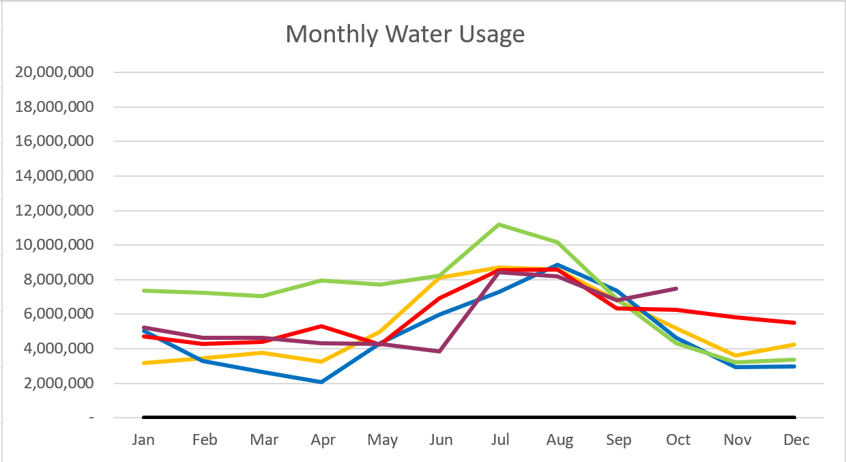

2023 – Purple
2022 – Red 2021 – Yellow
2020 – Blue 2019 – Green

October 2023

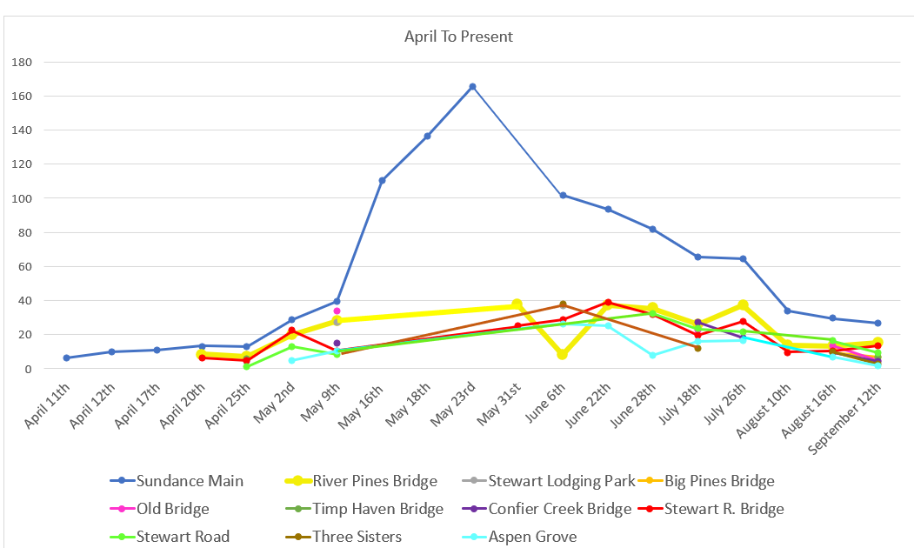

Water Department Information for October
- Our overall water consumption is higher than compared to past years.
- Aspen Grove wet-well levels are averaging 7.74 feet for October 2023 which is down from last month. This time last year for October 2022, our average was 5.70 feet. The average is 2 feet higher this year compared to last.
- Unaccounted water
  - Upper Pressure Zone
    - We will have more accurate number next month. We had the source meters calibrated.
  - Lower/Stewart Zone
    - Our team has been replacing meters as we get them in. Doing a fantastic job! We are starting to put in cellular endpoints as we get them.
- Stewart Spring rehab is 100 percent complete.
- Infiltration Sampling has begun. Once a month for 6 months
- Endress Hauser did a verification/calibration check on the meters at the Stewart Tank and Conifer Tank
- Sundance master meters are installed.

Wastewater Department Information for October
- We have three labs for October. BOD was over limits on one of the labs. Rest was within limits.
- The Plant upgrade is moving forward we are at the 60% design should be done in the next week.
- Working with Sundance to get the drain field radio back up and running.
- Plant is running great still operating on one side.

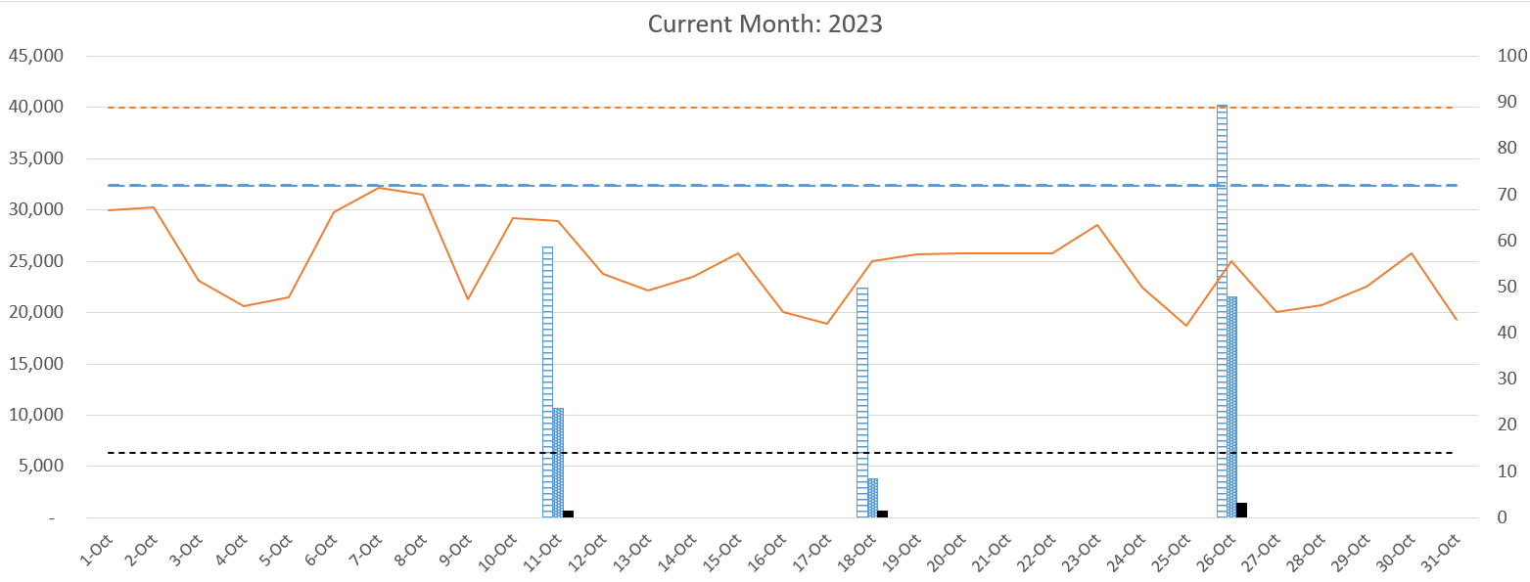

AVERAGE DAILY FLOW (GPD) | 24,641
HIGHEST DAILY FLOW (GPD) | 32,206

