State of Utah
Department of Workforce Services Office of Homeless Services

United States Department of Housing and Urban Development (HUD) Pathways to Remove Obstacles to Housing (PRO Housing) Application

Table of Contents
Exhibit A: Executive Summary 3
Exhibit B: Threshold Requirements and Other Submission Requirements 5
Exhibit C: Need 7
Exhibit D: Soundness of Approach 15
Exhibit E: Capacity 24
Exhibit F: Leverage 28
Exhibit G: Long-term Effect 30
Attachments
Attachment A: Comments
Attachment B: 424-CBW PRO Housing Final Budget Attachment C: PRO Housing Certifications Attachment D: HUD-LLL
Attachment E: Verification of Leverage Letters

Exhibit A: Executive Summary

State of Utah
Department of Workforce Services Office of Homeless Services

Throughout the state of Utah, there are countless efforts being made to address and mitigate affordable housing barriers. Over $100,000,000 have been awarded across the state by The Department of Workforce Services Office of Homeless Services (DWS-OHS) in the past two years for the acquisition, construction, and rehabilitation of deeply affordable housing projects through the Deeply Affordable Housing Fund, which is the first program of its kind in the state. Preservation efforts are being conducted by the Utah Housing Preservation fund, and have saved 650 units from reverting to market-rate, and another 550 will follow suit in the next few years.
Additional ventures are being conducted by other State-based agencies, developers, and nonprofits in every corner of the Beehive State.

Despite these efforts, data shows that there is still a deficit of over 70,000 in deeply affordable housing options, which creates a strain on individuals and families across Utah. Similarly, there is a risk of losing over 3,000 affordable units in the next five years as the result of concluding deed restrictions. These stressors, among many others, are more apparent in rural communities where developers and agencies have little to no capacity, land or funds to produce or preserve units effectively. Even so, rural communities are often the least assisted or informed on opportunities to improve their housing market.

DWS-OHS proposes to use PRO Housing funds to pilot the Utah Housing Development Program, whose sole purpose is to bridge the gaps that have been identified through community outreach, statewide studies, and active initiatives by local agencies. DWS-OHS also proposes to use a portion of PRO Housing funds for land banking in an effort to reduce costs for developers and to pinpoint spaces that would be best for affordable housing. Lastly, a portion of the funding will be for the implementation of Transfer of Development Rights (TDR) workshops, which will aid in the long-term preservation of affordable housing. Although there are numerous barriers, we have found that the most common obstacles include: zoning concerns, land acquisition, objections from local officials, lack of structured support for affordable housing preservation, gaps in funding, and inadequate information on how to make affordable housing projects a reality. These most common barriers can be overcome through the creation of this program.

The success of the Utah Housing Development Program will create the groundwork for streamlining affordable housing development across Utah. This program will be the first of its kind at the State level in Utah and will create further collaboration between local leaders and on- the-ground agencies who are working diligently to create a positive impact on making Utah an affordable state to call home.
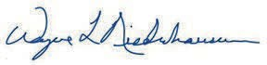
Tricia Davis Wayne Neiderhauser
Assistant Director State Homeless Coordinator

Exhibit B: Threshold Requirements and Other Submission Requirements

State of Utah
Department of Workforce Services Office of Homeless Services

The State of Utah and this application comply with the threshold requirements listed in the NOFO.

Resolution of Civil Rights Matters
The State of Utah does not currently have any outstanding civil rights matters.

Timely Submission of Applications
The submission of this application will be done prior to the established deadline of November 6, 2023 at 11:59:59PM Eastern time.

Eligible Applicant
The State of Utah is categorized as a State government, and therefore is an eligible applicant in reference to the PRO Housing NOFO.

Number of Applications
This application is the only one that will be submitted by the State of Utah in reference to the PRO Housing NOFO.

Other Submission Requirements
This application meets the National objective of benefiting low- and moderate-income persons

All activities outlined in the application and budget are eligible according to the requirements laid out within the NOFO

The State of Utah is not applying for any waivers to the NOFO requirements at this time, but may request waivers related to program implementation according to the standards outlined within the NOFO.

As outlined in the narrative of this application, advancing racial equity and affirmative marketing of projects supported by these funds will be a key component of all activities performed.

Exhibit C: Need

State of Utah
Department of Workforce Services Office of Homeless Services

The State of Utah is a strong advocate and supporter for the development of affordable housing, especially as the demand and deficit have steadily increased in recent years. The state’s joint and collaborative effort to recognize and minimize barriers to affordable housing is prevalent, as exemplified throughout this application.

Our agency, the Department of Workforce Services Office of Homeless Services (DWS-OHS), is taking the initiative to support the acquisition, construction, and rehabilitation of rental units for individuals and families whose income is 30% or below the area median income (AMI), better known as deeply affordable housing. In the 2022 General Legislative Session, $55 million was awarded to DWS-OHS, which inaugurated the Deeply Affordable Housing Fund (DAHF). With these funds, 18 agencies were awarded that helped in creating 1,159 affordable housing units–
of which 693 are deeply affordable and 572 are dedicated to households experiencing homelessness.

In the 2023 General Legislative Session, DWS-OHS was allocated another $47 million that was awarded to 15 projects to create 453 affordable housing units– of which 363 are deeply affordable and 311 are homeless-dedicated. Additional units within these projects were dedicated to domestic violence survivors, homeless or at-risk youth, those diagnosed with substance use disorders (SUDs), and those with mental, physical, or behavioral health conditions. In an effort to preserve the affordability of these units, all grantees were required to have a 50-year deed restriction. For the 2024 General Legislative Session, the Office of Homeless Services has requested an additional $50,000,000 in development funding for the purpose of creating deeply affordable housing.

DWS-OHS was also allocated $5,000,000 in the 2023 General Legislative Session towards the Attainable Housing Grant (AHG) program, which provides a monthly project based rental subsidy and allows properties to provide case management services and deeply affordable rental units. During the first round of the Affordable Housing Grant, six projects were awarded, solidifying 134 units of deeply affordable housing. Another round of the AHG will be conducted in mid-November to allocate the remaining funds that were not yet assigned. For the 2024 General Legislative Session, the Office of Homeless Services has requested an additional and an additional $15,000,000 for Attainable Housing Grant project based vouchers.

One of the most vulnerable populations that are in need of deeply affordable housing are those who are at risk of or are currently experiencing literal homelessness. DWS-OHS works to collaborate and provide support with each regional community of homeless providers, known in Utah as Local Homeless Councils (LHCs). This includes the implementation of the State’s Homelessness Strategic Plan. One of the goals highlighted in this plan is to “Expand homeless prevention efforts by increasing coordination, resources, and affordable housing opportunities.” This effort further conveys the need for more housing options for those who fall within these

categories. The State Strategic plan was created with the support of multiple state agencies, local governments, and nonprofits.

Other Utah State departments play a crucial role. Rob Terry works as the Statewide Land Use Training Director for the Office of the Property Rights Ombudsman. His office provides statewide training for land use laws, and receives $1.4 million in recurring funding created by a real estate transaction tax. Additionally, the Department of Workforce Services Housing and Community Development team (DWS-HCD) provides affordable housing tools for tenants, landlords, and developers. This includes three different services: The Olene Walker Housing Loan Fund (OWHLF), which helps to develop affordable housing to very-low, low, and moderate-income households; the Section 8 Landlord Incentive Program, which provides financial assistance to landlords to mitigate damages caused by tenants under the HUD Housing Choice Voucher (HCV) Program; and lastly, the Commission on Housing Affordability, which analyzes data and collaborates with other agencies to identify housing needs, gaps, and opportunities. Outside of these recurring services, DWS-HCD also awarded Evision Utah with funds to conduct research on barriers and solutions to affordable and attainable housing. This report calls attention to what progress Utah has made thus far, and recommends actions that state, regional, and local governments can take to increase the amount of affordable units in their respective communities.

One study conducted by the National Housing Preservation Database reports that 3,173 publicly supported rental homes are at risk of being lost in less than five years due to expiration of affordability deed restrictions; 7,218 of these types of homes are at risk of loss in less than 15 years. One organization that is paving the way to mitigate this issue is the Utah Housing Preservation Fund (UHPF). Their mission is to “preserve Utah’s existing affordable housing through the purchasing, remodeling, and the rent-stabilization of housing units.” As of early 2023, UHPF has preserved 650 affordable housing units. In March of this year, UHPF received a
$10 million investment from the State (that will also be matched by philanthropic entities). This funding will help preserve an additional 550 affordable housing units over the next three years.

The Utah 2023 General Legislative Session provided more resources for further development of affordable housing. H.B. 406 helped to further standardize rules for land use and development. This included improved development agreements and standards, annexations, and moratoriums, which provided more uniformity in the overall development process. H.B. 364 “modifies provisions related to the moderate income housing reporting requirements.” This bill also created a fixed State-funded Low Income Housing Tax Credit LIHTC cap of $10,000,000.These state tax credits are combined with the federal Low Income Housing Tax Credit application process to create more capital funding for affordable housing projects. S.B. 174 provided revisions to the Local Land Use and Development Act, which included a more simplified subdivision process, as well as a penalty system for cities and counties that did not submit a moderate income housing

plan. This penalty involves paying a fee of $250 per day for the year they are non-compliant; these funds would be allocated to the aforementioned Olene Walker Housing Loan Fund.

Moderate income housing, as outlined in the Utah Code of Amendment sections 10-9a-103(40) and 17-27a-103(43), is defined as “housing occupied or reserved for occupancy by households with a gross household income equal to or less than 80% of the median gross income for households of the same size in the county in which the city is located.” The moderate income housing plan is part of each community’s general plan, which outlines the framework for growth in a neighborhood over an established amount of time. The Utah State Department of Housing and Community Development oversees that these plans are submitted, and condenses the data to an accessible, public format. These reports consist of 95 different entities who establish multiple strategies to improve moderate income housing in their local areas. Among the most common include Strategy E (82 entities), which is to “create or allow for, and reduce regulations related to, internal or detached accessory dwelling units in residential zones,” and Strategy B (62 entities), which sets to “zone or rezone for higher density or moderate income residential development in commercial or mixed-use zones near major transit investment corridors, commercial centers, or employment centers.”

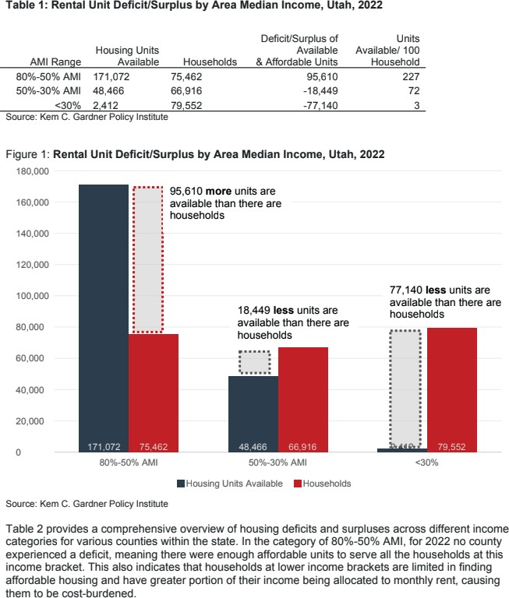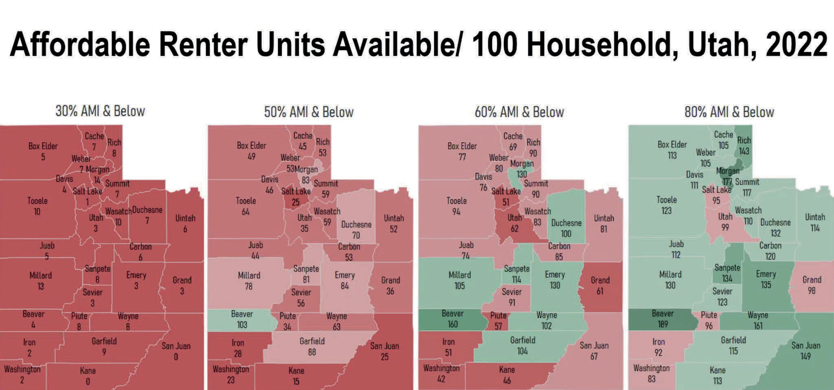
The State of Utah has a dire need and high demand for affordable housing, especially for rental units at 30% AMI and below. A recent study (2022, Kem C. Gardner) broke down the number of affordable rental units available per county per 100 households.

The data shows that every county within the State of Utah has a shortage of deeply affordable units. As of last year, the current statewide deficit of units at 30% AMI or below was 77,140 units, with only three for every 100 of those units being actively available to the community. This need is also echoed through the amount of requests received from the last two rounds of DWS-OHS’ Deeply Affordable Housing Fund (DAHF). In the 2022 round of funding for DAHF,
$55 million was available, and a maximum total of $168,066,168 was requested from 27 applicants. In the 2023 round, $47 million was available, and $105,911,906 was requested from

21 projects. The number of applicants as well as the amounts requested demonstrates a dire need for deeply affordable housing and community support.

The need for affordable housing is also supported by the 2023 “Annual Data Report on Homelessness” conducted by the Utah Office of Homeless Services. As indicated in the report, “In Federal Fiscal Year (FFY) 2022, a greater number of Utahns were affected by homelessness compared to previous years. Data from the Utah Homeless Management Information System (UHMIS) revealed a 10% increase in the count of individuals experiencing homelessness for the first time and a 5% increase among those who have experienced homelessness multiple times accessing services during the reporting period. The 2023 Point in Time Count (PIT) also confirmed this rise, with 10.9 out of every 10,000 Utahns identified as experiencing literal homelessness on a single night in January. This rate is higher than the 9.6 out of 10,000 Utahns reported in the 2020 PIT…[It] is likely that structural challenges, such as rising living costs and the lack of accessible and affordable housing, contribute to the difficulty Utahns face in both preventing and exiting homelessness.” The graphs below reflect these trends over the past five years.

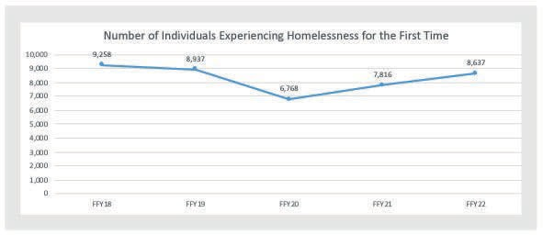
Number of Individuals Experiencing First-Time Homelessness
PIT: Total Homeless Count
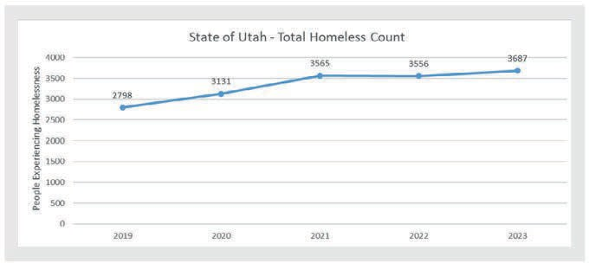

There are multiple barriers that are prevalent within the State of Utah. Thorough outreach was conducted amongst the identified high priority county service providers and affordable housing developers, as well as several other local government staff and community members.
Discussions amongst these entities surrounded the topic of affordable housing barriers, and what they would need to minimize or eliminate these obstacles.

From a development perspective, a common concern involved the lack of available and correctly zoned land. In addition, developers are uninterested if there is no incentive or would not make a profit from an affordable housing project. They instead will shift gears to more market-rate level projects that will have a more guaranteed return on investment. The financing pieces of creating affordable housing can be difficult as well. Low Income Housing Tax Credits (LIHTC) have their own provisions in place when applying which include restrictions that encourage larger projects, rather than smaller-scale duplexes or homes. There is also a severe lack of non-loan based funding options, which reduces the chances of making any profit in low-income housing unless there are mixed rates within the building itself. Many stakeholders that DWS-OHS spoke with mentioned that they would prefer to have a more community-minded and holistic approach to the design of housing in their community. For example, a community that only has 30,000 residents in the entire town does not need a 60-unit market-rate highrise apartment complex.

From a tenant perspective, there are a lot of barriers centered around the strict requirements set in place by landlords across the state. Such restrictions include: an income requirement of three times the rent, automatic denials for any criminal or eviction history, and instant denial or required double deposit based on a lower credit score. Individuals and families often struggle to meet all these requirements, especially in a post-pandemic world, and those with housing vouchers who can financially afford these units are also turned away if the standards set by landlords are not perfectly met. It is due to this unshifting position taken by the landlords in these communities, where there is already an extremely limited housing inventory, that many of the members of that community are left unassisted. This is largely due to the fact that landlords will simply take the best tenant on paper, rather than offering someone a second chance. In the State of Utah, there is also a severe lack of tenant rights that leave many locals without legal resources or a choice in how they are treated by landlords and the courts during eviction proceedings.

One of the most vulnerable populations that struggle with finding and securing affordable housing are those experiencing homelessness. Winters in Utah are known to be notoriously harsh, and individuals are forced to come up with desperate measures in order to survive. Access to outreach services is especially difficult during this time of year as individuals may have been focused to abate their typical camp and flee the area, creating displacement in other cities. Many temporary solutions have been developed for this population, such as motel vouchers and

overflow spaces, but a long-term solution for these individuals is accessible and affordable housing.

Individuals who are actively in recovery also experience barriers to housing. Those who have been ordered to attend a ‘Drug Court’ format for the foreseeable future are forced to live outside during that intermittent time between when they have their last court date and move into housing. This adds to the rigorous and stressful program they have already joined through the courts.
Transitional housing is greatly needed for the above-mentioned situations in these communities. These units would allow the clients to stabilize long enough to find potential employment as well as providing the essential space to think critically in order to plan the next steps for their future.

Envision Utah is a non-profit that was selected by the Department of Housing and Community Development to receive $250,000 to conduct research on the best practices to reform zoning and housing regulations. This funding for the study was awarded in the 2022 General Legislative Session with the goal to further increase efforts towards housing attainability and affordability in the state. One of the key takeaways from this analysis was that there are a myriad of limitations and restrictions in reference to zoning laws. Envision Utah’s report, which studied 14 counties and 21 cities across the state, highlights:

“...local zoning ordinances often make it illegal to build anything other than single-family homes on large lots in residential zones segregated from city and employment centers.
Other product types are often built in planned community or planned unit development zones under site-specific development agreements, leading to an increasing variety of housing types. These kinds of zones often work well for larger developers and can lead to well-planned development, but approval is subject to the discretion of a council or commission, which adds significant uncertainty, deters many small-scale landowners and builders, and often results in a negotiated reduction in units.”

The monopoly of larger-scale developers prevents smaller agencies and entities from working on beneficial affordable housing projects. As a result, these potential plots of land are utilized to build market-rate apartments which is unattainable for a large percentage of Utah residents.

While all of these aforementioned obstacles need to be tackled, the most common concern entities had was the necessity for further capacity, resources, and knowledge to take the first steps towards affordable housing development and preservation. Multiple stakeholders stated if they had a designated contact, who could be the guide to navigate the development process step- by-step, it would result in a more streamlined process and lead to increased affordable housing, especially in rural communities.

Exhibit D: Soundness of Approach

State of Utah
Department of Workforce Services Office of Homeless Services

Of all of our office’s conversations with entities throughout the state, there were two common topics of concern: agency capacity and land availability. Agencies reported the lack of staffing and capacity required to initiate housing projects, despite the need for affordable housing units in their area. Additionally, agencies who potentially had capacity were unable to initiate affordable housing projects due lack of available land options for development. Our vision is to utilize this program to focus on the obstacles that prevent sufficient deeply affordable housing from being created within the state. This will begin the monumental task of closing the gap between the number of Utahns at 30% AMI and the number of affordable housing units available to the community.

As a result, the State of Utah is requesting $5,290,132 in PRO Housing funds. Our vision is to utilize $1,540,652 of the funds to establish three key staff positions that would be the pioneers of the Utah Housing Development Program (UHDP) for a minimum of five years. This program would bridge the gap between affordable housing ideas and make them a reality. These three proposed positions will be the guiding forces in helping agencies create affordable housing in their communities at any needed level of support, during any point of the development process. This team will also help to establish the creation of deeply affordable transitional housing, which is needed in certain communities that cannot easily establish permanent affordable housing but could quickly create transitional housing. Each employee would have a collective caseload of projects and collaborate to provide on-going technical assistance both during project development and after the project’s completion. Although the specifics of the positions’ process are subject to change to best fit community and capacity needs, an outline of the respective job duties of those proposed positions would be as described. When an agency reaches out to UHDP with a project they are working on, an introductory evaluation and discussion would be conducted. This would help to gauge where the project is at and what level of support is needed. Some examples of a lower-support project may include assistance with gap financing, barriers mid-development, and conflict with local officials regarding support of the project. Some examples of higher-level support may include assistance with starting development, budgeting, land acquisition, staffing, or first-time agencies that are creating affordable housing.

Based on the level of support identified, UHDP will create a timeline with the agency, with the goal being project completion. This timeline may range from a few months, up to a few years. Goals and itemized tasks can be set at a pace that works best for the agency, and can be adjusted as needed. Collaboration with other agencies would also be encouraged, where UHDP can act the supporting intermediary. The team would conduct meetings both virtually and in-person, and re-evaluate goals as needed if projects are falling short of their deadlines. If the agency is identifying obstacles with development, city officials, or citizens in neighboring areas, UHDP can act as an in-between to help educate and answer questions on the project, and its essential benefits to the local community.

The three proposed positions on the Utah Housing Development Program team would consist of one State employee that focuses on the technical assistance (TA) and mediator element of the process, another State employee whose expertise would fall within the development realm of responsibilities, and a third state employee whose focus would entail consulting services. All three positions would work collaboratively to best benefit the client(s), and many job duties will be shared outside of specific assignments to create a healthy and manageable work balance. If awarded, the Office of Homeless Services would submit requests to the State Legislature for funding to continue the program beyond the initial five years.

$3,230,000 in ask would be utilized for land banking and specialized consultant costs. The State of Utah would identify at least one parcel of land in each prioritized geographical area, if not more, to help secure locations for affordable housing development. These plots of land would be purchased by the State of Utah and offered to those working on affordable housing projects at no cost in an effort to reduce their budget costs and needs. Long-term land leases would be in place with the developers to guarantee long term affordability of the parcels for at least the next 99 years. By purchasing the land, the State of Utah could avoid zoning and land use restrictions that would otherwise take time and money to navigate.

This vision was further solidified after reviewing and speaking with organizations who have similar efforts in place. The Housing sector of the Rural Community Assistance Corporation (RCAC) helps to finance, develop, and operate affordable housing programs in many states across the West Coast, including Utah. However, upon conversing with one of their staff in a virtual meeting, their services are not as utilized in Utah, and having a more centralized and state-specific program would best benefit rural areas. Our office also had a discussion with BeauxSimone Consulting, who offers training, TA, and project development to rural, urban, and tribal communities within and around Colorado and neighboring states. One element of their organization is providing a Pathways Home Toolkit, which provides “technical assistance and peer learning sessions designed to help non-profits, housing authorities, and service providers increase the number of permanent supportive housing units available in their community.” This toolkit sets a great example of how this program can be successful within the State of Utah with the right staffing, accessibility and connection to resources.

Use of third party consultants during the first two years of this program will build a solid foundation for how the UHDP will operate over the initial five years of the program.

The Department of Workforce Services Office of Homeless Services’s (DWS-OHS) plan is to provide services to any area within the State of Utah, though there will be heightened focus on those within rural areas and identified by HUD as a prioritized geography. These focused areas include, though are not limited to, Daggett County, Morgan County, Summit County, Wasatch County, and Washington County. Additional focus will be placed on identified prioritized cities

via HUD. Our goal is to identify at least one entity (or a collaboration between multiple entities) within these identified counties or cities, and assist them in creating a deeply affordable housing project to benefit local residents. By initiating a housing project within the identified prioritized areas, it creates a groundwork for creating more affordable housing projects in these areas that typically may be discouraged due to the continual barriers they face in the process.

One way to initiate further discussion of affordable housing projects in these prioritized areas is through Utah’s Associations of Government (AOGs). DWS-OHS has conducted outreach to AOGs for the purpose of this application to discuss what affordable housing barriers and progress they have made in their respective communities. This pathway can also be made through Utah’s Local Homeless Councils (LHCs). DWS-OHS participates in each LHC meeting in every region of the state. This opportunity for State-backed housing development assistance would be advertised at these meetings, and LHC representatives could then discuss what projects they would hope to create within their communities.

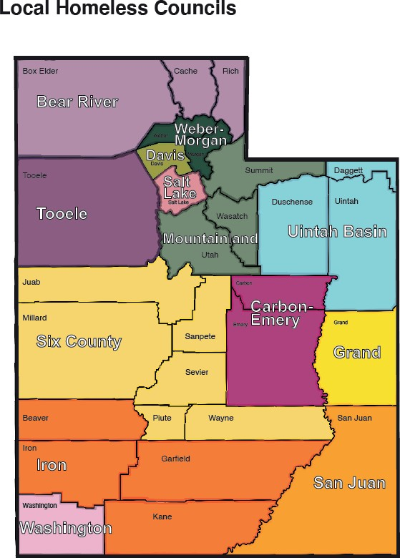
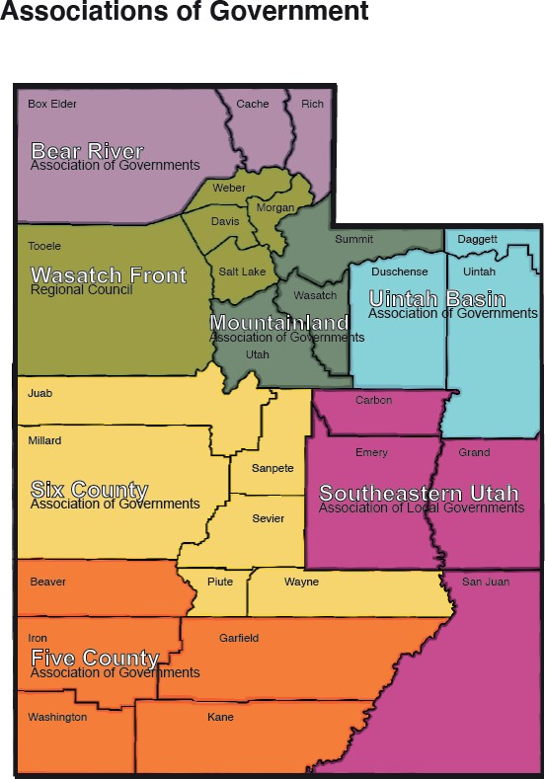

The Department of Workforce Services Office of Homeless Services (DWS-OHS) has engaged in multiple conversations with entities across Utah. These parties include Local Homeless Councils (LHC), Associations of Government (AOG), housing developers, housing authorities, and state agencies.

Local Homeless Councils, as described on the DWS-OHS site, “...are counties or groups of counties…and are the designated local oversight bodies that are responsible for developing a common agenda and vision for reducing homelessness in their respective regions, developing a spending plan that coordinates the funding supplied to local stakeholders, [and] aligning local funding to projects that improve outcomes and target specific needs in the community.” Our office meets with the LHCs on a monthly basis with further outreach conducted to specifically discuss affordable housing barriers that are identified within their respective areas. Outreach initially was conducted via a Google Forms survey, with a follow-up meeting with LHC leaders to discuss the results and provide a space for additional feedback. DWS-OHS received input via surveys from LHC leaders overseeing multiple areas including: Daggett, Duschense, Uintah, San Juan, Davis, and Summit, Wasatch, and Utah counties. These areas also engaged in the virtual meeting, with additional input from both high-density counties (i.e. Salt Lake County) and less-populated counties (i.e. Grand County). During the virtual meeting, all LHC leaders involved expressed their support for DWS-OHS’ application and their hopes that these discussions on housing barriers become an important part to bettering the state’s housing market in the future.

The Associations of Government, as defined by Six County’s AOG website, “...were formally established in the early 1970’s to (1) provide a common forum to identify, discuss, study, and resolve area wide problems, (2) to achieve advantages of cooperative action which cannot be achieved individually and to make the most effective use of local leadership and staff resources,
(3) to provide local input into state programs which are undergoing increasing decentralization to a regional level, (4) to serve as a multi-purpose ‘umbrella-type’ organization to engage in and carry out planning and development programs with respect to existing and emerging problems of industry, commerce, transportation, population, housing, agriculture, public services, local governments and any other matter which are relevant to the Association’s purposes, (5) to maintain liaison with members, governmental units and groups of organizations, and to serve as the regional voice for local governments; and (6) to perform such other functions as may be deemed necessary under the direction of local elected officials.” Outreach was conducted via Google Forms to engage with AOG officials, and responses were received from three of the seven AOGs who oversee Carbon, Emery, Grand, San Juan, Summit, Wasatch, Utah, Beaver, Iron, Washington, Garfield, and Kane Counties.

Conversations were also had via virtual meetings with a multiple of different housing developers and similar-acting nonprofits. These organizations include: Ivory Innovations, BeauxSimone, and Rural Community Assistance Corporation. All entities offered support or resources in providing information, as well as gave DWS-OHS insight on the work that they do and what has been successful (either within or outside of Utah) thus far. Engagement with housing authorities located throughout Utah was conducted through a recently established quarterly meeting to discuss overall updates and concerns that need to be addressed. In their second meeting, DWS-

OHS presented their concept for this PRO Housing application and received unanimous support. Lastly, DWS-OHS engaged in early discussions with the Housing and Community Development (HCD) team to gain insight on their efforts towards the creation of affordable housing, such as the monitoring of the Moderate Income plans submitted by officials across the state.

Input from the entities above were incorporated through this application, in areas that were most applicable to the prompt. Our office’s efforts and requests for input on the needs of affordable housing do not end after the completion of this application. We hope to continue these conversations, regardless of whether funding is awarded, to help pinpoint how LHCs and the State can work collaboratively to tackle the prevalent barriers to housing.

As per the Kem C. Garner study, one of the greatest needs is deeply affordable housing, which specifies units for those at 30% AMI or below. A previous study from this institute also noted that 76% of Utahns are unable to afford a median-priced home, making housing opportunities extremely limited. Utah’s population, per the last Census, around 90% of residents identify as White, 1.6% as Black or African American, 1.5% as American Indian or Alaska Native, 2.8% as Asian, 1.2% as Native Hawaiian or Other Pacific Islander, and 15.1% as Hispanic or Latino.
However, there is a disparity between the breakdown of race, and the percent of minority groups experiencing poverty. According to KFF.org, Only 7.1% of White households are experiencing poverty compared to 21.1% black households, 11.6% Hispanic households, 6.7% Asian, Native Hawaiian and Pacific Islander households, and 35.9% American Indian and Alaska Native households. The deeply affordable housing units that will stem from the creation of Utah Housing Development Program’s (UHDP) support will primarily focus on serving those who fall within the 30% AMI and below range. By focusing on those who have extremely low incomes, we will address the increased demographic disparity present within this group.

In order to promote desegregation, one requirement of agencies engaging with UHDP will include the documentation of demographic information for clients in affordable housing units, as well as the documentation of supportive services to ensure resources are distributed equitably.
By requiring this reporting mechanic, UHDP can discuss any discrepancies or discrimination in services that may occur, though restrictions and guidelines set by the team will be provided prior to minimize chances of such discrimination occurring in the first place.

One concern identified by this PRO Housing NOFO is the concentration of affordable housing in low-opportunity areas, or in spaces where there is ample supply of such housing. One of the essential pieces of UHDP working with agencies is that the project in question benefits the community, while minimizing or eliminating the negative impacts in the neighboring areas. This includes creating a focus on areas that have more limited affordable housing opportunities, and looking at nearby amenities such as public transit, employment opportunities, and grocery stores.

Another UHDP goal for developing affordable housing is the accessibility to supportive services to its tenants. If an entity has no case management background, UHDP can connect them to local non-profit organizations that have knowledge in providing these vital services. The combination of affordable housing and case management are key to a tenant’s long-term success and growth. There will be increased focus on how individuals with disabilities will access the housing services for specific projects supported by UHDP. As part of the Department of Workforce Services, UHDP will have a strong connection with the Utah Department of Health and Human Services, Division of Services for People with Disabilities (DSPD). Through UHDP’s interactions with projects, we will be able to connect them with existing services provided by DSPD.

In regards to displacement, the risk has been considered and is important to keep in mind when developing affordable housing projects. One strategy by Salt Lake City entitled “Thriving in Place” provides an amazing outline for how to minimize gentrification and displacement. These efforts can be kept in mind when UHDP works on housing projects across the state. In addition to anti-displacement strategies, the Office of Homeless Services (OHS) ensures that all entities and grantees that work with the department follow fair housing practices, and that fair housing rights are a mandatory item to be provided and reviewed with all tenants. OHS also has rapport with the Disability Law Center, and could collaborate with them further to assist with project compliance in reference to ADA laws and requirements. Lastly, to ensure accessibility of UHDP assistance to as many protected classes and entities as possible, preference will be given to minority-, women-, and veteran-owned applicants to encourage their engagement in the program.

Progress towards advancing racial equity in all UHDP supported projects will be measured by using project and client level data. Whenever possible and applicable, projects whose development is supported by the UHDP will use the Utah Homeless Management Information System (UHMIS) or other applicable tracking database to track who they are serving. Utilizing a common set of databases will allow UHDP to see the different racial and demographic information for households that the projects assist and ensure that disparities in any specific group can be addressed through better tenant selection and advertising practices.

Using existing UHMIS data, we can see exactly who is presently accessing existing homeless dedicated housing resources in a community, as well as who is experiencing sheltered and unsheltered homelessness. Trends in these groups reflect who is eligible and in need of deeply affordable and affordable housing.

The UHDP will also coordinate with local advocacy groups that focus on the needs of Utah members of BIPOC and LGBTQ communities to remove barriers to access that these groups face. It is difficult to anticipate the specific barriers that will exist after reviewing the data outlined above and working with projects to change their marketing and access points. By

coordinating with these groups even after the projects are open, UHDP will ensure that everyone that needs these facilities will be able to access them as easily as possible.

These demographic breakdowns are important when looking at the racial equity of affordable housing programs, as we believe that comparing just the general population racial and demographic breakdown to who is being served by a program does not accurately reflect what the need is. For example, using the latest HUD Racial Equity Analysis Tool we can see that Salt Lake County has a general population that is 2% black, but those in poverty are 6% black, and those experiencing homelessness are 12% black. We see the same trend when looking at ethnicity as well, with 23% of those experiencing homelessness are Hispanic but the general population of Salt Lake County is 18% Hispanic. Being aware of the discrepancy between the population as a whole compared to individuals that are most in need of affordable and deeply affordable housing will help programs identify how they can change to meet the needs of their communities.

The State of Utah has outlined a budget for three different award scenarios and has been broken down based on being awarded at 30%, 60%, and 100% ask. These scenarios are outlined below from lowest to highest amount.

The full scope of the proposed project is the creation of the Utah Housing Development Program (UHDP). This program would comprise of three State of Utah, Office of Homeless Services staff that would oversee all communities across Utah, with a special focus on high demand areas identified in the PRO Housing NOFO. In addition to these three positions, the program includes costs for travel across the state in a State of Utah owned vehicle, costs for a statewide consultant to assist with highly technical training for agencies to address community specific barriers, and funds to start a rural Utah land bank owned and operated by the State of Utah. A portion of these funds will also help to implement a Transfer of Development Rights (TDR) workshop, which is further outlined in the sections below. Please see the included budget, form 424-CBW (Attachment B), for a detailed breakdown of costs.

At about a 30% ask, the State would be able to support all three UHDP staff positions over the course of five years. The State believes that having these positions is vital to ensure the success of clients’ projects. The Office of Homeless Services would still request ongoing funding from the legislature for these positions before the five-year period ends to ensure its sustainability.
Despite the security of the UHDP team, this significant drop in awarded funding would prevent the purchasing any parcels of land for the purpose of this program. A common concern that was reported, especially throughout rural communities, was the lack of land available for development, which creates a massive roadblock towards creating deeply affordable housing opportunities.

At about a 60% ask, this would include UHDP’s five year security, along with a couple of essential additions. The State of Utah would be able to secure three different land parcels and provide them to identified agencies at no cost through long-term land leases. By purchasing the properties and holding that land as state-owned, local zoning ordinances would not be enforceable. UHDP staff would work with local municipalities to comply with ordinances whenever possible, but the flexibility of using state land for the developments would ensure projects could be created in areas that otherwise would not allow affordable housing development. This increase in funding would also permit the execution of Transfer of Development Rights (TDR) workshops across the state.. These workshops will be offered five times a year over the course of at least five years, and would educate cities and developers on how the process of TDR. This specific concept was recommended by Salt Lake City during the public comment period. TDR increases the capacity of municipalities to develop affordable housing in certain areas without compromising a long-term housing master plan or making major changes to zoning standards. This highly technical process is best trained through specialized, focused workshops led by experts in this area.

At a 100% ask of $5,290,132, the State would utilize the additional $2,116,052.80 would provide and additional seven parcels of land to provide for the purposes of this program. This would permit UHDP to be able to keep a stronger focus on rural areas, and increase the amount of projects implemented in prioritized geographic areas.

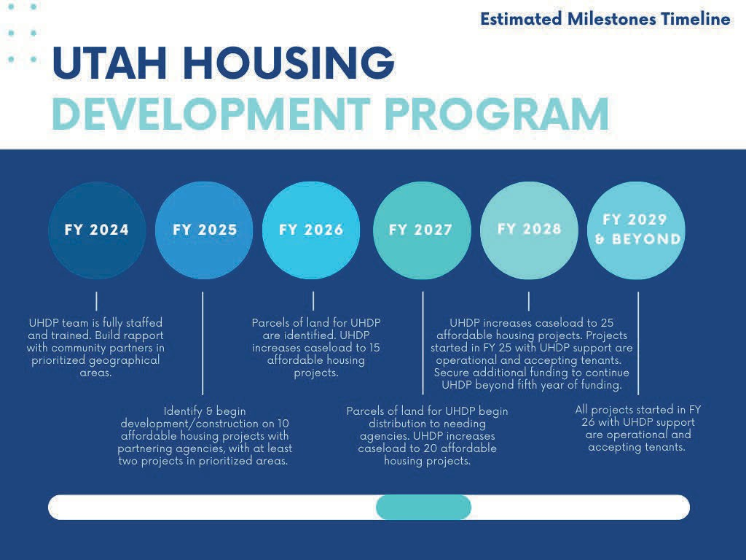
The Utah Housing Development Program’s goal is to have collaborated projects begin their development or construction process by the end of FY 2025, with those projects coming alone no later than end of FY 2028. This three-year timeline for projects to come to fruition will remain consistent throughout the UHDP. The milestone timeline below further explains our expectations, along with additional milestones in reference to acquiring land for further housing opportunities.

Exhibit E: Capacity

State of Utah
Department of Workforce Services Office of Homeless Services

Per our department’s website, The Department of Workforce Services Office of Homeless Services (DWS-OHS), “allocates funds from federal and state sources through a competitive grant application process. The office not only provides assistance in delivering homeless services but also facilitates the coordination of such services across the State of Utah.” In the past two years, the Office of Homeless Services has also added an entire housing team that administers funding related to affordable housing development, including overseeing the funding process for over $105mm in development capital, a state funded housing voucher program, and federal HOME-ARP development dollars. DWS-OHS also coordinates closely with the State of Utah Housing and Community Development Division (HCD), which administers statewide CDBG, HOME, and HTF funding. Until 2020, DWS-OHS was nested within HCD but was moved to become its own division after state legislative action to allow our team to better focus on the needs of those experiencing homelessness.

DWS-OHS will add the Utah Housing Development Program (UHDP) and its staff as their own department. All three positions would be supervised by the Assistant Director. This organizational and departmental placement will be subject to change if a more suitable set-up is identified within DWS, or if an organizational transition occurs. This funding request creates the internal capacity to execute the UHDP pilot program via the creation of new positions. DWS- OHS currently comprises four separate teams: Homelessness Housing Funding, Data, Balance of State and Local Homeless Council Coordination, and Funding and Contracts.

Please see below the organization chart for DWS-OHS. The chart also reflects the structure for the three UHDP positions. The vacancy shown in the organization chart is classified as of the submission of this application; these vacancies may be filled in future readings of this application. Although this impacts the capacity of the Balance of State and Local Homeless

Council Coordination team, it does not have a heavy impact on the department as a whole, and therefore would not create any additional strain in the UHDP roles.

A benefit of the structure of DWS-OHS, all teams have consistent collaboration, and the Utah Housing Development Program team would have additional support and guidance from each team to be fully immersed in the department, as well as to have the needed resources to network
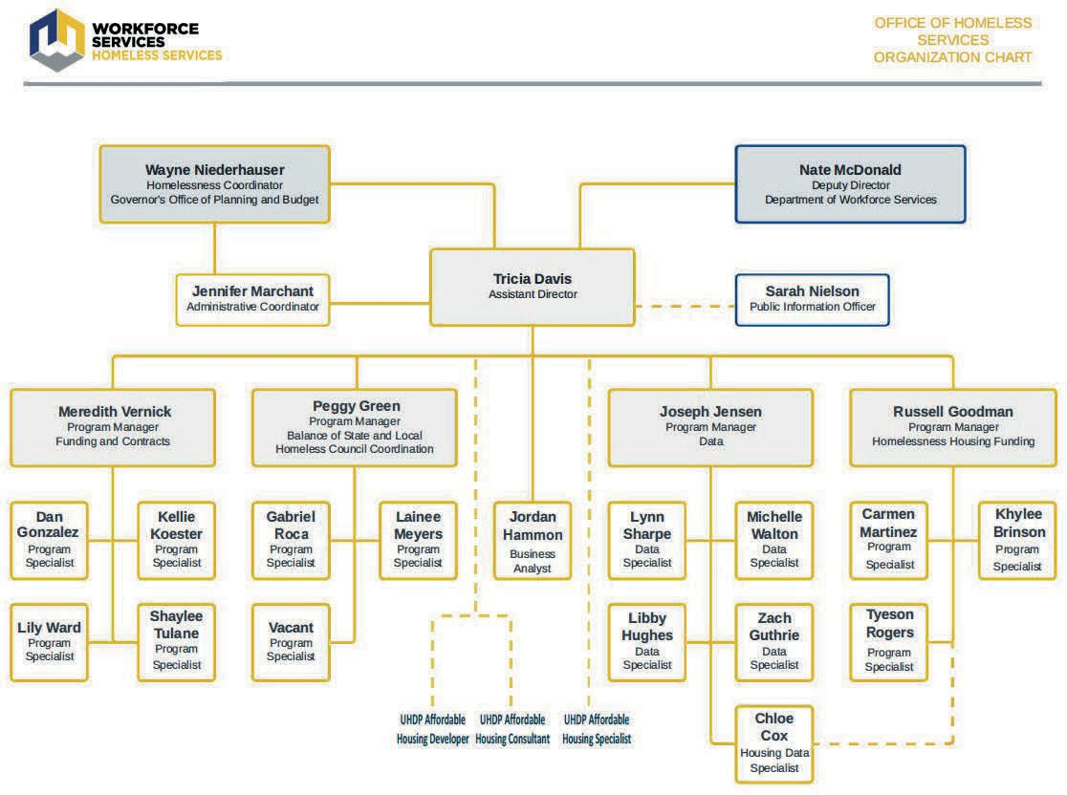
the program out to entities throughout the State. Balance of State and Local Homeless Council Coordination team regularly engages with Utah’s Continua of Care (CoCs) and 13 Local Homeless Councils (LHCs). This team would be vital in getting state entities aware of the UHDP, and encourage interested parties involved. Based on outreach discussions conducted for this application, there is active interest in working with UHDP, and compiling a caseload of clientele would be exponential. Additionally, the Homelessness Housing Funding team oversees the Deeply Affordable Housing Fund (Development and capital funding) and the Attainable Housing Fund grants (state funded housing vouchers) for the office, and in turn is also knowledgeable in both internal and external resources for funding housing projects.
Collaboration between this team and the UHDP can quickly expand the knowledge of resources (financial, developmental, and staffing, among others) to relay to UHDP clientele.

The Funding and Contracts team oversees funding sources for services for those who are actively or at risk of homelessness. These services include homeless prevention, rapid re-housing, diversion, transitional housing, permanent supportive housing, emergency shelter, and street outreach. Collaboration between the Funding and Contracts team with UHDP would increase involvement from non-profit homeless providers to create a strong movement for deeply

affordable housing to aid in our office’s goal of making homelessness rare, brief, and non- recurring. Lastly, the Data team oversees reporting and maintenance of the Utah Homeless Management Information System (UHMIS). This team keeps tracks homeless services across the state, conducts trainings and provides resources for HMIS-users, oversees federal and state reporting requirements (i.e. Point in Time Count, Housing Inventory Count, System Performance Measurements), which can be utilized in the Annual Data Report on Homelessness, and gathers data on a myriad of factors provided through the UHMIS database. Collaboration between the UHDP and Data teams are vital, as UHDP can utilize HMIS to monitor success of ongoing and completed housing projects (despite whether they were aided through UHDP), to improve on reporting, and minimize negative client outcomes (evictions, incarceration, etc.) Our State Homeless Coordinator, Wayne Niederhauser, can also bring up this new program in a legislative space as appropriate.

Our department has extensive experience working with and coordinating partners through the extensive number of contracts that have been awarded, assembled, executed, and monitored through their respective teams. OHS actively works alongside DWS’ Contract Analyst team to ensure proper construction and execution of contracts both awarded to our office, as well as those that are executed to subrecipients. Once contracts are executed with subrecipients, OHS engages with grantees for reimbursement claims, site visits, technical assistance, and monitoring, along with additional support in other areas as needed. One of the many items reviewed during the monitoring process is the verification of rights to fair housing documented in client files, and encouraging active fair housing practices to grantees.

In regards to the leadership capacity and legal authority to implement the UHDP, DWS-OHS leadership and Wayne Niederhauser would take lead to integrate the program into the office’s scope of work, and network the program throughout state entities, alongside the efforts to incorporate and advertise the program from a legislative to public level.

This PRO Housing application for the State of Utah was written by the Homeless Housing Funding team within DWS-OHS. This includes three program Specialists (Carmen Martinez, Khylee Brinson, Tyeson Rogers), and a Program Manager (Russell Goodman). Additional editing was provided by Zachary Guthrie, who works within DWS-OHS’ Data department. Kevin Goldthorpe with our Fiscal Management team also helped to assemble the budget portion of the application. All members worked efficiently and collaboratively to complete all sections of the narrative and additional documents.

Exhibit F: Leverage

State of Utah
Department of Workforce Services Office of Homeless Services

The Department of Workforce Services Office of Homeless Services has identified a few sources that will be utilized as leverage for this funding. One identified source is the funds for the Attainable Housing Program, totaling $5,000,000 annually. This money supports rental subsidies for 500 units per year, a portion of which will be in PRO Housing created projects as they come online. Another source of funding that supports the activities of the UHDP team is capital funding provided by a group of private philanthropists that will be used to support projects that are supported by the UHDP, totaling to $13,312,500. Both of these sources directly relate to the implementation of the program outlined in this application, as they provide the operating and capital costs needed to complete the projects developed by the UHDP and land banking programs. Finally the UHDP will have access to funds deposited into the Deeply Affordable Housing Fund, which provides development grants to projects serving households at or below 30% AMI. Currently the fund has around $105,000,000 in active grants and a request for an additional $50,000,000 will be considered in the 2024 Utah General Legislative Session.

An additional leverage has been identified through $1.4 million in annual funding created by a real estate transaction tax that is allocated to the Office of the Property Rights Ombudsman. This program provides training to cities, counties, non-profits, and private developers who are facing challenges to affordable housing development created by zoning and other local restrictions. The UHDP will coordinate directly with this program and provide additional specialized support to organizations that attend the different training sessions.

Please see Attachment E: Verification of Leverage Letters for more information concerning this funding.

Exhibit G: Long-Term Effect

State of Utah
Department of Workforce Services Office of Homeless Services

Within the initial five years of Utah Housing Development Program’s (UHDP) creation, the intention is to collaborate with a minimum of 25 affordable housing projects throughout the state, with at least 20% residing within the prioritized geographical and rural areas throughout the state. The Office of Homeless Services (OHS) also hopes to further promote self-sufficiency for other projects based on tactics and methods that prove successful from completed housing projects. Additional long-term goals include the formation of stronger connections between local officials and neighboring agencies, creation of more legislative support for affordable housing, and the minimization of the NIMBY (Not In My Backyard phenomenon) mentality through open forums and citizenship engagement.

On a citizen-based level, The UHDP intends to actively remove barriers while assisting marginalized, underrepresented, underserved and vulnerable populations to find affordable housing. Examples of these populations include those experiencing homelessness, refugees, asylum seekers, racial and ethnic minorities, and those with physical, mental, or behavioral impairments.

An obstacle that the UHDP program may face relates to the five year restriction of the program. As a proactive measure to ensure longevity of the program and its long-term successes, DWS- OHS would be prepared to request additional funds as a means to expand the program beyond this threshold. Another potential obstacle is the level of engagement and motivation from other entities taking part in the program. In the event that an entity drops out of, or strays from engaging with UHDP staff, the UHDP will take initiative to have a regulatory discussion and take immediate action to ensure that resources, time, and money are used efficiently. As discussed in the evaluation phase of the program, a timeline would be set on projects and can be reevaluated and adjusted accordingly to create attainable and realistic goals.

Communities across Utah face several environmental risks. A significant threat to consider is earthquakes, as the Wasatch fault, which is composed of ten segments, contains five that are considered active and could cause massive damage and displacement as a result. Another environmental risk considered is air quality, as the imposing pollution has long-term detrimental impacts on overall health and well-being of Utahns, especially for those experiencing homelessness. Our unhoused neighbors are not only the most vulnerable, but their exposure to environmental hazards far exceeds any other population.

For all intents and purposes of this project, when deciding what to purchase and hold state- owned land for, a factor that can be considered is the proximity to neighboring amenities, or the need for space for their production by other partners. This may include but is not limited to schools, businesses for employment opportunities, public modes of transit, and community spaces.

Once the UHDP is up and running, the program can be utilized as a model for other communities on a city and county level.The State of Utah would provide support and collaboration with these entities to help them create the framework to best support their community’s unique needs. A starting point to create similar programs can be through communication to the State legislature, Local Homeless Councils, Associations of Government, Continua of Care, the Utah League of Cities and Towns, and Housing Authorities. The ultimate goal across our state is to eliminate the deficit of affordable housing, and the most effective way is when each entity is an active participant in making a change. As proclaimed by former State Senate President Wayne Niederhauser in the State Strategic Plan, “There is much more we can accomplish if we do it together.”

Attachment A: Comments

State of Utah
Department of Workforce Services Office of Homeless Services

10/10/2023

Tony Milner, Director of Housing Stability Division: Salt Lake City Corporation

Comment:
Salt Lake City would like to create a Transfer of Development Rights (TDR) policy and program with the assistance of PRO Housing funding to allow property owners to transfer development capacity to other areas of the city in exchange for the preservation of existing affordable housing. As a result, SLC is requesting $200,000 to be added to the State of Utah PRO Housing application & budget to secure the services of a proven consultant to develop and guide a TDR model with Salt Lake City and other municipalities in Utah.

Response:
The State of Utah believes this program will be highly beneficial in the preservation of affordable housing units in Salt Lake City and other areas across the state. This recommendation will be incorporated into the PRO Housing application.

10/20/2023

Rocky Cordray - Salt Lake City Social Worker

Comment:
My name is Rocky Cordray, I was born in Salt Lake City, and have been a social worker in the city since 2013.

The Annual Data Report on Homelessness indicates that the recidivism rate of people returning to homelessness 24 months after being placed in permanent housing is at 30%. Given that rate of effectiveness, it would seem appropriate to provide more life skills training and transitional resources to people who have experienced multiple instances of homelessness.

I would propose writing a grant for the purpose of purchasing or building facilities that are designated for this transition into housing, so as to implement life skills training as a form of harm reduction.

Anyone who returns to homelessness can tell you how traumatizing it is to find themselves on the street again, so this is why it is imperative for us to i) understand recidivism as trauma, and
- to therefore implement a policy of Trauma Informed Care that directly addresses this issue.

My experience as a case manager for individuals experiencing chronic homelessness tells me that there are many individuals who do not understand what a home is, or what safety is. It is often these individuals who will try to live the law of the street while they are housed, and thereby they get themselves routinely evicted from both permanent supportive housing and from scattered site apartments.

A facility that is decidedly not permanent, and not congregate, will afford these individuals an opportunity to be sheltered, to store their belongings, and to prepare themselves for maintaining permanent housing once they obtain it.

This facility would have ample space for life skills classes, and for visits with clinical therapists and mobile medical units. The non-congregate nature of such housing is precisely what would make it safer for the clients than current model of congregate resource centers.

I would also propose that this facility be large enough to accommodate those who are experiencing soft evictions to curtail the harm done by the eviction process. If a facility that is appropriate for these two overlapping groups is deemed inadequate, then perhaps a second facility designated solely for evictions could be funded.

I also wanted to point out that while application fees are a worthy target for the funds, it may be wise to consider implementing a perpetual fund that residents of the city can contribute to (perhaps attached to an automated tax write-off mechanism) to address this consistent need. That way there won't be an unintentional limit placed on the city's ability to assist with this issue that cancels itself down the road because it is limited to begin with.

Response:
Thank you for your comment! Having a transitional housing piece with services attached is an incredibly vital element needed throughout the state. Allowing individuals and families to have direct resources in a transitional setting would increase their chances of stability and success in a long-term or permanent housing situation.

Although some elements of this comment may not be directly eligible for PRO Housing funds, these suggestions can be recommended to entities through our proposed Utah Housing Development Program (UHDP) to reduce barriers for prospective tenants. We will work on incorporating your comment into the PRO Housing application that best aligns with the grant's eligibility criteria.

Attachment C: PRO Housing Certification

State of Utah
Department of Workforce Services Office of Homeless Services

PRO HOUSING CERTIFICATIONS FOR STATE APPLICANTS

In accordance with the applicable statutes and the regulations governing the consolidated plan regulations, the State certifies that:

Affirmatively Further Fair Housing -- The State will affirmatively further fair housing.

The Uniform Relocation and Real Property Acquisition Policies Act of 1970, as amended (URA), and Residential Anti-displacement and Relocation Assistance Plan (RARAP) -- It will comply with the acquisition and relocation requirements of the URA (42 U.S.C. 4601-4655) and implementing regulations at 49 CFR Part 24. It has in effect and is following a RARAP as required under 24 CFR Part 42 in connection with any activity assisted with funding under either the Community Development Block Grant or HOME programs.

Anti-Lobbying--To the best of the State's knowledge and belief:
No Federal appropriated funds have been paid or will be paid, by or on behalf of it, to any person for influencing or attempting to influence an officer or employee of any agency, a
Member of Congress, an officer or employee of Congress, or an employee of a Member of Congress in connection with the awarding of any Federal contract, the making of any Federal grant, the making of any Federal loan, the entering into of any cooperative agreement, and the extension, continuation, renewal, amendment, or modification of any Federal contract, grant, loan, or cooperative agreement;
  - If any funds other than Federal appropriated funds have been paid or will be paid to any person for influencing or attempting to influence an officer or employee of any agency, a Member of Congress, an officer or employee of Congress, or an employee of a Member of Congress in connection with this Federal contract, grant, loan, or cooperative agreement, it will complete and submit Standard Form­ LLL, "Disclosure Form to Report Lobbying," in accordance with its instructions; and
  - It will require that the language of paragraphs 1 and 2 of this ce1tification be included in the award documents for all subawards at all tiers (including subcontracts, subgrants, and contracts under grants, loans, and cooperative agreements) and that all subrecipients shall ce1tify and disclose accordingly.

Authority of State -- The submission of the PRO Housing application is authorized under State law and the State possesses the legal authority to carry out the programs under the consolidated plan for
I
which it is seeking funding, in accordance with applicable HUD regulations. ^{Ii}
!'
Consistency with plan -- The housing activities to be unde1taken PRO Housing funds are consistent I
with the strategic plan in the State's consolidated plan. I
tt
I
Section 3 -- It will comply with section 3 of the Housing and Urban Development Act of 1968 (12 Ii
U.S.C. 1701u) and implementing regulations at 24 CFR Pait 75. i
m
!
Build America, Buy America (BABA) - It will comply with Title IX, Subpart A of the
'
Infrastructure Investment and Jobs Act of2021 (41 U.S.C. 8301 et seq.). g

I
i
Public Participation -- It is in full compliance with the PRO Housing streamlined public
paiticipation requirements found in Section VI.E of the PRO Housing NOFO and each unit of general local government that receives assistance from the State is in full compliance with the same.

Consultation with Local Governments --
- It has consulted with affected units of local government in the non-entitlement area of the State in determining the method of distribution of funding, if applicable;
- It engages in or will engage in planning for community development activities;
- It provides or will provide technical assistance to units of local government in connection with community development programs; and
- It will not refuse to distribute funds to any unit of general local government on the basis of the particular eligible activity selected by the unit of general local government to meet its community development needs, except that a State is not prevented from establishing priorities in distributing funding on the basis of the activities selected.

Local Needs Identification - It will require each unit of general local government to be funded to identify its community development and housing needs, including the needs of low-income and moderate-income families, and the activities to be undertaken to meet these needs.

Community Development Plan -- Its consolidated plan identifies community development and housing needs and specifies both short-term and long-term community development objectives that have been developed in accordance with the primary objective of the CDBG program (i.e., the development of viable urban communities, by providing decent housing and expanding economic opportunities, primarily for persons of low and moderate income) and requirements of 24 CFR parts 91 and 570.

Use of Funds -- It has complied with the following criteria:
- Maximum Feasible Priority. With respect to activities expected to be assisted with PRO Housing funds, it has developed its proposal so as to give maximum feasible priority to activities which benefit low- and moderate-income families or aid in the prevention or elimination of slums or blight. The proposal may also include activities which the grantee certifies are designed to meet other community development needs having particular urgency because existing conditions pose a serious and immediate threat to the health or welfare of the community, and other financial resources are not available (see Optional PRO Housing Ce1tification).
- Overall Benefit. The aggregate use of PRO Housing funds shall principally benefit persons of low and moderate income in a manner that ensures that at least 70 percent of the amount is expended for activities that benefit such persons.
- Special Assessments. It will not attempt to recover any capital costs of public improvements assisted with PRO Housing funds by assessing any amount against properties owned and occupied by perso_ns of low and moderate income, including any fee charged or assessment made as a condition of obtaining access to such public improvements. However, if PRO Housing funds are used to pay the prop01tion of a fee or assessment that relates to the capital costs of public improvements (assisted in pmt with PRO Housing funds) financed from other revenue sources, an assessment or charge may be made against the property with respect to the public improvements financed by a source other than PRO Housing funds. In addition, in the case of properties owned and occupied by moderate-income (not low-income) families, an assessment or charge may be made against the property for public improvements financed by a source other than PRO Housing funds if the jurisdiction certifies that it lacks PRO Housing funds to cover the assessment.

Excessive Force -- It will require units of general local government that receive CDBG funds to certify that they have adopted and are enforcing:

  - A policy prohibiting the use of excessive force by law enforcement agencies within its jurisdiction against any individuals engaged in non-violent civil rights demonstrations; and
2. A policy of enforcing applicable State and local laws against physically barring entrance to or
exit from a facility or location which is the subject of such non-violent civil rights demonstrations within its jurisdiction.

Compliance with Anti-discrimination laws -- The grant will be conducted and administered in conformity with title VI of the Civil Rights Act of 1964 (42 U.S.C. 2000d) and the Fair Housing Act (42 U.S.C. 3601-3619) and implementing regulations.

Lead-Based Paint -- Its activities concerning lead-based paint will comply with the requirements of 24 CFRpatt 35, subparts A, B, J, Kand R; and EPA's lead-based paint rules (e.g., Repair, Renovation and Painting; Pre-Renovation Education; and Lead Training and Ce1tification (40 CFR part 745)).

Compliance with RFRA -- The grant will be conducted and administered in conformity with the requirements of the Religious Freedom Restoration Act (42 U.S.C. 2000bb) and 24 CFR 5.109, allowing the full and fair patticipation of faith-based entities.

Environmental Review -- It will comply with environmental review procedures and requirements at 24 CFR patts 50 and 58.

Compliance with Laws -- It will comply with applicable laws.

i}W\/V)'hv---r
Signature of Authorized Official
10/31/2023

Date

Assistant Division Director Title

Attachment D: HUD-LLL

State of Utah
Department of Workforce Services Office of Homeless Services

DISCLOSURE OF LOBBYING ACTIVITIES 0MB Control Number: 4040-0013
Expiration Date: 2/28/2025 Complete this form to disclose lobbying activities pursuant to 31 U.S.C. 1352

- * Type of Federal Action:
D a. contract
0 b.grant
D c. cooperative agreement
D d.loan
D e. loan guarantee
D f. loan insurance
- * Status of Federal Action:
D a. bid/offer/application
0 b. initial award
D c. post-award
- * Report Type:
0 a. initial filing
D b. material change

- Name and Address of Reporting Entity:
0Prime OsubAwardee
I
•Name
lstate of Utah

- Street 1I

14 0 E 300 S
- City StateI
I Street 2I I

lsalt Lake City I UT: Utah
I Zip 184111 I

Congressional District, if known: luT-002 I
- If Reporting Entity in No.4 is Subawardee, Enter Name and Address of Prime:

- * Federal Department/Agency:
!Housing and Urban Development

- * Federal Program Name/Description:
!Pathways to Removing Obstacles to Housing (PRO Housing)
I
I

- Federal Action Number, if known:
I
10. a. Name and Address of Lobbying Registrant:
CFDA Number, if applicable: I I
- Award Amount, if known:
I $I I

PrefixI I•First NameIN/A Middle NameI I
- Last NameI I SuffixI I
'Street 1I I Street 2 I I
'City I IStateI I ZipI I
b. Individual Performing Services (including address if different from No. 10a)
Prenx I 1• First Name IN/A Middle Name I I
- Last NameI I SuffixI I
- Street 1 I I Street 2 I I
'City I IState I IZip I I
- Information requested through this form is authorized by tiUe 31 U.S.C. section 1352. This disclosure of lobbying activities is a material representation of fact upon which reliance was placed by the tier above when the transaction was made or entered into. This disclosure is required pursuant to 31 U.S.C. 1352. This information will be reported to
the Congress semi-annually and will be available for public inspection. Any person who fails to file the required disclosure shall be subject to a civil penalty of not less than
_ '"·™•: "'°"'rnsm,,,.
  - Signature: Ii":- _ _ -
I '

'Name: Prefix I•First NameI

Russell
IMiddle NameI I

- Last Name 1, I SuffixI I
Goodman
Title: !Program Manager I Telephone No.: lao1-231-1339 loate: I 10/30/2023 I
Federal Use Only: I
STANDARD FORM LLL (REV. 7/1997)
Authorized for local Reproduction

Attachment E: Verification of Leverage Letter

State of Utah
Department of Workforce Services Office of Homeless Services

United States Department of Housing and Urban Development

Dear PRO Housing Grant Reviewer,

The State of Utah, Department of Workforce Services, Office of Homeless Services is applying for the Pathways to Removing Obstacles to Housing (PRO Housing) NOFO. I have reviewed this application, and I am providing this letter to verify leverage funding that the Office of Homeless Services will be utilizing to support this application.

The Office of Homeless Services administers many federal and state funded programs that support the acquisition, rehabilitation, and construction of deeply affordable housing. The PRO Housing application submitted by the State of Utah outlines that awarded funds from this NOFO will be used to create the Utah Housing Development Program (UHDP). This program will support communities in Utah who do not have the capacity or expertise to create affordable and deeply affordable housing effectively. This program will also assist communities in removing zoning, planning, and other obstacles to affordable housing development and establish a land bank for future development.

One source of funding administered by the Office of Homeless Services that will support the UHDP directly is the Deeply Affordable Housing Fund. Currently, this fund has an allocation of $105,000,000 that has been directed to projects that serve households at or below 30% of the Area Median Income. An additional $50,000,000 has been requested for this fund and will be considered during the 2024 Utah General Legislative Session. Combining the Deeply Affordable Housing Fund with the services that UHDP will provide will allow our Office to not only assist in building capacity and expertise of communities but also provide the much- needed capital to follow-through with projects being created.

This letter serves as our Offices commitment to use the existing funding available and any future funding deposited into the Deeply Affordable Housing Fund to support the UHDP and the projects it helps create.
Russell Goodman
Utah Office of Homeless Services Program Manager

140 East 300 South Salt Lake City Utah, 84111
Administrative Coordinator: 385-418-9989 https://jobs.utah.gov/homelessness

