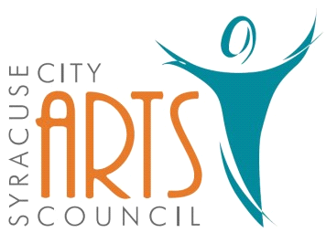
Syracuse City Arts Council Meeting Agenda
November 8, 2023 8pm
Meeting begins at 8pm
in the Syracuse City Municipal Building’s large conference room
located at 1979 West 1900 South.
1. Opening Business
- Call to Order
- Adoption of November 8, 2023 Agenda
- Review and Adoption of October 4, 2023 Minutes
- Approve Budget Expenditures since October 4, 2023

2. Public Comment-This is an opportunity to address the Council regarding concerns or ideas. Please limit comments to three minutes.

3. 2023-2024 SCAC Upcoming Season Events
Orchestra: December 18, 2023 – Christmas Theme, March 11, 2024 – Complete Classical Work, May 20, 2024 – Possible Guest Artist
Jazz Band: December 4, Event at Library
Jr. Theatre: Broadway Bootcamp, (next season - Finding Nemo Jr.)
Theatre: Newsies July 18-22, 2024
Fundraisers:
Other:

4. Jr. Theatre - Discuss dates for next Jr. Theatre show & discuss Summer Camp

5. Fundraiser ideas

6. Storage update

7. Publicity: Syracuse Connection information & other publicity as needed

8. Discuss date for December meeting/Party

9. Walk in items

WORK SESSION
10. Committee/Board Member Updates/Discussion

11. Future Agenda Items

12. Adjournment
~~~~~~~~~~~~~~~~~~~~
In compliance with the Americans Disabilities Act, persons needing auxiliary communicative aids and services for this meeting should contact the City Offices at 801-825-1477 at least 48 hours in advance of the meeting.

CERTIFICATE OF POSTING
On Nov. 7, 2023 this agenda was provided to the Standard Examiner and submitted to Syracuse City for posting on the Syracuse City Hall Notice Board and for publishing on the Syracuse City website, at http://www.syracuseut.com, and on the State Public Notice website, at http://www.utah.gov/pmn/indix.html. A copy was also submitted to the website manager for publishing on the Syracuse City Arts Council website, at http://www.syracuseutaharts.org/about-us/council-minutes. Libby Fawcett, Syracuse City Arts Council Chair

