

Housing Element
Plain City, Utah
General Plan Update 2023

Prepared for Plain City, Utah, by
Planning and Development Services, LLC
Salt Lake City, Utah
pds@utahplanning.com
801/277-4435



PLAIN CITY HOUSING ELEMENT, 2023
(INCLUDING A MODERATE-INCOME HOUSING PLAN)
AN ELEMENT OF THE PLAIN CITY GENERAL PLAN

INTRODUCTION

This General Plan Housing Element (2023) is prepared and adopted by Plain City to meet the existing and emerging residential housing needs of the City. This Element is determined to follow the standards of the Utah Code, including Section 10-9a-403 et seq., which requires all Utah municipalities (meeting certain classifications) to complete a Moderate-Income Housing Plan (“MIHP”). A MIHP may be adopted by a municipality (city or town) as a stand-alone plan or incorporated into the framework of the municipality’s General Plan, often as an element of the General Plan. The Plain City MIHP (“MIHP”) is incorporated into and adopted as part of the Plain City General Plan’s Housing Element. The General Plan Housing Element estimates the City’s needs for moderate-income housing and addresses other housing issues. This Element also outlines the strategies the City will pursue to provide reasonable opportunities for a variety of moderate-income housing units to be provided, that includes preserving existing housing units and the construction of new units, allowing “persons with moderate incomes to benefit from and fully participate in all aspects of neighborhood and community life."0F This Housing Element also considers and proactively addresses any barriers to providing moderate-income residential housing.

Moderate Income Housing Defined and Moderate-Income Housing Income Threshold

The Utah Code defines moderate income as equaling eighty percent (80%) of the Area Median Income (AMI).1F The Weber County, Utah area, is the “area” used by this Housing Element. However, the U.S. Census Bureau does not report AMI for Weber County. What the U.S. Census Bureau does report is Weber County Median Household Income via the American Community Survey (“ACS”). For 2022 the ACS’ reported the Weber County Median Household Income was $83,949.00 (1-year estimate)(Table S1901). For this Housing Element the Weber County Median Household Income of $83,949.00 (ACS, Table S1901) is applied.

The U.S. Census Bureau’s ACS also supplies the Median Household Income for Plain City for 2021 (Table S1901). The Median Household Income for Plain City (ACS, 5-Year estimate) for 2021 was $107,222.00. The City’s reported Median Household Income (2021) was significantly higher than reported for the entire Weber County area.

The U.S. Department of Housing and Urban Development (“HUD”) also supplies home income limits. For the Ogden-Clearfield Utah, HUD Metropolitan Area (of which Plain City is part), the 2021 adjusted income limit for a low-income household of four (4) persons was $72,500.00.

Table 1
Plain City and Weber County 2020 Population and Population Projections

Year | 2020 Census Population & Projections |  | Growth Rate  (Decennial to Decennial years)
 | Plain City | Weber County | Plain City | Weber County
2020 | 7,833 | 262,223 | — | —
2030 | 9,641 | 300,477 | 23.0% | 14.6%
2040 | 11,553 | 349,009 | 19.8% | 16.2%
2050 | 12,798 | 398,699 | 10.1% | 14.2%
Source. 1. United States Census Bureau, 2020 Decennial Census, Table P1 (Retrieved from https://www2.census.gov/programs-surveys/decennial/2020/data/).
2. Plain City Population Projections Retrieved from https://data.wfrc.org/datasets/06cb3e239a3743fab7796165e1c66ad9/explore?location=41.241184%2C-112.091137%2C12.19.
3. Weber County Population Projections Retrieved from https://opendata.utah.gov/Government-and-Taxes/Weber-County-Census-Projections-2010-2060/cggy-vv82/data.

The information provided in Table 1 highlights the expected population growth for Plain City and Weber County. Plain City’s population growth from 2020 to 2030 will be significant, with the City’s population increasing by approximately 23% from 2020 to 2030. As expected, the population growth, measured as a percentage increase, is lower for Weber County due to the County’s larger starting population base through all years. The same occurs for Plain City. As the population increases, the percentage of population growth rate slows, expressed as a population growth percentage. It should be noted that the actual population increase is perhaps more critical for this Housing Element, including the Housing MIHP. For the 10-year periods of 2020 to 2030 and 2040 to 2050, actual population increases are 1,808 persons and 1,245 persons, respectively.

Figure 1
Plain City 2020 Population Pyramid

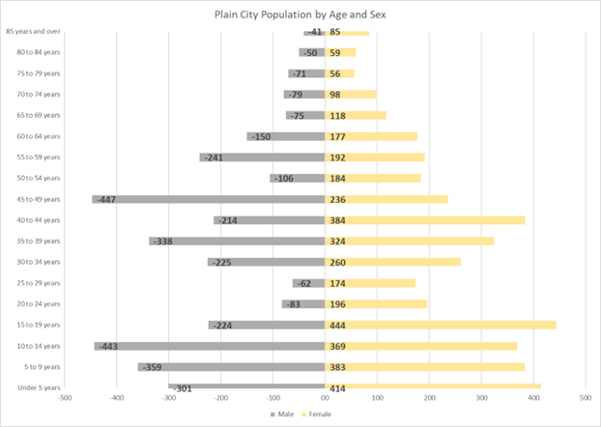
Source. 1. United States Census Bureau, American Community Survey, 2021, Table SO101 (Retrieved from https://api.census.gov/data/2021/acs/acs1/subject).
2. United States Census Bureau, American Community Survey, 2021, Table DP05, Retrieved from https://api.census.gov/data/2021/acs/acs5/sptprofile).

Figure 1 shows the Plain City population does not display a “balanced” or symmetrical population pyramid (by resident age or gender). The City’s 20 – 29-year-old age group is small, with a relatively lower number of residents in this age group than expected by a more symmetrical population pyramid. The young children’s age group (0 – 5 years) is also narrower than expected. If the children and youth age groups continue to be small compared to older age groups, arguably, the City's population is aging and is not self-sustaining.

Figure 1 also highlights that the City has a disproportionately large population of residents in the age groups between 40 to 49 years of age. This is pronounced for females 40 – 44 years and males 45 – 49 years. The City’s population pyramid then narrows for females and males in the over-65-year age groups. The relatively small 20 – 29 age group and the quickly declining population over 65 years may show that the preferred housing choice for these age groups is either not being supplied or, if provided, is either in short supply, is prohibitively expensive, or perhaps both. The MIHP considers those possibilities. For comparison only the population pyramid for Weber County, using 2021 ACS data (5-Year Estimates), is provided in Table 2.

Figure 2
Weber County, Population Pyramid

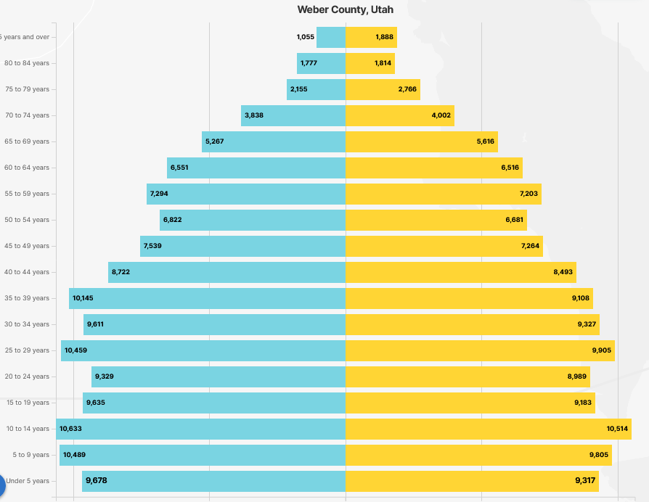

BACKGROUND AND EXISTING HOUSING CONDITIONS

In 2018, the Plain City City Council adopted the Plain City 2018 General Plan. That Plan was an update of the City’s earlier 2007 General Plan. Within the pages of the 2018 General Plan (beginning on page 16) were materials related to the City’s strategies to address moderate-income housing. The 2018 Moderate Income Housing section was included in the 2018 General Plan’s Land Use Element pages. The Moderate-Income Housing Plan provided six (6) “actions” designed “to ensure an adequate supply of moderate-income housing integrated throughout the City in various locations, and consistent with the needs of all segments of the population” (Plain City General Plan, 2019, p. 17). The six (6) action statements of the 2018 General Plan were,

- “Action: Develop programs and incentives to improve and maintain existing housing, especially in historic neighborhoods.
- Action: Create a neighborhood preservation zone for the residential districts in downtown Plain City.
- Action: Encourage a mix of lot sizes and housing types in residential and commercial zones so that moderate-income housing is integrated correctly and not concentrated in one development or area.
- Action: Consider utilization of state or federal funds or tax incentives to promote the construction of moderate-income housing.
- Action: Regularly update this chapter to determine the housing needs for all groups, to quantify specific housing needs, and to identify solutions to housing problems. This Element will be reviewed on a biennial basis.
- Action: Encourage life-cycle housing that provides different housing options to allow people to live and grow in the same community” (Plain City General Plan, 2018, pp. 17 – 18).

Since Plain City adopted the 2018 General Plan, the City has changed, including more residential and nonresidential growth. Also, various legislative amendments have been made to the Utah Code, affecting how Utah municipalities and counties address the provision of moderate-income housing. For example, a definition of moderate-income housing is now provided.2F Standards for the filing of Plain City’s Moderate Income Housing Report to the Housing and Community Development Division, Department of Workforce Services are also established (§10-9a-408, Utah Code). Section 10-9a-403(2)(b) (Utah Code) provides the minimum standards required by a “specified municipality” in the formulation and adoption of a Moderate-Income Housing Element.3F (Plain City, Utah, qualifies as a specified municipality). Plain City provides this General Plan Housing Element, including its Moderate-Income Housing Plan Update, to comply with all applicable Utah Code standards. However, before moving to the MIHP and its required accompanying implementation and monitoring strategies, a review of the City’s existing housing profile and other items is proper.

Figure 3 summarizes the existing occupied housing units (all housing types) for Weber County and Plain City, Utah. The U.S. Census Bureau provides this information via the American Community Survey (“ACS”).

In 2020, Plain City had 2,349 housing units (total) of all types (U.S. Census Bureau, Table H1, retrieved from https://data.census.gov/table?q=H1&g=160XX00US4960710&d=DEC+Demographic+and+Housing+Characteristics&tid=DECENNIALDHC2020.H1). In 2020 2,320 housing units were occupied, and 29 housing units were vacant (U.S. Census Bureau, Table H1, retrieved from https://data.census.gov/table?q=H1&g=160XX00US4960710). Figure 3 displays the total occupied housing units for Weber County and Plain City in 2020. In 2020, 6,019 housing units in Weber County were vacant.

Figure 3
Total Occupied Housing Units in Weber County and Plain City, Utah, 2020

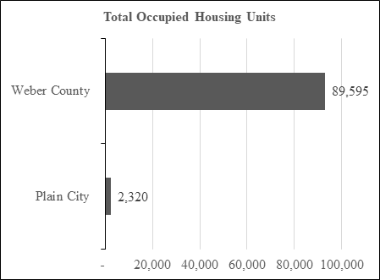Source: U.S. Census Bureau, Decennial 2020 Census, Table H1.

In 2020 Weber County had 95,614 total housing units (Table H1, 2020 Decennial Census). Approximately 73.6% of all Weber County housing units were owner-occupied in 2022 (Table DP04, ACS) while approximately 97.0% of all housing units in Plain City were owner occupied The ACS reported 85,205 total households in Weber County and an average household size of 2.96 persons per household (2020). The total number of households for Plain City was 2,062, with an average household size of 3.47 persons per household (2020), significantly larger than reported for Weber County. For 2020, the total number of families in Plain City was 1,783, and the average family size was 3.70 (U.S Census Bureau, American Community Survey, Table S1101). Figure 4 presents the average family sizes for Weber County and Plain City, 2020. Figure 5 also provides valuable information. Figure 5 has the total number of owner-occupied and renter-occupied housing units for 2020.
Figure 4
Average Family Size for Weber County and Plain City, Utah, 2020

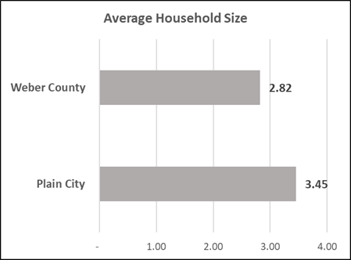

Figure 5
Occupancy Rates for Owner-Occupied and Renter-Occupied Housing Units for Weber County and Plain City, Utah

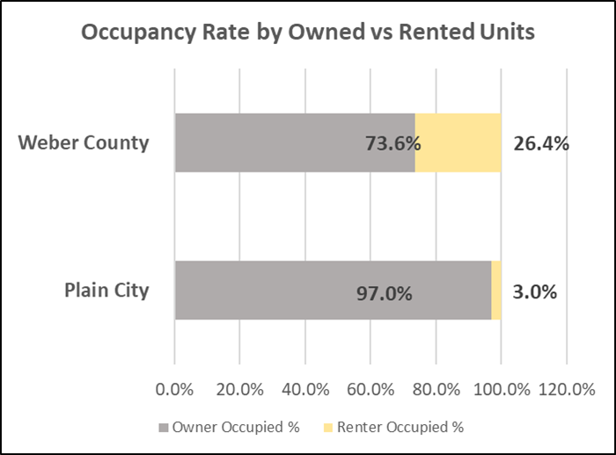

A few final figures are necessary to paint Plain City’s complete housing picture and to inform all readers on the City’s housing trends and needs . This information follows as provided by Figure 7, Median Value of Owner-Occupied Housing Units 2017 – 2021, Figure 8, Median Selected Monthly Owner-Occupied Housing Costs 2017 – 2021, Figure 9, Median Gross Rent 2017 – 2021, and Figure 10, Persons in Poverty.

Figure 6
Median Value of Owner-Occupied Housing Units, 2017 – 2021

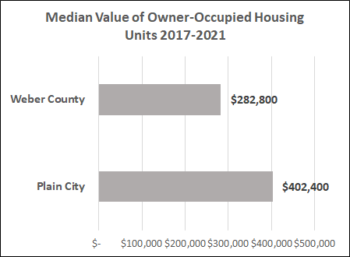

The ACS also provides the data for Figure 6. While this data set is subject to significant margins of error, it is not the actual numbers that are the most important but rather the data relationships and trends. Figure 6 highlights that the median value of owner-occupied housing units over the 2017 to 2021 period is much higher for Plain City than for Weber County.

Figure 7 highlights that median monthly housing costs, 2017 – 2021, are also higher for Plain City residents owning their own homes. Why is this the case? Arguably, Plain City’s higher owner-occupied monthly housing costs could perhaps be due to larger houses and larger lot sizes, resulting in higher property values with accompanying higher property tax assessments. Another explanation could be that the moderating effects of properties with lower assessed values and property tax obligations are absent, with fewer apartments and multifamily residential dwelling units included in the total housing stock than in Weber County. Additionally, higher monthly owner-occupied costs could be also result from the realities of larger homes and higher lot maintenance costs.
Figure 7
Median Selected Monthly Owner-Occupied Housing Costs 2017 – 2021

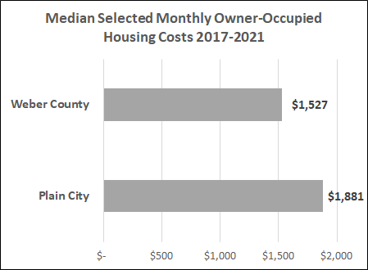

Figure 8
Median Gross Rent 2017 – 2021

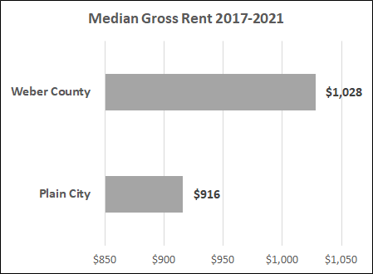

The median gross rent for 2017 – 2021 for Plain City renters is much lower than for renters in Weber County (as a whole). This is a trend worth preserving for the future. However, Figure 8 and this conclusion may be misleading. Misleading, how? The possibility exists that with fewer rental units and fewer renters (than in Weber County), the Plain City monthly gross rent data is coming from a small data set with the possibility of being skewed downward.

Figure 9 highlights that Plain City has fewer people in poverty than Weber County (as a percentage of the total population). However, the city is aware that a segment of the City’s population struggles financially to meet living costs. The City’s housing strategies recognize this reality and are directed explicitly at moderating poverty in the City.

Figure 9
Persons in Poverty

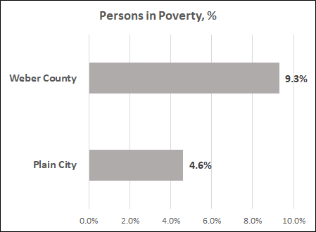

RESIDENTIAL ZONING OVERVIEW

Plain City provides a variety of residential opportunities within its residential zoning plan. The City provides five (5) Residential Estate Zones (RE-40, RE-30, RE-20, RE-18.5, and RE-15). These zones require minimum lot sizes of 40,000 square feet, 30,000 square feet, 20,000 square feet, 18,500 square feet, and 15,000 square feet, respectively. The purpose of the RE-40 and RE-30 zones “is to support a very low-density residential environment . . . . . with the nature of the environment substantially undisturbed” (Chapter 5, Article C, City Code). The purpose of the RE-20, RE-18.5, and RE-15 residential zones “is to provide and protect residential development at a low density in a semi-agricultural or rural environment” (Chapter 5, Article A, City Code).

The City also provides a Single-Family (R-1-11) Residential Zone. This residential zone requires a minimum lot size of 11,000 square feet and is provided to provide single-family residential uses and associated activities (Chapter 5, Article B, City Code).

Located within the City’s zoning plan is the Senior Housing Overlay Zone. This residential zone intends to allow residential housing opportunities for senior-aged citizens specifically. The Senior Housing Overlay (“SHO”) zone “is designed to provide residential uses that are appropriate for . . . . seniors, recognizing their unique lifestyles and needs by allowing higher densities, (and) a mix of uses. This zone intends to carry out the policies and objectives of all elements of the General Plan and to meet the standards necessary to satisfy the requirements for public health, safety, and general welfare” (Chapter 7, City Code).

Allowed within all City residential zones are detached and internal accessory residential units. Both detached and internal accessory dwelling units provide opportunities for the owner of the primary residential dwelling unit to integrate moderate-income housing opportunities (Chapter 21 and Chapter 22, City Code). Both detached and internal accessory dwelling units can be administratively approved before the issuance of a building permit. Permitting both detached and internal accessory dwelling units is an innovation to provide moderate-income housing, not typical for a Utah municipality. It demonstrates the City’s commitment to providing affordable housing choices for existing and future residents.

Plain City also provides the Neighborhood Commercial (C-11) and the General Commercial (C-2) zones. Both zones allow residential dwelling units with a Mixed-Use Overlay Zone (Chapter 19, City Code). Allowing a mix of compatible residential and nonresidential uses with commercial designation is another example of the City’s goals of providing opportunities to establish moderate-income housing. Also, consistent with Utah State Code standards, Plain City permits assisted living facilities for elderly persons, residential facilities for persons with a disability, and group home facilities to meet the housing requirements of persons with unique residential needs (Chapter 17, Chapter 23, and Chapter 25, City Code).

MODERATE INCOME HOUSING OPPORTUNITIES – PURCHASE AND RENTAL UNITS – A SNAPSHOT

On November 2, 2023, eight (8) homes were for sale in the City with asking prices of $500,000.00 or less. These homes were generally 1,500 to 1,900 square feet (finished) and had a three-bed, two-bath design configuration. Two (2) of these homes are listed at $450,000.00 (single-family), and a townhome is listed for $374,900.00 (realtor.com). Additionally, two (2) single-family homes were for rent, with asking rents of $2,500.00 and 2,650.00 per month. One (1) single-family home recently sold in the moderate-income affordability range. This home was 836 square feet, with two beds and one bath. Realtor.com reported a price of $315,000.00, but it is unclear if this was the asking or sale price. Realtor.com also provides a housing market analysis for Plain City, Utah. Their analysis (on November 2, 2023) identified the following facts.

- Median listing home price = $730,000.00.
- Median days on the market = 70 days.
- Median listing home price per square foot = $222/square foot.
- Active listings = 91 (including vacant residential lots (https://www.realtor.com).
PLAIN CITY HOUSING GOALS

This Section contains the City’s goals for housing, including those for moderate-income housing. This Section should be read and considered in conjunction with the General Plan’s Land Element. The Plan’s Housing and Land Use Elements are integrally related and interconnected, with reciprocal support occurring between housing and land use policies. Both the Housing Element and the Land Use Element address housing issues, including providing opportunities to increase the supply of moderate-income housing units within the City. However, the Plain City Housing Element focuses not only on moderate-income housing matters, but other housing issues also exist. Therefore, this Element provides general housing strategies for all housing and neighborhood areas.

The Utah Code provides several plan standards and requirements to address moderate-income housing specifically. These standards and requirements are found in the appendix with underlined or highlighted text. This Section addresses each Utah Code standard and requirement applicable to Plain City.4F

Applicable Definitions5F

The Utah Code provides several definitions to be recognized in formulating the City’s Housing Element. These definitions, provided by §0-9a-103 et seq. (Utah Code), aid the reader in understanding fully all Housing Element materials, including all goals, policies, strategies, implementation actions, and other Housing Element provisions. While not required (by the Utah Code), other definitions are also included to assist the reader with understanding and City leaders with Housing Element interpretations.

(1) "Accessory dwelling unit" means a habitable living unit added to, created within, or detached from a primary single-family dwelling and contained on one lot.

“Affordable housing” means housing available to a household before deductions like taxes or expenses, including utilities, at no more than thirty percent (30%) of the household’s gross monthly income. “Affordable housing refers to a specific type of housing, generally government-assisted rental housing, targeted for very low– to extremely low–income households” (Wood, James, 2022, retrieved from https://gardner.utah.edu/blog-reflections-on-affordability-in-utahs-housing-market/).

(11) "Development activity" means:
(a) any construction or expansion of a building, structure, or use that creates additional demand and need for public facilities.
(b) any change in use of a building or structure that creates additional demand and need for public facilities; or
(c) any change in the use of land that creates additional demand and need for public facilities.

(12) (a) "Development agreement" means a written agreement or amendment to a written agreement between a municipality and one or more parties that regulates or controls the use or development of a specific area of land.
(b) "Development agreement" does not include an improvement completion assurance.

(17) "General plan" means a document that a municipality adopts that sets forth general guidelines for proposed future development of the land within the municipality.

“Housing affordability” means “the general level of housing prices relative to the general level of household incomes.” The term does not refer to a type of housing (Wood, James, 2022, retrieved at https://gardner.utah.edu/blog-reflections-on-affordability-in-utahs-housing-market/).

(22) "Impact fee" means a payment of money imposed under Title 11, Chapter 36a, Impact Fees Act.

(26) "Infrastructure improvement" means permanent infrastructure that is essential for the public health and safety or that:
(a) is required for human occupation and
(b) an applicant must install:
(i) in accordance with published installation and inspection specifications for public improvements and
(ii) whether the improvement is public or private, as a condition of:
(A) recording a subdivision plat.
(B) obtaining a building permit or
(C) development of a commercial, industrial, mixed-use, condominium, or multifamily project.

(38) "Major transit investment corridor" means public transit service that uses or occupies:
(a) public transit rail right-of-way.
(b) dedicated road right-of-way for the use of public transit, such as bus rapid transit; or
(c) fixed-route bus corridors subject to an interlocal agreement or contract between a municipality or county and:
(i) a public transit district as defined in Section 17B-2a-802 or
(ii) an eligible political subdivision as defined in Section 59-12-2219.

(39) "Moderate income housing" means housing occupied or reserved for occupancy by households with a gross household income equal to or less than 80% of the median gross income for households of the same size in the county in which the city is located.

(48) "Plan for moderate income housing" means a written document adopted by a municipality's legislative body that includes:
(a) an estimate of the existing supply of moderate-income housing located within the municipality.
(b) an estimate of the need for moderate income housing in the municipality for the next five years.
(c) a survey of total residential land use.
(d) an evaluation of how existing land uses and zones affect opportunities for moderate-income housing; and
(e) a description of the municipality's program to encourage an adequate supply of moderate-income housing.

(57) "Residential facility for persons with a disability" means a residence:
(a) in which more than one person with a disability resides and
(b) which is licensed or certified by the Department of Health and Human Services under:
(i) Title 26B, Chapter 2, Part 1, Human Services Programs and Facilities; or
(ii) Title 26B, Chapter 2, Part 2, Health Care Facility Licensing and Inspection.

(71) "Transferable development right" means a right to develop and use land that originates by an ordinance that authorizes a landowner in a designated sending zone to transfer land use rights from a designated sending zone to a designated receiving zone.

(74) "Zoning map" means a map adopted as part of a land use ordinance that depicts land use zones, overlays, or districts.

In addition to §10-9a-103, et seq. (Utah Code), the definitions and provisions of §10-9a-401, et seq., (Utah Code) also apply. The following Utah Code standards must be met.

10-9a-401. General plan required -- Content.
(1) To accomplish the purposes of this chapter, a municipality shall prepare and adopt a comprehensive, long-range general plan for:
(a) present and future needs of the municipality; and
(b) growth and development of all or any part of the land within the municipality.
(3)
(a) The general plan of a specified municipality, as defined in Section 10-9a-408, shall include a moderate-income housing element that meets the requirements of Subsection 10-9a-403(2)(a)(iii).^{[1]}
(4) Subject to Subsection 10-9a-403(2), the municipality may determine the comprehensiveness, extent, and format of the general plan.

The United States Department of Housing and Urban Development (“HUD”) provides income limits annually (using ACS data) for all areas of the nation. HUD uses an area’s median income (“AMI”) to determine if individuals can afford to rent or buy a home within the corresponding area. Using the AMI data, HUD locates the midpoint in a region’s income distribution. HUD then divides the AMI into distinct levels according to household size. The income levels used by HUD are (1) Extremely Low Income - below 30% of AMI, (2) Very Low Income – below 50% of AMI, (3) Low Income – below 80% of AMI, and (4) Moderate income – 80% and 120% of AMI. Table 2 presents the HUD income levels for Fiscal Year 2023 for the Ogden – Clearfield, Utah region, where Plain City is located.
Table 2
Fiscal Year 2023 Income Limits

FY 2023 Income Limit Area | Median Family Income | Income Limit Category | Persons in Family
Ogden – Clearfield, Utah | $111,900 | Extremely Low Income - below 30% of AMI ($) |  | 1 |  | 2 | 3 |  | 4 |  | 5 | 6 |  |  | 7 | 8
Ogden – Clearfield, Utah | $111,900 |  |  | 22,350 |  | 25,550 | 28,750 |  | 31,900 |  | 36,140 | 40,280 |  |  | 45,420 | 50,560
Ogden – Clearfield, Utah | $111,900 | Very Low Income – below 50% of AMI ($) |  | 37,250 |  | 42,600 | 47,900 |  | 53,200 |  | 57,500 | 61,750 |  |  | 66,000 | 70,250
Ogden – Clearfield, Utah | $111,900 | Low Income – below 80% of AMI ($) |  | 59,600 | 68,100 |  |  | 76,600 | 85,100 | 91,950 |  |  | 98,750 | 105,550 |  | 112,350

The following formula calculates the maximum housing costs allowed by HUD.
Annual Income Limit for Number in Family(Low Income) ÷ 12 x 0.30 = $Maximum monthly housing-related costs (purchase or rent).

Table 3 presents the maximum monthly housing costs for the number of persons in a family for either the purchase or rent of a residential dwelling unit in Plain City in 2023. A family of four (4) can afford to buy or rent a housing unit in Plain City in 2023, provided total housing costs do not exceed $2,127.50 per month.

Table 3
Housing Affordability Analysis (Purchase or Rental) – Plain City 2023
FY 2023 Income Limit Area | Median Family Income | Income Limit Category | Persons in Family
Ogden – Clearfield, Utah | $111,900 | Low Income – below 80% of AMI ($) | 1 | 2 | 3 | 4 | 5 | 6 | 7 | 8
Ogden – Clearfield, Utah | $111,900 | Low Income – below 80% of AMI ($) | Total maximum monthly housing costs (purchase or rent)
Ogden – Clearfield, Utah | $111,900 | Low Income – below 80% of AMI ($) | 1,490.00 | 1,702.50 | 1,915.00 | 2,127.50 | 2,298.75 | 2,468.75 | 2,638.75 | 2,808.75

HOUSING ELEMENT POLICIES (GENERAL GUIDELINES)
AND IMPLEMENTATION PLAN

This Section now provides the City’s policies, or “general guidelines,” for the establishment of future housing, including moderate-income housing units, and associated with the future development of land found within the municipal boundaries of Plain City (§10-9a, 103[17], Utah Code).

The State of Utah, Section 10-9a-403 et seq. Utah Code, asks that municipalities similarly situated to Plain City adopt a minimum of three (3) strategies related to facilitating the production of moderate-income housing. Plain City is adopting four (4) moderate–income housing strategies to fully recognize the Utah legislature’s explicit intent for the provision of moderately priced housing.

The strategies adopted by Plain City to provide reasonable opportunities for the provision of more housing units available to moderate income individuals and families are.

1) Demonstrate investment in the rehabilitation or expansion of infrastructure that facilitates the construction of moderate-income housing (§10-9a-403(2)(b)(iii)(B), Utah Code).

2) Create or allow for and reduce regulations related to internal or detached accessory dwelling units in residential zones (§10-9a-403(2)(b)(iii)(E), Utah Code).

3) Zone or rezone for higher density or moderate-income residential development in commercial or mixed-use zones near major transit investment corridors, commercial centers, or employment centers (§10-9a-403(2)(b)(iii)(F), Utah Code).

4) Amend land use regulations to eliminate or reduce parking requirements for residential development where a resident is less likely to rely on the resident's own vehicle, such as residential development near major transit investment corridors or senior living facilities (§10-9a-403(2)(b)(iii)(H), Utah Code).

All General Plan policies and strategies must be made actionable and measurable with an accompanying implementation plan. The Implementation Plan provided by this Housing Element is for five years, addressing the implementation strategies recommended by the Plain City Planning Commission and formally adopted by the Plain City City Council.6F The Implementation Plan includes various success measures and benchmarks recommended by the Planning Commission and adopted by the City Council with the adoption of this Housing Element to assess achievements, or otherwise, of all housing-related strategies.

ANNUAL STAFF EVALUATION REPORT REQUIRED
HOUSING ELEMENT POLICIES (GENERAL GUIDELINES)

The clear intent of this Housing Element is to provide clarity in realistic and attainable housing policies. Further, this Element is intended to provide sufficient implementation plan details to allow a reader to assess the City’s progress toward achieving all housing policies, including ensuring an adequate supply of moderate-income housing units.

Annually, during or before May of each year, the City Staff shall provide the Planning Commission and City Council with a comprehensive annual housing report. This report shall, at a minimum, (1) include housing data including building permits issued by housing type, (2) identify all connections and correlations between the City’s land use regulations and land use decisions and the City’s activities occurring over the last twelve (12) months to achieve the City’s moderate-income housing strategies, (3) review and discuss how the private capital market has responded to Plain City’s moderate-income housing strategies, and (4) highlight any privately and publicly established barriers encountered by the City in achieving its housing strategies, including those related to moderate-income housing.
HOUSING POLICIES – IMPLEMENTATION PLAN

Table 3 contains the Implementation Plan materials for this Element’s housing goals and policies. Each policy is designed to be actionable and measurable with the establishment of related strategies, needed actions, lead participants, timeline for achievement, success measures, and resources available to the City with the potential to benefit policy and strategy successes. The Implementation Plan has a five-year action and implementation schedule at the end of which the City will evaluate its progress to achieving all adopted policies and adopt a new Implementation Plan with possible revised or new housing policies. As required by Section 10-9a-403(2)(c), Utah Code, the City’s six (6) adopted moderate-income housing strategies are included in the City’s Housing Implementation Plan (2023 – 2028). Further, by following the statutorily required procedure Plain City may consider from time-to-time necessary Housing Element amendments determined necessary to achieve the purposes of the City’s General Plan and the Utah Code.

Table 3
Plain City Housing Implementation Plan 2023 – 2028
(Note table cells will be revised following discussion with all City Officials.)

Housing Policy #1
Ensure all new residential dwellings and areas are safe and avoid all naturally occurring features that adversely affect personal and property safety.
Strategy | Required Action | Lead Participants | Timeline | Success Measures | Available  Resources
- Ensure all housing units are protected from all harmful, naturally occurring risks and events. | As necessary, monitor and update the General Plan and Land Use Ordinances to avoid locating housing units in areas subject to flooding, high groundwater, or other environmental risks. | Land Use Specialist, Planning Commission | At a minimum annually, or as new information and data become available | General Plan and Land Use Ordinances provide policies and actions necessary to protect all housing units from naturally occurring risks | Federal, State, and Local agencies, City Engineer
- Annual monitoring report. | Required Comprehensive annual housing report provided. Report reviewed by the Planning Commission and City Council | Land Use Specialist, | Annually (before May) | At a minimum, 1) the number of building permits issued, (2) connections and correlations between land use regulations and decisions related to moderate-income housing strategies,(3) review of how the private capital market has responded to moderate-income housing strategies, (4) highlight all private and public barriers to achieve City’s moderate-income housing strategies.  Necessary housing-related actions taken | Planning Consultant (as necessary)
Housing Policy #2
All permits to construct a new dwelling, remodeling an existing dwelling unit, or any other action requiring a building permit shall comply with the International Building Code, as adopted, and the Fire Code, as adopted.
Strategy | Required Action | Lead Participants | Timeline | Success Measures | Available  Resources
- Before issuance, all building permits shall comply with the City’s Land Use Ordinances, as applicable and as adopted. | Land Use Specialist to issue a Land Use Ordinance certificate of land use ordinance compliance | Land Use Specialist. Building Official | Ongoing | All building permits comply with the City’s Land Use Ordinances, as applicable and adopted. | Land Use Specialist, Building Official, Planning Consultant (as necessary)
- All new construction requiring a building permit shall comply with the IBC and Fire Code, as adopted. | The City’s Building Official shall authorize all building permits | Building Official | Ongoing | All building permits comply with the IBC and Fire Code, as adopted | Building and Fire Code, State of Utah
See also Strategy #2, Housing Policy #1
Housing Policy #3
Demonstrate investment in the rehabilitation or expansion of infrastructure that facilitates the construction of moderate-income housing (§10-9a-403(2)(b)(iii)(B), Utah Code).
Strategy | Required Action | Lead Participants | Timeline | Success Measures | Available  Resources
- The city-maintained infrastructure provided at the required Levels of Service | The City Engineer confirms the availability of required services at accepted levels of service. The developer/applicant provides required infrastructure at established service levels, or greater, as needed by the City with a reimbursement agreement. Impact Fee collection | City Engineer | Ongoing | All city-maintained infrastructure provided at established levels of service | City Engineer. Infrastructure service standards
See also Strategy #2, Housing Policy #1
Housing Policy #4
Create or allow for and reduce regulations related to internal or detached accessory dwelling units in residential zones (§10-9a-403(2)(b)(iii)(E), Utah Code).
Strategy | Required Action | Lead Participants | Timeline | Success Measures | Available  Resources
- Allow internal and external accessory residential dwelling units by ordinance. Establish required standards | Monitor and update the General Plan and Land Use Ordinances as necessary | Land Use Specialist. Planning Commission | As required to supply reasonable opportunities to provide internal and external accessory dwelling units in selected zones | General Plan and Land Use Ordinances updated, as necessary | State agencies, Land Use Specialist, Planning Commission, Planning Consultant (as needed)
- Biannual report of the number of internal and external accessory dwelling units permitted | Report data was assembled, and the report was drafted | Land Use Specialist, Building Official | Biannual | Information provided to the Planning Commission and City Council | Building permits
See also Strategy #2, Housing Policy #1
Housing Policy #5
Zone or rezone for higher density or moderate-income residential development in commercial or mixed-use zones near major transit investment corridors, commercial centers, or employment centers (§10-9a-403(2)(b)(iii)(F), Utah Code)
Strategy | Required Action | Lead Participants | Timeline | Success Measures | Available  Resources
- With all General Plan Updates, consider including areas that may be appropriate for designation as commercial centers or mixed-use areas. | Consistent with the General Plan, update the Land Use Ordinances, as necessary, to provide opportunities for commercial centers and mixed-use areas | Land Use Specialist | As required to follow the General Plan | Land Use Ordinances are consistent with the General Plan | Land Use Specialist, Planning Consultant (as necessary)Necessary budget allocation
- Consider allowing or requiring higher-density residential uses in commercial centers and other activity centers, as named by the General Plan. | Consider and consistent with the General Plan, updating the Land Use Ordinances, as necessary, to provide opportunities to establish higher density residential uses in commercial centers and other activity centers (that may include locations immediately next to schools, churches, or other public facilities) | Land Use Specialist, Planning Commission | As required to comply with the General Plan | Land Use Ordinances are consistent with the General Plan | Land Use Specialist. Planning Consultant (as necessary) Necessary budget allocation
- Avoiding any inconsistencies with §10-9a-534 (Utah Code), as amended, consider requiring architectural and site design elements for compatible residential uses in commercial centers and other centers' activity that promote consistency and compatibility with the City’s desired design character. | Amend the City’s Land Use Ordinances, as necessary, to provide architectural and site design elements in commercial centers and other activity centers. | Land Use Specialist, Planning Commission | Within 12 months of Housing Element adoption | Land Use Ordinance amendment considered by Planning Commission and City Council. | Land Use Specialist, Planning Consultant (as necessary)
See also Strategy #2, Housing Policy #1
Housing Policy #6
Amend land use regulations to eliminate or reduce parking requirements for residential development where a resident is less likely to rely on the resident's own vehicle, such as residential development near major transit investment corridors or senior living facilities (§10-9a-403(2)(b)(iii)(H), Utah Code).
Strategy | Required Action | Lead Participants | Timeline | Success Measures | Available  Resources
- Consider allowing reduced off-street parking requirements for certain residential land uses that may include residential uses for elderly persons and persons with a disability or other land uses predicted to require reduced off-street parking. | As necessary, update the Land Use Ordinances to reduce off-street parking standards for specific land uses. | Land Use Specialist, Planning Commission | Immediately | Land Use Ordinances, updated as necessary | Land Use Specialist, Planning Consultant (as needed)
See also Strategy #2, Housing Policy #1
Housing Policy #7
Apply for or partner with an entity that applies for state or federal funds or tax incentives to promote the construction of moderate-income housing, an entity that applies for programs offered by the Utah Housing Corporation within that agency's funding capacity, an entity that applies for affordable housing programs administered by the Department of Workforce Services, an entity that applies for affordable housing programs administered by an association of governments established by an interlocal agreement under Title 11, Chapter 13, Interlocal Cooperation Act, an entity that applies for services provided by a public housing authority to preserve and create moderate-income housing, or any other entity that applies for programs or services that promote the construction or preservation of moderate-income housing (§10-9a-403(2)(b)(iii)(O), Utah Code).
Strategy | Required Action | Lead Participants | Timeline | Success Measures | Available Resources
Work with the Weber Housing Authority to provide and protect moderate income housing opportunities. | Communicate and coordinate with Weber Housing Authority | Land Use Specialist, Planning Commission | Ongoing | Annual report to Planning Commission and City Council on Weber Housing Authority activities in Planning City | Land Use Specialist. Weber Housing Authority staff
See Strategy #2, Housing Policy #1
Housing Policy #8
Demonstrate implementation of any other program or strategy to address the housing needs of residents of the City who earn less than 80% of the area median income, including the dedication of a local funding source to moderate-income housing or the adoption of a land use ordinance that requires 10% or more of new residential development in a residential zone be dedicated to moderate-income housing (§10-9a-403(2)(b)(iii)(X), Utah Code).
Strategy | Required Action | Lead Participants | Timeline | Success Measures | Available Resources
As a General Plan policy and to avoid any inconsistencies with §10-9a-535 (Utah Code), as amended, consider requiring all new subdivisions or other residential developments to provide a minimum of 10% of lots or dwelling units dedicated as moderate-income housing units. | Consistent with General Plan policy, amend the City’s Land Use Ordinances to require a minimum of 10% of lots in subdivisions or 10% of dwelling units created in any other residential development to be dedicated as moderate-income housing units | Land Use Specialist, Planning Commission | Immediately | General Plan amendment considered by Planning Commission and City Council | Land Use Specialist, Planning Consultant (as necessary)
See Strategy #2, Housing Policy #1

CONCLUSION
(to be added and reviewed prior to City Council final action)

Section 10-9a-403(2)(b)(B), Utah Code.
Section 10-9a-103(39), Utah Code.
Footnote #2.
Section 10-9a-408, Utah Code.
Readers are advised that because data is derived from a survey and not a decennial census count, the margins of error are often significant.
For reference Section 10-9a-408 and Section 10-9a-403(2)(b) are provided as Appendix materials.
The Utah Code should be consulted for other definitions as may be required occasionally for clarity in understanding.
Section 10-9a-408, et. seq., Utah Code.

