Present: Zachary Posner (Information Technology), Reid Demman (Surveyor), Chris Stavros (Assessor), Phil Conder (Treasurer), Will Kocher (Recorder), Richard Jaussi (Auditor), Joey McNamee (Community Services), Michelle Hicks (Mayor Administration), Javaid Lal (Administrative Services), Rosa Rivera (Sheriff)-online, Hoa Nguyen (County Council)-online, Talia Butler (Public Works)-online, Matthew Dumont (Sheriff)-online
Representation Absent: Clerk, District Attorney, Human Services
Staff Present: Tony Jolley-online, Brandon Allgier-online, Mark Evans-online, Rina Shipley-online, Cindy Beck-online, Kimball Ball-online, Andrew Dudley-online, Corey Hess-online, Dean Bullock-online, Mark Miller, Cherie Root, Jon Thelen-online, Trevor Hebditch, Sam Sedivec, Valina Eckley, Mike Bailey-online, Allycen Farnsworth
TOPIC | POINTS OF INTEREST
Welcome & Remote Meeting Instructions | Phil Conder opened the meeting due To Chair and Vice-Chair had not yet arrived. *Motion by Richard Jaussi for Phil Conder to chair the meeting until the Chair or Vice Chair arrives. Javaid Lal second. No further discussion. Motion passed unanimously.  Trevor Hebditch shared the following slide:  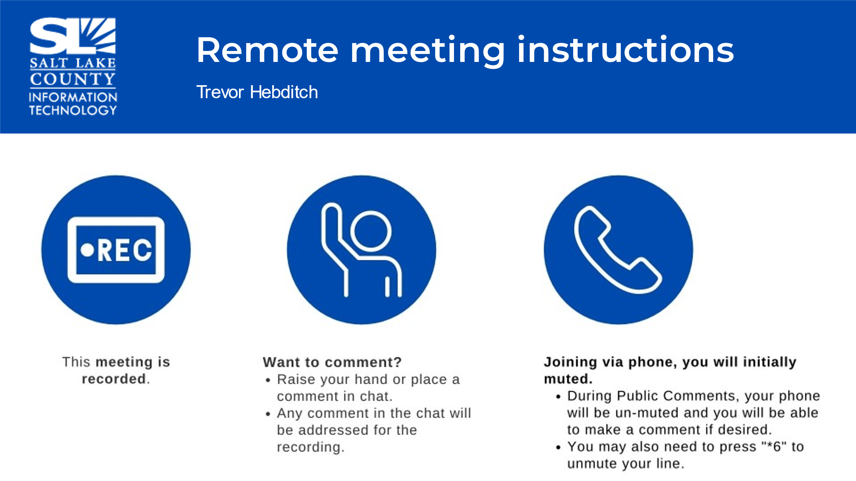
Public Comments  (Cherie Root) | No comments.
Portfolio Working Group (PWG) (Tony Jolley)  Portfolio Working Group (PWG)  (cont.)  (Tony Jolley)  The requests in ranked order. | 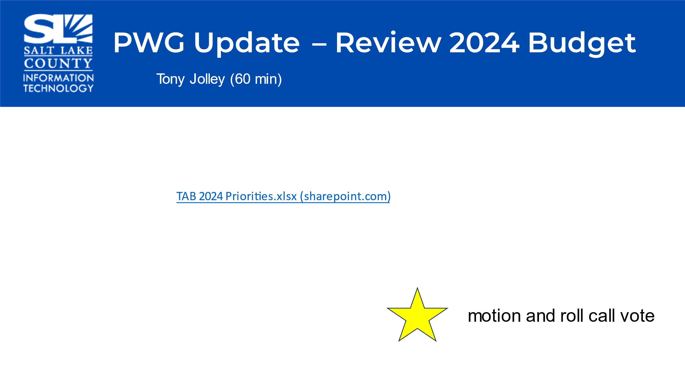  - This meeting is a continuation from August 10th, TAB meeting.  - The goal of this meeting is to rank and vote on the priorities for this session.  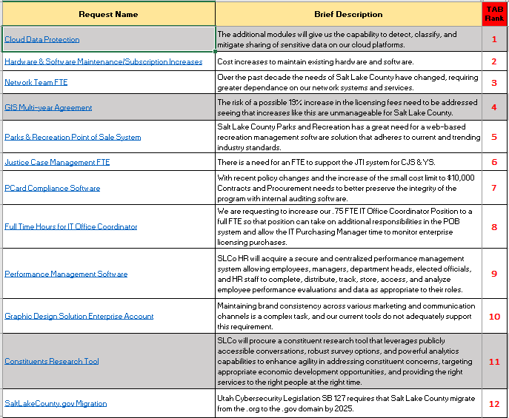  - The above list shows the twelve priorities in TAB ranked order.
TAB Priorities | Motion to Approve the TAB Ranked Priorities by Richard Jaussi and Will Kocher, seconds the motion.  Motion passed unanimously.  Roll Call 1st - TAB by Cindy Beck (Representation Absent): Clerk, District Attorney, and Human Services  Roll Call 2nd – GIS Steering by Allycen Farnsworth (Representation Absent): Clerk, District Attorney, Human Services, Regional Development, and Public Works
Separate Funding  Existing Funding  Informational as these requests already have the funding. | - 2 New FTE’sfor Health IT Support – Justin Daniels explained in detail why the “need” of two FTE’s are being asked due to being understaffed with the amount of work that needs to be done in this agency as it relates to IT.  - 2024 7900 Series Phone Replacements – Some agencies have requested for (physcial) phones.  Motion to Advance both of these requests (Separate Funding) by Phil Conder and Chris Stavros, seconds.  Motion passed unanimously.  - Pattern Recgonition and Early Problem Detection  - Robo Trap Community Cats  - Goosechase Scavenger Hunt Software  - Classification Web Plus  - PDQ Inventory & Deploy Admin Licenses  - Policymap Enterprise License
Follow Up Items  (Cherie Root) | 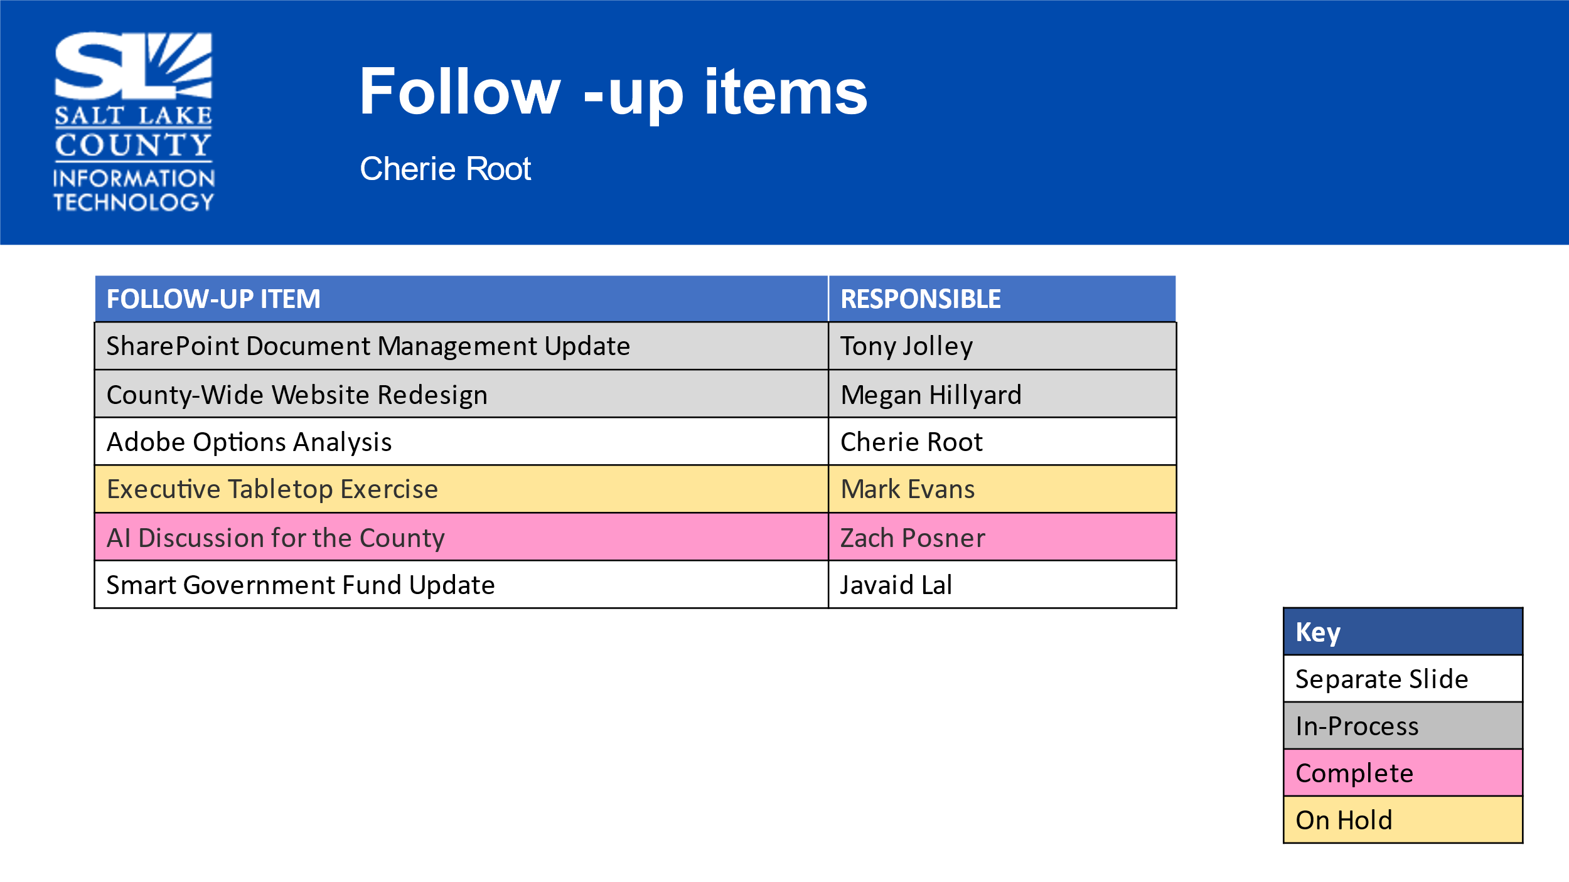
Adobe Options Analysis (Cherie Root) | 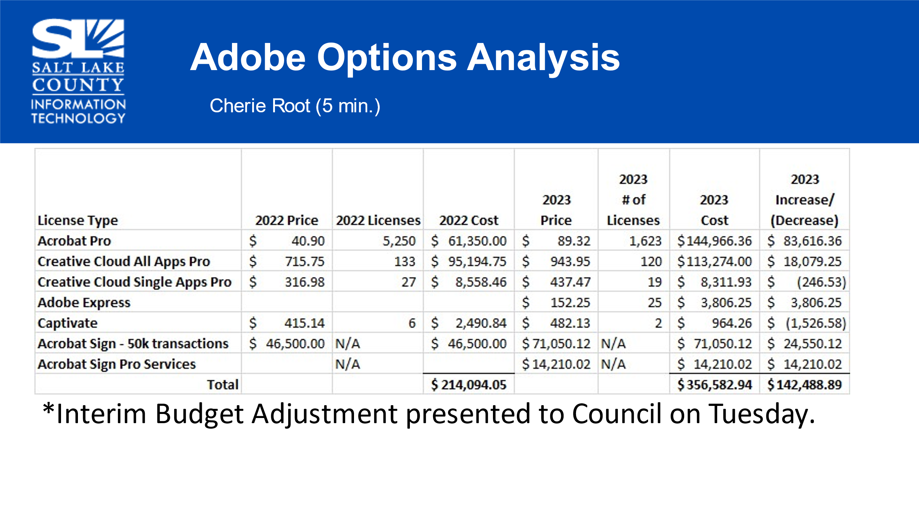
Smart Gov Fund Update  (Javaid Lal) | 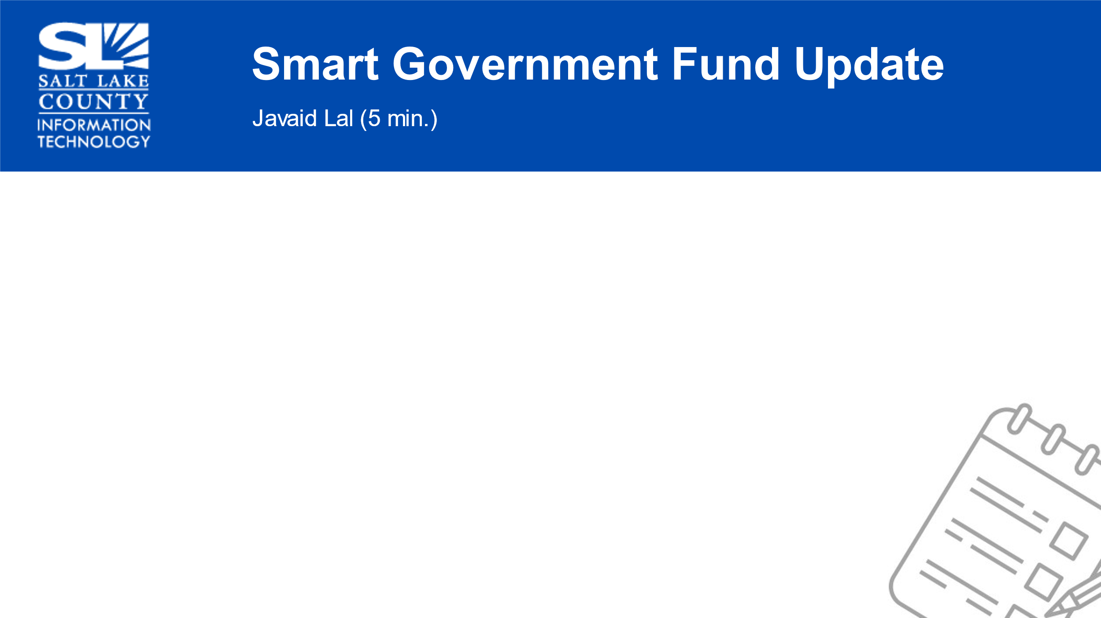  - Internal Data Sharing Agreement is being “re-drafted” by DA’s office.  - AI Best Practices document to provide general guidance is being created by the Data Gov Working Group + CIO.
Smart Gov Fund Update  (cont.)  (Javaid Lal) | 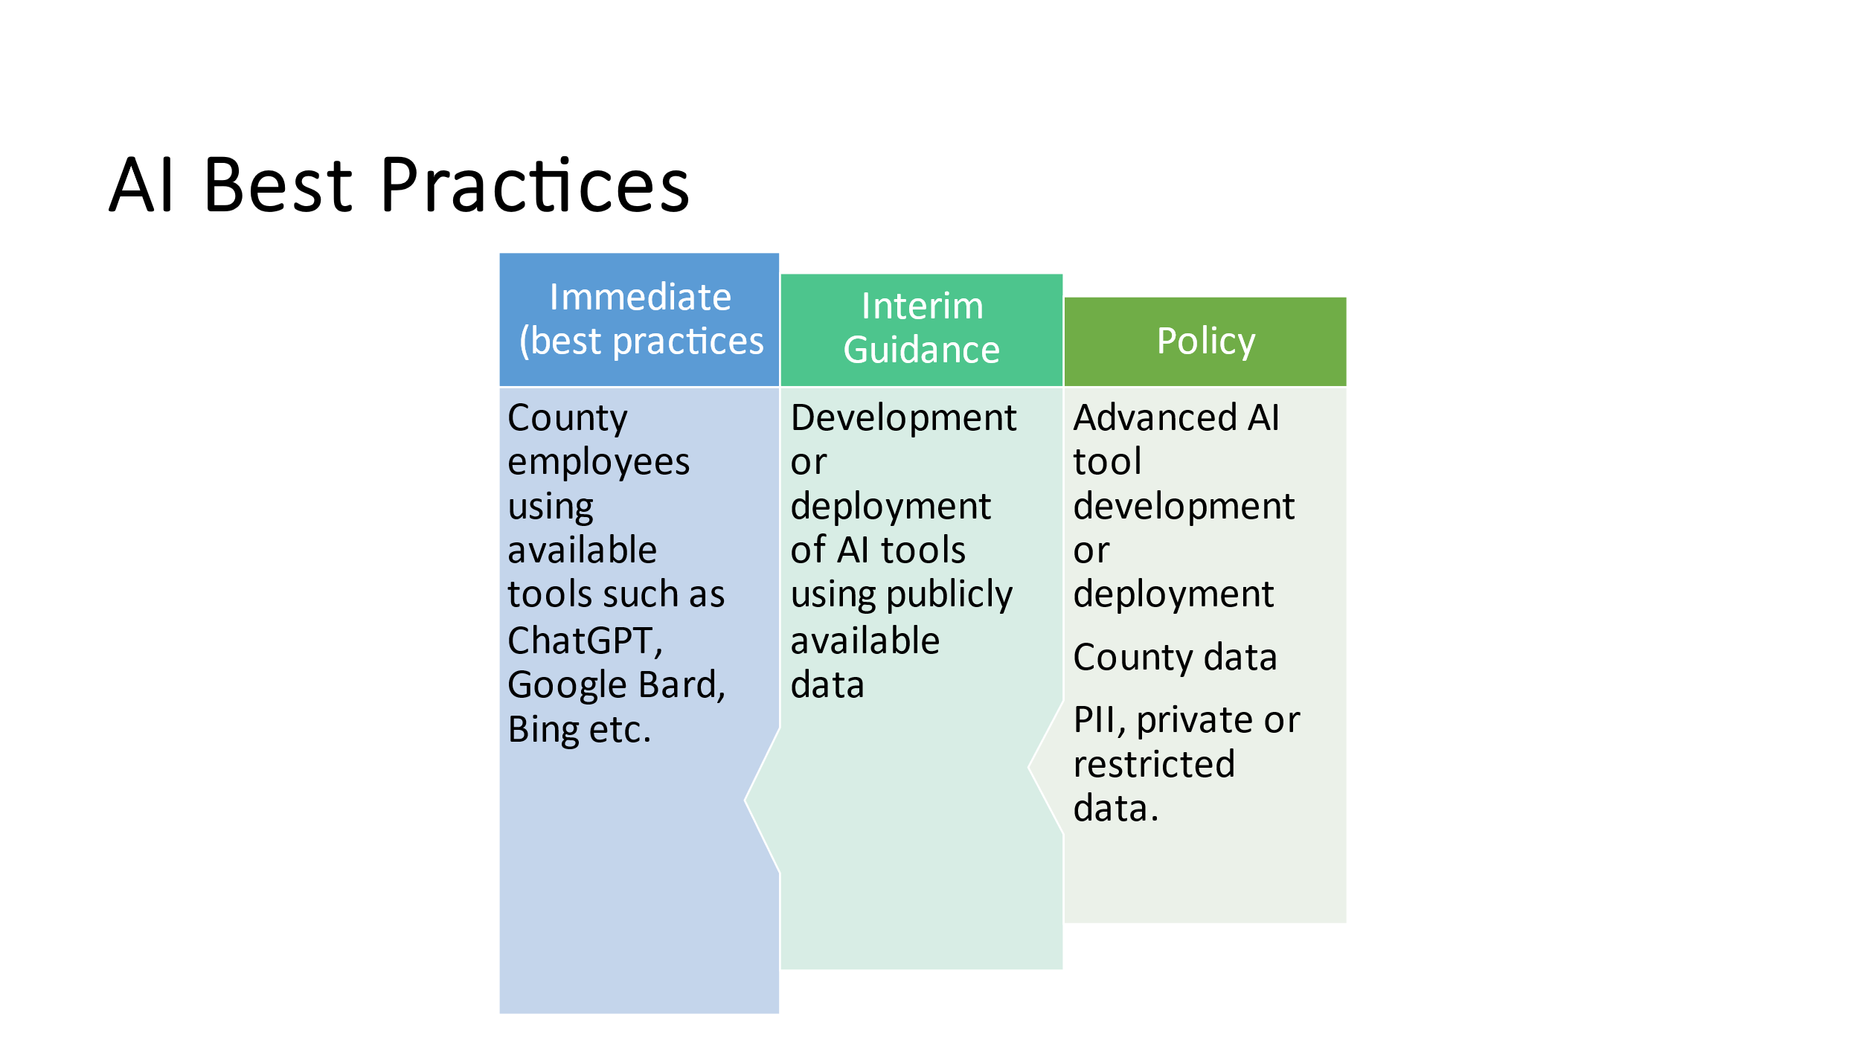
Smart Gov Fund Update  (cont.)  (Javaid Lal) | 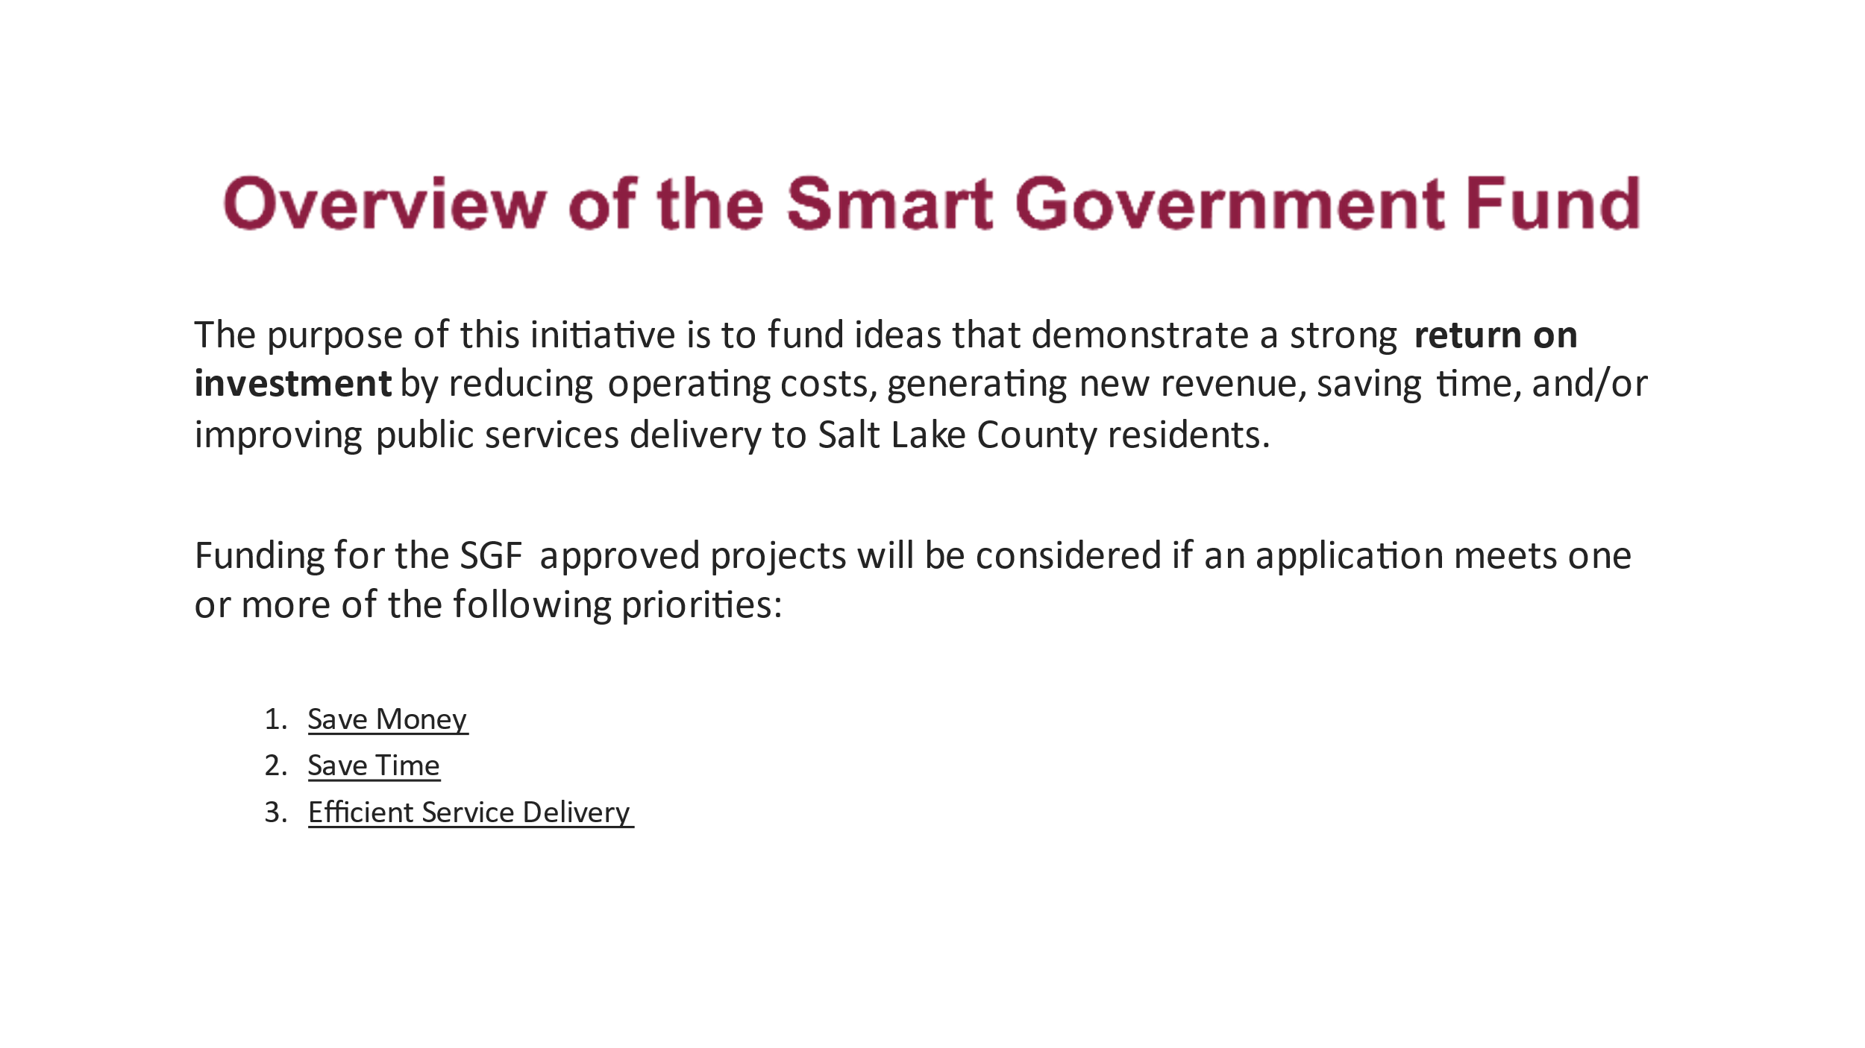
Smart Gov Fund Update  (cont.)  (Javaid Lal) | 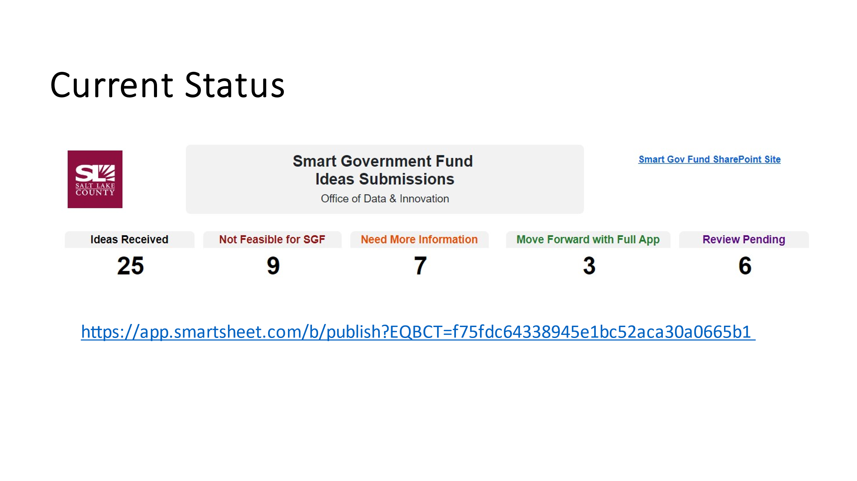  - Dashboard of Current Status of Submissions
Smart Gov Fund update  (cont.)  (Javaid Lal)  1st one funded  Assessor’s Office | 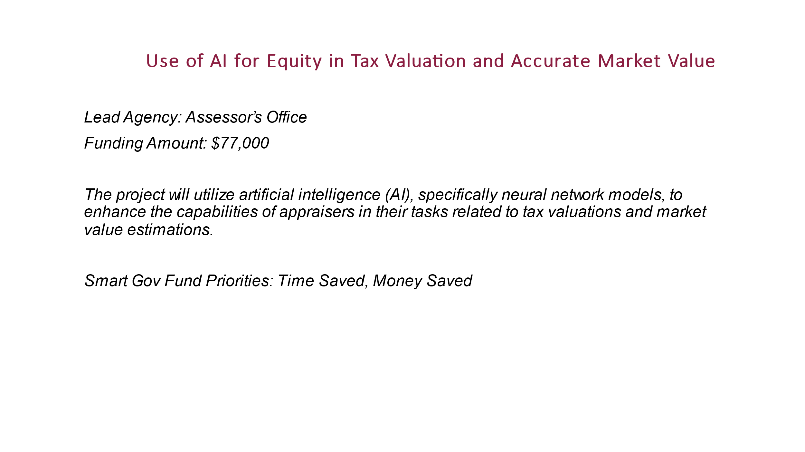  - Example of Smart Gov Fund Priority in process and the benefits
Smart Gov Fund Update  (cont.)  (Javaid Lal)  2nd one funded  Facilities Services | 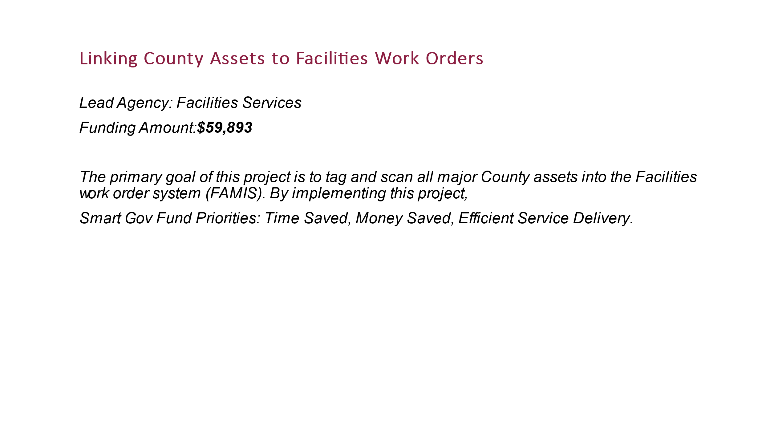  - Example of Smart Gov Fund Priority in process and the benefits
Smart Gov Fund Update  (cont.)  (Javaid Lal)  3rd one funded  Animal Services | 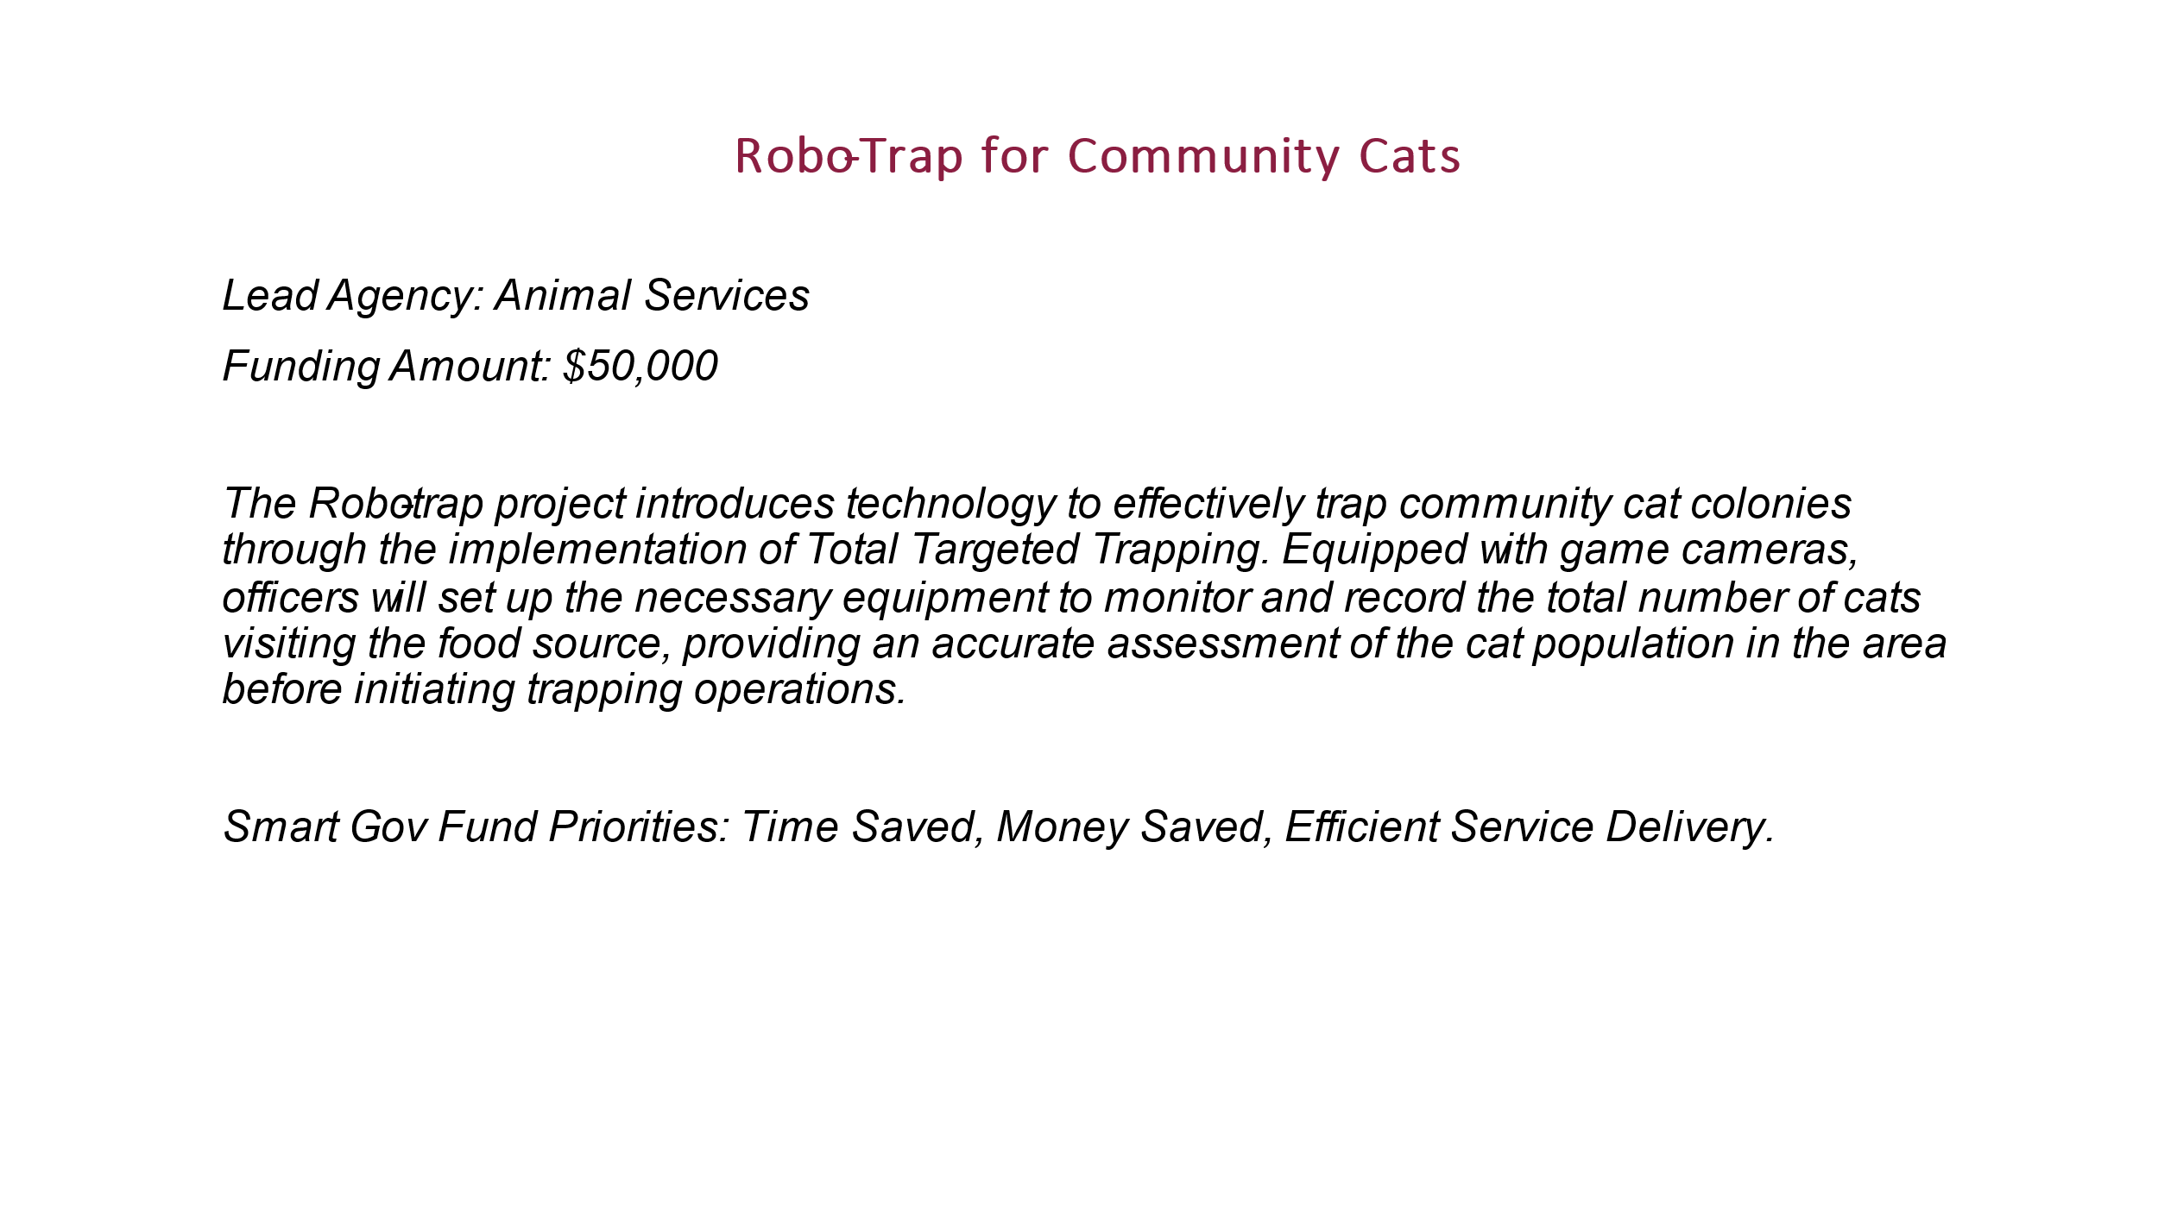  - Example of Smart Gov Fund Priority in process and the benefits
Technology Positions County-Wide  (Sharon Roux) | 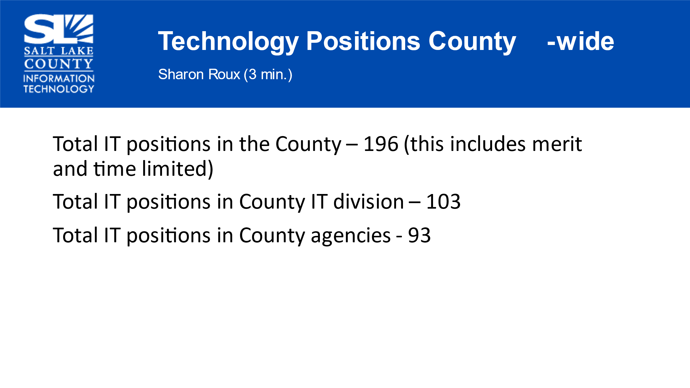  - This report is produced on a quarterly basis.
Other Business (TAB Members) | Sharon Roux will bring analysis of Technology Positions county-wide for the October 26th, TAB meeting.
Communication Items (Chair & CIO | 2024 TAB Priorities
Upcoming Meeting Schedule (Cindy Beck)  Next Meeting October 26th, 2023 | 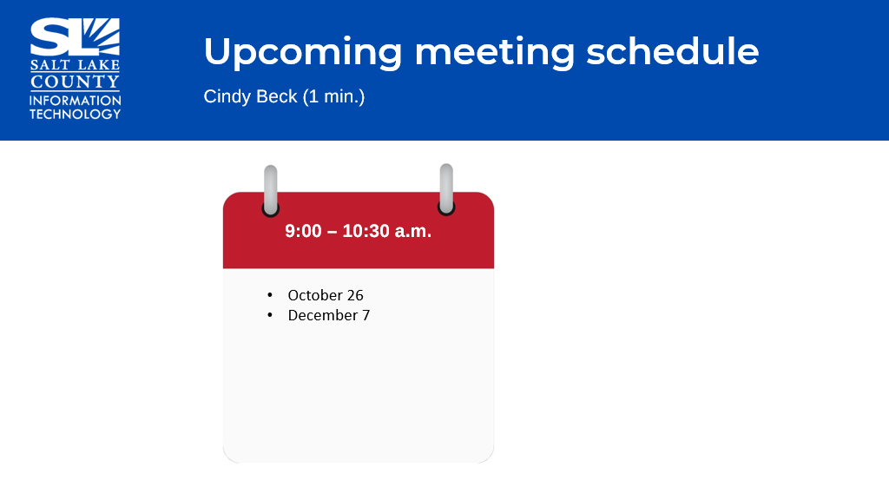
Review Action Items (Cindy Beck) | - Review the Technology Positions in October.
End of Session | - Motion to adjourn the meeting by Phil Conder, Richard Jaussi second. No objections. Meeting adjourned.
Next Meeting | October 26th, 9:00 AM – 10:30 AM
Submitted by Cindy Beck | *It was noted there was no conversation/questions in the chat for this session.

