Present: Zachary Posner (Information Technology), Reid Demman(Surveyor), Chris Stavros (Assessor), Megan Hillyard (Administrative Services), Phil Conder (Treasurer), Rashelle Hobbs (Recorder), Lisa Ashman (District Attorney)-online, Richard Jaussi (Auditor), Joey McNamee (Community Services)-online, Katy Fleury (Mayor Administration), Matthew Dumont (Sheriff)-online, David Delquadro (Council Fiscal Manager), Katherine Fife (Human Services)-online, Kade Moncur (Public Works)-online, Dina Blaes (Regional Development)-online
Representation Absent: Clerk
Staff Present: Tony Jolley-online, Brandon Allgier-online, Mark Evans-online, Rina Shipley-online, Cindy Beck, Kimball Ball, Andrew Dudley-online, Corey Hess, Dean Bullock-online, Lee Wilstead, Mark Miller, Cherie Root, Jon Thelen-online, Trevor Hebditch, Sam Sedivec, Valina Eckley, Mike Bailey, Allycen Farnsworth,
Resident: Steve Van Maren-online
TOPIC | POINTS OF INTEREST
Welcome & Remote Meeting Instructions | Reid Demman opened the meeting.  Trevor Hebditch shared the following slide:  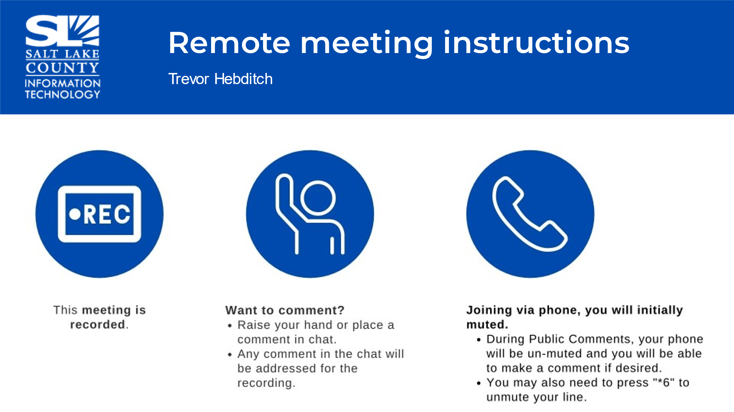
Public Comments | No comments.
Approval of minutes from June 22, 2023 meeting | Motion to accept the minutes by Phil Conder, Rashelle Hobbs, seconds the motion. No discussion.  Motion passed unanimously.
Portfolio Working Group (PWG) Update  (Tony Jolley) | 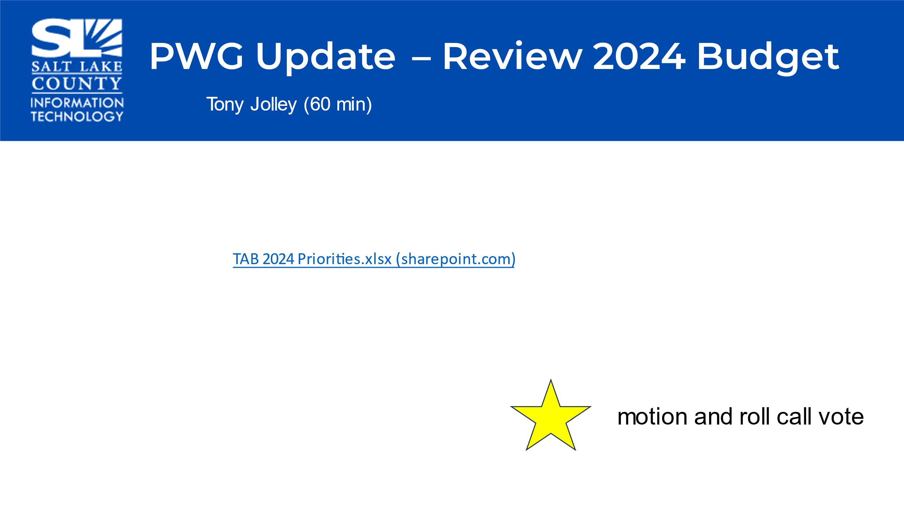  - Reviewed projects that were presented for the 2024 Budget.  - The spreadsheet was shared throughout the meeting and showed how IT leadership/Executive Team, Portfolio Working Group (PWG), and Solutions Working Group (SWG) scored the requests.  - The goal of this meeting is to have TAB prioritize the requests.
Portfolio Working Group (PWG) continued (Tony Jolley) | - Cloud Data Protection – Additional modules will give capability to detect, classify, and mitigate sharing of sensitive data on cloud platforms.  - Hardware & Software Maintenance/Subscriptions Increases – Cost increases to maintain existing hardware and software.  - Parks & Recreation Point of Sale (POS) – Have a great need for a web-based recreation mgmt. software solution that adheres to current and trending industry standards.  - Network Team FTE – Over the past decade the needs of the County have changed, requiring greater dependance on our network systems and services. This is the 2nd year asking for this position.  - Justice Case Mgmt. FTE – There is a need for an FTE to support the JTI system for CJS & YS.  - GIS Multi-Year Agreement – Risk of a possible 19% increase in the licensing fees need to be addressed seeing that increases like this are unmanageable for Salt Lake County. *A motion was made to accept the recommendation of SWG to pursue the Enterprise Licensing Agreement by Megan Hillard, Richard Jaussi seconds the motion. Motion passes unanimously.  - Full Time Hours for IT Office Coordinator – Asking to increase our .75 FTE IT to full FTE so that position can take on more responsibilities in the POB system and allow the IT Purchasing Manager time to monitor enterprise licensing purchases.  - Pcard Compliance Software – With recent policy changes and the increase of the small cost limit to $10k Contracts & Procurement needs to better preserve the integrity of the program.  - Constituents Research Tool – Leverage publicly accessible conversations, robust survey options, and powerful analytics capabilities to enhance agility, address constituent concerns, target appropriate economic development opportunities, and provide the right services to the right people at the right time.  - .gov Migration – Utah Cybersecurity Legislation SB 127 requires Salt Lake County to migrate from the .org to the .gov domain by 2025.  - Graphic Design Solution Enterprise Account – Maintaining brand consistency across various marketing and communication channels is a complex task, and our current tools do not adequately support this requirement. Performance Mgmt. Software – Acquire a secure and centralized performance mgmt. system allowing employees, managers, department heads, elected officials, and HR staff to complete, distribute, track, and store data as appropriate to their roles.  **Richard Jaussi recommended the GIS Multi-Year Agreement, and the Network Team FTE needs to be moved up or higher on the list.
Portfolio Working Group (PWG) continued  (Tony Jolley) | - 2 New FTEs for Health IT Support – By having additional service desk technicians, our team will be better staffed to assist employees with their technological challenges and needs.  - 2024 7900 Series Phone Replacements – The project is to support an upgrade to the phone system. Our current 7900 series phones are our dated and are not supported in future releases.
Upcoming Meeting Schedule (Cindy Beck)  Next Meeting August 16th, 2023 | 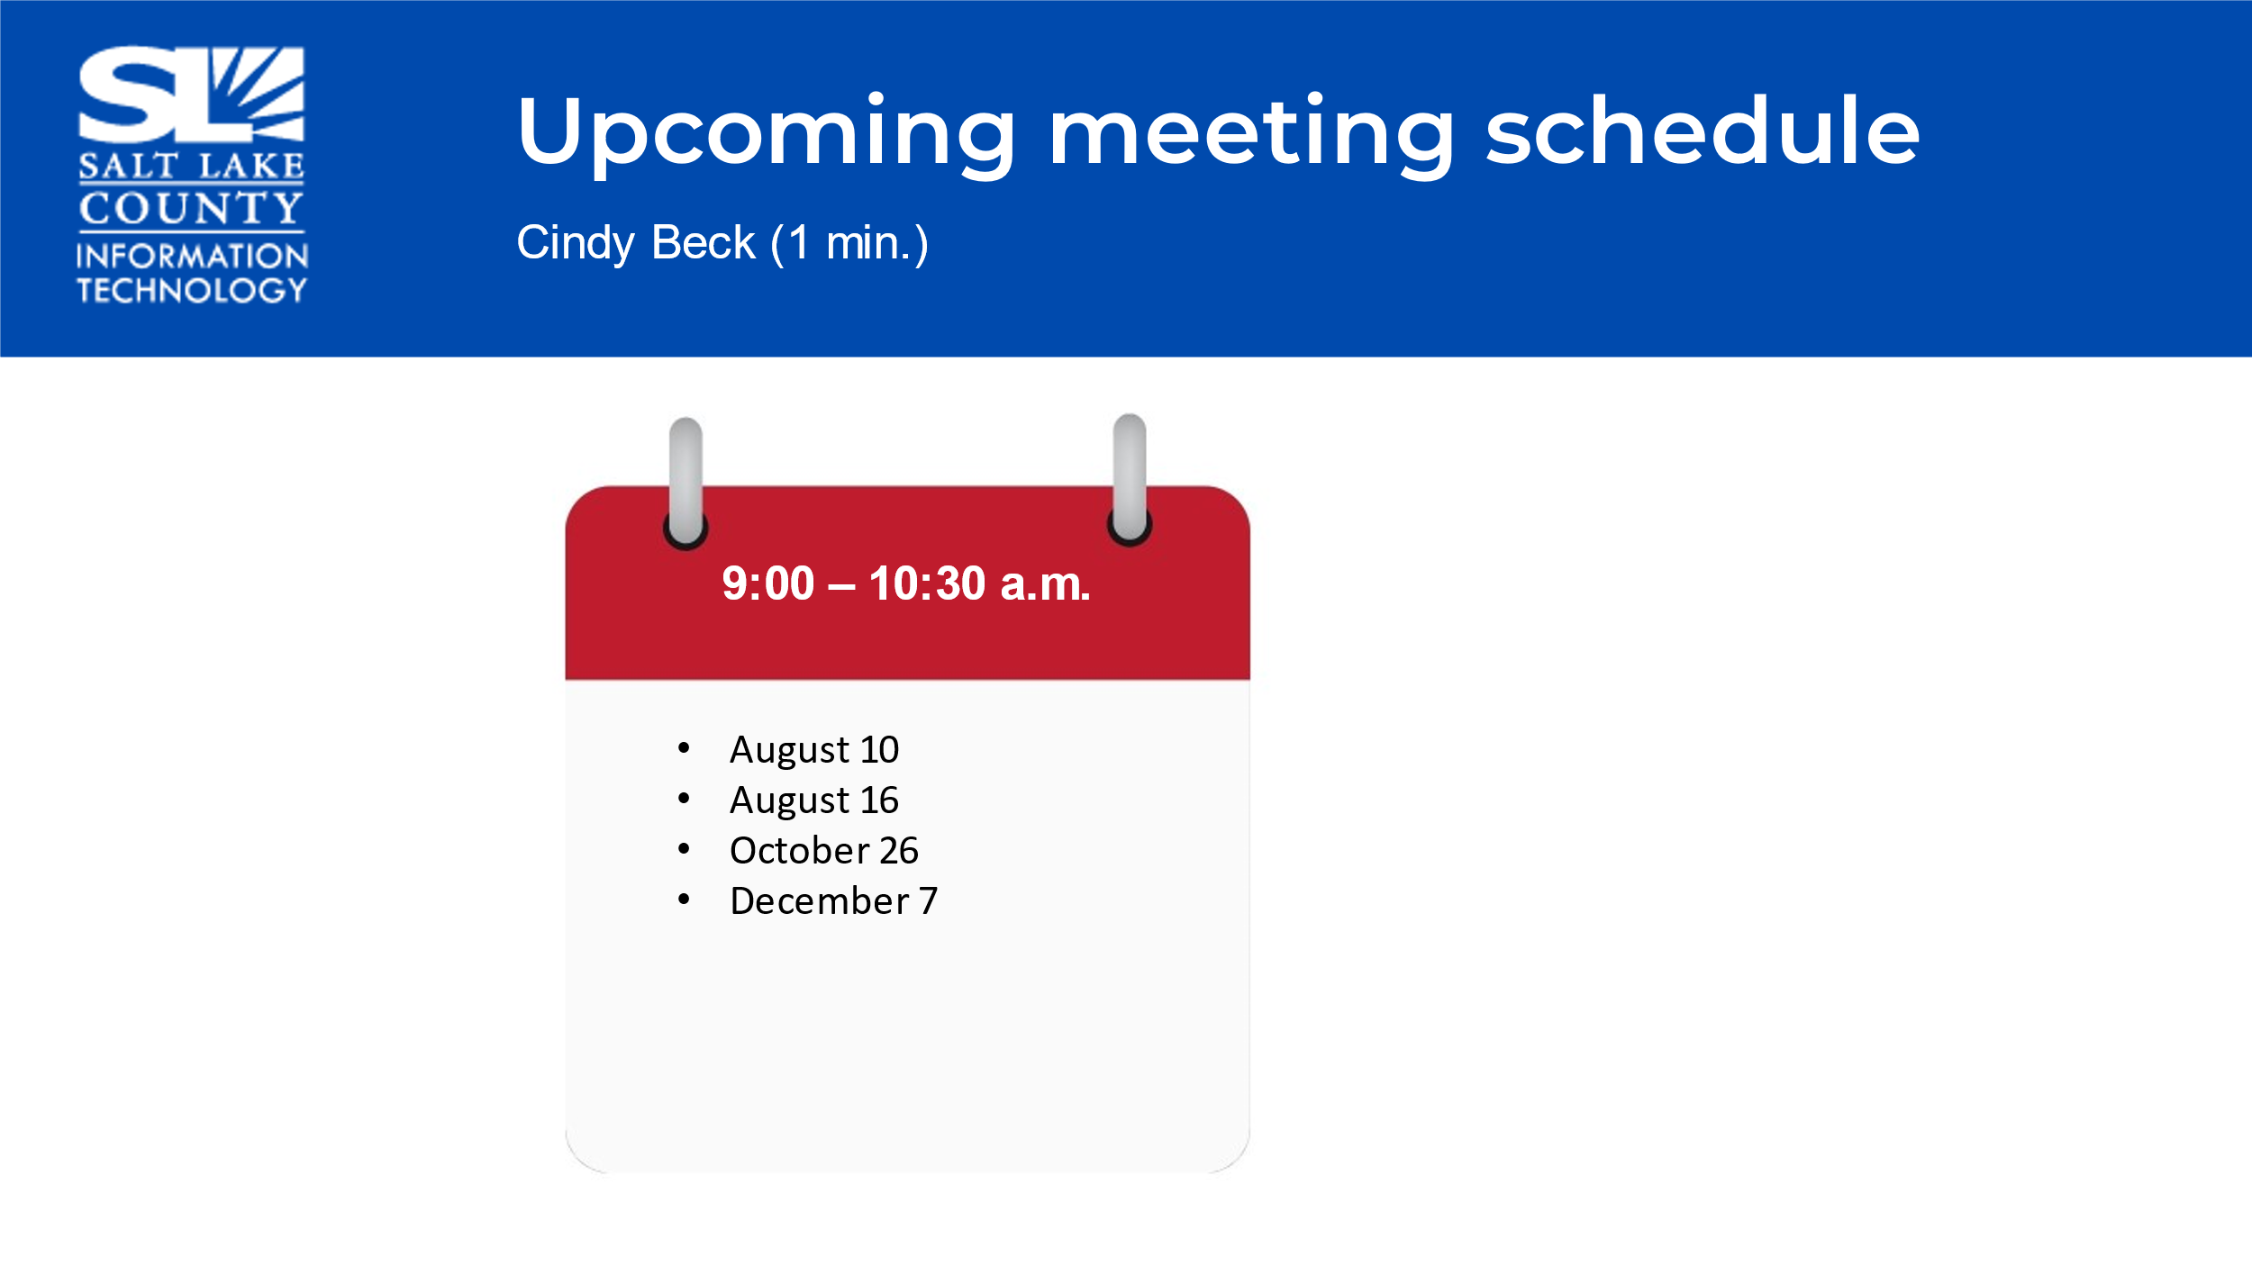  - Due to time constraints, we will continue the discussion on August 16th, with the ranking of all priorities and voting on the priorities.
End of Session | - Motion to adjourn the meeting by Phil Conder, Richard Jaussi seconds the motion. No objections. Meeting adjourned.
Next Meeting | August 16th, 9:00 AM – 10:30 AM
Submitted by Cindy Beck

