October 25, 2023
Lake Point Residents:
As a resident in a subdivision with drainage swales, we want to make you aware of the importance of maintaining the swales on your property. Swales are the graded and engineered landscape feature appearing as a linear, shallow, and open channel with trapezoidal or parabolic shape located in the road right-of-way.
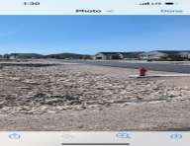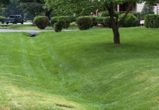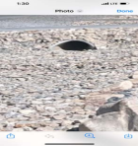
The swale design promotes the conveyance of storm water at a controlled rate during times of above average rainfall and/or snowmelt. Swales function as the City Storm Water Management System. Swales also function as a filter, removing pollutants and allowing storm-water infiltration to the aquifer. When properly designed and maintained, a swale results in significant improvement over the traditional ditch, in both slowing and cleaning of water.
When originally designed, your subdivision incorporated swales to provide a way to deal with storm-water runoff. Alteration of the swales, such as filling in or leveling, elimination of slopes, placing of culverts, or improper landscaping can jeopardize your property and/or that of your neighbors.
(1) The following materials shall be prohibited in swale public property in rights-of-way:
(a) asphalt or concrete, other than drive approaches with required piping.
(b) trash, debris, and dirt.
(c) any non-swale material that can be removed when kicked, blown, or washed may clog storm swales and drains, prevent percolation of water into the soil, or cause a visual barrier to pedestrians, bicyclists, motorists or for the commission of a crime.
(2) After proper notice to the owner to voluntarily correct the issues, if no corrective action is taken, the City may remove obstructions that violate city ordinances on swales at the expense of the landowners. Such removal shall not preclude or be a determination as to nuisance or other compliance action being taken.
For reference, subdivision road rights-of-way within Lake Point City can extend up to 16 feet or more past the edge of the asphalt. The only way to know for sure where your property line begins is to contact a private surveyor to help locate your property corners.
In closing, if you are contemplating altering the swale in any way, you are required to comply with the city ordinances, and we strongly urge you to consider possible ramifications. Be mindful of not only consequences to your own property, but those of neighboring lots as well. If you are currently complying with the ordinance, we thank you.
Sincerely,
Lake Point City Council

