Kanosh Town Corporation held the regular council meeting on Wednesday, September 13, 2023, in the town office at 7:00 p.m.

Members present:
Mayor Scott McDonald, Council members: Neil Shumway, Hayden George, Kanosh Town Treasurer DeniAnn Whitaker, and Kanosh Town Clerk Cindy Turner

Councilmember David Whitaker was unable to attend tonight's meeting he is fighting fire out of the state. Brandon Stephenson unable to attend

Others: Sara Robison, CentraCom Jeff Cox and Branch Cox, Heidi McDonald, Josh Whitaker, Dan DeGraffenreid, Jim Weaver, Ben Coray, Stan Koyle, Star Cummings, Carole Hardy, Jim Kooy, Perry Watts, Paulette Staples, Johanna Whitaker, Justin Wayment
Mayor Scott McDonald offered the opening ceremonies through an invocation.
Councilmember Hayden George led everyone in the Pledge of Allegiance.
Minutes of the August 2023 meeting were read and approved as amended through a motion by Councilmember Neil Shumway, Councilmember Hayden George provided a second to the motion, and all Council members in attendance voted in favor as noted below:
Mayor Scott McDonald Aye
Council members:
Neil Shumway Aye
Hayden George Aye

Warrants for August 2023 were read, discussed, and approved to be paid through a motion by Councilmember Neil Shumway, Council member Hayden George seconded the motion, and all Council members voted in favor as noted below:
Mayor Scott McDonald Aye
Council members:
Neil Shumway Aye
Hayden George Aye

CERT:
Kanosh Cert Captain Geri Minton reported the CERT team had their September meeting. The October meeting will be bypassed. The next meeting will be February 7 and the March mini conference will be held March 23rd. There will be a State speaker at the conference.

Kanosh Fire Department:
Fire Chief Lorin Shumway reported things have been quiet for the fire department.
There have been people commenting on the flat tires on one of the fire trucks at the fire station. Chief Shumway stated this truck would be the 4^{t.h} truck to respond to a fire and would not go out unless there was a pretty big fire anyway. We do have other trucks that will respond as needed. The cost of a set of new tires runs around $10,000.00, which exceeds the current budget.
As a voting member/representative for the Town in the Fire District, There is a company doing a solar project on the west side of the county, near the Juab County line. This company has asked for a tax break for the first eight years of their production. The majority of Fire District members are voting against the tax break stating that if they are an outside company coming in for profit they should pay their taxes up front, not ask for a discount. However, if they are unable to start the project we would not be able to recoup any of those taxes, it doesn't look like we are out any tax, we are just not getting as much upfront.
A discussion ensued over the taxing base of such a company. Chief Shumway noted that the majority of the voting Fire District members will be voting in favor of the company paying their taxes upfront.
Note: the tax rate for the fire district was left the same, with no increase.
Planning and Zoning
The commission had nothing new to report at this time.

There has not been a decision made yet on the setback ordinance. Council members will work on the ordinance again this month to come to some kind of resolution on the proposed changes.

Centra Com:
Mr. Branch Cox the CEO and Mr. Jeff Cox the fiber optic manager for CentraCom presented their plans for the installation of the fiber internet to Kanosh. CentraCom received a state Broadband access grant which will cover 75 % of the project, CentraCom will come up with the other 25%, there is no obligation of funding to the city. It will all be fiber to the home technology and they are participants in the "affordable connectivity program" so there will be discounts for low-income people and there is also a tribal discount. The monthly pricing for service will be competitive with what they have in other areas. The starting rate right now is a 50-meg package at 39.95/month. CentraCom Internet service gives you download speeds of up to 1 Gbps. You can enjoy everything the Web has to offer, CentraCom now offers a new mesh Wi-Fi router called the CentraWiFi Blast to eliminate dead spots in the home. For larger homes mesh extenders can be added giving a strong signal throughout the home (their technicians would help determine if extenders are needed). Mr. Cox questioned if they could use the Kanosh power poles to build the network, they would prefer to do an aerial build, it would make things go a lot faster, but they are good either way.

Council members noted we are moving everything underground.

They will only be taking this service to those requesting the service. To receive the service you will have to call their office and get on the list.

Canvass Election:
Kanosh Town Corporation held the canvass of the election votes for the primary election with the following results:
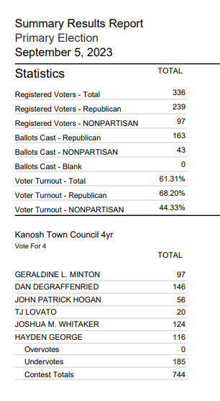
Councilmember Neil Shumway motioned to approve the canvass as presented, Council member Hayden George provided a second to the motion, and all Council members in attendance voted in favor as noted below:
Mayor Scott McDonald Aye
Council members:
Neil Shumway Aye
Hayden George Aye

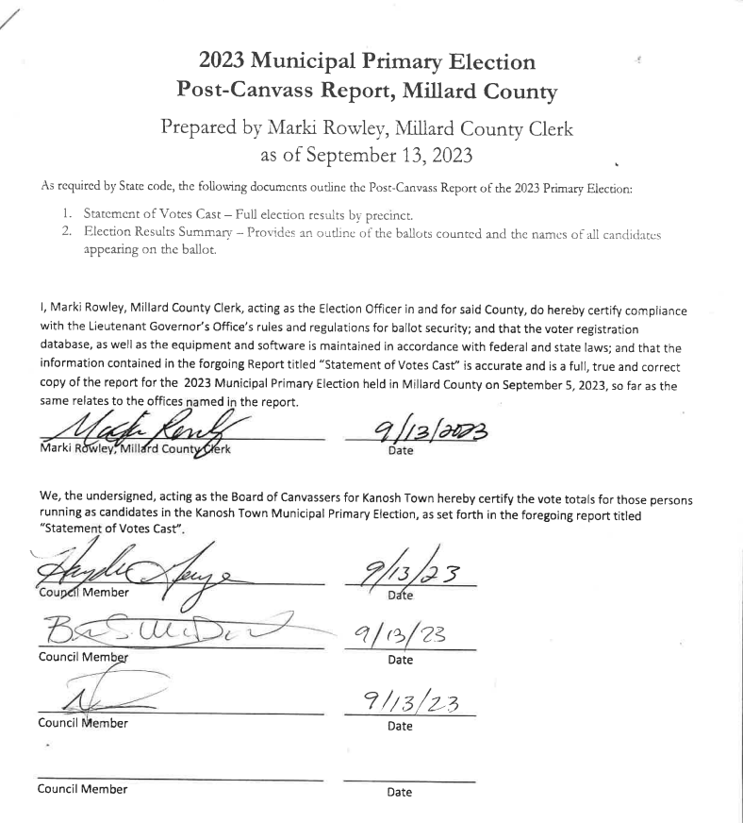

Electrical rates and surcharge:
Mayor McDonald and Councilmember Neil Shumway explained the electrical rates and the associated surcharge, stating Kanosh has maintained the base electrical rates, residential is set at .12/kwh and commercial rates at .13/kwh and then we have been adding on a surcharge of .05/kwh, this formula worked for a month and then for some reason, Pelorus is kicking that out and we are billing closer to .9 1/2 cents overall per kwh, which is less than our rate. We are going to have to come up with some kind of a table, it is unclear at this time what kind of table they want. There was discussion to maybe get rid of the surcharge to make it easier for Pelorus and make sure we get this chart/table figured out, UAMPS has been consistent with their billings. In doing the math for our billing for July, the total charge is high at $27,000.00 for the month of July but kilowatt hours was 350,000 kwh so it comes out at about .08/kwh. The Council is considering raising the base fee to include the additional .05/ kwh resulting in our base rate being .17/kwh residential and .18/kwh commercial, leaving the surcharge for later. This change could be made by resolution and does not require a public hearing.

Council members were hoping the rates would come down and it has a little, 1/2 cent a kwh in six months. It is staying pretty steady. The surcharge has allowed Council members to react within a month, however, this is more confusing for Pelorus. There was a suggestion to have a work meeting with Pelorus to find out why the rates are not matching up.
Council member Neil Shumway will arrange a time he can meet via telephone with Pelorus in an attempt to do what is needed.

Council members agreed to stick with what we have been doing for now

Departmental reports:
*Water Department: Councilmember Whitaker is over the water department, he was called out on a fire in California and is not in attendance tonight.
Town Employee Lorin Shumway explained the procedure for testing our water: We are required to test the chlorine residual at least 12 times per month, usually, our employees do it even more frequently averaging about every other day so about 15 times a month. There is a quarterly report on the testing, if there is an issue it goes to the state. Our chlorine residual is right now running about 16 3/4% of the max, trying to keep the chlorine at a minimal, yet enough in there to keep the water safe.

Roads: Councilmember Brandon Stephenson is over the roads, is working in Arizona, and is unable to get back in time for this meeting. Nothing new to report.

Parks and Cemetery: Councilmember Hayden George reported that everything looks good, everything is green. Fernando does a fantastic job. We need to do some work at the ball diamond, we need some new bags, new grass, etc.

One of the Kanosh Town Residents in attendance reported a lot of beer cans were located in the cemetery. The town employee noted the same.

10 Commandment statue:
This is a Privately funded 10 commandment sign, nothing has been decided on a location.

Electric Department:
Councilmember Neil Shumway reported he has called in 4 street lights for replacement.

Utility Delinquency Review:
Council members reviewed the monthly delinquency list. It was determined, again, to handle those accounts in arrears according to established Town policy.

Public Comments:
There were no public comments at this time.

Well Update:
Mr. Ben Coray provided an update on the Well project. Rural Development has new staff and a series of requirements. They are requiring the contractors to provide coverage for builders with all risk insurance. However, that insurance does not apply to every phase of the project. That insurance applies to vertical construction, not well construction. However, because it is a blanket requirement with Rural Development they want to see it from our Well contractor.

In short, Builders risk insurance offers limited coverage for damages that occur to vertical construction in the process (before the owner takes ownership). Examples of this include:
- Fire
- Lightning strikes
- Hail
- Theft
- Vandalism
- An aircraft or vehicle crashing into a structure

A Builders risk policy could be used to recover the loss from a covered event, protecting the contractor from substantial financial risk, bankruptcy, etc.

Mr. Coray stated intent is to show that the well driller has other policy riders that offer coverage similar in intent to a Builders risk policy. Sunrise will review the Well Drillers insurance coverage in detail and then between Sunrise, Kanosh Town, and the Town Council, we will state that the coverage meets the intent of that requirement. White Mountain’s insurance agent is preparing a document that details the various coverage limits White Mountain also has the following policy riders:
- Cargo Coverage – provides coverage for materials in transit to the job site
- Underground Resources Coverage – covers damage caused by drilling “blowouts” that impact others.

In good faith White Mountain went out and tried to obtain the required coverage, contacting 8-9 insurance carriers, and was denied by all of them because they are a well driller and not a vertical construction contractor. There is not a policy out there that would satisfy this requirement in those specific terms.

Hopefully, this can be resolved fairly quickly and we can get moving forward. The drillers will email Mr. Coray a copy of the insurance, at that time they will see if what they have meets the intent of the coverage. It does force the Town to go out on a little bit of a limb, to say that we of Kanosh Town are accepting of the insurance policy that the driller has.

The backup plan here is the contractor has a "performance of payment bond", so he has secured a bond for the full amount of his contract. If something were to occur so he could not finish his work, i.e. if he lost all of his equipment and went bankrupt on us we turn around and put that bond in effect, and the bonding agency comes in and completes the project for us.

Corn Creek Project:
Councilmember Hayden George stated this project is still going full steam ahead. There have been some issues that they were able to work around.

Set back ordinance:
Councilmember Neil Shumway wrote up the setback ordinance to include the changes discussed in last month's meeting. There was little feedback, the Mayor offered feedback on a few things he would like changed, and with that, we missed the 14-day posting window. Some people have noted they would like to get rid of it altogether. A discussion ensued, some of which would rather not have any setback ordinance wishing to make use of all of their property.

Mayor Scott McDonald requested that each council member put their thoughts to paper. Stating that if we are going to do it needs to be right.

Councilmember Hayden George made the motion to move into closed session for pending litigation and annexation, and Councilmember Neil Shumway seconded the motion, Through a roll call vote, Council members voted in favor
Mayor Scott McDonald Aye
Council members:
Neil Shumway Aye
Hayden George Aye

Closed Session 8:55

The closed session concluded at 10:20.

Following the discussion in the closed session Council members agreed to drop the lawsuit.

There was no further action for follow-up following the discussion in the closed session

There being no further business to come before the board, the meeting adjourned.

Scott McDonald Cindy Turner,
Kanosh Town Mayor Kanosh Town Clerk

Closed session: 8:55 pm

Members present:
Mayor Scott McDonald, Council members: Neil Shumway, Hayden George, Kanosh Town Clerk Cindy Turner, Kanosh Tow Employee Lorin Shumway, Attorney Justin Wayment

Councilmember David Whitaker and Councilmember Brandon Stephenson were unable to attend this meeting.

Closed:

- Water lawsuit, dismiss it:

- Sponsor Kanosh for the Corn Creek Irrigation

- Burn Pit

- Annexation (10-2-403)

- 10 commandments

The closed session concluded at 10:20

Public hearing to discuss electrical rates/ resolution

