Laketown Planning and Zoning Commission Meeting
Wednesday, September 27, 2023
8:00 pm

Welcome & Attendance: Duane welcomed those present.

Members Present: Duane Robinson, Chairperson; Dennis Hodges, Tamie Gomez, Ruby Hunter, Jon Carver, Recording Secretary.

Public Members: Richard Droesbeke, Burdette Weston

Pledge of Allegiance: Led by Nellie.

Minutes: Members reviewed the minutes from August.

Duane requested a motion to accept the minutes.
Tamie motioned to accept the minutes.
Ruby seconded.
All in favor.

- Laketown City digital sign

- Richard Droesbeke shed building permit

- Sheds under 200 square feet setbacks

- New subdivision ordinance

- Report from City Council

- Other

- Around the Room

- Conditional use

- Wardle property

City Digital Marquee:
The Laketown Activities Committee needs to raise more money and will come back when ready to install the sign.

Richard N Droesbeke Building Permit:
Richard wants to build a 14’x36’ shed in the northwest corner of his property. the shed needs to be 30’ off the proposed road on the west and 10’ off of the northern property line.
Richard needs to supply a drawing showing where the shed will fit on his property with setbacks from the property lines, plans for the shed, filled out building permit
Duane requested a motion to approve the shed building permit pending required documentation.
Nellie motioned to accept the shed building permit request pending required documentation.
Ruby seconded.
All in favor.

Sheds under 200 sqft:
Should sheds under 200 sqft be required to have 10’ setbacks? Dennis suggested they could be closer to the property line as long as the snow off the shed does not land on the fence or in neighboring properties.
Sheds under 200 sqft have a setback of 5’
Duane asked the planning and zoning committee to think about small shed setback and be prepared to discuss next meeting.

Conditional Use Permit:
Will be discussed in the next meeting.

Wardle Property:
Approximately 2 acre lot East of Boyers and west of Hodges. Currently there is no road access to the property. the property owners need to solve the access issues before we will entertain a request for a building permit
Duane stopped at Hickman Title and took this picture showing the Wardle property. It shows the Wardle property is adjacent to the proposed 300 south road.
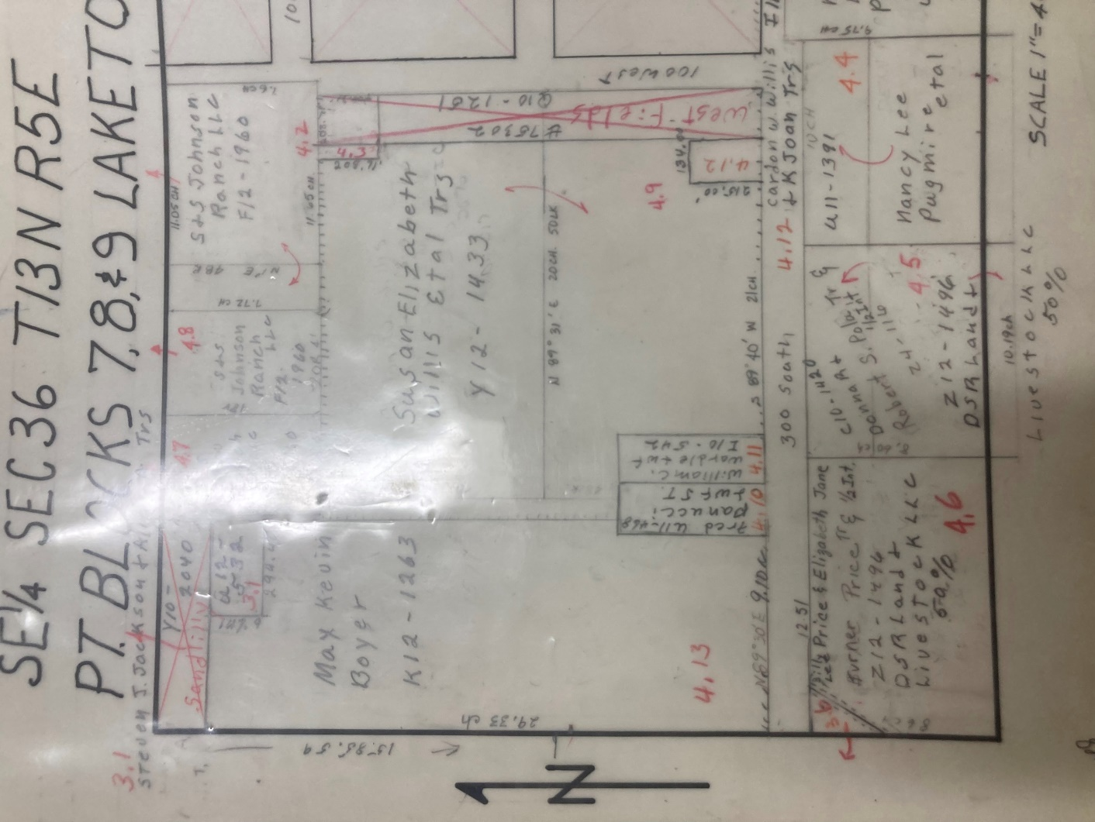

New Subdivision Ordinance:
Key dates for the Subdivision Ordinance:
Oct 25, 7:00pm: Kendall will be attending via Zoom the P&Z meeting to facilitate any questions or concerns from the commission.
Nov 29, 7:00pm: P&Z will hold a public hearing. Kendall will attend via Zoom.

The Planning and Zoning Commission made various changes to the subdivision ordinance for approval

Town Council Update – Brandon Willis:
Brandon was absent from the meeting. No report from city council

Around the Room:
Nothing brought up.

Duane entertained the motion to adjourn.
Nellie made the motion to adjourn the meeting at 9:54 pm.

