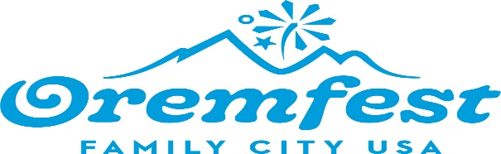
Oremfest Committee
56 North State Street - Orem, Utah
Council Conference Room
Wednesday, October 18, 2023
6:00 p.m.
This meeting may be held electronically to allow a board/commission member to participate.

Zoom Link: https://us02web.zoom.us/j/84859788060

AGENDA

1. Welcome Liz Woolf

2. Approval of the July 21, 2023 meeting recording/minutes Liz Woolf

- Elect Chair/Vice Chair for 2024 Karina Eckern
- Proposed changes to Events Karina Eckern
- Theme and Grand Marshall Discussion Karina Eckern
- Next Meeting Karina Eckern
January 17, 2024

7. Adjournment Karina Eckern

THE PUBLIC IS INVITED TO PARTICIPATE IN ALL CITY MEETINGS.
If you need a special accommodation to participate in the Advisory Commission meetings, please contact us on the City's website at orem.gov or call (801) 229-7000 at least 3 working days prior to the meeting. This agenda is available on the Utah Public Notice website at utah.gov/pmn.

