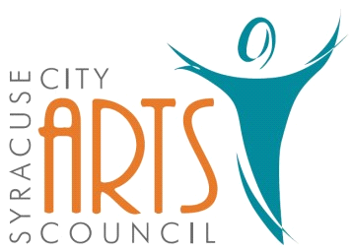
Syracuse City Arts Council Meeting Agenda
October 4, 2023 8pm
Meeting begins at 8pm
in the Syracuse City Municipal Building’s large conference room
located at 1979 West 1900 South.
1. Opening Business
- Call to Order
- Adoption of October 4, 2023 Agenda
- Review and Adoption of September 6, 2023 Minutes
- Approve Budget Expenditures since September 6, 2023

2. Public Comment-This is an opportunity to address the Council regarding concerns or ideas. Please limit comments to three minutes.

3. 2023-2024 SCAC Season Events
Orchestra: October 30, 2023 – Cosplay Theme, December 18, 2023 – Christmas Theme, March 11, 2024 – Complete Classical Work, May 20, 2024 – Possible Guest Artist
Jazz Band: December 4, Event at Library
Jr. Theatre: Seussical Jr. Nov. 2-4, 2023
Theatre: Hunchback July 2024
Fundraisers: ideas?
Other:

4. Budget Vote: Sept. 2023 – Aug. 2024 fiscal year.

5. Discussion and possible vote – Jr. show for next year

6. Publicity: Syracuse Connection information & other publicity as needed.

7. Walk in items

WORK SESSION
8. Committee/Board Member Updates/Discussion

9. Future Agenda Items

10. Adjournment
~~~~~~~~~~~~~~~~~~~~
In compliance with the Americans Disabilities Act, persons needing auxiliary communicative aids and services for this meeting should contact the City Offices at 801-825-1477 at least 48 hours in advance of the meeting.

CERTIFICATE OF POSTING
On Oct 2, 2023 this agenda was provided to the Standard Examiner and submitted to Syracuse City for posting on the Syracuse City Hall Notice Board and for publishing on the Syracuse City website, at http://www.syracuseut.com, and on the State Public Notice website, at http://www.utah.gov/pmn/indix.html. A copy was also submitted to the website manager for publishing on the Syracuse City Arts Council website, at http://www.syracuseutaharts.org/about-us/council-minutes. Libby Fawcett, Syracuse City Arts Council Chair

