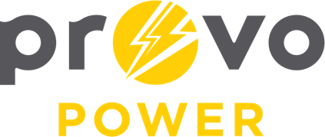
AGENDA
ENERGY BOARD MEETING
PROVO POWER
251 W 800 N
Monday, October 2, 2023
4:00 P.M.

- Welcome & Introductions - Chairman Gary Winterton
- Review & Approval of Minutes – September 11, 2023
- Financial Report – Charlie Little
- Energy Saving Devices/Power Factor Discussion – Engineering
- KPI Report – Charlie Little
- Forestry Report – Chaz Addis
- Manager Report – Travis Ball
- Calendar & Scheduling
  - Next Board Meeting: November 6th, 2023

A copy of the agenda was posted in the Civic Center, and the Provo City Library, on September 28, 2023, and also delivered to the Mayor,
City Council Members, required news media, and adjacent cities in
compliance with the Utah Code 52-4-202

