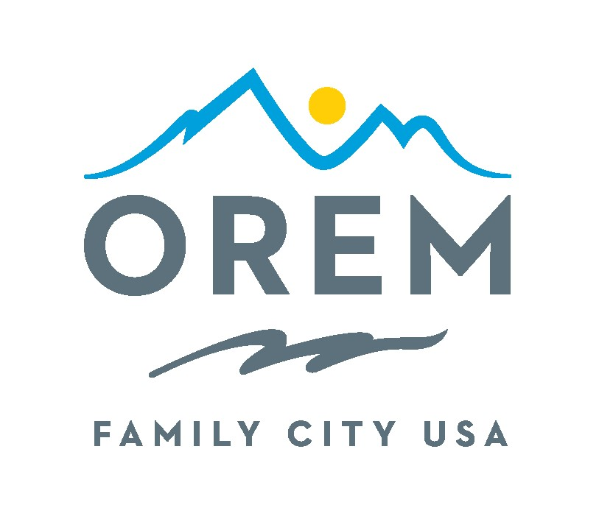
LEGAL NOTICE
OFFICIAL CERTIFICATION
CITY OF OREM
PRIMARY MUNICIPAL ELECTION
September 5, 2023

The Board of Canvassers of the City of Orem has prepared a report of the election results for the September 5, 2023 City of Orem Municipal Primary Election and certified the following results on Tuesday, September 19, 2023
Councilmember
Jeffrey K Lambson 7,056
Jenn Gale 6,489
Chris Killpack 6,323
Crystal Muhlestein 4.489
Matt McKell 4,138
Spencer Rands 3,573
Mike Carpenter 1,701
Heather M. Fry 1,150
Greg Duerden 956
David Edward Garber 573
Wade A. Sewell 250
Archie A. Williams 147
The following individuals were nominated and will be placed on the ballot for the General Municipal Election, which will be held on November 21, 2023:
Councilmember (Four-Year Term)
Jeffrey K Lambson
Jenn Gale
Chris Killpack
Crystal Muhlestein
Matt McKell
Spencer Rands
s/s
Teresa McKitrick, City Recorder
You can review or obtain a copy of the entire certified report by going to the city website at https://orem.org/elections/
Orem City Office, 56 North State Street, Orem Utah 84057 – City Recorder, 801-229-7298

