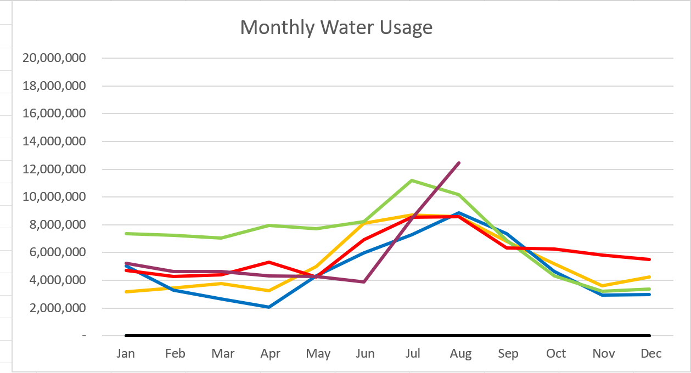

2023 – Purple
2022 – Red 2021 – Yellow
2020 – Blue 2019 – Green

August 2023

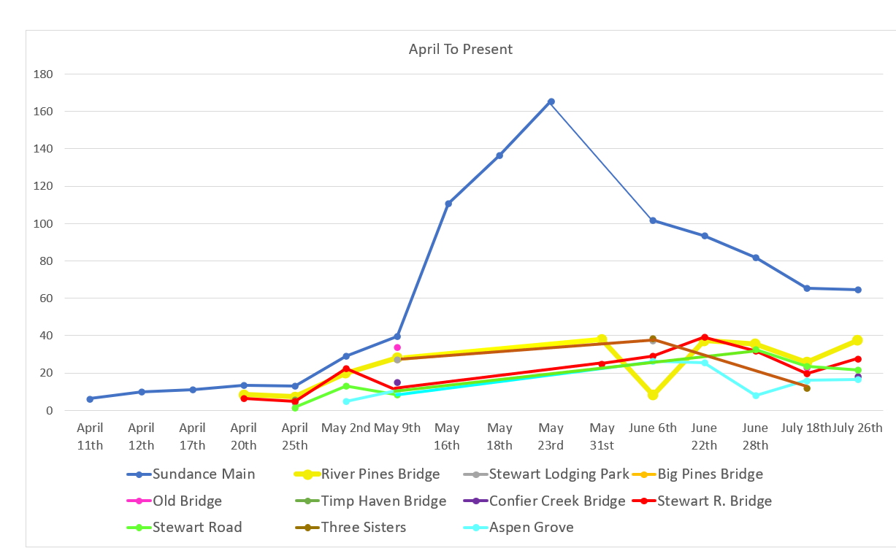

Water Department Information for August
- Our overall water consumption is very high compared to past years, due to metered leaks.
- Unaccounted water
  - Upper Pressure Zone is showing zero
  - Lower/Stewart Zone is showing zero
    - Our team has been replacing meters as we get them in. Doing a fantastic job! We are starting to put in cellular endpoints as we get them.
- APCO: chlorine samplers are running at both sites.
- We will need to meet all the DDW requirements by the end of the month. Which we are on track to do the last thing we need to do is start the chlorinator at tank 3(conifer tank)
- We will be drilling for the infiltration gallery at the end of the month the 28&29
- CCC policy. We need to draft a policy and start implementation beginning 2024.
- Stewart Spring is now under construction.
- We are working on getting GPS locations with the trimble and getting them updated to the map.

Wastewater Department Information for August
- We have five labs for August. BOD and TSS were over limits on three of the labs. Rest was within limits.
- The Plant upgrade is moving forward. 30% drawing meeting will happen this month

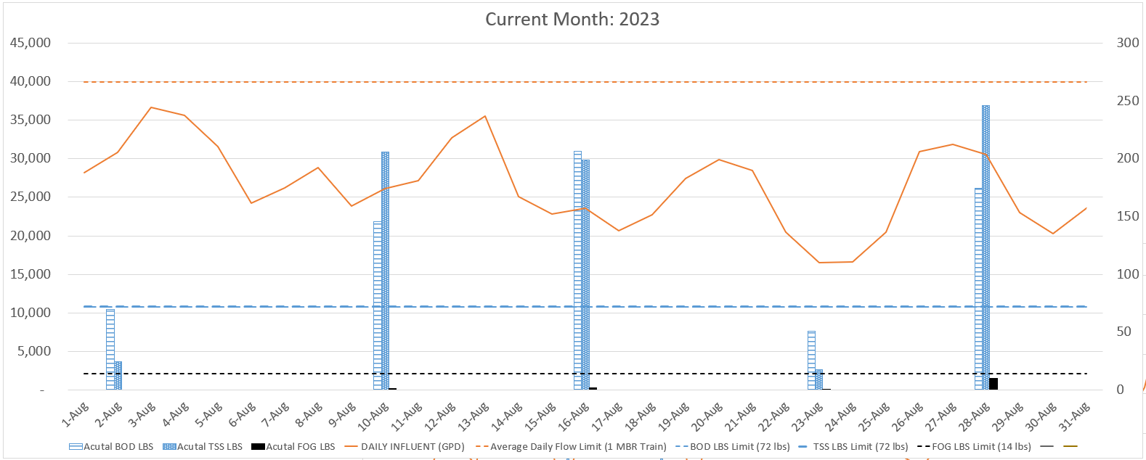

AVERAGE DAILY FLOW (GPD) | 26,540
HIGHEST DAILY FLOW (GPD) | 36,652

