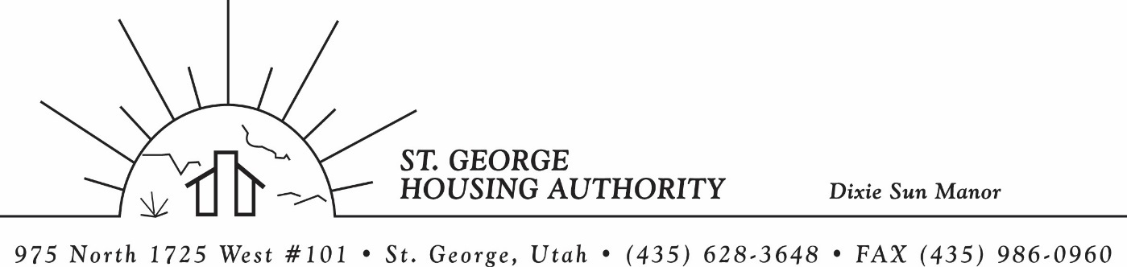
BOARD MEETING
DIXIE SUN MANOR 975 N. 1725 W. # 101
Tuesday June 13, 2023

PRESENT: Mike Barben, Greg Whitehead, Kenny Miller, Gloria Shakespeare. Tom Cover, Jane Fehrenbacher.

EXCUSED: Jimmie Hughes

MINUTES: Minutes of Board Meeting held May 9, 2023 were reviewed. Motion made by Tom Cover to approve minutes as reviewed, motion seconded by Kenny Miller. Motion carried.

Review Housing Assistance Report for June 2023: Mike Barben handed out the HAP reports for June 2023. Board members were able to see the money spent for the months on rental assistance, see the average unit cost, and verify the units leased for the month. The board was also able to ask questions and have a discussion about portability, C of C, VASH, EHV, & Mainstream Vouchers. Each board member present signed off on the HAP payments and month end totals.

Review current 2022-2023 budget: Mike Barben handed the board a copy of the fiscal year 2022-2023 SGHA budget. The board was able to see how the SGHA is doing in the current fiscal year budget. Mike reported that for the most part, SGHA was right on budget, and let the board ask questions on any of the items on the report. The board has asked Mike to provide and present the most recent budget accounts at each board meeting. By providing the current budget monthly, the board can see how the SGHA is keeping up with the current budget throughout the whole year. The board thought it would be great to ask questions and be on top of what the SGHA is doing financially. Greg Whitehead asked Mike if he could get a history of the unit counts over the past couple of years. Mike said he would look into this and try and find a report. Mike agreed to do this.

Submitted 2023-2024 SGHA new budget: Mike reported that he submitted the new fiscal year 2023-2024 budget into HUD. Mike was confident that the budget would be approved. Mike will keep the board updated on the status of the budget as he hears any information.
New SGHA Income Limits: Mike Barben reported that effective 6-1-2023 new income limits will be used for new admissions. Mike reported that HUD came out with the new income limits in May. Mike handed a copy of the new numbers to each board member to look at and discuss.

Jane Fehrenbacker report on DSM: Jane reported that we had a new move in this month. She said DSM is completely full. Jane also reported on the community garden. She said most residents are very happy to have a garden. Jane said DSM is a great place to live and call home.

Report from Jimmie Hughes on City of St. George: Jimmie was out of town this month and was excused. The board did discuss that 3 spots on the City Council were open. 18 new applicants will be vying for the 3 spots. Jimmie is running again. The board is excited to hear this.

Report on accident at DSM: Mike Barben that an accident happened at the DSM complex. One of the tenants at DSM called an ambulance because she was not feeling well. When the ambulance came the ran into one of the covered parking awnings and caused some damage. Mike reported the incident with pictures and reported that Gold Cross Ambulance will be taking care of the damage through their insurance company. Mike will keep the board updated on the repairs.

Motion made by Greg Whitehead to close the meeting. Tom Cover seconded the motion. Motion carried. Meeting adjourned at 9:45 a.m.

