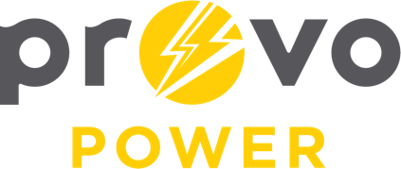
AGENDA
ENERGY BOARD MEETING
PROVO POWER
251 W 800 N
Monday, September 11, 2023
4:00 P.M.

- Welcome & Introductions - Chairman Gary Winterton
- Review & Approval of Minutes – July 10, 2023
- Financial Report – Charlie Little
- KPI Report – Charlie Little
- Manager Report – Travis Ball
- Calendar & Scheduling
  - Next Board Meeting: October 2nd, 2023

A copy of the agenda was posted in the Civic Center, and the Provo City Library, on July 5, 2023, and also delivered to the Mayor,
City Council Members, required news media, and adjacent cities in
compliance with the Utah Code 52-4-202

