ORDINANCE NO. 2023-XX - WORKING DRAFT 1

AN ORDINANCE ADOPTING SUPPLEMENTAL REGULATIONS FOR THE USE, DEVELOPMENT, AND MANAGEMENT OF LAND IN ALL ZONES WITHIN LAKE POINT

WHEREAS, pursuant to Utah Code Title 10, Chapter 9a, Lake Point is authorized to adopt land use regulations, create and define zoning districts, and regulate and restrict the erection, construction, reconstruction, alteration, repair, or use of buildings and structures and the use of land within such districts;

WHEREAS, Lake Point desires to establish rules and regulations for the development, use, and management of all land within Lake Point, which rules and regulations supplement and are in addition to the zone-specific rules and regulations for such land;

WHEREAS, the Lake Point Planning and Zoning Commission provided notice of and conducted a public hearing regarding such supplemental regulations, which hearing was held on DATE;

WHEREAS, the Planning and Zoning Commission issued a recommendation regarding such supplemental zoning regulations for the review of the Lake Point City Council on DATE;

WHEREAS, the City Council provided notice of and conducted a public hearing regarding the proposed supplemental zoning regulations and the recommendation of the Planning and Zoning Commission related thereto, which hearing was held on DATE;

WHEREAS, after reviewing the recommendation of the Planning and Zoning Commission, and after having made such adjustments to the recommended supplemental zoning regulations as the City Council found appropriate and necessary, the City Council finds that it will be in interest of Lake Point and its residents, and will provide for the general welfare, prosperity, and benefit of Lake Point residents, to adopt the supplemental zoning regulations as set forth herein.

NOW, THEREFORE, BE IT ORDAINED by the Lake Point City Council as follows:

- General Application of Regulations
  - The regulations set forth in this Ordinance shall be supplemental and in addition to all other land use regulations, and they shall apply to all zones and districts within Lake Point except where expressly superseded or exempted by this Ordinance or by the specific regulations for a particular zone or district.
  - Notwithstanding the foregoing, the standards, regulations, entitlements, and terms set forth herein shall not apply to any property for which a development agreement or other similar contract that establishes and vests development standards and rights has been, prior to the incorporation of Lake Point, executed and recorded for against title to the particular property. The zoning standards, regulations, entitlements, and terms for such property subject to a development agreement or other similar contract shall be as set forth in the applicable, recorded agreement or contract. The owner of such property subject to a development agreement or other similar contract may request that the City enter into a development agreement that modifies the vested development standards and rights established under the development agreement or other similar contract in accordance with state law.
- Definitions: The general definitions adopted by Lake Point apply herein, with the following additions or modifications:
- Review Procedures and Land Use Authority
  - The City Council shall be the land use authority for all land use applications except for building permits, construction and civil plans, subdivision plats, and other land use applications expressly authorized by ordinance to be approved by a different city- approved person or entity.
  - Land use applications shall be considered complete upon the applicant’s payment of all applicable fees and the submission of all applications, documents, and information required by city ordinance or regulations.
  - Applicants must move their land use applications and projects either to approval or denial in a reasonably expeditious manner and must proceed with after approval to implement the approval with reasonable diligence. Where no longer timeframe for the expiration or termination of a land use application or approval applies, a land use application or approval shall lapse and be terminated as set forth below:
    - Pending land use application for which no fees have been paid shall lapse if fees are not paid within 14 days of filing.
    - Pending land use applications for which fees have been paid that remain inactive for 180 days may be terminated upon 14 day’s written notice.
    - Issued land use approvals may be terminated, and the approval revoked, expired, and terminated, upon 14 day’s written notice if the applicant fails to carry out the approval within 180 days of the issuance of the approval, or if the applicant suspends or abandons the approved project for a period of 180 days after beginning.
    - Delay or inactivity caused by the city shall not result in terminating a land use application or approval for inactivity.
    - An extension may be granted by the land use authority if good cause is shown for the delay.
    - Upon expiration, revocation, or lapse of an application or approval, no fees shall be refunded. The applicant must begin the application and approval process again, including resubmission of any required applications and payment of any applicable fees. Such application shall be subject to all ordinances, regulations, and standards in effect at the time of submission.
- Fencing , walls and hedges.
  - Fences, walls and hedges may be erected to permitted building height six (6) feet. When required by the Building Code, a building permit shall be required prior to construction.
  - View-obscuring fences, walls, and hedges may not exceed three feet in height within any required front yard. Corner lots in residential zones are allowed a view obscuring fence, on the side of the house that does not face the street only, up to six feet in height at the property line provided the fence is at no time located less than 5 feet behind the front facade. No fences, walls, or hedges over two feet in height may be located in the clear view zone.
  - Where a fence, wall, or hedge is located along a property line separating two lots and there is a difference in the grade of the properties on the two sides of the property line, the fence, wall, or hedge may be erected or allowed to the maximum height permitted on either side of the property line.
  - Masonry or concrete fencing is required along any state road highway or collector road for all proposed residential developments. The plan must include a masonry or concrete fence for public safety and noise reduction of minimal height of 6 feet, maximum height of 8 feet. This fence must be installed within the back yards of lots by the developer, and the fence shall be owned and maintained thereafter by the owner of the lot.
- Parking
  - General Requirements.
    - The minimum off-street parking spaces required by the applicable zoning regulation shall be provided for any use of land or main building or structure in the city. Parking facilities shall be provided at the time the use is established or the building erected.
    - No building or structure shall be enlarged, altered, or converted unless there is provided and thereafter maintained for such building and its use the minimum number of required parking spaces.
    - Space for off-street parking being used in connection with an existing building shall not be reduced in the number or size of parking spaces, nor shall it be utilized for any other purpose than off-street parking. Parking areas shall be maintained in perpetuity as long as the requirement for off-street parking is needed, provided that parking areas may be relocated or redesigned, so long as there is no reduction of parking spaces.
  - Parking Location. Parking spaces and areas shall be located on the same lot or parcel as the main building or structure, unless a valid easement, covenant, declaration or other instrument is executed and recorded by all affected property owners granting a perpetual right to use adjacent property for parking areas, access, and maintenance.
  - Reciprocal Parking.
    - Up to 25 percent of the parking facilities required for uses considered to be primarily daytime uses may be provided by the parking facilities for uses considered to be primarily night-time uses or vice versa.
      - A use shall be considered to be a primarily day-time or night-time use based on information submitted by the applicant.
      - A use may be considered a day-time use if the majority of activity associated with the use ends no later than 6:00 p.m. each day.
      - A use may be considered a night-time use if the majority of activity associated with the use begins no earlier than 4:00 p.m. each day.
      - Residential uses shall not be considered either day-time or night-time uses, may not be served by reciprocal parking, and shall require parking spaces separately dedicated for the residential use.
    - Reciprocal parking areas shall be contiguous and the joint use of such facilities by different buildings, properties, or uses must be assured by easements, declarations, and/or covenants recorded against each affected property that provide that the parking areas shall not be removed or reduced and establish the terms by which the properties will share in the use and maintenance of the parking areas and related accesses and landscaping.
  - Parking Spaces and Alignment.
    - Alignment of parking spaces to require tandem/double parking (two vehicles end-to-end), where each space is not accessible from a separate drive aisle, shall not be allowed except for single-family and other residential dwellings.
    - Parking spaces shall be either ninety-degree parking or forty-five-degree parking as the spaces relate to the drive aisle.
    - Ninety-degree parking spaces shall be a minimum of ten feet wide by twenty feet long (10’ x 20’).
    - Forty-five-degree parking spaces shall be a minimum of ten feet wide by twenty-one feet long (10’ x 21’), with a minimum of 12.6 feet between the top corners of each space and a minimum of 21 feet from opposite corners of the space.
    - All handicapped parking spaces shall be provided and designed in accordance with the 2003 American National Standard, as now or hereafter amended. Parking areas with 1 to 100 spaces shall provide 1 accessible space per 25 parking spaces, and parking areas with over 100 spaces shall provide 1 accessible space per 50 parking spaces.
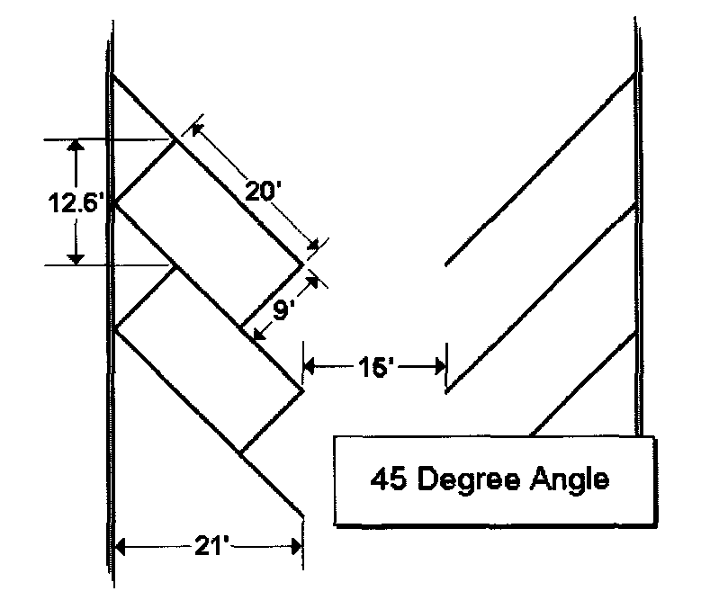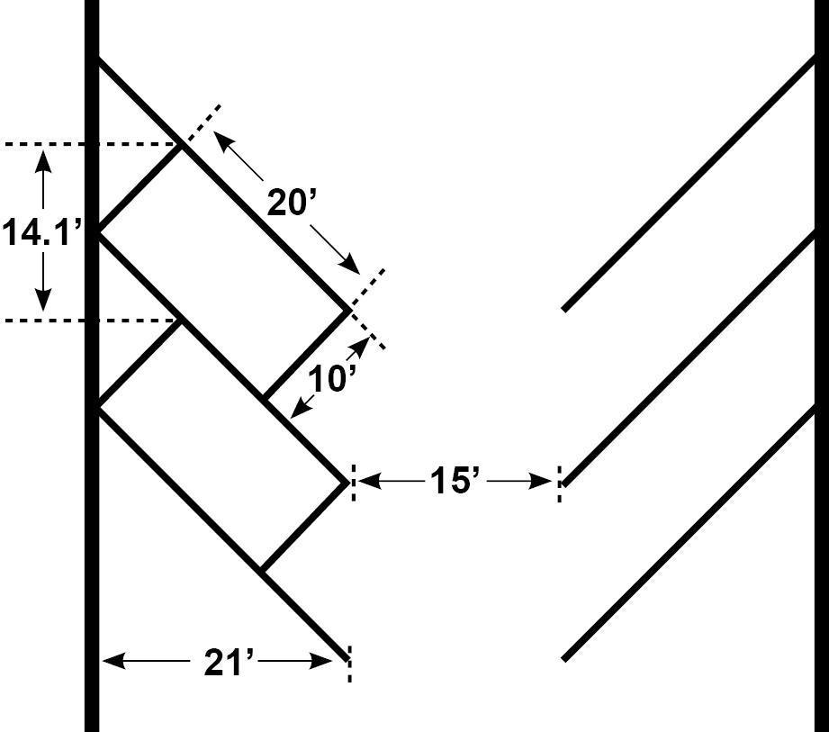
  - Access.
    - Drive aisles providing access to parking shall be a minimum of twenty feet between ninety-degree parking spaces or a minimum of fifteen feet between forty-five-degree parking spaces, unless the aisle is determined to be a fire access road and additional width is required by fire code.
    - Parking areas shall have access on public roads or approved private roads, and such access shall be a minimum width of 20 feet for non-residential properties and 8 feet for residential properties.
    - All commercial and institutional parking facilities shall have direct access to a street without backing into the right-of-way
    - Two access points from public roads shall be required in accordance with fire code.
    - Not more than two driveways or accesses shall be used for each one hundred feet (100’) of frontage for non-residential properties.
    - No driveway or access shall be provided closer than twenty feet (20’) to any intersection or other driveway or access for non-residential properties, and within to fourteen feet (14’) for residential properties.
    - Driveways or access to parking spaces that cross swales, ditches, canals, or other water conveyance facilities shall bridge, pipe, or culvert the conveyance facility in accordance with city or other owner of the conveyance facility’s standards.
- Lighting. The concerns of safety, utility, dark sky protection and aesthetic appearance need not compete. Modern lighting practices can provide adequate light for safety and utility without excessive glare or light pollution. Careful attention to when, where, and how much nighttime lighting is needed results in better lighting practices, darker skies and reduced energy use and costs. Lake Point City encourages lighting practices and systems which will: minimize light pollution, glare, glow, and excessive glare, and light trespass; conserve energy and resources while maintaining nighttime safety, utility, security, and productivity; and curtail the degradation of the nighttime visual environment. Any and all new and major addition to land uses, developments and buildings or structures are encouraged to use hooded lighting practices and adhere to the Dark Skies Ordinance.
- Landscaping/Buffering. The purpose of landscaping is to promote the following:
    - Water-wise beautification of the city.
    - Natural cooling affect and improves air quality
    - provides transition and buffering between various zones
    - protects from soil erosion
    - screening of parking, loading, utility, and other similar improvements.
  - Park strips and swales. Park strips, swales, and other similar landscaped areas within a public right of way that fronts on private property shall be maintained by the owner or resident of the adjacent private property.
- Construction and Occupancy; Site Plans.
  - The construction, alteration, erection, placement, or removal of any building, structure, mobile home, modular home, manufactured home, office trailer or part thereof as permitted in any chapter of this land use ordinance shall not be commenced or continued except after review by the zoning administrator or designated representative and a written permit from the building inspector. If work is not started or substantial progress is not made within 180 days a new permit will be required. The issuance of the permit shall be pursuant to an application that contains all required information as required by the state construction code.
  - An occupancy permit, requested and approved pursuant to state construction code and other applicable laws, shall be required prior to the occupancy of any structure.
  - A site plan must be approved prior to the issuance of building permits. Applications for building permits may be submitted contemporaneously with a site plan, provided that the building permit will not be approved prior to the approval of the site plan.
  - The applicant for any construction shall be solely responsible for coordinating and obtaining approval of and installing all utility connections, extensions, and facilities. Connections shall be installed in accordance with the standards of the servicing utility. In all cases where a proposed building or proposed use will involve the use of sewerage facilities and a connection to a public sewer system as defined by the Utah State Department of Environmental Quality is not available, and in all situations where a connection to a public water system approved by the Utah State Department of Environmental Quality is not available the sewage disposal and the domestic water supply shall comply with the requirements of Tooele County Health Department. The application for a building permit shall be accompanied by a certificate or other documentation of approval from the Tooele County Health Department and other utility servicing entities.
  - Except for automobile repair, car dealerships, service stations, and storage facilities, all storage, trash areas, garage doors and other loading and unloading facilities for non-residential uses shall be screened from public view and not be visible on the front of the building.
  - A stop work order shall be put on the project, and any building or other construction thereon, if any improvements are inconsistent with the approved site plan.
- Off-site Improvements.
  - The applicant for a site plan or building permit shall provide for the installation of swales (proper drainage and or water retention) along the entire property line abutting any public street. The installation of such improvements shall be of a type and design approved by the city, and shall be required on any existing street adjoining the lot or parcel on which a building is to be constructed or remodeled, or on which a new, changed, or expanded use is to be established. Such improvements may be required as a condition of a building permit, site plan, or use permit approval.
  - The planning commission may grant an exception to the installation of swales in rural or estate areas where topographic or other exceptional conditions exist, provided that the public health, safety, and welfare is preserved.
  - In the Commercial-Neighborhood; Highway; General; Industrial Zones, the installation of curbs, gutters, and sidewalks of a type approved by the Lake Point Engineer may be required on any existing or proposed street adjoining a lot on which a building is to be constructed or remodeled, or on which a new, changed, or expanded use is to be established. Such curbs, gutters, or sidewalks may be required as a condition of a building permit, site plan, or use permit approval.
  - The planning commission may grant an exception to the installation of curb, gutter and sidewalk in commercial and industrial areas where topographic or other exceptional conditions exist, provided that the public health, safety and welfare is preserved.
  - The applicant for a site plan or building permit shall provide, construct, and install all required utility lines, mains, and other facilities necessary to serve the property in accordance with the regulations and standards of the servicing entity.
  - No work, construction, or excavation shall be commenced within an existing public right of way except in accordance with City regulations and specifications, including requirements for the applicant’s submission of plans and specifications for the work, the applicant’s payment of applicable fees and provision of financial assurances, the applicant’s receipt of duly issued and approved permits and other approvals.
  - The applicant for a site plan or building permit shall provide, construction, improve, or widen, as necessary, the public or city-approved private road along the designated frontage of the lot or parcel. Such road shall be constructed to city standards, shall provide a minimum drivable surface as required by fire code, and shall include at least half of the drivable surface required by city road specifications and all adjacent facilities and improvements along the lot or parcel frontage.
- Buildable and Non-Conforming Lots.
  - Every lot shall have such area, width and depth as is required for the zoning district in which such lot is located in order to be a buildable, lawful lot.
  - Any lot created through an exemption from the subdivision requirements, including those exemptions under Utah Code § 10-9a-605 and Utah Code § 17-27a-605, and any other lot or parcel created without being platted on an approved subdivision plat, is not a buildable lot for a residential dwelling or use, unless the lot or parcel meets the definition of a buildable lot. To become a residential building lot, the lot or parcel shall first be subdivided, created, and recorded on a subdivision plat.
  - Any lot or parcel, other than those described in section 2 herein, lawfully subdivided and approved by the relevant land use authority, and which does not meet the size, frontage, or other requirements of the zoning district in which it is located, may be used for a single-family dwelling if it is located in a zoning district that permits single family dwellings. Such use shall conform to the applicable setback requirements for the zoning district.
  - Except as expressly authorized, each building shall be placed and maintained on a separate and buildable lot or parcel.
  - No building permit shall be issued for a building on a lot or parcel that does not have frontage upon or access to a publicly dedicated street or an approved private street. Lots used solely for the provision of essential services may be accessed via a recorded perpetual easement.
  - No lot for dwelling use shall be created which is more than three times as deep as it is wide, provided that, in the RR1 district, the City may approve the creation such lots if the applicant proves that a deeper lot is the most judicious configuration of the property, but in no case shall more than five such lots be approved in any subdivision, and no such lots shall be more than five times as deep as it is wide.
  - Lots divided by zone boundaries. A lot or parcel divided by a zone boundary shall be subject to the following special regulations:
    - The uses allowed on any portion of a lot or parcel shall only be those allowed in the district in which such portion of the property is located, and a use allowed within one portion of the property shall not extend across the zone boundary unless such use is also permitted in the adjacent zone, except as otherwise authorized herein.
    - A use allowed in the less restrictive zone but not allowed in the more restrictive zone may be allowed to extend into the more restrictive zone by up to 50 feet with the approval of the land use authority, if the land use authority finds that the extension is required for the reasons of justice and equity and will not be harmful to neighboring property, the intent of the applicable zoning regulations, and the city’s general plan.
    - Parking areas, vehicular and pedestrian access, landscaping, fencing, utility lines and facilities, and similar improvements that serve a use permitted within one portion of a lot or parcel may be extended through other portions of the property, even if the use being served is not permitted in the zone applicable to such other portions. Structures and buildings that are permitted within one portion of a lot or parcel shall continue to be permitted, even if the use or purpose of such structures or buildings is to support or serve a use within a different portion of the lot or parcel, where the use is not permitted on the first portion.
  - A nonconforming lot or parcel may have area added from adjacent property through a subdivision amendment, parcel boundary adjustment, or lot line adjustment, according to the processes set forth in state law, subject to the following:
    - The addition of land to the nonconforming lot or parcel may be approved even if the additional land will not result in the nonconforming lot conforming to minimum lot size, area, frontage, and other zoning requirements, so long as the amendment or adjustment does not increase the nonconformity of the lot or parcel and does not cause any other property to no longer conform to applicable lot size, area, frontage, and other zoning requirements.
    - Any such enlarged lot shall not be re-subdivided except through submission and approval of a subdivision plat in conformance with all applicable land use regulations.
- Yards
  - No required yard, setback area, or other open space required for a particular lot, parcel, or building shall be considered as providing a yard, setback area, or open space for another building or property, nor shall any yard, setback area, or other required open space on an adjoining property be considered as providing a yard, setback area, or open space for the property on which a building is to be erected or established.
  - Effect of official map. Wherever a front yard is required for a lot facing on a street for which an official map has been recorded, the depth of such front yard shall be measured from the mapped property line facing the street as provided by the official map. (Ord.)
  - Every part of a required yard shall be unobstructed and open to the sky, except for:
    - Permitted accessory buildings and structures;
    - the ordinary projections of eaves, skylights, sills, belt courses, cornices, chimneys, flues, and like features which project into a yard not more than two and one-half feet, provided such projections do not cross the property line;
    - trees and other vegetation; and
    - projections allowed by the building or fire codes for fire safety purposes shall be allowed to extend into a yard not more than five feet, provided such projections do not cross the property line.
    - In no case shall a stoop, cantilever, eave, or other projection extend into any designated easement for public utilities, drainage, access, etc. (Ord.)
- Clear View of Intersecting Streets and Sight Triangle Requirements
  - Clear Vision Area. No structure, building, fence, wall, hedge, or other visual obstruction in excess of three (3) feet in height shall be placed on any corner lot within a triangle area formed by the intersecting streets and an imaginary line connecting the streets at points forty (40) feet from the intersection of the streets, which points are located on the closest edge of the street to the lot. Pole signs and a reasonable number of trees pruned to at least ten feet clearance to grade to permit unobstructed vision to automobile drivers and pedestrians are permitted.
  - No structure, building, fence, wall, hedge, or other visual obstruction in excess of three (3) feet in height shall be placed closer than 14 feet to a neighboring driveway.
  - Where there is a difference in the grade of the properties related to the sight-triangle area or driveway, the height of a structure, building, fence, wall, hedge, or other visual obstruction shall be measured from the higher side.
  - There shall be no structure, building, fence, wall, hedge, or other physical obstruction within three (3) feet of any fire hydrant.
  - Signs or other advertising structures shall not be erected at the intersection of any street or driveway in such a manner as to obstruct free and clear vision. They shall not be erected at any location where by reason of the position, shape or color, they may interfere with, obstruct the view of or be confused with any authorized traffic sign, signal device, or make use of the words, “Stop,” “Drive-in,” “Danger,” or any other words, phrases, symbols or characters in such a manner as to interfere with, mislead or confuse vehicle operators.
- EASEMENTS AND RIGHTS OF WAY:
  - Uses of easements and/or rights-of-way shall be permitted in or through any zone for the purpose of serving a permitted or approved conditional use in the same or any zone. Such easements or rights-of-way may be used for uses similar to, but not limited to, the following:
    - Roads, streets, highways.
    - Railroads, tramways, cableways, and conveyor systems.
    - Pipelines for the transmission of water, wastewater, materials, fuels or products.
    - Overhead and underground transmission or distribution lines, including poles, towers, and conductors.
    - Uses not requiring continuous routes along the ground such as radio, television or microwave relay stations and towers.
    - Structures and facilities incidental to the above.
  - This section shall not modify or limit any requirement to provide, dedicate, and construct public or private roads according to Lake Point standards.
- RETAIL TOBACCO SPECIALTY BUSINESS PROHIBITED:
  - DEFINITIONS:
    - RETAIL TOBACCO SPECIALTY BUSINESS, TOBACCO PARAPHERNALIA, and TOBACCO PRODUCT have the same meaning as defined in Utah code section 10-8-41.6, as amended.
  - PROHIBITION:
    - The establishment and/or operation of a retail tobacco specialty business is prohibited in all areas of Lake Point City.
    - Lake Point City shall not issue a business license to any retail tobacco specialty business for use in any zone.
    - The use of a properly obtained business license for the operation of a retail tobacco specialty business in any zone in Lake Point City is prohibited.
- SOLAR ENERGY SYSTEMS:
  - Solar energy systems located on individual parcels/lots, which are used to supply energy to a principal use or structure on the parcel/lot, where the energy provided by the solar energy system to off-site uses or structures is de minimis, shall be allowed in any zone as an accessory use to a principal use or structure. Solar energy systems shall meet the setback and height requirements for an accessory building in the zone in which the system is located. Setbacks shall be measured to the outermost edge of the system nearest the property line. Solar energy systems which are attached to a building shall meet the same setbacks and height restrictions that are required for the building.
  - This section does not authorize the construction or installation of solar energy systems that are principally intended or used to provide energy to uses or structures on other property.
- General Regulations.
  - The city and all land use applicants are bound by and shall comply with all mandatory provisions of Lake Point land use, zoning, construction, and development ordinances, standards, codes, and regulations.
  - All departments, officials and public employees of Lake Point which are vested with the duty or authority to review, issue permits or licenses shall conform to the provisions of this land use ordinance and shall issue no permit or license for uses, buildings, or purposes where the same would conflict with the provisions thereof. Any permit or license, if issued in conflict with the provisions of this land use ordinance, shall be null and void.
  - No building, structure, or land shall be used, and no building or structure shall be hereafter erected, structurally altered, or enlarged except as authorized by applicable Lake Point regulations. No land, building or structure shall be used for any purpose not allowed in the zone in which such land, building or structure is located unless it is grand-fathered. This shall not restrict the use of land or the alteration, enlargement, or construction of buildings and structures for greenbelt and similar agricultural uses, as defined by the Utah Farmland Assessment Act and for uses and construction exempted under state construction code.
  - Fees shall be charged to applicants for building, occupancy, conditional use permits, zoning approvals, site and design review, subdivisions, planned unit development approval, hearings, appeals, and such other services required by this land use ordinance to be performed by public officers or agencies, as established by resolution in amounts reasonably necessary to defray costs to the public and the city.
  - This land use ordinance shall not nullify the more restrictive provisions of covenants, agreements, conditions of approval of any permit, plat, or other document, or other ordinances or laws, but this ordinance shall prevail over any such provisions which are less restrictive. All development, use, and management of land shall comply with all covenants, agreements, and conditions of approval of any permit, plat, or other document reviewed and approved by the City. Unless otherwise agreed to in writing by the City as part of approval of a permit, plat, or other application, the City shall not be responsible for the enforcement of private covenants, conditions, or restrictions, association bylaws, or similar agreements.
  - If any provision of this ordinance addresses a subject addressed by the state construction code or the state land use, development, and management act, the more restrictive provision shall apply, unless there is a direct conflict, in which case the state regulation shall apply.
  - Only one application for a particular use, construction, or development shall be permitted at one time. Multiple applications may be submitted for a single property, so long as each application is addressed to a different use, construction, or development. The submission of a new application regarding a use, construction, or development for which an application is pending shall, at the election of the applicant, be disregarded or shall revoke and replace the pending application. Fees shall be required for all new applications, and fees paid for prior applications shall not be applied to new applications.
  - No property, and no portion of any lot or parcel, that exceeds 30% slope shall be graded, constructed upon, or disturbed without appropriate engineering, performed by the applicant to the satisfaction of the city engineer or other designated person, which engineering demonstrates the proper soil conditions and compaction, construction materials, erosion and drainage control, and safe access. The city may require, as part of approval of construction on slopes exceeding 30%, that the applicant and property owner agree to record instruments absolving and releasing the city of liability for loss, injury, damage, or death related to the proposed construction.
  - SALE, LEASE, OR CONVEYED AWAY OF REQUIRED SPACE: No space or property needed to meet the width, yard, area, coverage, setback, parking, or other requirements of the Lake Point land use ordinances for a lot, parcel, building, or structure may be sold, deeded, subdivided, or otherwise conveyed away from such lot, parcel, or building.
  - SALE OF LOTS BELOW MINIMUM SPACE REQUIREMENTS: No parcel of land may be divided or subdivided from a larger parcel without being approved as a subdivision, unless exempt from subdivision requirements under state law, nor shall any parcel of land be divided or subdivided from a larger parcel in a manner that creates a lot that has less than the minimum width, frontage, setback, yard, and area requirements for the zoning district in which it is located, unless the lot is subject to a conservation easement or similar recorded restriction that controls and limits the use of the lot. This regulation applies whether the intent of the division or subdivision may or may not be for the purpose, whether immediate or future, of building, development, or any other land use.
  - All buildings and structures must conform to the height limit of the zoning district in which they are located. No space above the height limit shall be allowed for purposes of providing additional floor space. The following are the only exceptions which shall be allowed:
    - penthouse or roof structures for the housing of elevators, stairways, tanks, ventilating fans, or similar equipment required to operate and maintain the building;
    - fire or parapet walls, skylights, towers, steeples, flagpoles, chimneys, smokestacks, water tanks, wireless or television masts, theater lofts, silos, or similar structures;
    - public and quasi-public utility buildings.
    - transmission lines with nominal voltage rating of 50kV or greater; and
- substations. Penalties.
  - Unless otherwise specified herein, a violation of this Ordinance shall be an infraction.
  - The erection, construction, reconstruction, alteration, or change in occupancy of any building or structure without a building permit shall be an infraction.
  - A civil penalty may also be imposed, pursuant to administrative proceedings conducted by the city. The penalty amount shall not be greater than the fine that would apply were the violation prosecuted as a criminal matter. The pursuit of criminal penalties shall not restrict or prohibit the pursuit of civil penalties or other remedies, and vice versa.
  - The city may also enforce the provisions of this Ordinance by any other remedy available at law, including injunctions, mandamus, abatement, and proceedings to prevent, enjoin, abate, or remove the unlawful buildings, use, or act.
  - The city may also enforce the provisions of this Ordinance by withholding a building permit or certificate of occupancy, to the extent permitted by state law.
- This Ordinance shall be effective immediately upon its adoption and publication according to law.

PASSED, APPROVED, AND ADOPTED on the day of , 2023

Lake Point

By________________________________
Chair

ATTEST:

__________________________________ SEAL
City Recorder

Voting:

Daniel Crawford Yea___ Nay___ Absent ___
Doyle Garrard Yea___ Nay___ Absent ___
Jonathan Garrard Yea___ Nay___ Absent ___
Kathleen VonHatten Yea___ Nay___ Absent ___
Ryan Zumwalt Yea___ Nay___ Absent ___

