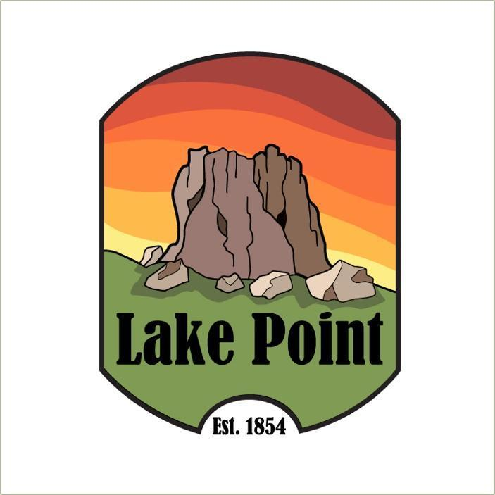

Notice of Public Hearing

Planning and Zoning Commission proposed
Land Use Regulations

COMMERCIAL & INDUSTRIAL ZONES – PURPOSES – RESTRICTIONS
COMMERCIAL & INDUSTRIAL ZONES – PERMITTED USES
COMMERCIAL & INDUSTRIAL ZONES – PERMITTED USES – EXHIBIT A
SUPPLEMENTAL REGULATIONS AND
APWS STANDARDS

Lake Point is in the process of adopting these land use regulations for the following
commercial and industrial zones
Agricultural (A-20); Commercial – General (CG); Commercial – Highway (CH); Commercial – Neighborhood (CN); Conservation (CRPO); Industrial (IND);
Multiple-Use (MU-40)

Planning and Zoning will be holding its Public Hearing on
Monday, Sept 11, 2023, Beginning at or After 7:00 PM

City Council will consider these regulations on
Wednesday, Sept. 27, 2023, at or after 7:00 PM

Meeting Location-
Lake Point Fire Station
1528 Sunset Rd. Lake Point Ut

If you have any questions, please email planning@lakepoint.gov

