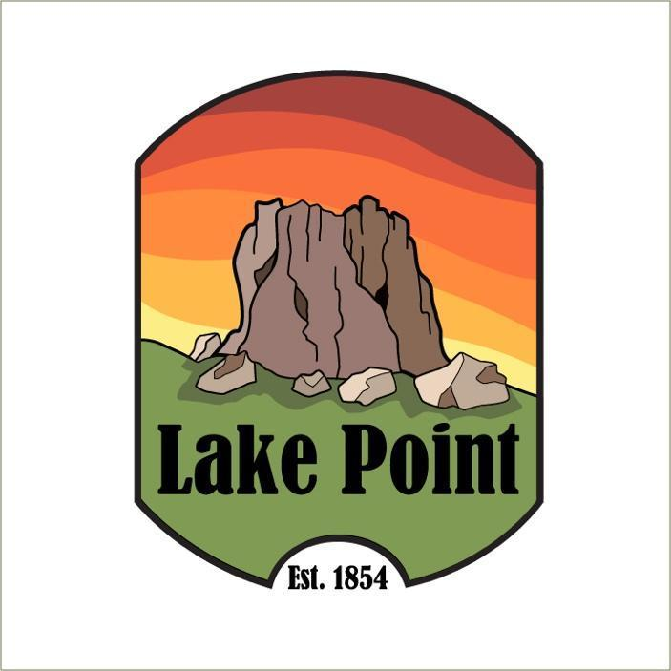

Notice of Public Hearing

City Council will be reviewing a land use regulation the Planning and Zoning Commission recommended
for Commercial Zoning Districts
and the Commercial Zoning Map, assigning the zoning districts described below to certain properties, for the following-
Agricultural (A-20)
Commercial General (CG)
Commercial Highway (CH)
Commercial Neighborhood (CN)
Conservation (CRPO)
Industrial (IND)
Multiple Use (MU-40)

Being held
Sept 6, 2023 @ 7 pm
Lake Point Fire Station
1528 Sunset Rd. Lake Point Ut

If you have any questions, please email info@lakepoint.gov

