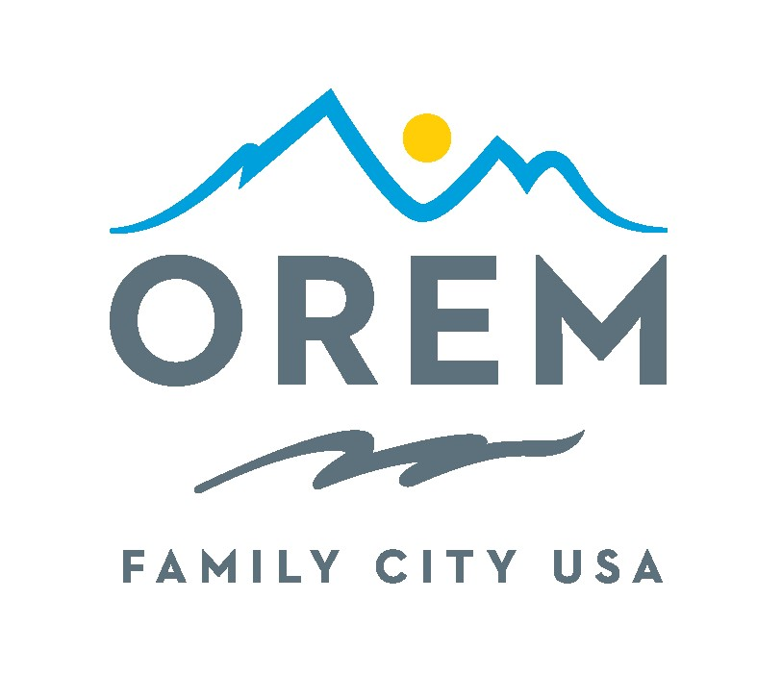
Invitation to Submit Arguments For or Against
A Ballot Proposition

The municipal General Election to be held on November 21, 2023, will include the following
ballot proposition:

Proposition #6, Proposal to Renew Orem’s Cultural Arts and Recreation Enrichment (CARE) Tax for Ten Additional Years

PROPOSITION:
Shall the City of Orem, Utah, be authorized to impose a 0.1% sales and use tax for:
- City-owned recreational and cultural facilities; and
- Ongoing operating expenses of city-owned recreational facilities; and
- Ongoing operating expenses of private non-profit cultural organizations?

The proposed CARE Tax would be collected at the rate of 1 cent for every $10.00 spent in Orem and may be used for purposes such as:
Parks  Playing Fields  Trails  Bike Paths  Splash Pads | Live Theater  Symphonies  Operas  Ballet/Dance Companies  Choral Groups

Any eligible voter may file a request to submit a written argument for or against the ballot proposition above (Proposition #6) for inclusion in the local voter information pamphlet in accordance with Utah State Code §20A-7-402. Requests to submit an argument must be filed with the election officer (the Orem City Recorder) no later than September 18, 2023 at 5:00 pm. Requests must be submitted to the Orem City Recorder’s office at 56 North State Street, Orem, UT 84057, or emailed to tmckitrick@orem.org. For more information, please contact the City Recorder at 801-229-7298.

/s/ Teresa McKitrick, City Recorder
Dated this 23rd day of August 2023
Published on the Utah Public Notice Website, in the Daily Hearld, the Orem City website, in Orem City Hall, and in the Orem City Library

