Notice of Public Hearing

From: Syracuse City Redevelopment Agency

Re: Syracuse 2500 W Community Reinvestment Project Area Plan and Budget

The Syracuse City Redevelopment Agency (the “Agency”) will hold a public hearing on SEPTEMBER 12, 2023 at 6:00 p.m. in the City Council chambers located at 1979 West 1900 South, Syracuse, Utah to consider the Syracuse 2500 W Community Reinvestment Project Area Plan (the “Plan”) and Project Area Budget (the ”Budget”) for a community development project area (the “Project Area”) located between the following boundaries: North edge of ROW of Hwy 193/North border of Syracuse City shared with West Point, East edge of ROW 2000 W/ Hwy 108, South border of 700 S ROW, West edge of 3000 W ROW.

A project area map is enclosed. The legal descriptions of the parcels, which are included in the proposed CRA, are listed in the Plan. The Plan and Budget are available, including property details, for inspection at the Agency’s office located at 1979 West 1900 South, Syracuse, Utah, during regular business hours. You may ask questions or request a copy of the draft plan at no cost, by contacting the Community Development Office at 801-614-9672 or at 1979 West 1900 South, Syracuse, Utah. An electronic, printable version is available at the City’s website at www.syracuseut.gov.

If approved, then property tax generated by new development will be used to implement the purposes of the Plan. The Plan will not result in new or higher taxes for existing uses within the Plan area. Property tax revenue resulting from an increase in valuation of property within the Project Area will be paid to the Agency for project area development rather than to the taxing entities to which the tax revenue would otherwise have been paid if one or more taxing entities agree to share property tax revenue under an interlocal agreement and the project area plan provides for the Agency to receive tax increment The purpose of the public hearing is to take comments from interested persons who may appear and comment on the Plan, including whether it should be revised, approved, or rejected.

The Agency has requested an estimated $33,299,244 million in property tax revenues with a cap of $20 million that will be generated by development within the Project Area to fund a portion of project costs within the Project Area. These property tax revenues will be used for the following: mandatory housing allocation as required by statute, payment and reimbursement of infrastructure costs, incentives to developers, Agency administrative expenses, and other expenditures as authorized by law. These property taxes will be taxes levied by the following governmental entities, and, assuming current tax rates, the taxes paid to the Agency for this project area from each taxing entity will be as follows: Syracuse City - $4,547,183, Davis County (Davis County, Multi-County Assessing, County Assessing, and County Library), - $5,218,395, Davis School District - $21,022,125, North Davis Sewer District - $1,876,091, Davis Mosquito Abatement District - $272,336; Weber Basin Water Conservancy District - $363,114. All of the property taxes to be paid to the Agency for the development in the Project Area are taxes that will be generated only if the Project Area is developed. All concerned citizens are invited to attend the project area budget hearing as noted above. A copy of the Project Area Budget is available at the Agency offices as described above.

You are invited to submit comments to the Agency concerning the Plan or Budget before the date of the hearing at the Agency’s office located at 1979 West 1900 South, Syracuse, Utah. Any person objecting to the Plan or contesting the regularity of any of the proceedings to adopt the Plan may appear before the Agency at the hearing to show cause why the Plan should not be adopted.

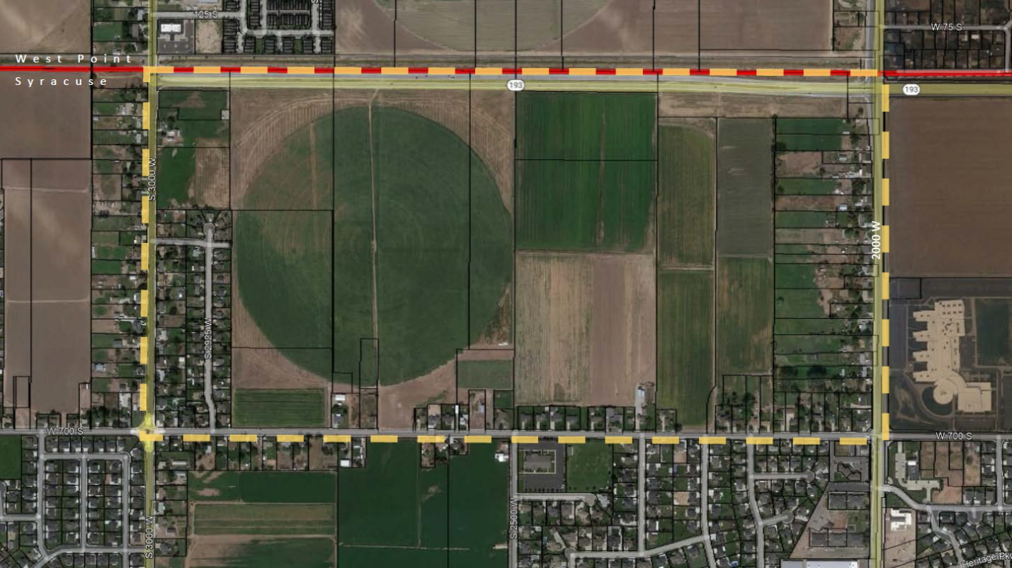
In compliance with the American Disabilities Act, persons needing auxiliary communicative aids and services for this meeting should contact the City offices at 825-1477 at least 48 hours in advance of the meeting.

cassie z. brown, MMC
syracuse city Recorder

Dated: august 17, 2023

