

H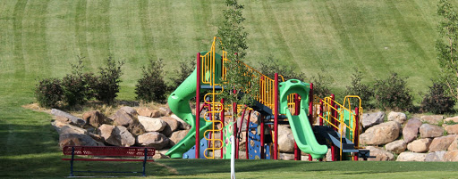
HYDE PARK CITY
ANNUAL BUDGET
FISCAL YEAR July 1, 2023 – June 30, 2024

HYDE PARK CITY
STATE OF UTAH

Approved Annual Budget Fiscal Year 2023 - 2024

Prepared by:

Bryan Cox, Mayor
Donja Wright, Finance Director

ELECTED OFFICIALS & CITY STAFF


Mayor Bryan Cox

 |  |  |  | 
Councilperson  Kevin Flint | Councilperson Gerald Osborne | Councilperson Stephanie Allred | Councilperson  Karl White | Councilperson  Tiffany Atkinson

APPOINTED OFFICIALS

City Treasurer ……………………………………………………………………………………………………………………………………… Susan Balls
City Recorder ………………………………………………………………………………………………………………………………….. Donja Wright

DEPARTMENT DIRECTORS

City Administrator ………………….…………. Marcus Allton
Planning Commission ....................................Rachel Erickson
Engineer ............................................................. Scott Archibald
Finance .................................................................. Donja Wright
Justice Court ....................................... Judge Matthew Lorz
Legal Services ................................................. Rob Patterson
Police ..................................................... Chief Kent Goodrich
Public Works .......................................................... Brett Knight
Fire .................................................. Interim Chief Jeff Peterson

BUDGET SUMMARY

BUDGET SUMMARY

The city is in a historic time of growth and development. Increased development is reflected in both tax revenue and development revenues. Tax revenues have grown by an average of 15% over the past five years and total general fund revenues have grown by an average of 18% over the same period. General fund expenditures have grown by an average of 18% over the same five-year period.

The overall city budget expenditures for fiscal year 2024 total $5,569,500. This amount represents all expenditures for both operating and capital purposes. Our goal was to balance conservative revenue forecasts with ongoing and real city needs because of our consistent, rapid development.
BUDGET SUMMARY
$30,787,901
$34,348,717
$36,737,357
$36,678,228
$40,435,896

Some highlights of the budget are as follows:

CONSERVATIVE REVENUE ESTIMATES
We estimate General Fund revenues for FY 2024 staying about the same as FY 2023. We are estimating a decrease in homes sales and development, an increase in property tax, and sales tax remaining level. As a community, we are experiencing stable court fines, forfeitures, and franchise fees. While most of our revenue streams appear to be trending upward, we err on the side of caution in our forecasts, thus protecting the city should there be any more changes in the economic climate.

SALES TAX

BUILDING PERMITS

Hyde Park Building Permits | 2017 | 2018 | 2019 | 2020 | 2021 | 2022
Single Family Dwelling | 43 | 49 | 83 | 56 | 59 | 49
Garage / Carport | 6 | 0 | 10 | 1 | 4 | 2
Home Additions | 6 | 2 | 7 | 12 | 7 | 11
Commercial – New | 2 | 4 | 6 | 3 | 9 | 7
Commercial – Addition | 8 | 1 | 4 | 8 | 11 | 4
Solar | 25 | 9 | 21 | 25 | 29 | 37
Barn / shed/ shop | 6 | 6 | 6 | 7 | 4 | 3
BDGET SUMMARY
FOCUS ON PUBLIC SAFETY
One of the core functions of the city is to provide both fire and police services for our residents. Hyde Park City’s population has increased over 34% since 2010. As Hyde Park continues to grow, it has become necessary to increase the size of the Police Department. Over the past few years, the budget has included funding for additional NPPD Police Officers.

PARK AND TRAILS DEVELOPMENT
Park and trail development continues to be a priority for the city. Park Impact Fees, Bonus Density Funds,
RAPZ Tax grants and general funds are used to build and maintain City Parks and expand the City trail system.
Park impact fees are collected on new developments to account for the demand on services from that development. We forecast approximately $60,000 a year in park impact fees. During FY 2023 we completed the work on the new park at 600 south 250 east. The city is currently working on a new trail system by the water tank, the Bonneville Shoreline trail, a walking trail by Wolf Pack Way and working with the County and developers towards other trail systems throughout the city. The city has a master trail plan and will continue to update this plan to meet future needs.

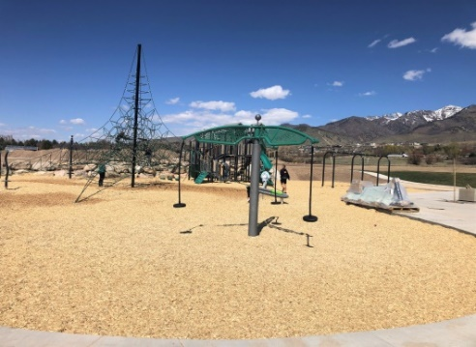
BUDGET SUMMARY
CAPITAL PROJECTS
In addition to park and trail development, several other planning projects are included in this budget. The city is finishing the master water plan and will continue with the storm water plan and transportation plan. The city has received grant funding to help fund most of the planning projects.
BUDGET SUMMARY

The Budget includes many other capital projects including the CMPO road (Wolf Pack Way) that will extend from North Logan to Hyde Park Center Street. This project will take several years to complete and will be funded in part with grants and road impact fees. Other capital projects in the budget include the start of a new city well, a spring transmission line, additional water meters, and maintenance on many of the city streets and sidewalks.

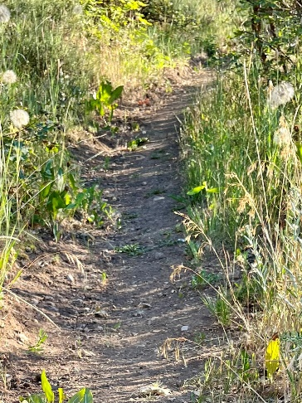
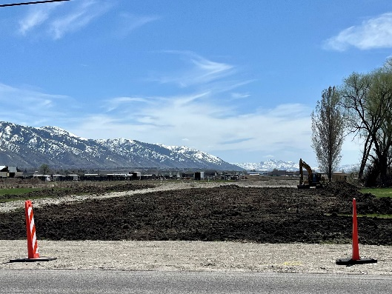
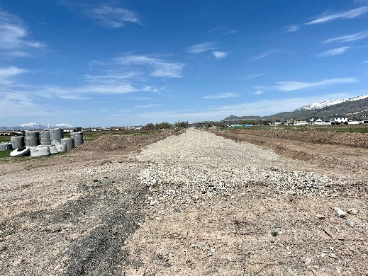

BUDGET SUMMARY

EVENTS
Hyde Park City is known for being a family-friendly community. Our annual events include an Easter Egg Hunt, Hyde Park Hometown Days Celebration, Tree Lighting Ceremony, Movies in The Park, and many Youth Council sponsored activities. Our best-known event is the Hometown Days Celebration which is the weekend prior to the 24th of July. Families come to the Celebration to participate in many activities including music, fireworks, fun run, softball tournament, games for the kids, and much more.
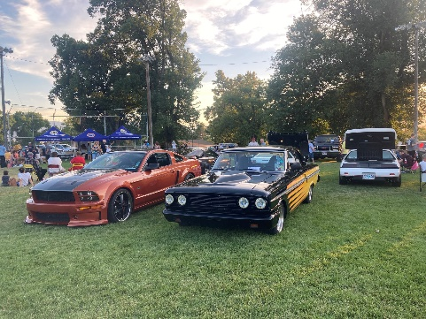
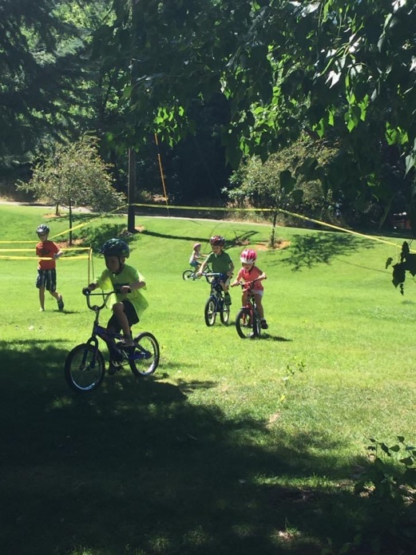
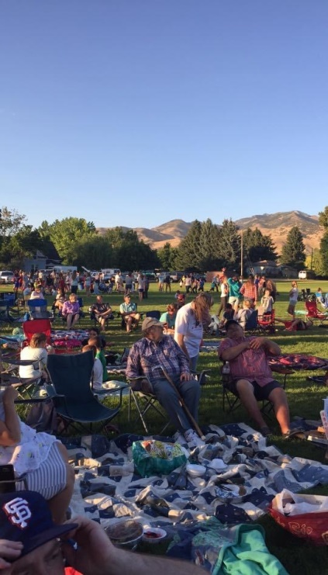
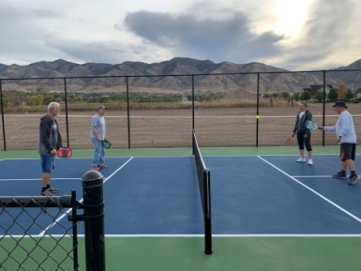
BUDGET SUMMARY
BUDGET SUMMARY

TAX AND RATE INCREASES
The FY 2024 budget proposes to keep property tax rate at the same level as last year. The City’s property tax policy is to annually adjust the property tax rate to the historic rate of 0.0011, the rate that allows the City to maintain services at the current level. When there is growth in real estate value, Cache County will certify a lower rate than Hyde Park’s current property tax rate. Therefore, if Hyde Park maintains the same rate as the previous year, state law considers that to be a tax increase, which requires the city to hold a Truth in Taxation hearing in August.
BUDGET SUMMARY

CONCLUSION
It is a wonderful time to live in Hyde Park City and to be at the forefront of the growth in Cache County.
With all our success comes the pain associated with growth. However, we believe this budget will address our most pressing needs without overburdening the citizens and businesses in Hyde Park City.

Respectfully,

Mayor Bryan Cox

General Fund
Revenue | Actual 2022 | Budgeted 2023 | Estimated 2023 | Budgeted 2024
Department
Taxes
Property Taxes | $ 598,728 | $ 742,102 | $ 770,000 | $ 800,000
Fees in Lieu | $ 33,145 | $ 20,000 | $ 29,000 | $ 30,000
Delinquent Taxes | $ 5,331 | $ 5,000 | $ 3,000 | $ 5,000
General Sales Tax | $ 1,453,862 | $ 1,200,000 | $ 1,526,000 | $ 1,550,000
Franchise Tax (Cable TV) | $ 47,849 | $ 35,000 | $ 35,000 | $ 35,000
Transit Tax | $ 350,000 | $ 300,000 | $ 350,000 | $ 350,000
Other Taxes
Total Taxes | $ 2,488,915 | $ 2,302,102 | $ 2,713,000 | $ 2,770,000
Department | Actual 2022 | Budgeted 2023 | Estimated 2023 | Budgeted 2024
Licenses & Permits
Business Licenses | $ 4,944 | $ 5,000 | $ 5,000 | $ 5,000
Building Permits | $ 338,292 | $ 180,000 | $ 120,000 | $ 160,000
Plan Review Fee | $ 36,369 | $ 15,000 | $ 9,000 | $ 10,000
1% State Surcharge | $ 3,257 | $ 2,000 | $ 1,200 | $ 2,000
Animal License & Control | $ 4,566 | $ 4,000 | $ 4,000 | $ 4,000
Total License & Permits | $ 387,428 | $ 206,000 | $ 139,200 | $ 181,000
Department | Actual 2022 | Budgeted 2023 | Estimated 2023 | Budgeted 2024
Intergovernmental Rev.
TPA Grant | $ - | $ 55,000 | $ 55,000 | $ -
Safe Route to School Grant | $ 52,457 |  | $ - | $ -
RAPZ Tax-Population | $ 24,399 | $ 12,000 | $ 12,000 | $ 12,000
Class "C" Road Funds | $ 304,333 | $ 290,000 | $ 325,000 | $ 550,000
State Liquor Fund Allot. | $ 3,514 | $ 3,000 | $ 4,000 | $ 4,000
Total Intergovernmental | $ 384,703 | $ 360,000 | $ 341,000 | $ 566,000
Department | Actual 2022 | Budgeted 2023 | Estimated 2023 | Budgeted 2024
Charges for Services
Zoning & Subdivision Fees | $ 5,235 | $ 2,000 | $ 2,000 | $ 2,000
Impact Fees – Parks | $ 88,892 | $ 48,000 | $ 30,000 | $ 50,000
Impact Fees – Roads | $ 142,120 | $ 93,000 | $ 45,000 | $ 100,000
Public Works Inspection Fees | $ 44,926 | $ 70,000 | $ 70,000 | $ 70,000
Public Wks. Labor / equip fee | $ 1,667 |  | $ - | $ -
Parks -Rental Fees | $ 3,307 | $ 2,000 | $ 2,000 | $ 2,500
City Bldg. -Rental Fees | $ 7,682 | $ 5,000 | $ 12,000 | $ 10,000
Garbage Collection | $ 595,924 | $ 600,000 | $ 625,000 | $ 625,000
911 Service Charge | $ 59,892 | $ 58,000 | $ 61,000 | $ 60,000
Emergency Services Fee | $ 20,186 | $ 36,000 | $ 40,000 | $ 40,000
Bldg. Inspections-other Cities | $ 375,540 | $ 400,000 | $ 450,000 | $ 300,000
Infrastructure. Const. Improv. | $ 115 | $ - | $ - | $ -
Total Charges for Services | $ 1,345,486 | $ 1,314,000 | $ 1,337,000 | $ 1,259,500
Department | Actual 2022 | Budgeted 2023 | Estimated 2023 | Budgeted 2024
Fine & Forfeitures
Court Fines | $ 49,038 | $ 40,000 | $ 40,000 | $ 40,000
Small Claims Filing Fees | $ - | $ -
Bail for Trials | $ - | $ -
Misc. Court - Revenue | $ - | $ -
Total Fines & Forfeitures | $ 49,038 | $ 40,000 | $ 40,000 | $ 40,000
Department | Actual 2022 | Budgeted 2023 | Estimated 2023 | Budgeted 2024
Contrib. & Transfers
Local Transit Tax | $ 165,649 | $ 140,000 | $ 155,000 | $ 155,000
Interest Earnings | $ 32,827 | $ 15,000 | $ 200,000 | $ 175,000
Youth Council | $ 3,615 | $ 3,000 | $ 3,500 | $ 3,000
Bonus Density lots | $ 352,465 | $ 200,000 | $ 250,000 | $ 100,000
Sundry Revenues | $ 89,455 | $ 22,000 | $ 45,000 | $ 20,000
Total Contribution & Transfers | $ 644,011 | $ 380,000 | $ 653,500 | $ 453,000
Total Revenues | $ 5,299,581 | $ 4,602,102 | $ 5,223,700 | $ 5,269,500
General Fund
Expenditures | Actual 2022 | Budgeted 2023 | Estimated 2023 | Budgeted 2024
Department
Executive/ Legislative
Mayor & Council | $ 39,432 | $ 39,000 | $ 35,000 | $ 38,000
Employee Benefits - FICA | $ 5,677 | $ 2,000 | $ 20,000 | $ 20,000
Total Executive | $ 45,109 | $ 41,000 | $ 55,000 | $ 58,000
Department | Actual 2022 | Budgeted 2023 | Estimated 2023 | Budgeted 2024
Court
Salaries -J.P. | $ 28,459 | $ 34,000 | $ 29,000 | $ 38,000
Salaries - Court Clerk | $ 67,533 | $ 72,000 | $ 72,000 | $ 42,000
Employ. Benefits - FICA | $ 7,343 | $ 7,000 | $ 7,500 | $ 7,500
State Unemployment | $ 159 | $ 100 | $ 200 | $ 200
Employ. Benefits – Health Insurance | $ 42,177 | $ 44,000 | $ 44,000 | $ 46,000
Justice Court Retirement | $ 11,271 | $ 11,000 | $ 11,000 | $ 11,000
Long Term Disability | $ 338 | $ 500 | $ 400 | $ 500
Convent. & Workshops | $ - | $ 500 | $ 500 | $ 500
Bks. Subscript. & Memberships | $ 250 | $ 500 | $ 500 | $ 500
Travel | $ 696 | $ 1,000 | $ 1,000 | $ 1,000
Office Supplies & Exp. | $ 3,765 | $ 5,000 | $ 5,000 | $ 5,000
Office Equip. Maintenance | $ 4,669 | $ 5,000 | $ 5,000 | $ 5,000
Meals & Hotels | $ 1,271 | $ 2,000 | $ 2,000 | $ 2,000
Telephone-Fax-Internet | $ 4,324 | $ 4,000 | $ 4,000 | $ 4,000
Profess. & Technical Service | $ 11,525 | $ 10,000 | $ 11,000 | $ 10,000
Restitution | $ - | $ 4,000 | $ - | $ 2,000
N.L. Shared Ct. Costs | $ (109,797) | $ (110,000) | $ (125,000) | $ (125,000)
Bail Refunds | $ 870 | $ 1,000 | $ - | $ 1,000
Witness & Jury Fees | $ - | $ 500 | $ - | $ 500
Miscellaneous | $ 20 | $ 500 | $ - | $ 500
Capital Outlay Equip | $ 2,092 | $ 3,000 | $ 3,000 | $ 3,000
Trans.-80% Surcharge | $ 4,391 | $ 4,000 | $ 4,000 | $ 4,000
Trans.-85% Surcharge | $ 6,651 | $ 4,000 | $ 7,000 | $ 7,000
Trans.-35% Surcharge | $ 3,859 | $ 3,000 | $ 3,000 | $ 3,000
Trans.-100% of $8.00 | $ 4,789 | $ 3,000 | $ 4,000 | $ 4,000
Off-Highway Vehicles | $ - | $ - | $ - | $ -
Total Court | $ 96,655 | $ 109,600 | $ 89,100 | $ 73,200
Department | Actual 2022 | Budgeted 2023 | Estimated 2023 | Budgeted 2024
Transfers
Transfer to Cap Park Fund | $ 510,000 | $ 250,000 | $ 250,000 | $ 100,000
Transfer to Cap Projects Fund | $ 150,000 | $ - | $ - | $ 450,000
Total Transfers | $ 660,000 | $ 250,000 | $ 250,000 | $ 550,000
Department | Actual 2022 | Budgeted 2023 | Estimated 2023 | Budgeted 2024
Administrative
Salaries | $ 192,518 | $ 206,000 | $ 240,000 | $ 275,000
Employee Benefit-FICA | $ 14,728 | $ 14,000 | $ 14,000 | $ 14,000
State Unemployment | $ 359 | $ 200 | $ 300 | $ 300
Employee Benefit, Health Insurance | $ 50,060 | $ 52,000 | $ 57,000 | $ 60,000
Employee Benefit-Retire. | $ 31,898 | $ 35,000 | $ 35,000 | $ 37,000
Benefits LT Disability | $ 918 | $ 1,000 | $ 1,000 | $ 1,000
Workers Comp | $ - | $ 2,000 | $ 2,000 | $ 2,000
Memberships, Books & Subs. | $ 11,162 | $ 10,000 | $ 10,000 | $ 10,000
Conventions & Workshops | $ 4,225 | $ 5,000 | $ 6,000 | $ 7,000
Public Notices | $ 1,157 | $ 2,000 | $ 2,000 | $ 2,000
Travel | $ 1,661 | $ 2,000 | $ 2,000 | $ 2,000
Office Supplies & Expenses | $ 8,539 | $ 8,000 | $ 8,000 | $ 8,000
Office Equip Maintenance | $ 4,668 | $ 5,000 | $ 8,000 | $ 10,000
Meals & Hotels | $ 7,364 | $ 6,000 | $ 7,000 | $ 8,000
Telephone-Fax-Internet | $ 2,725 | $ 3,000 | $ 3,000 | $ 3,000
Attorney Fee | $ 9,500 | $ -
Profess. & Tech, Services | $ 32,705 | $ 55,000 | $ 80,000 | $ 80,000
Discretionary Fund | $ 550 | $ 1,000 | $ 1,000 | $ 1,000
Elections | $ 6,232 | $ - | $ - | $ 13,000
Youth Council | $ 3,745 | $ 3,000 | $ 3,000 | $ 3,000
Youth Council Scholarship | $ - | $ 500 | $ - | $ 500
Insurance & Surety Bonds | $ 50,882 | $ 35,000 | $ 37,000 | $ 38,000
Sales Tax Incentive Distribution | $ 41,738 | $ 35,000 | $ 35,000 | $ 35,000
Miscellaneous | $ 5,919 | $ 5,000 | $ 5,000 | $ 5,000
CARES Funding | $ - | $ - | $ - | $ -
ARPA Funding | $ - |  | $ - | $ -
Capital Outlay-Equip. | $ 2,992 | $ 10,000 | $ 5,000 | $ 10,000
Total Administrative | $ 486,245 | $ 495,700 | $ 561,300 | $ 624,800
Department | Actual 2022 | Budgeted 2023 | Estimated 2023 | Budgeted 2024
General Govern Build.
Salaries | $ 5,352 | $ 5,500 | $ 6,000 | $ 7,000
Employee Benefits | $ 416 | $ 1,000 | $ 1,000 | $ 1,000
Bldg. Maintenance & Supplies | $ 4,544 | $ 3,000 | $ 3,000 | $ 3,000
Grounds - Maintenance &Supplies | $ 1,842 | $ 3,000 | $ 2,000 | $ 3,000
Utilities | $ 14,299 | $ 10,000 | $ 10,000 | $ 11,000
Pioneer Monu. -Maintenance |  |  | $ - | $ 1,000
Miscellaneous | $ - |  | $ - | $ -
Capital Outlay-Bldg. Maintenance | $ 37,120 | $ 100,000 | $ 100,000 | $ 40,000
Total Gen Govern Build | $ 63,573 | $ 122,500 | $ 122,000 | $ 66,000
Department | Actual 2022 | Budgeted 2023 | Estimated 2023 | Budgeted 2024
Planning & Zoning
P & Z Commission | $ 6,700 | $ 7,600 | $ 6,000 | $ 7,000
Employee Benefits - FICA | $ 10,480 | $ 600 | $ 1,000 | $ 1,000
Member, Books, Subscriptions | $ - | $ 1,000 | $ 1,000 | $ 1,000
Conventions, Workshops & Meals | $ 285 | $ 1,000 | $ 1,000 | $ 1,000
Public Notices | $ - | $ 500 | $ - | $ 500
Office Supp. & Expenses | $ 58 | $ 500 | $ 100 | $ 500
Telephone. -Fax-Internet | $ 870 | $ 2,000 | $ 1,000 | $ 1,000
Legal Fees | $ 400 | $ - | $ -
Planning Services | $ 6,786 | $ - | $ -
Engineering Services | $ 17,706 | $ 50,000 | $ 50,000 | $ 50,000
Bldg. Inspector Fees | $ 3,654 | $ -
Misc. | $ - |  | $ 1,000 | $ -
Total P&Z | $ 46,939 | $ 63,200 | $ 61,100 | $ 62,000
Department | Actual 2022 | Budgeted 2023 | Estimated 2023 | Budgeted 2024
Police Department
North Logan Contract Serv. | $ 529,923 | $ 700,000 | $ 700,000 | $ 810,000
911 Services | $ 53,927 | $ 60,000 | $ 60,000 | $ 60,000
Emergency Mgt.-CERT | $ 175 | $ 2,000 | $ 2,000 | $ 2,000
Police Dept.-Misc. | $ - |  | $ -
Police - State Fund Liquor allot | $ 3,514 | $ 3,500 | $ 4,100 | $ 4,000
Misc.
Capital Outlay - Building |  |  | $ 4,500 | $ -
Total Police Dept | $ 587,539 | $ 765,500 | $ 770,600 | $ 876,000
Department | Actual 2022 | Budgeted 2023 | Estimated 2023 | Budgeted 2024
Animal Control
Office Supplies & Exp. |  | $ 200 | $ 200 | $ 200
Shelter Services | $ 600 | $ 1,000 | $ 500 | $ 500
Total Animal Control | $ 600 | $ 1,200 | $ 700 | $ 700
Department | Actual 2022 | Budgeted 2023 | Estimated 2023 | Budgeted 2024
Fire Protection
Smithfield City-Fire Protection | $ 167,488 | $ 165,000 | $ 165,000 | $ 180,000
Capital Outlay-Substation |  | $ 2,000 | $ 2,000 | $ 2,000
Total Fire Protection | $ 167,488 | $ 167,000 | $ 167,000 | $ 182,000
Department | Actual 2022 | Budgeted 2023 | Estimated 2023 | Budgeted 2024
Building Department
Salaries | $ 243,624 | $ 276,000 | $ 280,000 | $ 310,000
Employee Benefit-FICA | $ 17,127 | $ 20,000 | $ 22,000 | $ 22,000
State Unemployment | $ 366 | $ 200 | $ 700 | $ 1,000
Employee Benefit, Health Insurance | $ 74,446 | $ 85,000 | $ 92,000 | $ 93,000
Employee Benefit-Retire. | $ 39,675 | $ 48,000 | $ 40,000 | $ 45,000
Benefits LT Disability | $ 1,119 | $ 1,000 | $ 1,500 | $ 2,000
Memberships. Books, Subs. | $ 11,778 | $ 10,000 | $ 10,000 | $ 10,000
Office Supplies | $ 3,044 | $ 5,000 | $ 6,000 | $ 6,000
Equipment Maintenance | $ 4,546 | $ 5,000 | $ 6,000 | $ 6,000
Travel, Hotels & Meals | $ 3,290 | $ 2,000 | $ 3,000 | $ 3,000
Utilities | $ - | $ 2,000 | $ 2,000 | $ 2,500
Telephone-Fax-Internet | $ 2,268 | $ 2,000 | $ 3,000 | $ 3,000
Professional Fees | $ 2,250 | $ 2,000 | $ - | $ 2,000
Education & Training | $ - | $ 2,000 | $ 3,000 | $ 3,000
1% Building Permit Surcharge | $ 2,700 | $ 4,000 | $ 3,000 | $ 3,000
Peer Review Fees | $ - | $ 5,000 | $ 1,000 | $ 1,000
Fuel | $ 5,511 | $ 5,000 | $ 5,000 | $ 5,000
Misc. |  |  | $ -
Capital Outlay Equipment | $ 8,827 | $ 15,000 | $ 20,000 | $ 20,000
Total Building Dept | $ 420,571 | $ 489,200 | $ 498,200 | $ 537,500
Department | Actual 2022 | Budgeted 2023 | Estimated 2023 | Budgeted 2024
Streets
Salaries | $ 78,112 | $ 84,000 | $ 100,000 | $ 110,000
Employee Benefit-FICA | $ 5,976 | $ 7,000 | $ 8,000 | $ 8,000
State Unemployment | $ 131 | $ 200 | $ 200 | $ 200
Employee Benefit, Health Insurance | $ 19,152 | $ 21,000 | $ 22,000 | $ 23,000
Employee Benefit-Retire. | $ 14,237 | $ 15,000 | $ 13,000 | $ 14,000
Benefits LT Disability | $ 391 | $ 500 | $ 500 | $ 500
Equipment Maintenance | $ 8,254 | $ 4,000 | $ 8,000 | $ 10,000
Travel, Meals, & Hotels | $ - | $ 500 | $ 500 | $ 500
Utilities | $ 17,499 | $ 20,000 | $ 20,000 | $ 20,000
Professional & Tech fees | $ 1,875 | $ 2,000 | $ - | $ 2,000
Engineering Fees | $ 11,756 | $ 55,000 | $ 55,000 | $ 55,000
Education & Training | $ 100 | $ 1,000 | $ 1,000 | $ 1,000
Misc. Road Funds | $ 400 | $ -
Class "C" Rd. Funds | $ 264,596 | $ 290,000 | $ 600,000 | $ 300,000
Fuel | $ 4,737 | $ 4,000 | $ 6,000 | $ 8,000
Transit Tax | $ 350,000 | $ 300,000 | $ 350,000 | $ 350,000
Capital Outlay-Equip. | $ 15,208 | $ 50,000 | $ 50,000 | $ 132,000
Capital Outlay-Road Imp. | $ 229,966 | $ 409,102 | $ 20,000 | $ 300,000
Total Streets | $ 1,022,390 | $ 1,263,302 | $ 1,254,200 | $ 1,334,200
Department | Actual 2022 | Budgeted 2023 | Estimated 2023 | Budgeted 2024
Garbage Collection
Contract Services | $ 602,454 | $ 600,000 | $ 620,000 | $ 620,000
Utilities - Bad Debt
Total Garbage Collection | $ 602,454 | $ 600,000 | $ 620,000 | $ 620,000
Department | Actual 2022 | Budgeted 2023 | Estimated 2023 | Budgeted 2024
Parks
Salaries | $ 54,078 | $ 120,000 | $ 100,000 | $ 130,000
Employee Benefit-FICA | $ 4,137 | $ 5,000 | $ 5,000 | $ 5,000
State Unemployment | $ 125 | $ 200 | $ 200 | $ 200
Employee Benefit, Health Insurance | $ 3,597 | $ 7,000 | $ 12,000 | $ 12,000
Employee Benefit-Retire. | $ 4,128 | $ 4,000 | $ 6,000 | $ 6,000
Benefits LT Disability | $ 79 | $ 200 | $ 200 | $ 200
Supplies & Maintenance | $ 35,987 | $ 20,000 | $ 40,000 | $ 40,000
Equipment Maintenance | $ 3,968 | $ 5,000 | $ 7,000 | $ 7,000
Utilities | $ 1,551 | $ 3,000 | $ 3,000 | $ 3,000
Travel, Meals, Hotels | $ 1,295 | $ 500 | $ 500 | $ 1,000
Capital Outlay – Equip | $ 59,675 | $ 15,000 | $ 16,000 | $ 16,000
Fuel | $ 6,118 | $ 4,000 | $ 10,000 | $ 10,000
Miscellaneous | $ - |  | $ -
Park Improvements | $ - |  | $ -
Total Parks | $ 174,738 | $ 183,900 | $ 199,900 | $ 230,400
Department | Actual 2022 | Budgeted 2023 | Estimated 2023 | Budgeted 2024
Recreation
Youth Programs | $ 452 | $ 3,000 | $ 3,000 | $ 3,000
Rec-RAPZ Tax Funds | $ 969 | $ 7,000 | $ 7,000 | $ 8,000
Celebrations | $ 30,255 | $ 18,000 | $ 18,000 | $ 19,000
Service Projects | $ - | $ 2,000 | $ 2,000 | $ 2,000
Ice Arena - Endowment | $ 20,617 | $ 20,000 | $ 20,000 | $ 22,700
Total Recreation | $ 52,293 | $ 50,000 | $ 50,000 | $ 54,700
Total Expenditures | $ 4,426,594 | $ 4,602,102 | $ 4,699,100 | $ 5,269,500
Total Revenue | $ 5,299,581 | $ 4,602,102 | $ 5,223,700 | $ 5,269,500
Total Expenditures | $ 4,426,594 | $ 4,602,102 | $ 4,699,100 | $ 5,269,500
Water Fund
Revenue | Actual 2022 | Budgeted 2023 | Estimated 2023 | Budgeted 2024
Department
Water Sales | $ 632,274 | $ 770,000 | $ 930,000 | $ 950,000
Water Impact Fees | $ 216,727 | $ 125,000 | $ 110,000 | $ 120,000
Penalties & Forfeitures | $ 3,562 | $ 3,000 | $ 3,000 | $ 3,000
Water - Meters | $ 14,240 | $ 3,000 | $ 10,000 | $ 15,000
Water - Line Extensions | $ 200,339 |  | $ - | $ -
Water - Sundry Revenue | $ 20,294 | $ - | $ - | $ -
ARPA Grant Revenue | $ 63,113 | $ 283,000 | $ 283,000 | $ -
BOR Grant - Meters |  | $ 100,000 | $ - | $ 100,000
CIB Grant |  | $ 31,000 | $ 31,000 | $ -
Reserve Impact Fees |  | $ 600,000 | $ 300,000 | $ 424,000
Reserve ARPA Funds |  | $ 220,000 | $ - | $ 510,000
Reserve Local Matching Grant |  |  |  | $ 1,000,000
Interest Earnings | $ 5,983 | $ 5,000 | $ 5,000 | $ 15,000
Water Bond DW Board 2021 | $ - | $ 2,500,000 | $ 2,500,000 | $ 1,000,000
Total Revenue | $ 1,150,549 | $ 4,640,000 | $ 4,172,000 | $ 4,137,000
Expenditures | Actual 2022 | Budgeted 2023 | Estimated 2023 | Budgeted 2024
Department
Salaries | $ 108,822 | $ 100,000 | $ 155,000 | $ 170,000
FICA Benefits | $ 8,325 | $ 5,000 | $ 12,000 | $ 12,000
State Unemployed. | $ 201 | $ 300 | $ 300 | $ 300
Employee Benefit, Health Insurance | $ 24,431 | $ 25,000 | $ 35,000 | $ 37,000
Employ. Retirement | $ 18,162 | $ 20,000 | $ 25,000 | $ 27,000
Benefits LT Disability | $ 483 | $ 1,000 | $ 1,000 | $ 1,000
Books, Subs. Memberships | $ 1,559 | $ 2,500 | $ 2,500 | $ 2,500
Travel-Meals-Hotels | $ 2,797 | $ 2,000 | $ 5,000 | $ 5,000
Office Supplies & Exp. | $ 7,275 | $ 8,000 | $ 10,000 | $ 10,000
Equipment Maintenance | $ 129,603 | $ 70,000 | $ 90,000 | $ 200,000
Utilities | $ 38,600 | $ 30,000 | $ 30,000 | $ 30,000
Prof. & Tech. Services | $ 40,136 | $ 111,000 | $ 135,000 | $ 50,000
Education & Training | $ 380 | $ - | $ - | $ -
System Maintenance | $ 19,651 | $ 10,000 | $ 25,000 | $ 25,000
Fuel | $ 7,596 | $ 5,000 | $ 10,000 | $ 10,000
Misc. Expend. | $ 7,165 | $ 200 | $ - | $ -
Depreciation | $ 236,441 | $ 195,000 | $ 195,000 | $ 195,000
Capital Expense Wolfpack Way (ARPA) | $ - | $ 503,000 | $ - | $ 510,000
Capital Outlay-Sys Improve | $ 118,786 | $ 650,000 | $ 650,000 | $ 80,000
Capital Outlay- Equip | $ (90,162) | $ 105,000 | $ 105,000 | $ 80,000
Irrigation System Fees | $ 1,025 | $ 7,000 | $ 7,000 | $ 7,000
Capital Outlay - Tank / Well | $ 5,126 | $ 2,500,000 | $ 2,500,000 | $ 2,350,000
Debt Service Principal | $ (6,393) | $ 200,000 | $ 200,000 | $ 335,000
Debt Service Interest | $ 70,757 | $ - | $ - | $ -
Benefit Expense | $ (17,380) | $ - | $ -
Total Expenditures | $ 733,386 | $ 4,550,000 | $ 4,192,800 | $ 4,136,800
Sewer Fund
Revenues | Actual 2022 | Budgeted 2023 | Estimated 2023 | Budgeted 2024
Department
Sewer Services | $ 979,884 | $ 950,000 | $ 1,000,000 | $ 1,010,000
Sewer Impact Fees | $ 193,510 | $ 43,000 | $ 60,000 | $ 45,000
Line Ext. Mt. Gate | $ 142,636 |  | $ -
Interest Earnings |  |  | $ -
Miscellaneous | $ 20,000 |  | $ -
Reserve Impact Fees |  |  | $ - | $ 500,000
Total Revenue | $ 1,336,030 | $ 993,000 | $ 1,060,000 | $ 1,555,000
Expenditures | Actual 2022 | Budgeted 2023 | Estimated 2023 | Budgeted 2024
Department
Salaries | $ 108,465 | $ 103,000 | $ 150,000 | $ 164,000
FICA Benefits | $ 8,219 | $ 6,000 | $ 12,000 | $ 12,000
State Unemployment | $ 198 | $ 10,000 | $ 500 | $ 500
Employee Health Insurance. | $ 24,029 | $ 25,000 | $ 35,000 | $ 36,000
Employ. Retirement | $ 17,907 | $ 20,000 | $ 20,000 | $ 21,000
Benefits, LT Disability | $ 476 | $ 1,000 | $ 1,000 | $ 1,000
Books, Subscriptions, memberships | $ - | $ 1,000 | $ 1,000 | $ 1,000
Travel-Meals-Hotels | $ 346 | $ 3,000 | $ 3,000 | $ 3,000
Offices Supplies & Exp. | $ 9,797 | $ 5,000 | $ 8,000 | $ 8,000
Equip. Maintenance | $ 10,105 | $ 10,000 | $ 18,000 | $ 10,000
Utilities | $ (4,308) | $ 2,000 | $ 2,000 | $ 2,500
Prof. & Tech. Services | $ 27,542 | $ 10,000 | $ 32,000 | $ 30,000
Logan Treatment | $ 467,412 | $ 500,000 | $ 490,000 | $ 490,000
Education & Training | $ - | $ 1,000 | $ - | $ 1,000
System Maintenance | $ 58,050 | $ 1,000 | $ 45,000 | $ 45,000
Fuel | $ 7,458 | $ 4,000 | $ 10,000 | $ 10,000
Misc. Expenditures | $ - | $ 1,000 | $ -
Depreciation | $ 130,982 | $ 130,000 | $ 130,000 | $ 130,000
Capital Outlay -Equip. | $ 3,609 | $ 60,000 | $ 60,000 | $ 50,000
Capital Outlay -System Improve |  | $ 100,000 | $ 100,000 | $ 540,000
Transfer to Cap Projects |  |  | $ -
Benefits Expense | $ (17,380) |  | $ -
Total Expenditures | $ 852,907 | $ 993,000 | $ 1,117,500 | $ 1,555,000
Storm Water Fund
Revenue | Actual 2022 | Budgeted 2023 | Estimated 2023 | Budgeted 2024
Department
Storm Water Services | $ 63,994 | $ 64,000 | $ 65,000 | $ 65,000
Storm Water Inspection Fees | $ 17,400 | $ 11,000 | $ 11,000 | $ 11,000
Contributions From Contractors | $ 117,834 | $ - | $ 20,000
Sundry Revenue
Appropriated Fund Balance
Total Revenue | $ 199,228 | $ 75,000 | $ 96,000 | $ 76,000
Expenditures | Actual 2022 | Budgeted 2023 | Estimated 2023 | Budgeted 2024
Department
Office Supplies Exp. | $ - | $ 500 | $ 5,000 | $ 4,000
Equipment Maintenance | $ 1,738 | $ 1,000 | $ 500 | $ 1,000
Prof. & Technical Serv. | $ 11,483 | $ 15,000 | $ 15,000 | $ 14,000
System Maintenance | $ 3,615 | $ 4,000 | $ 18,000 | $ 5,000
Fuel | $ 947 | $ 1,000 | $ 1,000 | $ 1,000
Depreciation | $ 23,872 | $ 35,000 | $ 35,000 | $ 35,000
Cap - System Improvements | $ 7,484 | $ 13,500 | $ 13,000 | $ 13,000
Capital Outlay-Equip. |  | $ 5,000 | $ - | $ 3,000
Transfer To Cap Projects |  |  | $ -
Total Expenditures | $ 49,139 | $ 75,000 | $ 87,500 | $ 76,000
Capital Projects Fund
Revenue | Accounts | Budgeted 2023 | Estimated 2023 | Budgeted 2024
Departments
CMPO Grant CCOG 2021 | 45-39200 | $ 5,440,000 | $ 2,000,000 | $ 3,440,000
COG Grant Roundabout | 45-39400 | $ 300,000 | $ - | $ 300,000
Transfers - Gen Fund | 45-39100 | $ 250,000 | $ 250,000 | $ 450,000
Prior Yr. Fund Balance | 45-39150 | $ 100,000 |  | $ -
Total Revenue |  | $ 6,090,000 | $ 250,000 | $ 4,190,000
Expenditures | Accounts | Budgeted 2023 | Estimated 2023 | Budgeted 2024
City Shop Maintenance & Supp | 45-40-560 | $ - | $ - | $ -
Building Addition | 45-40-710 | $ 200,000 | $ 189,000 | $ -
CMPO Road Project | 45-40-720 | $ 5,200,000 | $ 1,500,000 | $ 3,700,000
Lone Cedar Roundabout | 45-40-730 | $ 300,000 | $ 15,000 | $ 285,000
Snowplow | 45-40-750 | $ - | $ - | $ 205,000
Total Expenditures |  | $ 5,700,000 | $ 1,704,000 | $ 4,190,000
Capital Projects Park Fund
Revenue | Accounts | Budgeted 2023 | Estimated 2023 | Budgeted 2024
Departments
RAPZ Tax Grant Funds | 46-33-400 | $ 85,000 | $ 85,000 | $ 85,000
Transfer from General Fund | 46-39-100 | $ - |  | $ 100,000
6f Conversion Funds |  | $ - | $ 439,702
Prior Year Fund Balance | 46-39-150 |  |  | $ 136,000
Total Revenue |  | $ 85,000 | $ 524,702 | $ 321,000
Expenditures | Accounts | Budgeted 2023 | Estimated 2023 | Budgeted 2024
Engineering | 46-40-550 | $ - | $ 1,000 | $ 1,000
Maintenance & Supplies | 46-40-560 | $ - | $ 43,000 | $ -
Capital Improve-Prop Purch | 46-40-740 | $ - | $ - | $ -
Capital Improvements | 46-40-750 | $ 85,000 | $ 120,000 | $ 320,000
Transfer to Water fund | 46-50-720 | $ - | $ 134,000 | $ -
Total Expenditures |  | $ 85,000 | $ 298,000 | $ 321,000
MBA
Municipal Building Authority | Actual 2022 | Budgeted 2023 | Estimated 2023 | Budgeted 2024
MBA Depreciation Exp |  | $ 25,000 | $ 25,000 | $ 25,000
Total Expenditures | 0 | $ 25,000 | $ 25,000 | $ 25,000

