CITY OF OREM
PLANNING COMMISSION MEETING MINUTES
July 19, 2023

The following items are discussed in these minutes:
- PUBLIC HEARING – Vacating Lot 4 of Miller Park, Plat A and approving the plat for Miller Park, Plat B and the site plan for Boulder Industrial Park located generally at 138 South Mountain Way in the M2 zone. – Approved
- PUBLIC HEARING – Amending Article 22-5-3 (A) and the zoning map of the City of Orem by rezoning a portion of the property (approximately 0.084 acres) located at 426 East 1070 South from the R6.5 zone to the C2 zone. – Positive Recommendation
- PUBLIC HEARING – Amending Article 22-5-3 (A) and the zoning map of the City of Orem by rezoning a portion of the property that fronts Geneva Road from the OS5 zone to the PO zone (approximately 4.83 acres) and the remaining property from the OS5 zone to the PRD zone (approximately 4.79 acres) and amending Appendix KK of the Orem City code for the property located generally at 1875 South Geneva Road. – Neutral Recommendation

STUDY SESSION

Place: City Council Conference Room

At 3:33 p.m. Ms. Komen called the Study Session to order.

Those present: James Hawkes, Gerald Crismon, Madeline Komen, Mike Carpenter and Helena Kleinlein, Planning Commission members; Ryan L. Clark, Acting Assistant City Manager/Development Services Director; Jason W. Bench, Assistant Development Services Director; Gary McGinn, Legal Counsel; Makayla Wagstaff, Associate Planner; Grant Allen, Senior Planner; Sam Kelly, City Engineer;

Those excused: Murray Low and Haysam Sakar, Planning Commission members; Terry Peterson, City Council Liaison; Cheryl Vargas, Associate Planner; Matt Taylor, Senior Planner;

The Commission and staff briefly reviewed agenda items and minutes from the June 21, 2023 meeting.

The Commission discussed a date to hold a special meeting to discuss the Transportation Master Plan.
A date was not selected at this time.

Gary McGinn gave a training.

The meeting was adjourned at 4:28 p.m. to the City Council Chambers for the regular meeting.

REGULAR MEETING

Place: Orem City Council Chambers

At 4:34 p.m. Ms. Komen called the Planning Commission meeting to order and asked Mr. Crismon, Planning Commission member, to offer the invocation.

Those present: James Hawkes, Gerald Crismon, Madeline Komen, Mike Carpenter and Helena Kleinlein, Planning Commission members; Ryan L. Clark, Acting Assistant City Manager/Development Services Director; Jason W. Bench, Assistant Development Services Director; Gary McGinn, Legal Counsel; Makayla Wagstaff, Associate Planner; Matt Taylor and Grant Allen, Senior Planners; Sam Kelly, City Engineer;

Those excused: Murray Low and Haysam Sakar, Planning Commission members; Terry Peterson, City Council Liaison; Cheryl Vargas, Associate Planner;

Ms. Komen asked Mr. Bench to introduce Agenda Item 3.1: (click here for recording)

PUBLIC HEARING – Vacating Lot 4 of Miller Park, Plat A and approving the plat for Miller Park, Plat B and the site plan for Boulder Industrial Park located generally at 138 South Mountain Way in the M2 zone.

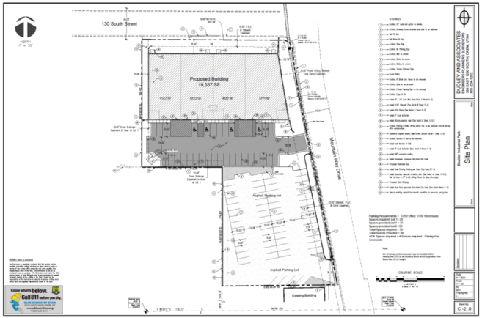
Staff Presentation:
The applicant is proposing to construct a four-unit office warehouse building on an existing parking lot in the M2 zone. The property is currently one lot and it will be subdivided into two lots. Each lot will meet the minimum lot size requirements of the M2 zone which is 10,890 square feet (one-quarter acre). Lot 1 will be 44,054 square feet and Lot 2 will be 26,586 square feet. (22-9-6)

Architecture: The materials used for the building will be 2-tone CMU blocks, split face block, metal panels and scoured block. The highest part of the building will be twenty-seven (27) feet four (4) inches high. The maximum building height allowed in the M2 zone is sixty (60) feet high. (22-9-6)

Landscaping: The landscaping plan meets the requirements of the requirements of the M2 zone with a minimum ten (10) foot landscaped strip located on the right-of-way line of the street. 22-9-7(B)

Parking: In the M2 zone, the required parking is one (1) space per seven hundred fifty (750) square feet of warehouse space and one (1) space per two hundred fifty (250) square feet of office space. This project meets those parking requirements as they are required to provide sixty-six (87) stalls and that is what they are providing: 22-15-4(D)
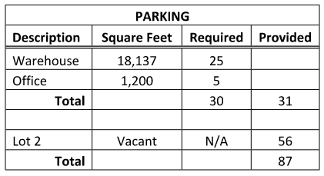

Recommendation:
Staff recommends the Planning Commission vacate Lot 4 of Miller Park, Plat A and approve the plat for Miller Park, Plat B and the site plan for Boulder Industrial Park located generally at 138 South Mountain Way Drive in the M2 zone.

Ms. Komen asked the Planning Commission members if they had any questions for Mr. Bench.

Ms. Komen asked the applicant to come forward.

Roger Dudley came forward representing the applicant and explained the project.

Ms. Komen opened the public hearing.

When no one came forward, Ms. Komen closed the public hearing.

Ms. Komen called for a motion on this item.

Planning Commission Action:
Mr. Hawkes moved to vacate Lot 4 of Miller Park, Plat A and approve the plat for Miller Park, Plat B and the site plan for Boulder Industrial Park located generally at 138 South Mountain Way Drive in the M2 zone. Ms. Kleinlein seconded the motion. Those voting aye James Hawkes, Gerald Crismon, Madeline Komen, Mike Carpenter and Helena Kleinlein. Motion passed unanimously.

Ms. Komen asked Mr. Bench to introduce Agenda Item 3.2: (click here for recording)

PUBLIC HEARING – Amending Article 22-5-3 (A) and the zoning map of the City of Orem by rezoning a portion of the property (approximately 0.084 acres) located at 426 East 1070 South from the R6.5 zone to the C2 zone.

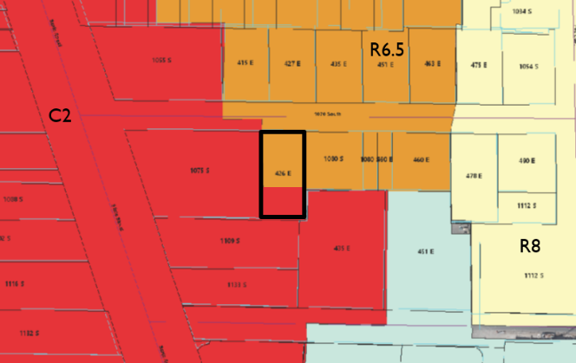
Staff Presentation:
The applicant owns approximately .25 acres of land and requests a zoning map amendment to approximately 0.084 (3,659 square feet) acres of land from R6.5 zone to the C2 zone. The 0.084 (3,659 square feet) acres they are requesting to be rezoned are on the south side of the property. The applicant wishes the north side of the property to remain R6.5. (Section 22-1-5).

Mi Ranchito, located at 1109 South State Street and the property located at 426 East 1070 South are owned by the same family. They took the back part of the residential property and turned it into an overflow parking lot for the Mi Ranchito commercial property. They also erected a fence five (5) feet from the rear of the house to separate the home from the parking lot. The commercial use in a residential zone is not permitted. There is also a twenty-five (25) foot setback that is required on the residential property.

This request is for the rezone only of the portion of the residential lot that can be rezoned to commercial. A site plan will be required to make the improvements on the parking lot area and bring it up to current code. The fence a few feet from the home, will need to be moved back twenty-five (25) feet. A final plat will also need to be recorded to move the property line between the residential and commercial portions of the lot. If the City Council approves the rezone application, the applicant will need to apply for a site plan and final plat. (Section 22-14-20)

Recommendation:
Staff recommends the Planning Commission amend Article 22-5-3 (A) and the zoning map of the City of Orem by rezoning a portion of the property (approximately 0.084 acres) located at 426 East 1070 South from the R6.5 zone to the C2 zone.

Ms. Komen asked the Planning Commission members if they had any questions for Mr. Bench.

Ms. Komen asked the applicant to come forward.

Mr. Hawkes commented on the parking challenges at this location.

Ms. Komen opened the public hearing.

Dorothy Alborne came forward. Asked the difference between the yellow and orange areas of the zoning map. Ms. Alborne asked about the encroachment of the mall on the neighborhood.

Mr. Bench addressed her questions.

Ms. Komen closed the public hearing.

Ms. Komen called for a motion on this item.

Planning Commission Action:
Mr. Carpenter moved to forward a positive recommendation to the City Council to amend Article 22-5-3 (A) and the zoning map of the City of Orem by rezoning a portion of the property (approximately 0.084 acres) located at 426 East 1070 South from the R6.5 zone to the C2 zone. Mr. Hawkes seconded the motion. Those voting aye James Hawkes, Gerald Crismon, Madeline Komen, Mike Carpenter and Helena Kleinlein. Motion passed unanimously.

Ms. Komen asked Mr. Bench to introduce Agenda Item 3.3: (click here for recording)

PUBLIC HEARING – Amending Article 22-5-3 (A) and the zoning map of the City of Orem by rezoning a portion of the property that fronts Geneva Road from the OS5 zone to the PO zone (approximately 4.83 acres) and the remaining property from the OS5 zone to the PRD zone (approximately 4.79 acres) and amending Appendix KK of the Orem City code for the property located generally at 1875 South Geneva Road.

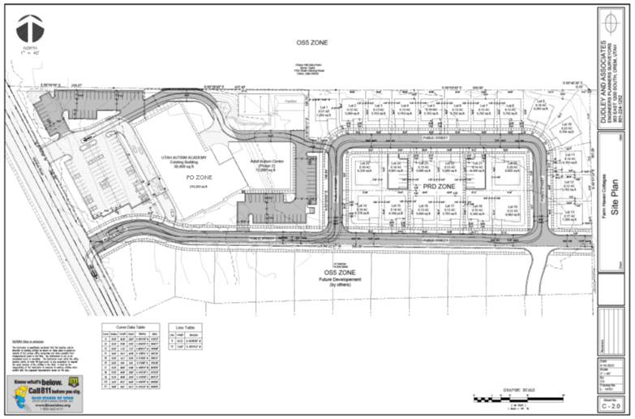
Staff Presentation:
The applicant is proposing to split an existing parcel that is 9.62 acres into two lots and two zones. The lot fronting Geneva Road will be 4.83 acres and includes the Utah Autism Academy. That academy and structures near it will remain and continue to work as an autism academy. This portion of the lot will be rezoned from the OS5 zone to the PO (Professional Office) zone. The autism academy is currently a legal non-conforming use in the OS5 zone, but it is a permitted use in the PO zone. (22-8-12)

The rear portion of the lot will be split off and a Planned Residential Development (PRD) will be created. This will be approximately 4.79 acres and twenty-three (23) single family homes will be built to accommodate families with autistic children. There will also be space to meet the visitor parking requirement which is one-half (1/2) space per unit and within one hundred fifty (150) feet of each unit. (22-7-12(J))

Both proposals will meet the required size for the zone they are in. The PO zone may not be applied to an area of less than one acre. (22-8-8(A)) The PRD zone requires 1.5 acres minimum. (22-7-3(F))

Appendix KK of the Orem City Code will also be amended. This is an appendix where elevations and concept plans for the various PRDs are located. As this will be a new PRD, it will also be added to Appendix KK, if approved. (Appendix KK)

Staff would recommend as a condition of approval, that a plat dedication or development agreement that is signed by both property owners and the City be in place and submitted to the City prior to this project going to City Council for approval. A non-binding agreement between the developer (north property) and south property owner is attached to this staff report packet.

Recommendation:
Staff recommends the Planning Commission consider a recommendation to the City Council to amend Article 22-5-3 (A) and the zoning map of the City of Orem by rezoning a portion of the property that fronts Geneva Road from the OS5 zone to the PO zone (approximately 4.83 acres) and the remaining property from the OS5 zone to the PRD zone (approximately 4.79 acres) and amending Appendix KK of the Orem City code for the property located generally at 1875 South Geneva Road.

Ms. Komen asked the Planning Commission members if they had any questions for Mr. Bench.

Mr. Carpenter asked if the properties will be rentals.

Mr. Bench stated that it was originally part of the application, but that it may not be the case and advised that the question be posed to the applicant.

Ms. Komen asked the applicant to come forward.

Paul Washburn came forward and addressed that the lots will be sold not rented, but that CCNRs will be placed on the properties to follow the intent of the homes to accommodate families and individuals with Autism.

Trish came forward to explain the project and the reasoning behind the project.

Ms. Komen asked if the CCNRs will be able to fulfill what is expected in this neighborhood.

Trish explained the reasoning behind not placing a legal restriction on the neighborhood because support for the Autistic community can come from many places.

Ms. Kleinlein asked how the applicant plans to continue to limit the area years in the future.

Mr. Washburn explained that through the CCNRs the expectations for the neighborhood will be outlined and that at closing the buyers will be required to sign the CCNRs.

Ms. Kleinlein asked who would be designing the homes.

Mr. Washburn explained that the home designs will be designed by them, the applicant, and that the designs are being made specifically to help those with autism.

Trish explained that the homes will have particular lighting, safe appliances, and extra space in the bathrooms to allow someone to be present to support the autistic individual.

Mr. Carpenter asked how many units are proposed.

Trish stated that there are 23 units, and that there is a great need for these homes.

Ms. Komen opened the public hearing.

John Porter came forward. Mr. Porter lives in the neighborhood to the south of the project. Mr. Porter expressed concern about the future connection to the south be removed to prevent traffic from going through his neighborhood.

Keith Nelison came forward who lives in Mapleton. Mr. Nelison came to speak in favor of the autism school and the proposed autism friendly neighborhood. Stated that the only other option there is for autistic adults to live is in group homes.

Keith Walker came forward. Stated that this is a good idea and that most of the kids will not be driving so the traffic shouldn’t be an issue. Mr. Walker asked that the applicant be sure how they envision the houses being built.

Linda Brown came forward. Ms. Brown is concerned regarding the traffic which could be generated from this project going through her neighborhood to the south. Ms. Brown mentioned that this project would not be able to have access to Geneva Road per previous conversations with UDOT.

Sydney Dameron came forward. Ms. Dameron stated that this project is a great use for the space, but that connection to the south through the neighborhood would not benefit the area.

Bronson Dameron came forward. Mr. Dameron stated that he shares Ms. Dameron’s thoughts on the project and feels that this is a great project for the area. Mr. Dameron expressed that traffic is concern for this project.

Connie Porter came forward. Ms. Porter stated that she only objects to the connection to the south neighborhood.

Pamela Moose came forward. Ms. Moose stated that she is not sure how she would feel about the road connecting but that she is concerned about the traffic. Ms. Moose is also concerned about the future of the proposed neighborhood as the homes are resold. Ms. Moose is also concerned about how the autistic members of the community will be able to travel if they do not drive.

Sydney Squilliam from Draper came forward. Ms. Squilliam came forward and spoke on behalf of the autism academy as she is a parent of a student there. Ms. Squilliam expressed that a major concern for her is what will happen to her child when she no longer can take care of them and that this neighborhood provides that answer.

Holly came forward. Holly currently lives in Vineyard and works at the academy. Holly expressed that she hopes to someday raise her family in a community that is friendly and inclusive to those with autism.

Dorothy Alborne came forward. Ms. Alborne expressed that she understands the concern for traffic and asked for speed bumps to be considered to help control the speed in the area. Ms. Alborne encouraged having creative thinking to address concerns.

Adam came forward. Adam has a child who attends the academy. Adam pointed out that the applicant does not own the portion directly to the south where the potential connector street is located is just proposed should that portion of property be developed. Adam stated that development is inevitable and stated that those who were present prior to the Peyton’s crossing development likely were concerned about that development before it came in too.

Bronson Dameron came forward. Mr. Dameron stated that he feels this is a good thing for the community and that it is important to take care of those in our society who most need help.

Scott Child came forward. Mr. Child does not live in Orem. He lives in a neighborhood which has experience some increased traffic due to new developments and shares those concerns. Mr. Child stated that he supports an autistic friendly neighborhood as he has a neighbor who would benefit from this.

When no one came forward, Ms. Komen closed the public hearing.

Mr. Washburn came forward to explain how the plan changed from twin homes to the current proposal of single family homes. Mr. Washburn spoke to the concerns for the proposed connection to the south, with that the owner of the property to the south but that the current owner has no interest in allowing that connection across his property.

Trish came forward to express gratitude to the neighbors to come forward and consider this project.

Ms. Komen asked Mr. Kelly to speak to the concerns regarding traffic.

Mr. Kelly spoke to that when the Peyton’s crossing development came through about half of that neighborhood would not have been allowed to happen without the street connection being master planned in this area. The proposed project may not be able to go forward through the site plan phase without some kind of circulation option for the water utility due to the requirements for fire hydrants.

Ms. Komen asked about the access to Geneva Road.

Mr. Kelly explained that the road would be an expansion to the existing access from the school to Geneva Road.

Ms. Komen asked if there is currently a development agreement in place between the applicant and the land owner to the south property.

Mr. Washburn came forward to address this and referenced the letter which the property owner has submitted regarding the easement for the access.

Ms. Kleinlein asked about protecting the autistic residents of the homes and that the community will meld into just regular homes.

Trish came forward to address the comment that the state is moving away from allowing the area to be exclusively for those with autism. There is training for those with autism at the academy to eventually help those individuals to live in any community.

Ms. Kleinlein asked Mr. Kelly about what options there are for access to this property.

Mr. Kelly explained that there are multiple facets to this, as it is also important to be able to have the ability to get help into the neighborhood if needed. Mr. Kelly also expressed that even though it tends to be our desire to protect the autistic community this neighborhood is intended for, but that containing the autistic community is not the answer and the connections will help to serve those in the neighborhood.

Mr. Washburn expressed that since the connector roads will feed the neighborhood but does not go anywhere other than the neighborhood.

Mr. Hawkes asked how the plans changed following the neighborhood meeting.

Mr. Washburn explained that the change was in response to the comments they received at the neighborhood meeting.

Planning Commission members discussed and addressed comments with members of staff and amongst themselves.

Ms. Komen called for a motion on this item.

Planning Commission Action:

Mr. Hawkes moved to forward a positive recommendation to the City Council to amend Article 22-5-3 (A) and the zoning map of the City of Orem by rezoning a portion of the property that fronts Geneva Road from the OS5 zone to the PO zone (approximately 4.83 acres) and the remaining property from the OS5 zone to the PRD zone (approximately 4.79 acres) and amending Appendix KK of the Orem City code for the property located generally at 1875 South Geneva Road. Mr. Crismon seconded.

Discussion was held among Planning Commission members regarding the motion.

Ms. Kleinlein expressed concern regarding the road connections and how the neighborhood could possibly meld into future development.

Mr. Carpenter expressed concerns regarding the density of the project and how that will impact the density of future developments in the area.

Ms. Komen expressed concern about the need for the development agreement to be part of the recommendation.

Mr. Hawkes did not wish to amend his motion.

Mr. Hawkes moved to forward a positive recommendation to the City Council to amend Article 22-5-3 (A) and the zoning map of the City of Orem by rezoning a portion of the property that fronts Geneva Road from the OS5 zone to the PO zone (approximately 4.83 acres) and the remaining property from the OS5 zone to the PRD zone (approximately 4.79 acres) and amending Appendix KK of the Orem City code for the property located generally at 1875 South Geneva Road. Mr. Crismon seconded. Those voting aye James Hawkes, Gerald Crismon, Madeline Komen. Those voting nay: Mike Carpenter and Helena Kleinlein. Forwarded a neutral recommendation to the city council.

Minutes: The Planning Commission reviewed the minutes from the June 21, 2023 meeting. Ms. Komen called for a motion to approve the minutes for June 21, 2023. Mr. Carpenter moved to approve the meeting minutes for June 21, 2023. Mr. Hawkes seconded the motion. Those voting aye: James Hawkes, Gerald Crismon, Madeline Komen, Mike Carpenter and Helena Kleinlein.

Adjourn: Ms. Komen called for a motion to adjourn. Mr. Hawkes moved to adjourn. Mr. Crismon seconded the motion. Those voting aye: James Hawkes, Gerald Crismon, Madeline Komen, Mike Carpenter and Helena Kleinlein.

Adjourn: 5:51 p.m.

Ryan L. Clark
Planning Commission Secretary

Approved:

