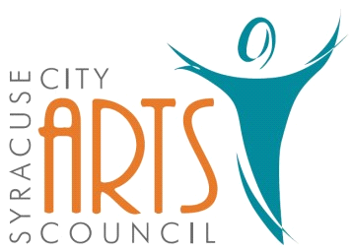
Syracuse City Arts Council Meeting Agenda
August 2, 2023 8pm
Meeting begins at 8pm
in the Syracuse City Municipal Building’s large conference room
located at 1979 West 1900 South.
1. Opening Business
- Call to Order
- Adoption of August 2, 2023 Agenda
- Review and Adoption of June 7 & June 29, 2023 Minutes
- Approve Budget Expenditures since June 7, 2023

2. Public Comment-This is an opportunity to address the Council regarding concerns or ideas. Please limit comments to three minutes.

3. Remaining 2022-2023 SCAC Season Events
Orchestra: complete
Jazz Band: complete
Jr. Theatre: complete
Theatre: complete
Fundraisers: Battle of the Bands August 26, 2023
Other:

4. Summer Musical Debrief/next year

5. Possibility of paying Pro team to stay competitive

6. AcaCon update

7. Update Battle of the Bands – continue, postpone or cancel

8. Update on storage - Dave

9. Publicity: Syracuse Connection information & other publicity as needed.

10. Walk in items

WORK SESSION
11. Committee/Board Member Updates/Discussion

12. Future Agenda Items

13. Adjournment
~~~~~~~~~~~~~~~~~~~~
In compliance with the Americans Disabilities Act, persons needing auxiliary communicative aids and services for this meeting should contact the City Offices at 801-825-1477 at least 48 hours in advance of the meeting.

CERTIFICATE OF POSTING
On July 31, 2023 this agenda was provided to the Standard Examiner and submitted to Syracuse City for posting on the Syracuse City Hall Notice Board and for publishing on the Syracuse City website, at http://www.syracuseut.com, and on the State Public Notice website, at http://www.utah.gov/pmn/indix.html. A copy was also submitted to the website manager for publishing on the Syracuse City Arts Council website, at http://www.syracuseutaharts.org/about-us/council-minutes. Libby Fawcett, Syracuse City Arts Council Chair

