CITY OF OREM
PLANNING COMMISSION MEETING MINUTES
June 21, 2023

The following items are discussed in these minutes:
- PUBLIC HEARING – Vacating Sandhill Grove PRD Plat A and approving Sandhill Grove PRD Plat A Amended located generally at 537 West 1770 South in the PRD zone. – Approved
- PRELIMINARY PLAT – Approving the preliminary plat for Hidden Vale Plat C located at 1428 South 100 West in the R8 zone. – Approved
- PUBLIC HEARING – Amending the development agreement for the property located at 1981 South Geneva Road in the C2 zone. – Negative Recommendation

STUDY SESSION

Place: City Council Conference Room

At 3:33 p.m. Mr. Low called the Study Session to order.

Those present: James Hawkes, Murray Low, Mike Carpenter and Helena Kleinlein, Planning Commission members; Jason W. Bench, Assistant Development Services Director; Makayla Wagstaff and Cheryl Vargas, Associate Planners; Matt Taylor and Grant Allen, Senior Planners; Sam Kelly, City Engineer; Steve Earl, Legal Counsel;

Those excused: Gerald Crismon, Haysam Sakar, Madeline Komen, Planning Commission members; Ryan L. Clark, Acting Assistant City Manager/Development Services Director; Gary McGinn, Legal Counsel; Terry Peterson, City Council Liaison;

The Commission selected Mr. Low as acting chair for this meeting due to the absence of the Chair and Vice-Chair.

The Commission and staff briefly reviewed agenda items and minutes from the June 7, 2023 meeting.

The meeting was adjourned at 4:26 p.m. to the City Council Chambers for the regular meeting.

REGULAR MEETING

Place: Orem City Council Chambers

At 4:30 p.m. Mr. Low called the Planning Commission meeting to order and asked Mr. Hawkes, Planning Commission member, to offer the invocation.

Those present: James Hawkes, Murray Low, Mike Carpenter and Helena Kleinlein, Planning Commission members; Jason W. Bench, Assistant Development Services Director; Makayla Wagstaff and Cheryl Vargas, Associate Planners; Matt Taylor and Grant Allen, Senior Planners; Sam Kelly, City Engineer; Steve Earl, Legal Counsel; Terry Peterson, City Council Liaison;

Those excused: Gerald Crismon, Haysam Sakar, Madeline Komen, Planning Commission members; Ryan L. Clark, Acting Assistant City Manager/Development Services Director; Gary McGinn, Legal Counsel

Mr. Low asked Ms. Vargas to introduce Agenda Item 3.1: (click here for recording)

PUBLIC HEARING – Vacating Sandhill Grove PRD Plat A and approving Sandhill Grove PRD Plat A Amended located generally at 537 West 1770 South in the PRD zone.

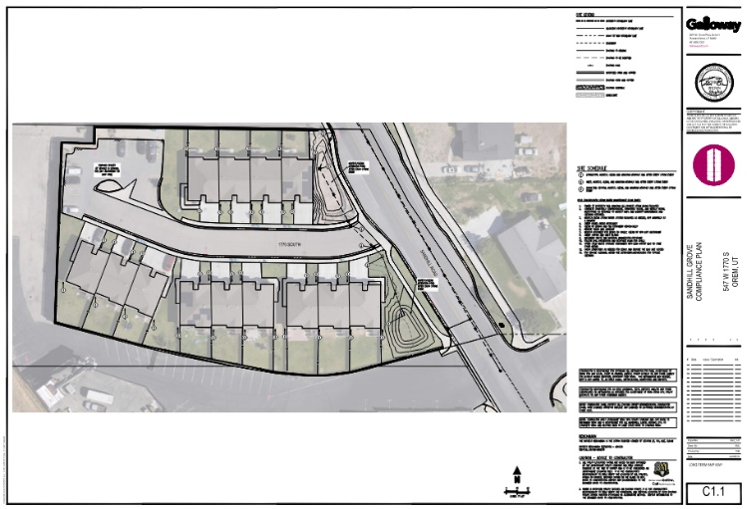
Staff Presentation:
In 2007 a site plan was approved for this site which shows the northwest portion of the property being landscaped with a playground. On the site this was changed sometime after 2007 to be a parking lot instead. This change was done without amending the site plan for the property.

The applicant is bringing the property into compliance by amending their plat to show the northwest area as parking with surrounding landscaping. Due to the change in the amount of impermeable surface, they also are adding an additional drainage basin on site to help with the additional storm water. Both the existing drainage basin and the
new basin will be landscaped, and additional landscaping is to be installed surrounding the parking area.

In addition to amending the plat to show the parking area they also are extending the limited common areas behind each unit to the property line. This reflects the current area which is fenced for each unit to use.

Recommendation:
Staff recommends the Planning Commission vacate Sandhill Grove PRD Plat A and approve Sandhill Grove PRD Plat A Amended located generally at 537 West 1770 South in the PRD zone.

Mr. Low asked the Planning Commission members if they had any questions for Ms. Vargas.

Mr. Low asked the applicant to come forward.

The applicant was not present.

Mr. Low opened the public hearing.

When no one came forward, Mr. Low closed the public hearing.

Mr. Low called for a motion on this item.

Planning Commission Action:
Mr. Hawkes moved to vacate Sandhill Grove PRD Plat A and approve Sandhill Grove PRD Plat A Amended located generally at 537 West 1770 South in the PRD zone. Mr. Carpenter seconded the motion. Those voting aye: James Hawkes, Murray Low, Mike Carpenter and Helena Kleinlein. Motion passed unanimously.

Mr. Low asked Ms. Vargas to introduce Agenda Item 3.2: (click here for recording)

PRELIMINARY PLAT – Approving the preliminary plat for Hidden Vale Plat C located at 1428 South 100 West in the R8 zone.

Staff Presentation:
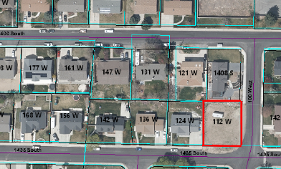
The applicant is proposing to plat a vacant lot located at 1428 South 100 West. This property is currently a lot of record. This is a corner lot and there is currently no structure on the lot and there are no sidewalks, curbs or gutters.

The applicant will build a new home on the lot. In addition to the home, the applicant will also install street improvements, such as curbs, gutters and sidewalks, as well as sewer and water laterals. (17-4)

The lot will be eight thousand six hundred twelve (8,612) square feet, which meets the requirements for lot size in the R8 zone. (22-6-8)

Recommendation:
Staff recommends the Planning Commission approve the preliminary plat for Hidden Vale Plat C located at 1428 South 100 West in the R8 zone.

Mr. Low asked the Planning Commission members if they had any questions for Ms. Vargas.

Mr. Low asked if the applicant was present. They were, however, there were no questions for them.

Mr. Low called for a motion on this item.

Planning Commission Action:
Ms. Kleinlein moved approve the preliminary plat for Hidden Vale Plat C located at 1428 South 100 West in the R8 zone. Mr. Hawkes seconded the motion. Those voting aye: James Hawkes, Murray Low, Mike Carpenter and Helena Kleinlein. Motion passed unanimously.

Mr. Low asked Ms. Vargas to introduce Agenda Item 3.3: (click here for recording)

PUBLIC HEARING – Amending the development agreement for the property located at 1981 South Geneva Road in the C2 zone.

Staff Presentation:
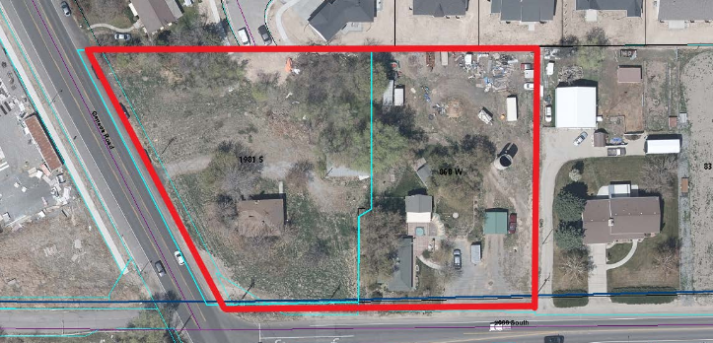
In December of 2020 this property was rezoned to the C2 zone and a development agreement was approved in conjunction with that rezone. This development agreement limited the uses which could be built on this property to a gas station with a convenience store. The agreement also limited the building materials and architectural style of the building as well as the allowed operating hours for the convenience store.

The applicant is requesting to amend the development agreement from December 2020 to allow a carwash to be built on the site along with the gas station and convenience store. The amended agreement adds the option of the drive-thru at the convenience store. The proposed amended agreement also changes the materials and architectural style of the buildings on the site.

The proposed changes to the development agreement do not alter the allowed hours of operation of 5am to midnight, and the proposed carwash would also be held to these hours of operation. These are consistent with the times when the lights would be required to be dimmed on the site.

Recommendation:
Staff recommends the Planning Commission consider a recommendation to the City Council to amend the development agreement for the property located at 1981 South Geneva Road in the C2 zone.

Mr. Low asked the Planning Commission members if they had any questions for Ms. Vargas.

Mr. Carpenter asked if they could recommend some elements while not recommending other. Ms. Vargas and Mr. Earl addressed that each element of the agreement can be separated out.

Ms. Kleinlein presented a concern regarding the bright coloring of the proposed façade changes.

Mr. Low asked the applicant to come forward.

Mr. Low asked if any Planning Commission members had questions for the applicant.

Brent Neel came forward. The drive-thru would not be a separate business, it would be part of the Holiday Oil business.

Mr. Low asked if they have already purchased the property. Mr. Neel let them know that they have purchased the property already.

Mr. Carpenter asked if they will maintain the same landscaping. Mr. Neel addressed that they have some preliminary plans for the landscaping, but have not fully designed a landscape plan for this site yet.

Mr. Hawkes asked if the proposed architectural features are on all of the stores. Mr. Neel addressed that this is the current standard for the store.

Mr. Hawkes asked about the drive-thru. Mr. Neel addressed that having the drive-thru is a newer concept.

Mr. Hawkes asked about how many stores currently have carwashes. Mr. Neel stated that about 70% of stores have a carwash.

Ms. Kleinlein asked about the placement of the dumpster. Mr. Neel stated that they are willing to work with the city during site plan approval to move the location of the dumpster. Mr. Bench verified that the city could work with Holiday Oil as far as the location of the dumpster.

Mr. Low asked what the plan was if the requested changes were denied by the City Council. Mr. Neel stated that they would need to redesign or sell the property at that point.

Mr. Hawkes asked how the size of this site compares to other Holiday Oil sites. Mr. Neel stated that most sites are about the same size as this property, approximately 2 acres.

Ms. Kleinlein asked about the lighting of the site, particularly within the drive-thru. Mr. Neel stated that they would dim lighting to help reduce the lighting which would spill onto the neighboring properties.

Mr. Hawkes asked how much business happens after hours. Mr. Neel addressed the hours which they have proposed for the store operation would be the same for the carwash.

Mr. Low opened the public hearing.

Hunter Kimball came forward as a Provo resident who lives half a mile away from the site. Mr. Kimball expressed concerns about the gas station being located in a residential area, and is opposed to the gas station going on the site. Mr. Kimball expressed that his biggest concern is the environmental impact from the site.

John Porter came forward who lives directly north of the site. Mr. Porter expressed concern about the noise and fumes from cars in the drive-thru window. Mr. Porter expressed concerns about the carwash, and that it is too major of the change to the development agreement at this stage. Mr. Porter expressed concern about the noise and odor, and potential unwanted activities which come with the dumpster. Suggested placing the dumpster in the southwest corner of the lot.

Linda Brown came forward who lives on 2000 South. Ms. Brown mentioned that the neighborhood meeting was held outside in February. Ms. Brown stated that there are already many other gas stations and car washes nearby, negating the need of a gas station at this location. Ms. Brown stated that they have already addressed the light pollution concerns she has.

Sydney Dameron came forward who lives directly north of the proposed site. Ms. Dameron expressed concerns regarding that dimmed lights increase crime, and bright lights mean dealing with light. Ms. Dameron expressed concerns about the location in proximity to the Autism Academy. Ms. Dameron expressed concern that C2 zoning is the only zone which allows for a gas station to be this close to residential properties. Ms. Dameron requested that the Planning Commission help to make the best of the situation by giving a negative recommendation.

Zach Price came forward who lives directly north of the site. Mr. Price expressed concern that those using the gas station would be able to see into their yard due to the elevation change. Mr. Price expressed that his greatest concern surrounds safety for the kids in the neighborhood.

Don Bahr came forward as a nearby Provo resident. Mr. Bahr expressed that he would not have the gas station located there. Mr. Bahr expressed that he was grateful he was notified of this meeting.

Alan Moose came forward. Mr. Moose expressed that they did not know that this was being rezoned, and understands that likely is under buyer beware. However, that most people do not research this kind of thing when finding a home in the area they wish to live in. Mr. Moose requested that the project not move forward.

Casey Backus came forward. Mr. Backus expressed concerns about the traffic which would be generated by this project. Mr. Backus expressed that he does not want a gas station there.

Connie Porter came forward who lives directly north of the property. Ms. Porter expressed that she is concerned about the property value of her home and is disappointed in the decision to rezone the property.

Pamela Moose came forward. Ms. Moose and expressed that she is also not in favor of having the gas station at this location for a variety of reasons already expressed by others.

Bronson Dameron came forward who lives directly north of the project. Mr. Dameron expressed that he does not have anything to add, but is grateful for the opportunity to express their thoughts and have their voices heard on this issue.

Carlyn Price came forward who lives directly north of the property. Ms. Price expressed that they have two autistic children and having additional noise will be an additional stimulant and will add extra stress for their family.

Kurt Pulham came forward. Mr. Pulham expressed that he agrees with what has already been said and that he is against having the gas station in the neighborhood.

Leo Vargas came forward. Mr. Vargas expressed that he is opposed to this development.

Terry Petersen came forward. Mr. Petersen explained the process as how the Planning Commission will forward a recommendation to the City Council. Mr. Petersen encouraged those attending this meeting to attend the City Council meeting.

Barry Brown came forward. Mr. Brown expressed concern regarding the access to the gas station. Mr. Brown expressed that he does not support putting a gas station at this location and that something else should go there.

Heather Fry came forward. Ms. Fry expressed that she is working to learn how things happen in Orem.

Mr. Low closed the public hearing.

Mr. Low asked the members of the Planning Commission to speak on this item. Planning Commission members discussed with each other, with staff, and with Brent Neel about this item. The topics addressed in the public hearing and additional questions from Planning Commission members were addressed.

Mr. Low called for a motion on this item.

Planning Commission Action:

Ms. Kleinlein moved to forward a negative recommendation to the City Council to amend the development agreement for the property located at 1981 South Geneva Road in the C2 zone. Mr. Hawkes seconded the motion. Those voting aye: James Hawkes, Murray Low, Mike Carpenter and Helena Kleinlein.

Minutes: The Planning Commission reviewed the minutes from the June 7, 2023 meeting. Mr. Low called for a motion to approve the minutes for June 7, 2023. Mr. Carpenter moved to approve the meeting minutes for June 7, 2023. Ms. Kleinlein seconded the motion. Those voting aye: James Hawkes, Murray Low, Mike Carpenter and Helena Kleinlein.

Adjourn: Mr. Hawkes called for a motion to adjourn. Ms. Kleinlein moved to adjourn. Mr. Hawkes seconded the motion. Those voting aye: James Hawkes, Murray Low, Mike Carpenter and Helena Kleinlein.

Adjourn: 5:51 p.m.

Ryan L. Clark
Planning Commission Secretary

Approved: July 19, 2023

