Lake Point City Council Minutes

Date: Wednesday, July 5, 2023
Place: Lake Point Fire Station 1528 Sunset Rd Lake Point, UT 84074
Time: 6:00 PM

- Call to Order- 6:02 pm
- Prayer- Doyle Garrard
- Pledge of Allegiance- Tina Garrard
- Presiding Officer- Jonathan Garrard
- Attendance Roll Call- Jonathan Garrard

Lake Point Council & Staff (C=Council) | Public | Public
Jonathan Garrard (Chair) | Tina Garrard | Adams
Ryan Zumwalt (Vice Chair) | Jordan Taylor | Adams
Dan Crawford (C.) | Tina Garrard | Lori Chigbrow
Kathleen VonHatten (C.) | Matt Littlefield | Todd May
Doyle Garrard (C.) | Tina Littlefield
Jamie Olson (RCDR) | Gail Garrard
Rob Patterson (Attorney) Left at 8:47pm

- Legal Training – Rob- (2:20 recording)
  - Planning and Zoning sent him information on the sexually oriented businesses which could be reviewed later or briefly gone over now.
    - (Kathleen) asked if what they proposed was unconstitutional.
    - (Rob) A complete ban is likely unconstitutional and then he explained it more in detail.
- Public Comment- (8:56 recording)
  - Motion- Dan to open Public Comment. Doyle 2nd
  - Vote was unanimously approved
    - Jordan Taylor (9:50 recording)
      - Had questions on definitions of buildings and structures, and if that included shipping containers.
        - (Rob) yes that includes shipping containers because it is on the grounds
      - Questioned items 10. and 11. Dead trees and abandoned structures and is concerned for example Doyle’s barn, and sometimes they give character and brought up buildings by pioneers that might need restoration.
      - Will we have to get a building permit for a shipping container, could the square footage be raised to 400 sq ft?
        - (Jordan) It pushes people to build more small buildings to avoid building permits
        - (Jordan) is a building contractor and is familiar with his concerns.
        - (Jordan) Thanked for the agriculture exemption.
          - Does it protect agriculture buildings from getting building permits?
          - The State is 2 acres or larger and may be reduced to 1 acre since most of Lake Point is 1 acre.
      - Tina Garrard (16:40 recording)
        - Are we going to be able to get a copy of the notes for the nuisance committee? Yes, Kathleen will send it out.
      - Todd May (17:16 recording)
        - Is there a deadline to get this nuisance passed?
          - (Kathleen) not necessarily a deadline, just keeping it going.
        - Handed out decibel examples (Exhibit A)
        - Explained the 65-decibel noise level and in construction and printed is 60 decibels is a conversation between 2 people.
        - Seemed pretty low. A train is 80 decibels
          - (Dan) What would you suggest
            - (Todd) Going higher than 60
        - Impact wrenches would impact people’s businesses
        - He contracted months ago for a sports court. And would like to know if a sports court was permitted.
          - (Kathleen) They don’t have a permit for that.
      - Ken Child (read by Jonathan emailed to the entire Council before the meeting) (22:10 recording)
        - Lake Point has done pretty well in 170 years, and he would like this nuisance ordinance not to be rushed.
        - An overly detailed and restrictive nuisance ordinance is not rural. Against having a code enforcement officer. It would encourage neighbors to snitch out neighbors. Citizens should be encouraged to work together to resolve differences.
        - Could appoint an arbitrator and the City Council could be the appeals process.
        - He understood the enforcement of building codes but was concerned with an overzealous building inspector.
      - Adams- (25:12 recording)
        - Concerned with fireworks. Adams had a rude awakening and wasn’t aware of it on social media
        - Very lucky the horses didn’t go through the fence. It was right outside their backyard. They were very large and very loud. What are the rules on what is allowed and who monitors that? She is not opposed to celebrating America but she doesn’t think it was appropriate to be in residential and around farm animals.
          - Why was it permitted in a residential neighborhood and would like to understand the laws better?
          - This year was a good year for greenery, another year that could have caught fire quickly
          - Do we have any way to kibosh this and do something different in the future? An A-frame or letters giving notice?
            - (Kathleen) asked Rob if they could add some way to add a notification requirement to surrounding property owners. Kathleen would like the firework permit amended to require notification to neighbors.
            - (Kathleen) Utah state allows the fireworks and it’s up to the city to say what and where.
            - (Kathleen) We either allow them or ban them. The city chose to do permits.
        - Further discussion with the public and council.
      - Public (no name given)- her horse wanted to go through the fence and was dripping sweat.
      - Council and Public bounced ideas (37:00 recording)
      - Jordan Taylor-
        - Explained Gino’s intent
      - (Kathleen) discussed how to communicate better with the public.
      - Council and the public continued to discuss.
  - Motion- Jonathan to close Public Comment. Dan 2nd
    - Vote was unanimously approved
- Reports/Presentations (54:00 recording)
  - No reports or presentations
- Action/Business Items (54:08 recording)
  - R-2023-21 Fee Schedule (to add engineering fees)
    - Kathleen introduced the fee schedule
    - Council and Counsel discussed added permit fees and deposits.
      - Motion- Kathleen to approve the Fee Schedule to approve pages 1 through 7 without the “land use” last page “land use – other” page. Dan 2nd (1:06:07 recording)
      - Roll Call Vote-Jonathan Yea -Ryan Yea -Dan Yea -Kathleen Yea -Doyle Yea
        - Passed unanimously
  - Ordinance 2023-16 Nuisance Working Draft Amending Section 3-8 (no final vote will be taken) (1:07:30 recording)
    - Council discussed the “abandoned structure or building” definition (1:08:00 recording)
    - Section 3. Noise Nuisance discussed (1:13:17 recording)
    - Section 4. Code Enforcement discussed (1:31:04 recording)
    - Motion- Kathleen- to table until the middle of August. Doyle 2nd (2:13:00 recording)
      - 4 yay and 1 nay
      - Motion passed 4 to 1
  - (Ryan) asked for some clarification on prior existing buildings concerning Ken Childs’s public comment. (2:18:00 recording)
  - (Doyle) wanted to explore some of Jordan’s concerns regarding agriculture and shipping containers. (2:20:00 recording)
    - Jordan Taylor handed Doyle a paper that is Duchesne County application. (Exhibit B)
  - (Ryan) asked Rob if they are missing something in the nuisance and if they miss it, they can’t regulate it.
    - If it’s allowed under zoning, you can’t backdate it.
- Attorney Clarification (2:33:34 recording)
  - (Kathleen) asked Rob to clarify the notification process for a zoning change.
    - Rob explained.
- Council Updates (2:45:09 recording)
  - Kathleen VonHatten
    - Mass care training in case of a mass emergency
      - (Kathleen) explained we need to have a process in place possibly readdress end of August.
    - Sales Tax update from the state
      - (Kathleen) we need to balance the books from monies borrowed from the county and funds that came into the county for Jan. Feb. Mar. for Lake Point.
    - P&Z citizen comments on the procedure
      - (Kathleen) had a concern that was sent in, and it never got a response. (Kathleen)
        - Council discussed.
    - Infrastructure in General Plan
      - (Kathleen) suggested adding something to the general plan addressing utility infrastructure.
    - Notification of Zoning Change (3:25:29 recording)
      - Already addressed this with counsel.
    - Dark Sky update.
      - (Kathleen) wanted to know if the council wants to have a presentation and answer the council’s question for July 19th.
        - Kathleen will reach out and see if he is available.
  - Jonathan Garrard (3:33:20 recording)
    - Water line/asphalt replacement inspection and fee follow-up.
      - Council discussed.
    - Discuss the idea of having a place on our agenda for upcoming discussion items, but not quite ready for Action/Business.
      - Council discussed this topic. (3:40:00 recording about)
      - Council will try to add verbiage to make it clear to the on items in the action section if they are drafts or not intended to be voted on.
  - Doyle Garrard (3:52:25 recording)
    - Would like an invoice from the fire dept. to make sure they get paid.
      - Doyle will follow up about getting an actual invoice.
  - Dan Crawford (3:53:56 recording)
    - Consider outline of 'Process for Submittals' referenced by Matt Laurendeau, from Jones & DeMille Engineering, Inc.
      - (Dan) updated council.
    - (Dan) gave an update on the roads
    - Eagle Scout Project - Lake Point Sign update
    - (Dan) asked for an update on all the Utility Easements
      - Council gave updates.
  - Ryan Zumwalt (3:57:05 recording)
    - No updates
- Public Comment (3:57:25 recording)
  - Motion-Kathleen to open Public Comment. Ryan 2nd
  - Vote was unanimously approved
    - Lori Chigbrow (3:57:47 recording)
      - (Lori) Kirk Pearson brought the constitutional banning of sexual-oriented businesses to the Planning and Zoning. Lori wanted to know the mileage from houses, so they can restrict distance from the residence.
      - (Lori) was curious about Salt Lake’s ordinance on sexually oriented businesses.
      - (Lori) On the topic of possibly missing a nuisance and Lori liked how Cane County and then read part of their definitions.
      - (Lori) likes Cane County and how theirs is written.
      - (Lori) quoted Cane County’s purpose. (4:08:18 recording)
      - (Lori) is interested in code enforcement and involving planning and zoning and is interested in helping with that. Also suggested having it be two people.
        - And having fees of the mediator be paid by the one at fault.
      - (Lori) discourages limiting distance for complaints. Since it was previously mentioned that someone on one side of town can’t complain about a nuisance that may be on the other side of town.
      - (Lori) Decibels and electric lawnmower are 75 decibels and gas-powered is 90 decibels. And there were concerns from the public on continuous barking dogs is a problem.
        - Dogs were discussed.
  - Motion- Jonathan to close Public Comment. Doyle 2nd
  - Vote was unanimously approved
- Adjournment 10:22 pm

Note-The minutes may include a summary of what was discussed and are not intended to be verbatim. All public meetings have an audio recording, time stamps are included in the minutes to help the public find where certain topics were discussed. Please see the audio recording of this meeting for a full audio record of the meeting.

Note- Additional information concerning meetings including agendas, minutes, recordings, written/typed public comment, other distributed materials, ordinances, resolutions, public notices, and how to sign up for notifications on the Public Notification Website, can be found at https://lakepoint.gov under Departments-Recorder.

Note- This meeting includes public comment that was written and given to the city recorder for the record. To find the complete record please visit lakepoint.gov Departments-Recorder-Downloaded Forms- Meeting Minutes.

DRAFT verbiage in Header- MINUTES DRAFT/NOT APPROVED

PASSED AND APPROVED but the Council this ______day of _________, 2023

________________________________________
Jonathan Garrard, Chair
ATTEST:

_____________________________________
Jamie Olson, City Recorder

Exhibit A
2023 07.05
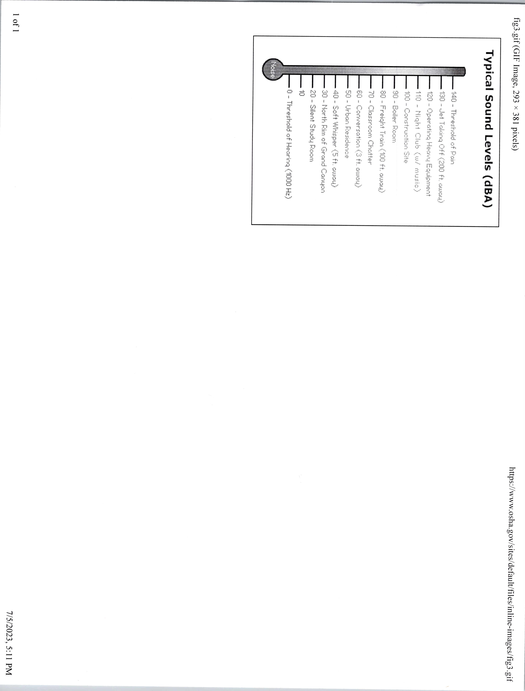

Exhibit B
07.05.2023

