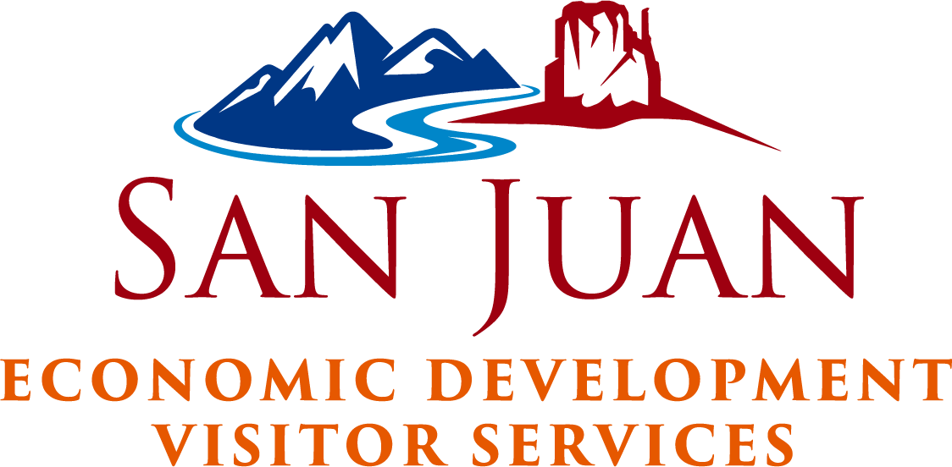

To Whom It May Concern,

This is to verify that the SJC Economic Development Board participated in all aspects of the 2022-2023 Rural County Grant process - by reviewing the application, the budget drafted, the actual allocation of the funds to each business that applied, and the follow-up.

This letter confirms that the San Juan County Economic Development Department will participate in the 2023-2024 application for the Rural County Grant Program.

San Juan County Economic Development Board

Meghan McFall, Chair

