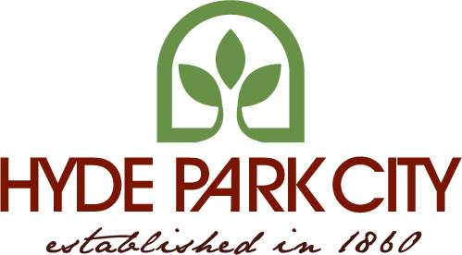

Hyde Park City Council / Zoom Meeting

July 26, 2023

7:00 p.m.

Agenda

Council meeting will be held live and via zoom
Zoom: 796 947 6317
Passcode: H88vx6
Welcome
Prayer

Pledge of Allegiance
Adoption of Agenda
Approval of Minutes from July 12th

Citizen Input

- Public Hearing to consider Resolution 2023-06 – A resolution amending the general plan to include moderate income housing requirements.

- Consider Resolution 2023-06 A resolution amending the general plan to include moderate income housing requirements.

- Consider Ordinance 2023-11 – An Ordinance amending the Commercial & Industrial Zones

- Departments

