REQUEST FOR PROPOSALS

FINANCIAL ADVISOR SERVICES

Issued: October 25, 2016
Due: November 23, 2016

KEARNS IMPROVEMENT DISTRICT

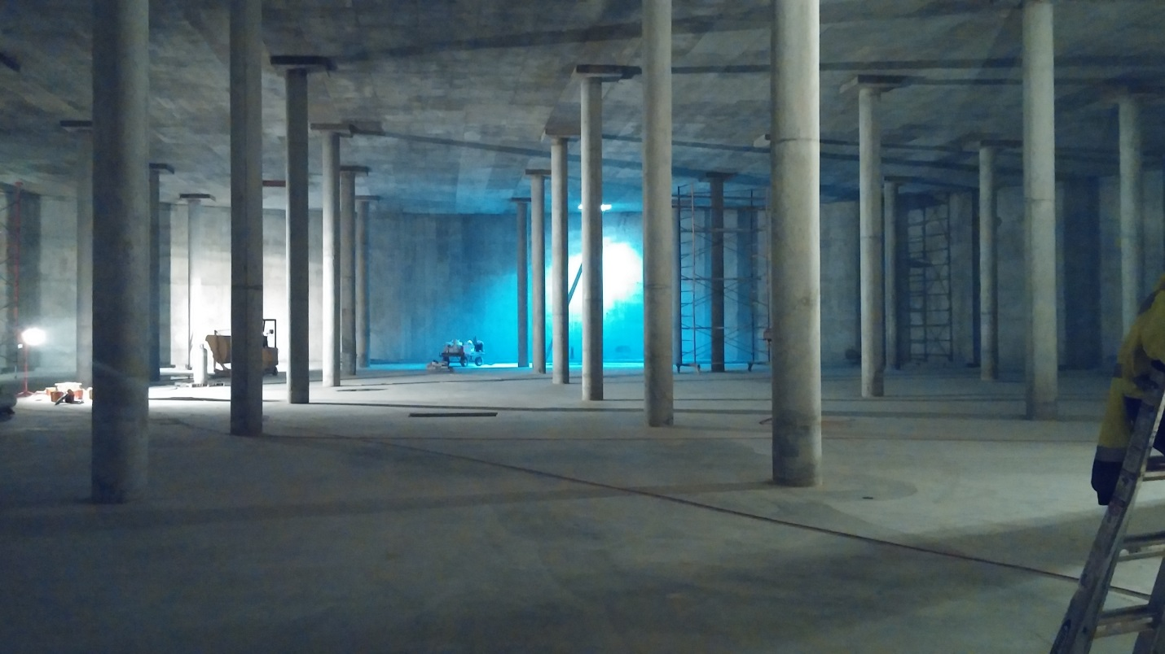

KEARNS IMPROVEMENT DISTRICT REQUEST FOR PROPOSALS (RFP)

TO PROVIDE FINANCIAL ADVISOR SERVICES

GENERAL

The Kearns Improvement District (KID) operates a water and sewer utility located in Kearns, Salt Lake County, Utah. KID encompasses the area formerly known as Camp Kearns, which was established as an air force replacement center during World War II, in addition to adjoining areas. KID is a political subdivision of the State of Utah with specific statutory powers. It is governed by an elected Board of Trustees. The District currently has 13,800 customers, and serves approximately 50,000 residents.

RFP CONTACT

This Request for Proposals (RFP) has been prepared by KID and KID is the issuing entity of this RFP. KID’s representative for this RFP is Bruce Hicken, CPA, Finance Director.

PURPOSE OF RFP

The purpose of this RFP is to solicit proposals from qualified firms to establish a contract to provide financial advisor services to the District, consisting of on-going advice pertaining to proposed and existing bond issues, investment of District funds and related matters. The District’s financial advisor shall be prepared to provide certain services that will include, but not necessarily be limited to:

- the preparation and presentation of information to rating agencies and bond insurance companies
- bond issue structuring
- official statement preparation
- underwriter(s) selection
- coordination of the particulars of issuing bonds
- interface with bond counsel
- arbitrage and other compliance
- investment of reserves and funds and related matters
- strategic financial planning, including planning for the impact to KID resulting from the operations of Jordan Valley Water Conservancy District (JVWCD) and Central Valley Water Reclamation Facility (CVWRF)

- preparation of a water and sewer rate study for implementation in January, 2018
- assist the District in analyzing the financing impact of project costs, cash flow projections, and rate implications

This RFP is designed to provide basic information sufficient to solicit proposals from qualified firms, but (except to the extent expressly provided otherwise) is not intended to limit a proposal’s content or exclude any relevant, important, or essential information. This RFP is part of a competitive procurement process which is intended to serve the best interests of KID and its citizens. It also provides each qualified firm responding to this RFP with a fair opportunity for its services to be considered.

KID desires to contract with a firm to provide financial advisor services as it is anticipated to issue approximately $20,000,000 of bonds in the next ten years. KID would also like advisory services as significant costs are being incurred by JVWCD and CVWRF; which has a direct impact on KID. Additionally, KID would like to contract with a firm to conduct a water and sewer rate study for implementation in January, 2018 (study would need to be completed no later than August 31, 2017).

TIMELINE

The following timeline will be followed with respect to this RFP:

- Beginning date: Tuesday, October 25, 2016
- Response submission deadline: Wednesday, November 23, 2016
- Evaluation committee review period: Monday, November 28, 2016 – Wednesday, December 7, 2016
- Anticipated award of contract: Tuesday, December 13, 2016

CONTENTS OF PROPOSAL

The District requires all proposals to be submitted in two separate documents. The first document will include responder information and requested qualification criteria as outlined in items B and C below, and shall be no more than ten (10) pages in length. The second document will be the Cost Proposal, described in item D below, and shall be no more than two (2) pages in length.

Proposals should be submitted following these guidelines:

- Submission Time, Place and Manner

Printed copies (3 copies) or an electronic copy (in PDF format), of the Proposal Documents and Cost Proposal, must be received on or before Thursday, November 23, 2016 at 5:00 p.m. (MDT). Mail to Kearns Improvement District, PO Box 18608, Kearns, UT 84118, or e-mail as follows:

Proposal Documents: Attention: Bruce Hicken
E-Mail: bhicken@kearnsid.org

Cost Proposal: Attention: Pamela Gill
E-Mail: pgill@kearnsid.org

Late Submission: Proposals received after November 23, 2016 at 5:00 p.m. (MDT) will not be considered. Any mailed proposal received after that date and time will not be considered, irrespective of the date of mailing or any other factor.

- Responder Information

The first page of the proposal should include:

Title: “Proposal to Provide Financial Advisor Services”
Responder information: Firm Name / RFP Contact Person
Address
Telephone
E-Mail

- Response Criteria

The proposal should address the following:

- Qualifications and ability to provide financial advisor services:

Qualifications and expertise:
- Provide a brief description of your firm including ownership, volume of business, number of employees, and number of years in business
- Describe your overall business philosophy
- Describe your firm’s strength in the marketplace
- What distinguishes your firm and the services you offer from other firms

Support team:
- Describe the team that would service the District relationship, specifying the individual who will be the lead person
- Describe the responsibilities, expertise, experience, and education of each team member

Services provided:
- Provide a list of services provided by your firm, and indicate those services that will be included in your Cost Proposal

- Work plan:

Include a complete narrative of your assessment of the work to be performed, your firm’s ability and approach, and the resources necessary to fulfill the requirements. Include discussion of the following, and any other role of a financial advisor:

- Bond structure strategy and risk/reward. Provide any suggestions, creative ideas and/or cost-effective measures that your firm feels might be of benefit to the District and should be taken into consideration.
- Target savings and recommended point at which bonds should be refunded.
- A financial advisor’s role in maintaining/improving credit rating, including presentations to Rating Agencies.
- Describe the characteristics of an optimum finance team (Finance Advisor, Underwriter, Bond Counsel, etc.)
- Role pertaining to providing financial advice regarding the District’s investment of reserve and other funds, and also arbitrage and other compliance issues
- Willingness and availability to make presentations to the District’s Board of Trustees, when requested
- Strategy related to the best way to plan for District costs related to the operations and construction activities of JVWCD and CVWRF
- Ability and process to develop a water and sewer rate study for the years 2018-2022
- Describe your firm’s role to assist the District in analyzing the financing impact of project costs, cash flow projections and rate implications

- Past performance:

- List references (including a contact person and that person’s contact information and title) of entities for which financial advisor services have been provided, and who can render an opinion regarding the ability of the responder to provide those services
- Describe any work performed for water and/or sewer districts, or other similar local or special service districts

- Standard Agreement:

Provide a standard contract, including terms and conditions, which your firm uses for financial advisor agreements. This is necessary to satisfy Utah Code Ann. § 63G-6a-703(2) (d)(iii).

- Conflicts of interest:

Indicate whether there are any potential conflicts of interest that would affect the ability of your firm to fairly represent the District. For each potential conflict of interest state:
- The names of the individuals and entities involved;
- The nature of the conflict, and
- The steps that responder will take to mitigate the impact of the conflict

- Cost Proposal (Separate Document)

In a separate document entitled “Cost Proposal”, include all information on cost for financial advisor services and any related items for which the responder may charge. A proposal may be deemed to be nonresponsive if any cost information is included in any portion of the proposal response other than in the “Cost Proposal” document. Please include the following:

- Cost of financial advisor services in regards to revenue bond and revenue refunding bond issuances. (Assume $15 million of new money revenue bonds, and $8 million of refunding revenue bonds)
- Cost of other financial advisor services and method of billing, including hourly rates of employees. (Please provide cost based on the assumption of 50 consulting hours anticipated each year)
- Cost of a comprehensive water and sewer rate study for the five year time period 2018 through 2022
- List other anticipated costs that will require reimbursement, either on an actual cost basis or any other basis, if any
- Any other information relevant to cost

EVALUATION AND CONTRACT

Evaluation Criteria
An evaluation and selection committee will meet to consider all responsive proposals submitted and rank the proposals based on the criteria stated below. If a responder is eliminated during the evaluation process, the firm will be notified in writing.

Evaluation categories are assigned a maximum number of points for evaluation purposes, with a maximum cumulative total of 100 points. Cost proposals will be retained by the District and will be evaluated only after the basic proposals have been evaluated and ranked. The proposals will be evaluated based on the following factors:

 | Criteria |  | Score (0 - 5) * | Weight | Maximum Points
1 | Demonstrated qualifications and ability to provide financial advisor services:
 |  | Qualifications and expertise | 5 | x 2 | 10
 |  | Support team | 5 | x 3 | 15
 |  | Services provided | 5 | x 1 | 5
2 | Responsiveness of work plan
 |  | Clearly written proposal which indicates an understanding of the key issues, clearly defines deliverables, and the responders ability to meet the demands of financial advisor services, as they arise. | 5 | x 6 | 30
3 | Past Performance
 |  | Demonstrated experience (i.e. proven track record). Positive references indicating successful past performance for districts or other similar local or special service districts. | 4 | x 5 | 20
4 | Standard Contract Provided
 |  | The provided contract should be suitable for the services being sought and the relationship between KID and the firm responding to the RFP. The contract should be fair and balanced and should adequately protect KID’s interests. KID reserves the right to discuss proposed contract terms and negotiate appropriate changes with the successful firm. | 5 | x 1 | 5
5 | Cost Proposal - based on formula (see phase 4 below). |  | 5 | x 3 | 15
 | Total Maximum Score Available |  |  |  | 100
Score (0 – Unacceptable, 5 – Superior)
Evaluation Process

Phase 1: The evaluation committee will review all proposals that are timely received. Proposals that are not responsible, responsive, or do not comply with the requirements of this RFP and the requested submission format will be eliminated from consideration.

Phase 2: The evaluation committee will evaluate proposals that are not eliminated in Phase 1 in accordance with criteria 1 – 4 listed above. Proposals that achieve a total technical score of 60 points or more will be designated as finalists and will move on to Phase 3.

Phase 3: If needed, discussions may be conducted with responders who were not eliminated in Phase 1 or Phase 2. The discussions may be conducted in person or by telephone. The scores awarded under Phase 2 could be adjusted, if justified. If discussions are deemed unnecessary, proposals may be evaluated and ranked without discussions.

Phase 4: After the adjustments described in Phase 3 are made, if any, each finalist will receive a score for “Cost” of up to 15 points, as follows:

The proposal with the lowest cost will receive the maximum points available. All other proposals will receive points determined by the ratio for the lowest proposal’s cost to each other proposal’s cost with the points being rounded down to the nearest whole number. The ratio is calculated as follows: the maximum points available for the cost category, multiplied by lowest proposed price/proposal price.

Utah Procurement Code

All proposals will be evaluated in accordance with the requirements of the Utah Procurement Code, Title 63G, Chapter 6a of the Utah Code.

E-Verify Compliance

The firm that is awarded the bid much certify that they are in compliance with Utah Code Ann. § 63G-12-302(3) (including amendments and substitutions to the law) relative to the verification of the work eligibility status of employees and, in particular, that Firm is registered and participates in a Status Verification system as required by law. Please see attached certification form.

Multiple Firms

Joint ventures including up to two firms to perform the functions of the financial advisor will be considered by KID as long as the needs of the District would be sufficiently met.

Accuracy of Proposal

All proposals will be relied upon to be true and accurate. The District will rely on this information when evaluating each submission by the criteria listed in the Evaluation and Contract section.

Best and Final Offers

In accordance with Utah Code Ann. § 63G-6a-707.5, the evaluation committee may request best and final offers from responsible offerors who have submitted responsive proposals that meet the minimum qualifications, evaluation criteria, or applicable score thresholds identified in this RFP, if:

- no single proposal addresses all the specifications stated in the request for proposals;
- all or a significant number of the proposals are ambiguous on a material point and the evaluation committee requires further clarification in order to conduct a fair evaluation of proposals;
- the evaluation committee needs additional information from all offerors to complete the evaluation of proposals;
- the differences between proposals in one or more material aspects are too slight to allow the evaluation committee to distinguish between proposals;
- all cost proposals are too high or over budget; or
- another reason exists supporting a request for best and final offers, as provided in established rules.

Best and final offers will then be evaluated and scored by the evaluation committee in accordance with the evaluation criteria and procedures stated in this RFP.

Contract

A contract may be awarded (pending successful contract negotiations) to the responder whose proposal is the most advantageous to the District, taking into consideration price and the other evaluation factors described in this RFP.

In accordance with Utah Procurement Code, the District reserves the right to award the contract to a technically lower-cost responder that scored lower than the highest scoring responder if, based on a cost benefit analysis required by the Utah Procurement Code, the highest scoring responder will not provide the best value to the District.

The contract may be for a period of up to five (5) years, and may be canceled at any time with or without cause upon 30 days written notice from either the District or the firm.

The District reserves the right to reject any and all proposals.

Addenda

In the event that it becomes necessary to revise any part of this RFP, respondents that are invited to submit in response to the RFP, and any other person requesting such information, will be notified by e-mail that a copy of the addenda is available. It is the responsibility of each respondent to ensure that its contact information given to KID is correct. The final date for the issuance and notification of addenda will be five (5) days prior to the due date of the proposal.

Protected Information

As a governmental entity, KID is subject to the Government Records Access and Management Act, Title 63G, Chapter 2 of the Utah Code (“GRAMA”), and cannot guarantee that information provided in a proposal will not be subject to disclosure under GRAMA.

Cost of Responding to RFP and Contract Negotiations

All expenses relating to responding to this RFP, including, but not limited to, preparing, submitting, and presenting a proposal, attending meetings in relation to this RFP, discussions, and all travel, dining, lodging, and communication expenses will be borne by the responder. The District assumes no liability for any costs incurred by a responder in responding to this RFP.

All expenses of the successful responder relating to conducting contract negotiations, including, but not limited to, drafting, research, legal review, preparation, attending meetings, site visits, travel, dining, lodging, and communication expenses will be borne by the responder. The District assumes no liability for any costs incurred by a responder relating to contract negotiations.

Responder will not bill for any expense that was incurred before the contract is signed.

CERTIFICATION OF COMPLIANCE
WITH E-VERIFY PROGRAM OR EQUIVALENT

This is to certify that __________________________________________ (“Firm”) covenants, represents and warrants to Kearns Improvement District (“District”) that Firm is and at all times during the performance of any contract with the District will be in full compliance with the requirements of Utah Code Ann. § 63G-12-302(3) (including amendments and substitutions to the law) relative to the verification of the work eligibility status of employees and, in particular, that Firm is registered and participates in a Status Verification system as required by law.

Dated this ____ day of ________________________, 201__.

Name of Firm

By:
Title:
Printed Name:

