MINUTES OF THE CITY OF WEST JORDAN
CITY COUNCIL MEETING

Wednesday, October 12, 2016
6:00 p.m.
Council Chambers
8000 South Redwood Road
West Jordan, Utah 84088
________________________________________________________________________

COUNCIL: Mayor Kim V. Rolfe, and Council Members Dirk Burton, Jeff Haaga, Zach Jacob, Chris McConnehey, and Sophie Rice. Council Member Chad Nichols was excused.

STAFF: Mark Palesh, City Manager; David R. Brickey, City Attorney; Melanie Briggs, City Clerk; David Oka, Economic and Community Development Director; Brian Clegg, Parks Director; Bill Pyper, Deputy Finance Director; Justin Stoker, Deputy Public Works Director; Marc McElreath, Fire Chief; Richard Davis, Deputy Police Chief; Scott Langford, City Planner; Larry Gardner, Senior Planner; Ray McCandless, Senior Planner; Holly Lang, Detective Police Sergeant; Paula Merrill, Community Service Officer; Duncan Murray, Deputy City Attorney; Jim Riding, CIP/Facilities Project Manager, Dave Murphy, CIP Engineering Manager; and Steve Glain, Assistant to the City Manager.

- CALL TO ORDER
Mayor Pro-tem McConnehey called the meeting to order at 5:00 p.m.

- WORKSHOP
REVIEW OF PLANS FOR THE PROPOSED RECREATION CENTER AND PUBLIC WORKS BUILDINGS
The Council and staff reviewed the plans for the proposed Recreation Center and Public Works Buildings.

The meeting reconvened at 6:00 p.m.

- PLEDGE OF ALLEGIANCE
The Pledge of Allegiance was led by Clive Killpack.

- PRESENTATION
PRESENTATION FROM SIMPLY HEALTHY NUTRITION REGARDING CONTRIBUTION TO THE WEST JORDAN POLICE DEPARTMENT PEER SUPPORT PROGRAM
Richard Davis, Deputy Police Chief introduced a few members of the West Jordan Police Department Peer Support Program, Holly Lang, Detective Police Sergeant and Paula Merrill, Community Service Officer.

Al Richards, Simply Healthy Nutrition, Nutrition Coach, briefly commented on the contributions made by Simply Healthy Nutrition and Popeye’s Louisiana Kitchen.

Faranisisi Filo, Simply Healthy Nutrition, Owner, presented the West Jordan Police Department Peer Support Program with a check for $250.00.

Al Richards said Popeye’s Louisiana Kitchen held a fund raiser which raised $229.97 for the West Jordan Police Department Peer Support Program.

- COMMUNICATIONS
CITY MANAGER COMMENTS/REPORTS
STAFF COMMENTS/REPORTS
Marc McElreath –
- Cancer Awareness Week, October 23-28, 2016, Fire personnel would be wearing pink t-shirts to show their support. All City employees were welcome to participate.
- West Jordan’s Fire Department raised over $12,000, and took 2nd place at a recent ‘Chili Cook-off’ event to raise funds to send children to burn camp.

CITY COUNCIL COMMENTS/REPORTS
Councilmember Rice –
- Expressed her appreciation to those in attendance at this evenings City Council meeting.

Councilmember Jacob –
- Reported on his attendance at a press conference put on by Ben McAdams, Salt Lake County Mayor. This conference was regarding growth along Mountain View Corridor and a possible commission. He said a similar body was already formed called the Western Growth Coalition. He reported that the Western Growth Coalition was well attended by Westside Mayors, Council Members, Legislators, and others. He said as a City, he would like to look into legitimizing the body into what had been proposed by Mayor McAdams possibly with an Interlocal agreement, other cities, Salt Lake County, etc.

Mayor Rolfe agreed with Councilmember Jacob’s comments.

Councilmember McConnehey –
- Expressed his appreciation to staff for handling residents’ concerns in a timely manner.
- Expressed his appreciation to the Police Officers who took the time to show his family and other families, how they train for the upcoming K-9 Competition in Las Vegas, Nevada. He wished them luck at the upcoming event.

- CITIZEN COMMENTS
Jennifer Gardiner, West Jordan resident, spoke about the West Jordan Victim Advocate’s Program. She reported that she worked for Channel 4, and one of her jobs was to listen to the police scanner for crimes. She said the domestic violence crimes in West Jordan were astronomical and very few detectives were assigned to domestic violent cases. She commented on a letter she received about Veronica Bustillos, former West Jordan employee, and how volunteers were without direction. She emphasized how important paid victim advocates were and urged the City to re-look at their Victim Advocates program.

Casey Stallone, South Jordan resident, also commented on how important it was to have a victim advocate to guide you. She reported that she had started a foundation for divorce men and found out that Veronica Bustillos had also started one for men who had been through abuse. Without Veronica Bustillos being on the board it greatly affected the program. She asked the Council to review the program and the role that Veronica Bustillos played.

Kimberly Mascherino, American Fork resident, commented on Public Hearing Item 7b. Jordan Hollow. In 2005, her father worked with the City to get their land rezoned. She provided her families vision for the land. Their hope in developing this land was to be able to sell the lots to individuals or a small home builder. She felt the neighborhood would complement the City.

Jackie Horman, Sandy resident, agreed with her daughter Kimberly Mascherino comments. She said the property had been in her family over 50 years, paying taxes, and obeying City rules/requests. She thanked the City’s Planning staff, and Planning Commissioner, Judy Hansen for her knowledge, kindness and wisdom.

Bill Horman, Eagle Mountain resident, agreed with the previous comments made by his family. He expressed his appreciation to City staff especially with the passing of his father. He reported that an independent traffic engineering had been hired regarding the Jordan Hollow rezone, which had been included in the study.

David Short, West Jordan resident, spoke on Business Item 7b. He provided the following information:
“I was surprised I was not notified by the city, I was informed by the neighbors because I don't live within 300 feet of the development. But it will affect everyone in the neighborhood and access to 4000 west.

As a City Council you invite us to Planning and City Council meetings where you ask us for our input and you listen but we want you to hear us. I am against the rezone in Jordan Meadows Subdivision that would make the lots about 10,000 square feet, especially the rezone of the 1.74 acres at the end of Susan Way which there are already homes on 1-acre zoned lots with farm animals and flood irrigation that runs down the south of the property and joins a ditch on the east side of this property, and try to put in basically 4 houses and a street corner next to the existing houses on 1-acre lots to access the 21.04 acres on the other side of the canal after building some type of bridge, and then use traffic calming bumps to slow traffic down on our streets. Have you ever tried to pull a horse trailer loaded with horses over multiple speed bumps, it makes everyone unhappy including the horses.

While the landowner has every right to try and develop this property, they have no right to dramatically affect the property around them, by dramatically increasing the traffic flow down our streets onto 4000 West. 4000 West is already a traffic nightmare during morning and evening rush hours and anytime something is going on at the park on 4000 West and 7800 South.

I live on 8350 South that horseshoes with 8250 South which keeps traffic to a minimum, and that's good, because most of us have horses or other farm animals that we load and unload, with minimal traffic, and the traffic that does come thru knows about the struggle with livestock and that traffic moves cautiously.

If rezoning is permitted and 4-5 times the amount of traffic is allowed thru the neighborhood, that did not grow up around livestock and the items associated with them, this is an invite for accidents.

Most of us have barns and out-building that contain thousands of dollars in equipment for our land and animals that now would be seen by extra hundreds of people going by both walking and driving, and make easy targets for theft.

I am not opposed to development of the land the way it is zoned, just the access thru our streets, there are 3 access points for that development, one is on Mapleleaf Way (about 3750 West) with north access, the south exit on Meadowlark Lane (about 3600 West that joins with old Bingham Hwy) on the other side of the development, but we all know that the majority of the new traffic would come down Susan Way to 8350 South to access 4000 West, if you do want access for emergency vehicles off Susan Way then put in a crash gate for emergency vehicles and leave our neighborhood untouched from lots of extra traffic.

Please keep the zoning the way it was is and don't dramatically affect our way of living.”

Clifford Bills, West Jordan resident, addressed his concerns regarding the proposed rezone for Jordan Hollows:
- Irrigation
- Increased traffic

Karen Yakovich, West Jordan resident, spoke on Business Item 7b. She provided the following information:
“Change is inevitable, the development of this property is going to happen, and it doesn't matter if we are happy about it or not.

However the development will greatly impact us not only with the increase in traffic, in all our neighborhoods but also our already overcrowded schools.

Currently the property is in the boundaries of Columbia Elementary, they currently use 2 portables, there are 2 buses that stop at the top of 8400 W 4000 S Villa West Trailer court, 1 bus currently has 3 students per seat and the 2nd has 2 students per seat. Even with the new connecting streets to Maple Way and 3620 West, there still will be no access to the walkway over Bangerter highway. Most of the homes will be considered within the 1- mile radius of the school and those students would not be bused. I don't know about you but I certainly wouldn't want my young child walking on 7800 West across the on and off ramps to Bangerter highway to get to school safely.

Huntington Estates neighborhood does not have sidewalks; with the increase in traffic our concern is with our children's safely. 25 ft. of asphalt and no sidewalks with a car parked on each side does not leave enough room for cars to pass and a child to walk. You cannot possibly tell us you will be increasing the flow of traffic and not provide us with sidewalks. If you are providing us with sidewalks will the city be funding those sidewalks for will our taxes be raised. If it will what do we have to do to utilize the Federal sidewalk grant.

The increase from 41 homes to 82 homes will most definitely increase the traffic. The traffic analysis done in August 2016, was school was in session at that time, it does not give an exact date. If it was not then it needs to be done again. How can we possibly determine the through traffic cutting through to go through tracks or the hospital?

The land owner representative stated in the last meeting, what was the land owner supposed to do not develop the land, we know it's his land but why can't he develop it the way he purchased it in half acres. Building double the houses than what was originally planned is greed over the safety of our children.”

Meredith Llewellyn, West Jordan resident and current PTA President at Columbia Elementary, spoke on Business Item 7b., and provided the following information:

In past years, the City agreed that there was a hazard walk situation for the students in this area. When Bangerter was adjusted and the safe walk overpass was created the City agreed that there needed to be access created from the Lindsey Estates to connect to 3850 West (the site of the safe overpass). This had never been accomplished. The proposed rezone would increase the number of students which would need to walk an unsafe route. She asked that the burden to create access a safe walking route to school be provided by the developer.

Holly Kingston, West Jordan resident, also commented on Business Item 7b. She said there was no border between her home and the adjacent triangle lot with the proposed 10, 000 square foot homes. She asked if there would be a barrier in this area. She addressed the increase in traffic and requested that the area be zoned not less than half-acre lots in the small triangle area.

Alexandra Eframo, West Jordan resident, asked for a moment to reflect upon the common goals of the business of the City Council meeting.

She commented on the following items:
- She reported that she was still waiting for an apology since April 29, 2015, from
one specific Councilmember to the Mayor, City Council, and West Jordan residents.
- Welcomed Councilmember Haaga back
- Her attendance at the Salt Lake County Council Meeting. She was against the proposed $90 million bond.

Paul Emmet, West Jordan resident, said every city had ‘givers’ and ‘takers;’ however, to create a strong community we should attract ‘givers.’ He felt this Council had injured the trust of two of the cities communities when it decided to sell City open space and violated the City’s General Plan, and broke the unspoken contract. He urged the Council to repair the injuries and rebuild trust.

Scott Lambson, West Jordan resident, commented on Business Item 7b. He asked for clear direction regarding:
- Street/sidewalks
- Children safety

He felt the 10,000 square foot homes would not appreciate the noise of the nearby farm animals.

Councilmember Jacob reminded the audience of the Council Chambers decorum.

Garth Hardy, West Jordan resident, commented on Business Item 7b. He said the Planning Commission reported there was an overabundance of high-density housing and small lots. Residents with half-acre and one-acre lots tended to stay longer in the homes.

Alan Arko, West Jordan resident, commented on Business Item 7c., regarding the Hamlet Homes Development. He said he lived in the subdivision contiguous to that development to the south. His subdivision had been there for 36 years with 14-plus acres of open space and the open space was watered from secondary water from the west. He wanted to make sure the secondary water would be maintained. He asked that prior to any approval of the Hamlet Development that the Council make sure that the secondary water for open space was addressed.

John Grand, West Jordan resident, commented on Business Item 7b. He had been in the neighborhood since 1977 and watched it grow with a nice lifestyle. He would like to see development rezoned at two homes per acre. He opposed curb and gutter. He was disappointed with the amount of high-density housing. He would like to see more one-acre lots.

Sara Kent, West Jordan resident, commented on the departure of Veronica Bustillos as the City’s Victim Advocate. She commented on hardships to her family and the amazing work that Veronica Bustillos provided to her and her family. She felt there should be more victim advocates like Veronica Bustillos.

Darren Watson, West Jordan resident, Government Affairs Committee with the Board of Realtors, reported that currently high-density/medium-density housing was needed, but in the future there would be citizens wanting half-acre or larger lots. He felt the Council should look into the future, when they consider planning in the future.

Brian Young, Sandy City resident, commented on Business Item 7b. He said a traffic study showed that the traffic would impact the area surrounding this development minimally. He felt that current residents must have been aware that change was inevitable. He said where he lives in Sandy (one-quarter acre lot), and down the road a large apartment complex was built. He said this proposed rezone had lots greater than 10,000 square feet. He appreciated the comments made.

Brad Beck, West Jordan resident, commented on Business Item 7b. He agreed with half-acre lots, but did not want anything smaller.

Mayor Rolfe called the names of citizens that filled out comment forms.
Sarah Young
Marilyn Morris
Charlotte Batchelor
Chandy Brimson
Suzy Horman
Les Mascherino
Matt Erickson

There was no one else who desired to speak.

- CONSENT ITEMS
  - Approve the minutes of September 7, 2016 and September 21, 2016 as presented

  - Approve Resolution 16-148, confirming the appointment of members to serve on various City Committees

  - Approve Resolution 16-149, declaring items from various City Departments that are no longer of any value or use as surplus property, and authorize the disposition

  - Approve Resolution 16-150, authorizing the Mayor to execute Amendment No. 1 to the Agreement with JRCA Architects for additional design services for the new Public Works Facility, in an amount not-to-exceed $312,300.00

  - Approve Resolution 16-151, authorizing the Mayor to execute Amendment No. 2 to the Professional Service Agreement with Stantec for the Barney’s Wash Detention Basin Relocation Project in an amount not to exceed $310,420.00

  - Approve Resolution 16-152, authorizing the Mayor to execute a contract with Haynes & Fuelling for conflict appointment of public defender services

  - Approve Ordinance 16-40, amending the 2009 West Jordan Municipal Code Title 7, Chapter 4, Section3, regarding Truck Routes

  - Approve Resolution 16-154, authorizing the Mayor to execute a Real Estate Purchase Agreement between the City of West Jordan and Urban Chase Property Management, LLC, for 6.73 acres of Surplus Property located at approximately 7800 South and New Sycamore Drive

The Council pulled Consent Items 6.e. and 6.h. for further discussion.

MOTION: Councilmember Jacob moved to approve all Consent Items except 6.e. and 6.h. The motion was seconded by Councilmember McConnehey.

A roll call vote was taken

Councilmember Burton Yes
Councilmember Haaga Yes
Councilmember Jacob Yes
Councilmember McConnehey Yes
Councilmember Nichols Absent
Councilmember Rice Yes
Mayor Rolfe Yes

The motion passed 6-0.

- PUBLIC HEARINGS
CONTINUED FROM SEPTEMBER 21, 2016 – RECEIVE PUBLIC INPUT AND CONSIDER FOR APPROVAL ORDINANCE 16-41, AMENDING THE FUTURE LAND USE MAP FOR 138.5 ACRES OF PROPERTY LOCATED AT 7800 SOUTH HIGHWAY U-111 FROM LOW DENSITY RESIDENTIAL, HIGH DENSITY RESIDENTIAL, MIXED USE, AND COMMERCIAL TO LOW DENSITY RESIDENTIAL, MEDIUM DENSITY RESIDENTIAL, AND COMMERCIAL DESIGNATION; AND REZONE 138.5 ACRES FROM MU, HFR, LSFR, AND SC-2 TO P-C ZONE; HOLMES HOMES/ PATRICK H. HOLMES, APPLICANT
Ray McCandless said this 138.5-acre piece of property was located on the northwest corner of 7800 South and U-111. It was vacant and had been used as a gravel pit for many years. The Future Land Use Map of the General Plan designated this property as Low Density Residential, High Density Residential, Mixed Use, and Commercial as illustrated in Exhibit B included in the Council’s agenda packet. The property was currently zoned MU (Mixed Use), HFR (High Density Multi-Family Residential), LSFR (Low Density Single-family Residential) which were West Side Planning Area (WSPA) Zoning Districts. The southeast 13.5 acres was zoned SC-2 (Community Shopping Center) as shown in Exhibit C included in the Council’s agenda packet.

In 2013, the City Council adopted Ordinance 13-11 limiting the area of the WSPA to the Highlands development only, making the legal application of WSPA zoning standards on this property unclear. This property is not located in the Highlands development yet it is still zoned and designated on the Future Land Use Map as being in the WSPA (excluding the area zoned SC-2).

In 2014, the City Council adopted what was referred to as the “Cap and Grade Ordinance”, Ordinance 14-31 (City Code, Section 13-8-23: Annual Cap on Multi-Family Development Applications) limiting the number and type of multi-family applications the City could accept in a given year to bring the ratio of single-family residential and multi-family residential in line with the 83% single-family residential to 17% multi-family residential ratio established in the General Plan.

Following adoption of Ordinances 13-11 and 14-31, the applicant requested to rezone the property to traditional R-1-10E, R-1-6B, R-1-5A and SC-1 zones and amend the future land use map to reflect the proposed zoning. This application was reviewed by the Planning Commission on January 19, 2016. The Planning Commission voted 6-1 to forward a negative recommendation to the City Council for reasons stated in the minutes (Exhibit H) included in the Council’s agenda packet. The concept plan at that time showed a 434 lot single-family residential development as shown in Figure 1.

Figure 1. January 19, 2016 Concept Plan

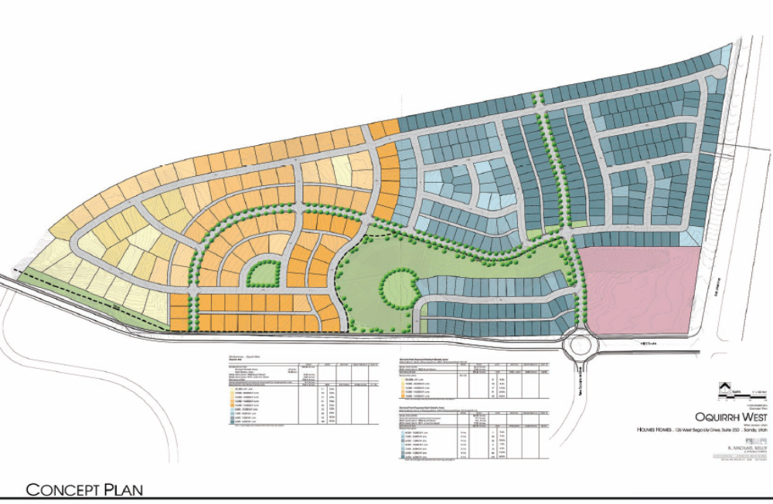

Following the January 19, 2016 Planning Commission meeting, the applicant requested that the proposal not be forwarded to the City Council as the Planning Staff was concurrently working on an amendment to the Cap and Grade Ordinance that would broaden the exemptions for multi-family development on large planned developments.

On May 11, 2016, the City Council adopted Ordinance 16-22 exempting specific types of multi-family housing from “cap and grade” requirements under certain conditions. The code now reads as follows:

13-8-23: Annual Cap on Multi-Family Development Applications:

B. Exemptions: The following types of two-family and multi-family housing are not subject to the annual cap or to the timing requirements of this section:

1. Residential housing developments in compliance with the general plan that are:

a. Multi-family housing (2 or more housing units) in a transit station overlay district (TSOD).
b. Senior housing for age fifty-five (55) and older.
c. Multi-family housing for disabled persons.
d. Low and moderate income housing owned by a nonprofit or a local housing authority.
e. Multi-family housing as part of a master planned community that meet the following provisions:

- Master Plan shall be a minimum of 75 undeveloped acres and be zoned PC or PRD.
- Two-family and multi-family housing not exempt by the provisions listed in part “a through d” above, shall comprise no greater than 17% of the total number of dwelling units in the approved master development plan.
- Two-family and multi-family housing units not exempt by the provisions listed in part “a through d” above, shall be individually owned as either condominiums or townhomes.

Ordinance 16-22 allows two-family and multi-family development in large planned developments over 75 acres in area, provided that they were zoned PC or PRD, that the ratio of multi-family to single-family residential dwellings not exceed 17% multi-family to 83% single-family-residential and that all multi-family dwellings be individually owned.

Following adoption of Ordinance 16-22, the applicant submitted a revised concept plan that was reviewed by the Planning Commission on July 5, 2016 (Figure 2).

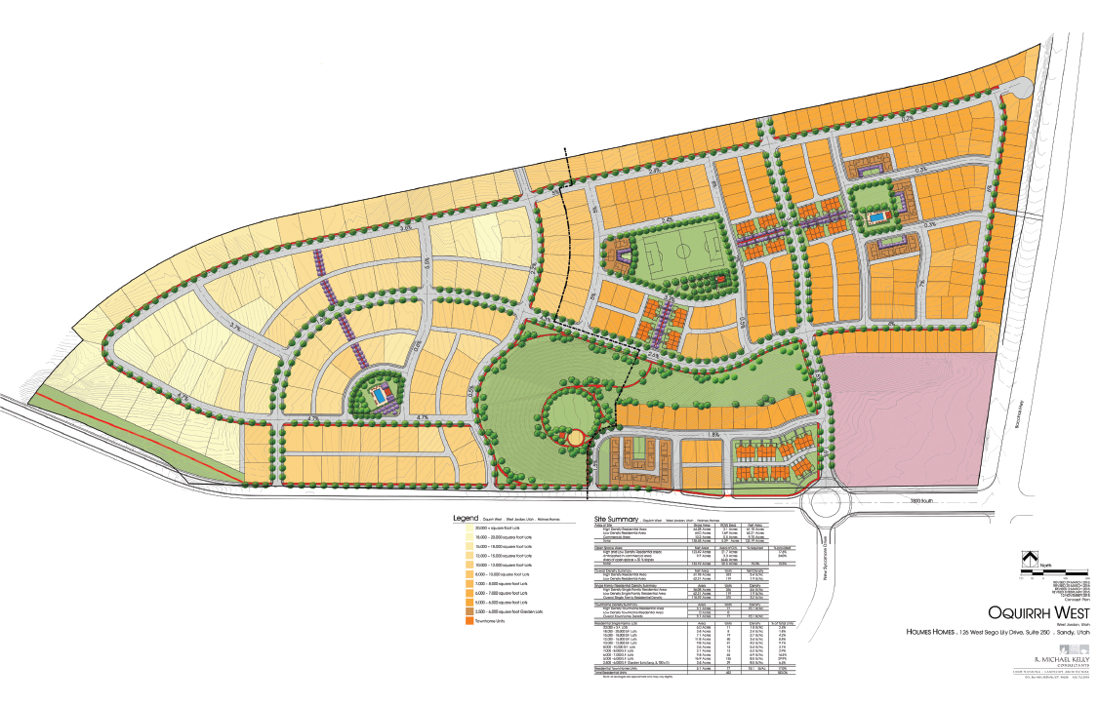
Figure 2. July 5, 2016 Concept Plan

Single-Family Dwellings - 375 (83%)
Town Homes - 77 (17%)
Total Dwelling Units - 452

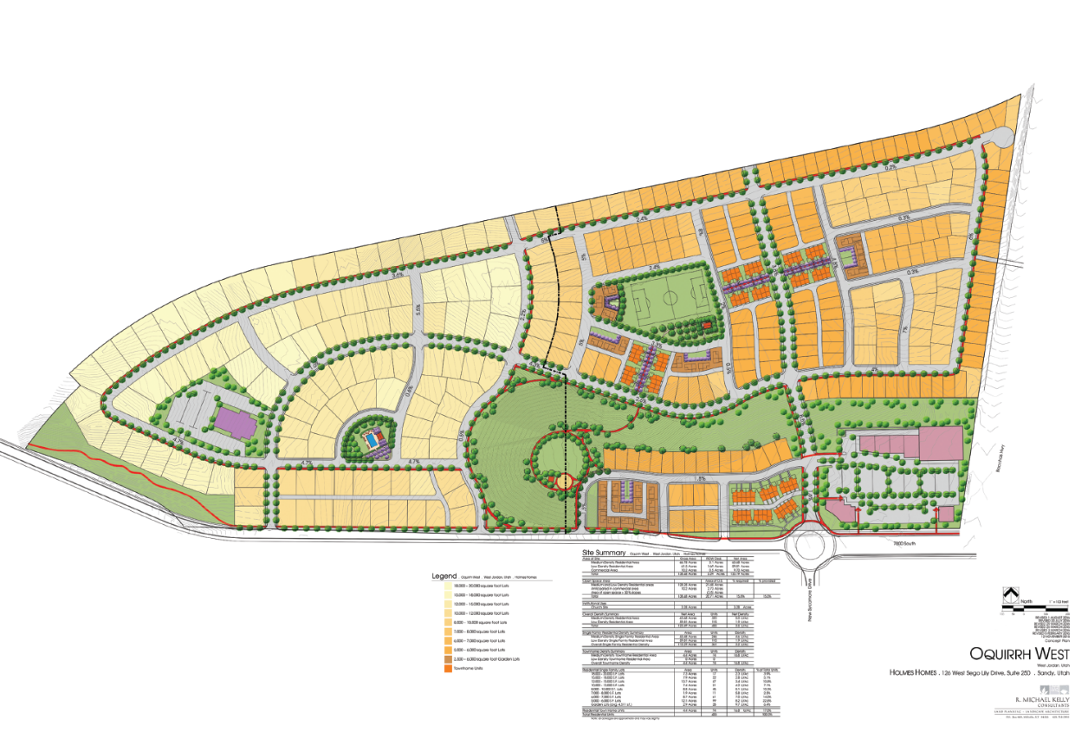
The Planning Commission voted 5-0 to table the item to allow the applicant time to address several concerns raised at the meeting. The concept plan was revised to address the Planning Commission’s concerns. The latest proposed concept plan is shown below in Figure 3.

Figure 3 – Proposed Concept Plan.

Single-Family Dwellings - 361 (83 %)
Town Homes - 74 (17%)
Total Dwelling Units - 435

This plan was reviewed by the Planning Commission on August 16, 2016. The Planning Commission voted 6-1 to forward a positive recommendation to the City Council to amend the Future Land Use Map and rezone the property as requested.

The proposed concept plan meets the exemption standards of the 2009 City Code Section 13-8-23.B.1.b. The property was over 75 acres, the ratio of single-family lots to multi-family residential lots is 83% single-family lots to 17% multi-family lots and all lots are proposed to be owner occupied; however, as a side note, as in any residential development, there was nothing to prevent owners from renting their home.

The distribution of lot sizes is illustrated on the following table:

Lot Size (Square Feet) | Concept Plan
18,000 – 20,000 | 17
15,000 – 18,000 | 22
12,000 – 15,000 | 47
10,000 – 12,000 | 31
8,000 – 10,000 | 45
7,000 – 8,000 | 11
6,000 – 7,000 | 61
5,000 – 6,000 | 99
Garden Lots (avg. 4,511 s.f.) | 28
Townhomes | 74
Total | 435

The proposed concept plan showed 117 lots over 10,000 square feet. There are 45 lots between 8,000 and 10,000 square feet, 61 lots between 6,000 and 7,000 square feet and 99 lots between 5,000 and 6,000 square feet. There are 28 garden lots with an average lot size of 4,511 square feet.

The concept plan showed a 10.2-acre commercial area on the southeast corner of the property which included an open space area on the north side of the commercial area that would not only provide open space connectivity to the residential areas, but would serve as a buffer between the commercial and residential uses to the north.

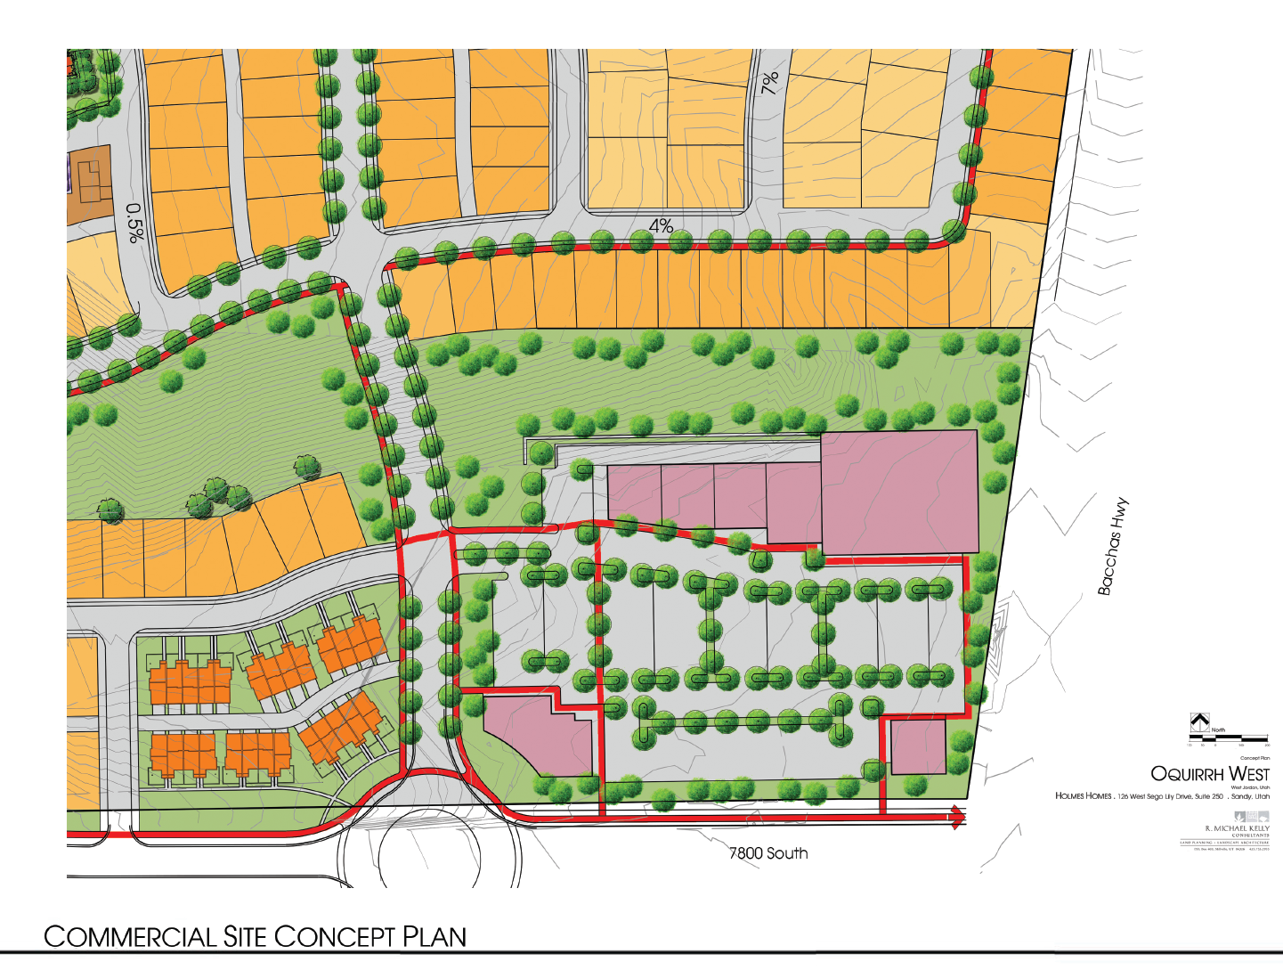
Commercial Area
Open space Connection
Pedestrian Connections
Residential / Commercial Buffer

The applicant had provided a drawing showing open space acreages. The application stated that 20.79 acres of open space would be provided which was 15.01% of the site which met the minimum 15% open space requirement of the P-C zone.

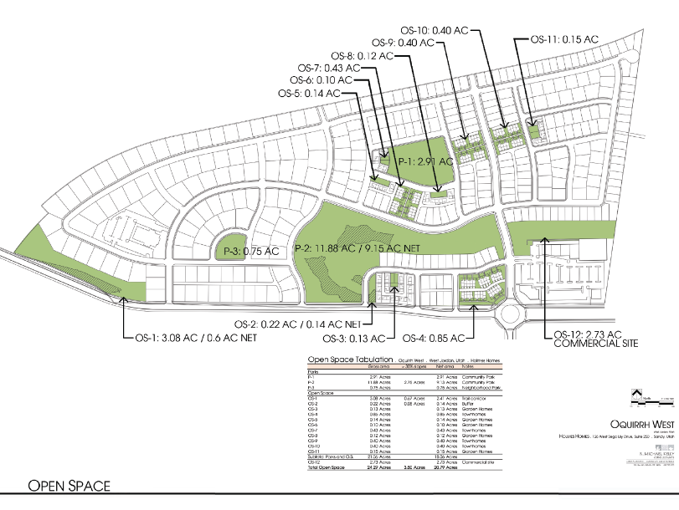

The proposed densities factor in a church site which was shown on the concept plan drawing.

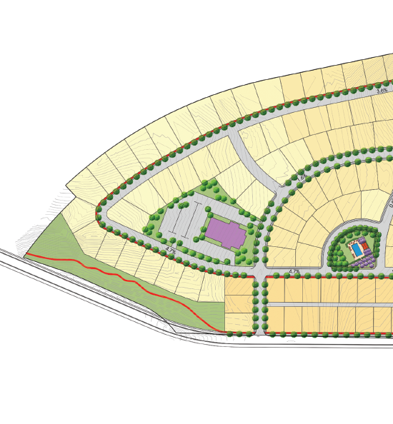

Church Site

Amenities included an 11.9-acre community park (passive open space), 2.9-acre community park, soccer field, playground and open play fields, a 0.7-acre neighborhood park, swimming pool and open lawn area. All open space would be maintained by a homeowner’s association.

General Information & Analysis
The applicant was proposing to rezone the property from LSFR (Low Density Single-Family Residential, HFR (High Density Multi-Family Residential), and MU (Mixed Use) [which was West Side Planning Area (WSPA) zoning districts] and SC-2 to a PC (Planned Community) zoning district. The Future Land Use Map would also be amended from Low Density Residential, High Density Residential, Mixed Use, and Commercial to a Low Density Residential, Medium Density Residential, and Commercial Designation to be consistent with the proposed zoning. The purpose of the request was to accommodate a new 435 unit planned development on the property. The project consisted of 361 single-family dwellings and 74 town homes as shown on the concept site plan (Exhibit F) included in the Council’s agenda packet.

The subject property’s surrounding zoning and land uses were as follows:

 | Future Land Use | Zoning | Existing Land Use
North | Public Facilities  Future Park  Medium Density Residential | A-5 | Vacant
South | Parks/Open Land | PC | Open Space
West | Very Low Density Single-Family Residential Parks and Open Land | A-5 | Vacant
East | Medium Density Residential/ | PC | Single-Family Residential

The applicant had submitted very thorough application packets which include a detailed analysis of and justification for both the Land Use Map amendment and the rezoning request (Exhibit J) in the Council’s agenda packet. The applications include a revised concept plan, they address the City’s General Plan and Zoning Map Amendment findings; they include a detailed discussion on proposed densities and land use compatibility and include a discussion on property serviceability. The applications also include renderings of proposed housing types and show the amenities that would be constructed as part of the development.

General Plan Amendment Discussion:
The changes to the Future Land Use Map would reflect the proposed zoning on the property. The western half of the property was currently designated as Low Density Residential on the Future Land Use Map. This area would remain Low Density Residential; however, the boundary will shift to match the proposed concept plan. There were currently 61.5 acres designated as Low Density Residential. This area would remain unchanged at 61.5 acres. The areas shown as Mixed Use and High Density Residential would be changed to Medium Density Residential.

Figure 2 illustrated the existing land use designations and associated acreages for the property.
Figure 3 showed the proposed land use designations and associated acreages.

Figure 2. Existing Future Land Use Map Designations
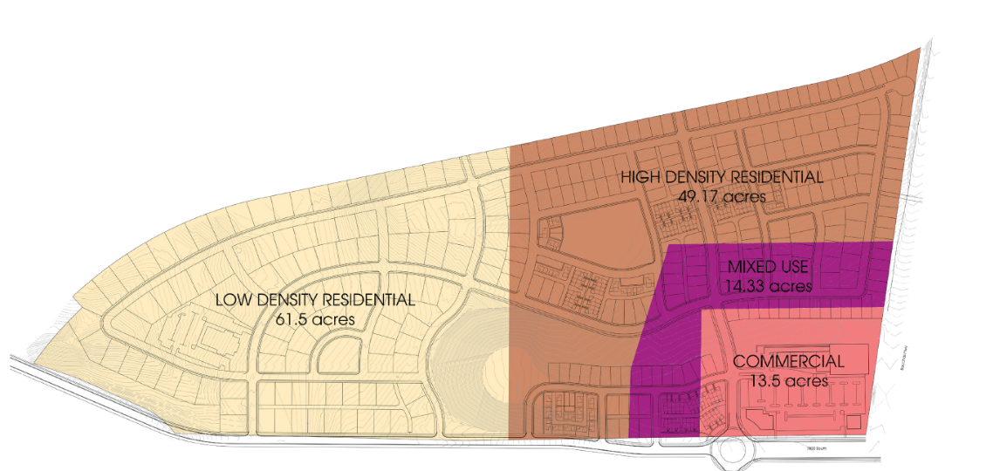

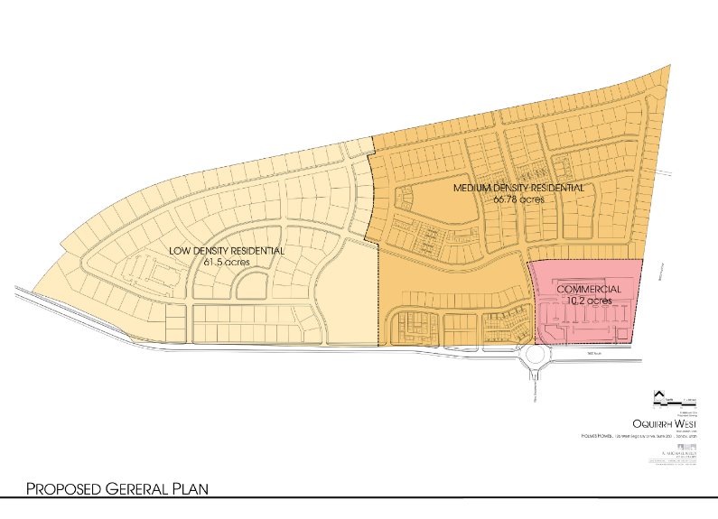
Figure 3. Proposed Future Land Use Map Designations

Land Use Map Amendment Summary:

Land Use Category | Current General Plan | Proposed Amendments
Low Density Residential | 61.5 Acres | 61.5 Acres
High Density Residential | 49.17 Acres | 0 Acres
Medium Density Residential | 0 Acres | 66.78 Acres
Mixed Use | 14.33 Acres | 0 Acres
Commercial | 13.5 Acres | 10.2 Acres
Totals | 138.5 Acres | 138.5 Acres

The following tables were from the 2012 General Plan showing the various density ranges each of the residential land use categories:

Residential Density for the Performance Based Planning Area (WSPA) - Adjusted Net Density
Density Designation | Density Range  (Dwelling Units Per Acre) | Zoning Districts
Very Low Density | Up to 2.0 | VLSFR
Low Density | 1 to 3.5 | LSFR
Medium Density | 3.1 to 7.6 | MFR
High Density | 5.1 to 14.1 | HFR
Mixed Use | 0-25 | MU

Residential Density - Adjusted Net Density (Excluding Multi -Family Residential)
Density Designation | Density Range  (Dwelling Units Per Acre) | Zoning Districts
Very Low Density | Up to 2.0 | All A, RR, RE Zones, PC, PRD
Low Density | 1 to 3.0 | RR, RE, R-1-12, R-1-14, PC, PRD
Medium Density | 3.1 to 5.0 | R-1-8, R-1-9, R-1-10, PC, PRD
High Density | 5.1 to 10.0 | RM, R-1-5, R-1-6, R-2, R-3-6, R-3-8,  R-3-10, PC, PRD
Very High Density | 10.1 and up | R-3-12, R-3-16, R-3-20, R-3-22, PC, PRD

The overall net density of the entire project is 3.2 dwelling units per acre which lands the development in the low end of the Medium Density range in the General Plan.

The density range for Low Density Residential was 1 to 3.5 du/ac. in the WSPA and 1 to 3.0 outside the WSPA. The base density in the LSFR (Low Density Single-Family Residential zone is 2.01 du/ac. The applicant was proposing a residential density of 1.9 dwelling units per acre (du/ac.) on the west half of the property which was in the middle of the Low Density Residential range in both tables. As the proposed density of 1.9 du/ac. is within the ranges established for Low Density Residential, staff did not have any concerns with the proposed Low Density Residential designation on the west 61.5 acres of property.

On the eastern half of the property, the applicant was proposing to develop the areas currently shown in the General Plan as High Density Residential and Mixed Use at a density of 5.0 du/ac. As noted in the density tables above, the density range for Medium Density Residential in the WSPA is 3.1 to 7.6 du/ac. The Medium Density Residential range in all other areas was 3.1 to 5.0 du/ac. The proposed 5.0 du/ac. was in the Medium Density Residential designation and was appropriate for this area.

The density of the western half of the property would be about the same as what would be allowed as a base density in the LSFR zone. The proposed density of the eastern portion of the property will be lower than if the property were developed under the WSPA HFR and MU zoning. The overall density of the development at 3.2 du/ac is at or lower that what could be developed under the existing WSPA zoning.

FINDINGS OF FACT

Section 13-7C-6: Amendments to the Land Use Map
Prior to approving a General Plan Future Land Use Map amendment, the City Council must make the following findings:

Finding A: The proposed amendment conforms to and is consistent with the adopted goals, objectives, and policies set forth in the City General Plan.

Discussion: The General Plan contains several goals and policies that support the proposed amendment. Examples of these were as follows:

Provide opportunities for single-family detached and other owner-occupied housing.” Page 69

”Encourage the development of residential neighborhoods with a range of lot sizes to offer variety for home buyers.” Page 69

“Enhance the visual character of residential areas by maintaining open space, parks and public facilities”. Page 69

“Create a variety of neighborhood types which offer an array of housing densities and styles. Page 30”.

“Provide opportunities for existing homeowners to purchase homes within the community” Page 70

“Provide housing targeted for the diversified market.” Page 70

“While lower density single-family residential uses are most preferred in West Jordan, the City should also address in its General Plan a range of residential densities and housing types in order to provide housing opportunities for all age groups and income levels.” Page 23

The following was from Page 3 of the applicant’s General Plan Amendment Application:

Low Density Area
18,000 - 20,000 s.f. lots 17
15,000 - 18,000 s.f. lots 22
12,000 - 15,000 s.f. lots 47
10,000 - 12,000 s.f. lots 29 115 Total lots in Low Density area

Medium Density Area
8,000 - 10,000 s.f. lots 45
7,000 - 8,000 s.f. lots 11
6,000 - 7,000 s.f. lots 61
5,000 - 6,000 s.f. lots 99
2,500 - 6,000 garden lots 28
Town Homes 74 320 Total lots in Medium Density area
Total Lots 435

Of the 361 single-family residential lots (excluding townhomes) approximately 45% are larger than 8,000 square feet. Approximately 32% of the lots (excluding townhomes) are over 10,000 square feet.

The proposed general plan amendment was consistent with these goals and policies as the proposed development is primarily single-family residential and provided a range of residential densities and housing targeted for a variety of home buyers.

Finding: The proposed amendment conforms to and is consistent with the adopted goals, objectives, and policies set forth in the City General Plan.

Finding B: The development pattern contained on the land use plan inadequately provides the appropriate optional sites for the use and/or change proposed in the amendment.

Discussion: The layout of the development was thoughtfully designed. The smaller lots were inter-dispersed throughout the east side of the property which added interest and variety to the development and provided a much better neighborhood feel than if they were clustered in only one area as was shown on previous plans. Although there are other areas in the City that were zoned for single-family residential, changing the use designation in this area would not be contrary to the General Plan.

Finding: The development pattern contained on the land use plan inadequately provides the appropriate optional sites for the use and/or change proposed in the amendment.

Finding C: The proposed amendment will be compatible with other land uses, existing or planned, in the vicinity.

Discussion: The lot sizes in the residential areas of the Oquirrh West development were similar to those in the Sycamores development to the south of the subject property. The Sycamores is also zoned P-C and was primarily a single-family residential development with some townhomes. The lots on the east side of the Sycamores are just over 5,000 sq. ft. in size. Lots on the west side of the Sycamores near U-111 are larger, over 10,000 sq. ft. The Oquirrh West development has a similar lot configuration with the smaller lots on the east side of the property next to U-111 transitioning to larger lots further to the west. The Sycamores also had townhomes as does the Oquirrh West project.

The Maples development (which is also zoned P-C) was located on the east side of U-111. Near U-111, the lots vary in size from approximately 3,500 sq. ft. to 5,000 square feet and transition to larger lots further away from U-111. The proposed development was consistent with other land uses in the area.

Finding: The proposed amendment would be compatible with other land uses, existing or planned, in the vicinity.

Finding D: The proposed amendment constitutes an overall improvement to the adopted general land use map and is not solely for the good or benefit of a particular person or entity.

Discussion: The applicant would directly benefit from approval of the proposed amendment; however, the amendment allowed for a better use of property that was consistent with the goals and policies of the General Plan.

Finding: The proposed amendment constitutes an overall improvement to the adopted general land use map and was not solely for the good or benefit of a particular person or entity.

Finding E: The proposed amendment will not adversely impact the neighborhood and community as a whole by significantly altering acceptable land use patterns and requiring larger and more expensive public infrastructure improvements, including, but not limited to, roads, water, wastewater and public safety facilities, than would otherwise be needed without the proposed change.

Discussion: The proposed amendment would not significantly alter the land use pattern in the area as all adjoining land uses are or will be residential. The amendment would not result in larger or more expensive public infrastructure as there would be fewer units to provide services to than would be possible under the current WSPA zoning and land use designations.

The Engineering Division had reviewed the proposed amendment and had indicated that water, sewer and storm drain infrastructure is generally available to service the proposed development but additional off-site improvements would be needed to fully serve the property (Exhibit G) in the Council’s agenda packet. The westernmost corner of the property above 5,200 sq. ft. cannot be serviced by city water at this time and was not on any planned City projects for the foreseeable future. The applicant was aware of this as noted in the application. This area cannot be developed until these improvements were constructed. The Engineering Division had indicated there was no reason not to proceed with consideration of rezoning request.

The site would be accessed from 7800 South with an emergency access to U-111. In the future, the site would also be accessed to the property to the north.

Finding: The proposed amendment would not adversely impact the neighborhood and community as a whole by significantly altering acceptable land use patterns and requiring larger and more expensive public infrastructure improvements, including, but not limited to, roads, water, wastewater and public safety facilities, than would otherwise be needed without the proposed change.

Finding F: The proposed amendment is consistent with other adopted plans, codes and ordinances.

Discussion: Each phase of development would be reviewed against applicable Code requirements when preliminary subdivision applications were submitted for review. The amendment was reviewed for consistency against the City’s General Plan. Staff does not anticipate any inconsistencies with other adopted plans, codes or ordinances.

Finding: The proposed amendment was consistent with other adopted plans, codes and ordinances.

Section 13-7D-7(A): Amendments to the Zoning Map

Prior to amending the Zoning Map, the City Council shall make the following findings:

Criteria 1: The proposed amendment is consistent with the purposes, goals, objectives, and policies of the City’s General Plan.

Discussion: See Future Land Use Map Amendment Finding A.

Finding: The proposed amendment is consistent with the purposes, goals, objectives, and policies of the City’s General Plan.

Criteria 2: The proposed amendment will result in compatible land use relationships and does not adversely affect adjacent properties.

Discussion: Single-family residential was compatible with adjoining properties, particularly since the lot sizes will be comparable to or larger than those in adjoining developments. Other impacts would be mitigated as discussed in Future Land Use Map Amendment Finding A, C and E.

Finding: The proposed amendment will result in compatible land use relationships and does not adversely affect adjacent properties.

Criteria 3: The proposed amendment furthers the public health, safety and general welfare of the citizens of the city.

Discussion: The proposed conceptual residential development associated with this request will make productive use of a vacant and undeveloped piece of property. The use would enhance the residential interests of the city and was intended to provide housing options for future residents. Rezoning the property as proposed was compatible with the existing zones and uses found in surrounding neighborhoods and would not harm the public health, safety or welfare of the city as a whole.

Finding: The proposed amendment furthered the public health, safety and general welfare of the citizens of the City.

Criteria 4: The proposed amendment will not unduly impact the adequacy of public services and facilities intended to serve the subject zoning area and property than would otherwise be needed without the proposed change, such as, but not limited to, police and fire protection, water, sewer and roadways.

Discussion: See Future Land Use Map Amendment Finding E.

Finding: The proposed amendment would not unduly impact the adequacy of public services and facilities intended to serve the subject zoning area and property than would otherwise be needed without the proposed change, such as, but not limited to, police and fire protection, water, sewer and roadways.

Criteria 5: The proposed amendment is consistent with the provisions of any applicable overlay zoning districts which may impose additional standards.

Discussion: The Hillside Overlay District, applies to properties with slopes exceeding 10% which applies to this property as shown on the slope map in the application. There were some areas where the slope exceeds 30%; however, these areas are within proposed open spaces. Each phase of development would be reviewed against the requirements of the Hillside Overlay District as they were submitted for review.

Finding: The proposed development would be reviewed for compliance with any additional standards imposed by the Hillside Overlay District as each phase of development was submitted for review.

City Code, Section 13-5C-1: Purpose and Intent: describes the intent of planned developments in a list of fourteen items. Although not required findings for a zoning change or land use map amendment, the City Council may use this criterion to determine if the intent of the P-C zone is met.

The intent of planned developments (PC or PRD) is to:

- Create more attractive and more desirable environments in the city;

As demonstrated in the land use map amendment and rezoning applications, the proposed development will improve the environment in the City.

2. Allow a variety of uses and structures and to encourage imaginative concepts in the design of neighborhood housing and mixed use projects;

A variety of housing styles and types would be used and would add interest to the project design. The future commercial development would also add to the design and overall feel of the development.

3. Provide flexibility in the location of buildings on the land;

Building location and setbacks would be established with the adoption of the final Development Plan and subdivision approvals.

4. Facilitate and encourage social and community interaction and activity among those who live within a neighborhood;

Social and community interaction and activity would be enhanced through construction of active and passive open space, trail system and recreational amenities.

5. Encourage the creation of a distinctive visual character and identity for each planned development;

Visual character and identity would be created through integration of open spaces, recreational amenities and variety of housing types.

6. Produce a balanced and coordinated mixture of uses and related public and private facilities;

The combination of single-family dwellings, townhomes and future commercial amenities would provide a balanced mix of uses.

7. Encourage a broad range of housing types, including owner and renter occupied units, single-family detached dwellings and multiple-family structures, as well as other structural types;

The application gave examples of housing that would be built within the development. The applicant had demonstrated that there was a broad range of housing types. Renter occupied units were not being proposed.

8. Preserve and take the greatest possible aesthetic advantage of existing trees and other natural site features and, in order to do so, minimize the amount of grading necessary for construction of a development;

The layout of the development would utilize the topography of the site as many of the streets follow the existing contour of the property. This would minimize the grading necessary to develop the site. There were no trees on the property or other significant site features on the property to preserve.

9. Encourage and provide for open land for the general benefit of the community and public at large as places for recreation and social activity;

The PC zone required 15% open space exclusive of areas with slopes over 30% which is met. Approximately 20.79 acres would be active and passive open space. The open space areas within the development would be owned and maintained by a homeowner’s association. Sidewalks and trails would provide adequate access throughout the development, which would encourage recreation and social activity. There would be an 11.9-acre community park with active and passive open areas, a 2.9-acre community park with a soccer field and a 0.7-acre neighborhood park with a swimming pool as illustrated in the map amendment application. There were adequate opportunities for recreation and social activity proposed for this development.

10. Achieve physical and aesthetic integration of uses and activities within each development;

Physical and aesthetic integration of uses and activities within the development was achieved through the parks, amenities and trail system. There were no physical barriers that would prevent social interaction.

11. Encourage and provide for development of comprehensive pedestrian circulation networks, separated from vehicular roadways in order to create linkages between residential areas, open spaces, recreational areas and public facilities, thereby minimizing reliance on the automobile as a means of transportation;

Most of the trails would be along sidewalks and through the open space areas. There were several places where trails will be installed between houses that would interconnect the parks and open spaces. Sidewalks and trails would be separated from vehicular roadways and will create linkages between residential areas, open spaces, recreational areas and public facilities.

12. Since many of the purposes for planned development zones can best be realized in large scale developments, development on a large, planned scale is encouraged;

The proposed development was 138.5 acres in size and was considered a large planned development.

13. Achieve safety, convenience and amenity for the residents of each planned residential development and the residents of neighboring areas;

There were no safety concerns with the concept plan. The commercial area would eventually provide additional retail services for the area and the open spaces would provide recreational amenities for the residents.

14. Assure compatibility and coordination of each development with existing and proposed surrounding land uses. (2001 Code § 89-3-401)

Adjoining land uses were either single-family residential, townhomes or vacant property. The proposed use was compatible with existing and future land uses.

Ray McCandless said both the Planning Commission and staff supported the proposed Future Land Use Map and Zoning Map amendments associated with this request.

Staff recommended the following:
Future Land Use Map Amendment
Based on the findings set forth in this staff report, staff recommends that the City Council amend the Future Land Use Map for 138.5 acres from Low Density Residential, High Density Residential, Mixed Use, and Commercial to a Low Density Residential, Medium Density Residential, and Commercial designation on property generally located at the northwest corner of 7800 South and U-111.

Zoning Map Amendment
Based on the findings set forth in this staff report, staff recommends that the City Council rezone 138.5 acres of property generally located at 7800 South U-111 from MU (Mixed Use), HFR (High Density Multi-Family Residential), LSFR (Low Density Single-family Residential), and SC-2 (Community Shopping Center) to a PC (Planned Community) Zoning District.

On August 16, 2016, the Planning Commission in 6 to 1 vote recommended that the City Council approve the proposed Future Land Use Map amendment and rezoning request as noted in the attached Planning Commission meeting minutes.

The Council and staff discussed clarifying questions regarding:
- How binding was the PC zone
- Development begins, but never get completed (amenities were in later phases and never get put in)
- Phase plans updated to possibly include the park in phase two, instead of phase five
- 28 gardens lots

Mayor Rolfe said the Council should not be looking at a concept plan to make a decision on a zoning change to P-C zone. Should this be zoned P-C it would remain P-C even if the developer were to change.

Scott Langford addressed concept plans. He said concept plans were not binding; however, it did set expectations.

Mayor Rolfe opened the public hearing.

Alexandra Eframo, West Jordan resident, felt this change would eliminate high-density residential, which she was in favor of.

Mike Kelly, Planner for this project for Holmes Homes, addressed the price ranges:
- Townhomes and Garden lots - $210,000 - $250,000
- 5,000 – 8,000 sq. ft. lots - $300,000 - $350,000
- 8,000 – 10, 000 sq. ft. lots - $350,000 - $400,000
- 10,000 plus - $375,000 plus
- Custom homes - $500,000 plus

There was no one else who desired to speak. Mayor Rolfe closed the public hearing.

Councilmember Burton said he was impressed with Holmes Homes when they presented this item to the Planning Commission.

Councilmember McConnehey felt the P-C zoning was appropriate; however, he was concerned with the following:
- Smaller sized lots
- SC-2 zone reducing in size 13 acres to 10 acres

He would like to approve the P-C zone at the same time as the concept plan.

Mayor Rolfe felt the P-C zoning was better than the current zone.

MOTION: Councilmember Burton moved that the City Council approve Ordinance 16-41, amending the Future Land Use map from Low Density Residential, High Density Residential, Mixed Use, and Commercial to a Low Density Residential, Medium Density Residential, and Commercial Designation and Rezone 138.5 acres from MU (Mixed Use), HFR (High Density Multi-family Residential), LSFR (Low Density Single-family Residential), and SC-2 (Community Shopping Center) to a PC (Planned Community) Zoning District on property generally located on the northwest corner of 7800 South U-111. The motion was seconded by Mayor Rolfe.

A roll call vote was taken

Councilmember Burton Yes
Councilmember Haaga Yes
Councilmember Jacob No
Councilmember McConnehey Yes
Councilmember Nichols Absent
Councilmember Rice Yes
Mayor Rolfe Yes

The motion passed 5-1.
RECEIVE PUBLIC INPUT AND CONSIDER FOR APPROVAL ORDINANCE 16-42, REGARDING A REZONE 1.74 ACRES LOCATED AT 8415 SOUTH SUSAN WAY AND 8157 SOUTH MAPLE LEAF WAY, FROM RR1-C (RURAL RESIDENTIAL 1-ACRE LOTS) AND 21.04 ACRES FROM RR-.5E (RURAL RESIDENTIAL HALF-ACRE LOTS) TO R-1-10E (SINGLE-FAMILY RESIDENTIAL 10,000 SQUARE FOOT LOTS MINIMUM); JORDAN MEADOWS LLC/KIMBERLY MASCHERINO, APPLICANT
Scott Langford said that the property under review for a rezone was presently vacant and was located on two separate parcels with the addresses 8157 South Mapleleaf Way and 8415 South Susan Way. The larger parcel was located towards the east portion of the development and encompasses a little over 26 acres. The entirety of this parcel would not be rezoned however. The north portion of this parcel, with approximately 5 acres in area, was already zoned R-1-10E, and would therefore not be included as part of the rezone of the potential development. This larger parcel was presently zoned RR-.5E. The second parcel included in the rezone was 1.74 acres of property, and is in the zone RR-1C.

The subject property was surrounded by previously approved single-family subdivisions: Pheasant Run to the north, Huntington Estates to the west, and Bloomington Acres to the south. Each of these subdivisions were providing at least one access to the subject site. At this time only the proposed rezone was subject to review, however a subdivision concept plan was included in the Council’s agenda packet as Exhibit C. This concept plan is showing anticipated connections to these four existing and separate local streets which would potentially feed into this concept subdivision. The accesses to the north, south, and west would be sufficient for the type and quantity of traffic expected for the proposed zone. The concept plan was also showing lots with at least 10,000 square feet of lot area. Regardless, this concept plan is subject to change when a full review is conducted by City Staff and the Planning Commission during Major Subdivision review.

Earlier this year the Planning Commission heard the proposed rezone and subsequent public comments from neighboring subdivisions. The final recommendation from the Planning Commission was to deny the proposed rezone citing that the amendment did not meet Criteria 2. Criteria 2 included the standard that the proposed amendment must result in a compatible land use and that the amendment will not result in adversely affecting surrounding properties.

After this Public Hearing the applicant submitted a Traffic Impact Study (TIS). This traffic study looked at the traffic impacts the proposed development would have on surrounding neighborhoods. Included in the Council’s agenda packet was the summary of the TIS (Exhibit F). The City’s Traffic Engineer had also reviewed this Impact Study and had concurred with its findings.

The subject property’s surrounding zoning and land uses were as follows:
 | Existing Land Use | Zoning
North | Single-Family/Vacant | R-1-10E
South | Single-Family | R-M
East | Bangerter Highway/Single-Family | R-1-8A
West | Single-Family | RR-1C

Finding of Fact
Section 13-7D-7(A): Amendments to the Zoning Map

Prior to making a positive recommendation to the City Council for an amendment to the Zoning Map, the Planning Commission shall make the following findings:

Criteria 1: The proposed amendment is consistent with the purposes, goals, objectives, and policies of the City’s General Plan.

Discussion: The subject property was located in the Medium Density Residential designation in the Future Land Use Map. The rezone to R-1-10E is supported by the 2012 Comprehensive General Plan. The Medium Density Residential designation provided for areas which are, “moderate intensity single-family attached/detached units”, and areas, “that should be designated as medium density residential uses should be preferred for infill development that are well buffered from commercial and industrial uses”.

Medium Density Residential supported development with 3.1 to 5.5 dwelling units per acre. An R-1-10 zone typically had a density of 4.3 dwelling units per acre; this density was well within the maximum standards of the existing Land Use designation.

Finding: The proposed amendment was consistent with the purposes, goals, objectives, and policies of the City’s General Plan.

Criteria 2: The proposed amendment will result in compatible land use relationships and does not adversely affect adjacent properties.

Discussion: The area proposed for the rezone was surrounded by existing residential subdivisions. The properties located to the north, including the vacant portion which would be included in this projected subdivision, were presently zoned R-1-10E (Single-Family Residential 10,000 lots, E sized homes).

The neighborhood to the west was zoned for 1-acre lots in the RR-1C (Rural Residential 1 acre lots, C sized homes) zoning district. Between this subdivision and the subject parcel proposed to be rezoned was a canal with a future trail. This separation should be sufficient between the different densities in this area; City staff doesn’t anticipate that the subject property’s higher density would negatively affect the subdivision to the west. Included in the concept plan, included in the Council’s agenda packet as Exhibit C, City staff required that a fourth access to the anticipated subdivision was provided by connecting to the stub road in Huntington Estates subdivision. This connection is required due to the subdivision to the north limited street system, while two stub streets are provided to the north, these streets will eventually consolidate into a single street before accessing another subdivision in order to connect to 4000 West (a collector street). Exhibit A in the Council’s agenda packet showed (circled in red) this street connection described here.

Finally, the property to the south was zoned R-M (Mobile Home) and had a developed subdivision. A single access was provided to the subject site. This street would provide access to Old Bingham Highway further to the south. The average lot size in Bloomington Acres (the fully developed subdivision to the south) is approximately 8,000 square foot lots. Staff does not anticipate a rezone to an R-1-10E district would negatively affect this subdivision as well.

While the property was being proposed to be rezoned to a zone with a higher density, the subzone (or the minimum house size allowed) of the majority of the rezone would remain the same. Presently the subzone on much of this site is sub-zoned E; the chart below outlined the minimum square footages for this parcel. The parcel with the address 8415 South Susan Way is proposed to change from subzone C to Subzone E, this change would require larger home sizes and which would be more compatible with the R-1-10 Zone.

Subzone | Dwelling Type | Minimum Living Space (In Sq. Ft.) | Zone to which the subzone applies
E | 1 level dwelling (rambler or split entry) | 3,000 | R-1-10
E | Split level dwelling | 2,400 | R-1-10
E | Multi-story dwelling (2 or more) | 3,000 | R-1-10

Finding: The proposed amendment will result in compatible land use relationships and does not adversely affect adjacent properties.

Criteria 3: The proposed amendment furthers the public health, safety and general welfare of the citizens of the city.

Discussion: The proposed zone of this site was consistent with the surrounding residential areas in the community; it is also consistent with the location of the site: this property was immediately adjacent to Bangerter Highway to the east.

This rezone would advance the general safety and welfare of the residents in the City by improving the degree of connectivity between new and existing neighborhoods. The development potential of this site was considered to be infill development and would improve connectivity by completing existing stub roads in surrounding subdivisions, particularly in the Pheasant Run subdivision which had a singular point of access to a collector street at this time. The potential development on this site would also improve emergency access to this site as well as surrounding residential neighborhoods.

At this time only the rezone was under review, any concerns with the concept plan or potential construction would be reviewed by Staff and Planning Commission at a later date to ensure the site would meet the requirements found in Title 13 and Title 14 of the 2009 City code.

Finding: The proposed amendment furthers the public health, safety and general welfare of the citizens of the City.

Criteria 4: The proposed amendment will not unduly impact the adequacy of public services and facilities intended to serve the subject zoning area and property than would otherwise be needed without the proposed change, such as, but not limited to, police and fire protection, water, sewer and roadways.

Discussion: The City’s Engineering Department has reviewed the proposal to rezone the property. At this time the existing infrastructure: storm drain, traffic, water, and sewer are sufficient. However, a more detailed review by the applicant will be required at the time of Subdivision submittal to ensure the development of the site can meet established City serviceability standards. At this time (rezone review), City Staff does not have sufficient information which indicates that public services will be disproportionately impacted as a result of the approval of this requested rezone. This proposed rezone will therefore meet this finding of fact that, while further information will be required prior to any development on the subject site, sufficient information hasn’t been given which indicated the proposed amendment will unduly impact the adequacy of public services.

Additional and more specific review will be needed at the time of Subdivision submittal to ensure adequate storm water drainage. The applicant will be responsible for any updates; if found necessary, to the public services that will be required by the City to meet established serviceability standards. A memo from our Engineering Department is attached to this report as Exhibit E which further describes their review of existing facilities.

Finding: The proposed amendment will not unduly impact the adequacy of public services and facilities intended to serve the subject zoning area and property than would otherwise be needed without the proposed change, such as, but not limited to, police and fire protection, water, sewer and roadways.

Criteria 5: The proposed amendment is consistent with the provisions of any applicable overlay zoning districts which may impose additional standards.

Discussion: This subject site is within the Airport Overlay District in the Horizontal (Ah) and Conical (Ac) Zones. The Airport Overlay District restricts some uses in certain zones in this Overlay District. Single-family residential uses are permitted in both the Ah and Ac zones. Other single-family houses are within these two overlay districts (subdivisions to the north and west of the subject site).

Finding: The proposed amendment is consistent with the provisions of any applicable overlay zoning districts which may impose additional standards.

The proposed Zoning Map Amendment to rezone the Jordan Hollow property to the R-1-10E zoning district met all the criteria for approval and was not contrary to any current goals and policies in the General Plan or conflicting with Title 13 of the 2009 City Code.

Staff recommended that based on the analysis and findings contained in the staff report, that the City Council rezone the property located at 8157 South Mapleleaf Way from RR-1C (Rural Residential 1 acre lots with “C” sized homes) and RR-.5E (Rural Residential .5 acre lots with “E” sized homes) to R-1-10E (Single-Family Residential “E” sized homes).

On July 5, 2016, the Planning Commission in a 3 to 2 vote recommended that the City Council deny the request to rezone the property located at 8157 South Mapleleaf Way from RR-1C (Rural Residential 1 acre lots “C” sized homes) and RR-.5E (Rural Residential .5 acre lots with “E” sized homes) to R-1-10E (Single-Family Residential “E” sized homes). This recommendation was due specifically disagreeing with City staff and finding that Criteria 2 was not being met, that the amendment will result in incompatible land use relationships and does adversely affect adjacent properties.

Scott Langford said land use would not be a huge issue; however, traffic would create an impact. He said staff must abide by the City codes equally and uniformly.

The Council and staff discussed clarifying questions.

Mayor Rolfe opened the public hearing.

Vicky Ashby, West Jordan resident, voiced her concerns regarding:
- Traffic flow
- Speed bumps would affect the rural residents with their horse trailers
- Canal water
- Kindergarten overcrowding at Columbia Elementary
- Soccer fields causing additional traffic

Gary Peterson, West Jordan resident, was concerned with the traffic. He asked if consideration was given to 4000 West during peak summer hours when soccer was in play. He suggested making the soccer parking on the west side or removing some of the soccer fields for parking.

Clive Killpack, West Jordan resident, said Huntington Estate homeowners wanted to maintain their rural residential lifestyle. He commented on water rights and was concerned that should this property be rezoned to a subdivision; current homeowner’s water rights would be changed. He said this area was rural residential and should remain rural with at least half-acre lots.

Alexandra Eframo, West Jordan resident, stated she was against the proposed rezone. She was concerned with the safety of children, schools, etc.

Curtis Ball, Stantec Consulting representing the property owners, stated that their efforts to rezone the property were in conformance with the Master Plan as medium-density. He said the lots were averaging 11,000 square feet per acre. The canal would provide a natural buffer between the one-acre subdivision to the west. An additional traffic study was performed which showed minimal impact to the surrounding intersections regarding the level of service.

Positive impacts:
- Improved connectivity to surrounding neighborhoods
- Improved emergency access
- Improved fire flows
- Sound wall being continued

He expressed his appreciation to City staff for their help and support.

Scott Lambson, West Jordan resident, questioned whether the current street size met the City code.

Jeremy Searle, Hales Engineering, reported that their company performed the Traffic Impact Study looking at the two busy peak hours. He said there would be additional traffic; however, the impact would not be significant. He agreed with providing connectivity through the stub roads. He said a safe route map was provided.

Dave Birch, West Jordan resident, commented on the increased traffic in this area. Most of the new traffic would be traveling on Maple Leaf Way. Currently during soccer season, he was unable to get out of his driveway. He suggested removing some of the soccer fields in the middle to allow for parking. He reported that the soccer fields were costing the City money and this should be addressed.

John Grand, West Jordan resident, addressed items brought up by the developers. He commented on the number of people coming and going into the neighborhood for work, the stores, etc. Also, there had never been mention of a bridge or road over the significant irrigation canal.

There was no one else who desired to speak. Mayor Rolfe closed the public hearing.

The Council discussed clarification regarding the following:
- Connection to Susan Way
- Water and sewer mains
- Buffering between R-1-10 and Rural residential
- Proximity to farm animals
- Water rights from the canal
- Potential to move from small lots to a larger lot in the future

MOTION: Councilmember Burton moved that the City Council deny Ordinance 16-42, to establish the rezone of the property located at 8157 South Mapleleaf Way from RR-1C (Rural Residential 1 acre lots with “C” sized homes) and RR-.5E (Rural Residential .5 acre lots with “E” sized homes) to R-1-10E (Single-Family Residential “E” sized homes). The motion was seconded by Councilmember Haaga.

A roll call vote was taken

Councilmember Burton Yes
Councilmember Haaga Yes
Councilmember Jacob Yes
Councilmember McConnehey Yes
Councilmember Nichols Absent
Councilmember Rice Yes
Mayor Rolfe Yes

The motion passed 6-0.

Councilmember McConnehey said just prior to this meeting a workshop was held and the Council discussed plans for a new Public Works building, which would be placed immediately north of the current Public Works building eliminating some of the soccer fields.

MOTION: Councilmember Jacob moved to take a five-minute recess. The motion was seconded by Councilmember Burton and passed 6-0 in favor.

The meeting recessed at 8:05 p.m. and reconvened at 8:15 p.m.

RECEIVE PUBLIC INPUT AND CONSIDER FOR APPROVAL ORDINANCE 16-43, REGARDING A GENERAL PLAN AMENDMENT FOR 7.95 ACRES FROM COMMUNITY COMMERCIAL TO MEDIUM DENSITY RESIDENTIAL; AND ORDINANCE 16-44, REZONE FROM SC-2 (COMMUNITY SHOPPING CENTER) ZONE TO (PLANNED RESIDENTIAL DEVELOPMENT) ZONE; FOR PROPERTY LOCATED AT 2735 WEST 7800 SOUTH; HAMLET DEVELOPMENT/MICHAEL BRODSKY, APPLICANT
Larry Gardner reported that the subject property was designated Community Commercial on the Land Use Map and was zoned SC-2. The entire property was rezoned to a commercial designation in 1978 with the commercial development of part of the property. The property had been for sale for the last decade with the SC-2 zoning designation. The applicant was proposing to rezone 7.95 acres of the 8.75 parcel of property located at 2735 West 7800 South from SC-2 (The Community Shopping Center Zone) to PRD (M) (Planned Residential Development). The PRD (M) zone allowed for clustering of homes and reduced setbacks maintaining the medium density designation established on the Future Land Use Map. The site was designated as Community Commercial on the Future Land Use Map and an application to amend the Future Land Use Map had been submitted changing the designation to Medium Density Residential which would support PRD (M) zoning. The map amendments were in preparation for a subdivision application.

General Information & Analysis
The subject property’s surrounding zoning and land uses were as follows:

 | Future Land Use | Zoning | Existing Land Use
North | Community Commercial | SC-2 | Arby’s restaurant; a daycare, a single home, vacant land
South | Medium-Density Residential | R-1-10 | Single Family Residential
West | Community Commercial | SC-2 | Canal, Vacant Land
East | Community Commercial | SC-2 | Cal-Ranch Shopping Center

Findings of Fact

Section 13-7C-6: Amendments to the Land Use Map
Prior to approving a General Plan Future Land Use Map amendment, the City Council shall make the following findings:

Finding A: The proposed amendment conforms to and is consistent with the adopted goals, objectives, and policies set forth in the City General Plan.

Discussion: The applicant was proposing to amend the Future Land Use Map from Community Commercial to Medium Density Residential. Staff could not find any language in the General Plan that discourages rezoning commercial property to residential land use. There are references to the preferred locations of commercial areas. The General Plan states:

GOAL 2. PROVIDE ADEQUATE AND ACCESSIBLE COMMERCIAL AND BUSINESS SERVICES TO ALL CITY RESIDENTS.
Policy 1. Continue to implement the policy of limiting commercial centers to “nodes” located at the intersections of major arterial streets or, in the case of neighborhood commercial centers, at designated locations within large planned residential communities.

The subject property was originally intended to be a commercial center from 2700 West to 3200 West. The “nodes” at 2700 West and 3200 West have developed as commercial centers but the mid-block commercially zoned properties had remained undeveloped (Exhibit D) in the Council’s agenda packet. From the language of the General Plan it is clear that the intent was not to have a continuous commercial uses along transportation corridors, but at the major intersections or nodes.

LAND USE. GOAL 3. Promote land use policies and standards that are economically feasible and orderly, which also protect desirable existing land uses and minimize impacts to existing neighborhoods.

Implementation Measures; 1. The type, location, timing, and intensity of growth shall be managed. Premature and scattered development shall be discouraged.

The majority of the properties around the site had been developed with the exception of the subject parcel and a 4.3-acre parcel on the west side of the canal. There does not seem to be interest in expanding the Cal-Ranch site with more commercial development.

2. Growth shall be limited to those areas of the city that can provide for adequate levels of service (i.e. water, sewer, fire and police protection, schooling, and transportation).

Water, sewer was adequate in the vicinity and easily accessible. The site was accessible from 7800 South and would need to meet all public safety requirements when developed.

4. Infill development shall be compatible with surrounding land uses and development.

The uses surrounding the subject property were commercial and single family residential. If a housing project was approved by code a 20-foot landscaped buffer and wall would be required between the commercial and residential. A new residential development would be compatible with the single family use to the south. The uses are the same and the densities are close to the same with Woods Cove (the development to the South) at 4.54 units per acre and the proposed development being 4.77 units per acre (Exhibit E) in the Council’s agenda packet. The lot sizes and home sizes would be similar to Woods Cove.

RESIDENTIAL LAND USE. Goal 4; Policy 2. Single-family housing should be the primary residential development type in the city.
Implementation Measures; 2. Require the density of residential infill development to be similar to existing, adjacent, residential development.

The applicant’s concept plan showed intent to construct single family housing on the 7.95 acres of property. The residential properties adjacent and near this property have a gross density range from 3.7 to 7.1 units per acre. The Medium-Density Residential Land Use designation allowed a density range of 3.1 to 5.5 units per acre. The concept plan as provided (Exhibit F) illustrates the proposed roadway design and lot configurations. The actual lot sizes would be determined with the subdivision application.

Finding: The proposed amendment conformed to and was consistent with the adopted goals, objectives, and policies set forth in the City General Plan. The applicant will be required to upsize the sewer line in 4950 west.

Finding B: The development pattern contained on the land use plan inadequately provides the appropriate optional sites for the use and/or change proposed in the amendment.

Discussion: The development pattern along arterial streets has been to develop primarily at the nodes or intersections of arterial streets. The nodes tend to be larger where arterial streets intersect and smaller where an arterial street intersects with a collector street. 7800 South and 2700 west was a case where an arterial intersects with a collector. The mid-block development after the node tends to be more residential in nature. Long spines of commercial tend not to be as productive. What the applicant was proposing is more in line with what is done in other areas of the city with mid-block parcels.

Between the Jordan River and Bangerter Highway there was only approximately 50 acres of undeveloped land that designated on the Land Use Map as Medium Density Residential. Moreover, of the vacant land, none of it was for sale at this point or is under contract. What the applicant was proposing was more in line with what is done in other areas of the city with mid-block parcels.

Finding: The development pattern contained on the land use plan inadequately provides the appropriate optional sites for the use and/or change proposed in the amendment.

Finding C: The proposed amendment will be compatible with other land uses, existing or planned, in the vicinity.

Discussion: The proposed amendment would result in single family residential that would be similar in density as other single family in the area. The new use would be compatible with the other single family and commercial uses surrounding the property.

Finding: The proposed amendment would be compatible with other land uses, existing or planned, in the vicinity.

Finding D: The proposed amendment constitutes an overall improvement to the adopted general land use map and is not solely for the good or benefit of a particular person or entity.

Discussion: The change in the Land Use Map and Zoning map would not be to the benefit of the owners or the applicant. The proposed changes in the Land Use Map and Zoning Map are a “down zone” and generally lower the sales value of property.

The development pattern along arterial streets had been to develop primarily at the nodes or intersections of arterial streets. The nodes tend to be larger where arterial streets intersect and smaller where an arterial street intersects with a collector. 7800 South and 2700 west is a case where an arterial intersects with a collector. The mid-block development after the node tends to be more residential in nature. Long spines of commercial tend not to be as productive. What the applicant was proposing was more in line with what is done in other areas of the city with mid-block parcels.

Finding: The proposed amendment constitutes an overall improvement to the adopted general land use map and is not solely for the good or benefit of a particular person or entity.

Finding E: The proposed amendment will not adversely impact the neighborhood and community as a whole by significantly altering acceptable land use patterns and requiring larger and more expensive public infrastructure improvements, including, but not limited to, roads, water, wastewater and public safety facilities, than would otherwise be needed without the proposed change.

Discussion: The proposed amendment would result in a less intense use of property than what could occur if the property was developed as a commercial retail site. The proposed residential use was more compatible with the adjacent residential. The new development would connect via a walkway only to the existing Woods Cove development. The infrastructure in the area was adequate for the proposed development including roads, water, wastewater and public safety facilities. The development would connect directly to 7800 South, if constructed.

Finding: The proposed amendment would not adversely impact the neighborhood and community as a whole by significantly altering acceptable land use patterns and requiring larger and more expensive public infrastructure improvements, including, but not limited to, roads, water, wastewater and public safety facilities, than would otherwise be needed without the proposed change.

Finding F: The proposed amendment is consistent with other adopted plans, codes and ordinances.

Discussion: The amendment was reviewed for consistency against the City’s General Plan, the zoning ordinance and adopted engineering standards.

Finding: The proposed amendment was consistent with other adopted plans, codes and ordinances.

PLANNED RESIDENTIAL DEVELOPMENT 13-5C-1: PURPOSE AND INTENT

Prior to approval of a zone change to a PRD (M) designation, the City Council shall find that the proposed zone and associated conceptual plan is consistent with the purpose and intent outlined in section 13-5C-1 of this article.

“13-5C-1: PURPOSE AND INTENT:
A. Planned Residential Development Zone: The purpose of the planned residential development (PRD (M)) zone is to encourage imaginative, creative and efficient utilization of land by establishing development standards that provide design flexibility, allow integration of mutually compatible residential uses, and encourage consolidation of open spaces, clustering of dwelling units, and optimum land planning with greater efficiency, convenience and amenity than may be possible under the procedures and regulations of conventional zoning classifications. A planned residential development should also incorporate a common architectural design theme throughout the project that provides variety and architectural compatibility, as opposed to a development of individual, unrelated buildings located on separate, unrelated lots.”

The site the applicant was proposing to construct homes upon was surrounded on two sides by commercial development. The PRD (M) zone will allow for buffering of homes and the integration of 15% open spaces in the development. The applicant’s intent was to design and build homes that are common in architectural design and that follow a common theme. A few of the homes were illustrated in the concept plan.

C. Overall Intent: It is the intent of the city that site and building plans for planned developments be prepared by a designer or team of designers having professional competence in urban planning, site planning, and architectural and landscape architectural design. However, it is not the city's intent that design control be so rigidly exercised that individual initiative is stifled or that substantial additional expense is incurred. Rather, it is the intent of this section that the control exercised be the minimum necessary to achieve the purpose of this chapter. The intent of planned developments (PRD (M)) is to:

1. Create more attractive and more desirable environments in the city;
The PRD (M) zone will allow the applicant to design and build a single family development that is adjacent to commercial and commercially zoned land that has been vacant for many years. The addition of homes at this location will break up a potential long section of strip retail along 7800 South and improve the image of the City.

2. Allow a variety of uses and structures and to encourage imaginative concepts in the design of neighborhood housing and mixed use projects;
The applicant intends to construct single family dwellings that will be adjacent to commercial. The design of the development will be integrated with the commercial uses and offer the ability for residents to walk, drive or make use of the mass transit options in the area.

3. Provide flexibility in the location of buildings on the land;
The PRD (M) zoning allows the applicant to construct with varying setbacks and yard areas. The area is sandwiched between commercial, housing a canal and a major arterial street. The PRD (M) zone allows for flexibility in subdivision design that may be critical for this development.

4. Facilitate and encourage social and community interaction and activity among those who live within a neighborhood;
The development will not be gated and will have 15% common open area for the residents to use. All of the streets will be connected by sidewalks.

5. Encourage the creation of a distinctive visual character and identity for each planned development;
The applicant builds a unique housing product that will differ from the existing homes in the area.

6. Produce a balanced and coordinated mixture of uses and related public and private facilities;
The applicant will be installing private streets in the development. Because of the small size of the development a mixture of public services, i.e., parks, trails etc. is not practical.

7. Encourage a broad range of housing types, including owner and renter occupied units, single-family detached dwellings and multiple-family structures, as well as other structural types;
At this time because of the cap and grade ordinance the applicant can only build single family detached dwellings.

8. Preserve and take the greatest possible aesthetic advantage of existing trees and other natural site features and, in order to do so, minimize the amount of grading necessary for construction of a development;
There is nothing on the site that is a unique natural feature. The applicant will be required to determine if the existing trees on the property are worth preserving.

9. Encourage and provide for open land for the general benefit of the community and public at large as places for recreation and social activity;
The applicant will be providing 1.2 acres of open space that will be in landscape buffers and open “park like” area.

10. Achieve physical and aesthetic integration of uses and activities within each development;
The new homes will be unique to the area and will complement the existing homes while maintaining distinguishable identity.

11. Encourage and provide for development of comprehensive pedestrian circulation networks, separated from vehicular roadways in order to create linkages between residential areas, open spaces, recreational areas and public facilities, thereby minimizing reliance on the automobile as a means of transportation;
The development will be connected to the existing public sidewalks and roadways. There are not any trail systems in the area.

12. Since many of the purposes for planned development zones can best be realized in large scale developments, development on a large, planned scale is encouraged;
This development is small in area. This site is unique in that it would be sandwiched between commercially zoned properties. The PRD (M) zoning is the only zone that addresses unique infill issues.

13. Achieve safety, convenience and amenity for the residents of each planned residential development and the residents of neighboring areas;
The project will be designed in a manner that is safe, accessible and connected to the existing neighborhood to the north. The open area will provide some recreational opportunities for the residents.

14. Assure compatibility and coordination of each development with existing and proposed surrounding land uses.
The development of single family homes on this property will be compatible with the neighboring uses.

Section 13-7D-7(A): Amendments to the Zoning Map

Prior to approval of an amendment to the Zoning Map the City Council shall make the following findings:

Criteria 1: The proposed amendment is consistent with the purposes, goals, objectives, and policies of the City’s General Plan.

Discussion: The subject property was located within the Medium-Density Residential land use designation. This designation was created for those residential uses which fall between 3.1 and 5.5 dwelling units per acre. The applicant was proposing to change the zoning designation on 7.95 acres of land currently zoned as SC-2 to PRD (M) (Planned Residential Development). The submitted concept plan shows a residential density of 4.77 single family units per acre which is consistent with the Medium Density Land Use designation of the General Plan.

Furthermore, Goal 4 Policy 2 states: “Single-family housing should be the primary residential development type in the city.” The applicant’s intent was to subdivide the property and construct single family homes. The proposed amendment conforms to and was consistent with the adopted goals, objectives, and policies set forth in the General Plan. Also see “Finding A Amendments to the Land Use Map.”

Finding: The proposed amendment was consistent with the purposes, goals, objectives, and policies of the City’s General Plan.

Criteria 2: The proposed amendment will result in compatible land use relationships and does not adversely affect adjacent properties.

Discussion: The concept plan shows thirty-eight single-family lots in a clustered development pattern. The development would provide 15% open space and a 20-foot landscape buffer around the development as required by 2009 City code. The development would be compatible in density at 4.77 units per acre with much of the surrounding housing. The Woods Cove development would be connected via a walkway to the proposed development. The City Engineering Department had indicated that the City does have the ability to service the concept project. Water and sanitary sewer connections would be made to existing lines.

Finding: The proposed amendment would result in compatible land use relationships and does not adversely affect adjacent properties.

Criteria 3: The proposed amendment furthers the public health, safety and general welfare of the citizens of the city.

Discussion: The PRD (M) zoning district had specific standards which would be met when the property was subdivided and developed. The PRD (M) zone and the applicant’s concept plan was compatible with the existing commercial and residential zones and housing densities found in surrounding neighborhoods and would not harm the public health, safety or welfare of the City as a whole.

Finding: The proposed amendment furthers the public health, safety and general welfare of the citizens of the City.

Criteria 4: The proposed amendment will not unduly impact the adequacy of public services and facilities intended to serve the subject zoning area and property than would otherwise be needed without the proposed change, such as, but not limited to, police and fire protection, water, sewer and roadways.

Discussion: The Engineering Department had determined that the City had the ability to service the development with water, sewer, streets and storm drainage subject to developer constructed improvements at the time of subdivision plat approval. The Fire Department would review the proposed development at the time of subdivision application to ensure full serviceability. The addition of thirty-eight single-family homes would not unduly impact public services.

Finding: The proposed amendment would not unduly impact the adequacy of public services and facilities intended to serve the subject zoning area and property than would otherwise be needed without the proposed change, such as, but not limited to, police and fire protection, water, sewer and roadways.

Criteria 5: The proposed amendment is consistent with the provisions of any applicable overlay zoning districts which may impose additional standards.

Discussion: The property was not located within any overlay zone.

Finding: This criterion does not apply.

Larry Gardner said staff supported the proposed Land Use Map and Zoning Map amendment associated with this request, believing that the intended residential infill for this area would be compatible with adjoining land uses and with the neighborhood.

Based on the analysis and findings contained in the Staff Report, Staff recommends that the City Council amend the Future Land Use map from Community Commercial to Medium Density Residential and Rezone 7.95 acres from SC-2 (Community Shopping Center) Zone to PRD (M) (Planned Residential Development) Zone on property located at 2735 West 7800 South.

On September 20, 2016, the Planning Commission in a 5-1 vote, recommended that the City Council amend the Future Land Use Map from Community Commercial to Medium Density Residential and in a 5-1 vote recommended that the City Council Rezone 7.95 acres from SC-2 (Community Shopping Center) Zone to PRD (M) (Planned Residential Development) Zone on property located at 2735 West 7800 South.

Michael Brodsky, Hamlet Homes, applicant, spoke about their vision and called this classic infill property. He commented on the following:
- Buffer along 7800 South
- Masonry wall right side of property between commercial and residential property
- Commercial wall on bottom side of property against existing shopping center
- Six-foot vinyl fence along the canal
- Two parks (prior to development of homes)
- Homeowners Association (HOA)
- Landscaping
- Homes $350,000 and up
- Down zoning from commercial use
- Utility already available
- Pump house would not be interrupted
- 10-foot easement along their neighborhood and the Wood Cove neighborhood
- Hope to preserve irrigation
- Sidewalks from one neighborhood the other
- Minimum 5,000 sq. ft. to 7,000 sq. ft.

The Council and staff discussed clarifying questions.
- Gated or fencing (not gated, fenced on three sides)

Mayor Rolfe opened the public hearing.

Alexandra Eframo, West Jordan resident, suggested that the developer use a mix of sod and rock for their landscaping.

Ken Diamond, West Jordan resident, said this property had been in the family since 1938. He provided background information regarding this property. He felt this would be a good development at this location.

Matt Brown, West Jordan resident, Wood Cove HOA President, voiced his concerns regarding the following:
- 10-foot easement, turn into sidewalk, not part of someone’s property
- Easement legally binding
- Walkway
- Pump house

Meredith Lewellen, West Jordan resident, reported that this property was located within Columbia Elementary boundaries. She appreciated Hamlet Homes connecting the safe walking route for students.

Cindy Summer, West Jordan resident, spoke in favor of the proposed change.

There was no one else who desired to speak. Mayor Rolfe closed the public hearing.

Councilmember McConnehey addressed his concerns:
- No off-set intersections
- Concerned with zoning away commercial
- Entrances
- Irrigation

Councilmember Jacob agreed with amending the future land use map; however, he disagreed with the Planned Residential Development (PRD). He felt this rezone did not meet the intent of the Code for a PRD.

MOTION: Councilmember Jacob moved to extend the meeting past 9:00 p.m. The motion was seconded by Councilmember Haaga and passed 6-0 in favor.

Councilmember Jacob suggested an R-1-8 zoning for this property. He also disagreed with the proposed east side park placement.

MOTION: Councilmember Jacob moved to approve Ordinance 16-43, changing the Future Land Use Map from Community Commercial to Medium Density Residential. The motion was seconded by Mayor Rolfe.

A roll call vote was taken

Councilmember Burton Yes
Councilmember Haaga Yes
Councilmember Jacob Yes
Councilmember McConnehey Yes
Councilmember Nichols Absent
Councilmember Rice Yes
Mayor Rolfe Yes

The motion passed 6-0.

MOTION: Councilmember Burton moved to approve Ordinance 16-44, Rezoning 7.95 acres from SC-2 (Community Shopping Center) Zone to PRD (M) (Planned Residential Development) Zone on property located at 2735 West 7800 South. The motion was seconded by Councilmember Haaga.

A roll call vote was taken

Councilmember Burton Yes
Councilmember Haaga Yes
Councilmember Jacob No
Councilmember McConnehey Yes
Councilmember Nichols Absent
Councilmember Rice Yes
Mayor Rolfe Yes

The motion passed 5-1.

RECEIVE PUBLIC INPUT AND CONSIDER FOR APPROVAL ORDINANCE 16-45, ADOPTING THE WEST JORDAN IMPACT FEE FACILITIES PLAN (IFFP) AND IMPACT FEE STUDY DATED SEPTEMBER 26, 2016 PREPARED BY TISCHLERBISE, INC.
Steve Glain reported that West Jordan’s impact fees were last updated in 2013. Due to ongoing changes in the growth and development patterns, the Public Works Department had authorized an update of the impact fees. The City conducted a Request for Proposal process and selected TischlerBise, Inc. as our consultant. Tischler had helped West Jordan with our impact fees in past years, and was considered one of the top consultants in the nation.

As required by Utah state law (Title 11, Chapter 36a), the City had met all public noticing requirements, updated the Impact Fee Facilities Plan (IFFP), and updated all impact fees based on projected costs of growth-related capital projects.

Impact fees were one-time payments used to construct system improvements needed to accommodate new development. An impact fee represents new growth’s fair share of capital facility needs. By law, impact fees can only be used for capital improvements, not operating or maintenance costs.

Impact fees are subject to legal standards, which require fulfillment of three key elements; need, benefit and proportionally. First, to justify a fee for public facilities, it must be demonstrated that new development would create a need for capital improvements. Second, new development must derive a benefit from the payment of the fees (i.e., in the form of public facilities constructed within a reasonable timeframe). Third, the fee paid by a particular type of development should not exceed its proportionate share of the capital cost for system improvements.

The new proposed impact fees were “recommended” by the consultant and were based on industry standard methodologies. City Council was free to implement the consultant’s recommendations or adopt different fees, if desired, although the recommended fees were generally accepted as legally defensible. Impact fees would be revised for these categories: Water, Sewer, Stormwater, Roads, Police, Fire, and Parks.

For the fiscal and/or asset impact there would be an overall small increase in Impact Fee revenues. Small increases in Parks and Police fees, small decreases in Fire and Transportation fees, and some increases and decreases for Water, Wastewater, Stormwater fees (depends on customer categories).

Staff recommended adopting the 2016 Impact Fee Study and IFFP. However, should the Council adopt the plan as presented, then staff would need to come back to the Council to implement the fees and change the Municipal Code and fee schedule.

Malcolm Munkittrick, TischlerBise, Fiscal and Economic Analyst, provided a short overview of their findings. He explained that impact fees were meant to cover new developments fair share of infrastructure needs for a community. He briefly addressed the following: (note this information was provided in the Council’s agenda packet)
- What impact fees could be used
- Impact fee methodologies
- Evaluate the needs for credits
- Current fees
- Proposed fee summary

The Council and staff discussed clarifying questions regarding the following:
- What portion of the park impact fee was attributed to the recreation center
- Transportation (East - West corridors) Why the decrease?
- If projects not completed in the 6 years, funds must be refunded

Mayor Rolfe opened the public hearing. There was no one who desired to speak. Mayor Rolfe closed the public hearing.

MOTION: Councilmember McConnehey moved to approve Ordinance 16-45, adopting the 2016 West Jordan Impact Fee Study and Impact Fee Facilities Plan (IFFP) completed by TischlerBise, Inc. The motion was seconded by Councilmember Burton.

A roll call vote was taken

Councilmember Burton Yes
Councilmember Haaga abstained
Councilmember Jacob Yes
Councilmember McConnehey Yes
Councilmember Nichols Absent
Councilmember Rice Yes
Mayor Rolfe Yes

The motion passed 5-1.

Councilmember McConnehey recommended addressing Consent Item 6.e, 6.h, and Business Item 8.c., and tabling the rest of the items until the next City Council meeting.

The Council agreed.

CONSENT ITEM 6.E.
RESOLUTION 16-151, AUTHORIZING THE MAYOR TO EXECUTE AMENDMENT NO. 2 TO THE PROFESSIONAL SERVICE AGREEMENT WITH STANTEC FOR THE BARNEY’S WASH DETENTION BASIN RELOCATION PROJECT IN AN AMOUNT NOT TO EXCEED $310,420.00
It was reported that in July this year, a request for proposals was offered by the City for the Barney's Wash Detention Relocation(100%design) and the 8600 South Road design (30% design) in coordination and preparation for the new City recreation center project. Those designs and approvals have progressed to the point where full 100% design is now required for the 8600 South roadway and bridge over the Mountain View Corridor.
Staff and Stantec have completed the concept planning and 30%design coordination, and this design amendment is required to fully complete the design and cost estimates for the project, and to obtain the appropriate amount of funding for the construction of the project.

The full 100% design scope and fee is attached. Based upon and estimated$6 million preliminary cost for the project, this fee is approximately 5.2%of that amount. Staff recommends approval of the amendment.

Funding would be from the Roads Capital Projects account.

Staff recommended approval of Amendment No. 2 to the Professional Service Agreement with Stantec for the Barney’s Wash Detention Basin Relocation Project in an amount not to exceed $310,420.00.

The Council and staff discussed clarifying questions.

MOTION: Councilmember Burton moved to approve Resolution 16-151, authorizing the Mayor to execute Amendment No. 2 to the Professional Service Agreement with Stantec for the Barney’s Wash Detention Basin Relocation Project in an amount not to exceed $310,420.00. The motion was seconded by Councilmember Rice.

A roll call vote was taken

Councilmember Burton Yes
Councilmember Haaga Yes
Councilmember Jacob Yes
Councilmember McConnehey Yes
Councilmember Nichols Absent
Councilmember Rice Yes
Mayor Rolfe Yes

The motion passed 6-0.

CONSENT ITEM 6.H.
RESOLUTION 16-154, AUTHORIZING THE MAYOR TO EXECUTE A REAL ESTATE PURCHASE AGREEMENT BETWEEN THE CITY OF WEST JORDAN AND URBAN CHASE PROPERTY MANAGEMENT, LLC, FOR 6.73 ACRES OF SURPLUS PROPERTY LOCATED AT APPROXIMATELY 7800 SOUTH AND NEW SYCAMORE DRIVE

MOTION: Councilmember McConnehey moved to table Consent Item 6.h. to a date uncertain. The motion was seconded by Councilmember Haaga.

A roll call vote was taken

Councilmember Burton Yes
Councilmember Haaga Yes
Councilmember Jacob Yes
Councilmember McConnehey Yes
Councilmember Nichols Absent
Councilmember Rice Abstained
Mayor Rolfe Yes

The motion passed 5-1.

- BUSINESS ITEM
DISCUSSION AND POSSIBLE ACTION REGARDING RESOLUTION 16-153, APPROVE THE MODERATE INCOME HOUSING BIENNIAL REPORT
This item was continued until October 26, 2016.

REPORT AND UPDATE REGARDING THE CITY PROVIDING SOLID WASTE HAULING SERVICES TO ACCOMPANY CART MAINTENANCE AND BILLING
This item was continued until October 26, 2016.

DISCUSSION AND POSSIBLE ACTION ORDINANCE 16-46, APPROVING A TEMPORARY LAND USE ORDINANCE, NOT TO EXCEED SIX MONTHS, TO TEMPORARILY DISALLOW THE FILING OF APPLICATIONS FOR ZONING MAP AND LAND USE MAP AMENDMENTS IN THE PIONEER DISTRICT, LOCATED IN THE SOUTHWEST PART OF THE CITY
It was reported in the Council’s agenda packet that the City’s existing Zoning and Land Use Maps identify that the current and potential future uses of parcels of property within the Pioneer District were primarily uses other than multi-family and high density residential development. The City’s current capital facilities plan and other development plans do not plan for the level of public infrastructure (streets, sanitary sewer systems, culinary water rights and systems, etc.) to provide the necessary services for multi-family and high density residential development.

There was a recent significant increase in the number of applications being filed for Zoning Map and Land Use Map Amendments for multi-family and high density residential development throughout the City. If Zoning Map and Land Use Map Amendments were filed and approved for areas within the Pioneer District, especially Map Amendments for multi-family and high density residential development, then the City may be approving Map Amendments that do not comply with the capital facilities plans and other development plans for the Pioneer District, and the City may not be able to provide services to the newly developed areas (because the infrastructure may be grossly inadequate to provide the dramatically increased level of services).

A compelling, countervailing public interest thus exists that allows for a temporary halt to filing, considering, and potentially approving Zoning Map Amendments, Land Use Map Amendments for parcels of property within the Pioneer District. Assuming that this Temporary Land Use Ordinance was approved, the City staff would have time necessary to address these concerns and to propose more permanent solutions, which would be considered by the City Council.

Fiscal and/or asset impact there would be no material fiscal impact, since City staff would review and make subsequent recommendations to the City Council.

Staff recommended approval of the proposed ordinance.

Mark Palesh reported that several months ago the City created a new Redevelopment Area (RDA) based on the City trying to locate Facebook into a 232-acre piece of property; however, a large piece was selected to avoid the mandate of the new rules governing RDA’s. He reported that Facebook was now terminated from the horizon. In order to make sure there were no other submittals for the use of that property, staff was recommending a six-month hiatus.

Duncan Murray said this was an ideal example of where planning of entire districts within the City helps to bring forth the purposes that were envisioned by the General Plan. It was also an opportunity for the Council to ratify the planning that had been done for this particular district. He reported on the layout of the 1,700 acres. He said this was a very important part of the community and had been identified as an economic development area (Pioneer Technology District). There had been some capital facility plans for the area, current and future infrastructure. Since this had been identified as a key area this would provide staff with the opportunity to come back with other options for fulfilling the plans for this area.

This proposed Temporary Land Use Ordinance was limited in two ways:
- Just the 1,700 acres
- Scope

He reported on the items that were still allowed by developers.

Councilmember Jacob felt the City should work with members of the Western Growth Coalition.

Councilmember McConnehey said this area had already been master planned. This would provide staff time to make sure the revisions were still current.

Mayor Rolfe wanted to let it be known that the City wanted to create an Economic Development Area (EDA) out of the 1,700 acres.

MOTION: Councilmember McConnehey moved to approve Ordinance 16-46 (Temporary Land Use Ordinance), not to exceed six months, regarding Map Amendments in Pioneer District. The motion was seconded by Councilmember Jacob.

A roll call vote was taken

Councilmember Burton Yes
Councilmember Haaga Yes
Councilmember Jacob Yes
Councilmember McConnehey Yes
Councilmember Nichols Absent
Councilmember Rice Yes
Mayor Rolfe Yes

The motion passed 6-0.

DISCUSSION AND POSSIBLE ACTION ORDINANCE 16-47, AMENDING THE 2009 WEST JORDAN MUNICIPAL CODE, TITLE 1, REGARDING AN ETHICS COMMISSION
This item was continued to October 26, 2016.

DISCUSSION AND POSSIBLE ACTION REGARDING WATER RATES
This item was continued to October 26, 2016.

DISCUSSION AND POSSIBLE ACTION REGARDING SEWER RATES
This item was continued to October 26, 2016.

DISCUSSION AND POSSIBLE ACTION REGARDING STORM WATER RATES
This item was continued to October 26, 2016.

- REMARKS
There were no remarks.

- CLOSED SESSION
DISCUSSION OF THE CHARACTER PROFESSIONAL COMPETENCE, OR PHYSICAL OR MENTAL HEALTH OF AN INDIVIDUAL; STRATEGY SESSION TO DISCUSS PENDING OR REASONABLY IMMINENT LITIGATION, AND STRATEGY SESSION TO DISCUSS THE PURCHASE, EXCHANGE, OR LEASE OF REAL PROPERTY, INCLUDING ANY FORM OF A WATER RIGHT OR WATER SHARES

COUNCIL: Mayor Kim V. Rolfe and Council Members Dirk Burton, Jeff Haaga, Zach Jacob, Chris M. McConnehey, and Sophie Rice. Council Member Chad Nichols was excused. Council Member Jeff Haaga recused himself.

STAFF: David R. Brickey, City Attorney.

MOTION: Councilmember McConnehey moved to go into a closed session to discuss the character professional competence, or physical or mental health of an individual; Strategy Session to discuss pending or reasonably imminent litigation, and a Strategy Session to discuss the purchase, exchange, or lease of real property, including any form of a water right or water shares, and adjourn from the closed session. The motion was seconded was seconded by Councilmember Jacob.

Councilmember Haaga recused himself from the meeting.

A roll call vote was taken

Councilmember Burton Yes
Councilmember Haaga Yes
Councilmember Jacob Yes
Councilmember McConnehey Yes
Councilmember Nichols Absent
Councilmember Rice Yes
Mayor Rolfe Yes

The motion passed 6-0.

The Council recessed at 9:45 p.m. and convened the Closed Session at 9:55 p.m.

- ADJOURN

The meeting adjourned at 11:15 p.m.

The content of the minutes is not intended, nor are they submitted, as a verbatim transcription of the meeting. These minutes are a brief overview of what occurred at the meeting.

KIM V ROLFE
Mayor
ATTEST:

MELANIE BRIGGS, MMC
City Clerk

Approved this 2nd day of November, 2016

