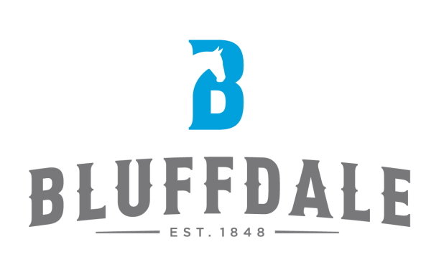

NOTICE OF PUBLIC HEARING

Notice is hereby given that Public Hearings will be held before the Bluffdale City Planning Commission on Wednesday, November 9, 2016 which will begin at 7:00 p.m., or as soon thereafter as possible and before the Bluffdale City Council on Wednesday, November 16, 2016 which will begin at 6:30 p.m., or as soon thereafter as possible at the Bluffdale Fire Station, 14350 South 2200 West, Bluffdale, Utah, for the purpose of receiving public comment a Preliminary Subdivision Application for the Independence Village Subdivision located at approximately 14774 S Noell Nelson Drive and a Text Amendment Application to amend Bluffdale Code 2016-12. The hearings are scheduled in connection with a regularly scheduled meeting of the Bluffdale City Planning Commission and City Council. If you cannot attend, please provide comments in writing. In compliance with the Americans with Disabilities Act, individuals needing assistance or other services for this meeting should contact Bluffdale City Hall at least 24 hours in advance of such meeting at 801-254-2200. TTY 7-1-1. The City’s Internet website is located at www.bluffdale.com.

For more information regarding this application you may contact Caitlyn Miller at (801)-858-0510 or cmiller@bluffdale.com.

