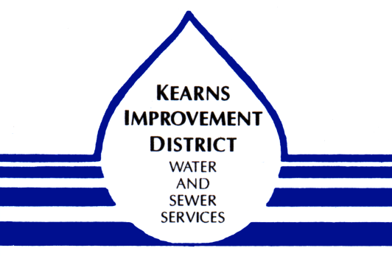

***NOTICE***

The Central Valley Water Reclamation Facility (CVWRF) is comprised of seven member agencies , of which Kearns Improvement District is one. Each of the agencies has an ownership interest in the Facility. Today, as the Facility approaches thirty years in age, CVWRF is faced with addressing the following challenges:

- Permit Renewal
- Asset Management (aging infrastructure)
- Nutrient Removal
- Funding Strategies

The cost of these challenges will be over $200 million over the next 30 years. The Kearns Improvement District Board of Trustees will be discussing these challenges and our path forward to fund our portion of these projects.

Please join us at our Board meeting on July 12 beginning at 4:30 p.m. to hear the discussion and provide comment.

