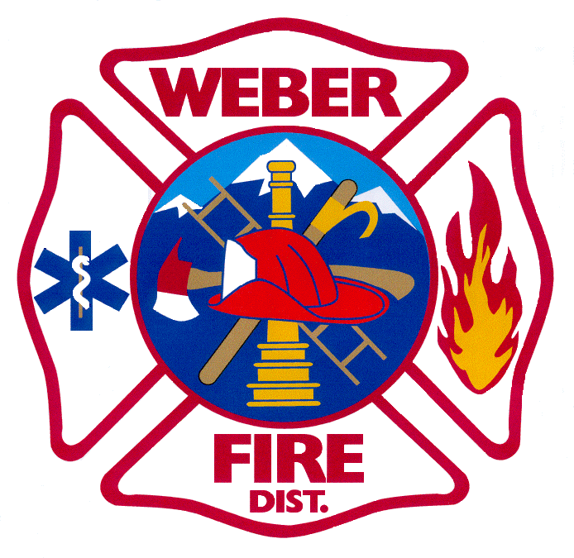

WEBER FIRE DISTRICT
BOARD OF TRUSTEES MEETING NOTICE AND AGENDA
2023 WEST 1300 NORTH
FARR WEST CITY, UTAH
NovEMBER 10, 2015

5:30 PM

1 Call meeting to order
2 Pledge of Allegiance
3 Opening ceremony
4 Public comments: Resident(s) attending meeting will be allotted three (3) minutes to address the Board of Trustees regarding concerns or ideas. No action can or will be taken on any issues presented.

***THE BOARD OF TRUSTEES MAY TAKE ACTION AS DEEMED NECESSARY ON ANY OF THE FOLLOWING AGENDA ITEMS***

5 Approval of October 13, 2015 Board Meeting Minutes

6 Presentation and approval of financial report

7 Presentation and discussion of the proposed 2015 Amended Budget

8 Presentation, discussion, and approval of the 2016 Tentative Budget

9 Set Public Hearing of December 8, 2015 at 6:00 p.m. for:
Approval of the 2015 Amended Budget
Approval of the 2016 Budget

10 Public Employee Hearing: Presentation, discussion, and consideration for approval to transfer from the URS Tier 1 Public Employee Contributory Retirement System to the Tier 1 Public Employee Noncontributory Retirement System

11 Presentation and discussion on the 2700 North Community Development Project Area Plan; a Pleasant View and Farr West Community Development and Renewal Agency

12 Update on UDOT project plans for expansion of SR-37 (4000 South) and impacts to Station 63

13 Administration Report

14 Board Presentations

15 Adjournment

The Weber Fire District, in compliance with the American Disabilities Act, provides accommodations and auxiliary communicative aids and services for all those citizens in need of assistance. Persons requesting these accommodations for District-sponsored public meetings, services, programs, or events should call Chief Austin, 801-782-3580 at least three (3) working days before the meeting. Meeting will be held at the District’s Station 61, 2023 W 1300 N, Farr West, UT 84404. CERTIFICATE OF MAILING and Notice: The undersigned duly appointed hereby certifies that a copy of the foregoing Notice and Agenda was sent to each member of the Governing Body, posted at Stations 61, 62, 63, 64, 65, and 66, and posted Meeting Notice and Agenda on the Utah Public Meeting Notice Website (http://www.utah.gov/pmn/index.html) on November 4, 2015.

_________________________________________________ ‘Andrea Fiske, Administrative Clerk

