MIDVALE CITY
CITY COUNCILWORKSHOP MEETING
Minutes

Tuesday, March 10, 2015
Council Chambers
7505 S. Holden Street
Midvale, Utah 84047

MAYOR: JoAnn Seghini

COUNCIL MEMBERS: Council Member Wayne Sharp
Council Member Stephen Brown
Council Member Paul Glover
Council Member Paul Hunt
Council Member Quinn Sperry

STAFF: Phillip Hill, Asst. City Manager/CD Director; Laurie Harvey, Asst. City Manager/Admin. Services Director; Rori Andreason, City Recorder/H.R. Director; Alan Hoyne, Interim Public Works Director; Stephen Black, Interim Public Works Director; Lesley Burns, City Planner; Danny Walz, Redevelopment Agency Director; and Mike Welling, IT Technician.

Mayor Seghini called the meeting to order at 6:00 p.m.

- DISCUSSION ITEMS
A. TOUR OF MIDVALE CITY PUBLIC WORKS FACILITY
B. RESIDENTIAL PROJECTS TOUR
The Council and staff toured the new remodel of the Public Works facility as well as a few residential projects within the City.

C. KIMPTON SQUARE DISCUSSION
Phillip Hill introduced Jeff Nielsen, Wasatch Properties.

Jeff Nielsen discussed the parking for Kimpton Square discussed the following items:

Proposed Overlay Amendment for Senior Affordable Housing
A. Parking
- The land immediately to the north of the project (area highlighted in yellow below) will be reserved as a future surface parking lot containing 56 parking stalls. The senior housing will be built with 97 parking stalls located underneath the building and 32 surface guest parking stalls. This equates to 1.33 stalls per unit.

- The surface lot will be converted to 7 single family residences IF the 32 guest parking stalls are less than 75% occupied for the 6 months following the date in which the project achieves 95% occupancy. The stalls will be surveyed Monday-Friday at noon and 5 pm daily. If not, the surface lot will be constructed.

B. Density
- Increase the density by 3.5 units/acre from 16 units/acre to 19.5 units/acre.
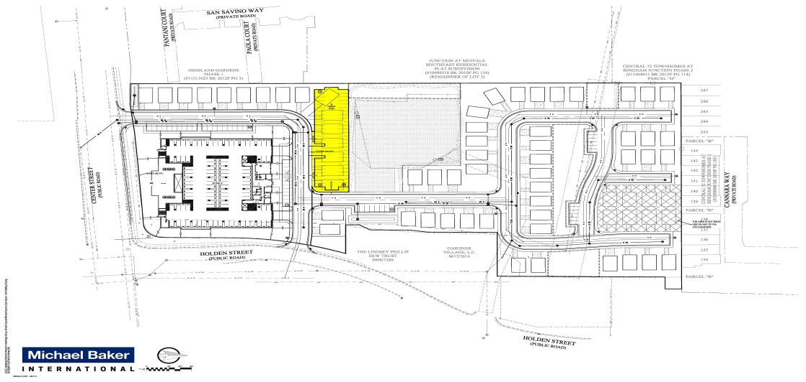

Parking Analysis -Tuscany Villas
A. Tuscany Villas is a senior affordable housing community consisting of 76 apartment homes with studios, one bedroom and two bedroom units.

B. Parking - 96 total parking stalls as follows (1.26 stalls per unit):
- 76 covered stalls (1 stall per unit) of which 55-60 stalls are occupied and 15-20 stalls are consistently vacant.
- 20 open visitor stalls (1 stall per 4 units) of which 10-15 are used during daytime and evening hours. The stalls are empty during the nighttime hours. Visitor stalls accommodate independent nursing staff, family and other visitors.

Tuscany Villas is located within close proximity to the Bingham Junction TRAX station; however, use by residents is very limited.

C. Conservatively speaking, it appears that approximately 80% of the covered stalls and 75% of the guests parking stalls are used consistently. The project has ample parking to meet the needs of the residents and their guests.

After an in-depth discussion by the Council, staff and the developer, a compromise was met with the developer removing two units to add additional parking. This item will be scheduled for final approval at a future meeting.
II. ADJOURN

Mayor Seghini adjourned the meeting at approximately 8:48 p.m.

Rori L. Andreason, MMC
CITY RECORDER
Approved this 17th day of March, 2015.

