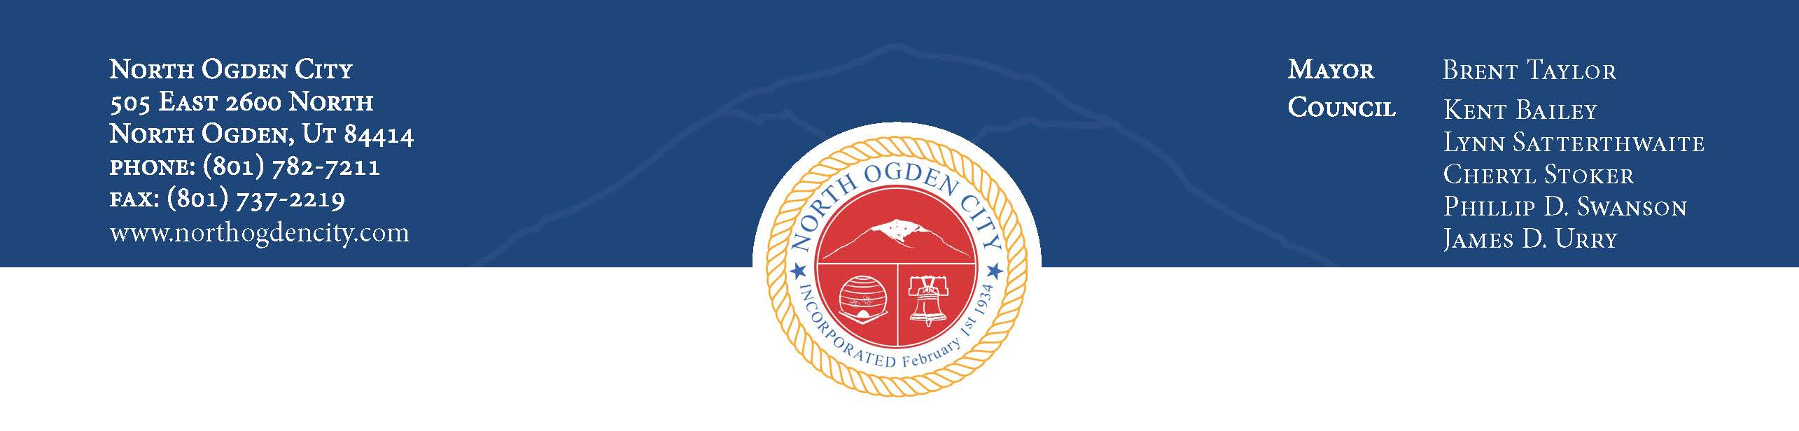
Planning Commission Meeting
September 3, 2014 – 6:30PM
505 East 2600 North
North Ogden City, Utah

Welcome: Chairman Thomas
Invocation and Pledge of Allegiance: Commissioner Barker

6:30PM – Regular Meeting

Active Agenda
- Public Comments
- Discussion and/or recommendation to annex property located at approximately 1700 North Washington Boulevard and zone the property Commercial Zone (C-2)
- Discussion and/or recommendation to accept a petition for a variance regarding the North Ogden City subdivision standards for Legacy North PRUD Phase IV, located at approximately 2400 North 500 East
- Discussion to amend Ordinance 11-16, Home Occupation, to clarify the standards for the allowance of accessory buildings/garages
- Public Comments
- Planning Commission/Staff Comments
- Adjournment

