DAVIS COUNTY BOARD OF HEALTH

ELECTRONIC SMOKING DEVICE REGULATION

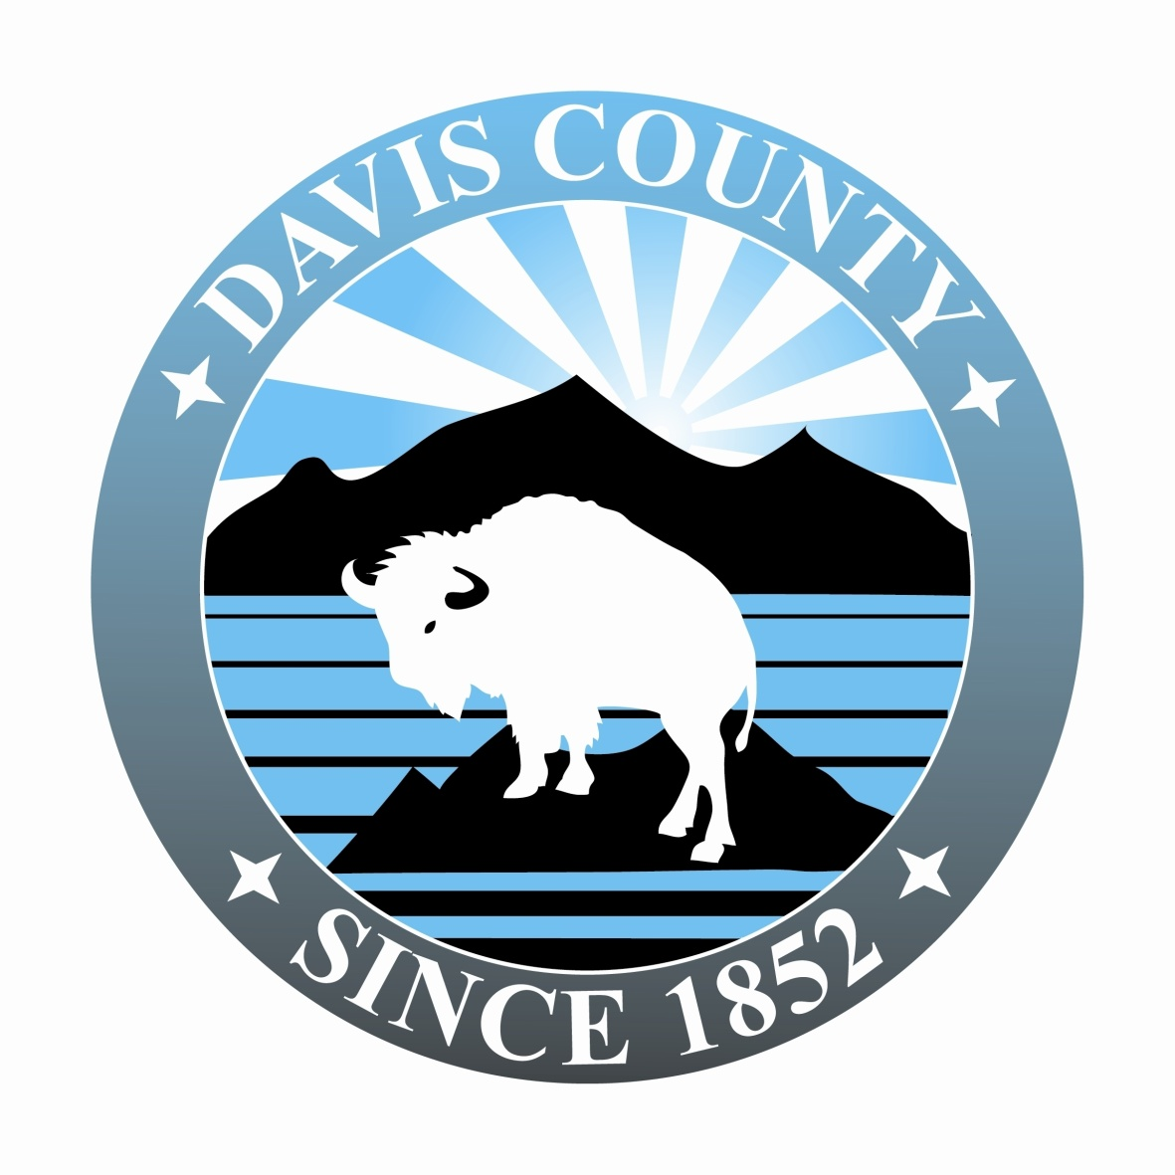

Table of Contents
1.0 PURPOSE 1
2.0 SCOPE 1
3.0 AUTHORITY AND APPLICABLE LAWS 1
4.0 DEFINITIONS 1
5.0 REGULATION 2
6.0 PENALTY 5
7.0 SEVERABILITY 5
8.0 FEES 6

1.0 PURPOSE

The purpose of this regulation is to protect the public health, safety, and welfare of residents and employees by establishing practices and provisions for the sale of Electronic Smoking Devices (ESDs) and E-Liquid; and the safe preparation and handling of E-Liquid components in Davis County.

2.0 SCOPE

This regulation applies to ESDs and E-Liquid sampled, sold and/or manufactured in incorporated and unincorporated areas of Davis County. Requirements for ESDs are consistent with and support all applicable state and federal laws.

3.0 AUTHORITY AND APPLICABLE LAWS

3.1 This regulation is adopted under the authority of the Davis County Board of Health in accordance with Section 26A-1-121 of the Utah Code Annotated.

3.2 Title 26 Section 38: Utah Indoor Clean Air Act of the Utah Code Annotated, is hereby adopted and incorporated by reference subject to the additions, modifications and exceptions set forth in this regulation.

3.3 R392-510: Utah Indoor Clean Air Act is hereby adopted and incorporated by reference.

3.4 Title 76 Section 10-104: Providing cigar, cigarette, electronic cigarette, or tobacco to a minor of the Utah Code Annotated, is hereby adopted and incorporated by reference.

3.5 Title 76 Section 10-105: Buying or possessing a cigar, cigarette, electronic cigarette, or tobacco by a minor of the Utah Code Annotated, is hereby adopted and incorporated by reference.

4.0 DEFINITIONS

4.1 DEPARTMENT: The Davis County Health Department.

4.2 ELECTRONIC SMOKING DEVICE (ESD): An electronic and/or battery-operated device, the use of which may resemble smoking that can be used to deliver an inhaled dose of nicotine or other substances. “Electronic Smoking Device” includes any such device, whether manufactured, distributed, marketed, or sold as an electronic cigarette, an electronic cigar, an electronic cigarillo, an electronic pipe, an electronic hookah, or any other product name or descriptor.

4.3 E-LIQUID: Liquid product that is vaporized and inhaled when using an ESD. Also referred to as, but not limited to, E-Juice or Smoke Juice.

4.4 E-LIQUID COMPONENTS: The ingredients used in making E-Liquid including, but not limited to propylene glycol (PG), vegetable glycerin (VG), nicotine, and flavorings.

4.5 GOOD HYGIENIC PRACTICES: General activities that include, but are not limited to, washing hands, covering open wounds or abrasions, not working when experiencing signs or symptoms of an illness, keeping work areas clean and free from food and drink, etc.

4.6 MANUFACTURING: Process that includes, but is not limited to, mixing, re-packaging and/or re-sizing E-Liquid.

4.7 MANUFACTURING FACILITY: Any business within Davis County that manufactures, repackages, or resizes E-Liquid for sale or for resale.

4.8 NICOTINE: An alkaloid derived of tobacco and other plants, or produced synthetically which has addictive and other physiological effects when ingested or inhaled.

4.9 PREPARATION AREA: Physical location in which E-Liquid Components are mixed, repackaged, or resized for sale to the consumer.

4.10 SAFETY PRECAUTIONS: General activities that include, but are not limited to, wearing gloves, wearing eye protection, using equipment that is in good repair, cleaning up spills, access to a first aid kit, etc.

4.11 SAMPLING: Demonstrating to the potential purchaser of an ESD how to use the device, or the customer sampling an E-Liquid sold for use in an ESD.

4.12 UNITED STATES PHARMACOPEIA (USP) STANDARDS: Written standards for medicines, food ingredients, dietary supplement products and ingredients. These standards are used by regulatory agencies and manufacturers to help ensure products are of the appropriate identity, as well as strength, quality, purity, and consistency.

5.0 REGULATION

5.1 E-LIQUID FOR SALE IN DAVIS COUNTY

5.1.1 Packaging - All containers must have child proof caps.

(1) Have child-proof caps;

(2) Be leak-proof at the time of sale;

(3) Be tamper-evident.

5.1.2 Labeling

5.1.2.1 Labels shall clearly display:

(1) Nicotine content in mg/mL or percent by volume;

(1) Nicotine and nicotine content

(2) Vendor name;

(3) Ingredients;

(4) Safety warnings. stating “Keep away from children and pets.”

5.1.2.2 Labels must be smear resistant.

5.1.3 Nicotine level in E-Liquid

5.1.3.1 The maximum allowable nicotine content shall be no greater than 36 mg/mL or 3.6% by volume.

5.1.3.2 Nicotine level shall not exceed a 10% variation in mg/mL from the content level indicated on the label.

5.1.3.3 E-Liquid labeled 0 nicotine mg/mL or 0% by volume shall have no nicotine present.

5.1.4 E-Liquid may be subject to random testing by the Department.

5.1.5 Section 5.1 shall not apply to E-Liquid sold in pre-filled ESD products or sealed, pre-filled, disposable replacement cartridges for use in ESDs.

5.2 ESD AND E-LIQUID ADVERTISING

5.2.1 Retailer websites, social media pages, or in-store advertisements shall not make any health or therapeutic claims such as ESDs and/or use of E-Liquid are a healthy alternative to smoking.

5.2.2 Retailer websites, social media pages, or in-store advertisements shall not make any claims that ESDs and/or use of E-Liquid are a smoking cessation product.

5.2.3 Retailers must have information readily available for consumer explaining the difference between mg/mL and percent by volume of nicotine.

5.3 YOUTH ACCESS IN DAVIS COUNTY

5.3.1 The selling of E-Liquid to any person under 19 years of age is prohibited.

5.3.2 The possession of E-Liquid by any person under 19 years of age is prohibited.

5.3.3 ESDs and E-Liquid shall not be directly accessible to the public. ESDs and E-Liquid on display must be behind the counter or in locked display cases. persons under 19 years of age.

5.4 E-LIQUID MANUFACTURING FACILITIES IN DAVIS COUNTY

5.4.1 E-Liquid Manufacturing Facilities within Davis County must obtain a ESDs and E-Liquid Operating Permit from the Department.

5.4.2 Sanitation and Safety

5.4.2.1 E-Liquid preparation surfaces must be smooth, non-absorbent and easily cleanable.

5.4.2.2 Floors, walls, and ceilings in the Preparation Area must be smooth, non-absorbent and easily cleanable.

5.4.2.3 All E-Liquid preparation equipment shall be easily cleanable and in good repair.

5.4.2.4 Individuals preparing E-Liquid shall use Good Hygienic Practices and take proper Safety Precautions.

5.4.2.5 Drinking, eating, vaping or smoking is not permitted in the Preparation Area.

5.4.2.6 No animals shall be permitted in the Preparation Area.

5.4.2.7 E-Liquid Components shall be stored to prevent contamination and/or spillage.

5.4.2.7.1 Nicotine shall be stored in a manner to prevent contamination of Preparation Areas, equipment, supplies and other E-Liquid Components.

5.4.2.8 Chemicals not involved in the preparation of E-Liquid shall not be stored in preparation or ingredient storage areas.

5.4.3 Operating Procedures

5.4.3.1 Standard Operating Procedures (SOPs) for manufacturing E-Liquids shall be written and must incorporate Good Hygienic Practices and Safety Precautions. SOPs shall be made available to the Department upon request.

5.4.3.2 Employees shall be trained on all SOPs and training logs shall be maintained. Logs shall be made available to the Department upon request.

5.4.4 Quality and Safety of E-Liquid Components

5.4.4.1 E-Liquid Components included but not limited to, propylene glycol (PG), vegetable glycerin (VG), nicotine, and flavorings must be at a minimum US Pharmacopeial (USP) grade certified, food grade, FDA approved, or equivalent.

5.4.4.1.1 Documentation must be available for all E-Liquid Components showing certification, approval, grade, or equivalency and shall be made available to the Department upon request.

5.5 SAMPLING FACILITIES IN DAVIS COUNTY

5.5.1 Businesses who generate 75% of their gross income from ESDs and E-Liquid are allowed to take a sampling exemption in accordance with the Utah Indoor Clean Air Act, 26-38-2.6, Utah Code Annotated.

5.5.2 In accordance with the Utah Indoor Clean Air Act, 26-38-2.6, Utah Code Annotated, Tobacco Specialty Retailers who allow electronic cigarette product sampling in their store cannot permit a person under the age of 19 to enter the establishment.

6.0 PENALTY

6.1 Criminal Penalties

6.1.1 Any Person who is found guilty of violating the provisions of this regulation is guilty of a class B misdemeanor pursuant to Section 26A-1-123, Utah Code Annotated. A Person found guilty of a subsequent violation within two years is guilty of a class A misdemeanor pursuant to Section 26A-1-123, Utah Code Annotated.

6.2 Civil and Administrative Penalties

6.2.1 Violations of this regulation shall be subject to the Department’s Adjudicative Hearing Procedures and may result in suspension or revocation of the ESDs and E-Liquid Operating Permit.

7.0 SEVERABILITY
In the event any court of competent jurisdiction should declare any particular clause or sentence of this regulation invalid or unconstitutional, the remaining portions shall remain in full force and effect. Toward that end, the provisions of these regulations are declared to be severable.

8.0 FEES

ESDs and E-Liquid Operating Permit (Annual) $200

IN WITNESS WHEREOF, the Davis County Board of Health has passed, approved and adopted this regulation this 11th day of February, 2014.
Effective date: 11th day of February, 2014.

Signed: _________________________ Witness: ___________________________
Don Wood Lewis Garrett, MPH
Board Chairman Director of Health

